# Power supply measurement

# StrainGAUGE switching

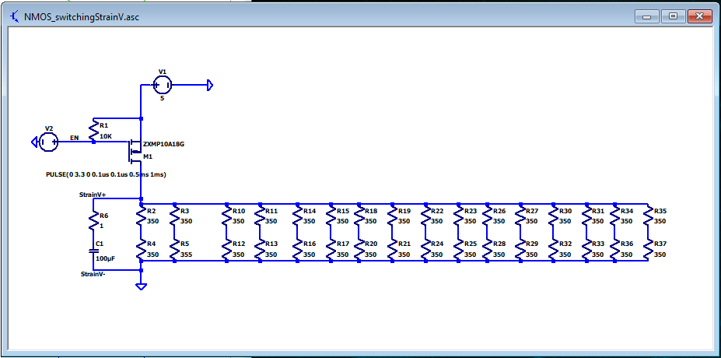

# Strain gauge Amplifier

I had difficulty combining with the clamping diodes in the next circuit. Wondering if it has to do with the output current of the OP-AMP. Will need to explore this a bit further.

Diode clamping circuit (*Note, reverse voltage can vary quite a bit as seen by Vz on circuit)

