# Ideal Standard - Multi-Select (M-S) - Qcon format - Word - inline answers

1. Which of (1) the following **individuals** are credited with determining the exact speed of light?
   1. *Albert Einstein
   2. *Albert Michelson
   3. Edward Williams Morley
   4. Thomas Edison
2. Which of (2) the following **individuals** are credited with determining the exact speed of light?  
   @ Blah Blah overall feedback
   1. *Albert Einstein
   2. *Albert Michelson
   3. Edward Williams Morley
   4. Thomas Edison

Title: Who (3) determined the exact…

1. Which of the following **individuals** are credited with determining the exact speed of light?  
   @ Blah Blah overall feedback
   1. *Albert Einstein
   2. *Albert Michelson
   3. Edward Williams Morley
   4. Thomas Edison

Title: Who (4) determined the exact…

1. Which of the following **individuals** are credited with determining the exact speed of light?  
   @ Blah Blah overall feedback
   1. *Albert Einstein
   2. *Albert Michelson
   3. Edward Williams Morley
   4. Thomas Edison

Points: 2

Title: Who (5) determined the exact…

1. Which of the following **individuals** are credited with determining the exact speed of light?  
   @ Blah Blah overall feedback
   1. *Albert Einstein
   2. *Albert Michelson
   3. Edward Williams Morley
   4. Thomas Edison

Title: Who (6) determined the exact…

1. Which of the following **individuals** are credited with determining the exact speed of light?  
   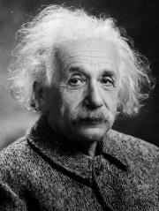 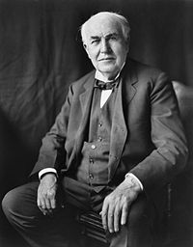  
   @ Blah Blah overall feedback
   1. *Albert Einstein
   2. *Albert Michelson
   3. Edward Williams Morley
   4. Thomas Edison

Title: Who (7) determined the exact…

1. Which of the following **individuals** are credited with determining the exact speed of light?  
   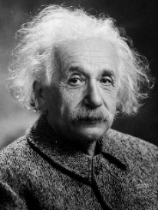   
   @ Blah Blah overall feedback
   1. *Albert Einstein  
      @ Yes, sort of ☺
   2. *Albert Michelson  
      @ You are correct, sir!
   3. Edward Williams Morley  
      @ Incorrect, sorry  
      
   4. Thomas Edison  
      @ Try again

Title: Who (8) determined the exact…

1. Which of the following individuals are credited with determining the exact speed of light?  
   See this video:  
   source: <https://www.youtube.com/embed/fpJdq12ddgk>  
   @ Blah Blah overall feedback
   1. *Albert Einstein
   2. *Albert Michelson  
      @ You are correct, sir! $A=πr^{2}$
   3. Edward Williams Morley
   4. Thomas Edison