# Ideal Standard - Multi-Select (M-S) - Respondus format - Word – answers @ end

Type: MR

1. Which of (1) the following **individuals** are credited with determining the exact speed of light?
   1. Albert Einstein
   2. Albert Michelson
   3. Edward Williams Morley
   4. Thomas Edison

Type: MR

1. Which of (2) the following **individuals** are credited with determining the exact speed of light?  
   @ Blah Blah overall feedback
   1. Albert Einstein
   2. Albert Michelson
   3. Edward Williams Morley
   4. Thomas Edison

Type: MR

Title: Who (3) determined the exact…

1. Which of the following **individuals** are credited with determining the exact speed of light?  
   @ Blah Blah overall feedback
   1. Albert Einstein
   2. Albert Michelson
   3. Edward Williams Morley
   4. Thomas Edison

Type: MR

Title: Who (4) determined the exact…

1. Which of the following **individuals** are credited with determining the exact speed of light?  
   @ Blah Blah overall feedback
   1. Albert Einstein
   2. Albert Michelson
   3. Edward Williams Morley
   4. Thomas Edison

Type: MR

Points: 2

Title: Who (5) determined the exact…

1. Which of the following **individuals** are credited with determining the exact speed of light?  
   @ Blah Blah overall feedback
   1. Albert Einstein
   2. Albert Michelson
   3. Edward Williams Morley
   4. Thomas Edison

Type: MR

Title: Who (6) determined the exact…

1. Which of the following **individuals** are credited with determining the exact speed of light?  
   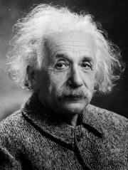 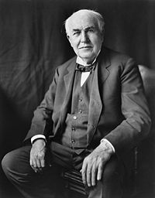  
   @ Blah Blah overall feedback
   1. Albert Einstein
   2. Albert Michelson
   3. Edward Williams Morley
   4. Thomas Edison

Type: MR

Title: Who (7) determined the exact…

1. Which of the following **individuals** are credited with determining the exact speed of light?  
   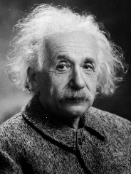   
   @ Blah Blah overall feedback
   1. Albert Einstein  
      @ Yes, sort of ☺
   2. Albert Michelson  
      @ You are correct, sir!
   3. Edward Williams Morley  
      @ Incorrect, sorry  
      
   4. Thomas Edison  
      @ Try again

Type: MR

Title: Who (8) determined the exact…

1. Which of the following individuals are credited with determining the exact speed of light?  
   See this video:  
   source: <https://www.youtube.com/embed/fpJdq12ddgk>  
   @ Blah Blah overall feedback
   1. Albert Einstein
   2. Albert Michelson  
      @ You are correct, sir!

* 1. Edward Williams Morley
  2. Thomas Edison

Answers:

1. a, b
2. a, b
3. a, b
4. a, b
5. a,b
6. a,b
7. a,b
8. a,b