Building a Swarmie

Table of Contents

2 Chassis Assembly 1

2.1 Brackets 1

2.2 Motors 2

2.3 Wheel Assembly 2

2.4 Bottom Plate 2

3 Top Plate Assembly 2

3.1 3D Printed Parts 3

3.2 Ultrasounds, Camera, IMU, GPS 3

3.3 PCB, Switch, and Bus Connections 3

3.4 Cover Plate Assembly and Attachment 3

# Introduction

[Place any notes or important information needed prior to assembly]

All metric screws are colored black.

All imperial screws are stainless steel.

# Chassis Assembly

Tools:

* Phillips screw driver – M3x6mm screws
* 2mm hex key – M3x4mm screws
* 3/32” hex key – 4-40x1.5” screws
* ¼” nut driver – 4-40 nyloc nuts

Parts:

* 12x M3x6mm screws – packaged with the chassis kit.
* 8x M3x4mm screws
* 8x 4-40x1.5” screws
* 2x pairs of black brackets – packaged with the chassis kit.
* 4x DC motors
* Laser cut bottom plate
* Battery
* Fire retardant bag
* 3D printed battery base
* 3D printed battery brace
* 3D printed battery cross strap
* 2x wheel mounting hub kits – comes with 2 hubs each.

## Brackets

Using eight M3x6mm screws, attach all four brackets together as seen below.

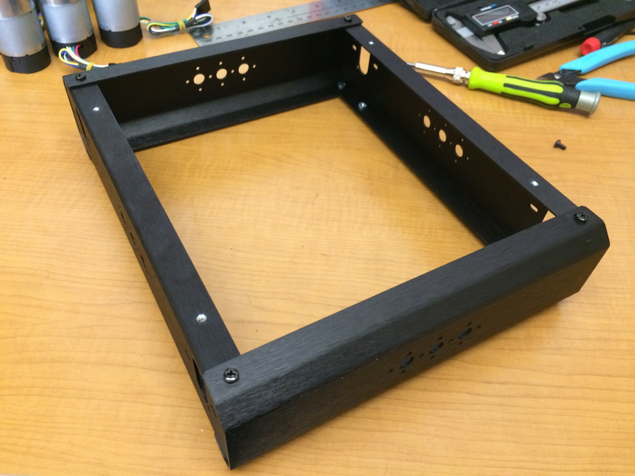

Figure : Chassis brackets fully attached

## Motors

Attach motors to mounting holes using two M3x4mm screws per motor. The motor shaft should be towards the bottom of the chassis. See below for detail.

[Picture of close-up motor inside chassis]

[Picture of all four motors attached in chassis]

## Tire Assembly

Wheel assembly instructions have been adapted from Lynxmotion’s instructions found here: <http://www.lynxmotion.com/images/html/build007.htm>

1. 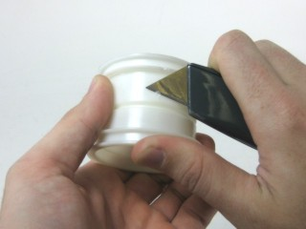First use a utility knife, or similar, to carefully remove any imperfections on the inner part of the rim. This will make things much easier later on.
2. Pull one side of the tire out, so that it protrudes, like in the image. Insert one side of the rim. It helps to insert at an angle in the middle, where the opening is the largest. Rotate the rim slowly, while pressing it in, to help coax it into place.

Figure 2

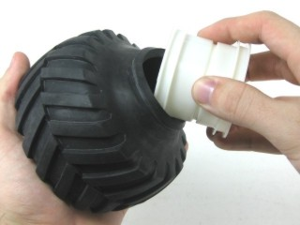

Figure 3

1. 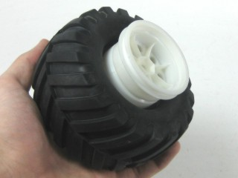You should end up with the tire and rim looking like Figure 4.

Figure 4

1. Pull out the side of the tire again, so that it looks like Figure 5.

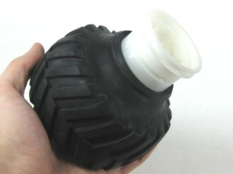

Figure 5

1. 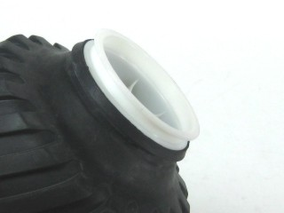Gently press and rotate the rim into the tire. You want to end up with the rim almost fully into the tire with the bead still sticking out, as in Figure 6. If there are any imperfections leftover from Step 1, then it may be difficult to pass the tire over them.

Figure 6

1. Quickly press the rim into the tire from both sides. The bead should now be completely in the flange. This step may require several attempts.

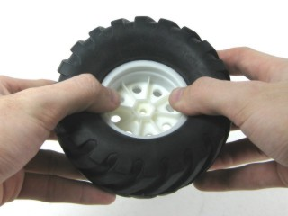

Figure 7

1. 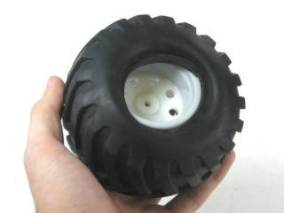Flip the tire over. It should look something like Figure 8.

Figure 8

1. Almost half the bead is in the flange. Just hold that side in and pull the rest of the bead away from the center, and it will retract back into the flange. It may be helpful to use a screw driver to pull the tire over the wheel.

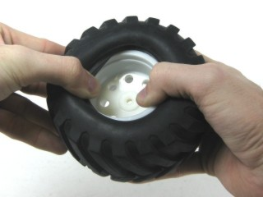

Figure 9

1. 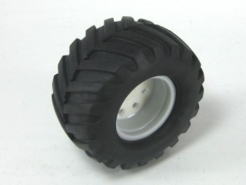A completed tire is shown in Figure 10.

Figure 10

## Bottom Plate

Tools:

* 1/16” hex key – 4-40x1/2”
* 3/32” hex key – 4-40x1.5” screws
* ¼” nut driver – 4-4- nyloc nuts

Parts:

* 8x 4-40x1.5” screws
* 4x 4-40x1/2” screws
* 4x M3x6mm
* 16x washers
* Battery Base
* Battery Brace
* Battery Cross Strap
* Battery
* Fire retardant bag

Using 8 4-40x1.5” screws and nyloc nuts, attach the battery base and battery brace. The battery brace is flatter on one of the sides with screw holes, this is the bottom. Use washers on both sides of the screws.

[Photo of battery base and battery brace attached]

Using 4 M3x6mm screws, attach the bottom plate to the bottom of the chassis. You will notice that the motor shafts are closer to one side of the chassis, this side is the bottom. The plate can be attached in orientation that it fits, the orientation will matter when the wheels are attached.

[Photo to make sure correct side is used]

Insert the battery into the fire retardant bag in the following way. With the bag’s warning facing you, insert the battery with the wire leads coming out on the right. Close the Velcro flap and wrap it around the back of the bag as tightly as possible. This is necessary to properly fit into the battery base.

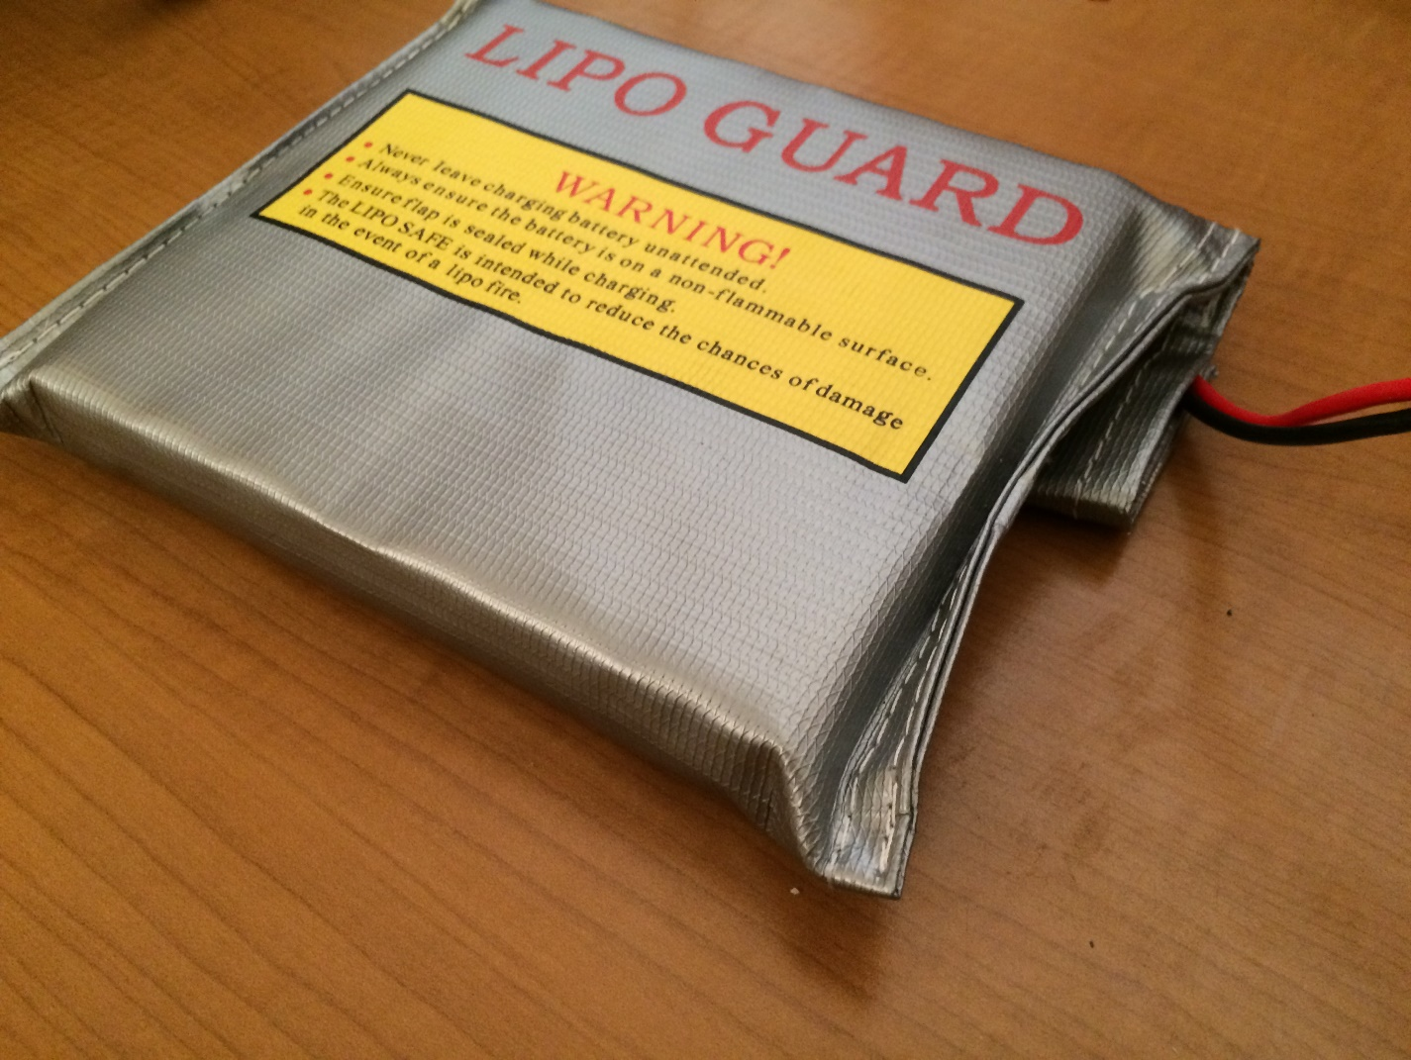

[Waiting for newest version of laser cut plate]

## Wheel Attachment

# Top Plate Assembly

The following is needed for constructing the top plate.

[Tools list]

[Parts list]

[This section includes instructions to attach all 3D printed parts to the top plate as well as electronics (ie. PCB, US, IMU, GPS, switch, buses, NUC, camera)]

[Waiting for newest version of the top plate]

## 3D Printed Parts

[Where and in what orientation to attach]

## Ultrasounds, Camera, IMU, GPS

[Will mostly include pictures of attachment. The US mounts require some assembly as well.]

## PCB, Switch, and Bus Connections

[Great stuff]

## Cover Plate Assembly and Attachment

[Current version of the cover plate is in stock]

# Fully Assembled

[Include information about and pictures of the fully assembled Swarmie]