Designing a Basic DC Linear
Motor Controller
for IGBT

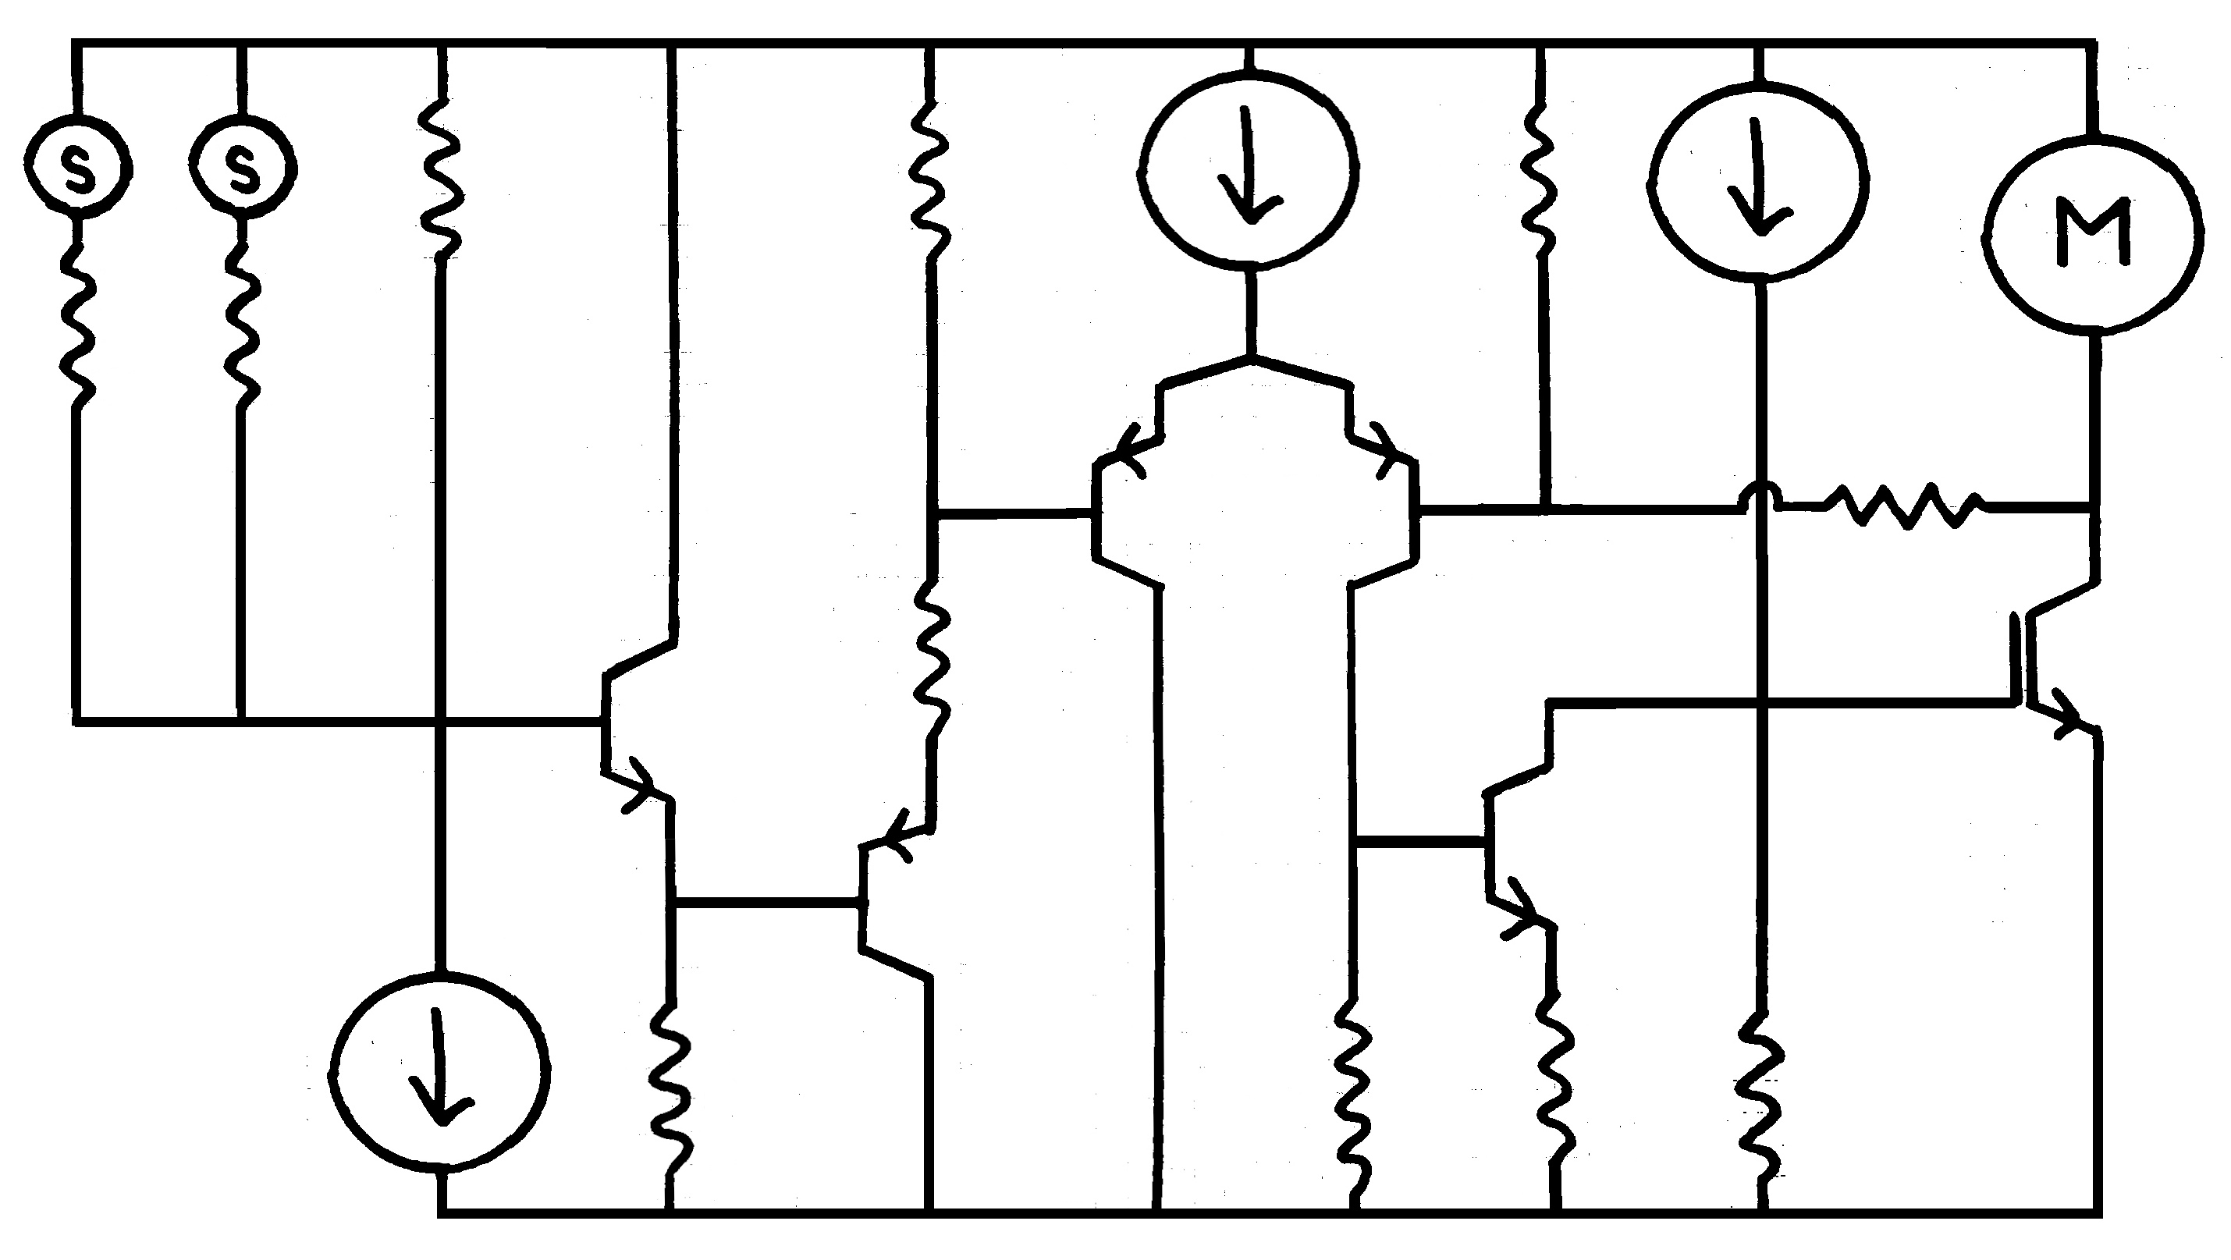

By: Ben Moore
Nov, 2025

The Output Device:

When it comes to choosing an output device for a motor controller amplifier, it is pretty safe to say that BJTs usually should not be considered. For the purpose of this article we will begin by considering the use of a BJT output, and then explain why although it is very possible to achieve a working BJT amplifier, the use of BJTs is typically not desirable to run a motor controller. Ideally, the output device should not draw any DC control current and it should also be capable of operating from nearly rail-to-rail on the same single-ended power supply as the motor itself. It is for this reason that a motor controller output will typically operate with an IGBT or enhancement MOSFET as the output control element.

Beginning by considering a BJT as an output device, a collector-follower amplifier is disqualified immediately. Even with a relatively high-beta power transistor, wasting power by just dumping base current into the rail is not acceptable. If we need to use a BJT as an output device then the load will most certainly be placed in the emitter. In this manner, at least the alpha current is also used to power the load. That solves one problem, still, the beta of a power transistor is generally not very large and the idea that 20% of the load current must be delivered through the base diode is not an absurd concept at all. This is inconvenient because in all likelihood the VA stage will not be capable of providing this much current on its own, so an extra unwanted buffer is almost always necessary.

Perhaps the ideal control element for a motor controller is an enhancement mode MOSFET. The gate-source switching voltage is conveniently small, the gate impedance is incredibly high, and the voltage drop across the control element is negligibly small when the FET is ‘ON’. The problem comes in finding a suitable real-world part to run a linear amplifier under the required operating conditions. One must be extremely diligent in examining the datasheets to ensure that the thermal characteristics of the part will support the linear operation of the design load in question as many MOSFET devices are designed for high-speed switching applications.

For this project, the control element of choice is an Insulated Gate Bipolar Transistor. The IGBT shares many of the same characteristics with the BJT, with the base diode having been replaced with a FET-style capacitor. The obvious huge advantage to this as compared to a BJT amplifier is that none of the DC emitter current is supplied by the control signal anymore. The downside to this arrangement is that the 0.68volt ‘ON’ threshold of a base-emitter junction has been significantly increased to a much higher gate-emitter voltage. This gate-emitter voltage makes an emitter-follower architecture impossible given our rail-to-rail requirement. Of course, will no base current flowing we can now place the load in the collector of the IGBT without issue. In this manner, the gate-emitter voltage can overlap the voltage drop across the motor load satisfying our near rail-to-rail requirement. The voltage drop across an ‘ON’ IGBT transistor is the worst/largest of the transistor types considered, and the nature of the transfer function of the IGBT gate means that feedback will be required to operate as a linear device, but IGBTs are great at dealing with thermals!

I fully intended to share the actual part# and manufacturer of the cool, industrial grade, 1700V rated dual IGBT output device that was used for this project but when I contacted the manufacturer to request permission to republish a portion of their datasheet, the manufacturer responded by reminding me that my part is nearly 40years old and requested that I not even mention them in this article. I was initially disappointed, but the actual descriptions herein need only address the general function of any IGBT, so we shall proceed without describing any specific identifying information. The process of specifying an actual real-world semiconductor is beyond the subject of this article as it can become quite complicated, but it is safe to say that the characteristics of the control element will be determined by the motor load itself. We begin our design with a part known to operate safely under all expected operating conditions with a known motor load.

The Output Stage:

A quick check of my George Brown College notes gives the formula:

Speed=(Va-IaRa)/(k(flux))

What this shows us is that we can vary the speed of a DC motor by varying the voltage across the armature, but what does this formula even mean?

Va is the voltage being applied across the armature. The term IaRa (armature current × armature resistance) is the voltage drop across the armature created by driving current across the armature resistance. The speed then, is directly related to the difference between the applied voltage and the voltage dropped across the motor. Neat!

When I look at the formula though, it appears that increasing the current through the armature winding would decrease the value of numerator. The reality is that the term Va (Applied Voltage) will contain the exact same current term (Ia) as the voltage drop across the armature winding.

Speed=(IaZa-IaRa)/(k(flux))

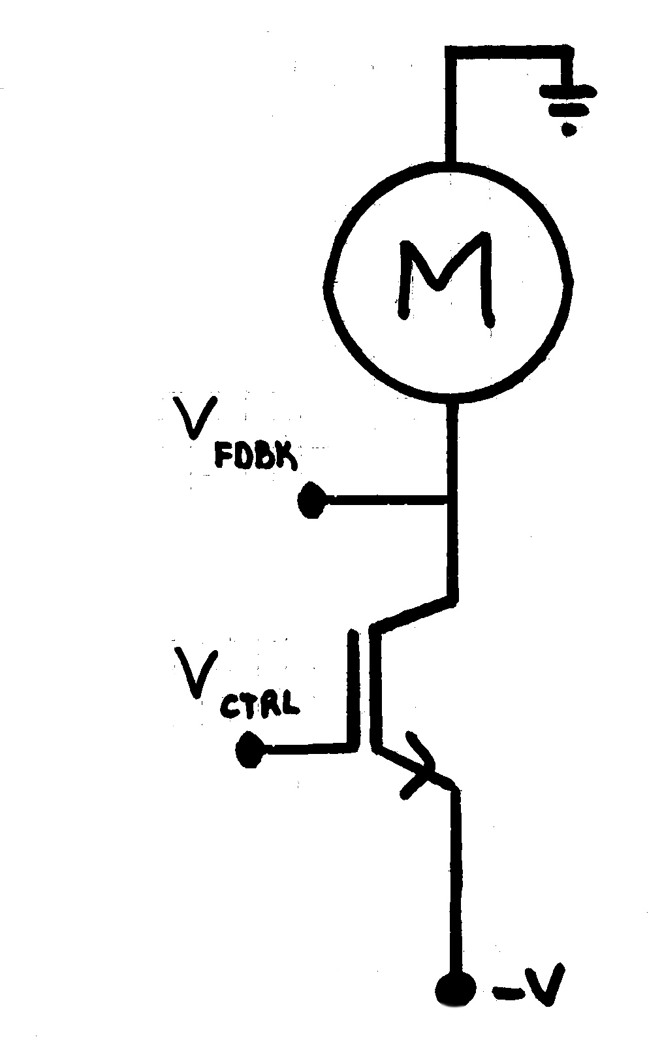

My notes mention that we can reduce the speed of the motor by reducing the current through the windings, but looking at this expanded formula we can see that what we really have control of is the impedance at the armature. Hey, perfect! We can modify the impedance with the IGBT, and we can monitor the voltage across the motor for our feedback reference. That is what we will do.

Again, one of the reasons that IGBTs are ideal for motor control elements is that gate doesn’t draw any DC current. In a switching circuit or a high-speed linear circuit the designer will have to pay close attention to providing enough current to drive the gate capacitance, but for our controller we really need not worry too much. From the datasheet, we must be able to drive 13000pF of Input Capacitance. This is no problem at all. Also from the datasheet, we will need somewhere between 4 volts and 8 volts between the gate and emitter in order to turn the IGBT on. Because of this, we use the collector follower architecture and eliminate the need for extra voltage headroom.
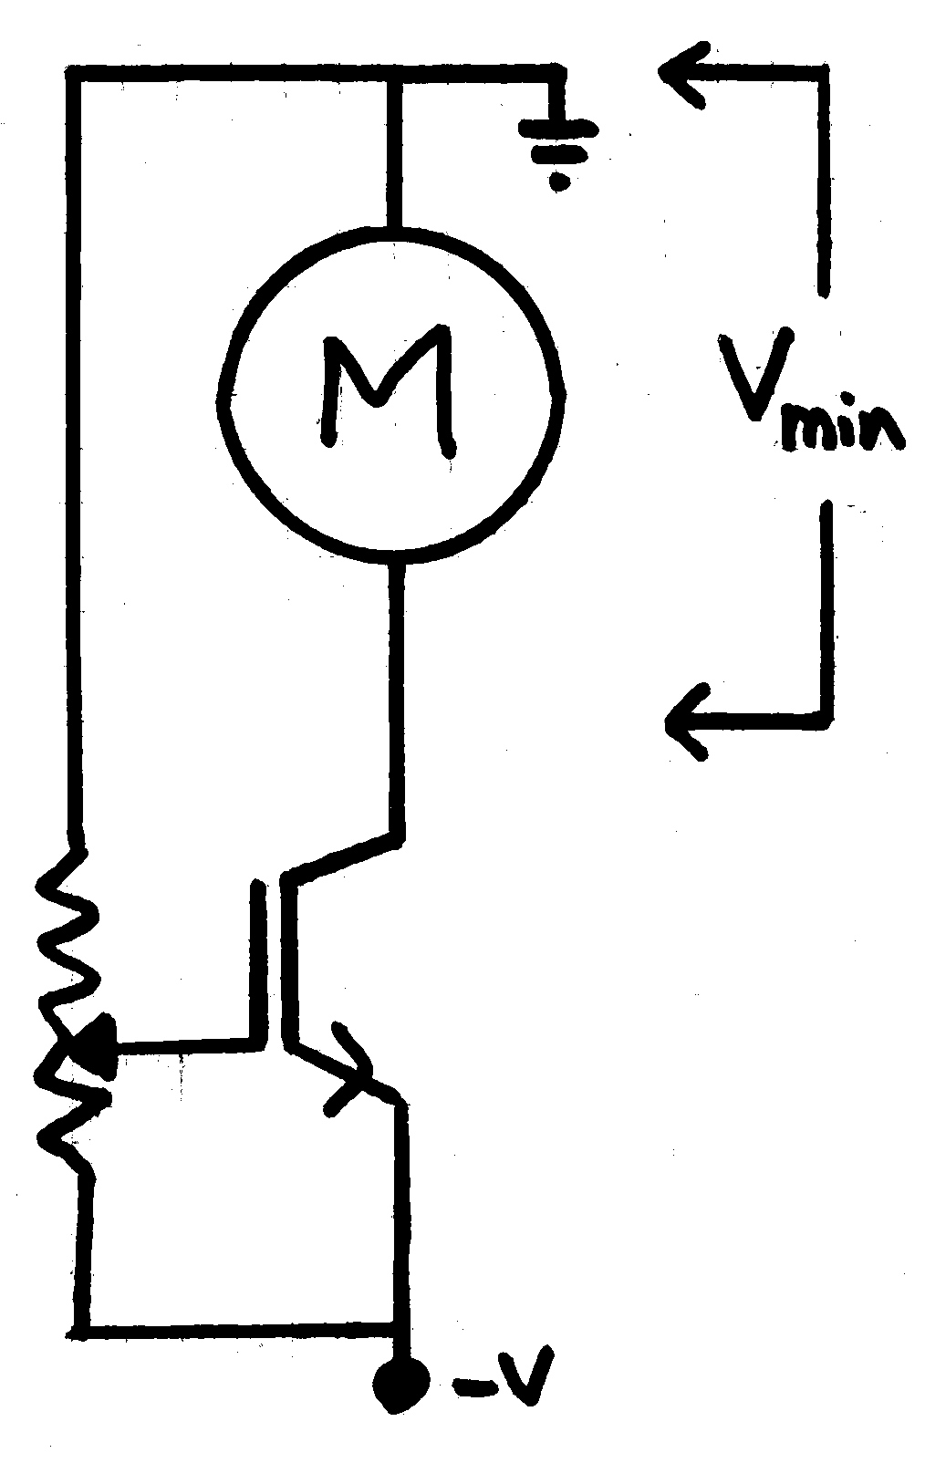

A simple test can be performed by wiring a potentiometer across the power supply rails and connecting the wiper to the IGBT gate. I was able to determine that a good minimum operating voltage for this pump motor is about 3.5V. We will use this voltage later when we design the VA stage.

The last thing to check for the Output stage before moving on to the VA is the thermal performance of the load and control elements.

The pump is really straightforward in this case. It bears maximum ratings of 14.4VDC and 3.5A. The unit is internally thermally protected. It is also internally protected from overpressure and simply asks to be fused at 4A. Looking to the control element now, we will be ridiculously conservative with our calculation inputs:

Maximum Current = 4A

Maximum Rail Voltage = 18VDC

Maximum Power Dissipation = 18VDC × 4A
= 72 Watts

So then, if our power supply was making 18 volts, our motor had zero resistance, and we were drawing the full 4A without blowing the fuse then our IGBT would need to be able to dissipate 72 watts of heat. From the data sheet, the transistor component has a thermal resistance (junction-to-case) of a mere 0.114*C/Watt!

Case Temperate Rise = 72 Watts × 0.114°C/Watt
= 8.2°C

With this absurdly overspec’d output transistor, we can expect a temperature rise of no more than 8°C above ambient. Even that scenario would require something else pretty major to go wrong first. We can feel just fine simply screwing the IGBT to some plywood for this test-rig. Now, on to the voltage amplifier!

The Voltage Amplifier:

The voltage stage is the first place in our design where we are going to start to consider some real-world problems and to begin designing them out of the controller amplifier. This is a 12VDC motor controller and initially the project was battery powered. Battery power means that eventually the power rails will begin to collapse as the charge on the battery becomes depleted. Typically, the internal resistance of a battery power supply means that the actual voltage across the power rails will be changing continuously if/as the load varies so we will definitely design for changing rail voltages.

Luckily, protecting our circuit from varying supply voltages is pretty simple and straightforward. Is his incredible textbook High-Power Audio Amplifier Construction Manual, author G. Randy Sloane goes into great depth explaining constant current sources and describing several different iterations of CCS circuitry. I highly recommend sourcing a copy of this textbook to anybody interested in learning more about designing current sources or high-power amplifiers in general. Years ago I purchased 500x 1N4148 small-signal diodes and so now I nearly always use this circuit:

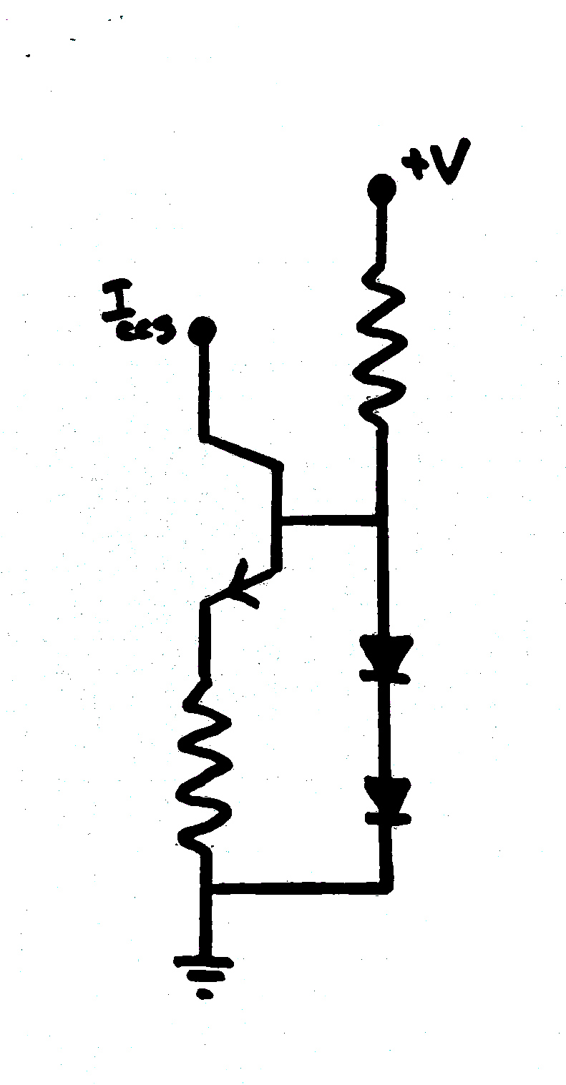

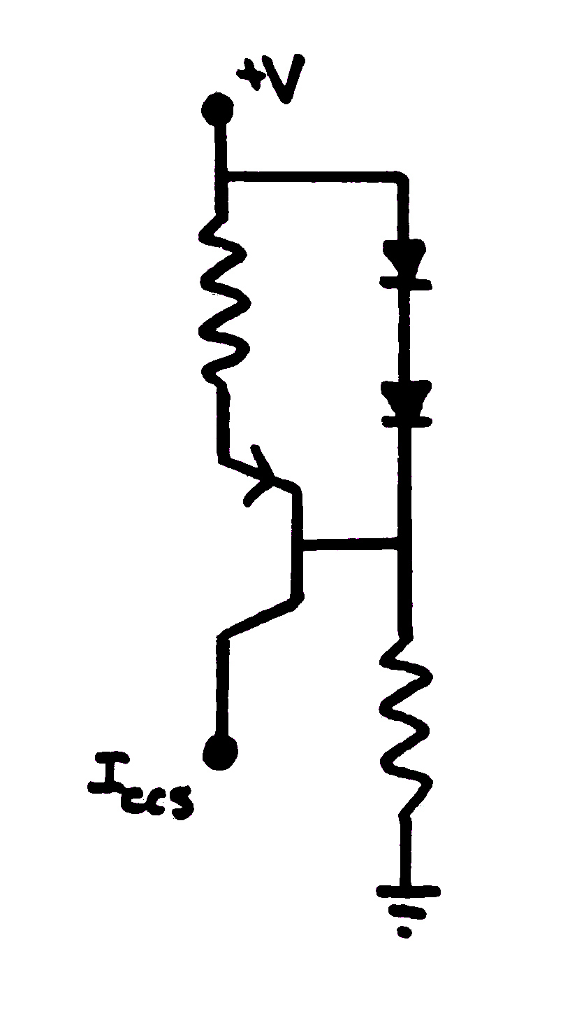

If you imagine a set of imaginary ‘perfect’ power rails, then we could confidently set a voltage or current by using a simple voltage divider. In practice, the actual real potential between the positive and negative terminals is fluctuating constantly. If we were to replace one of the fixed resistances with a current source, then the voltage across the CCS will be forced to fluctuate with the rail voltage in order to maintain a constant current output. Now, with the same amount of current flowing through the fixed resistance regardless of the rail voltage, and the voltage across the fixed resistor will remain stable.

This particular motor circuit is normally required to run at full speed. Under sensor input, we need to reduce power to the pump motor. For this reason, the voltage stage will begin as a static DC voltage amplifier. Remembering from the IGBT datasheet, we may require a V_ge as high as 8V to turn the IGBT on, so we will set our amplifier for 8V. Somewhat arbitrarily, I have chosen 3.5mA as our working current. I say somewhat arbitrary because I tend to design control circuits to operate on very little current and 3.5mA is still quite low but stable enough with 2N5401/2N5551 transistors, so I won’t worry too much.

Beginning with 270ohms in the emitter of a 2N5401 across a collector resistance of 2200ohms, there was not enough gate voltage to turn on the IGBT. Paralleling the 270ohm with an 820ohm gave a measured emitter resistance of 202ohms and gives very nearly 3.5mA. Testing showed the voltage across the 2200ohm resistance was now sufficient to run the pump motor.

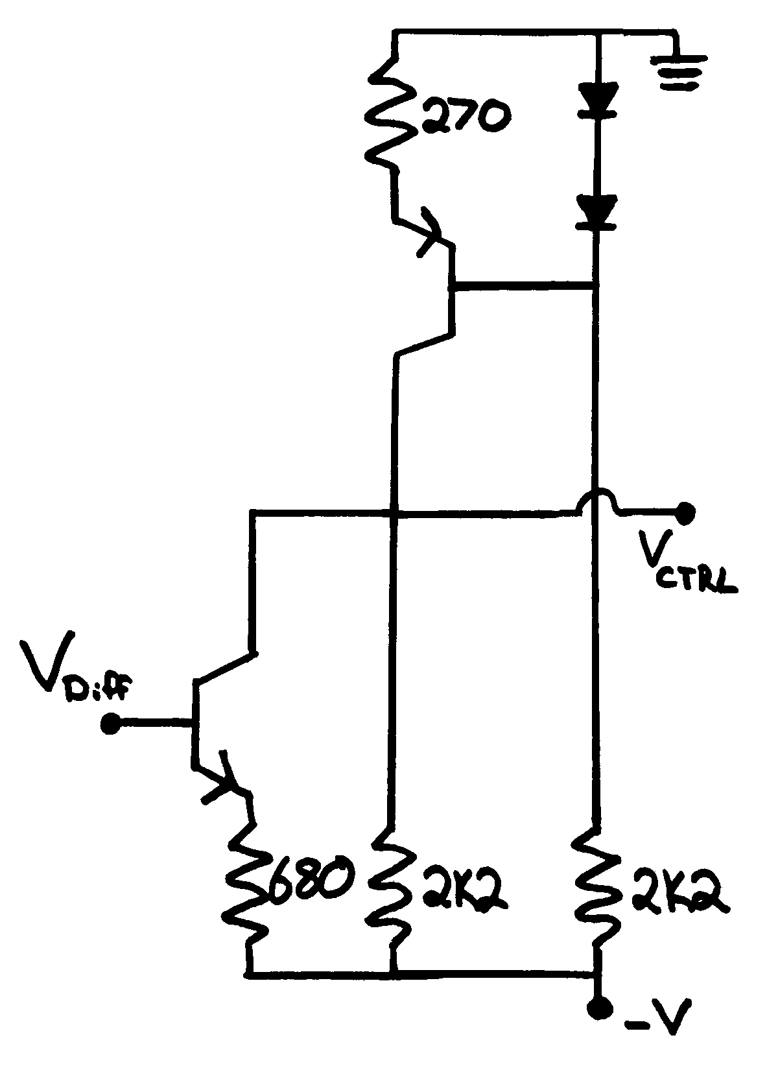
The plan now is to shunt current away from the 2200ohm resistor, reducing the voltage across the pump motor when the sensors call for it. We already know from our previous test that the motor will not run if the gate-emitter voltage is only 5VDC but we will use the numbers from the data sheet anyways and allow the amplifier’s feedback and gain to deal with it. The data sheet says that the minimum ON voltage is rated at 4V so then we can be confident that the IGBT will be OFF with a gate voltage of 3.5V. In reality, we could just disregard this elevated OFF voltage and allow the gain element to deal with the whole voltage swing down through 0V. By removing some of that unnecessary gain, we will add some stability to the circuit performance by reducing the current burden on the differential stage. As an added benefit, every mW burned in a fixed resistance is a mW no longer heating up our semiconductors!

The actual voltage amplifier here is the NPN transistor. If we imagine that the NPN transistor tis completely saturated, a 680ohm resistor in parallel with the 2200ohm resistor would give a gate-emitter voltage of about 1.8V. This is somewhat lower than the 3.5V previously considered the design goal, but it is unlikely that the impedance of the transistor will approach zero very closely, and a breadboard test shows it to work just fine. That’s all there is to designing the VA stage.

The Differential Amplifier:

The differential amplifier is the veritable heart of the feedback control loop. There are, of course, many different methods of applying negative feedback to an amplifier circuit, but it is the differential amplifier which allows us the magical feedback control of an Operational Amplifier.

The differential amplifier is the source of the greatest difficulties in terms of design parameters. This architecture exposes the designer to the very limiting reality of a maximum 5V base-to-emitter potential. Because both separate control transistors share the same emitter load, and hence same emitter voltage, it is very easy to design a circuit with parameters which will force one base voltage further than 5V from its emitter voltage at which point the base-emitter diode breaks down and that transistor will never work again. Base-emitter junction over-voltage failures are far less exciting than say a secondary breakdown type event with a tell-tale odour, blue smoke, possible sparks. One might not even notice a b-e junction being destroyed during breadboard prototyping, things just stop working. The designer must be very careful during the design phase of a BJT differential amplifier that one never allows such >5Vbe situations to occur.

Another frustration that comes up when designing the differential stage is that it is nearly impossible to test as a standalone stage. This is because it depends so heavily on the effects of the feedback current. This amplifier follows the general Lin 3-stage amplifier architecture and so it is important to have a full grasp of both the current-to-voltage relationship between the differential and VA stages, as well as knowing how our feedback voltage must respond to a changing input voltage (the phase/inversion).

Getting started on the stage design, I tried very hard to come up with some value for a fixed tail resistance that could be used to successfully build the simplest possible diff amp architecture, however I could simply not get away from using a CCS for the tail current. This particular controller has a requirement for near rail-to-rail input sensitivity because of its unity-gain design. This requirement in combination with the aforementioned +/-5Vbe limit of the control BJTs means that out circuit requires the tail-resistance to be amplified so that its voltage can swing between the rails without requiring the tail current to change. A major benefit of knowing the total available current at any point in time is that setting the collector control resistance becomes pretty simple.
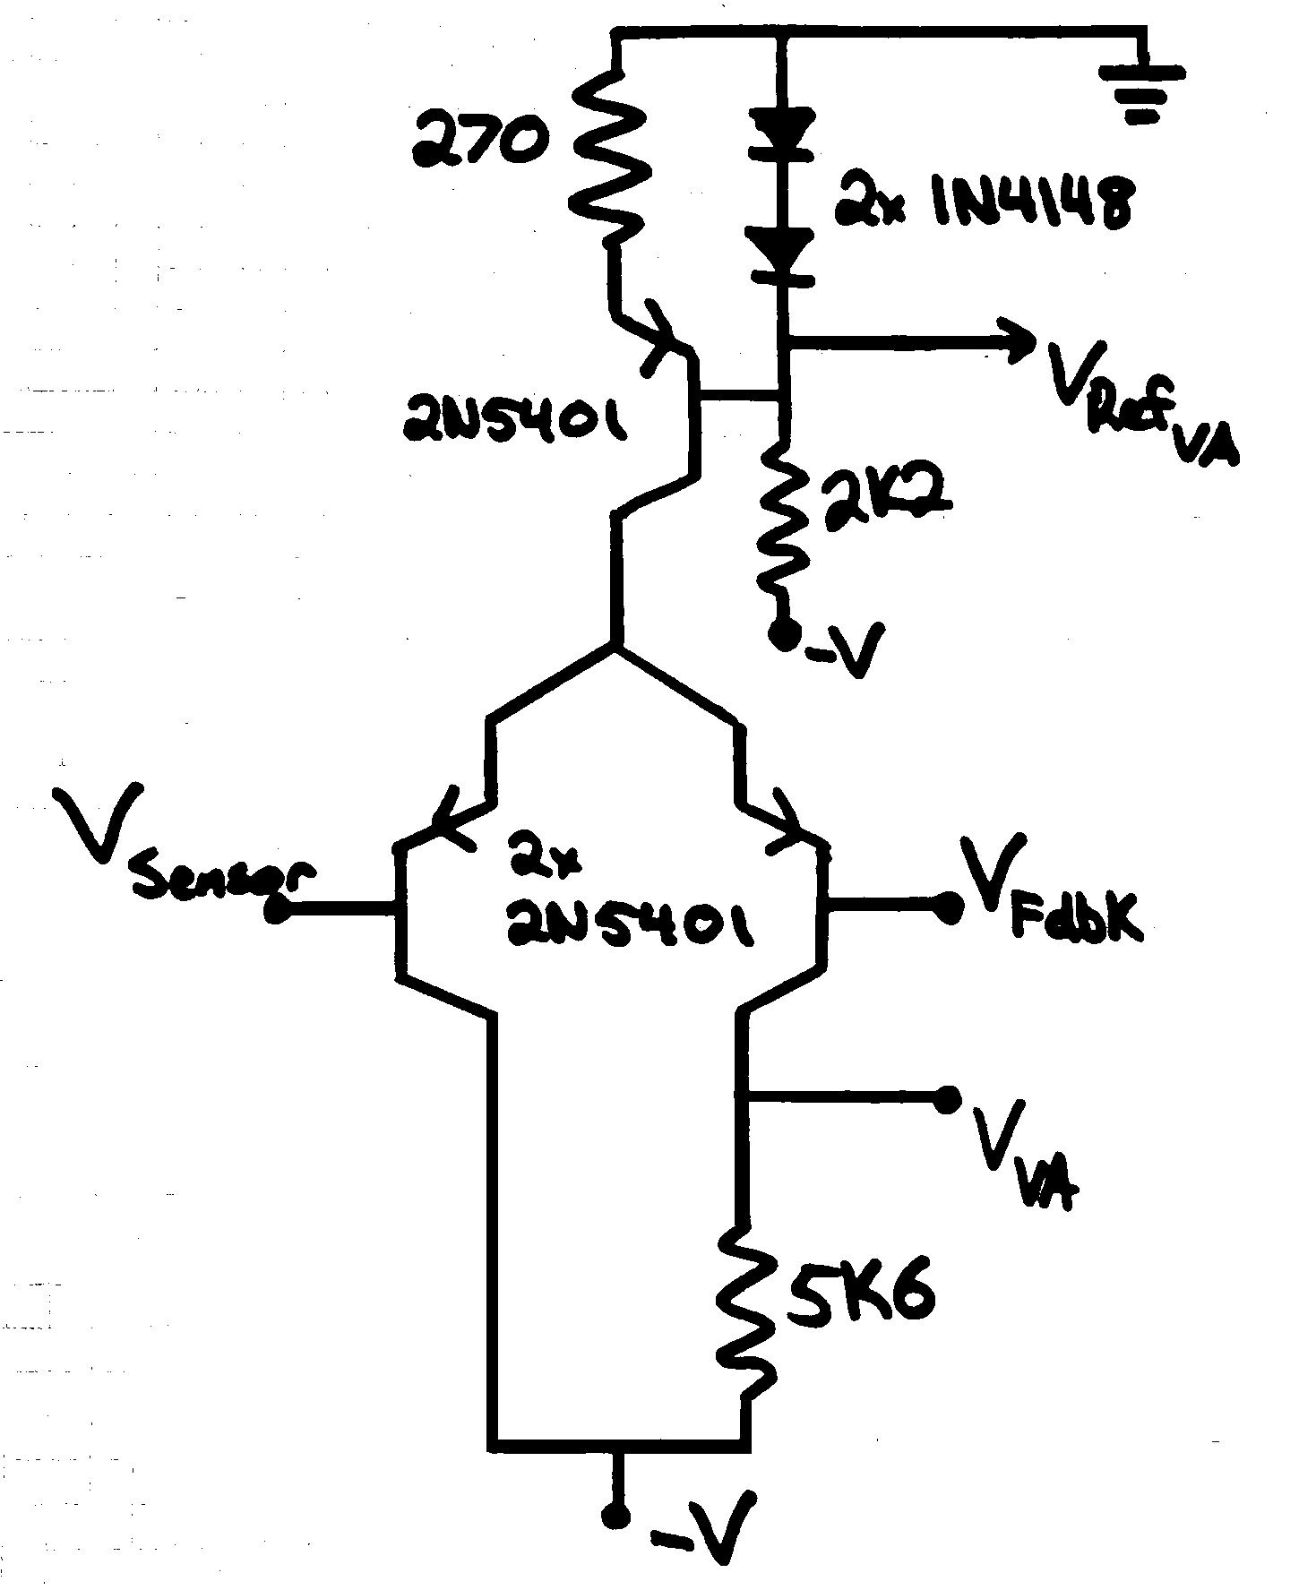
The collector resistor does two things. First, it sets the output impedance of the differential stage and second, it determines the gain and therefore the slew-rate of the differential stage. Beginning with the issue of output impedance, let’s determine an upper limit. This resistance will be used to drive the base voltage of the shunt transistor on the VA stage. Having a large 680ohm emitter resistance in the VA and an Hfe multiplication factor of at least B=150 because I used a 2N5551 as the NPN transistor gives a load resistance for the differential stage of about 100kohms. The classic rule of thumb, then, suggests an upper limit for our collector resistance of about 10kohms.
At 3.5mA, 10kohms would deliver 35 volts, or around 3x the supply voltage. Current through the two differential collectors will be roughly equal when the amp is balanced and the VA will never need more than just a couple of volts. For these reasons, 10kohms seems too high and a 5600ohm resistor was chosen.

This brings up the concept of amplifier gain. The larger the value of the collector resistance, the less differential base current is needed to drive the VA transistor base into saturation. In an amplifier circuit designed to produce voltage gain between the input and output ports, then high amounts of gain are desirable because more current gain here gives room for more linearizing negative feedback in the global feedback loop. For our unity-gain amplifier though, the gain factor here is not so important in fact we might get away a resistance with as low as 560ohms (1.8V × 3.5mA).

Obviously we cannot make more voltage than the supply voltage (reactive loads excluded), and so at some point a transistor collector will no longer be able to deliver any more current to the load due to voltage restrictions, and the excess emitter current must then flow through the base-emitter diode. A differential amplifier is only really happy when the base currents of the two control transistors are equal. This means that the voltage at the bases will essentially be the same when the system is working correctly. Because it current rather than voltage which rules the behaviour of BJTs, it is important that the input impedance of the two differential transistors and transistor betas be very closely matched in order to protect from hard clipping at the transistor bases.

To clarify, when the impedance at one of the bases is significantly lower than the impedance at the other transistor base, excess current will be drawn through the base-emitter diode of lower impedance and this will place V_be stress on the transistor with the higher input impedance and this is how transistors are ruined. We will set the actual impedance of the inputs a little bit later in the process when we address the sensor input stage. For now, just understand that the input impedances on both sides of the differential amplifier shall be set to be closely matched, and the two transistors will at the very least be of the same part number and possibly beta-matched.

Now, we need a control signal.

The Sensor Stage:

Ahhhh, the sensor stage... The entire test-rig for this project was purely a contrivance built from in-stock components and inspired by some reasonably defendable concept. The idea was to have a tank which was to be filled with water by a pump system. In this case, I assumed that making an electrochemical switch from table salt and copper wire would be rather simple. Initial testing showed the theory to work flawlessly, but once I got fancy and began using a centre conductor and an axial copper can, then the stored charge in the sodium lattice began playing tricks on me. That is a nightmare for a different article.

For now, simply accept that when the salt is dry and the sensor is manufactured correctly, the impedance between the two contacts is very high. Once the sensor is submerged in water, dissolved sodium ions will allow for current to flow easily between electrodes and the impedance of the submerged sensor will be low.

It is desirable for the mounting studs and the sensor ‘common’ be at Ground potential because the sensor is to be submerged in water when/after being triggered. In this circuit, Ground potential has been set as the circuit positive potential and that is because the pump motor is a load in the collector of the IGBT output device and it is desirable to have the motor winding at Ground potential. This amplifier, by design, is unity-gain voltage input to output and with a positive ground on the motor, the lower the signal voltage is, the more power will be driven to the pump motor.

With all of this in mind, we would like to begin with a steady-state voltage of -12V at the input so that the voltage across the pump motor will be controlled to be 12V. From there, each new motor speed will be called for by a reduction in sensor impedance and the voltage be need to approach Ground potential.

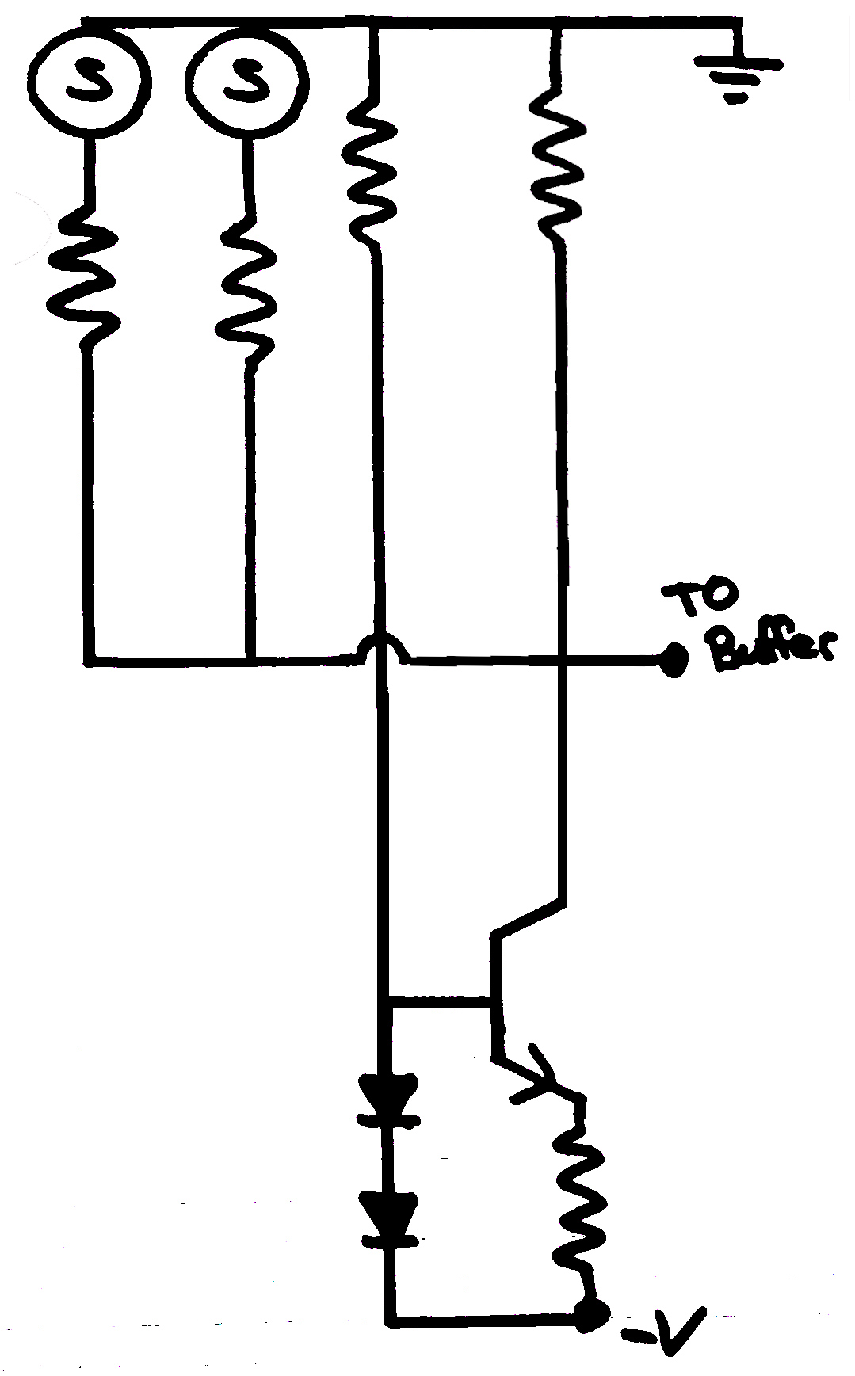
Again we will use a CCS as one half of a voltage divider in series with a fixed resistance to make -12V, and we will then parallel the sensors across the fixed resistance to sequentially reduce the voltage-to-GND and allow the CCS to amplify out any movement of the supply rail. Again, 3.5mA was chosen as the operating current and this time we use a 2N5551 on the negative supply rail and pin our fixed resistance to Ground. Each sensor is fitted with a series resistance such that the desired voltage appears at the collector of the CCS for each trigger stage. From here, the signal from the sensors is buffered through a DC coupling voltage follower amplifier to the non-inverting input of the diff amp.

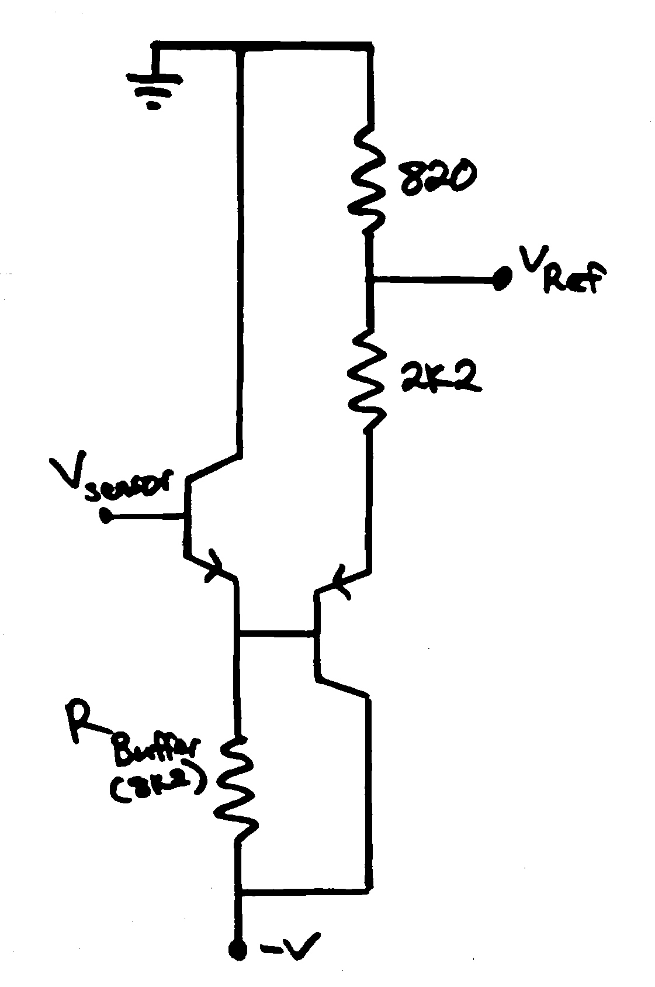
This 2 transistor buffer amplifier is a neat trick to use the diode drop of the second emitter follower to offset the diode drop of the first emitter follower. In practice, this circuit still ended up 200mV off, but the two stages allows for staggered current gain as well. The input impedance of the sensor amplifier worked out to be 4100ohms, so 8200ohms was used for the first buffer stage allowing for a large impedance while maintaining a reasonable operating current, then 2200ohms taken as the initial nominal impedance of the second buffer amp.

Now, we must revisit V_be limits. Our input signal is required to swing from at least -12V to -3.5V and to assume that the amplifier will always remain in perfect balance is foolish. Adding 820ohms in series with the 2200ohm resistor on the Ground side and taking the signal from there reduces the signal voltage swing from the perspective of the diff amp to about 27% of the actual signal voltage swing. Eventually, the battery was traded out for a linear DC power supply. This supply is capable of making around 16volts, 27% of 16volts works out to be about 4.3volts which is a safe BJT input voltage. Remembering that it is important to maintain similar impedances at the inverting and non-inverting inputs of the diff amp, we will simply match the 820ohm/2200ohm voltage divider on the feedback side of the amplifier. To do this, the base of the inverting input transistor is pinned up to Ground via another 820ohm resistor, the 4ish ohms of the pump can be disregarded so the 2200ohms simply go in series between the transistor base and the collector of the IGBT. Because of the unity gain design there is no feedback reactance to tune and so, if everything was done correctly then it will now work. A smart designer would have incorporated some variable resistors and would be able to now tune the trigger voltages under testing, but I just used fixed resistors.

SUMMARY

Why should we build a discrete OpAmp instead of just using a commercially available chip? Well, why not? Sure the unity gain amplifier is easily and inexpensively available on countless different parts which would work perfectly fine. This is true, however, the power control transistor itself will always be a discrete part, and any integrated circuit chip will require some level of supporting circuitry anyways, so then why not take full control of all of the parameters?

Of course, this is a rather simple amplifier design with very few constraints, but let us review the design process in summary and perhaps consider designing custom controllers for certain projects instead of settling for commercially available compromised multi-function versions.

Step #1: Determine Motor Parameters
-3.5V to -12V across the motor terminals

Step #2: Choose Output Device
Massive Used IGBT

Step #3: Set Limits, Set Gain Conditions
Gate Voltage must swing at a minimum 3.5-8V gate-to-emitter
Unity Gain, Non-Inverting

Step #4: Design suitable VA Stage

Step #5: Design Differential Stage

Step #6: Set up the Input Conditions

Step #7: Match Feedback Conditions to Input Conditions

Step #8: Build and Test

Slone, G. Randy. High-Power Audio Amplifier Construction Manual. New York: McGraw-Hill, 1999.

