***Comsats University Islamabad (Vehari campus)***



***DSA Lab (Assignment 1)***

***Submitted by:***

*Saman Atif*

***Roll no:***

*SP22-BCS-070(Section B)*

***Department*:**

*Computer Science*

***Subject*:**

*Data structure and algorithm*

***Submitted to:***

*Mam Yasmeen Jana*

**Question no1:** **How to create a GitHub account?**

**Ans:** **Step 1:** **Access the GitHub Website Open your preferred web browser.**

In the address bar, enter the URL for the GitHub website: <https://github.com/>.

**Step 2:** **Sign Up**

**3**. On the GitHub homepage, locate and click the “Sign up” button in the top-right corner of the page.

**Step 3: Provide Basic Information**

**4**. You will be directed to the “Create your account” page. Here, you need to fill in the following information:

Username: Choose a unique username for your GitHub account.

Email address**:** Enter a valid email address.

Password: Create a strong, secure password for your account.

**Step 4: Click “Continue”**

**5**. After entering your information, click the green “Continue” button.

**Step 5: Choose a Username**

**6**. If the username you selected is already taken, GitHub will prompt you to choose an alternative username. Follow the instructions to select a unique username.

**Step 6: Verify Your Email**

**7**. GitHub will send a verification email to the address you provided. Open your email inbox and locate the email from GitHub.

Click on the verification link in the email to confirm your email address.

**Step 7: Complete Your Profile (Optional)**

**9.** You have the option to complete your GitHub profile by adding your name and a profile picture. This step is optional but can help others identify you on the platform.

**Step 8:** **Submit Your Information**

**10**. After completing your profile (or skipping it), click the “Submit” button to create your GitHub account.

**Step 9: Personalize Your Experience**

**11**. GitHub may prompt you to select your preferences and interests. Customize these settings to tailor your GitHub experience.

**Question no2:**

**Program 1:**

Printing Variable Addresses in C++

#include <iostream>

Using namespace std;

Int main()

{

// declare variables

Int var1 = 3;

Int var2 = 24;

Int var3 = 17;

// print address of var1

Cout << “Address of var1: “<< &var1 << endl;

// print address of var2

Cout << “Address of var2: “ << &var2 << endl;

// print address of var3

Cout << “Address of var3: “ << &var3 << endl;

}

**Output:**

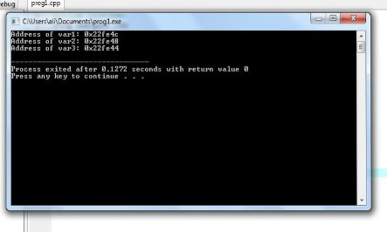

**Program 2:**

Working of C++ Pointers

#include <iostream>

Using namespace std;

Int main() {

Int var = 5;

// declare pointer variable

Int* pointVar;

// store address of var

pointVar = &var;

// print value of var

Cout << “var = “ << var << endl;

// print address of var

Cout << “Address of var (&var) = “ << &var << endl

<< endl;

// print pointer pointVar

Cout << “pointVar = “ << pointVar << endl;

// print the content of the address pointVar points to

Cout << “Content of the address pointed to by pointVar (*pointVar) = “ << *pointVar << endl;

Return 0;

**}**

**Output:** 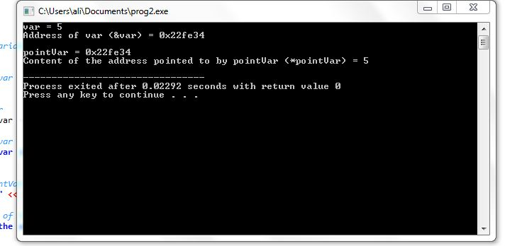

**Program 3:**

Changing Value Pointed by Pointers

#include <iostream>

Using namespace std;

Int main() {

Int var = 5;

Int* pointVar;

// store address of var

pointVar = &var;

// print var

Cout << “var = “ << var << endl;

// print *pointVar

Cout << “*pointVar = “ << *pointVar << endl

<< endl;

Cout << “Changing value of var to 7:” << endl;

// change value of var to 7

Var = 7;

// print var

Cout << “var = “ << var << endl;

// print *pointVar

Cout << “*pointVar = “ << *pointVar << endl

<< endl;

Cout << “Changing value of *pointVar to 16:” << endl;

// change value of var to 16

*pointVar = 16;

// print var

Cout << “var = “ << var << endl;

// print *pointVar

Cout << “*pointVar = “ << *pointVar << endl;

Return 0;

}

**Output:**

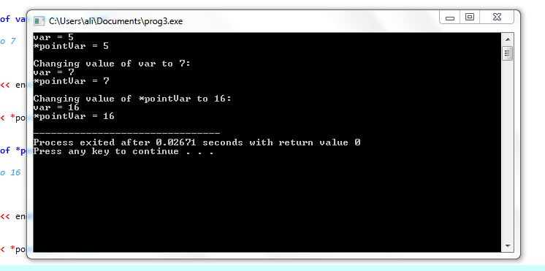

**Program 4:**

#include <iostream>

#include <ctime>

Using namespace std;

Void getSeconds(unsigned long *par);

Int main () {

Unsigned long sec;

getSeconds( &sec );

// print the actual value

Cout << “Number of seconds :” << sec << endl;

Return 0;

}

Void getSeconds(unsigned long *par) {

// get the current number of seconds

*par = time( NULL );

Return;

}

**Output:**

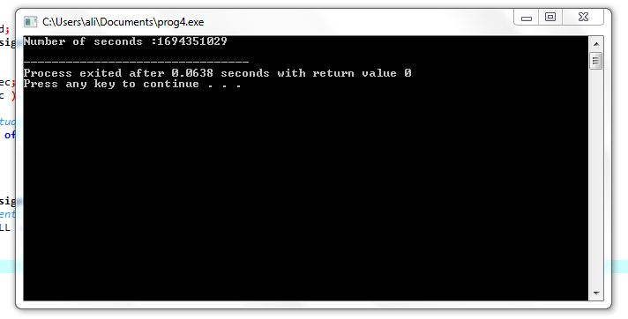

**Program 5:**

#include <iostream>

using namespace std;

class Student {

private:

int age;

public:

// constructor initializes age to 12

Student() : age(12) {}

void getAge() {

cout << "Age = " << age << endl;

}

};

int main() {

// dynamically declare Student object

Student* ptr = new Student();

// call getAge() function

ptr->getAge();

// ptr memory is released

delete ptr;

return 0;

}

**Output:**

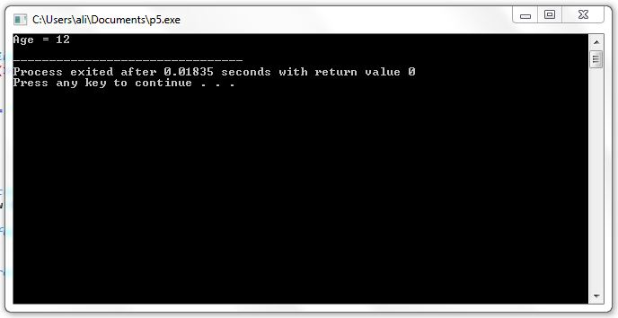

**Program 6:**

#include <iostream>

using namespace std;

struct Distance {

int feet;

float inch;

};

int main() {

Distance *ptr, d;

ptr = &d;

cout << "Enter feet: ";

cin >> (*ptr).feet;

cout << "Enter inch: ";

cin >> (*ptr).inch;

cout << "Displaying information." << endl;

cout << "Distance = " << (*ptr).feet << " feet " << (*ptr).inch << " inches";

return 0;

}

**Output:**

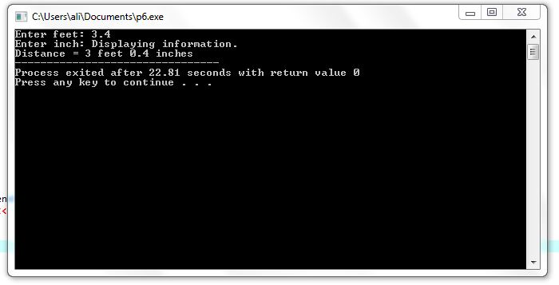

**Program 7:**

#include <iostream>

int main() {

int numbers[] = {1, 2, 3, 4, 5};

int* pointerToArray = numbers; // Initialize a pointer to the first element of the array

std::cout << "Elements of the array using pointer:" << std::endl;

for (int i = 0; i < 5; ++i) {

std::cout << "Element " << i << ": " << *pointerToArray << std::endl;

pointerToArray++; // Move the pointer to the next element

}

return 0;

}

**Output:**

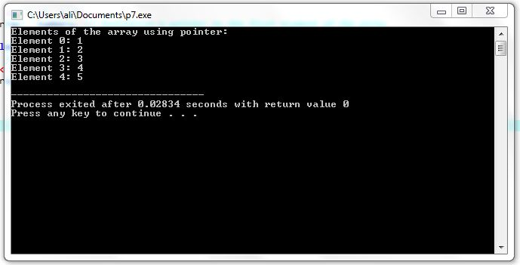

**Program 8:**

#include<iostream>

Using namespace std;

Int main()

{

Int *ptr;

Int arr[5] = {10, 20, 30, 40, 50};

Ptr = arr;

Cout<<”ptr = “<<*ptr;

Cout<<”\narr[0] = “<<arr[0];

Cout<<endl;

Return 0;

}

**Output:**

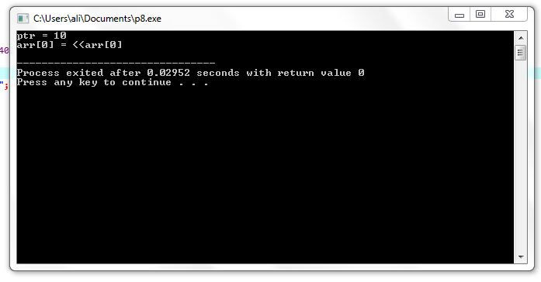

**Program 9:**

#include<iostream>

Using namespace std;

Int main()

{

Int *ptr, arr[5], I;

Cout<<”Enter any five numbers: “;

For(i=0; i<5; i++)

Cin>>arr[i];

Ptr = arr;

For(i=0; i<5; i++)

{

Cout<<”\n\nptr = “<<*ptr;

Cout<<”\narr[“<<i<<”] = “<<arr[i];

Ptr++;

}

Cout<<endl;

Return 0;

}

**Output:**

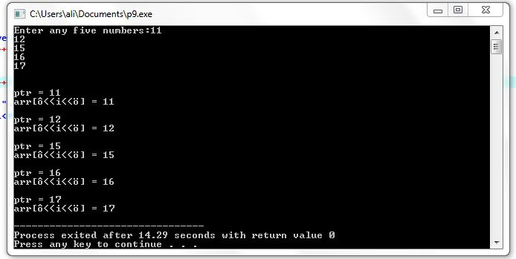

**Program 10:**

#include<iostream>

Using namespace std;

Int main()

{

Char name[] = “CodesCracker”;

Char *cptr;

Cptr = name;

While(*cptr != ‘\0’)

{

Cout<<*cptr;

Cptr++;

}

Cout<<endl;

Return 0;

}

**Output:**

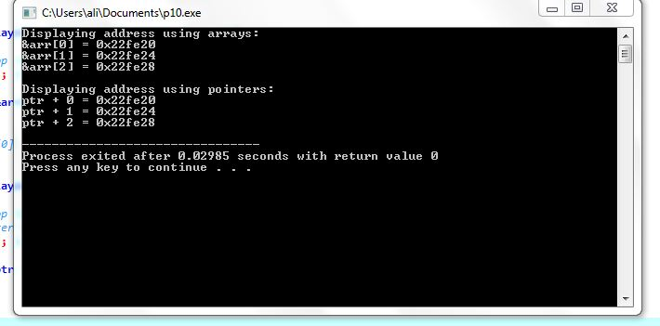

**Program 11:**

#include <iostream>

#include <string>

Using namespace std;

Int main() {

String food = “Pizza”;

String* ptr = &food;

// Output the value of food

Cout << food << “\n”;

// Output the memory address of food

Cout << &food << “\n”;

// Access the memory address of food and output its value

Cout << *ptr << “\n”;

// Change the value of the pointer

*ptr = “Hamburger”;

// Output the new value of the pointer

Cout << *ptr << “\n”;

// Output the new value of the food variable

Cout << food << “\n”;

Return 0

}

**Output:**

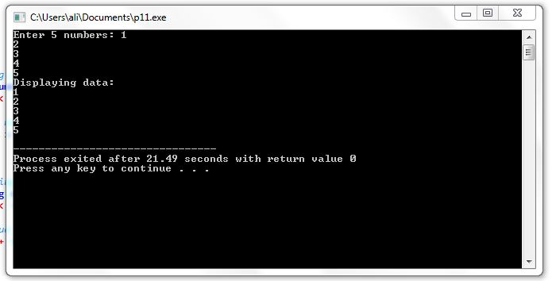

**Program 12:**

#include <iostream>

Using namespace std;

Const int MAX = 3;

Int main () {

Int var[MAX] = {10, 100, 200};

Int *ptr;

// let us have address of the last element in pointer.

Ptr = &var[MAX-1];

For (int I = MAX; I > 0; i--) {

Cout << “Address of var[“ << I << “] = “;

Cout << ptr << endl;

Cout << “Value of var[“ << I << “] = “;

Cout << *ptr << endl;

// point to the previous location

Ptr--;

}

Return 0;

}

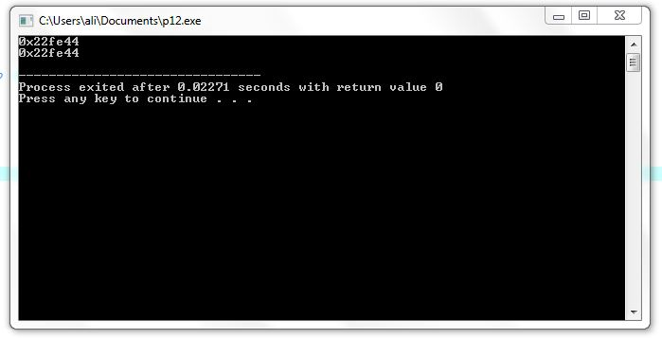**Output:**

**Program 13:**

#include <iostream>

int main() {

int number = 42;

int* pointerToNumber = &number; // Declare and initialize a pointer to an integer with the address of 'number'

std::cout << "Value of number: " << number << std::endl;

std::cout << "Address of number: " << &number << std::endl;

std::cout << "Value of pointerToNumber: " << *pointerToNumber << std::endl;

std::cout << "Address stored in pointerToNumber: " << pointerToNumber << std::endl;

return 0;

}

**Output:**

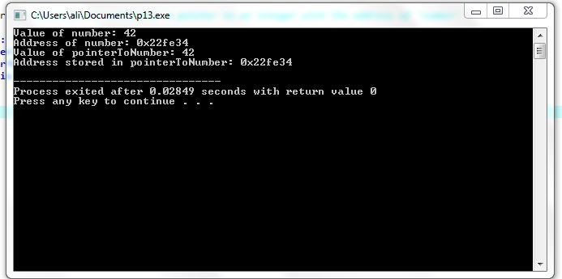

**Program 14:**

#include <iostream>

using namespace std;

int main() {

// declare an int pointer

int* pointInt;

// declare a float pointer

float* pointFloat;

// dynamically allocate memory

pointInt = new int;

pointFloat = new float;

// assigning value to the memory

*pointInt = 45;

*pointFloat = 45.45f;

cout << *pointInt << endl;

cout << *pointFloat << endl;

// deallocate the memory

delete pointInt;

delete pointFloat;

return 0;

}

**Output:**

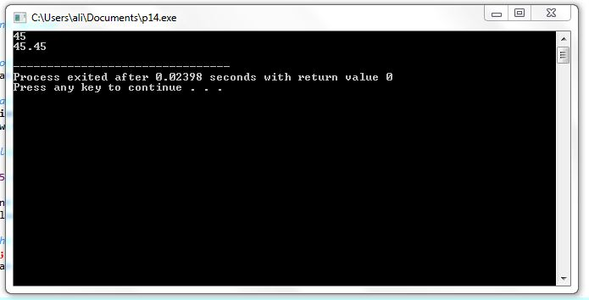

**Program 15:**

// C++ Program to store GPA of n number of students and display it

// where n is the number of students entered by the user

#include <iostream>

using namespace std;

int main() {

int num;

cout << "Enter total number of students: ";

cin >> num;

float* ptr;

// memory allocation of num number of floats

ptr = new float[num];

cout << "Enter GPA of students." << endl;

for (int i = 0; i < num; ++i) {

cout << "Student" << i + 1 << ": ";

cin >> *(ptr + i);

}

cout << "\nDisplaying GPA of students." << endl;

for (int i = 0; i < num; ++i) {

cout << "Student" << i + 1 << ": " << *(ptr + i) << endl;

}

// ptr memory is released

delete[] ptr;

return 0;

}

**Output:**

