Political Saga - System Architecture

Tech Stack
Layer | Technology
Frontend | React 18 (CRA), React Router, Tailwind CSS + Radix UI, Framer Motion, Recharts, D3-geo
Backend API | Node.js, Express, Mongoose (MongoDB)
Ingestion engine | Python, separate process
Auth | JWT + custom RBAC/scope middleware
AI / LLM | Ollama, Cohere
Media | Puppeteer, media-download service
Translation | Google Translate

1. System Context
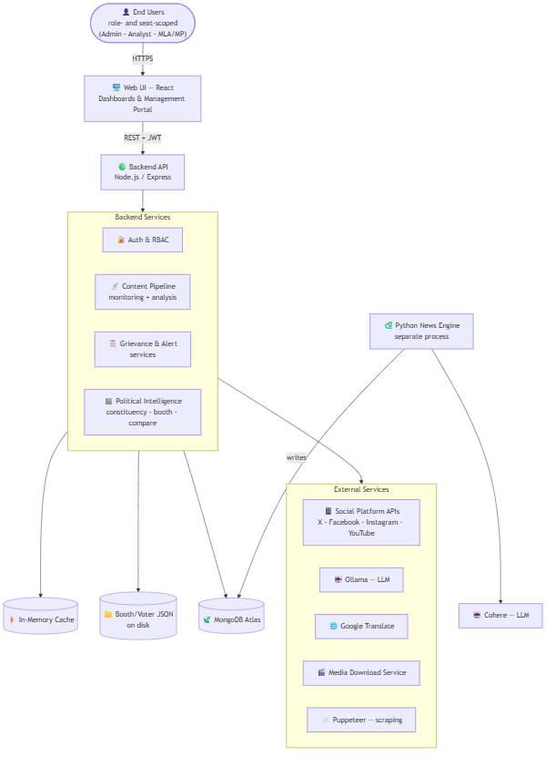

2. Component Diagram — Fetch → Process → Store → Serve
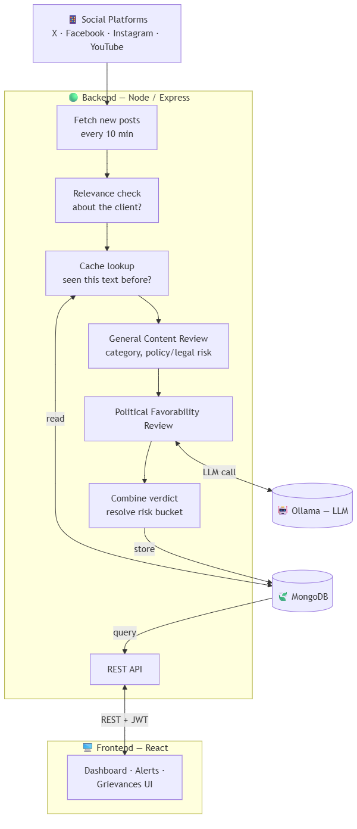

3. Political Favorability Outcomes
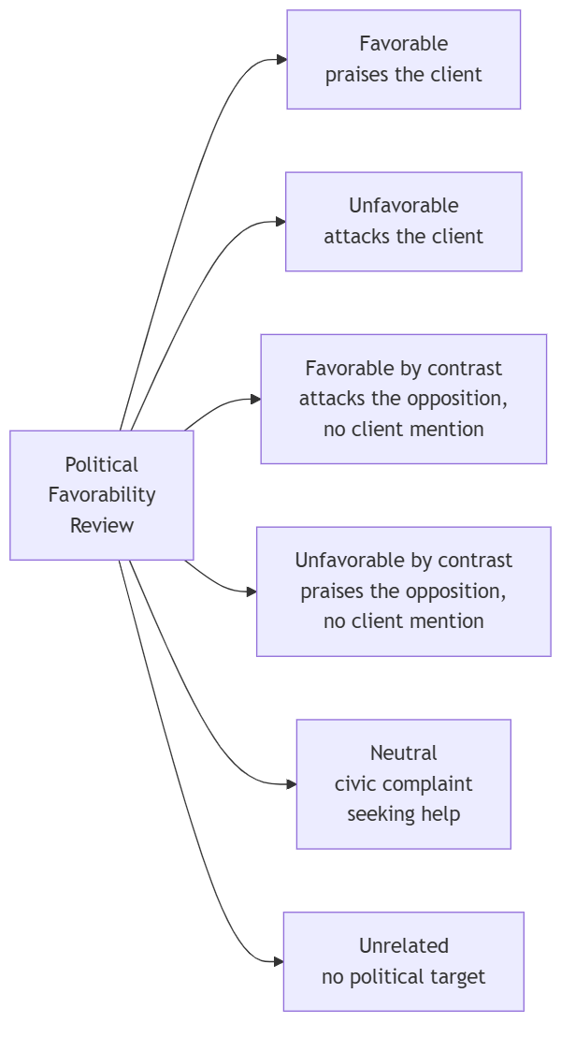

4. Viral Posts
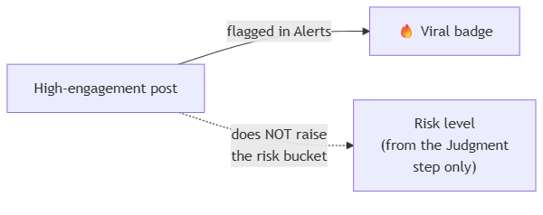

5. Backend, by Domain
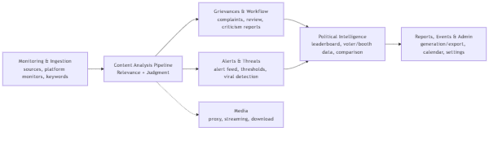

6. Political Intelligence Layer
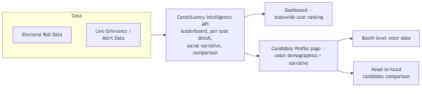

7. Booth-Level Voter Data
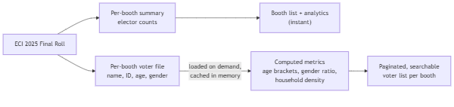

8. Access Control
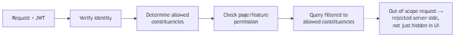

9. Role → Scope
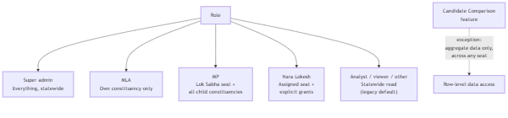

10. Background Jobs
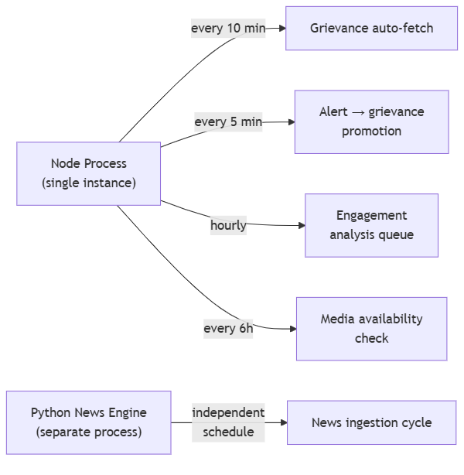

11. Frontend Structure
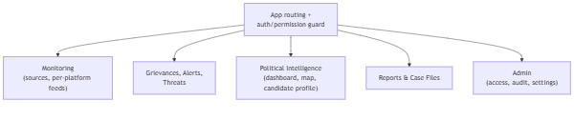

12. Core Data Models
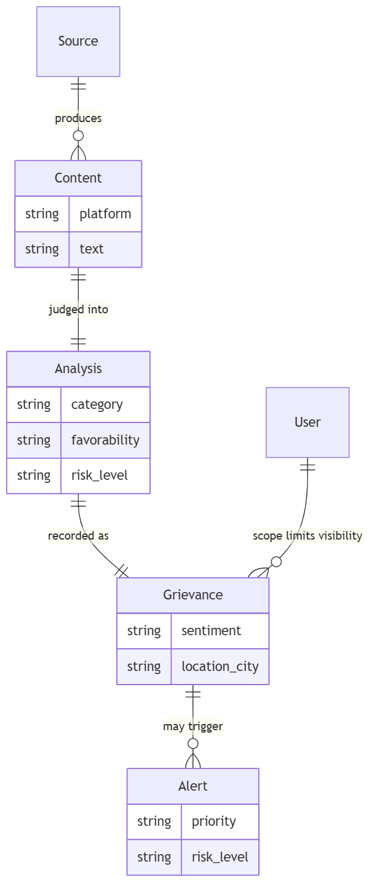

13. External Integrations
