This internship schedule is added to the internship agreement of student Bas Calders, student number 20171670 as a part of course unit 2200FTIMPR - II-Master's Project Electronic.
Extract from internship agreement

Article 8. Absences
[External] The Traineeship Provider / [Internal] The Receiving Unit will notify the Trainee’s Supervisor responsible at University each time the Trainee is absent during days that have been allocated to the execution of his Traineeship. Before the start of the Traineeship all parties will be provided with a timetable indicating the days and hours during which the Traineeship will be carried out. The Trainee’s Supervisor will take appropriate measures towards the student. Parties agree that such timetable can be flexible. The traineeship can occasionally take place in the evening, during the weekend or on holidays.
Timetable for internship period from 26.09.2022 until 01.07.2023.
Start- and end time | Monday | Tuesday | Wednesday | Thursday | Friday | Saturday | Sunday
morning
from… until |  |  | 8:00 – 12:00 |  |  | 8:00 – 12:00 | 8:00 – 12:00
from… until
from… until
noon
from… until
from… until
from… until
evening
from… until |  |  | 12:30 – 18:00 |  |  | 12:30 – 18:00 | 12:30 – 18:00
from… until
from… until

Further information concerning internship schedule (optional)

Signature of approval
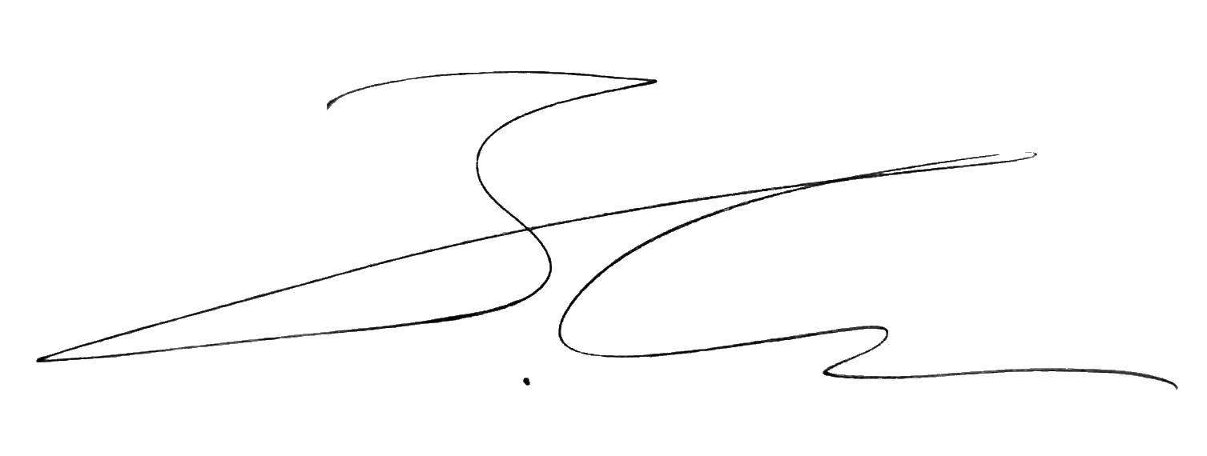
Student-Trainee Internship mentor
Bas Calders Rafael Berkvens
………………………………………………………………. …………………………………………………………….

