Brandon Craine

Dr. Santore

Comp 490

16 March 2021

Gui Testing

In gui testing, there are a few things you can do to ensure that it will work or is working properly. To start off, you need to make sure that the actual window comes up. When you first build the gui with your dimensions, it is a good practice to run it quickly to make sure that the window comes up and that there are no bugs there. I would say that the next step if the process (once everything visual is there) is to ensure the buttons work. You may want to hook the button up to a large-scale function, but for the sake of the test just hook it up to a simple print command. If you click the button and it prints your line, then you know you have a working button.

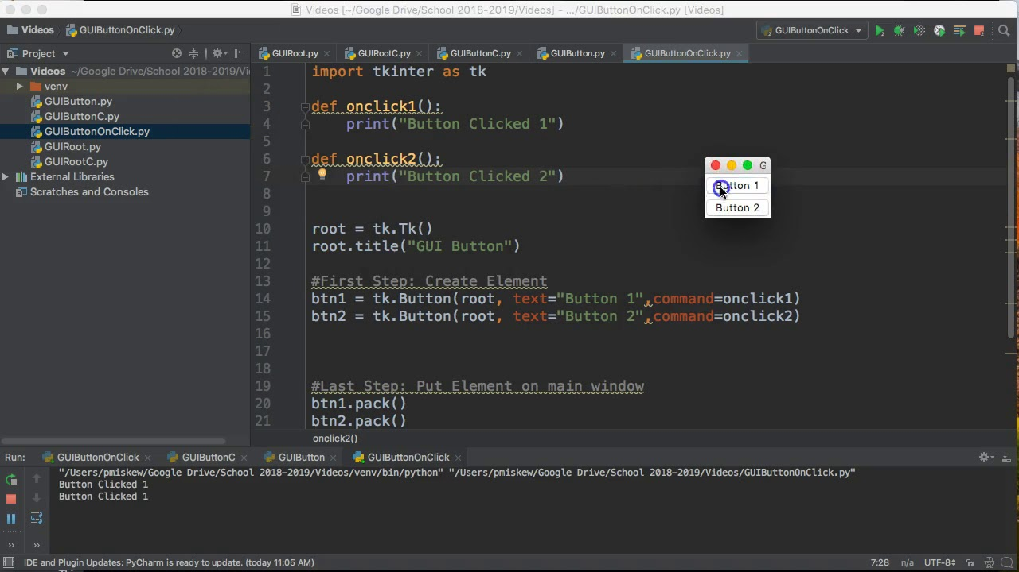

Now that the general gist of the gui’s main function is working, it would be time to start adding the real data into it. In my opinion, the best thing to do at this step is work one thing at a time. You don’t want to give each button in your gui a function and have everything attempting to display at one time. This will cause either a bunch of overwhelming errors to come up at the same time, or it will create an issue that you can’t pinpoint to the last thing you did because you did 10 things before testing. As long as you do things one step at a time when creating a gui and testing it, you should be pretty successful.