P

Dhaka, June 2016

Economic Relations Division
Ministry of Finance
Government of Bangladesh

TECHNICAL MANUAL

Version 1.0
Bangladesh IATI – AIMS Import

Bangladesh IATI – AIMS Import

TECHNICAL MANUAL

Version 1.0
June 16, 2016

Technical Assistance By

TechnoVista Limited



Table of Contents

1.0 Introduction 3
2.0 Platforms 4
2.1 Development Platform 4
2.2 Installation Requirements 4
3.0 Installation Instructions 5
3.1 Database 5
3.2 Web Application 5
3.2.1 Application Hosting Procedure in IIS 7 or Higher 5
3.2.2 Application Configuration 7
3.3 Console Application 8
3.3.1 How to configure Scheduled Task 8
4.0 maintenance 11
5.0 disclaimers 11
5.1 Support Contact 11

List of Tables

No table of figures entries found.

List of Figures

Figure 1 Creating Web Site in IIS 6
Figure 2 App Pool basic properties 6
Figure 3 App Pool advance properties 6
Figure 4 Convert to Application 7
Figure 5 Open task scheduler 9
Figure 6 Create new Task 9
Figure 7 Create trigger for the Task 10
Figure 8 Choose the program for the Task 10

Introduction

Aid Information Management System (AIMS) is a web-based software application that will record and process information about development activities and related aid flows in Bangladesh. Aid Information Management System (AIMS) will capture project‐level information on commitments and disbursements, by Development Partners, implementers, sectors and geographic locations. AIMS Bangladesh also includes information on aid‐financed expenditures and results. This system will help to incorporate aid flows into national budget and improve the overall alignment of assistance with country priorities.

The overall objective of an AIMS is to provide a common information sharing platform for Government, Development Partners and all other stakeholders, in order to increase aid transparency, strengthen mutual accountability, improve aid coordination, strengthen alignment and allow for more efficient aid management. AIMS is an essential tool to implement international mutual commitments reflected in the Paris Declaration of Aid Effectiveness (2005), the Accra Agenda for Action (2008), the Busan Partnership Document (2011) and the Mexico Communique (2014).

As a general rule, the funding agency has the main responsibility to enter the project records and update the information contained in AIMS Bangladesh. In case of co-funded projects, funding agencies must select a leading agency that has the responsibility to create the project record and enter the general project information into AIMS as well as periodically update data.

What is IATI
Development partners have published a large amount of data on their aid activities through the International Aid Transparency Initiative (IATI). We’re going to start using IATI data in Bangladesh’s Aid Information Management System (AIMS).
The aim is to improve the quality of the data held in the AIMS and reduce the burden of data collection.

Futher documentation are published in: http://bd-iati.github.io/
Source code and issues are in: https://github.com/BD-IATI/edi

Platforms

Development Platform

Developer Workstation:
- Windows 7
- Microsoft .Net Framework 4.5, Asp.net Web API 2, Entity Framework 6.
- Html, JavaScript, Angular JS, Bootstrap CSS
- Microsoft Visual Studio 2015
- Microsoft SQL Server 2008 with Management Studio.
Database Server:
- Windows Server 2008 or Higher
- Microsoft .Net Framework 2, 3, 3.5, 4
- Microsoft SQL Server 2008 or Higher with Management Studio

Installation Requirements

Application Server:
- Windows Server 2008 or Higher
- IIS 7 or Higher
- Microsoft .Net Framework 4.5
- RavenDB portable (for session persistence, link: https://ravendb.net/downloads )
Database Server:
- Windows Server 2008 or Higher
- Microsoft .Net Framework 2, 3, 3.5, 4
- Microsoft SQL Server 2008 or Higher with Management Studio

Installation Instructions

Database

For creating new Database schema from backup:
- Open SQL Server Management Studio with providing valid database authentication.
- Open Object Explorer; right click on database tree node under Server root node.
- Choose Create database, provide the database name.
- Now right click on the newly created database, right click on it and choose Task->Restore->Database,
- Choose "From Device" option, browse the database backup file, and select the backup set to restore,
- In Options tab Check "Overwrite Existing Database", Modify the MDF and LDF file name in "Restore As" if required. Click OK.

For updating existing database schema from script:
- Open SQL Server Management Studio with providing valid database authentication
- Open Object Explorer; select the database from the tree node under Server root node.
- Open Menu File->New->Query with Current Connection (Ctrl+N).
- Run the provided scripts sequentially.

Web Application

Application Hosting Procedure in IIS 7 or Higher

- Copy the released Web Application folder from Deployment source (CD/DVD/Pen Drive) and Paste it anywhere into the Application Server (IIS Server).
- Go to the Control Panel > Administrative Tools > Internet Information Services (IIS) Manager. Or simply type "inetmgr" in run.
- Open the Site tree node under Server root node. Right click -> Add Web Site. Following screen will appear:
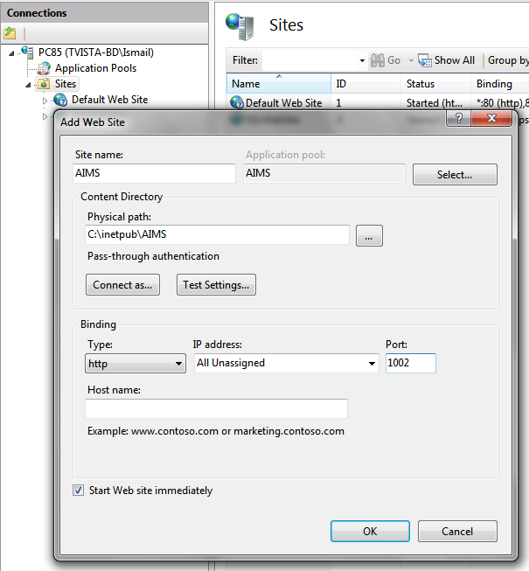  Figure 1 Creating Web Site in IIS | Enter a unique Site name (like AIMS).  Browse the Physical Path in Current Directory for the Application Files.  Enter an available Port number in Port Text field. (Default web site runs at port number 80)  Choose the Application Pool Name if already created; otherwise it will create a new one with same name as Site.

- Update Application Pool Properties:
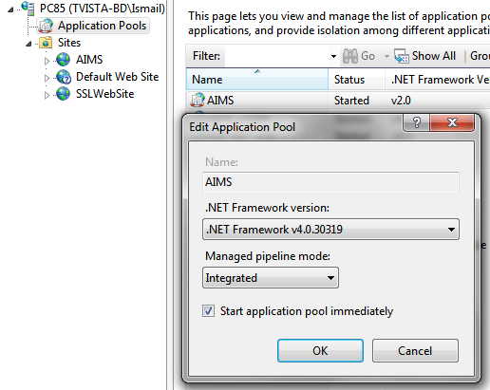  Figure 2 App Pool basic properties  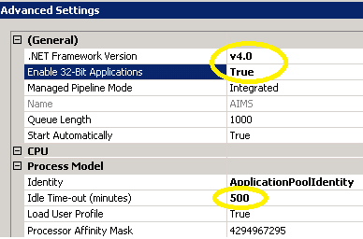  Figure 3 App Pool advance properties | Make sure the Pool is running with desired .Net Framework. Select the Application Pool that is created for the Web Site:  Right click -> Basic Settings..  - Choose the desired .NET Framework (v4.0)  - Click OK.  Right click -> Advance Settings..  - Choose True in "Enable 32-bit Application"  - Increase the "Idle Time-out (minutes)" to 500  - Click OK.

- Create Web Application for IATI Import Web API and IATI Import Site:
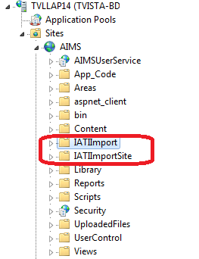  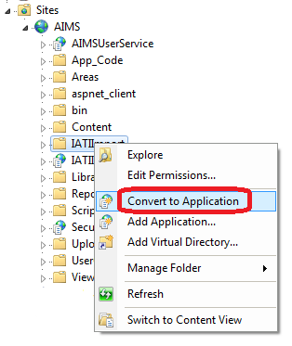  Figure 4 Convert to Application | Inside these Web Site there two more Web Application exists for Security Module:  - IATIImport (Web API back end)  - IATIImportSite (Html front End)  Convert those into web application, simply by right click on the folder -> select "Convert to Application", and then click OK.  Repeat this step for both these application.  Check the following URLs:  http://<ServerIP>:<Port>/IATIImportSite/#/Home  http://<ServerIP>:<Port>/IATIImportSite/Modules/IATIImport/IATIImportIndex.html#/login

Application Configuration

Data Source configuration:
Step1: Update "Web.config" under "AIMS/IATIImport" directory:

At Line#11; update the following AIMS and AIMS-IATI import module’s connection string.
- data source = the database server instance name,
- initial catalog = database name,
- user id = database authenticated user id,
- password = database authenticated user password.
- “AIMS_DBEntities” database is the base AIMS database where AIMS information are currently being used and this imported data of IATI will be imported here.
- “AIMS_DB_IATIEntities” database is the interim IATI xml database where IATI information are stored during scheduled update.
- “SessionEDB” connection strings will be used if Embedded RavenDB is used, however we have used the portable version of RavenDB, hence the “SessionDB” connection string key will used.

<connectionStrings>
<add name="AIMS_DBEntities" connectionString="metadata=res://*/AIMS_DB.csdl|res://*/AIMS_DB.ssdl|res://*/AIMS_DB.msl;provider=System.Data.SqlClient;provider connection string=&quot;data source=DBServer\SQL2008;initial catalog=AIMS_DB_Demo;persist security info=True;user id=sa;password=sa;MultipleActiveResultSets=True;App=EntityFramework&quot;" providerName="System.Data.EntityClient"/>
<add name="AIMS_DB_IATIEntities"
connectionString="metadata=res://*/AIMS_DB_IATI.csdl|res://*/AIMS_DB_IATI.ssdl|res://*/AIMS_DB_IATI.msl;provider=System.Data.SqlClient;provider connection string=&quot;data source= DBServer \SQL2008;initial catalog=AIMS_DB_IATI;user id=sa;password=sa;MultipleActiveResultSets=True;App=EntityFramework&quot;" providerName="System.Data.EntityClient"/>
<add name="SessionEDB" connectionString="DataDir = ~\App_Data\SessionDB" />
<add name="SessionDB" connectionString="Url = http://AppServer:8081/"/>
</connectionStrings>

At Line#68; update the following highlighted value:
address = the endpoint address URL of AIMS security service.
<endpoint address="http://<AppServer>:<Port>/AIMSUserService/AIMSUserManagementService.svc"
binding="basicHttpBinding" bindingConfiguration="BasicHttpBinding_IAIMSUserManagementService1"
contract="AIMSSecurityService.IAIMSUserManagementService" name="BasicHttpBinding_IAIMSUserManagementService1" />

Console Application

To run some automated backend process like IATI xml data download procedure, you need to setup a scheduled task in app server. To do that follow the below steps:

Update the application configuration file “AIMS_BD_IATI.Service.exe.config” of the Service application:
<connectionStrings>
<add name="AIMS_DBEntities" connectionString="metadata=res://*/AIMS_DB.csdl|res://*/AIMS_DB.ssdl|res://*/AIMS_DB.msl;provider=System.Data.SqlClient;provider connection string=&quot;data source=DbServer\SQL2008;initial catalog=AIMS_DB_Demo;persist security info=True;user id=sa;password=sa;MultipleActiveResultSets=True;App=EntityFramework&quot;" providerName="System.Data.EntityClient" />
<add name="AIMS_DB_IATIEntities" connectionString="metadata=res://*/AIMS_DB_IATI.csdl|res://*/AIMS_DB_IATI.ssdl|res://*/AIMS_DB_IATI.msl;provider=System.Data.SqlClient;provider connection string=&quot;data source=DbServer\SQL2008;initial catalog=AIMS_DB_IATI;user id=sa;password=sa;MultipleActiveResultSets=True;App=EntityFramework&quot;" providerName="System.Data.EntityClient" />
</connectionStrings>

<appSettings>
<add key="iati_url" value="http://datastore.iatistandard.org/api/1/access/activity.xml?" />
<add key="iati_recipient-country" value="BD" />
<add key="iati_reporting-org" value="*" />
<add key="iati_stream" value="True" />
</appSettings>

How to configure Scheduled Task
In Application server goto Control Panel -> All Control Panel Items -> Administrative Tools,
Open “Task Scheduler”.
Step1: Open task scheduler
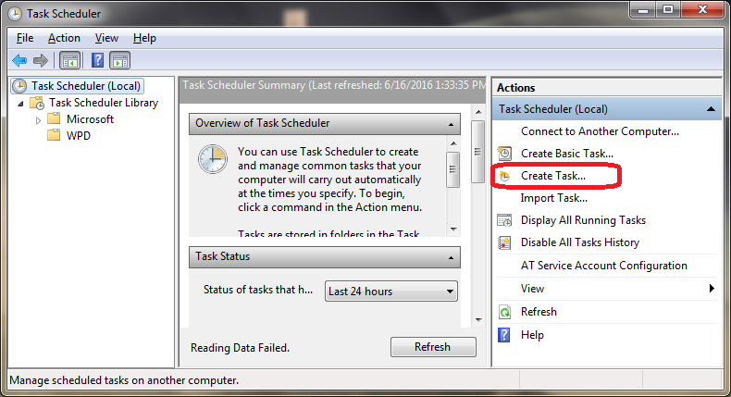
Figure 5 Open task scheduler

Step2: Create task with a Name, login informationa and Priority.
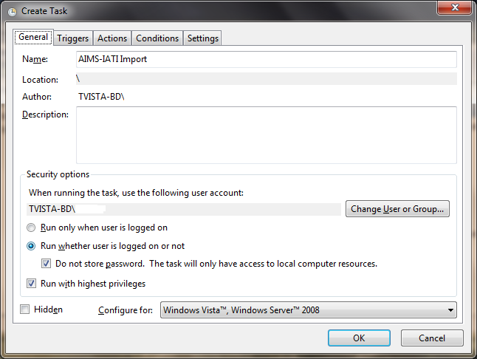
Figure 6 Create new Task

Step3: Create trigger for the task with a schedule to tun.
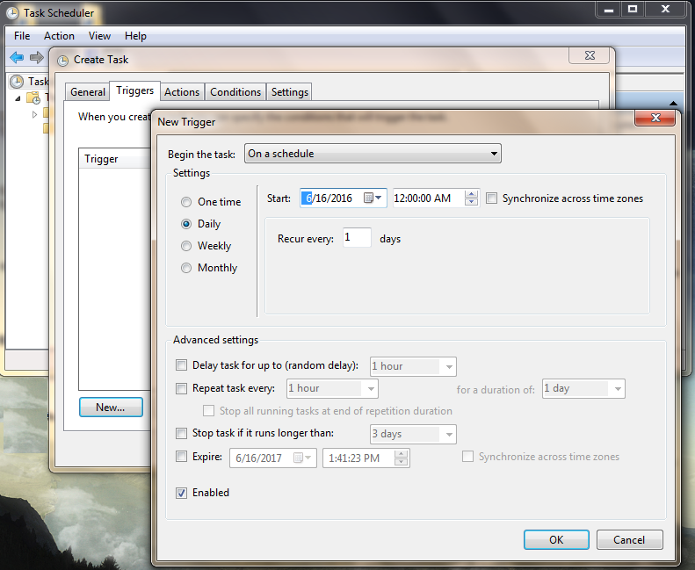
Figure 7 Create trigger for the Task

Step4: Choose the program for the a schedule to tun.
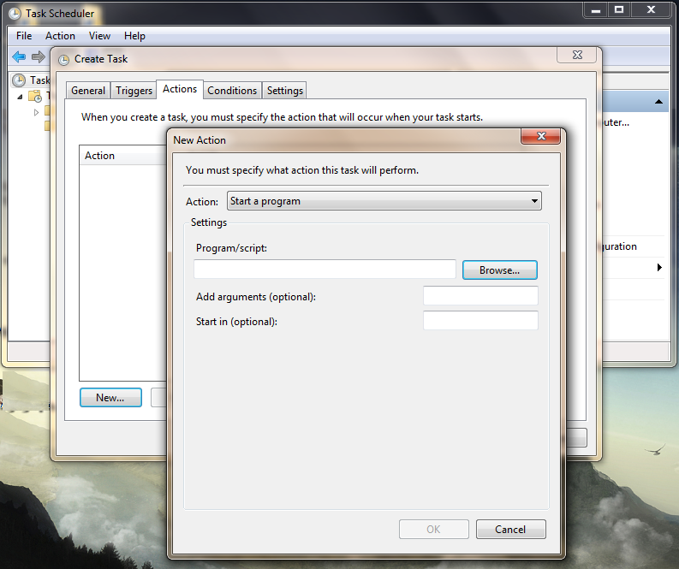
Figure 8 Choose the program for the Task

Browse the console applicaiton “AIMS_BD_IATI.Service.exe”and click OK.

maintenance

Following maintenance checklist need to be monitoed regurlarly:
- Backup of both and AIMS, AIMS Security and AIMS_IATI_BD.
- Check the Log files generated by IATI data download schediler.

disclaimers

The above instrustion are provided for a technical person only, who is familiar with Windows Server 2008, IIS 7, Sql Server database 2012.
Please do not attempt any of the steps above, if you are not familiar with above mentioned technologies, which may casuse severe data loss, database crush or apllication malfuntioning.

Support Contact

For any conceptual support please contact:
bd-iati@brough.io

For any technical support please contact:

TechnoVista Limited
107, Dhaka Mymensingh Road
North Tower (12th Floor)
Sector# 07, Uttara Model Town
Dhaka 1230, Bangladesh.
Tel: +880 2 7912264, 7912274
Fax: +880 2 8959254
Email: info@technovista.com.bd
URL: http://www.technovista.com.bd

