This call is at 10 am Pacific/12Central/1Eastern

Draft Agenda for 4/7call.

Parkinson’s Risk Model WG and NIH program staff

* Milestones – review of progress, dependencies and next steps. Carl and Mike. For context, see this picture of end-to-end system.
* 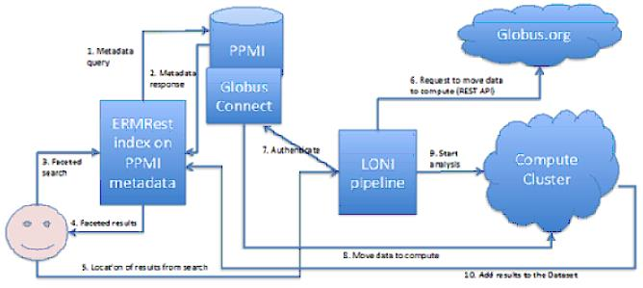

1) Need to define interfaces that move data collections and associated metadata between BDDS system components.  Look at existing standards for doing this.  Should move both data and appropriate metadata.  Need to version/id so that we can link results.

2) Need to duplicate ETL effort for PPMI data with ADNI data

3) Need to develop integrated data model that contains elements of both data sets.

4) Need to implement  REST interface including data-payload format for collection transfer between DAM and pipeline systems.  Should be read and write elements

5) Develop prototype workflows for target PPMI/ADNI modeling question

6) Develop and test initial end-to-end integration with LONI/Galaxy.  Show data roundtrip from DAM to pipeline, and then push results back with provenance linkage.

7) Test.

* Extension of Risk Model work. Review integration of PD & AD datasets.

* Modeling SNP data. Gustavo/Ben.

* Discussion.