CRFModel

Structural Report

Author: Dr. Nansu Zong  
Deepak Kumar Sharma

Revision: 0.2

|  |  |
| --- | --- |
| Mayo Clinic Health Sciences Research |  |
| 200 First Street SW Rochester, MN 55905 | Date: September 15, 2020 |

**Revision History**

|  |  |  |  |
| --- | --- | --- | --- |
| **Revision** | **Date** | **Reason For Changes** | **Author** |
| 0.1 | <date 1> | <draft> | <Author name> |
| 0.2 | <date 2> | <release> | <Author name> |
|  |  |  |  |

**Table of Contents**

Introduction 1

Purpose 1

Scope 1

Overview 1

CRFModel 2

CRFModel 2

Class AnciliaryTests 2

Class Colorectal 2

Direct Known Superclasses 2

Associations 3

Class Colorectal 3

Associations 3

Class LaboratoryTest 3

Class Macro 3

Direct Known Superclasses 3

Associations 3

Class Macro 4

Class Medication 4

Direct Known Superclasses 4

Class Micro 4

Direct Known Superclasses 4

Class Micro 4

Class Patient 4

Direct Known Superclasses 4

Class PreAnalytic 4

Class PreAnalytic 4

Direct Known Superclasses 4

Class Procedure 5

Direct Known Superclasses 5

Class Subject 5

Direct Known Superclasses 5

Class Surgery 5

Direct Known Superclasses 5

Class SynthesisOverview 5

Class Treatment 5

Direct Known Superclasses 5

CRFModel::Profile 6

Class LabTestResultItem 6

Class ResultWithDescription 6

Direct Known Superclasses 6

FHIR::R4::Context 7

author[x] 7

Class Annotation_author[x] 7

Direct Known Superclasses 7

Class author[x] 7

bounds[x] 8

Class bounds[x] 8

Class repeat_bounds[x] 8

Direct Known Superclasses 8

effective[x] 9

Class effective[x] 9

Class Observation_effective[x] 9

Direct Known Superclasses 9

value[x] 10

Class component_value[x] 10

Direct Known Superclasses 10

Class FocalDevice 10

Direct Known Superclasses 10

Class item[x] 11

Direct Known Superclasses 11

Class Observation_value[x] 11

Direct Known Superclasses 11

Class Performed[x] 11

Direct Known Superclasses 11

Class Performer 11

Direct Known Superclasses 11

Class Reporter_value[x] 11

Direct Known Superclasses 11

Class UsageContextValue 12

Direct Known Superclasses 12

Class value[x] 12

Class Qualification 12

Direct Known Superclasses 12

FHIR::R4::Datatype 13

Datatype 13

Class Address 13

Direct Known Superclasses 13

Class Age 14

Direct Known Superclasses 14

Class Annotation 14

Direct Known Superclasses 14

Class Attachment 14

Direct Known Superclasses 14

Class BackboneElement 14

Direct Known Superclasses 14

Class boolean 14

Direct Known Superclasses 15

Class canonical 15

Direct Known Superclasses 15

Class code 15

Direct Known Superclasses 15

Class CodeableConcept 15

Direct Known Superclasses 15

Associations 16

Class Coding 16

Direct Known Superclasses 16

Class ContactDetail 16

Direct Known Superclasses 16

Class ContactPoint 16

Direct Known Superclasses 16

Class date 16

Direct Known Superclasses 17

Class dateTime 17

Direct Known Superclasses 17

Class decimal 17

Direct Known Superclasses 17

Class Duration 17

Direct Known Superclasses 17

Class Element 17

Class Extension 18

Direct Known Superclasses 18

Class HumanName 18

Direct Known Superclasses 18

Class id 18

Direct Known Superclasses 18

Class Identifier 18

Direct Known Superclasses 19

Class instant 19

Direct Known Superclasses 19

Class integer 19

Direct Known Superclasses 19

Class markdown 19

Direct Known Superclasses 19

Class Meta 20

Direct Known Superclasses 20

Class Narrative 20

Direct Known Superclasses 20

Class Period 20

Direct Known Superclasses 20

Class positiveInt 20

Direct Known Superclasses 20

Class Quantity 21

Direct Known Superclasses 21

Class Range 21

Class Ratio 21

Direct Known Superclasses 21

Class Reference 21

Direct Known Superclasses 21

Class SampledData 21

Direct Known Superclasses 21

Class SimpleQuantity 22

Direct Known Superclasses 22

Class string 22

Direct Known Superclasses 22

Class time 22

Direct Known Superclasses 22

Class unsignedInt 22

Direct Known Superclasses 22

Class uri 23

Direct Known Superclasses 23

Class UsageContext 23

Direct Known Superclasses 23

Class ValueSet 23

Class ValueSetMember 23

Class xhtml 23

Direct Known Superclasses 23

Known other classes 23

FHIR::R4::Extension 24

Extension 24

Class DiagnosticReport-geneticsAnalysis 24

Direct Known Superclasses 24

Class DiagnosticReport-geneticsAssessedCondition 25

Direct Known Superclasses 25

Class DiagnosticReport-geneticsFamilyMemberHistory 25

Direct Known Superclasses 25

Class DiagnosticReport-geneticsReferences 25

Direct Known Superclasses 25

Class observation-geneticsAllele 25

Direct Known Superclasses 25

Class observation-geneticsAminoAcidChange 25

Direct Known Superclasses 25

Class observation-geneticsAncestry 26

Direct Known Superclasses 26

Class observation-geneticsCopyNumberEvent 26

Direct Known Superclasses 26

Class observation-geneticsDNARegionName 26

Direct Known Superclasses 26

Class observation-geneticsGene 26

Direct Known Superclasses 26

Class observation-geneticsGenomicSourceClass 26

Direct Known Superclasses 26

Class observation-geneticsInterpretation 27

Direct Known Superclasses 27

Class observation-geneticsPhaseSet 27

Direct Known Superclasses 27

Class observation-geneticsVariant 27

Direct Known Superclasses 27

FHIR::R4::Profile 27

Class DiagnosticReport-genetics 27

Direct Known Superclasses 27

Class Observation-genetics 27

Direct Known Superclasses 28

FHIR::R4::Resource 28

Auxiliary 28

Class Arm 28

Direct Known Superclasses 28

Class Batch 29

Direct Known Superclasses 29

Class Component 29

Direct Known Superclasses 29

Class Contact 29

Direct Known Superclasses 29

Class Ingradient 29

Direct Known Superclasses 29

Class Objective 29

Direct Known Superclasses 30

Class Organization 30

Direct Known Superclasses 30

Class Practitioner 30

Direct Known Superclasses 30

Class ReferenceRange 30

Direct Known Superclasses 30

Class repeatElement 30

Direct Known Superclasses 30

Class ResearchStudy 31

Direct Known Superclasses 31

Class ResearchSubject 31

Direct Known Superclasses 31

Class Timing 31

Direct Known Superclasses 31

Known other classes 31

basic 32

Class DomainResource 32

Direct Known Superclasses 32

Class Resource 32

Class StructureDefinition 33

Direct Known Superclasses 33

Extension 33

Known other classes 33

Resource 34

Class BodyStructure 34

Direct Known Superclasses 34

Class Condition 34

Direct Known Superclasses 35

Class DiagnosticReport 35

Direct Known Superclasses 35

Class Observation 35

Direct Known Superclasses 35

Known other classes 35

Class Person 35

FHIR::australia::Auxiliary 36

Auxiliary 36

Class TypeOfOperation 36

Class AustralianPatient 36

Direct Known Superclasses 36

Class braf 37

Class kras 37

Class LymphNodesDetails 37

Class msi 37

Class RelCoexistPathabnorm 37

FHIR::australia::Colorectal 38

ColorectalReport 38

Class LymphNodesDetails 38

Class RelCoexistPathabnorm 38

Known other classes 38

Appendix A: Tree 39

Class Hierarchy 39

**Table of Figures**

Figure 1. CRFModel 2

Figure 2. author[x] 7

Figure 3. bounds[x] 8

Figure 4. effective[x] 9

Figure 5. value[x] 10

Figure 6. Datatype 13

Figure 7. Extension 24

Figure 8. Auxiliary 28

Figure 9. basic 32

Figure 10. Extension 33

Figure 11. Resource 34

Figure 12. Auxiliary 36

Figure 13. ColorectalReport 38

# Introduction

## Purpose

This document is the UML structural report of the CRFModel.

## Scope

<Provide a short description of the system being specified and its purpose, including relevant benefits, objectives, and goals>

## Overview

<Describe what the document contains and explain how document is organized>

# CRFModel

## CRFModel

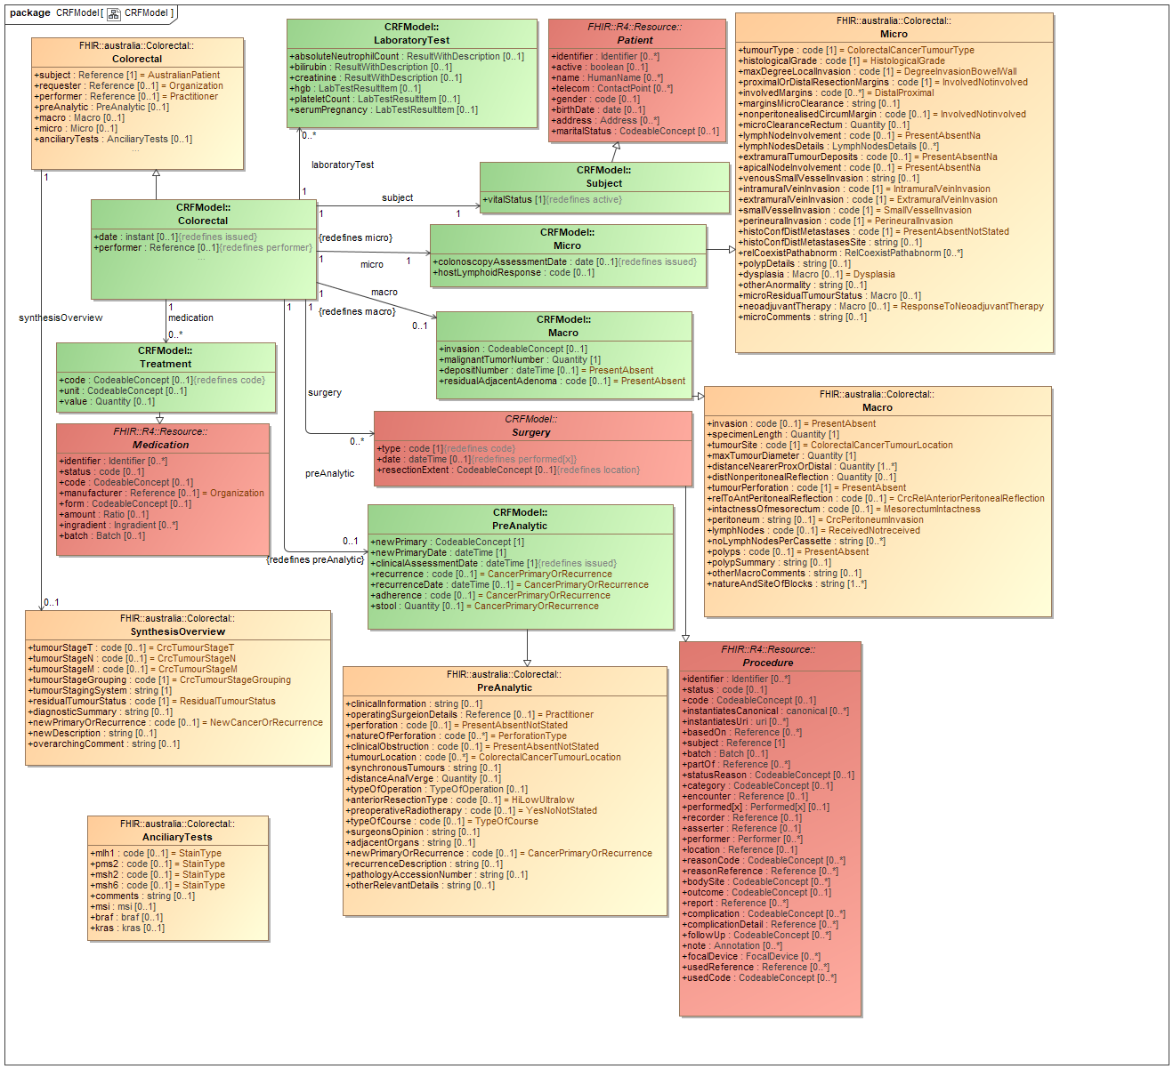

1. CRFModel

### Class AnciliaryTests

package FHIR::australia::Colorectal

public class AnciliaryTests

### Class Colorectal

#### Direct Known Superclasses

Colorectal, DiagnosticReport

package CRFModel

public class Colorectal

extends

Colorectal,

DiagnosticReport

#### Associations

-337330099.png public : LaboratoryTest [0..*]

-337330099.png public : Surgery [0..*]

-337330099.png public : Subject [1]

-337330099.png public : Micro [1]

-337330099.png public : Macro [0..1]

-337330099.png public : PreAnalytic [0..1]

-337330099.png public : Treatment [0..*]

### Class Colorectal

package FHIR::australia::Colorectal

public class Colorectal

#### Associations

-337330099.png private : SynthesisOverview [0..1]

### Class LaboratoryTest

package CRFModel

public class LaboratoryTest

### Class Macro

#### Direct Known Superclasses

Macro

package CRFModel

public class Macro

extends

Macro

#### Associations

-337330099.png public depositType : code [0..1] = PresentAbsent

Indicates that the value is taken from a set of controlled strings defined elsewhere (see Using codes for further discussion). Technically, a code is restricted to a string which has at least one character and no leading or trailing whitespace, and where there is no whitespace other than single spaces in the contents [Source: https://www.hl7.org/fhir/datatypes.html#code]

### Class Macro

package FHIR::australia::Colorectal

public class Macro

### Class Medication

#### Direct Known Superclasses

DomainResource

package FHIR::R4::Resource

public class Medication

extends

DomainResource

### Class Micro

#### Direct Known Superclasses

Micro

package CRFModel

public class Micro

extends

Micro

### Class Micro

package FHIR::australia::Colorectal

public class Micro

### Class Patient

#### Direct Known Superclasses

DomainResource

package FHIR::R4::Resource

public class Patient

extends

DomainResource

### Class PreAnalytic

package FHIR::australia::Colorectal

public class PreAnalytic

### Class PreAnalytic

#### Direct Known Superclasses

PreAnalytic

package CRFModel

public class PreAnalytic

extends

PreAnalytic

### Class Procedure

#### Direct Known Superclasses

DomainResource

package FHIR::R4::Resource

public class Procedure

extends

DomainResource

### Class Subject

#### Direct Known Superclasses

Patient

package CRFModel

public class Subject

extends

Patient

### Class Surgery

#### Direct Known Superclasses

Procedure

package CRFModel

public class Surgery

extends

Procedure

### Class SynthesisOverview

package FHIR::australia::Colorectal

public class SynthesisOverview

### Class Treatment

#### Direct Known Superclasses

Medication

package CRFModel

public class Treatment

extends

Medication

# CRFModel::Profile

## Class LabTestResultItem

package CRFModel::Profile

public class LabTestResultItem

## Class ResultWithDescription

### Direct Known Superclasses

LabTestResultItem

package CRFModel::Profile

public class ResultWithDescription

extends

LabTestResultItem

# FHIR::R4::Context

## author[x]

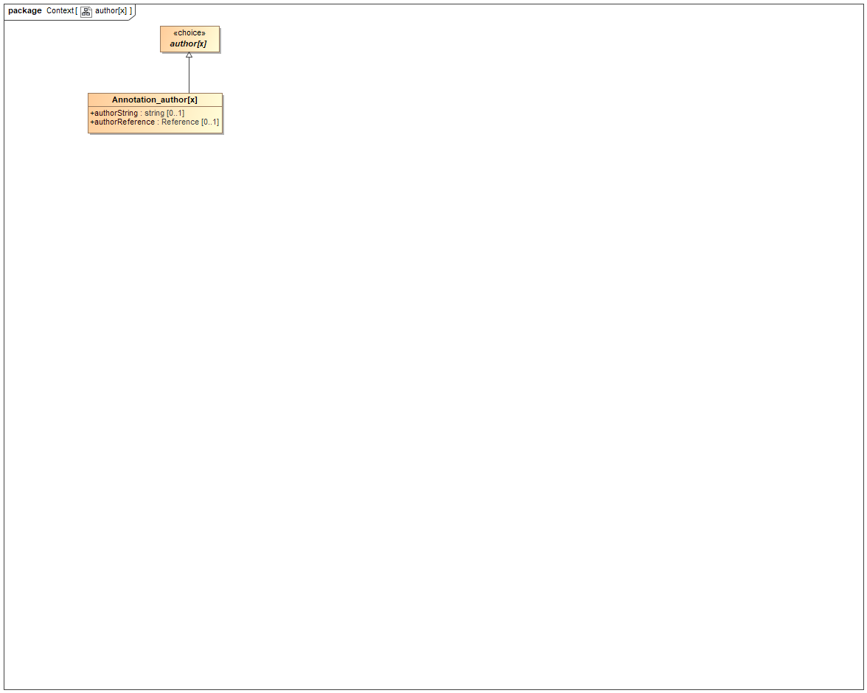

1. author[x]

### Class Annotation_author[x]

#### Direct Known Superclasses

author[x]

package FHIR::R4::Datatype

public class Annotation_author[x]

extends

author[x]

### Class author[x]

package FHIR::R4::Datatype

public abstract class author[x]

## bounds[x]

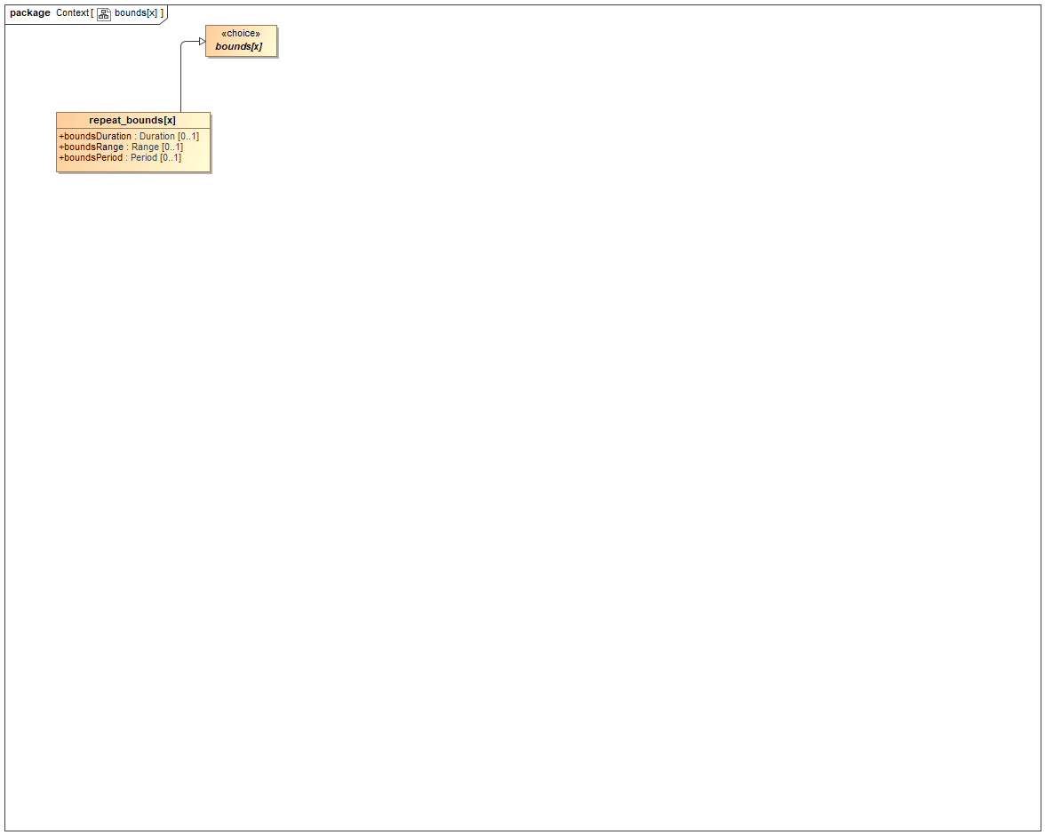

1. bounds[x]

### Class bounds[x]

package FHIR::R4::Datatype

public abstract class bounds[x]

### Class repeat_bounds[x]

#### Direct Known Superclasses

bounds[x]

package FHIR::R4::Context

public class repeat_bounds[x]

extends

bounds[x]

## effective[x]

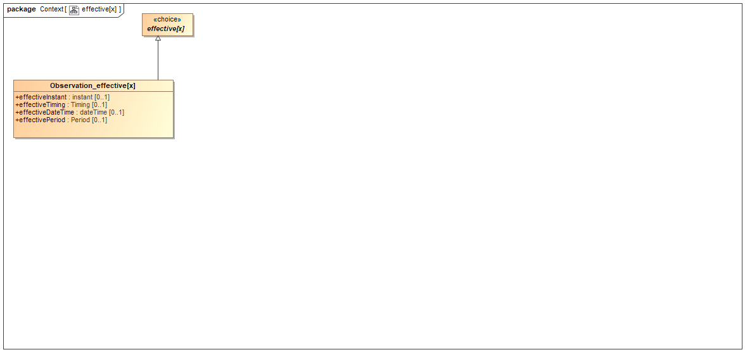

1. effective[x]

### Class effective[x]

package FHIR::R4::Datatype

public abstract class effective[x]

### Class Observation_effective[x]

#### Direct Known Superclasses

effective[x]

package FHIR::R4::Context

public class Observation_effective[x]

extends

effective[x]

## value[x]

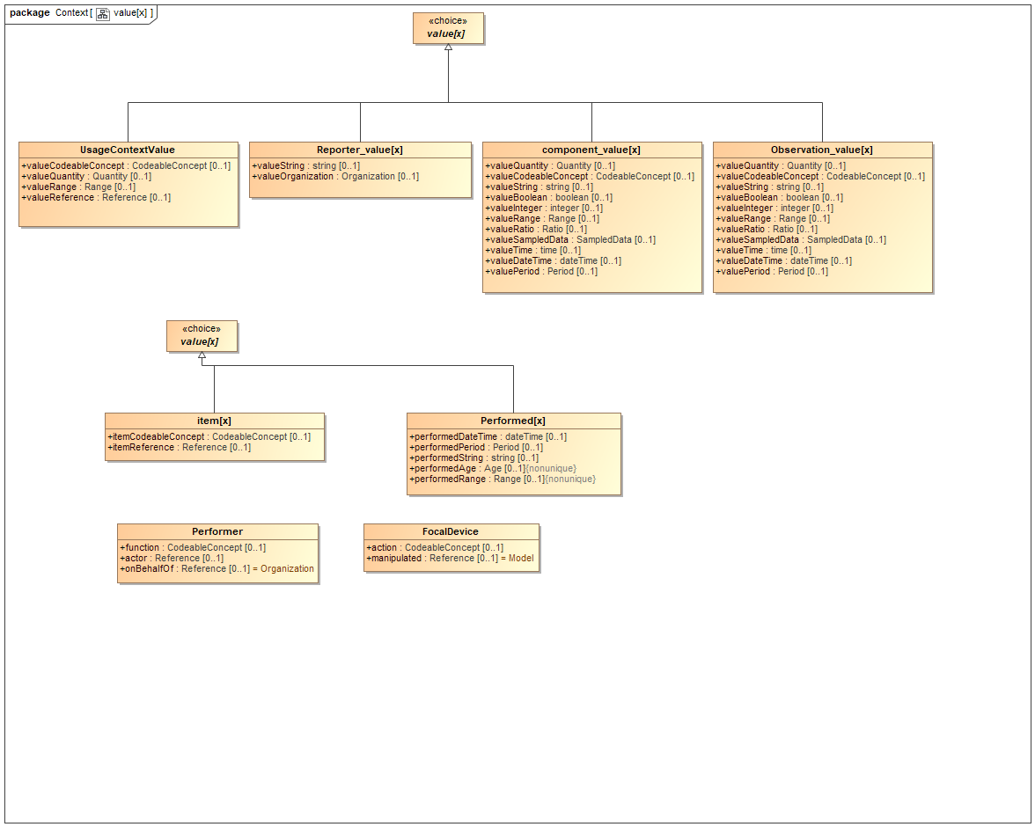

1. value[x]

### Class component_value[x]

#### Direct Known Superclasses

value[x]

package FHIR::R4::Context

public class component_value[x]

extends

value[x]

### Class FocalDevice

#### Direct Known Superclasses

BackboneElement

package FHIR::R4::Context

public class FocalDevice

extends

BackboneElement

### Class item[x]

#### Direct Known Superclasses

value[x]

package FHIR::R4::Context

public class item[x]

extends

value[x]

### Class Observation_value[x]

#### Direct Known Superclasses

value[x]

package FHIR::R4::Context

public class Observation_value[x]

extends

value[x]

### Class Performed[x]

#### Direct Known Superclasses

value[x]

package FHIR::R4::Context

public class Performed[x]

extends

value[x]

### Class Performer

#### Direct Known Superclasses

BackboneElement

package FHIR::R4::Context

public class Performer

extends

BackboneElement

### Class Reporter_value[x]

#### Direct Known Superclasses

value[x]

package FHIR::R4::Context

public class Reporter_value[x]

extends

value[x]

### Class UsageContextValue

#### Direct Known Superclasses

value[x]

package FHIR::R4::Context

public class UsageContextValue

extends

value[x]

### Class value[x]

package FHIR::R4::Datatype

public abstract class value[x]

## Class Qualification

A timing schedule that specifies an event that may occur multiple times

### Direct Known Superclasses

BackboneElement

package FHIR::R4::Context

public class Qualification

extends

BackboneElement

# FHIR::R4::Datatype

## Datatype

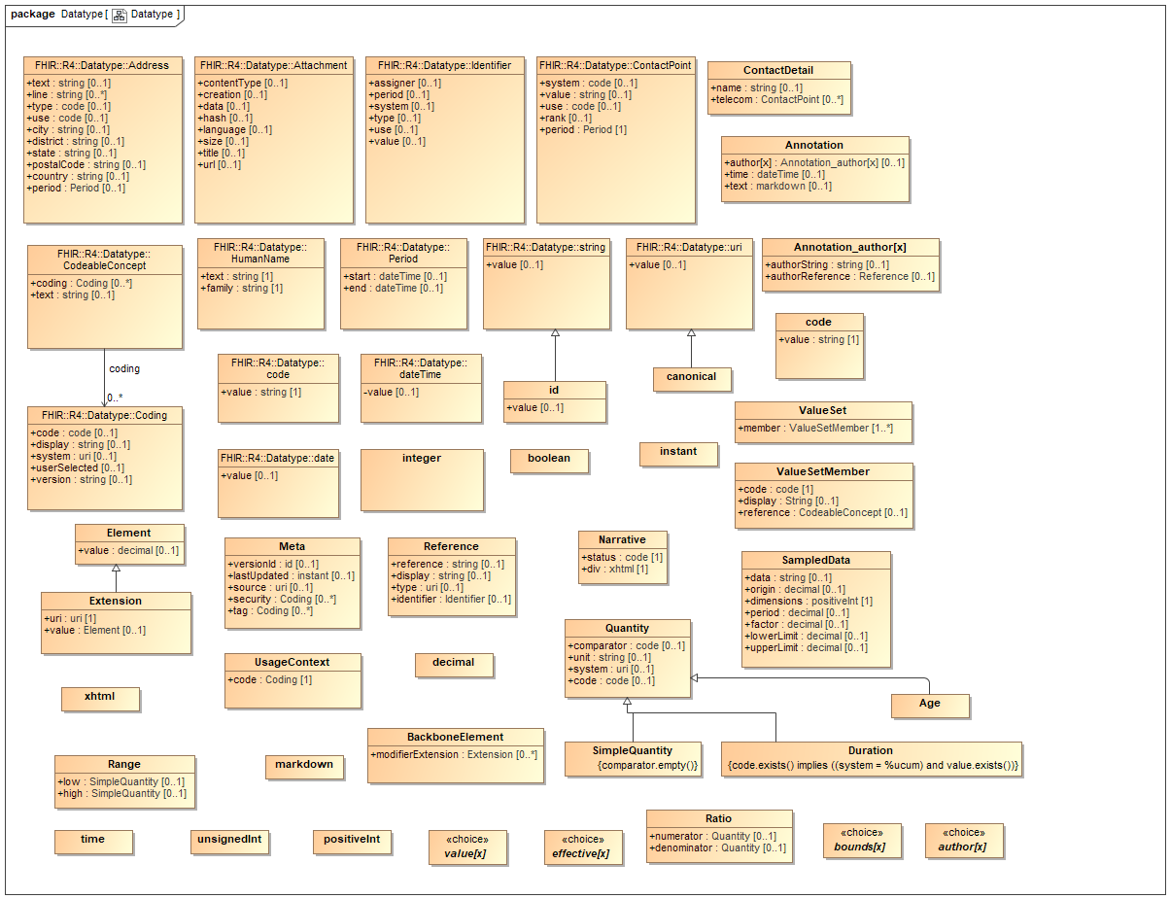

1. Datatype

### Class Address

An address expressed using postal conventions (as opposed to GPS or other location definition formats). This data type may be used to convey addresses for use in delivering mail as well as for visiting locations which might not be valid for mail delivery. There are a variety of postal address formats defined around the world.  
[ Source: https://www.hl7.org/fhir/datatypes.html#Address ]

#### Direct Known Superclasses

Element

package FHIR::R4::Datatype

public class Address

extends

Element

### Class Age

#### Direct Known Superclasses

Quantity

package FHIR::R4::Datatype

public class Age

extends

Quantity

### Class Annotation

A text note which also contains information about who made the statement and when.

#### Direct Known Superclasses

Element

package FHIR::R4::Datatype

public class Annotation

extends

Element

### Class Attachment

Content in a format defined elsewhere.  
This type is for containing or referencing attachments - additional data content defined in other formats. The most common use of this type is to include images or reports in some report format such as PDF. However it can be used for any data that has a MIME type. [Source: https://www.hl7.org/fhir/datatypes.html#attachment]

#### Direct Known Superclasses

Element

package FHIR::R4::Datatype

public class Attachment

extends

Element

### Class BackboneElement

#### Direct Known Superclasses

Element

package FHIR::R4::Datatype

public class BackboneElement

extends

Element

### Class boolean

true | false

#### Direct Known Superclasses

Element

package FHIR::R4::Datatype

public class boolean

extends

Element

### Class canonical

A URI that refers to a resource by its canonical URL (resources with a url property). The canonical type differs from a uri in that it has special meaning in this specification, and in that it may have a version appended, separated by a vertical bar (|). Note that the type canonical is not used for the actual canonical URLs that are the target of these references, but for the URIs that refer to them, and may have the version suffix in them. Like other URIs, elements of type canonical may also have #fragment references.

#### Direct Known Superclasses

uri

package FHIR::R4::Datatype

public class canonical

extends

uri

### Class code

Indicates that the value is taken from a set of controlled strings defined elsewhere (see Using codes for further discussion). Technically, a code is restricted to a string which has at least one character and no leading or trailing whitespace, and where there is no whitespace other than single spaces in the contents [Source: https://www.hl7.org/fhir/datatypes.html#code]

#### Direct Known Superclasses

Element

package FHIR::R4::Datatype

public class code

extends

Element

### Class CodeableConcept

Concept - reference to a terminology or just text  
A CodeableConcept represents a value that is usually supplied by providing a reference to one or more terminologies or ontologies, but may also be defined by the provision of text. This is a common pattern in healthcare data. [Source: https://www.hl7.org/fhir/datatypes.html#codeableconcept]

#### Direct Known Superclasses

Element

package FHIR::R4::Datatype

public class CodeableConcept

extends

Element

#### Associations

-337330099.png public : Coding [0..*]

A reference to a code defined by a terminology system.  
A Coding is a representation of a defined concept using a symbol from a defined "code system" [Source: https://www.hl7.org/fhir/datatypes.html#coding]

### Class Coding

A reference to a code defined by a terminology system.  
A Coding is a representation of a defined concept using a symbol from a defined "code system" [Source: https://www.hl7.org/fhir/datatypes.html#coding]

#### Direct Known Superclasses

Element

package FHIR::R4::Datatype

public class Coding

extends

Element

### Class ContactDetail

#### Direct Known Superclasses

Element

package FHIR::R4::Datatype

public class ContactDetail

extends

Element

### Class ContactPoint

Details for all kinds of technology-mediated contact points for a person or organization, including telephone, email, etc. [Source: https://www.hl7.org/fhir/datatypes.html#ContactPoint ]

#### Direct Known Superclasses

Element

package FHIR::R4::Datatype

public class ContactPoint

extends

Element

### Class date

A date, or partial date (e.g. just year or year + month) as used in human communication. There is no time zone. Dates SHALL be valid dates [Source: https://www.hl7.org/fhir/datatypes.html#date]

#### Direct Known Superclasses

Element

package FHIR::R4::Datatype

public class date

extends

Element

### Class dateTime

A date, date-time or partial date (e.g. just year or year + month) as used in human communication. If hours and minutes are specified, a time zone SHALL be populated. Seconds must be provided due to schema type constraints but may be zero-filled and may be ignored. Dates SHALL be valid dates. The time "24:00" is not allowed. [Source: https://www.hl7.org/fhir/datatypes.html#datetime]

#### Direct Known Superclasses

Element

package FHIR::R4::Datatype

public class dateTime

extends

Element

### Class decimal

Rational numbers that have a decimal representation. See below about the precision of the number

#### Direct Known Superclasses

Element

package FHIR::R4::Datatype

public class decimal

extends

Element

### Class Duration

#### Direct Known Superclasses

Quantity

package FHIR::R4::Datatype

public class Duration

extends

Quantity

### Class Element

The base definition for all elements contained inside a resource.

package FHIR::R4::Datatype

public class Element

### Class Extension

Every element in a resource or data type includes an optional "extension" child element that may be present any number of times.

#### Direct Known Superclasses

Element

package FHIR::R4::Datatype

public class Extension

extends

Element

### Class HumanName

A name of a human with text, parts and usage information.  
Names may be changed or repudiated. People may have different names in different contexts. Names may be divided into parts of different type that have variable significance depending on context, though the division into parts is not always significant. With personal names, the different parts may or may not be imbued with some implicit meaning; various cultures associate different importance with the name parts and the degree to which systems SHALL care about name parts around the world varies widely. [Source: https://www.hl7.org/fhir/datatypes.html#humanname]

#### Direct Known Superclasses

Element

package FHIR::R4::Datatype

public class HumanName

extends

Element

### Class id

Any combination of upper- or lower-case ASCII letters ('A'..'Z', and 'a'..'z', numerals ('0'..'9'), '-' and '.', with a length limit of 64 characters. (This might be an integer, an un-prefixed OID, UUID or any other identifier pattern that meets these constraints.)

#### Direct Known Superclasses

string

package FHIR::R4::Datatype

public class id

extends

string

### Class Identifier

A numeric or alphanumeric string that is associated with a single object or entity within a given system. Typically, identifiers are used to connect content in resources to external content available in other frameworks or protocols. Identifiers are associated with objects, and may be changed or retired due to human or system process and errors. [Source:https://www.hl7.org/fhir/datatypes.html#identifier]

#### Direct Known Superclasses

Element

package FHIR::R4::Datatype

public class Identifier

extends

Element

### Class instant

An instant in time in the format YYYY-MM-DDThh:mm:ss.sss+zz:zz (e.g. 2015-02-07T13:28:17.239+02:00 or 2017-01-01T00:00:00Z). The time SHALL specified at least to the second and SHALL include a time zone. Note: This is intended for when precisely observed times are required (typically system logs etc.), and not human-reported times - for those, use date or dateTime (which can be as precise as instant, but is not required to be). instant is a more constrained dateTime.

#### Direct Known Superclasses

Element

package FHIR::R4::Datatype

public class instant

extends

Element

### Class integer

A signed integer in the range −2,147,483,648..2,147,483,647 (32-bit; for larger values, use decimal) [Source: FHIR]

#### Direct Known Superclasses

Element

package FHIR::R4::Datatype

public class integer

extends

Element

### Class markdown

A FHIR string (see above) that may contain markdown syntax for optional processing by a markdown presentation engine, in the GFM extension of CommonMark format (see below)  
Regex: \s*(\S|\s)* (can't put size limit in the regex - too large)

#### Direct Known Superclasses

string

package FHIR::R4::Datatype

public class markdown

extends

string

### Class Meta

An address expressed using postal conventions (as opposed to GPS or other location definition formats). This data type may be used to convey addresses for use in delivering mail as well as for visiting locations which might not be valid for mail delivery. There are a variety of postal address formats defined around the world.  
[ Source: https://www.hl7.org/fhir/datatypes.html#Address ]

#### Direct Known Superclasses

Element

package FHIR::R4::Datatype

public class Meta

extends

Element

### Class Narrative

#### Direct Known Superclasses

Element

package FHIR::R4::Datatype

public class Narrative

extends

Element

### Class Period

A time period defined by a start and end date/time. A period specifies a range of times. The context of use will specify whether the entire range applies (e.g. "the patient was an inpatient of the hospital for this time range") or one value from the period applies (e.g. "give to the patient between 2 and 4 pm on 24-Jun 2013"). [ Source: https://www.hl7.org/fhir/datatypes.html#Period ]

#### Direct Known Superclasses

Element

package FHIR::R4::Datatype

public class Period

extends

Element

### Class positiveInt

Any positive integer in the range 1..2,147,483,647  
Regex: +?[1-9][0-9]*

#### Direct Known Superclasses

Element

package FHIR::R4::Datatype

public class positiveInt

extends

Element

### Class Quantity

#### Direct Known Superclasses

Element

package FHIR::R4::Datatype

public class Quantity

extends

Element

### Class Range

A set of ordered Quantity values defined by a low and high limit. A Range specifies a set of possible values; usually, one value from the range applies (e.g. "give the patient between 2 and 4 tablets"). Ranges are typically used in instructions.

package FHIR::R4::Datatype

public class Range

### Class Ratio

A set of ordered Quantity values defined by a low and high limit. A Range specifies a set of possible values; usually, one value from the range applies (e.g. "give the patient between 2 and 4 tablets"). Ranges are typically used in instructions.

#### Direct Known Superclasses

Element

package FHIR::R4::Datatype

public class Ratio

extends

Element

### Class Reference

A reference from one resource to another.

#### Direct Known Superclasses

Element

package FHIR::R4::Datatype

public class Reference

extends

Element

### Class SampledData

A reference from one resource to another.

#### Direct Known Superclasses

Element

package FHIR::R4::Datatype

public class SampledData

extends

Element

### Class SimpleQuantity

#### Direct Known Superclasses

Quantity

package FHIR::R4::Datatype

public class SimpleQuantity

extends

Quantity

### Class string

A sequence of Unicode characters. Note that strings SHALL NOT exceed 1MB in size. String should not contain Unicode character points below 32, except for u0009 (horizontal tab), u0010 (carriage return) and u0013 (line feed) [Source: https://www.hl7.org/fhir/datatypes.html#string]

#### Direct Known Superclasses

Element

package FHIR::R4::Datatype

public class string

extends

Element

### Class time

A time during the day, in the format hh:mm:ss. There is no date specified. Seconds must be provided due to schema type constraints but may be zero-filled and may be ignored at receiver discretion. The time "24:00" SHALL NOT be used. A time zone SHALL NOT be present. Times can be converted to a Duration since midnight.  
Regex: ([01][0-9]|2[0-3]):[0-5][0-9]:([0-5][0-9]|60)(\.[0-9]+)?

#### Direct Known Superclasses

Element

package FHIR::R4::Datatype

public class time

extends

Element

### Class unsignedInt

Any non-negative integer in the range 0..2,147,483,647  
Regex: [0]|([1-9][0-9]*)

#### Direct Known Superclasses

Element

package FHIR::R4::Datatype

public class unsignedInt

extends

Element

### Class uri

A Uniform Resource Identifier Reference (RFC 3986 ). Note: URIs are case sensitive. For UUID (urn:uuid:53fefa32-fcbb-4ff8-8a92-55ee120877b7) use all lowercase. URIs can be absolute or relative, and may have an optional fragment identifier. [Source: https://www.hl7.org/fhir/datatypes.html#uri]

#### Direct Known Superclasses

Element

package FHIR::R4::Datatype

public class uri

extends

Element

### Class UsageContext

#### Direct Known Superclasses

Element

package FHIR::R4::Datatype

public class UsageContext

extends

Element

### Class ValueSet

package FHIR::R4::Datatype

public class ValueSet

### Class ValueSetMember

package FHIR::R4::Datatype

public class ValueSetMember

### Class xhtml

#### Direct Known Superclasses

Element

package FHIR::R4::Datatype

public class xhtml

extends

Element

### Known other classes

Class Annotation_author[x], Class author[x], Class bounds[x], Class effective[x], Class value[x]

# FHIR::R4::Extension

## Extension

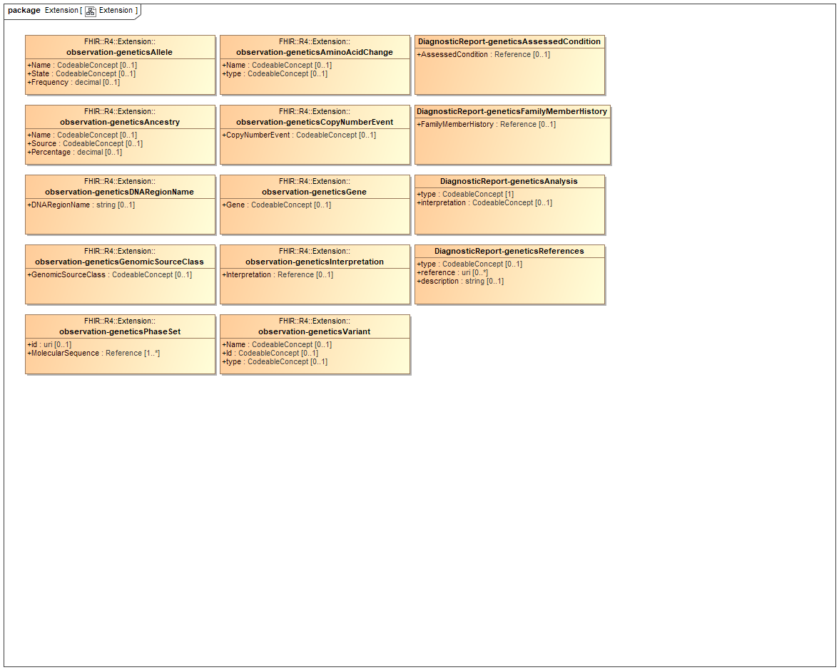

1. Extension

### Class DiagnosticReport-geneticsAnalysis

#### Direct Known Superclasses

DiagnosticReport

package FHIR::R4::Extension

public class DiagnosticReport-geneticsAnalysis

extends

DiagnosticReport

### Class DiagnosticReport-geneticsAssessedCondition

#### Direct Known Superclasses

DiagnosticReport

package FHIR::R4::Extension

public class DiagnosticReport-geneticsAssessedCondition

extends

DiagnosticReport

### Class DiagnosticReport-geneticsFamilyMemberHistory

#### Direct Known Superclasses

DiagnosticReport

package FHIR::R4::Extension

public class DiagnosticReport-geneticsFamilyMemberHistory

extends

DiagnosticReport

### Class DiagnosticReport-geneticsReferences

#### Direct Known Superclasses

DiagnosticReport

package FHIR::R4::Extension

public class DiagnosticReport-geneticsReferences

extends

DiagnosticReport

### Class observation-geneticsAllele

#### Direct Known Superclasses

Observation

package FHIR::R4::Extension

public class observation-geneticsAllele

extends

Observation

### Class observation-geneticsAminoAcidChange

#### Direct Known Superclasses

Observation

package FHIR::R4::Extension

public class observation-geneticsAminoAcidChange

extends

Observation

### Class observation-geneticsAncestry

#### Direct Known Superclasses

Observation

package FHIR::R4::Extension

public class observation-geneticsAncestry

extends

Observation

### Class observation-geneticsCopyNumberEvent

#### Direct Known Superclasses

Observation

package FHIR::R4::Extension

public class observation-geneticsCopyNumberEvent

extends

Observation

### Class observation-geneticsDNARegionName

#### Direct Known Superclasses

Observation

package FHIR::R4::Extension

public class observation-geneticsDNARegionName

extends

Observation

### Class observation-geneticsGene

#### Direct Known Superclasses

Observation

package FHIR::R4::Extension

public class observation-geneticsGene

extends

Observation

### Class observation-geneticsGenomicSourceClass

#### Direct Known Superclasses

Observation

package FHIR::R4::Extension

public class observation-geneticsGenomicSourceClass

extends

Observation

### Class observation-geneticsInterpretation

#### Direct Known Superclasses

Observation

package FHIR::R4::Extension

public class observation-geneticsInterpretation

extends

Observation

### Class observation-geneticsPhaseSet

#### Direct Known Superclasses

Observation

package FHIR::R4::Extension

public class observation-geneticsPhaseSet

extends

Observation

### Class observation-geneticsVariant

#### Direct Known Superclasses

Observation

package FHIR::R4::Extension

public class observation-geneticsVariant

extends

Observation

# FHIR::R4::Profile

## Class DiagnosticReport-genetics

Describes how the observation resource is used to report structured genetic test results.

### Direct Known Superclasses

Observation

package FHIR::R4::Profile

public class DiagnosticReport-genetics

extends

Observation

## Class Observation-genetics

Describes how the observation resource is used to report structured genetic test results.

### Direct Known Superclasses

Observation

package FHIR::R4::Profile

public class Observation-genetics

extends

Observation

# FHIR::R4::Resource

## Auxiliary

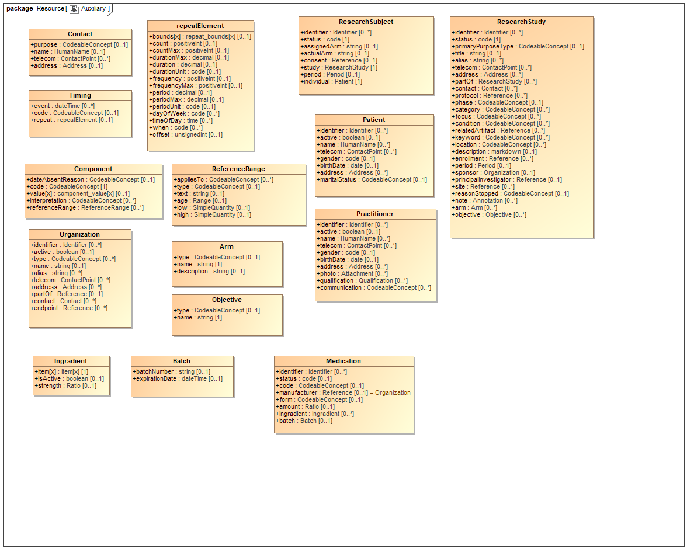

1. Auxiliary

### Class Arm

A timing schedule that specifies an event that may occur multiple times

#### Direct Known Superclasses

BackboneElement

package FHIR::R4::Resource

public class Arm

extends

BackboneElement

### Class Batch

#### Direct Known Superclasses

BackboneElement

package FHIR::R4::Resource

public class Batch

extends

BackboneElement

### Class Component

A timing schedule that specifies an event that may occur multiple times

#### Direct Known Superclasses

BackboneElement

package FHIR::R4::Resource

public class Component

extends

BackboneElement

### Class Contact

Contact with a certain purpose

#### Direct Known Superclasses

BackboneElement

package FHIR::R4::Resource

public class Contact

extends

BackboneElement

### Class Ingradient

#### Direct Known Superclasses

BackboneElement

package FHIR::R4::Resource

public class Ingradient

extends

BackboneElement

### Class Objective

A timing schedule that specifies an event that may occur multiple times

#### Direct Known Superclasses

BackboneElement

package FHIR::R4::Resource

public class Objective

extends

BackboneElement

### Class Organization

#### Direct Known Superclasses

DomainResource

package FHIR::R4::Resource

public class Organization

extends

DomainResource

### Class Practitioner

#### Direct Known Superclasses

DomainResource

package FHIR::R4::Resource

public class Practitioner

extends

DomainResource

### Class ReferenceRange

A timing schedule that specifies an event that may occur multiple times

#### Direct Known Superclasses

BackboneElement

package FHIR::R4::Resource

public class ReferenceRange

extends

BackboneElement

### Class repeatElement

#### Direct Known Superclasses

Element

package FHIR::R4::Resource

public class repeatElement

extends

Element

### Class ResearchStudy

#### Direct Known Superclasses

DomainResource

package FHIR::R4::Resource

public class ResearchStudy

extends

DomainResource

### Class ResearchSubject

#### Direct Known Superclasses

DomainResource

package FHIR::R4::Resource

public class ResearchSubject

extends

DomainResource

### Class Timing

A timing schedule that specifies an event that may occur multiple times

#### Direct Known Superclasses

BackboneElement

package FHIR::R4::Resource

public class Timing

extends

BackboneElement

### Known other classes

Class Medication, Class Patient

## basic

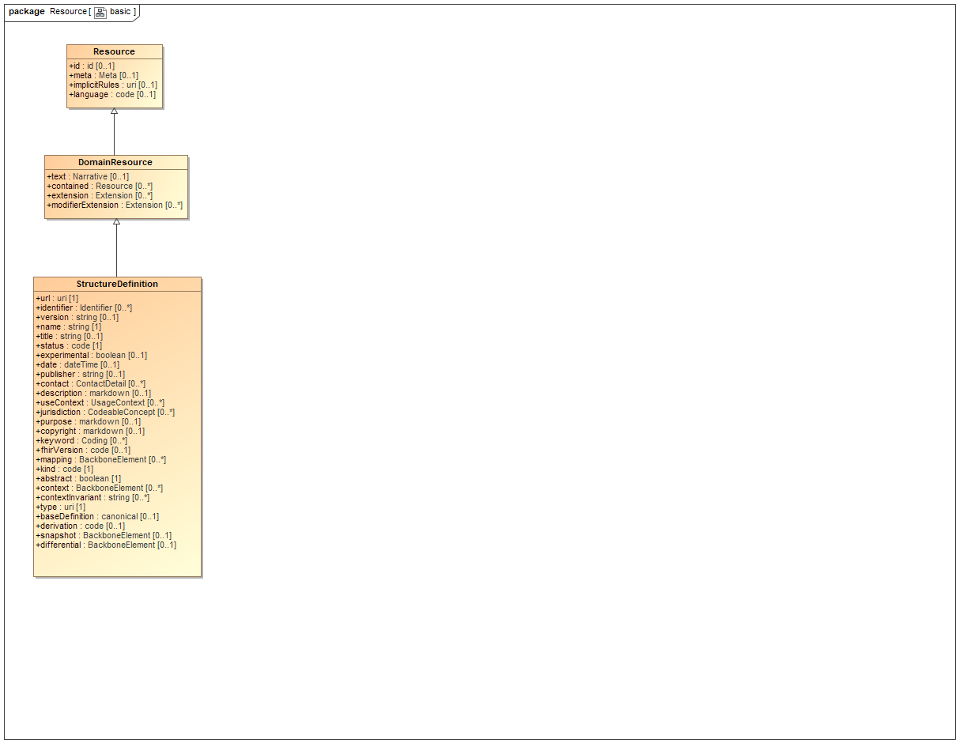

1. basic

### Class DomainResource

A resource with narrative, extensions, and contained resources

#### Direct Known Superclasses

Resource

package FHIR::R4::Resource

public class DomainResource

extends

Resource

### Class Resource

Base Resource

package FHIR::R4::Resource

public class Resource

### Class StructureDefinition

A definition of a FHIR structure. This resource is used to describe the underlying resources, data types defined in FHIR, and also for describing extensions and constraints on resources and data types.

#### Direct Known Superclasses

DomainResource

package FHIR::R4::Resource

public class StructureDefinition

extends

DomainResource

## Extension

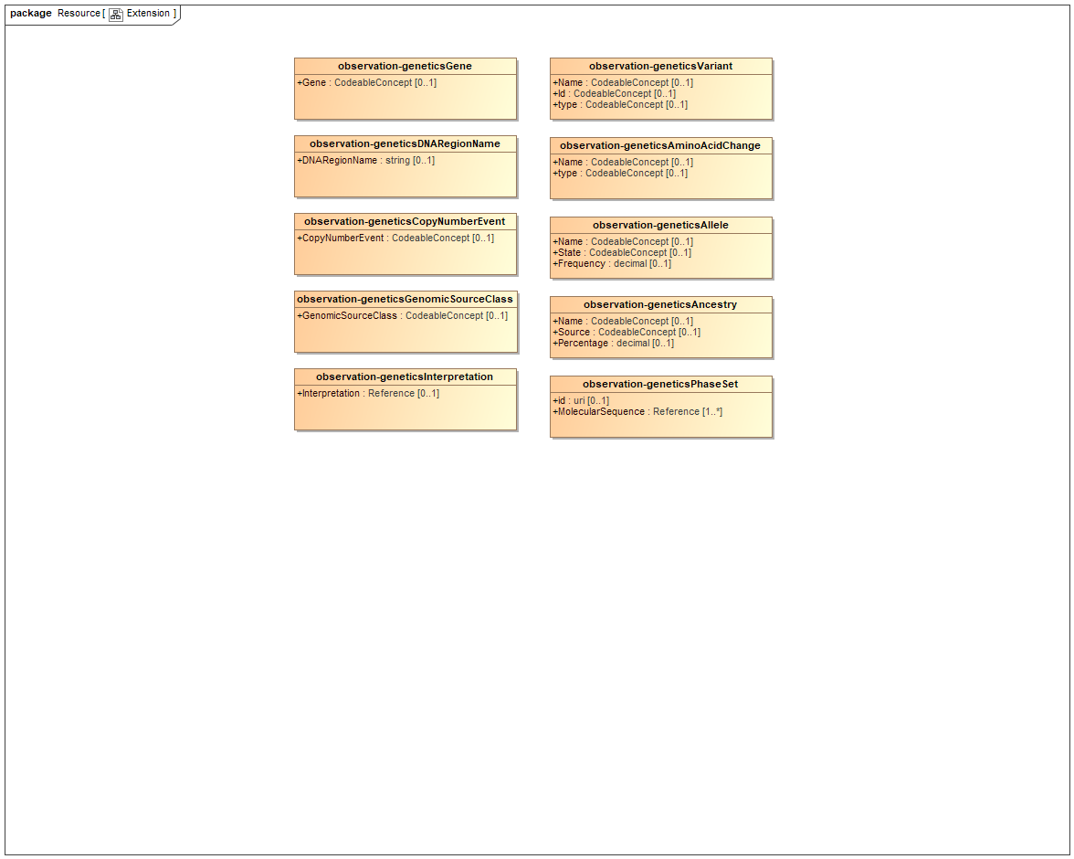

1. Extension

### Known other classes

Class observation-geneticsAllele, Class observation-geneticsAminoAcidChange, Class observation-geneticsAncestry, Class observation-geneticsCopyNumberEvent, Class observation-geneticsDNARegionName, Class observation-geneticsGene, Class observation-geneticsGenomicSourceClass, Class observation-geneticsInterpretation, Class observation-geneticsPhaseSet, Class observation-geneticsVariant

## Resource

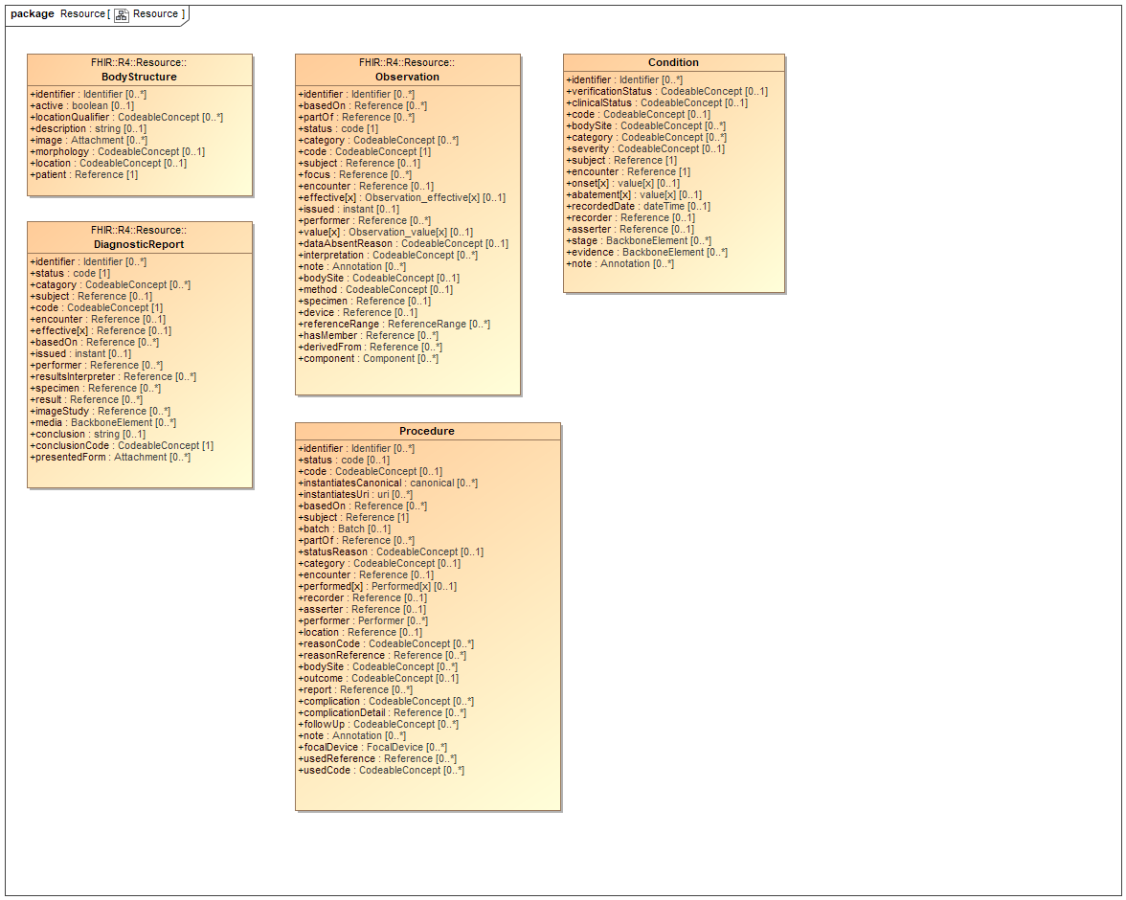

1. Resource

### Class BodyStructure

Specific and identified anatomical structure. Record details about an anatomical structure. This resource may be used when a coded concept does not provide the necessary detail needed for the use case. [Source: http://www.hl7.org/fhir/bodystructure.html]

#### Direct Known Superclasses

DomainResource

package FHIR::R4::Resource

public class BodyStructure

extends

DomainResource

### Class Condition

A clinical condition, problem, diagnosis, or other event, situation, issue, or clinical concept that has risen to a level of concern.

#### Direct Known Superclasses

DomainResource

package FHIR::R4::Resource

public class Condition

extends

DomainResource

### Class DiagnosticReport

The findings and interpretation of diagnostic tests performed on patients, groups of patients, devices, and locations, and/or specimens derived from these. The report includes clinical context such as requesting and provider information, and some mix of atomic results, images, textual and coded interpretations, and formatted representation of diagnostic reports.

#### Direct Known Superclasses

DomainResource

package FHIR::R4::Resource

public class DiagnosticReport

extends

DomainResource

### Class Observation

Measurements and simple assertions made about a patient, device or other subject.

#### Direct Known Superclasses

DomainResource

package FHIR::R4::Resource

public class Observation

extends

DomainResource

### Known other classes

Class Procedure

## Class Person

The Person resource serves as a linkage resource that may provide a reference set of common demographics for an individual (human or animal) across multiple roles. [Source: http://www.hl7.org/fhir/person.html]

package FHIR::R4::Resource

public class Person

# FHIR::australia::Auxiliary

## Auxiliary

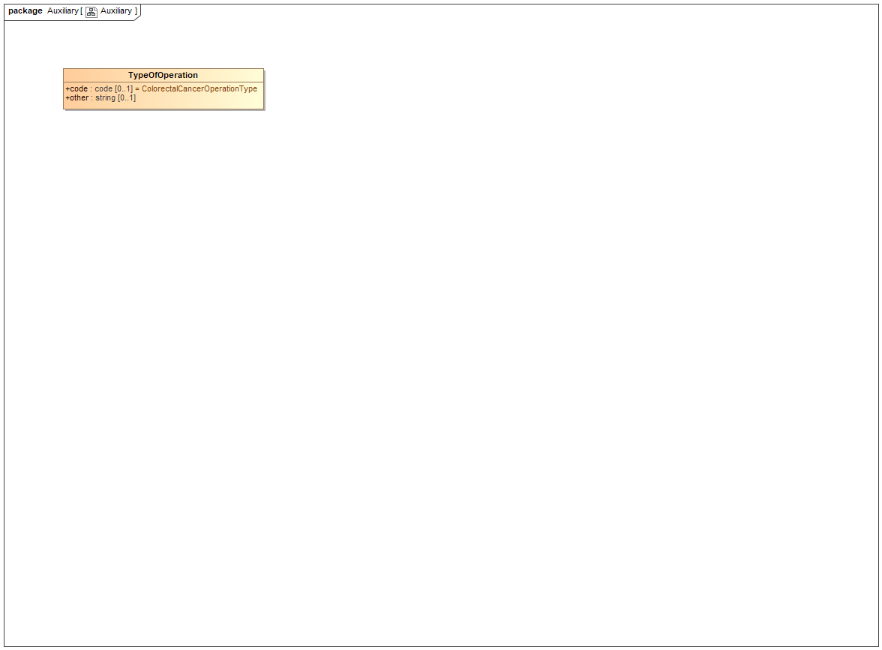

1. Auxiliary

### Class TypeOfOperation

package FHIR::australia::Auxiliary

public class TypeOfOperation

## Class AustralianPatient

### Direct Known Superclasses

Patient

package FHIR::australia::Auxiliary

public class AustralianPatient

extends

Patient

## Class braf

package FHIR::australia::Auxiliary

public class braf

## Class kras

package FHIR::australia::Auxiliary

public class kras

## Class LymphNodesDetails

package FHIR::australia::Auxiliary

public class LymphNodesDetails

## Class msi

package FHIR::australia::Auxiliary

public class msi

## Class RelCoexistPathabnorm

package FHIR::australia::Auxiliary

public class RelCoexistPathabnorm

# FHIR::australia::Colorectal

## ColorectalReport

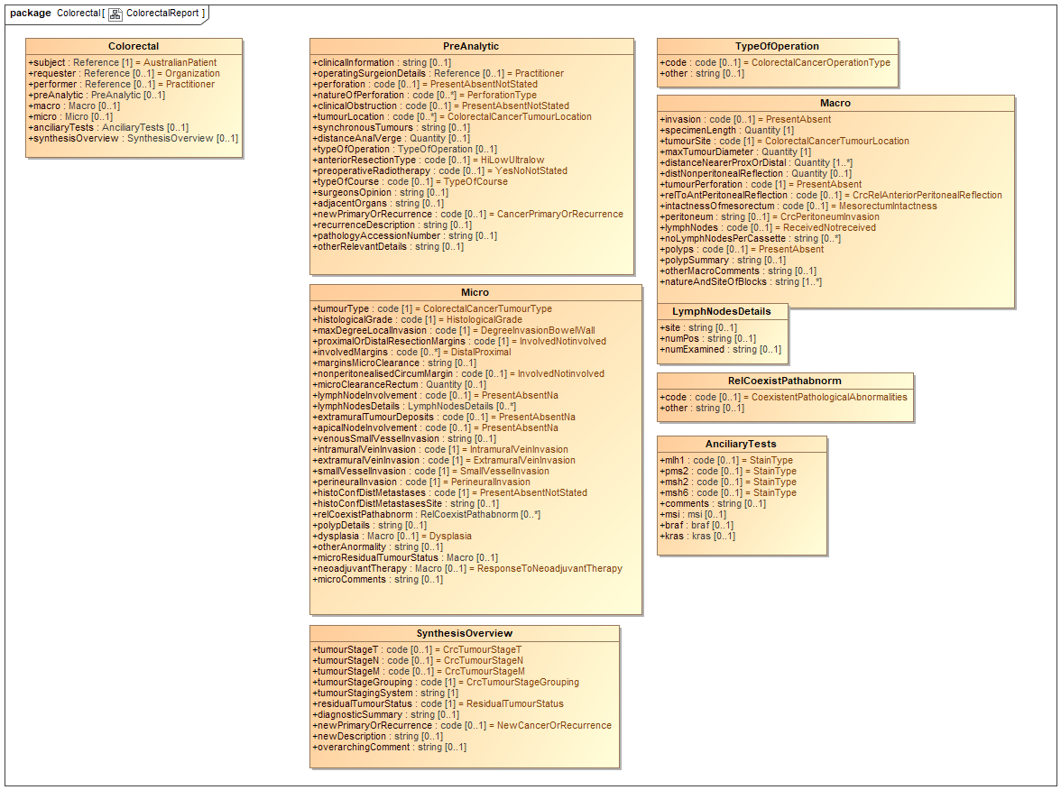

1. ColorectalReport

### Class LymphNodesDetails

package FHIR::australia::Colorectal

public class LymphNodesDetails

### Class RelCoexistPathabnorm

package FHIR::australia::Colorectal

public class RelCoexistPathabnorm

### Known other classes

Class AnciliaryTests, Class Colorectal, Class Macro, Class Micro, Class PreAnalytic, Class SynthesisOverview, Class TypeOfOperation

# Tree

## Class Hierarchy