LAB 2
INSHIKA THAKUR

(3) Create a Profile that has the following features and take a snapshot of the terminal
features window as well as the terminal itself. The features are Font: Ubuntu Sans
Mono with font size 10, dark background, I-Bean cursor shape, Enable cursor blinking,
disable cursor bell, background color palette entry 9.
Ans)
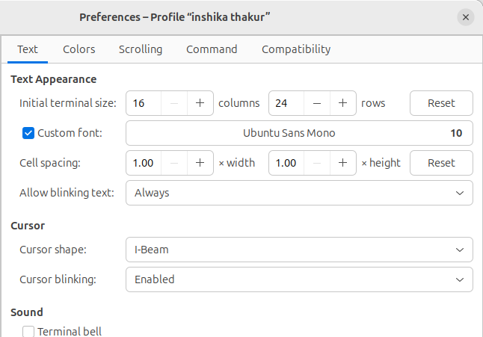
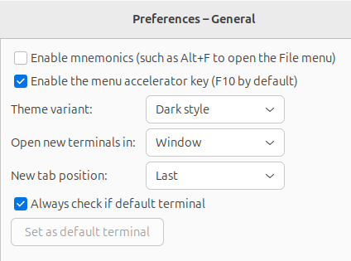
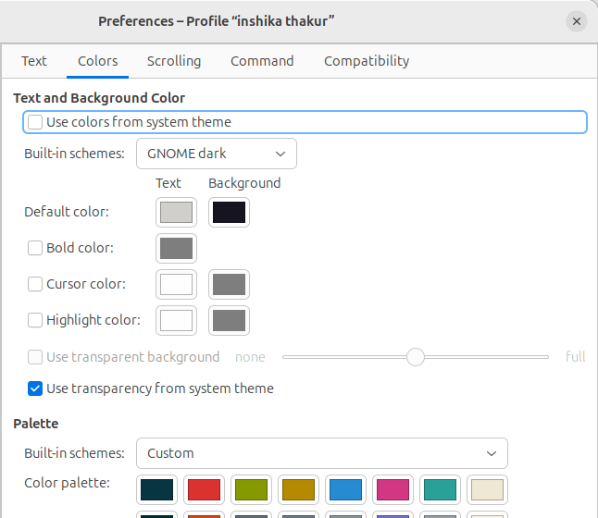
The font has been set to Ubuntu mono sans with font size 10, the background is set to dark and the cursor shape has been set to I beam, the cursor blinking is enables and the cursor bell is disabled and the background color palette entry is set to 9.

(4) Change your command prompt to ”MyTestPrompt1¿ ” and take a screenshot. Also take
a screenshot after reverting back to the default prompt.
Ans)
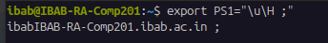

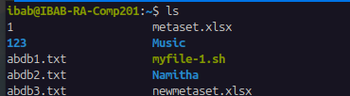

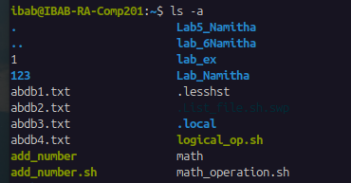

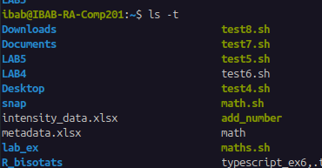
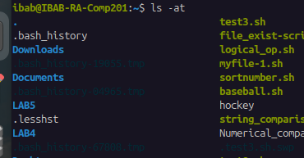

(5) Change your command prompt to make the username, hostname and time appear in
24-hour format.
Ans)
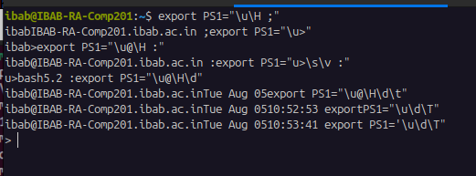

(6) Change your command prompt to make only the hostname, date and time appear, and
time should appear in 12-hour format
Ans)
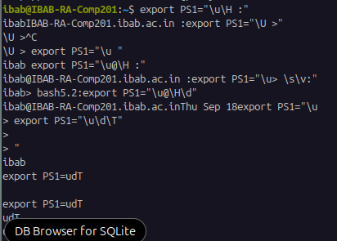

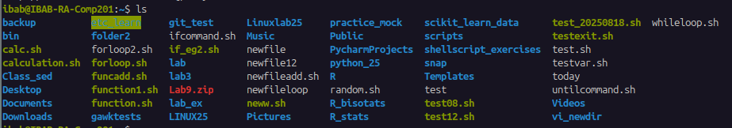

(7) Change the color of your command prompt to have Bold, underline and Blue appearance.
Ans) The command to change colour is:

export PS1=”\e[0;32m[\u@\h\W]$\e[0m”
\u: username
\h: Hostname
\H: full hostname
\W: Current working directory
\d: date
\t: time
\n: new line character
There are different codes for different colours:
:30 is for clack
:31 is for red
:32 is for green
:33 is for brown
:34 is for blue
:35 is for purple
:36 is for cyan
:37 is for light grey

