LAB5
INSHIKA THAKUR

(1) Look for the pattern ‘Meningioma’ in the data file. Redirect the output to a new
file called ’LinesWithMeningioma.out’. Show the command used and the contents of this new file in your screenshot.
Ans) To look for pattern Meningioma in the data file and redirect it to the new file we use the command:
- grep “Meningioma” BrainCancer.csv > LinesWithMeningioma.out
Then to see the content of the new file use the command:
- cat LinesWithMeningioma
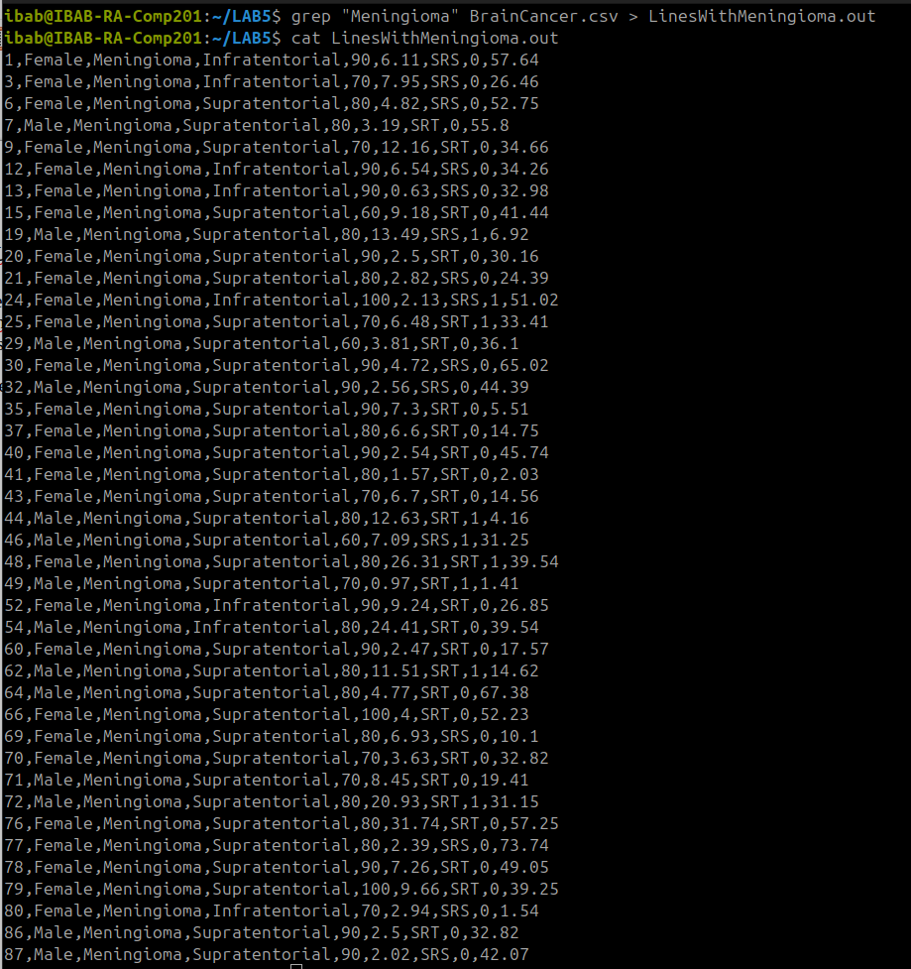
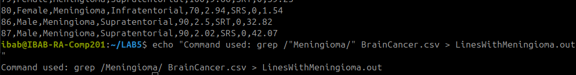

(2) How many males and females were present in this study? How will you create a grep filter to find this out?
Ans) To count the number of male in the study we use the command:
- grep -c “Male” BrainCancer.csv
To count the number of female in the study use the command:
- grep -c “Female” BrainCancer.csv
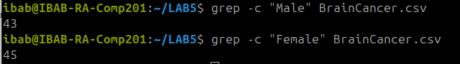
There were total of 43 male and 45 female in this study.

(3) How many males have supratentorial brain cancer and how many females have infratentorial cancer? Which option in grep makes you ignore the case while searching? Make use of this in this exercise.
Ans) Meningioma

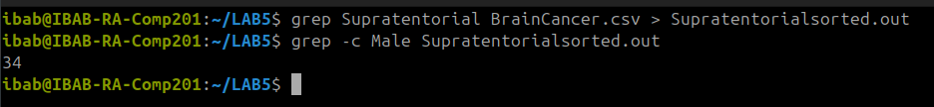
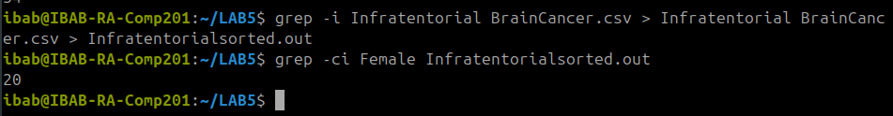

(4) Find out which patient has the lowest ki value.
Ans) To find out the patient with lowest ki value use command:
- sort -n -t ‘,’ -k5,5 BrainCancer.csv
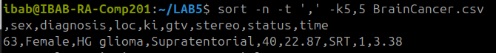
(5)Print out the output by searching for the patterns ’SRS’ as well as ’infratentorial’. How many entries are there?
Ans) First we created an output file for SRS after sorting it using the command:
- grep -e ‘SRS’ BrainCancer.csv > Srsbraincancer.csv

Then we use command:
- grep ‘Infratentorial’ Srsbraincancer.csv’
It gives us the list
- grep ‘Infratentorial’ -c Srsbraincancer.csv
This command is used to list the number of enteries.

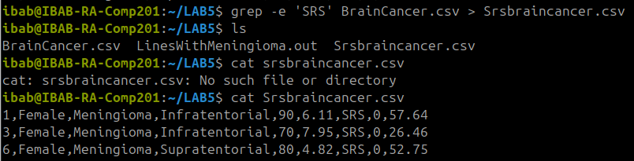
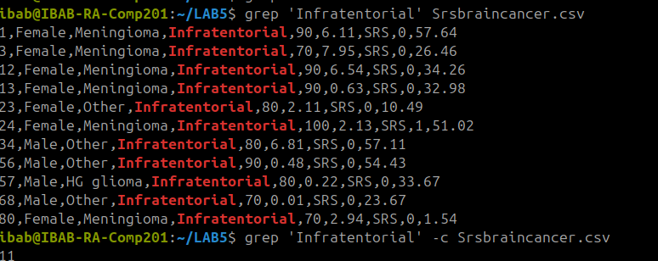

(6) List the patients who have survival times more than 50 months.
Ans)
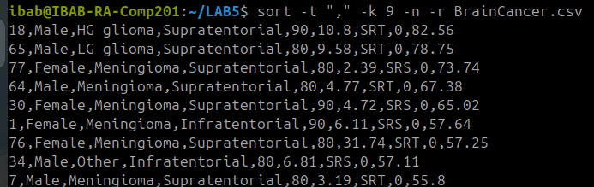

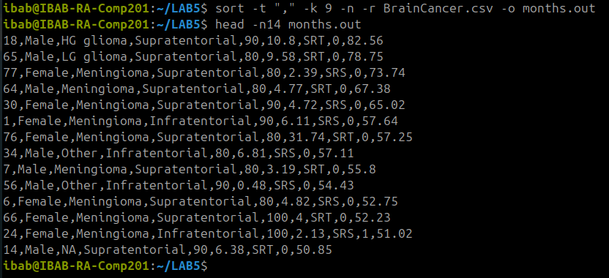

(7) List the patients who have HG glioma and have survival times more than 50 months. How many are there?
Ans)
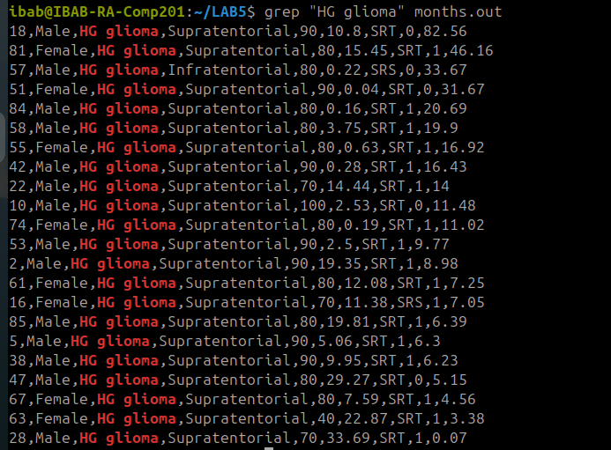

In order to get patients with HG glioma we used the command:
- grep “HG glioma” months.out
As we get the list, we will count the patients with survival time more than 50 months.
- There was only one patient with HG glioma and survival time more than 50 months.

(8) List the patients who have LG glioma with location supratentorial and survial times less than 30 months. How many are there?
Ans)
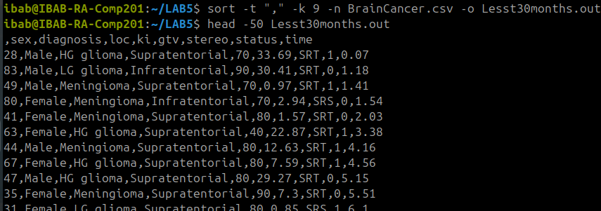
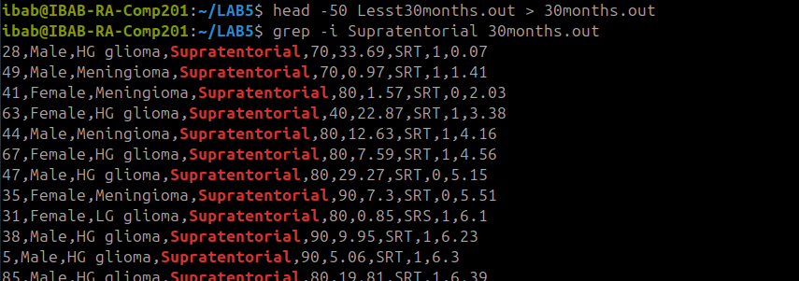

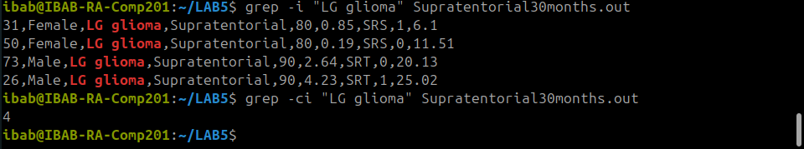

(9) By default does grep ignore or not ignore case? Demonstrate this by using the appropriate option and by running the grep command without this option.
Ans) By default grep does not ignore case but it does perform case sensitive searches.

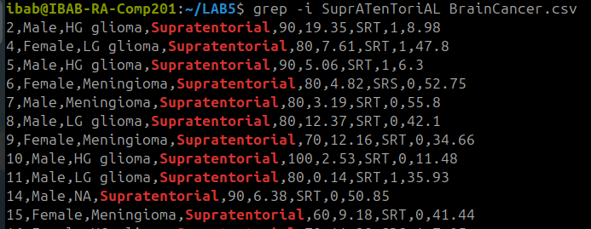
(10) List the patients who are dead at the end of the study. How many are there? Find
another way to listing this set of patients (look up grep man pages to look for a specific option to select non-matching lines)
Ans) In order to see the number of patients dead at the end of the study, as we know that 0=alive and 1=dead, we use the command
- grep “,1,” BrainCancer.csv
This will list all the patients that are dead at the end of the study

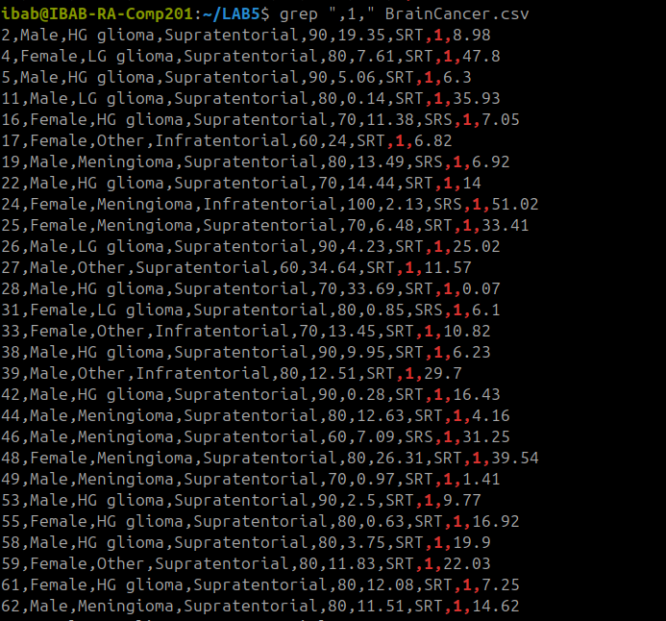
In order to get the number of the dead patients by the end of the study we will use the command:
- grep -c “,1,” BrainCancer.csv
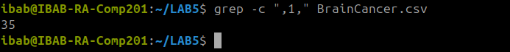
This will give us the number of dead patients i.e 35

(11) Let’s list the patients who have their cancer in infratentorial location. How many are there? How do I restrict the output to first ten patients?
Ans) In order to get the list of patients that have cancer in their infratentorial region we will use the command:
- grep “Infratentorial” BrainCancer.csv
This will list all the patients with cancer in infratentorial region.
To get the count of these patients we use the command:
- grep -c “Infratentorial” BrainCancer.csv
There were total 19 such patients
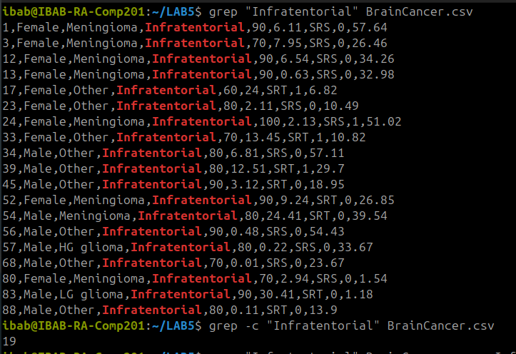
Now in order to restrict the output to first 10 patients we will first make a folder for the patients with cancer in infratentorial region, we will use the command:
- grep “Infratentorial” BrainCancer.csv > Infratentorialsorted.out
This command will make a separate folder, now in order to restrict the output to first 10 patients we’ll use the command:
- head -n10 Infratentorialsorted.out
We will get the list

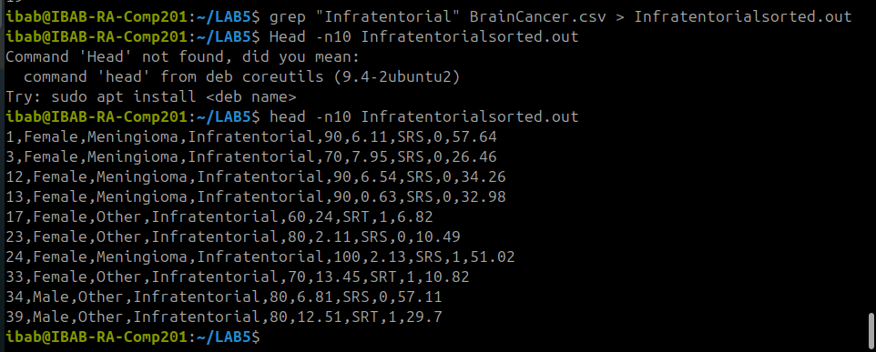

(12) Create an archive file by combining the outputs of questions 1-5.
Ans) In order to create an archive file by combining the outputs of question 1 to 5, first we have to create separate files for each output.
Then in order to create the output file we will give command:
- tar -cvf outputs.tar LinesWithMeningioma.out Maleesorted.out Femaleesorted.out Supratentorialsorted.out Infratentorialsorted.out Ki.out lowestki.out
This command creates an archive file of all the files created of outputs of 1-5.

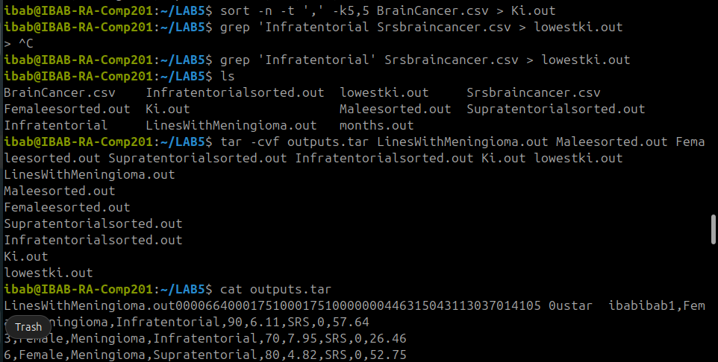
(13) Create a zipped and archived file by combining the outputs of questions 6-11.
Ans)

