LAB 7
INSHIKA THAKUR
255HSBD012

(1) The apropos command allows you to search the system’s manual pages for commands
that match a specific task or keyword. This is particularly useful when you need to find
a command that performs a specific task but you don’t know the name of the command.
Try the following and display the output in your lab document.
(i) apropos "search for files"
Ans)

(ii) apropos "list directory contents". Another way to get the same output is apropos "^list.*directory" (note the use of wildcards here). The ^ denotes that there is no other character before the word ‘list’ in the search.
Ans)
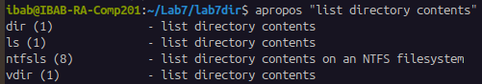
(iii) apropos "file compress"
Ans)
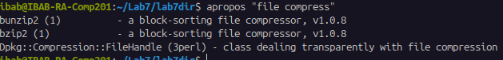
(iv) apropos "file.*copy$" (The $ denotes that there is no character to be searched
after the word ‘copy’.
Ans)
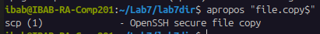

EXAMPLES FOR APROPOS COMMAND:
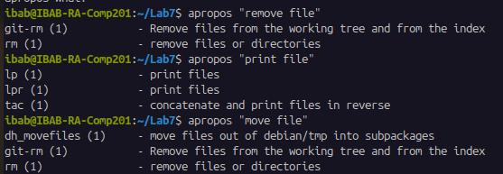

(2) File permisisons. Try the following exercises and explain the output in your work.
(i) touch newfile followed by ls a-l newfile. Describe the permissions set for the user, group and everyone else.
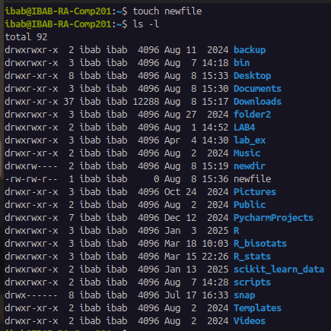
Ans)

First we will create a new file using the command touch newfile
Then we’ll give the command ls -al (shows all the files and hidden file) and this will be the output:
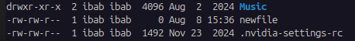

The permissions set for newfile are: -rw-rw-r--
User: rw (read/write)
Group: rw (read/write)
Others: r (read only)

(ii) Print the output of umask command. Explain what is the actual level of default permission based on this output for a file, and for a directory
Ans)
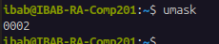

The output for umask command is 0002
The full permission for
Files: 666
Hence, 666-002=664 (rw-rw-r--)
Directories: 777
Hence, 777-002=775 (rwxr-rwxr-rx)

(iii) Create a new file in your Lab7 directory and print and explain the current permissions for the file. Write down the octal values for the user, group and everyone else.
Ans)
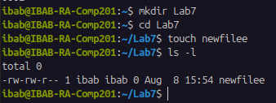

Current permissions for newfilee are: -rw-rw-r--
User: rw (read/write)
Group: rw (read/write)
Others: r (read only)

Octal value:
User: rw- : read(4)+write(2)+no execute(0)=6
Group: rw- :read(4)+write(2)+no execute(0)=6
Others: r-- :read(4)+no write(0)+no execute(0)=4
Therefore, the octal value will be 664

(iv) Create a new directory in your Lab7 directory and print and and explain the current permissions for the file. Write down the octal values for the user, group and everyone else.
Ans)

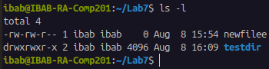

Current permission for testdir:
User: rwx(read/write/execute)
Group: rwx(read/write/execute)
Others:r-x(read and execute only)

Octal Value:
User: rwx : read(4)+write(2)+execute(1)=7
Group: rwx : read(4)+write(2)+execute(1)=7
Others: r-x: read(4)+no write(0)+execute(1)=5 Therefore, the octal value will be 775
(v) Copy the new file from above to the new directory and list the permissions of the file inside the directory. Is it the same as the file outside the directory? What does this tell you about the copying action?
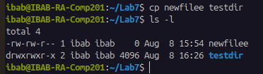
Ans)

The permission remains same (664), as the command cp will create a copy, but the copied file has the same permission as the original.
(vi) Change the permissions of the directory such that it is only readable and writable and executable by the user and the group, and only readable by everyone else. What happens to the permissions of the file inside the directory? Does it inherit the new permission you just set? What are the new octal values for the directory permissions?
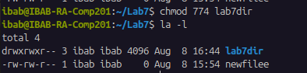
Ans)

In order to change the permission such that it is readable and writable by user and the group and only readable by everyone else, the code for it is 774
user (read+write+executable=7)
group (read+write+executable=7)
everyone else(only read=4)
Hence we will use the command chmod 774 testdir
OUTPUT: drwxrwxr--

(vii) Move the above-created new file to the new directory under a different name. Does
the moving action change the file permissions?
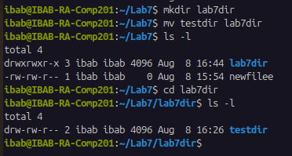
Ans)

So, here firstly we created a new directory using the command: mkdir lab7dir
Then we will move the above-created new file (testdir) by using the command:
mv testdir lab7dir
Then we will go to the new directory lab7dir by using the command : cd lab7dir
Then we will list the files by using the command ls -l
Output: Shows that the permission has not been changed even after moving the file to a new directory.

