LAB 4
INSHIKA THAKUR

1) Symbolic and hard links:
- If we use the same name for the links it fails to create symbolic link as the file already exists.
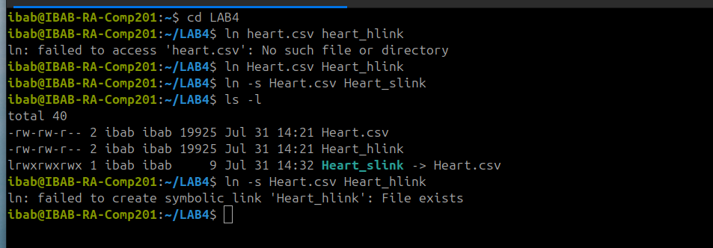

2) To determine the filetype of the downloaded data file:
- file Heart.csv


3) To View the contents of the data file using more and less and the number of pages:

a) more:
- more Heart.csv
- Number of pages is the amount of times we click on the spacebar
- Number of pages= 7
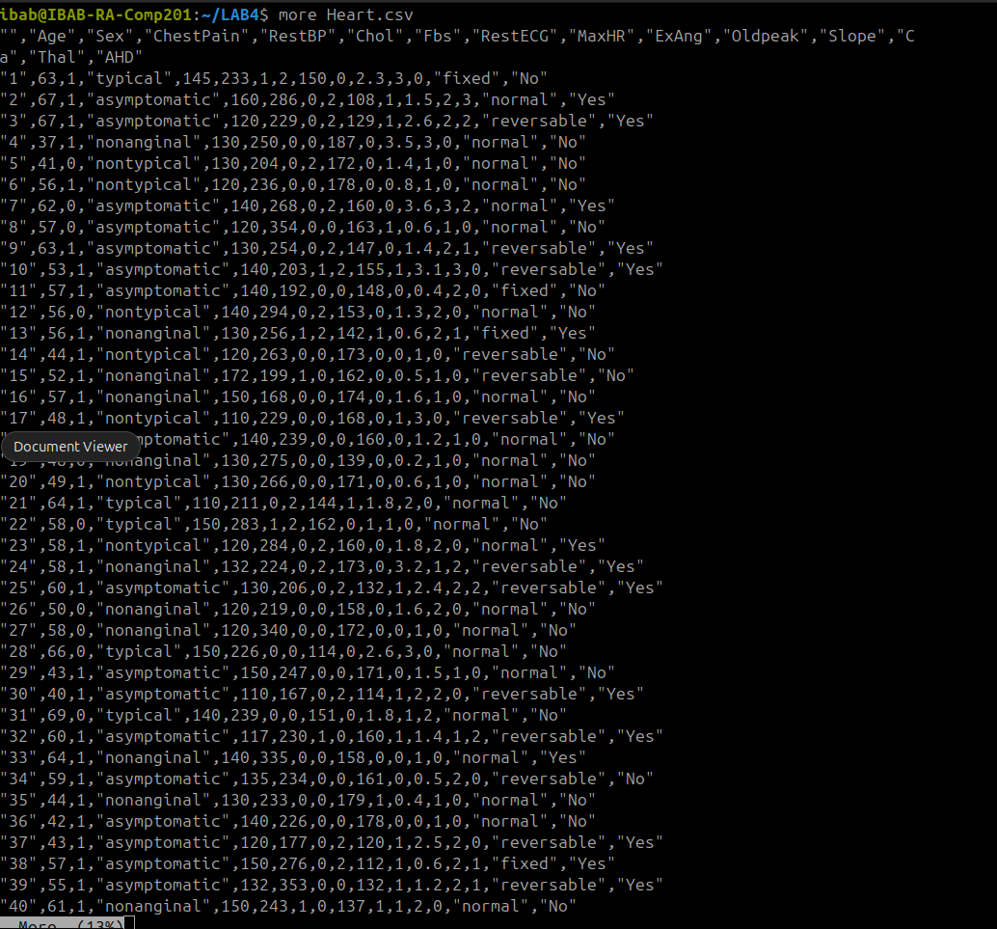

b) less command:
- less Heart.csv
- Number of pages = 7
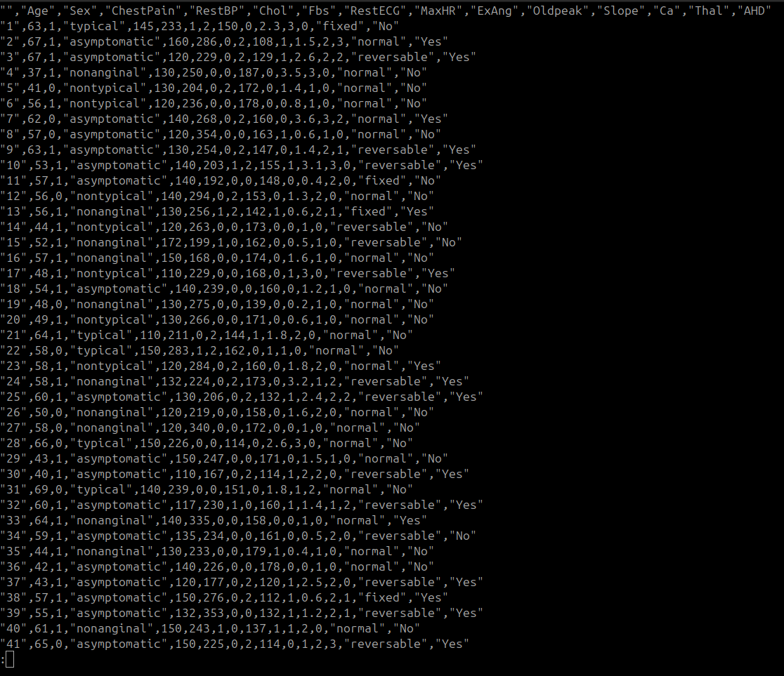

4) First 35 lines of the data file using the command
- head -n 35 Heart.csv
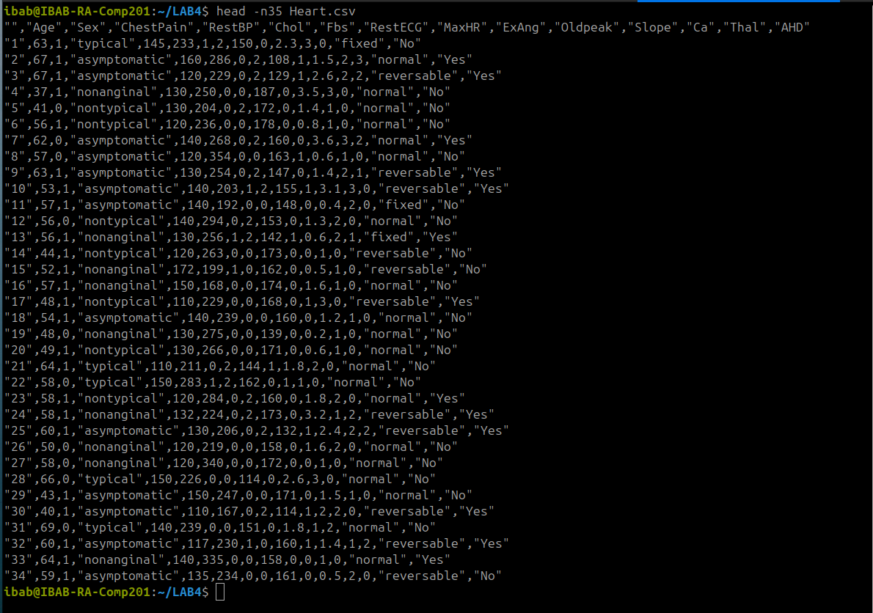

5) Last 15 lines using the command:
- tail -n 15 Heart.csv

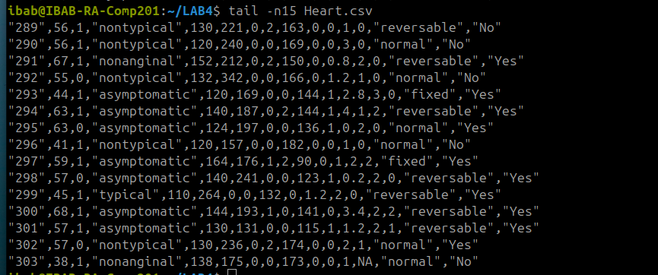

6) Used the history command to view the last few commands and then there was the process ID for each command using which the second last command in the list was executed. The command used:
- history
Once the history was listed the process ID for second last command is noted and then give the command:
- !1988
this command executes the second last command with the help of process ID
For executing the second last command using first letter of command note down the first alphabet of the second last command and then use the command:
- !t
this command executes the command with that first alphabet. In this case it executed the tail command.
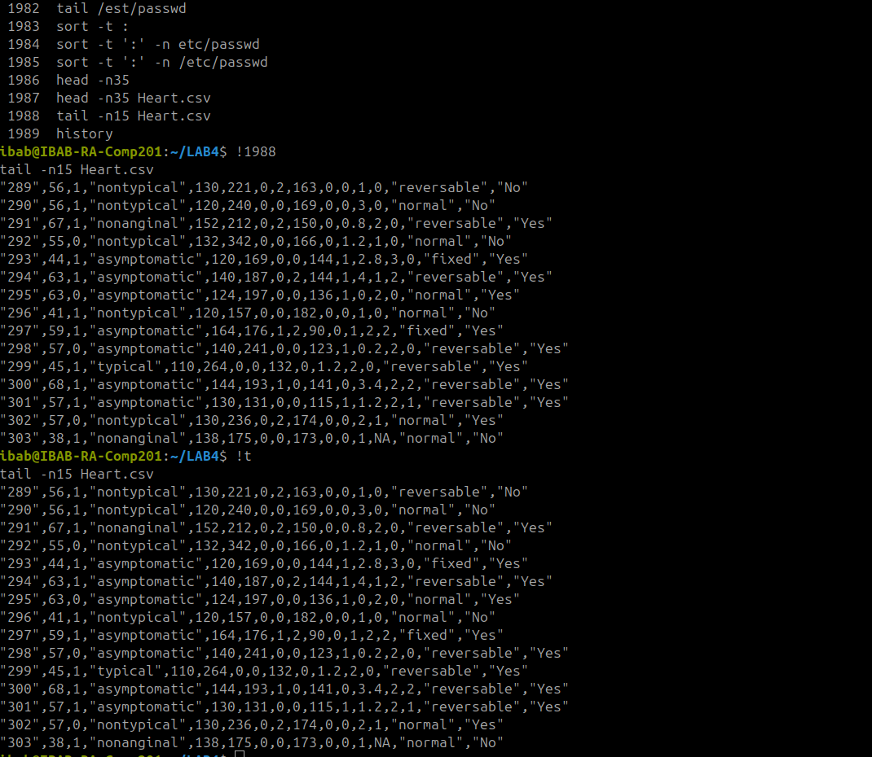

7)
i) To sort the data according to the first column we can use the command:
- sort -t ‘,’ -k 1 -n Heart.csv > col1_sorted.out
And to check if the data is sorted out use the command:
- sort -c col1_sorted.out
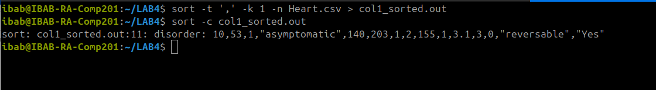

ii)To sort the data according to the age column we can use the command:
- sort -t ‘,’ -k 2 -n Heart.csv > age_sorted.out
And to check if the data is sorted out use the command:
- sort -c age_sorted.out


iii)To sort the data in reverse manner according to the RestBP column use the command:
- sort -t ‘,’ -k 5 -rn Heart.csv > restbp_revsort.out
To check if the data is sorted out use the command:
- sort -c restbp_revsort.out

iv) To repeat (ii) and (iii) by giving GNU style parameters to sort the command:
- sort --field-separator=’,’ --key=1 –numeric-sort Heart.csv > col1_sorted_gnu.out
- sort -c col1_sorted_gnu.out
- sort --field-separator=’,’ --key=2 --numeric-sort --reverse Heart.csv > age_sorted_gnu.out

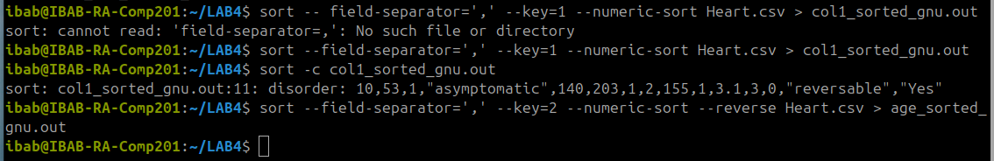

v) To sort the data according to age and then according to restBP use the command:
- sort -t ‘,’ -k 2 in -k 5 -n Heart.csv > age_restbp_sort.out
And to check if the data has been sorted according to age and then restbp use the command:
- sort -c age_restbp_sort.out
In this we have used multiple -k and -n operation in the same command to sort data as per multiple columns

vi) To sort the data according to sex, then as per age and then as per ChestPain we use the command:
- sort -t ‘,’ -k 3 -n -k 2 -n -k 4 -n Heart.csv_sex_age_chpain_sort.out
And to check if the data has been sorted out use command:
- sort -c sex-age_chpain_sort.out

