Inshika Thakur
255hsbd012
Lab 8

EXERCISES Start a fresh terminal for this Lab and make a new directory called ’Lab8’. Copy the ‘Braincancer.csv’ file to this directory. At the end of the lab, rename the data file as ‘Braincancer Lab8.csv’

(1) Open the data file using the VIM editor.

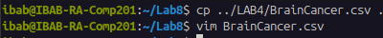
The file BrainCancer is copied to the new directory Lab8 by giving command:
- cp ../LAB8/BrainCancer.csv .
Then we open the file using the vim editor by giving the command:
- vim BrainCancer.csv

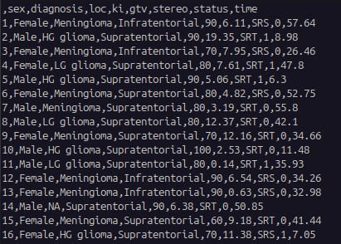
(2) Move to the beginning of the file and insert the text: ”VIM challenge begins!” on a new line at the very top.

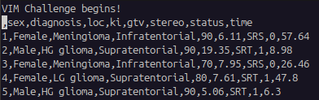
In order to move to the beginning of the file, give command:
- gg
Then to insert the text we need to enter the insert mode by giving command:
- i
And then we can enter our text.
To exit the insert mode we can use the ‘Esc’ key

(3) Find the word ‘Meningioma’ and replace it with ‘LG glioma’

In order to find the word ‘Meningioma’ and replacing it with ‘LG glioma’ we need to give command:
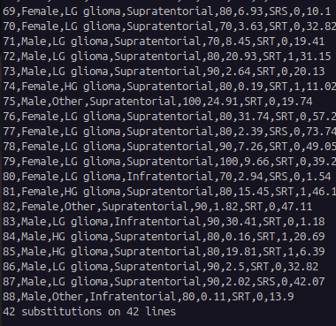
- :%s /Meningioma/LG Glioma/g

(4) Delete the entire line containing the time column entry ‘34.66’
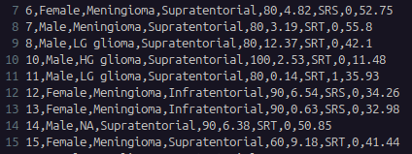
In order to delete the entire line that has the time column entry “34.66” we will first visually search for 34.66 and then in order to delete that line we will give the command:
- :10d
As the entry was on 10th line.

(5) Copy the current line and paste it two lines below. Show the screenshot before and after pasting with file line numbers to prove that you did it correctly.

BEFORE:
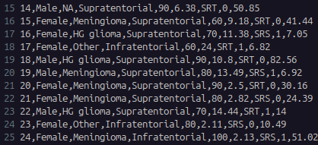

To copy the current line i.e 15 we will give the command:
- yy
And to paste it we will use the key ‘p’

AFTER:
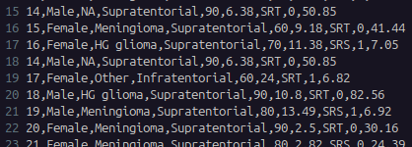
(6) Move to the 11th line of this file and insert ”Hello from line 11!”

In order to insert the line “Hello from line 11!” we need to get into insert mode by “i” key
And then type the sentence that we want to insert.

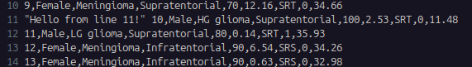
(7) Search for the word ‘SRT’ and replace it with ‘SRS’ (all occurences in the file)

In order to search the word ‘SRT’ we will give the command:
- /SRS

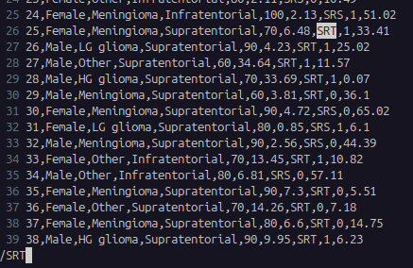
Then, in order to replace it wth ‘SRS’ we will give the command:
- :s/SRT/SRS
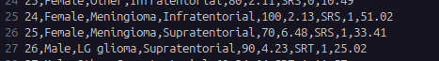

The ‘SRT’ has been replaced by ‘SRS’

(8) Yank the first 3 lines of the file and paste them at the bottom

In order to yank the first 3 lines we will give the command:
- 3yy
Make sure that your cursor is on the first line.
Now in order to copy the 3 copied lines at the bottom we first go to the bottom of the page by using command:
- shift+g
Now in order to paste it use the key ‘p’
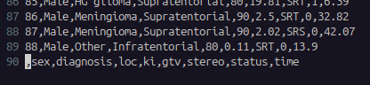
(9) Visually select this entire instructions list and indent it by two spaces.

First we need to enter the visual mode by using the command:
- ctrl + v
Then you will enter the visual mode.
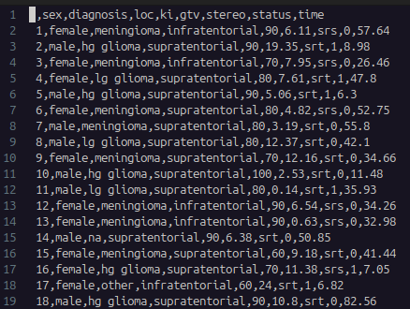
We then selected the first character and pressed Shift+g and then y, which will copy the entire first character column. After that we will take our cursor to the top and paste it using the key ‘p’. Then we will have a space and we will again enter visual mode and copy the empty space and paste it again which will indent it by two spaces.

(10) Go to the 50th line number, and insert the following text: “ The cat sat on the mat. Another cat was watching. The cat did not move.” Replace all occurences of the word “cat” with ”tiger”.

In order to insert the text we will first take the cursor to 50th line and enter the insert mode with the help “i” key and then type the sentence that we want to insert.
Now in order to replace the cat with tiger we will use the command:
- :%s /cat/tiger/g
This will replace the word cat with tiger.

(11) Insert the text “This is an important reminder for you.” at 70th line number. Then change the word ‘important’ to ‘critical’. Describe the sequence of keystrokes used in full.

In order to insert the sentence we will first enter the insert mode, our cursor before entering the insert mode must be at the 70th line. Then we can type the sentence that we wanted to insert. Once the sentence is inserted we can exit the insert mode with the help of ‘esc’ key.

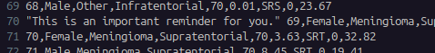

Now in order to replace the word “important” with “critical” we will give the command:
- :%s /important/critical
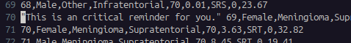

(12) Note down the current line number, jump to the end of the file and jump back to this line without scrolling through every line. Describe the sequence of keystrokes used in full.

Current number line: 18
In order to jump to the end of the file we will give the command:
- shift+g
And then to jump back to line 18 without scrolling we will give the command:
- :18
This will take us to line 18 again without scrolling.

(13) Add the following sentence at the end of the file: ”The quick brown fox (who was very quick) jumps over the lazy dog.” Delete the text inside the parentheses (including the parentheses) in the following text. Describe the sequence of keystrokes used in full.
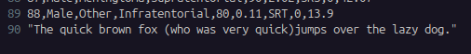
In order to go to the end of the file we will use the command shift+g. We will enter the insert mode in order to add the sentence and then type it. Then we will exit the insert mode by using the “esc” key.

Now in order to delete the text inside the parantheses we will first enter the visual mode by ctrl+v and then by taking the cursor to the “(“ and then press ctrl+v, then by using the moving key we will select the sentence that we want to delete i.e till the “)” . Once it has been selected we will press “x” and then “esc” to exit the visual mode.
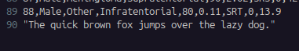

(14) Go to the last line of the file and append: ”– end of challenge”

In order to go to the end of the line we used shift+g and then entered insert mode by using key “a” and then inserted the line that we wanted to.
And exit the insert mode by using the “esc” key.

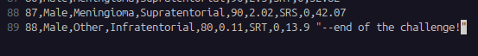
(15) In the remaining exercises, we are going to use Vim’s search, replace, visual modes and text objects. Open the file vim_cleanup_exercises.txt and do the following. Describe
the sequence of keystrokes fully for each problem.

(i) Fix spacing issues in the text in the lines 1-3.
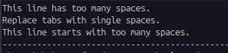

We fixed the spacing issues in lines 1-3 by pressing “x” wherever there is extra space.

(ii) Fix any capitalization and typographical errors in lines 5-8.

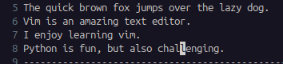

In order to fix the capitalization and typographical errors we entered insert mode using the key “I” and then we edited the changes that were meant to be made.

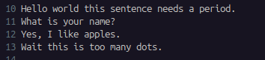
(iii) Correct punctuation errors in lines 10-13.

To correct the punctuation we will first enter insert mode and edit it.

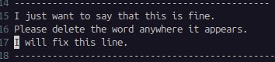
(iv) Remove unwanted words in lines 15-17.
We took the cursor to the first alphabet of the word that we wanted to delete and then entered the visual mode using the “v” key and then selected the sentence till which we want to delete it and then pressed the key “d” to delete it.

(v) Fix alignment issues in lines 19-22
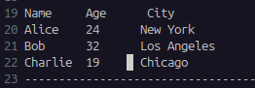

We will enter insert mode in this case as well to fix the alignment issues.

