LAB 6
INSHIKA THAKUR
255SHSBD012

(1) The echo command can be used simply to display a piece of text (useful in programs). Use echo to create a sentence. Pipe the output of this command to count the number of words in the sentence. How do I use the wc to count the number of lines in this sentence?
Ans)
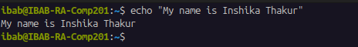

So first we used echo to create a sentence using the command :
- echo “My name is Inshika Thakur”

Now we need to pipe the output of this command I.e ‘My name is Inshika Thakur’ to count the number of words in the sentence:
- echo “My name is Inshika Thakur” | wc -l

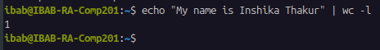

The output is 1, which is the number of lines.

(2) Execute the following command, and explain the meaning of the output. This concerns
the appearance of the command prompt, and you should be able to dissect the output
completely and explain it part by part. Make a list of the parts of the output and write
your explanations against each part. The command is cat .bashrc | grep ’PS1’
Ans)
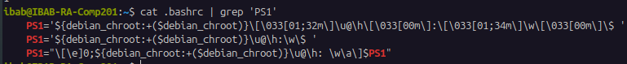
debian_chroot : This variable is used to show the current environment in the prompt.
[\033[01;32m\] : specifies the colour code
\u@\h\[\033[00m]:\[\033[01;34m\]\w\: it is the code for normal BASH prompt

(3) In the above exercise, filter the output based on ’HIST’ pattern. You will see a list
of environment variables. Figure out what they stand for and what the current values
mean.
Ans) HISTCONTROL: This controls how commands are saved to the history list.
HISTFILESIZE:This is the maximum number of lines that the history file can contain.
HISTSIZE: This is the number of commands to remember in the command history for the current shell session.

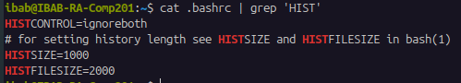

(4) The whereis command searches for a program in a predefined set of standard binary directories such as /bin, /usr/bin and /usr/sbin. Type whereis ls and study the output. What is the difference between which and whereis commands?
Ans)
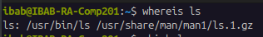

When the command whereis ls was given the output was
ls: /usr/bin/ls /usr/share/man/man1/ls.1.gz
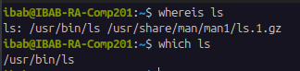

The whereis command shows all the locations that are related to the command (ls in this case). It shows the entire pathway where the command is or could be present.
AND the which command shows the exact path of the command (ls) that runs when you execute the command.

(5) The command dirname is used to retrieve the directory name in a given file path. Nav-
igate to a previous lab folder such as Lab4 and list the files. Then type the command dirname <filename> where give some existing filename in this command. What is the output?
Ans)
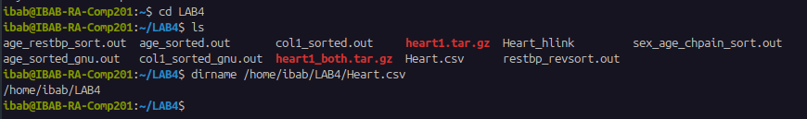
(6) Create a local variable called mylabdir, and set it to the following value: /home/ibab/Lab6
(which means that if you have not created a Lab6 folder you should do so). Print the
value of this variable using the echo command, and then the dirname command output
with a file you are working with, under the Lab6 directory.
Ans)
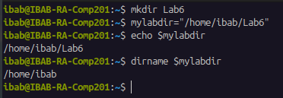

(7) Create a new bash subshell in this terminal. Prove that you have created a subshell using the ps command with the appropriate options. Inside this subshell print the value of the variable mylabdir. What is the value? If it is empty, how do you convert it to a global variable? Do the conversion and show that mylabdir is indeed a global variable.
Ans)
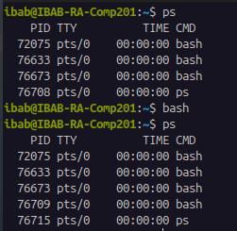

So first we give the command:
- ps
which gives us the table of bash subshells present in the terminal
In order to create a new bash subshell in this terminal we use the command:
- bash
And in order to prove that the bash subshell is created we will again give the command ps and in the output it can be seen that the number of bash in this output is more than previous output.
Now in order to print the value of the variable mylabdir inside the subshell we use the command:
- echo $mylabdir

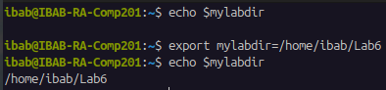

The output was empty so we will have to export it by using the command:
- export mylabdir=/homo/ibab/Lab6
And then to check the value again we will give command:
- echo $mylabdir
OUTPUT: /home/ibab/Lab6
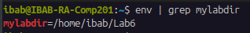

The command env | grep mylabdir shows that mylabdir is a global variable.

(8) Display the output of the command echo $PATH. Is PATH local or global variable? Describe two ways of finding this out.
Ans)
The PATH is a global variable.
The two ways of finding that out are
- 1) env | grep PATH
- 2) First we will enter into a new subshell by using the command
bash
And then we will give the command
echo $PATH again:
Since the path is also visible on the other subshell, which implies that the PATH is global
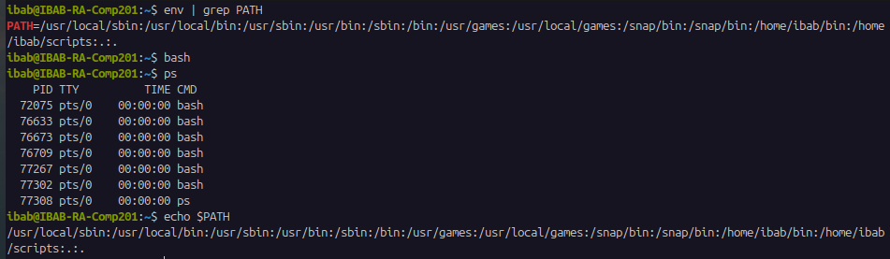
(9) The concept of a directory stack. Learning about this will allow you to know the powerful navigation mechanisms in Linux. The key commands in this exercise are dirs,cd -, pushd and popd. The directory stack operates like a stack of plates – the last plate on top is the first to be taken out. Try the following exercises to understand this.
(i) Execute dirs -v -l. What is the output? Learn more about the command and the options by looking up the man pages of what these options did. For each command below execute dirs -v -l to understand what happened to the directory stack.
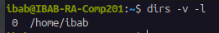

The output for the command:
- dirs -v -l
This command will list the directories that is present in the stack. -l is for long format and -v is for number.
(ii) By default the directory stack contains only one entry – the path to your $HOME. Let’s add some entries to this stack using the following commands:
(a) pushd /var/log
(b) pushd /tmp
(c) pushd /etc
(d) pushd ~/Downloads
(e) pushd ~/Documents
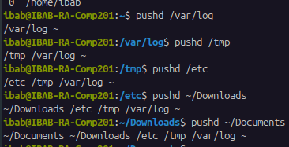

The pushd will stack the directory and changes the current directory.
(iii) Now execute dirs -v -l again. Explain the output.
Ans)
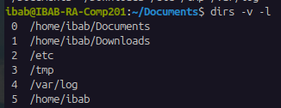

The output on using the command dirs -v -l is different from what we got in the previous question when the same command was used. The output has numbered stack with the recent directories (that we stacked using the pushd command)

(iv) Execute the command pushd +1. Explain what happened.
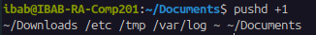
Ans)

The command that we executed (pushd +1) rearranged the stack. So it puts the directory in the first position instead to the 0 position

(v) Execute cd -. What happened?
Ans)
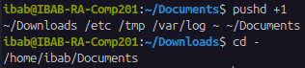

When the command cd – was executed it switches to the previous directory that we were in. So in this case we went from Documents to Downloads directory.
(vi) Execute cd /tmp. What happened? In this case, note that we simply changed directory to an entry in the directory stack without reference to the stack in any way.
Ans)
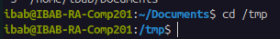

The cd /tmp is taking us to the /tmp folder in the system.
(vii) Execute popd. What happened? popd is responsible for removing the topmost “plate” in the stack and changes to the directory entry against index 1.
Ans)
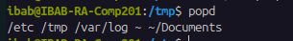

The popd command removed the top most directory from the stack, in this case it removed the Downloads directory as it can be seen in the (v) answer and that directory has now been removed in this output.

(viii) Execute popd +2. What happened? How is this different from pushd +2?
Ans)
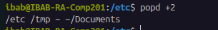

By executing the popd +2 command we have simply removed the directory at index 2 and leaving the rest as it is. SO it can be seen in the output that /var/log directory has been removed.
The difference between pushd +2 and popd +2:
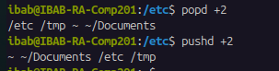

The popd +2 is removing the directory at index 2 but is not changing the current directory whereas the pushd +2 command is changing the directory, it is changing the directory at index 2 to the current directory.
(ix) In all the above, what was happening the entry that was indexed against ’0’? Explain what this entry represents.
Ans) The entry at index 0 represents the current working directory. When pushd was used it added a new directory and changes out current directory, and in this case index 0 was the new location. And when popd was used it removed the top directory and the location of other directory was at index 0.

