Basic SQL INJECTION
SELECT
INSERT
UPDATE
DELETE
DROP TABLE
Task SQL Injection💉 (Intro)
Look at the example table. Try to retrieve the department of the employee Bob Franco. Note that you have been granted full administrator privileges in this assignment and can access all data without authentication.
Employees Table
userid | first_name | last_name | department | salary | auth_tan
32147 | Paulina | Travers | Accounting | $46.000 | P45JSI
89762 | Tobi | Barnett | Development | $77.000 | TA9LL1
96134 | Bob | Franco | Marketing | $83.700 | LO9S2V
34477 | Abraham | Holman | Development | $50.000 | UU2ALK
37648 | John | Smith | Marketing | $64.350 | 3SL99A

In this task we are gonna talk with the server or which is called SQL. we are gonna use the the info we have and make a sql command and send to the website since we have full administrator privileges in this assignment, we can do this task easily. So, we said to the server select the department of the employee where first_name=’Bob’ and last_name=’Franco’
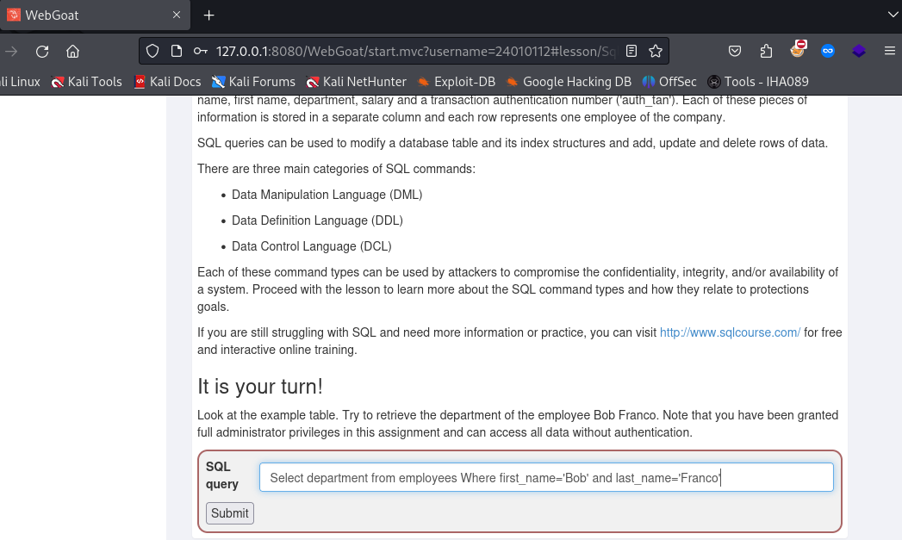

Result:
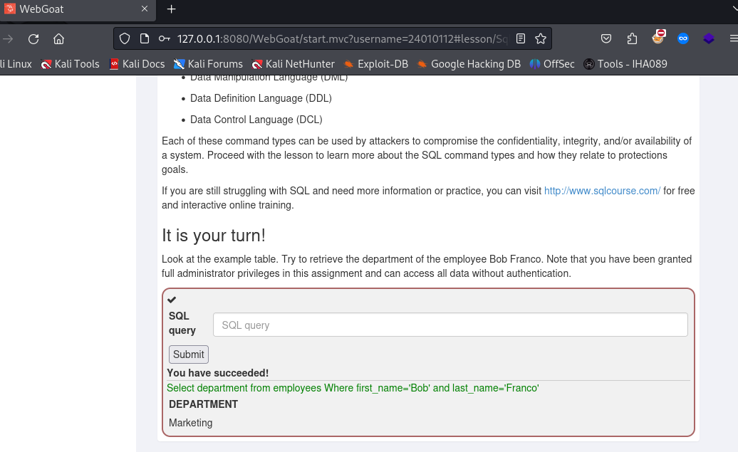

Data Manipulation Language (DML)

Try to change the department of Tobi Barnett to 'Sales'. Note that you have been granted full administrator privileges in this assignment and can access all data without authentication.
- DML commands are used for storing, retrieving, modifying, and deleting data.
- SELECT - retrieve data from a database.
- INSERT - insert data into a database.
- UPDATE - updates existing data within a database.
- DELETE - delete records from a database.
- Example:
  - Retrieve data:
  - SELECT phone
FROM employees
WHERE userid = 96134
  - This statement retrieves the phone number of the employee who has the user id 96134.
we are going to use the info we have and make a sql command and send to the website since we have full administrator privileges in this assignment, we can do this task easily. So, we said or gave command to the server UPDATE Employees SET department = 'Sales' WHERE first_name = 'Tobi'
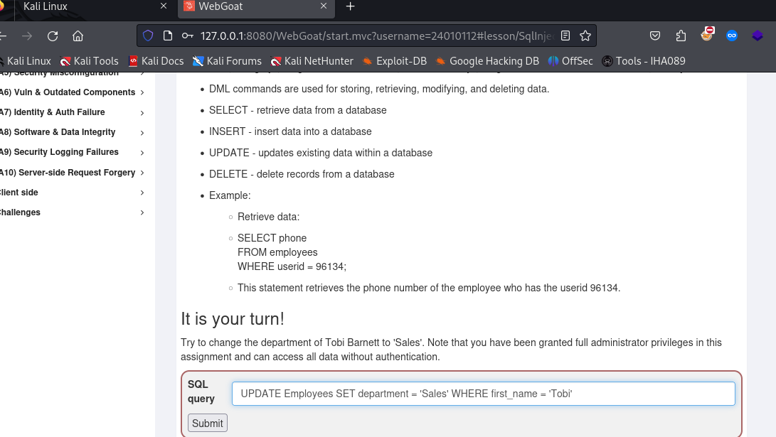
RESULT:
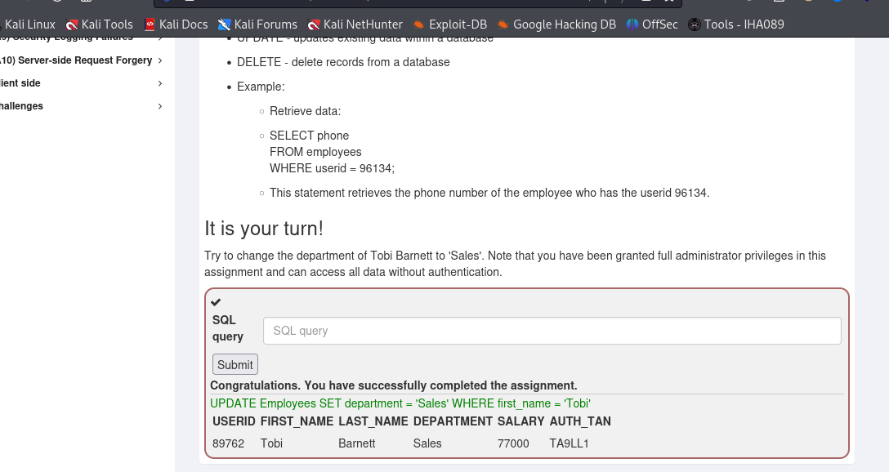

Data Definition Language (DDL)

SQL Injection (advanced)
Try It! Pulling data from other tables
SELECT : FROM user_data WHERE last_name = “; SELECT :FROM user_system_data;-

';SELECT * FROM user_system_data;--

Cross Site Scripting

lesson 2: solution
first go to developer webtool console tab to check cookies is protected or not type the following alert ("xss test");
alert (document. Cookie);
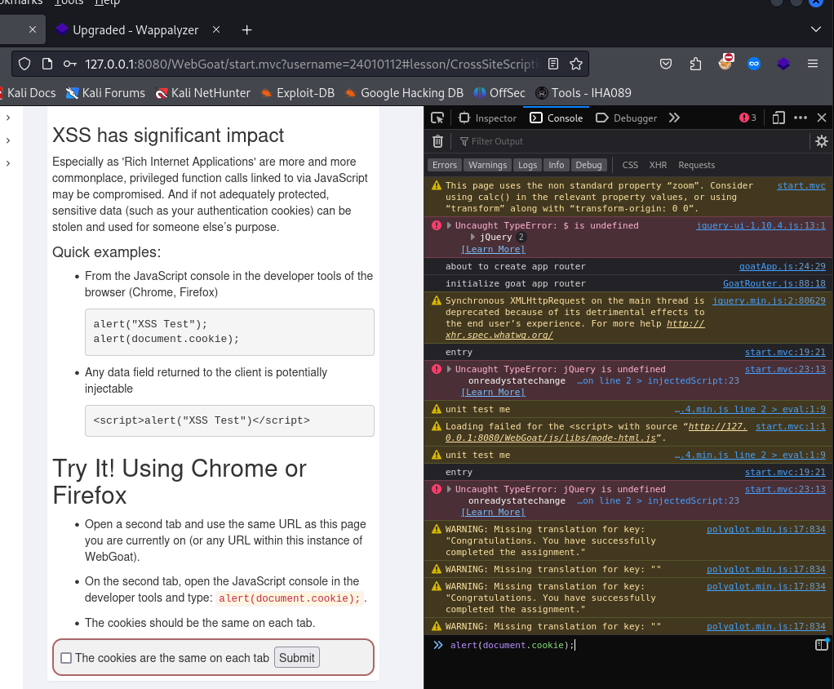
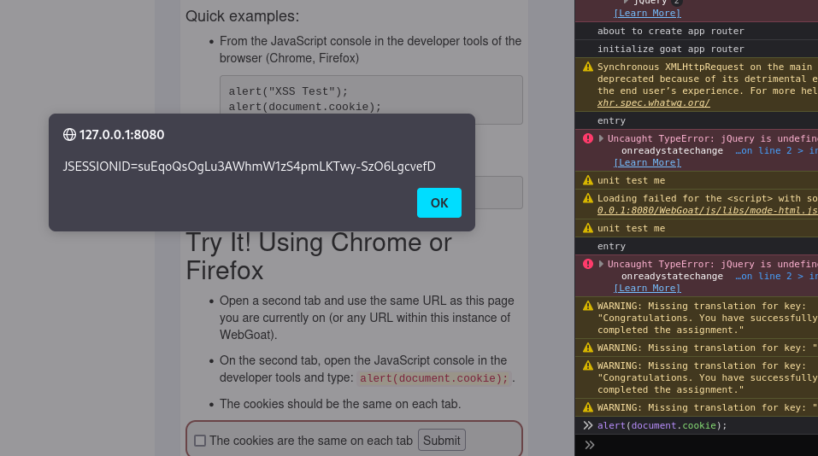
now in new tab get cookie value to find we get same value as cookie or not and if we got same value click the blank box and submit.
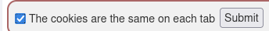

Try It! Reflected XSS
lesson 7 solution:
in this task we must find which input field is vulnerable for xss in enter your credit card number field input the following
<script>console.log()</script>
Or
<script>alert(Write anything)</script>
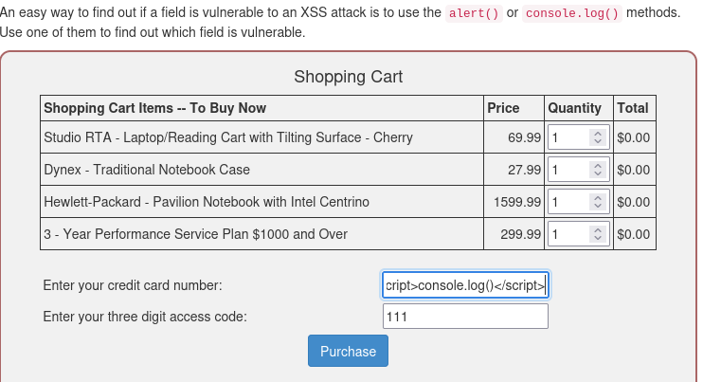
Result:
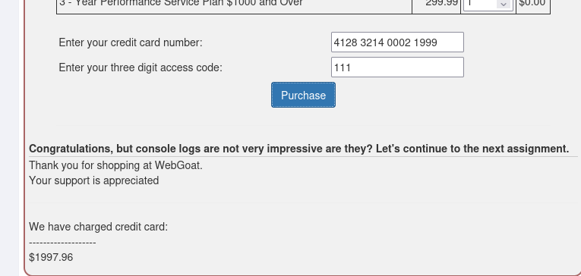
Identify potential for DOM-Based XSS
lesson 10 solution:
open developers’ tools in debugger, tab try to find Goat Router.js open it and search
for test route like following 'test/: param': 'test Route' submit the answer as
start.mvc#test/
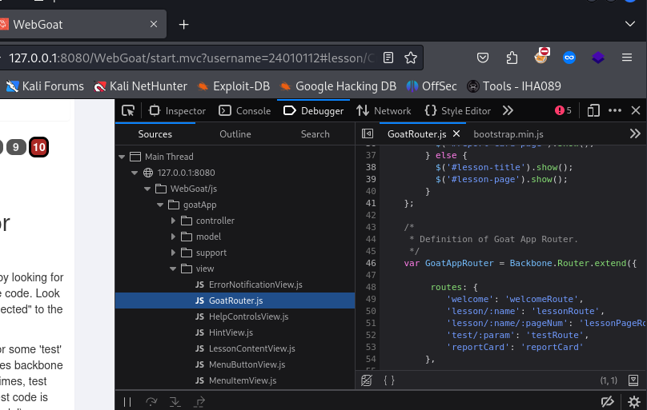
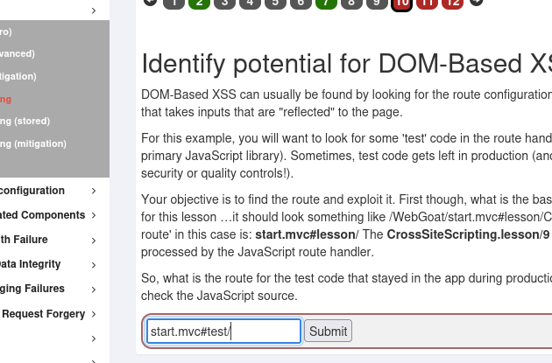
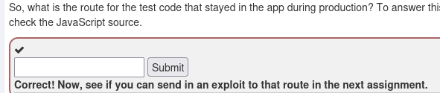

Try It! DOM-Based XSS

lesson 11 solution:
open a new tab navigate to location found in previous lesson as follows with developer tool in console tab.
webgoat.customjs.phoneHome()
Combine all info and we get this URL.
http://127.0.0.1:8080/WebGoat/start.mvc#test/<script>webgoat.customjs.phoneHome()<%2Fscript>
* we are accessing script from URL so we use URL encoding for / as %2F now in console tab generated random number copy the value and paste in answer field to clear the lesson Note [if the first code has – use it also or refresh the page for another code]
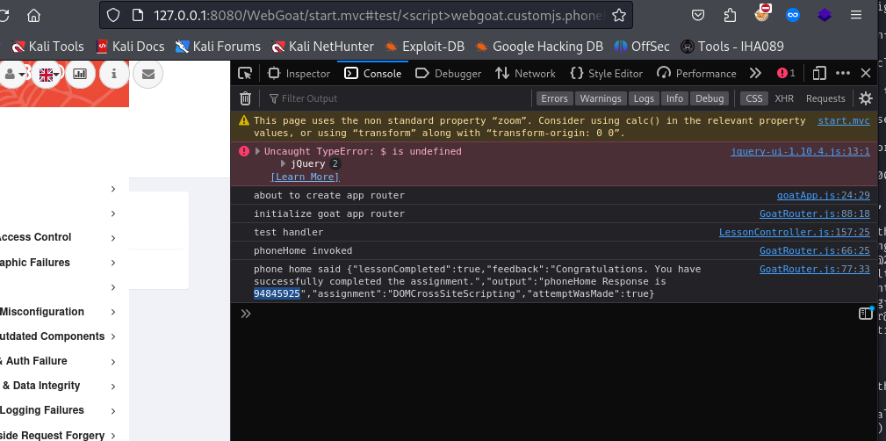
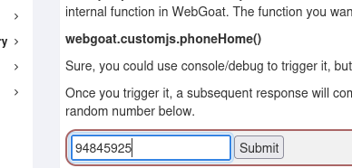
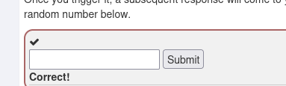

Cross Site Scripting (stored)
Lesson 3 Solution:
In this task must find a way to load your JavaScript dynamically to achieve the goal of extracting data fully. Add a comment with a JavaScript payload. Again …​ you want to call the webgoat.customjs.phoneHome function.
The JavaScript payload
<script>webgoat.customjs.phoneHome()</script>
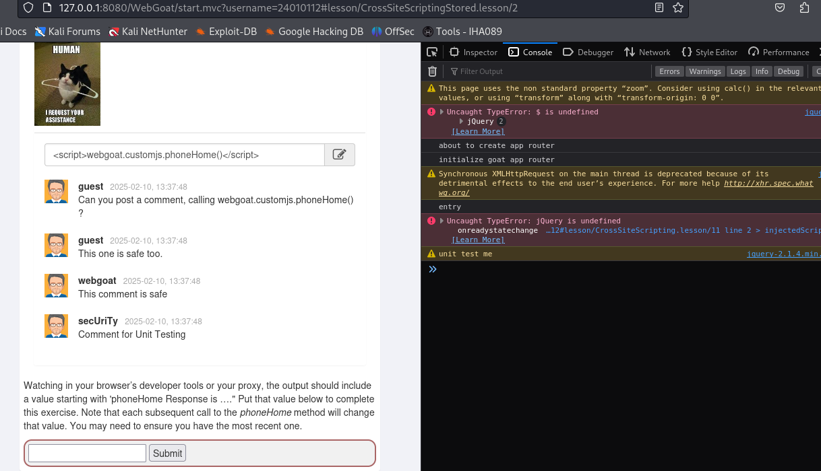
The Results:
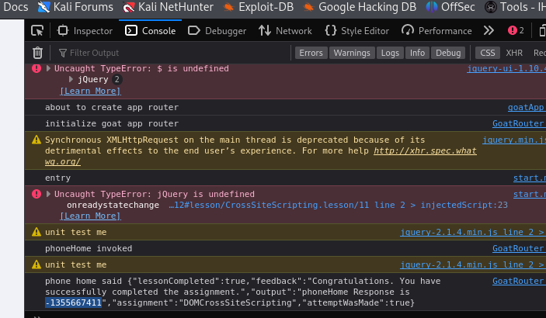
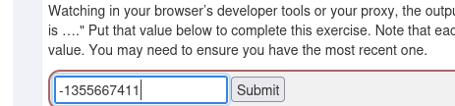
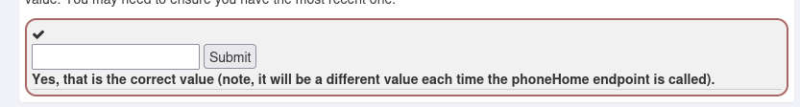

Cross Site Scripting (mitigation)

Reflective XSS
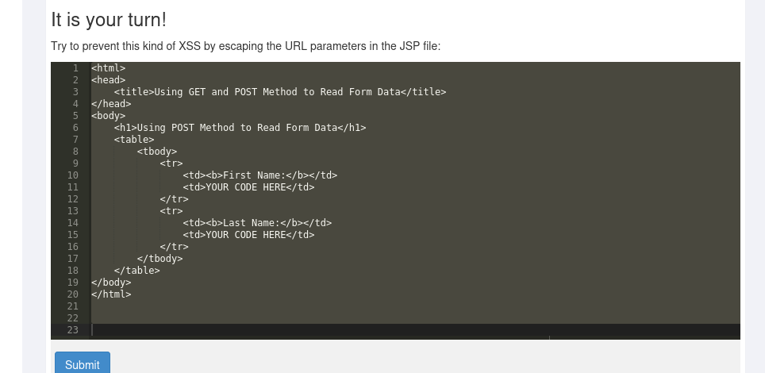
Lesson 5 Solution:
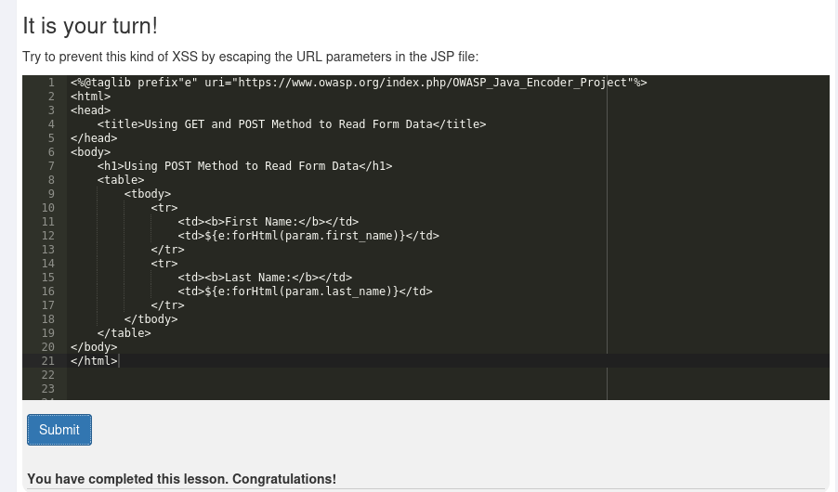
The code is a JSP (Java Server Pages) file that demonstrates how to use the OWASP Java Encoder to safely display form data in an HTML page.

Note: The url link is from lesson 4
<%@taglib prefix="e" uri="https://www.owasp.org/index.php/OWASP_Java_Encoder_Project" %>
- This line declares a tag library that allows the use of OWASP Java Encoder functions in the JSP file.
- The prefix="e" defines a prefix that will be used to reference the encoder functions.
- The uri attribute specifies the location of the tag library descriptor (TLD) for the OWASP Java Encoder.
The key part of this code is the use of the OWASP Java Encoder to prevent Cross-Site Scripting (XSS) attacks:
${e:forHtml(param.first_name)}
${e:forHtml(param.last_name)}
- param.first_name and param.last_name are the values submitted via a form.
- The ${e:forHtml(...)} function encodes these values to ensure they are safe to display in an HTML context.
- The forHtml method ensures that any special HTML characters (like <, >, &, etc.) in the input are converted to their corresponding HTML entities (e.g., &lt;, &gt;, &amp;), preventing malicious scripts from being executed.

Without proper encoding, an attacker could inject malicious scripts into the form fields. For example, if a user submits the following as their first name:
<script>alert('XSS')</script>
Without encoding, this script would be executed when the page is rendered, potentially stealing cookies or performing other malicious actions. However, with the OWASP Java Encoder, the input is converted to:
&lt;script&gt;alert(&#39;XSS&#39;)&lt;/script&gt;
This ensures that the browser interprets the input as plain text rather than executable code.

Stored XSS
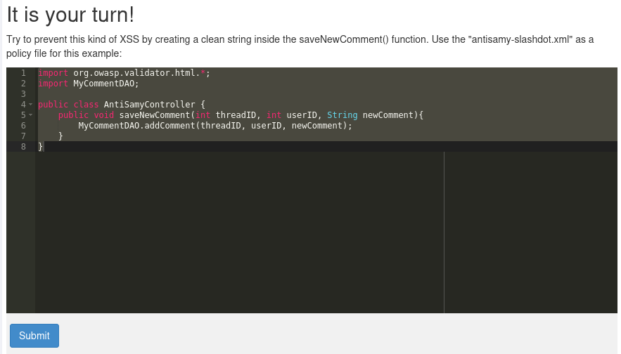Lesson 6 Solution:
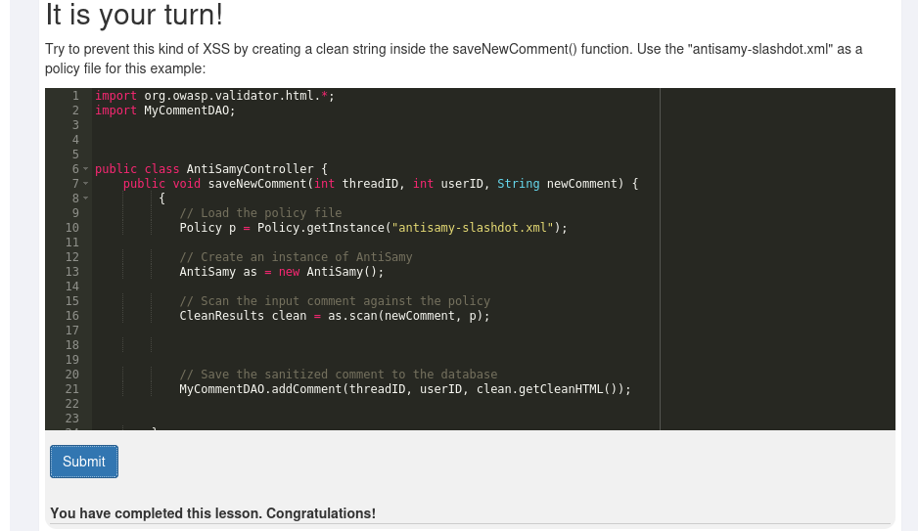
The code is a Java class named AntiSamyController that uses the OWASP AntiSamy library to sanitize user input before saving it to a database. This is a common practice to prevent Cross-Site Scripting (XSS) attacks by ensuring that any HTML content provided by users is cleaned according to a predefined policy.

Policy p = Policy.getInstance("antisamy-slashdot.xml");
- This line loads the policy file antisamy-slashdot.xml using the Policy.getInstance method.
- The policy file defines the rules for sanitizing HTML content. It specifies which HTML tags and attributes are allowed.
AntiSamy as = new AntiSamy();
- This creates an instance of the AntiSamy class, which is used to perform the sanitization.
- CleanResults clean = as.scan(newComment, p);
- This line scans the newComment string against the policy p.
- The scan method returns a CleanResults object, which contains the sanitized HTML content.

MyCommentDAO.addComment(threadID, userID, clean.getCleanHTML());
- This line retrieves the sanitized HTML content from the CleanResults object using clean.getCleanHTML().
- It then calls the addComment method of MyCommentDAO to save the sanitized comment to the database.

Path traversal

Path traversal while uploading files
access or store files and directories outside the application’s location. It may lead to reading files from other directories and overwriting critical system files in case of a file upload.
Lesson 2 Solution:
A image file has been uploaded to the following location outside the usual upload location.
So we are going to start encoding ../ before the request is sent to the server . if we URL encode ../ you will get %2e%2e%2f, and the webserver receiving this request will decode it again to ../
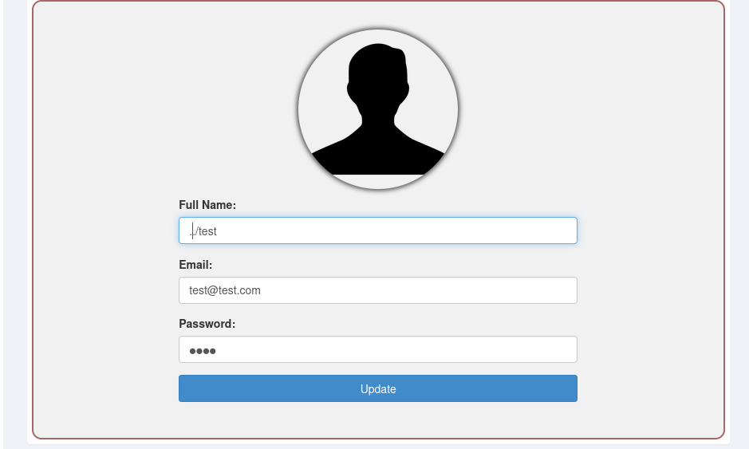
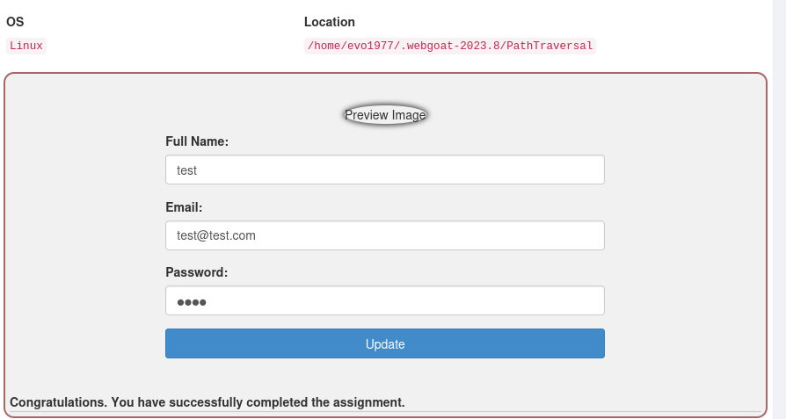

Path traversal while uploading files
The developer became aware of the vulnerability and implemented a fix that removed the ../ from the input. Again, the same assignment, but can you bypass the implemented fix?
Lesson 3 Solution:
A image file has been uploaded to the following location outside the usual upload location.
So we are going to start encoding ….// before the request is sent to the server . if we URL encode ….// you will get %2e%2e%2f%2e%2e%2f, and the webserver receiving this request will decode it again to ….//
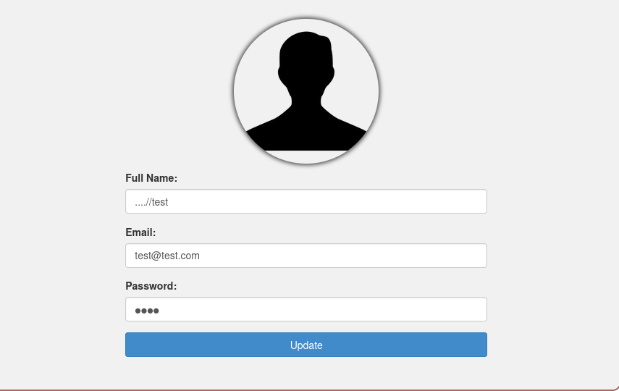
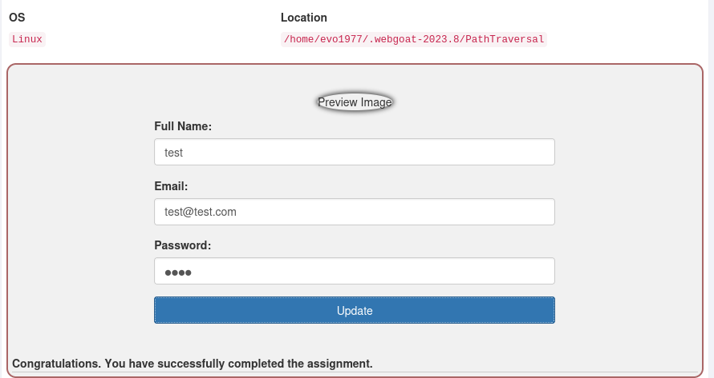
Path traversal while uploading files
The developer again became aware of the vulnerability by not validating the input of the full name input field. A fix was applied in an attempt to solve this vulnerability.
Again, the same assignment, but can you bypass the implemented fix?
Lesson 4 Solution:
* Note: This lesson is similar to the earlier one. Solution:
1. Start Burp Suite & make necessary changes in the proxy
2. Turn on the proxy in the Web Browser
3. Select the image of your choice and upload it on the given lesson
4. Go to the Burp Suite and forward the request Keep forwarding the request till you find → POST /WebGoat/PathTraversal/profile-upload-remove-user-input HTTP/1.1
5. Right click and send the request to the repeater
6. Click on the send button in the repeater tap and check the response
7. Scroll on the request tab and find "filename="test.jpg"
8. add ../ in front of (filename=". ./test.jpg") and send the request.
9. "feedback" : "Congratulations. You have successfully completed the assignment.",
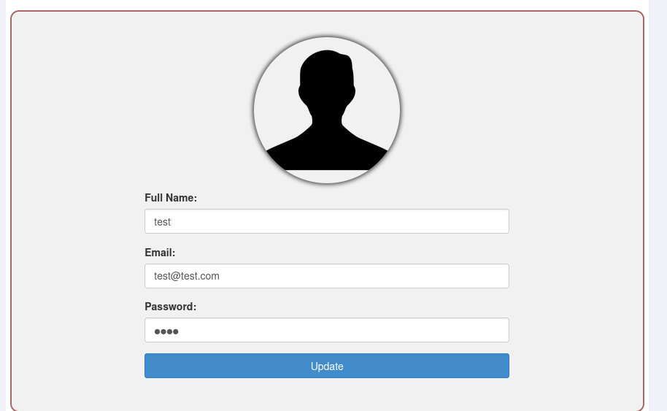
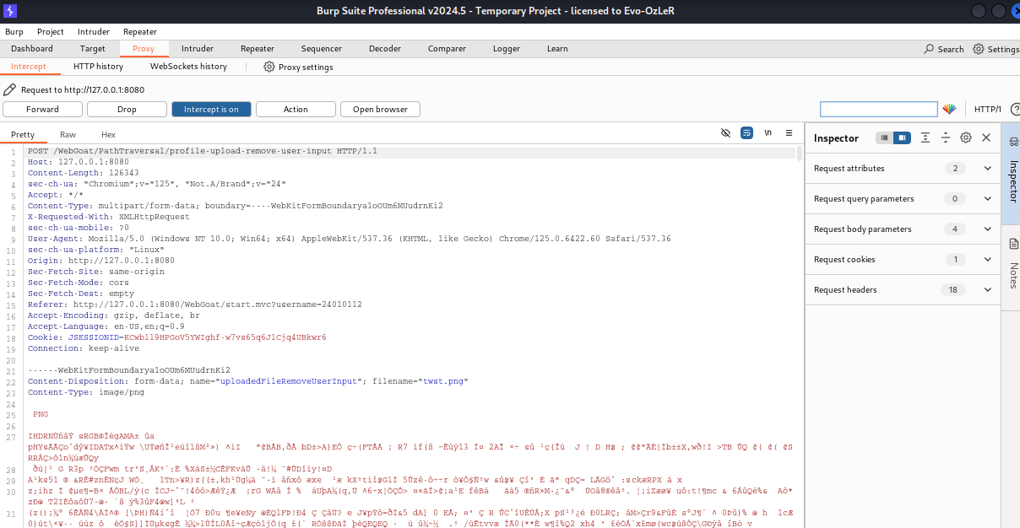
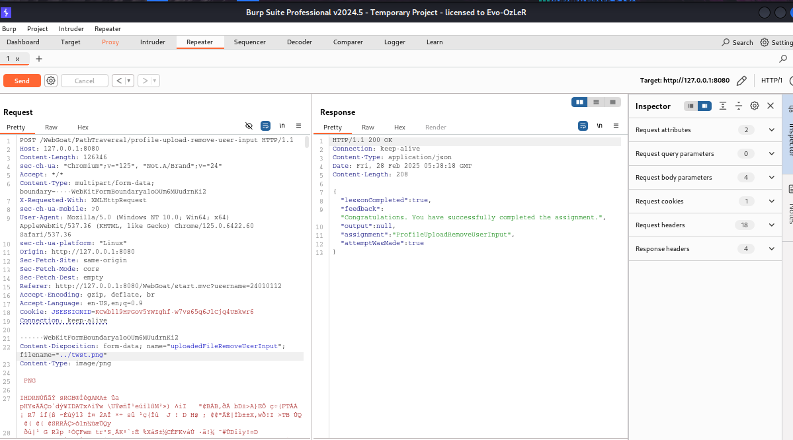

Retrieving other files with a path traversal
Lesson 5 Solution:
- Start Burp Suite & make necessary changes in the proxy and turn on the proxy in the Web Browser
2. Click on Show random cat picture button
3. Go to the Burp Suite and forward the request Keep forwarding the request till you find → GET /Web Goat/PathTraversal/random-picture HTTP/1.1
4. Right click and send the request to the repeater
5. Click on the send button in the repeater tap and check the response → Note the Location: /Path Traversal/random-picture?id=9.jpg
6. Go to the response tab and add ?id=../ in → e.g. GET/WebGoat/PathTraversal/random-picture?id=.. /) HTTP/1.1
→ Click on send
→ Response - Illegal characters are not allowed in the query params
→ Go back to Burp Suite
→ Decoder tab and encode .. / as URL value = %2e%2e%2f
→ Use the value %2e%2e%2f instead of ../ in repeater request tab and click on send
→ Note the details and try going one directory back .. / ../ i.e. %2e%2e%2f%2e%2e%2f and click on send
→ Use the id details as %2e%2e%2f%2e%2e%2fpath-traversal-secret and click on send
7. Note the response - You found it submit the SHA-512 hash of your username as answer
8. Open command prompt and type the command →
echo -n 'your username' | sha512sum
OR
just go to a SHA-512 converter website and convert your username which is used in webgoat
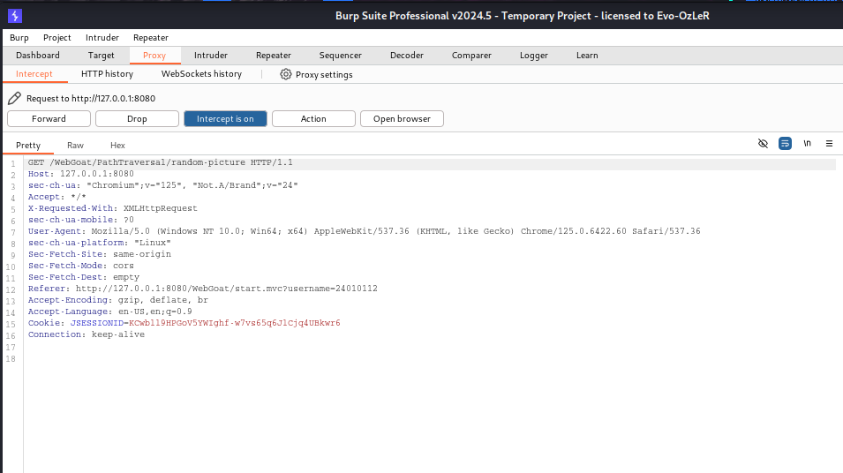
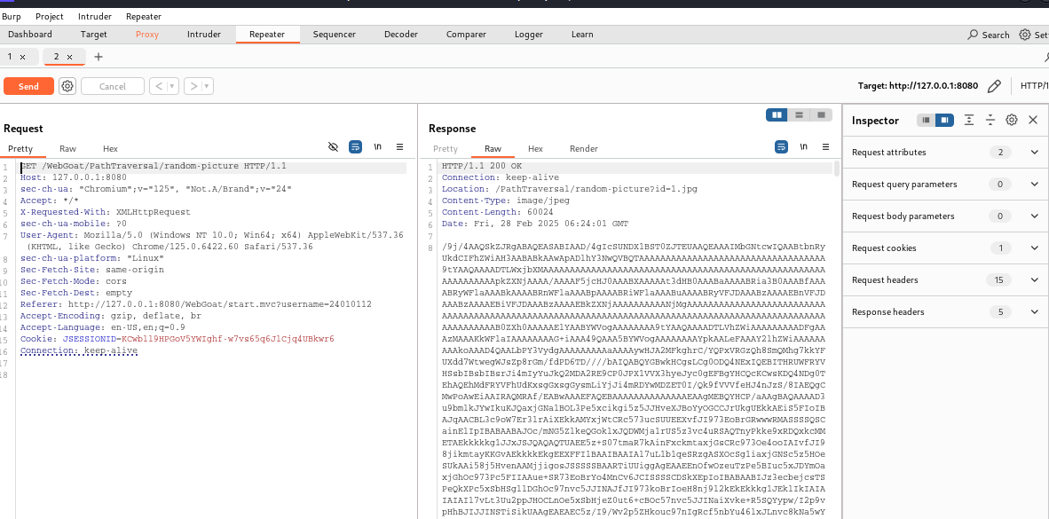
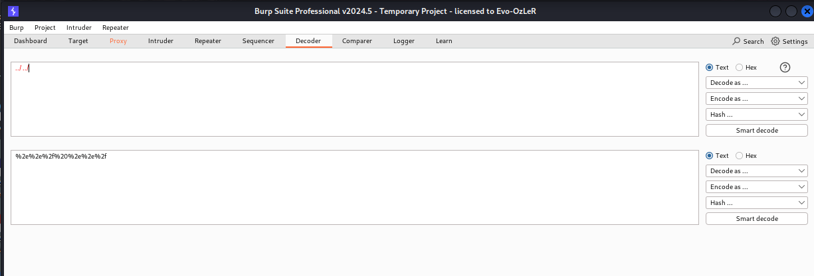
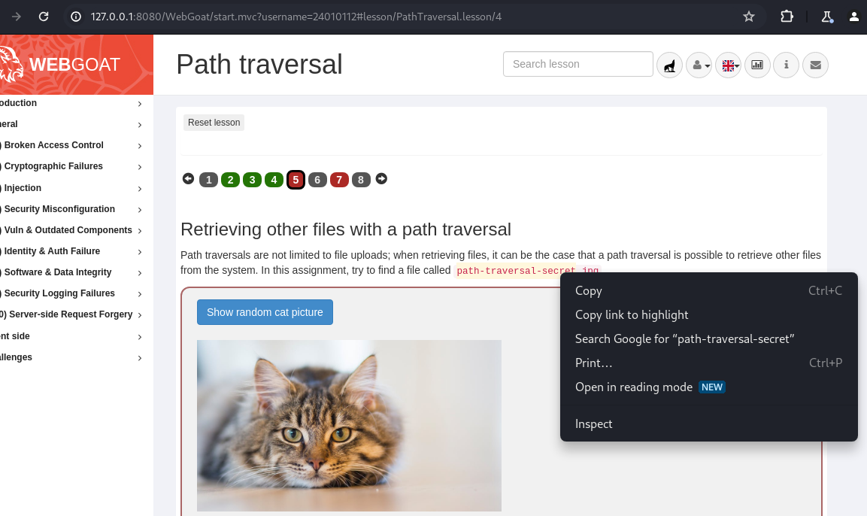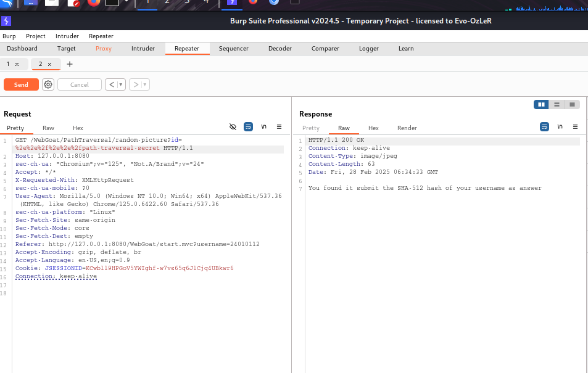
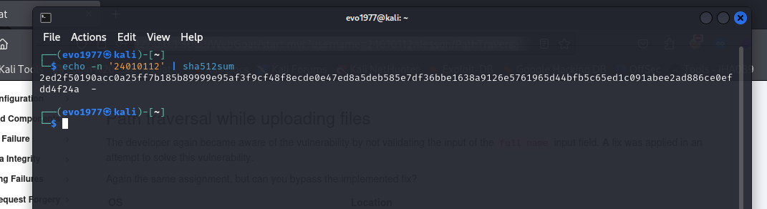
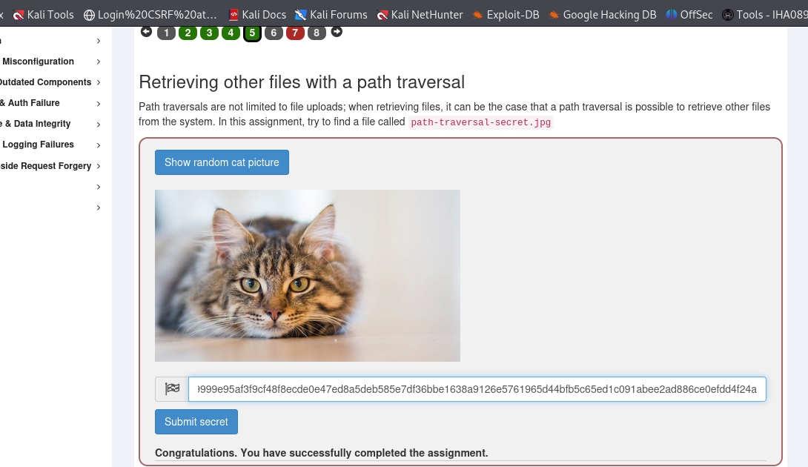
Zip Slip assignment
This time the developers only allow you to upload zip files. However, they made a programming mistake in uploading the zip file will extract it, but it will not replace your image. Can you find a way to overwrite your current image bypassing the programming mistake?
To make the assignment a bit easier below you will find the location of the profile image you need to replace: /home/evo1977/.webgoat-2023.8/PathTraversal/24010112/24010112.jpg
Lesson 7 Solution:
1.Let’s create a zip file that traverses to the top and then back into the given directory in the assignment.
First, create the directory structure:
- Go to lesson 8 use this commands
Note-( use root permission in terminal sudo su)
→ mkdir -p /home/evo1977/.webgoat-2023.8/PathTraversal/24010112

→ cd /home/evo1977/.webgoat-2023.8/PathTraversal/24010112

→ curl -o 24010112.jpg http://127.0.0.1:9090/WebWolf/images/wolf.png

→ zip profile.zip ../../../../../../../../home/evo1977/.webgoat-2023.8/PathTraversal/24010112/24010112.jpg
Move the profile.zip file to home or desktop
Use cmd → mv profile.zip /home/evo1977/Downloads
4. Now, if we upload this zip file, it solves the assignment.
