期末考试题
一共4part 8页 空白的位置少,写紧凑点 没有答题纸，可以在旁边打草稿
15个选择题，30分 （一个选择题2分）
- 2. 3. 前面的PPT
- 后面PPT
- 难（不做）
- 难 细致 估计是从哪个犄角旮旯出的题（可以放弃）
- 简单 中间
- 中（考试题）偏后
- 和前面
- 上课重点
- 弱智
- 上课例题
- 上课例题
- 偏后
- 偏后
简答题 2个 25分 9、16分 （有名词解释）
- 3小问 9分 ： Critical Path
- 2小问 16分：
PPT1-6，上了一门.........课，这门课讲了什么
Five group progress and ten knowledge area
47 processes ITTO

3个大题：12 13 8 33分
- Time management
- 3. Cost management

项目管理计划 12分
Assignment 2中3basline包含什么 11子计划，包含什么，要解释一下

疑似题目
plan risk management P35可能是选择
Quality P13 选择题
Procurement management P25
（Chapter 10 Stakeholder Management P16 选择）
Communication Management P29

WPF分解的最小层级：工作包 ， 活动？
work package is the work defined at the lowest level of the WBS
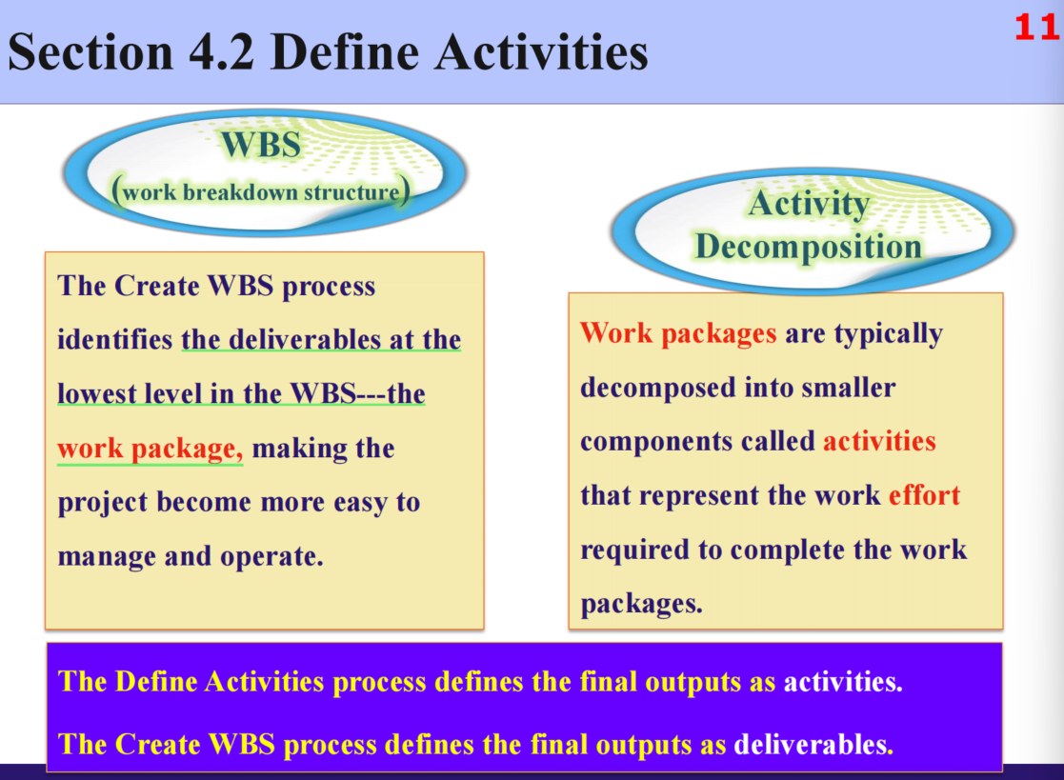

Project Management Plan 12分
3 baseline 11子计划，要解释一下，包含什么
Baseline
- Scope baselines
定义：is the approved version of a scope statement, WBS, and its associated WBS dictionary, that can be changed only through formal change control procedures and is used as a basis for comparison.
具体工作：1. Project scope statement
2. WBS
3. WBS dictionary
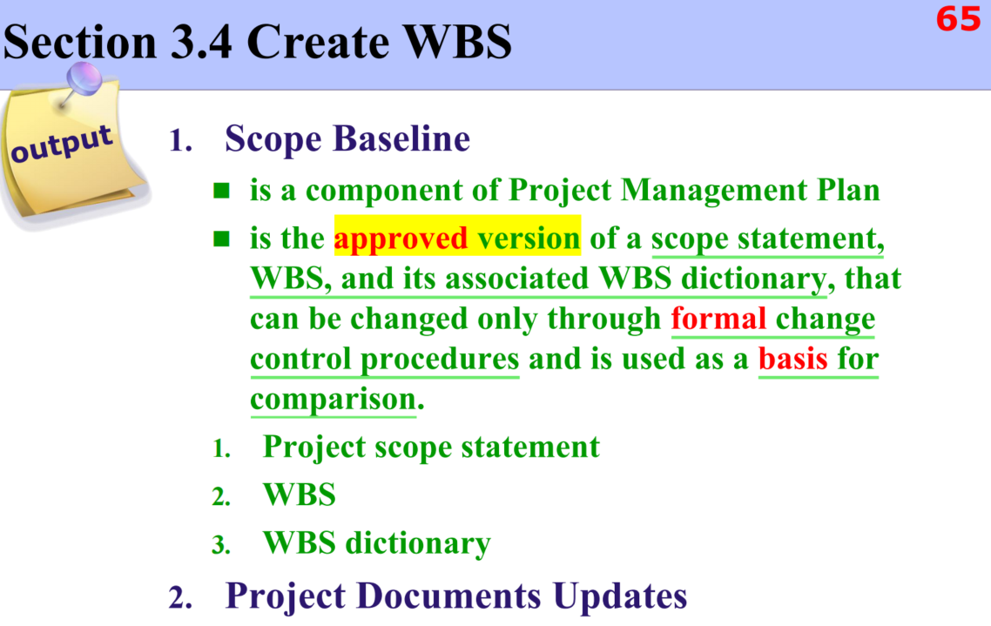
- Schedule baselines
定义：A schedule baseline is the approved version of a schedule model that can be changed only through formal change control procedures and is used as a basis for comparison to actual results
具体工作：Bar charts, Milestone charts, Project schedule network diagrams
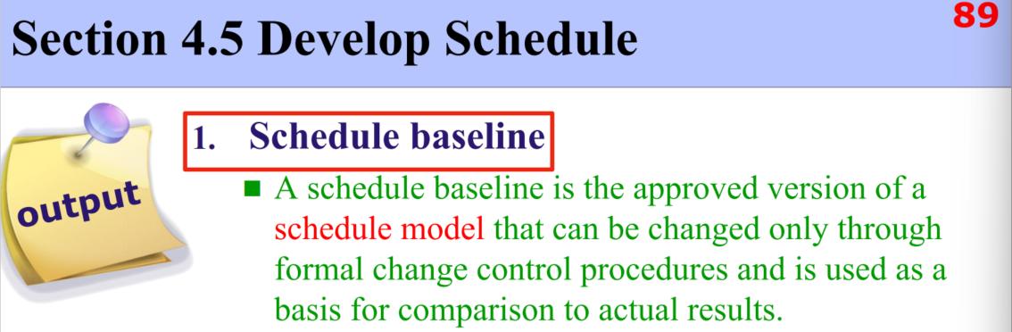

- Cost baselines
定义：The cost baseline is the approved version of the time-phased project budget, excluding any management reserves, which can only be changed through formal change control procedures and is used as a basis for comparison to actual results.
具体工作：time- phased view of the cost baseline （S-curve）
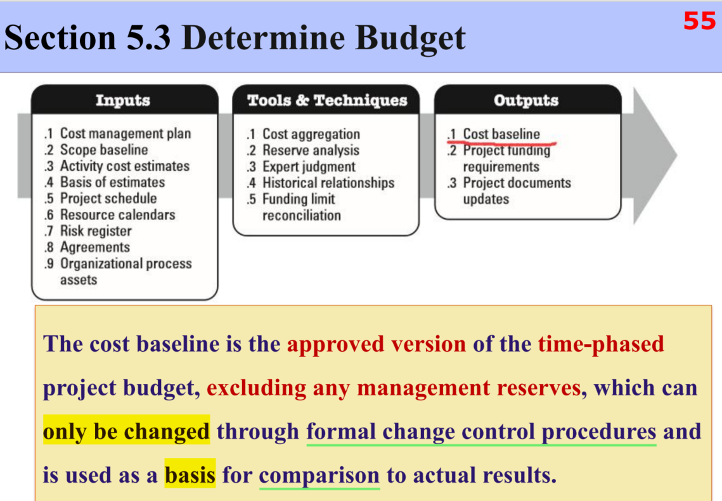
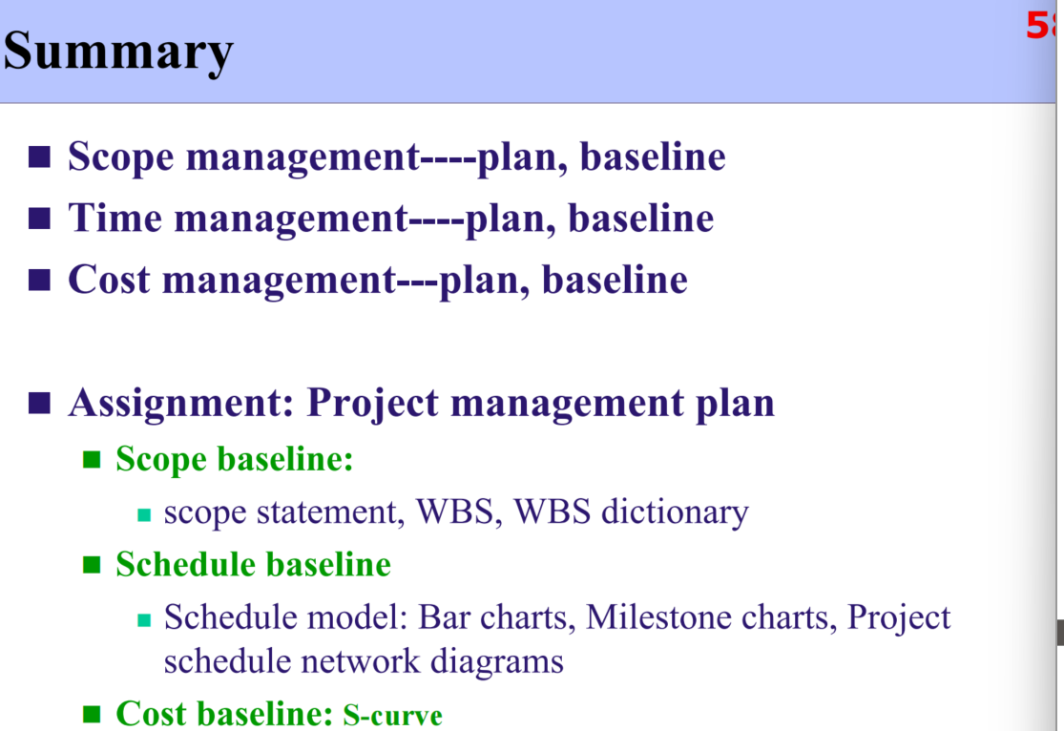
Subsidiary plans
- Scope management plan
定义： describes how the scope will be defined, developed, monitored, controlled, and validated.
具体工作：Process for preparing a project scope statement.
Process that enables the creation of the WBS（Work Breakdown Structure）
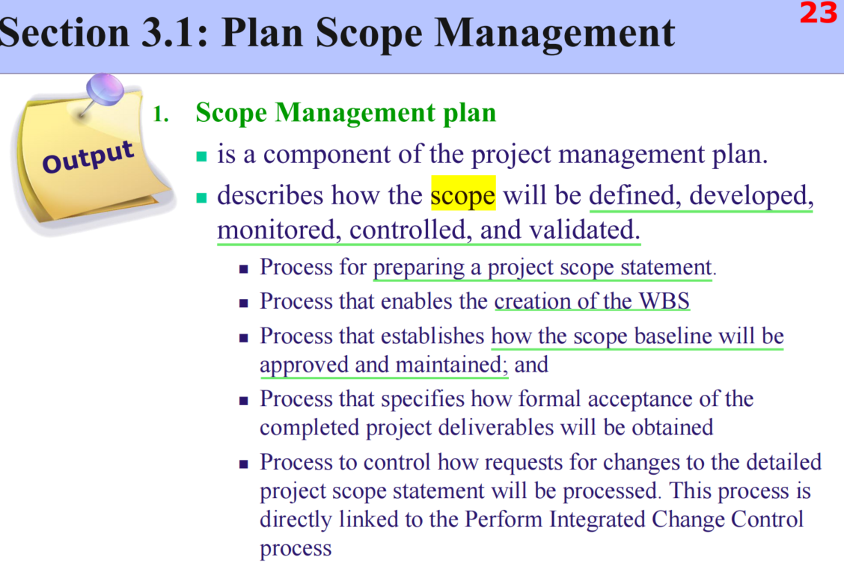
- Requirements management plan
定义：describes how requirements will be analyzed, documented, and managed.
具体工作：Requirements prioritization process;
Product metrics that will be used and the rationale for using them;
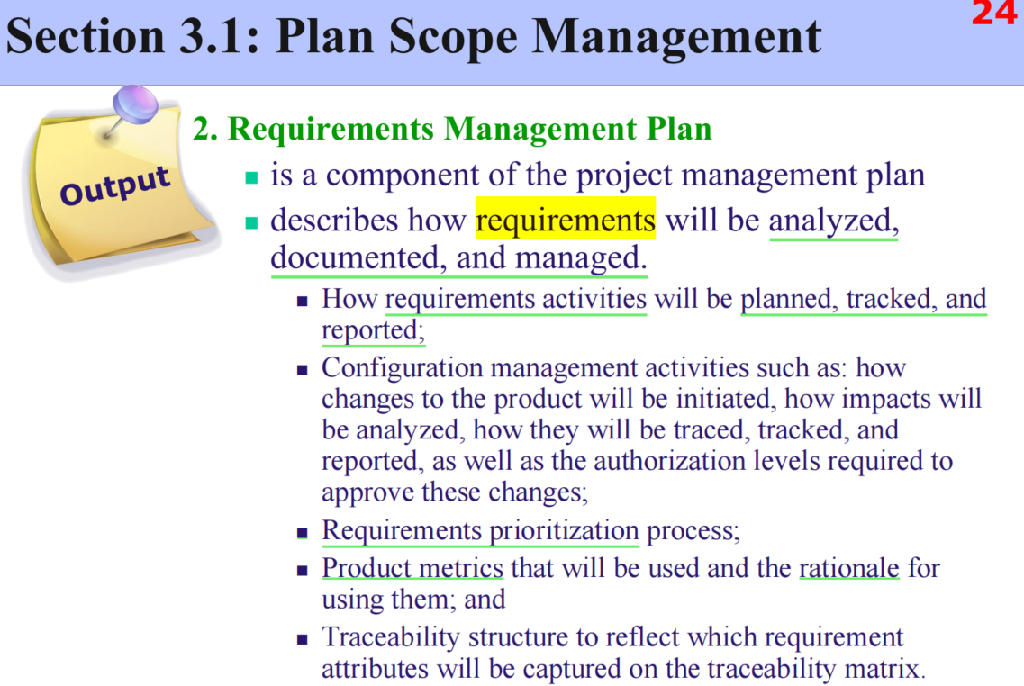
- Schedule management plan
定义：establishes the criteria and the activities for developing, monitoring, and controlling the schedule.
具体工作：
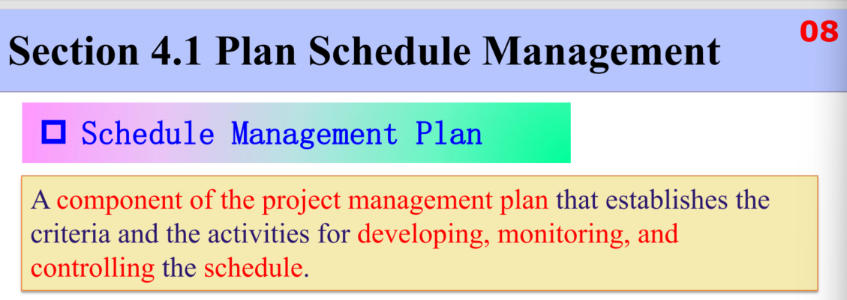
- Cost management plan
定义：describes how the project costs will be planned, structured, and controlled.
具体工作：Units of measure
Level of precision and accuracy
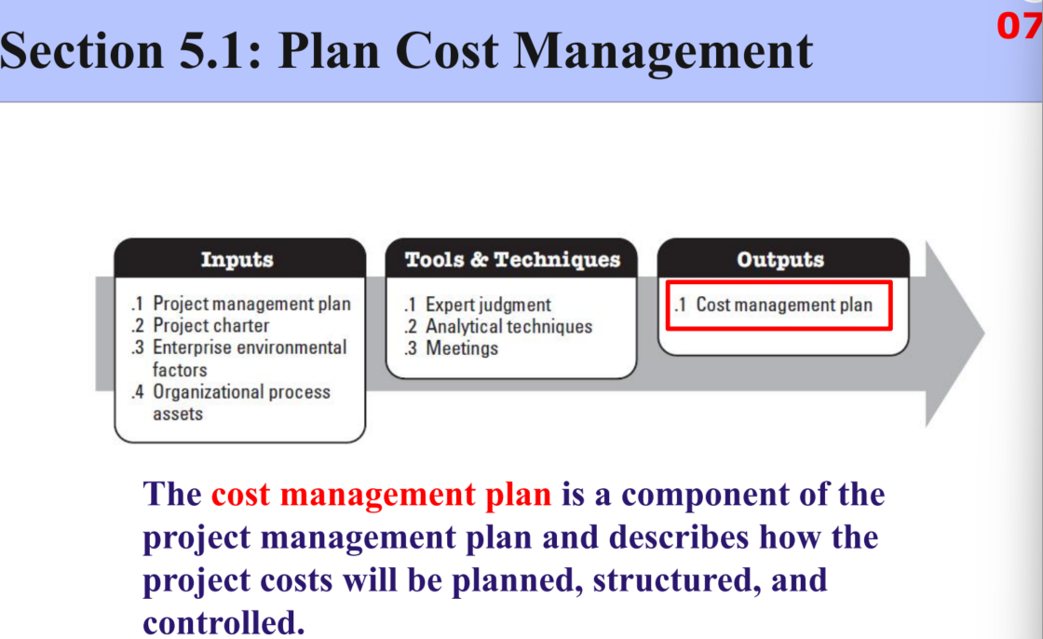
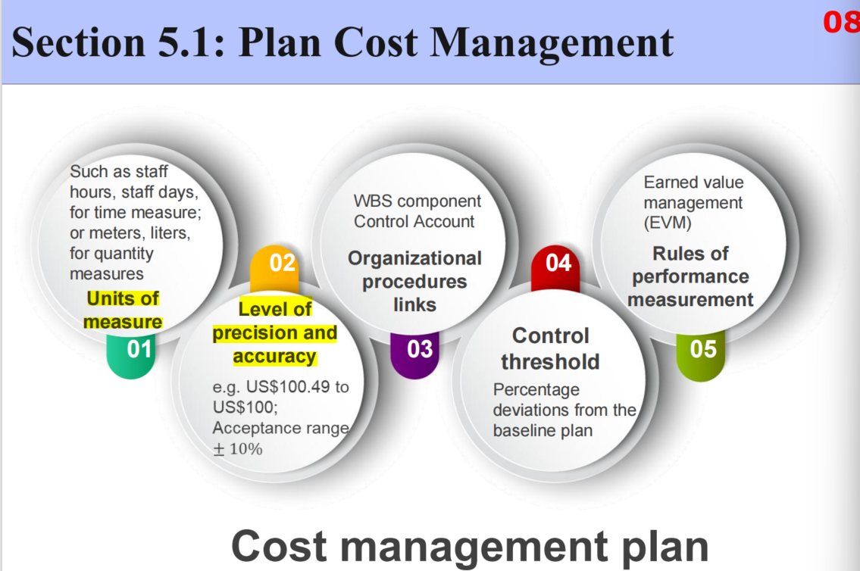

- Quality management plan
定义：
具体工作：
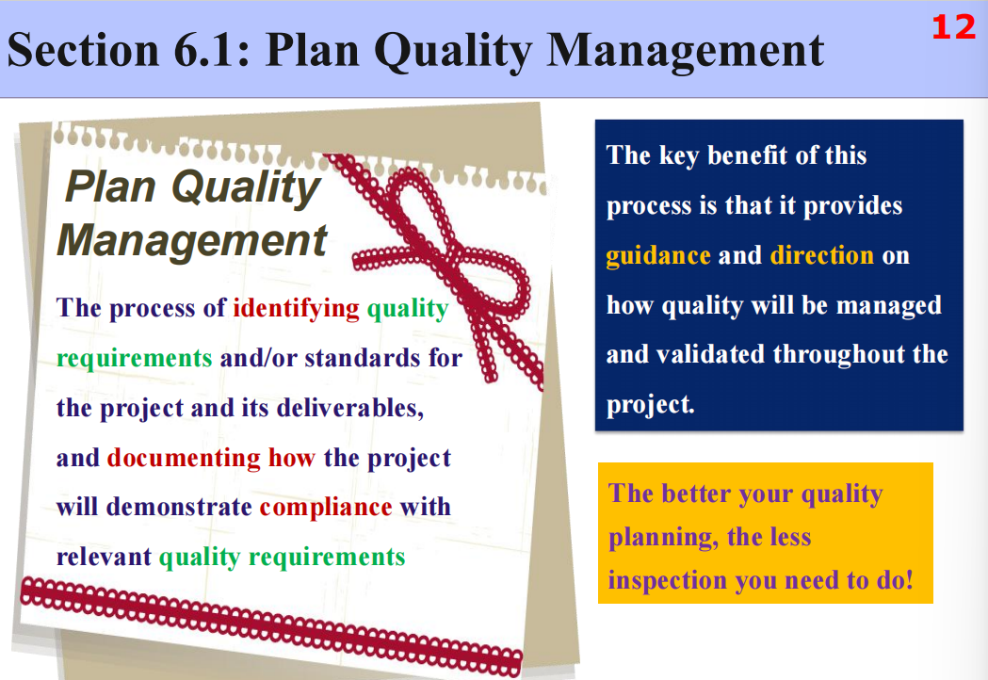

- Process improvement plan(PPT上没有)
定义：A structured solution for systematically optimizing work processes to enhance work efficiency or quality
具体工作：Diagnose existing problems → Implement optimization plans → Monitor effects and standardize

- Human resource management plan
定义：Human resource planning is used to determine and identify human resources with the necessary skills required for project success.
具体工作：describes Roles and responsibilities
Project organization charts
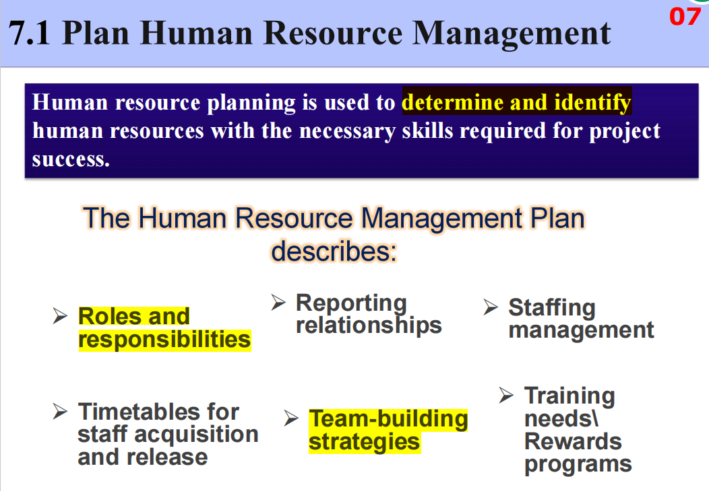
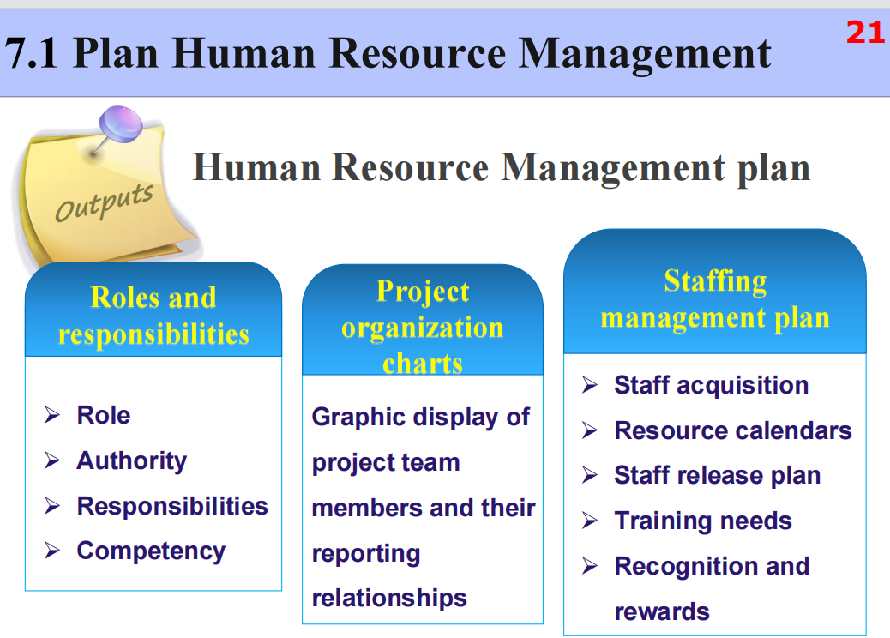
- Communication management plan
定义：ensure timely and appropriate planning, collection, creation, distribution,
storage, retrieval, management, control, monitoring, and the ultimate disposition of project information.
具体工作：
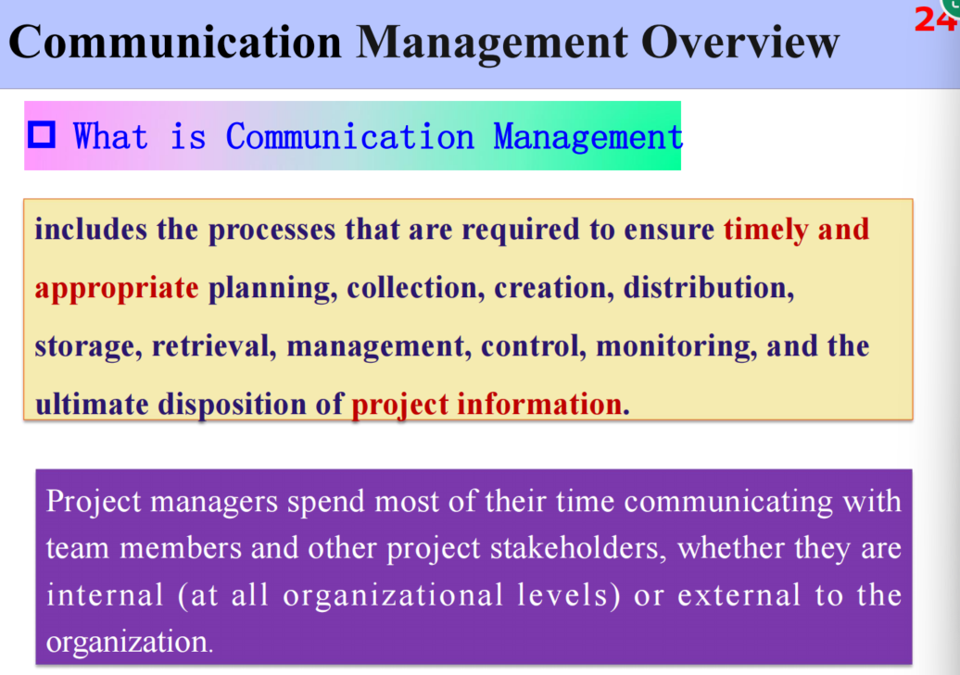
- Risk management plan
定义：describes how risk management activities will be structured and performed.
具体工作：Defines the approaches
Defines the risk management team members
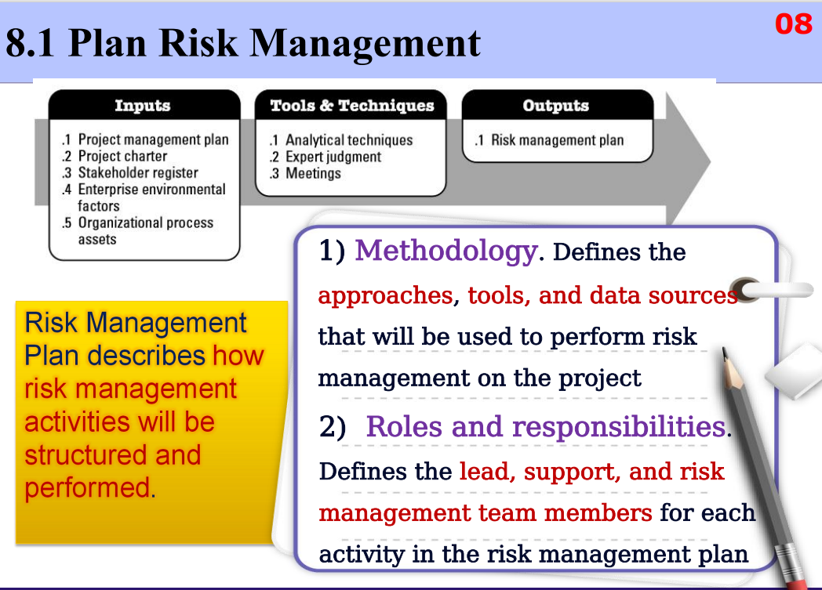
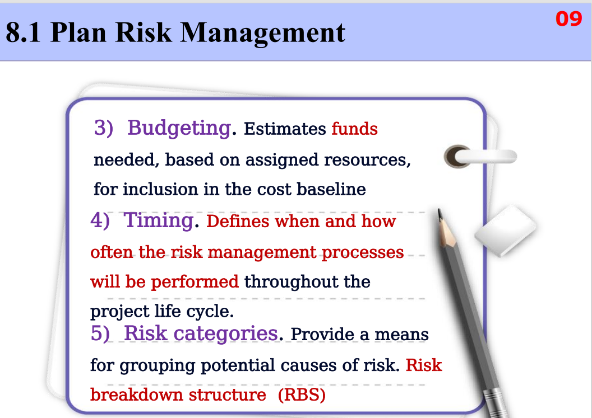
- Procurement management plan
定义：documenting project procurement decisions, specifying the approach and identifying potential sellers.
具体工作：evaluating potential sellers, risks
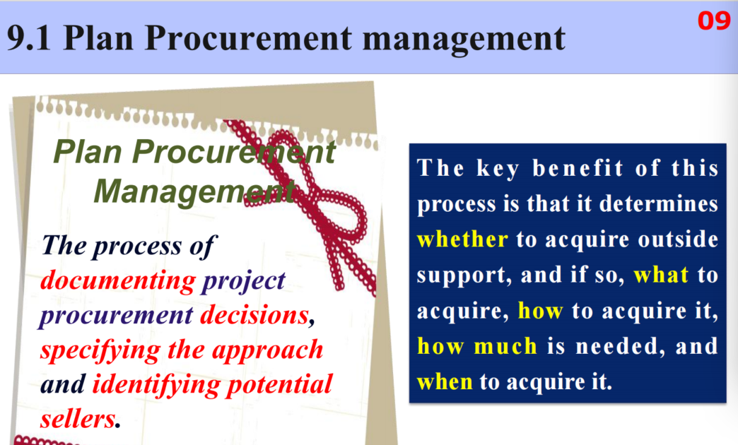
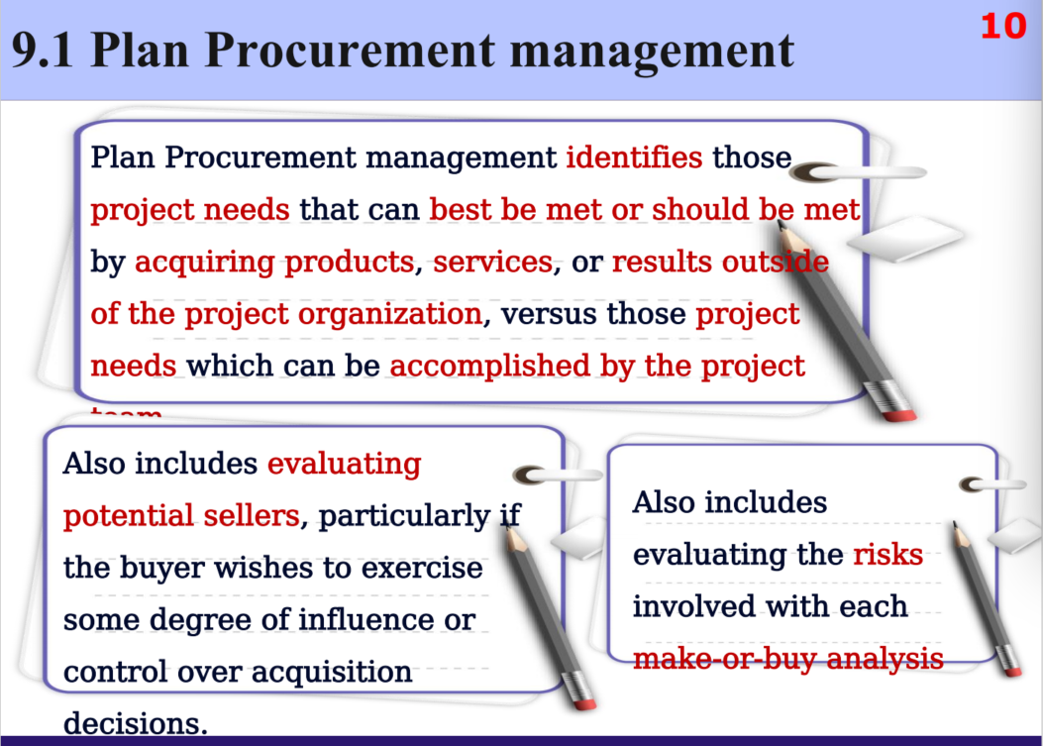
- Stakeholder management plan
定义：developing appropriate management strategies to effectively engage stakeholders throughout the project life cycle, based on the analysis of their needs, interests, and potential impact on project success.
具体工作：
