简答题（有名词解释）2小问 16分

What is Project?
A project is a temporary endeavor undertaken to create a unique product, service, or result

What is Project Management?
Project management is the application of knowledge, skills, tools and techniques to project activities to meet the project requirements.

Five progress groups and ten knowledge areas
47 logically grouped project management processes, which are categorized into 5 process groups.

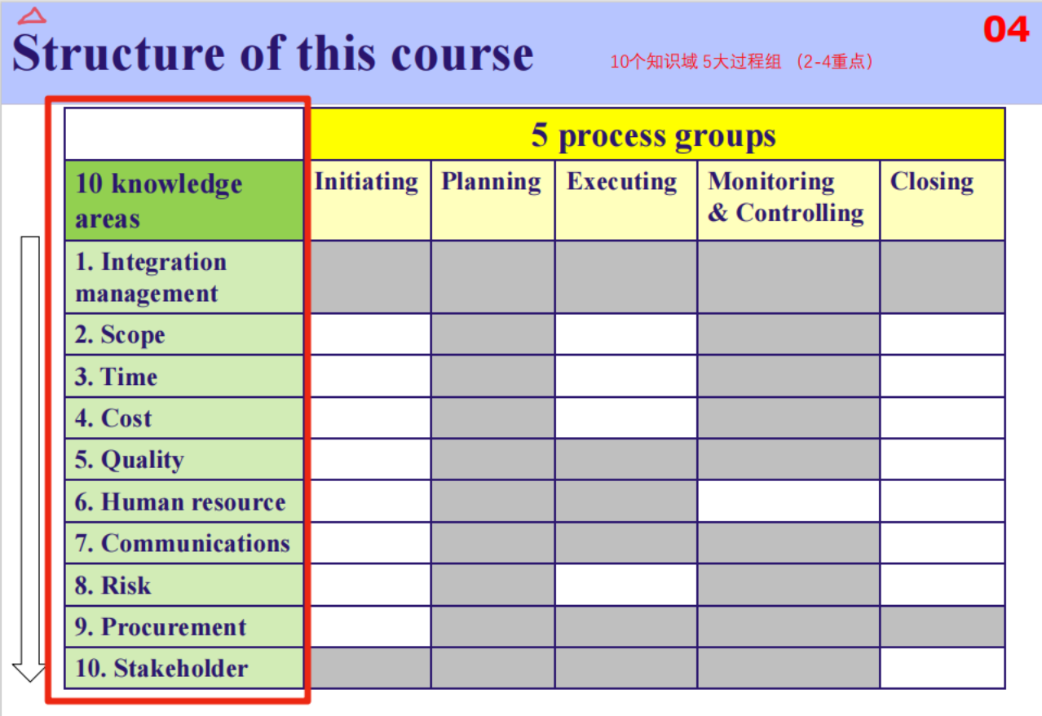

What is Software Project Management?
Software Project Management is a system management method based on software project, which uses the relevant knowledge, techniques and tools for planning, organizing, advising and controlling each stage of software project cycle to achieve the project objectives.

ITTO: Input Tools &Techniques Output
i.e. 黄字为通用回答
Direct and Manage Project Work
Input:
1. Project Management Plan
2. Approved Change Requests
3. Enterprise Environmental Factors
4. Organizational Process Assets

Tools &Techniques:
- Expert Judgment
- Project Management Information System
- Meetings

Output:
- Deliverables
- Work Performance Data
- Change Requests
- Project Management Plan Updates
- Project Documents Updates

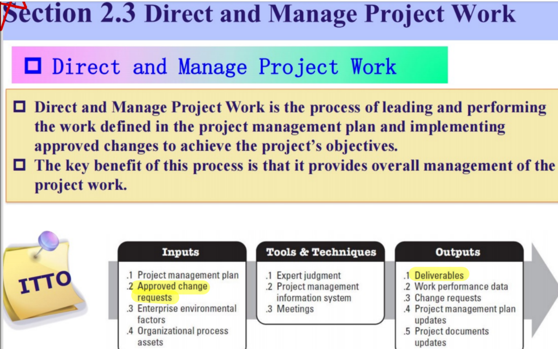

Develop project charter
Input:
1. Project statement of work
2. Business case
3. Agreements
4. Enterprise Environmental Factors
5. Organizational Process Assets

Tools &Techniques:
1. Expert Judgment
- Meetings

Output:
1. Project charter

