**简答题（有名词解释）2小问 16分**

**What is Project?**

A project is a temporary endeavor undertaken to create a unique product, service, or result

**What** **is** **Project** **Management?**

Project management is the application of knowledge, skills, tools and techniques to project activities to meet the project requirements.

**Five progress groups** and **ten knowledge areas**

**47** logically grouped project management **processes**, which are categorized into 5 process groups.

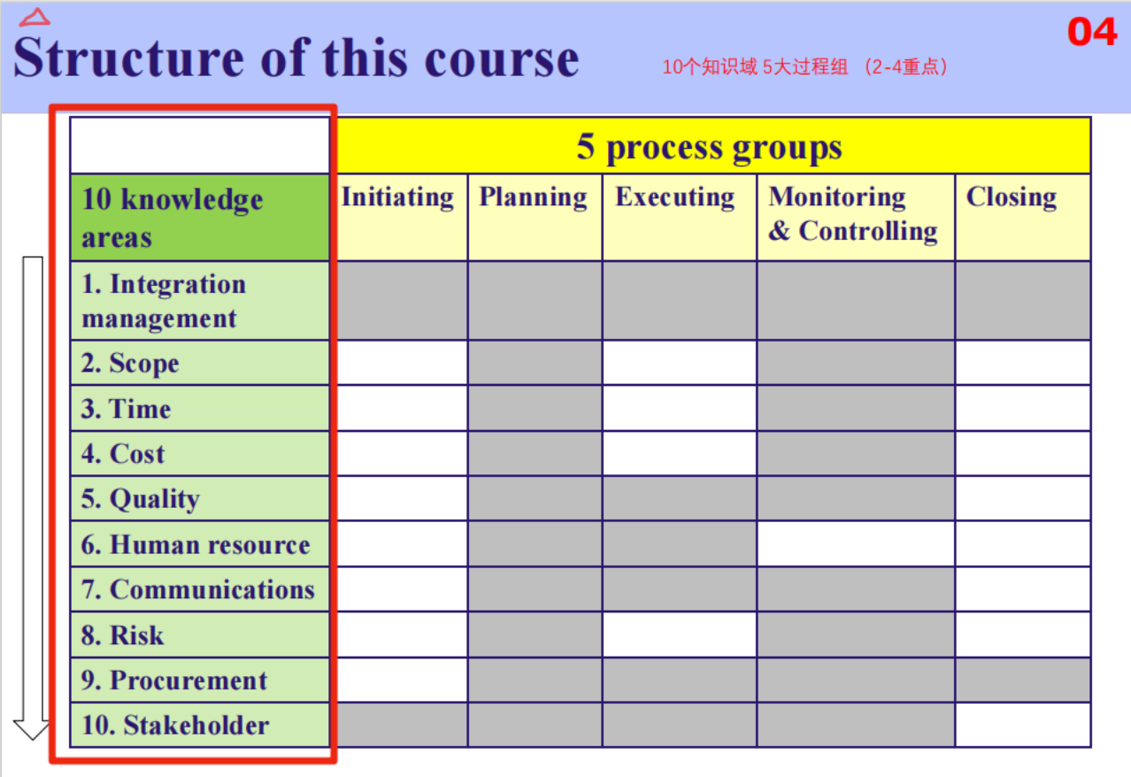

**What** **is** **Software Project Management?**

Software Project Management is a system management method based on software project, which uses the relevant knowledge, techniques and tools for planning, organizing, advising and controlling each stage of software project cycle to achieve the project objectives.

**ITTO:** Input Tools &Techniques Output

**i.e. 黄字为通用回答**

**Direct and Manage Project Work**

**Input:**

1. Project Management Plan

2. Approved Change Requests

3. Enterprise Environmental Factors

4. Organizational Process Assets

**Tools &Techniques:**

1. Expert Judgment
2. Project Management Information System
3. Meetings

**Output:**

1. Deliverables
2. Work Performance Data
3. Change Requests
4. Project Management Plan Updates
5. Project Documents Updates

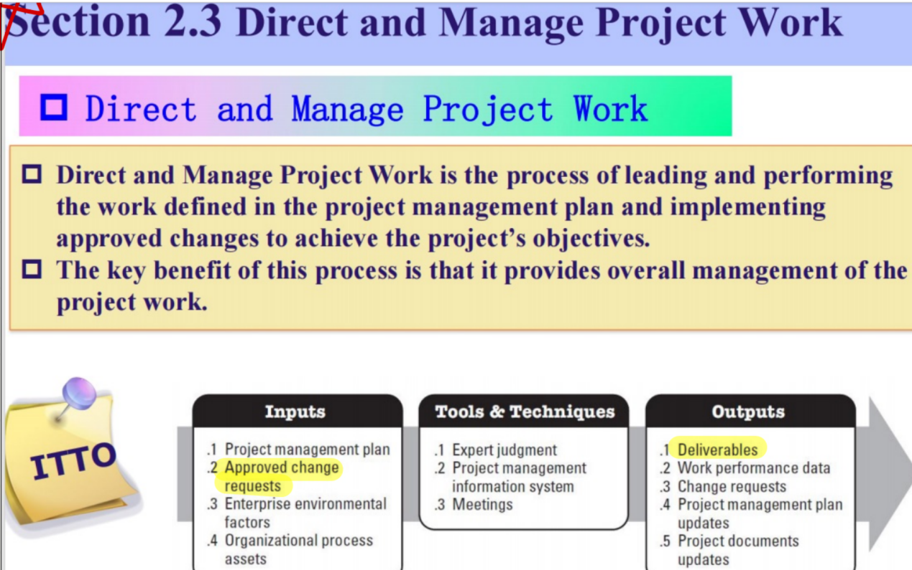

**Develop project charter**

**Input:**

1. Project statement of work

2. Business case

3. Agreements

4. Enterprise Environmental Factors

5. Organizational Process Assets

**Tools &Techniques:**

1. Expert Judgment

1. Meetings

**Output:**

1. Project charter

