Download ruby and rails plugin from netbeans clicking the URL:
http://plugins.netbeans.org/plugin/38549/ruby-and-rails 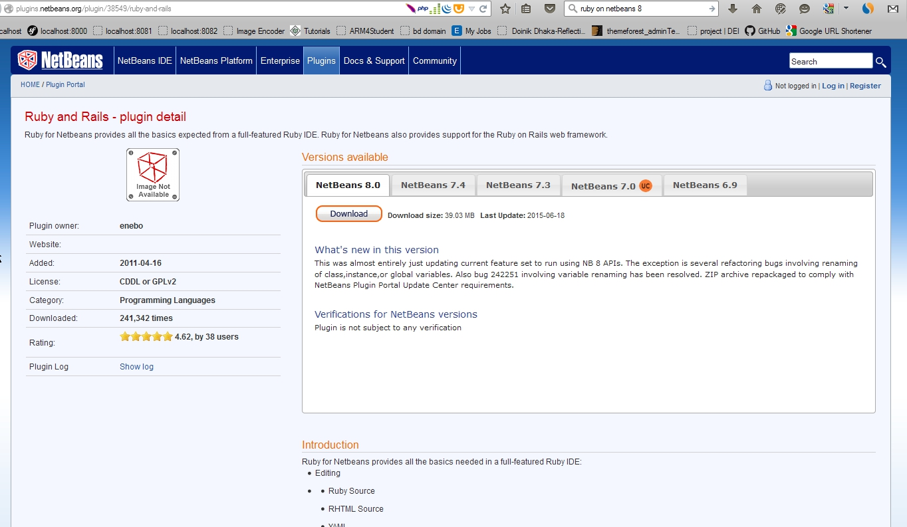
Extract all files from zip folder which you download from netbeans.org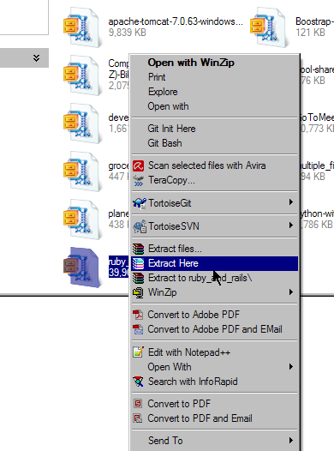

Open NetBeans IDE and go to Tools->Plugins->download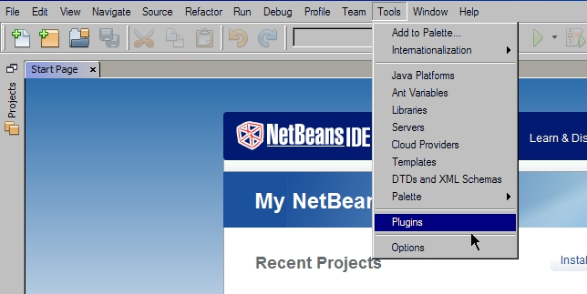
Now click Add Plugins… button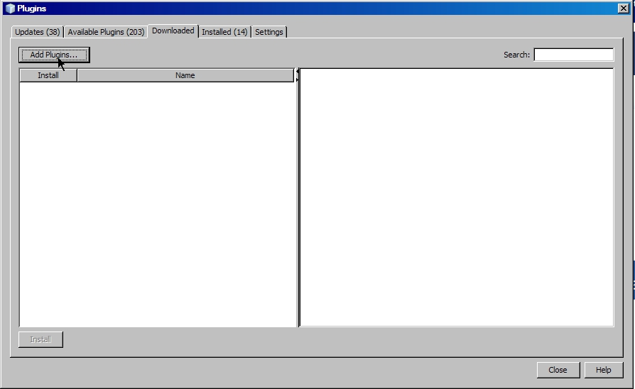
Now select all files as like picture given below: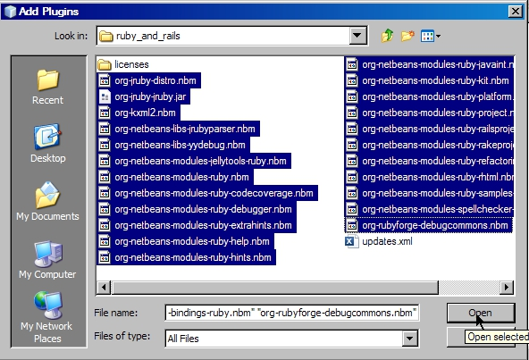
Now click Install button and install the ROR plugin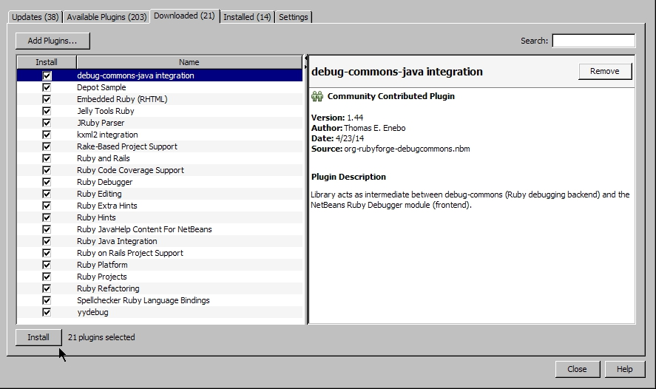
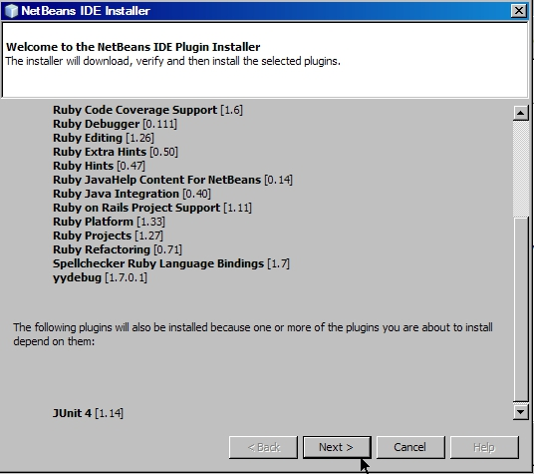
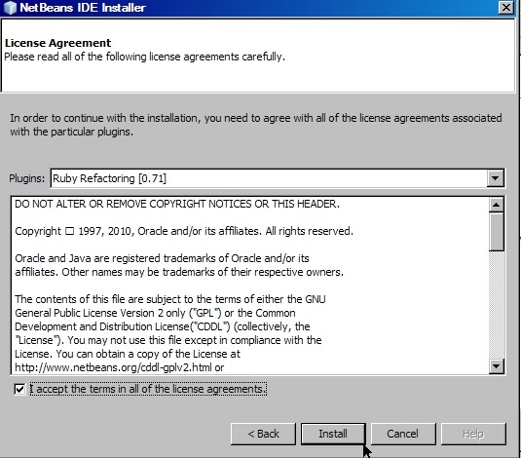
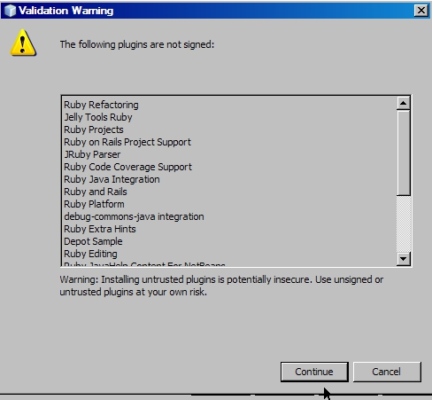
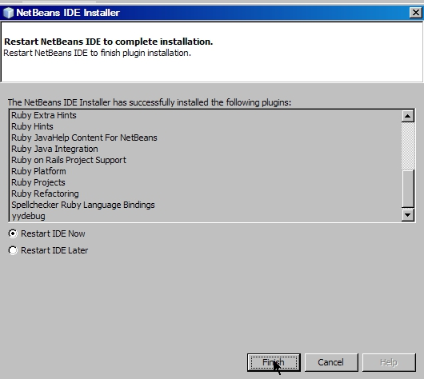
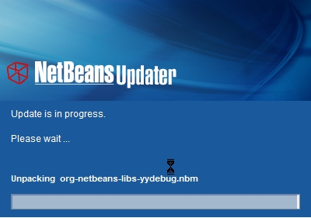
Now again go to Tools->options and select Miscellaneous
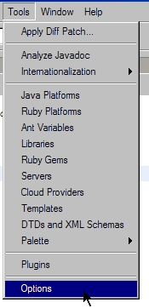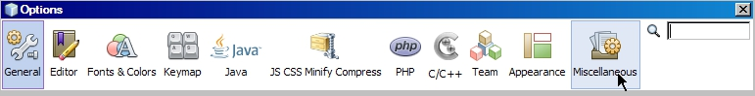

Now select Ruby from Miscellaneous and this page will appear to you.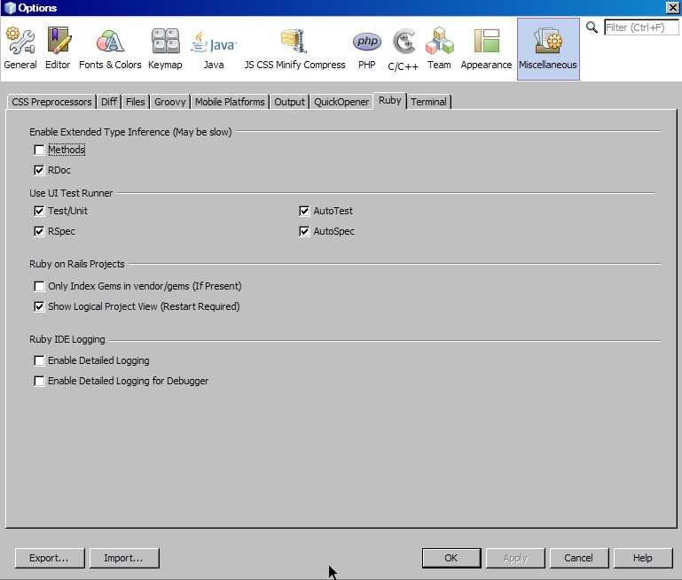
Now check all checkbox and click OK button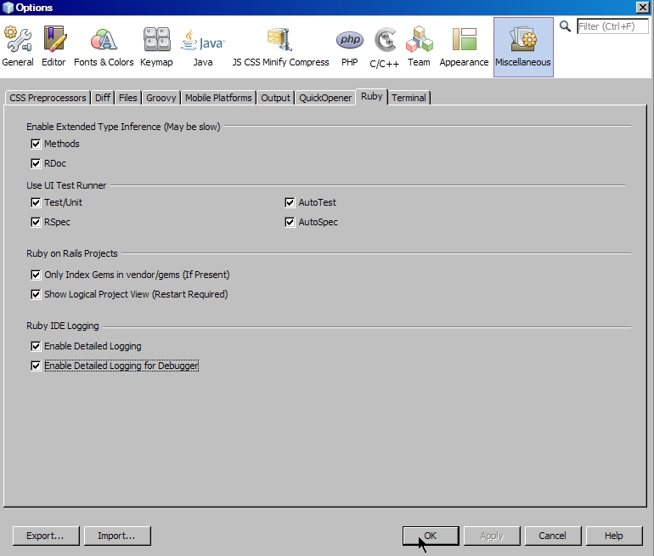
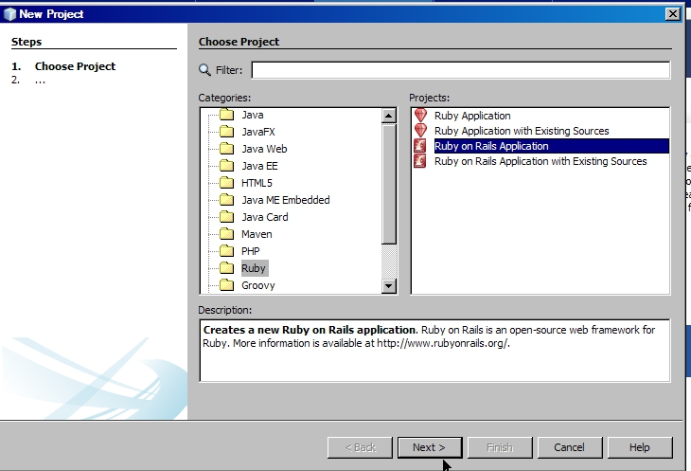
Now open File->New Project and select Ruby on Rails Application from Ruby categories.
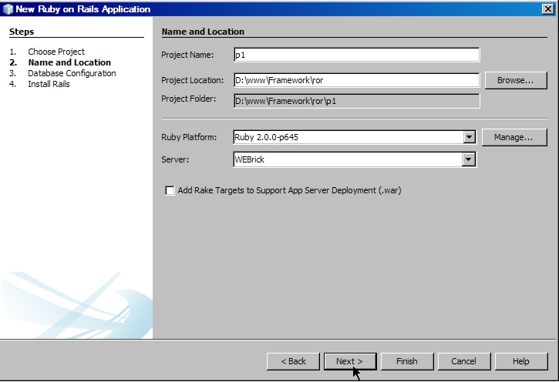
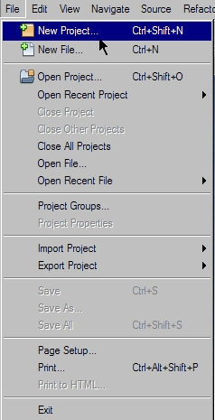
Now fill up the form as your wish and press Next button.

Now customize your database system, ruby comes with sqlite3 by default, if you want to use MySQL instead of sqlite3, you have to change Database Adapter name and also have to set Database Name, Username and Password regarding in your MySQL database. For Sqlite3 database, you can keep blank as like as this picture.
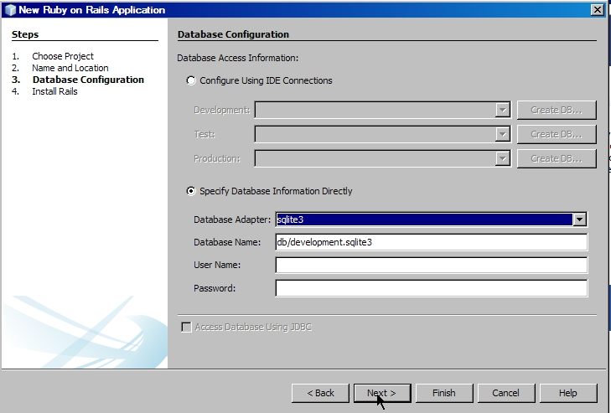
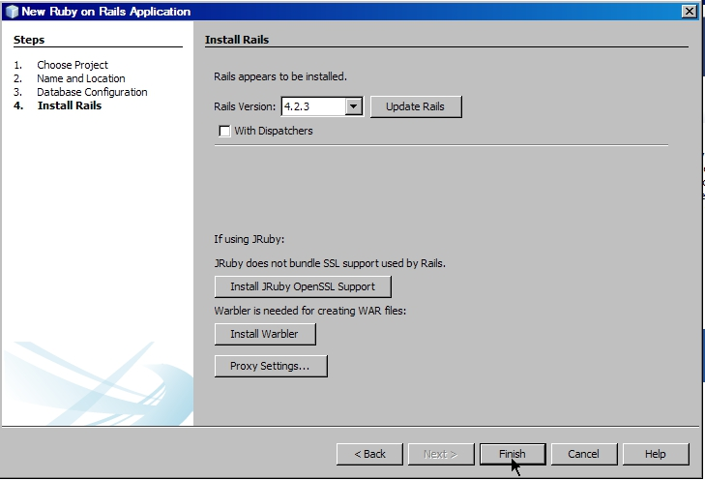
Now open in your project folder which you made through netbeans.
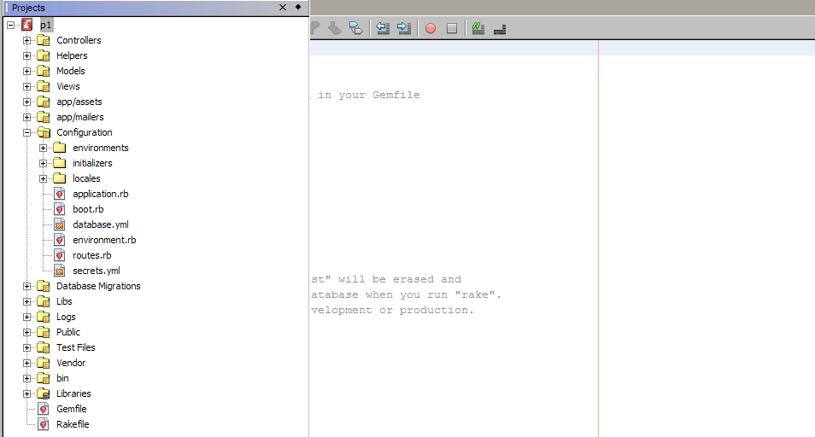

Now check that how does this plugin work nice!!!
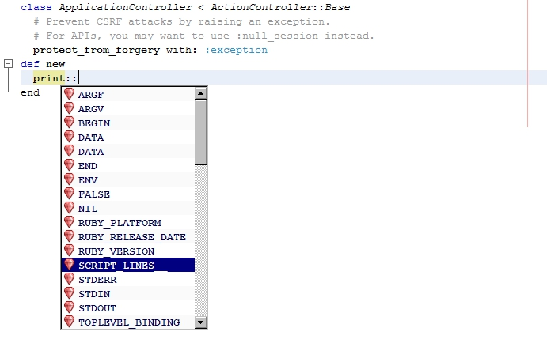
Now run the rails server from command window.
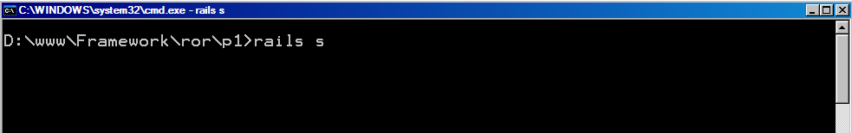
Open Firefox and go to localhost: 3000