Open Terminal.
Copy the 000-default.conf file as localhost.conf using this command:

sudo cp /etc/apache2/sites-available/000-default.conf /etc/apache2/sites-available/localhost.conf

For remove this file,use this command:

sudo rm /etc/apache2/sites-available/localhost.conf

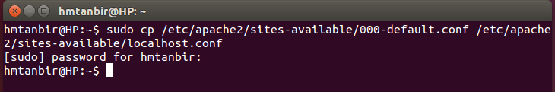
Now you have to edit this localhost.conf and also have to set it's document root and it's directory permission.

Now edit localhost.conf by gedit using this command:

sudo gedit /etc/apache2/sites-available/localhost.conf

Now select all text and delete all from the file and then paste the given below code:

<VirtualHost *:80>
ServerAdmin webmaster@localhost
DocumentRoot /home/hmtanbir/www/

#directory

<Directory /home/hmtanbir/www/>
Options Indexes FollowSymLinks MultiViews
AllowOverride None
Require all granted
</Directory>

#log file
ErrorLog ${APACHE_LOG_DIR}/error.log
CustomLog ${APACHE_LOG_DIR}/access.log combined
</VirtualHost>

DocumentRoot /Directory :: It is your own www or public_HTML folder location.

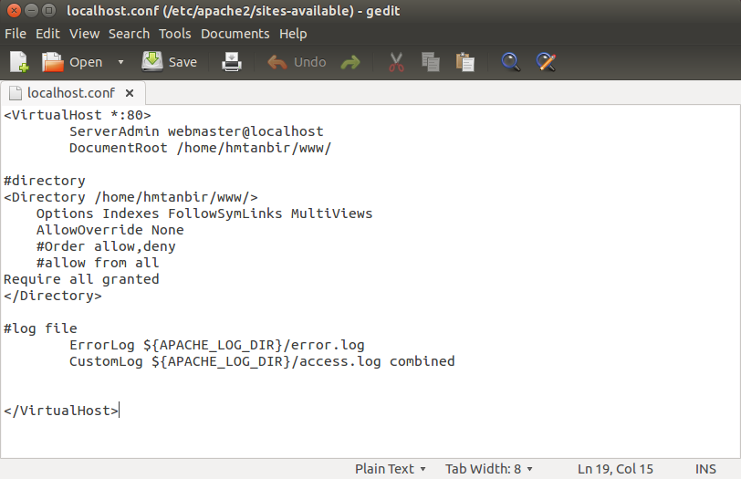
Now save it and exit the file.

Now you have to enable in this localhost.conf and disable 000-default.conf using these command

For disable site:
sudo a2dissite 000-default

For enable site:
sudo a2ensite localhost

Now you have to reload and restart apache2 service using this command:
sudo service apache2 reload && sudo service apache2 restart

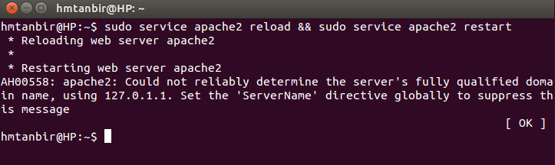

Now open in your browser and write localhost in address bar and you will see your www folder's index as like as this picture.

