If you want to run IDM (Internet Download Manager is good download manager for windows) on Ubuntu 14.04 LTS,you have to install wine at first nor it shall not work.
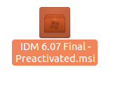

Open with wine program.
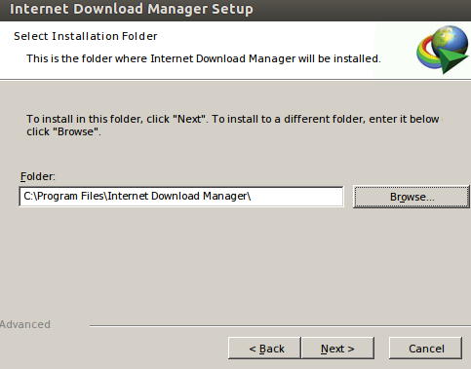
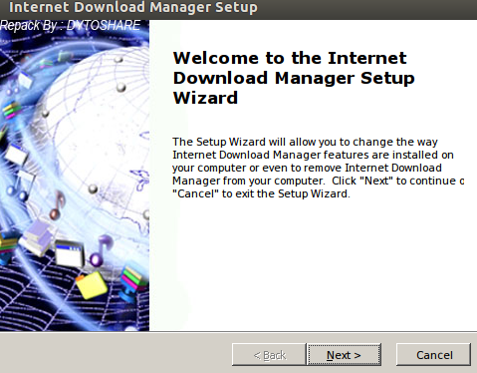

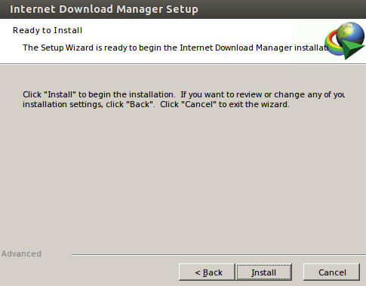
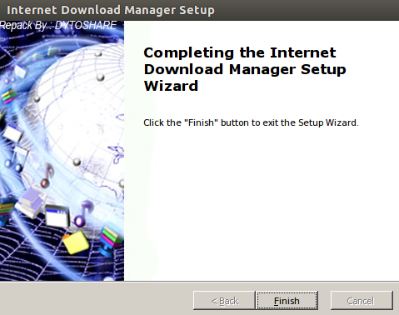

Now you have to integrate IDM with your Firefox browser. For this you have to install an add-ons named flash got.
From your Firefox browser menu,go to tools->Add-ons, if you have not this add-ons installed,then write flash got in search box and then install.

After installing this add-ons,you will find it Extensions tab.

Click Preferences button.

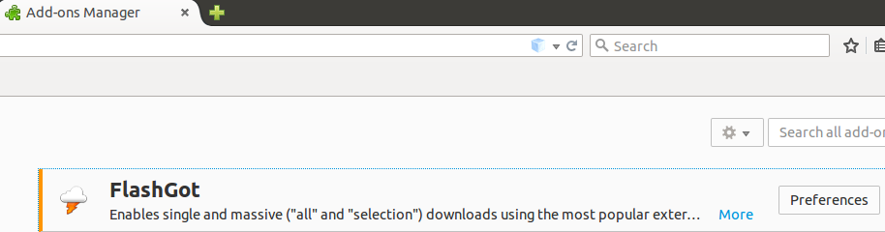
Click Add button.
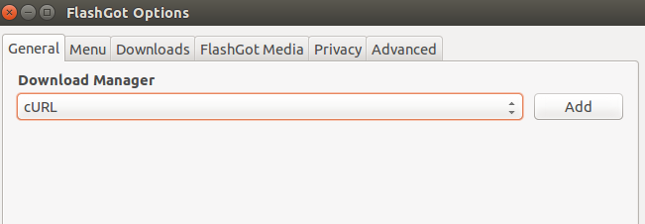

Give a name.
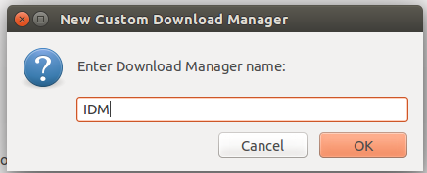

Then browse the path of IDMAN.exe file. This file is installed in your wine (hidden folder).Find out the path at first then select it neither it will not work.
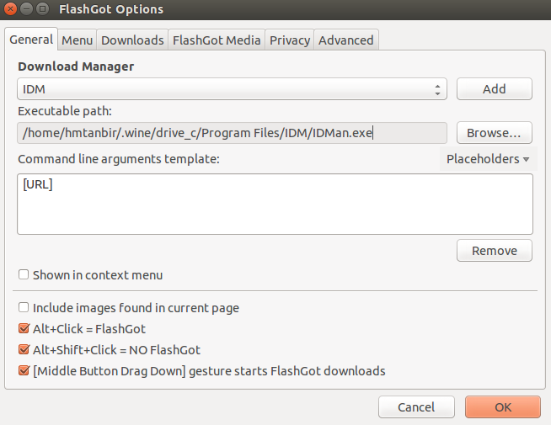

Then open IDM from Ubuntu menu bar. Furthermore, you have to customize IDM download path as like as picture clicking left button of your mouse.
