**General discussions , create application with out scaffolding .Interact with data base directly and fetch data from command prompt.**

Commands general : 3 types of command

* Rails deals with creation of application and file structure
* Rake deals with interaction with database
* 3rd one is gem deals with installation of 3rd party libraries called gems

From this we will create a sample application name sample_project.

--For this we need to open terminal

-- in the command prompt type rails new sample_project –d mysql (if we use mysql data base)

This will generate some files and structure.

-- to work on those files and folder structure open your editor . In my case I use sublime text 3 for this. We need to work on main 3 folders App, config and db. App folder contains the the MVC structure controller, model and view folders are inside this App folder.

Now change directory to sample_project.From here we proceed to create the contents of application.

First we in text editor move to config – datasae.yml folder configure password to root and save.

At this moment we have to create data base -- for this type in cmd as rake db:create. This will create a data base named as sample_project development and another sample_project test .

We mainly work on development data base, in case web hosting we will need production data base.

Now can we see the data base? For this we write in cmd prompt rails db-- this will ask for system password

_enter password .

Mysql > prompt will appear.

Enter show databases ;

This will show the list of databases.

For to see tables enter show tables ;

You will find no table as no table is created, as of now only database is created .

Table will be created when model is created.

Now to do this

We write as in sample_project > rails g controller students name address (here students is controller should be written in small letters and in plural name and address as actions )

Bellow the screen shot of a application named college I created.

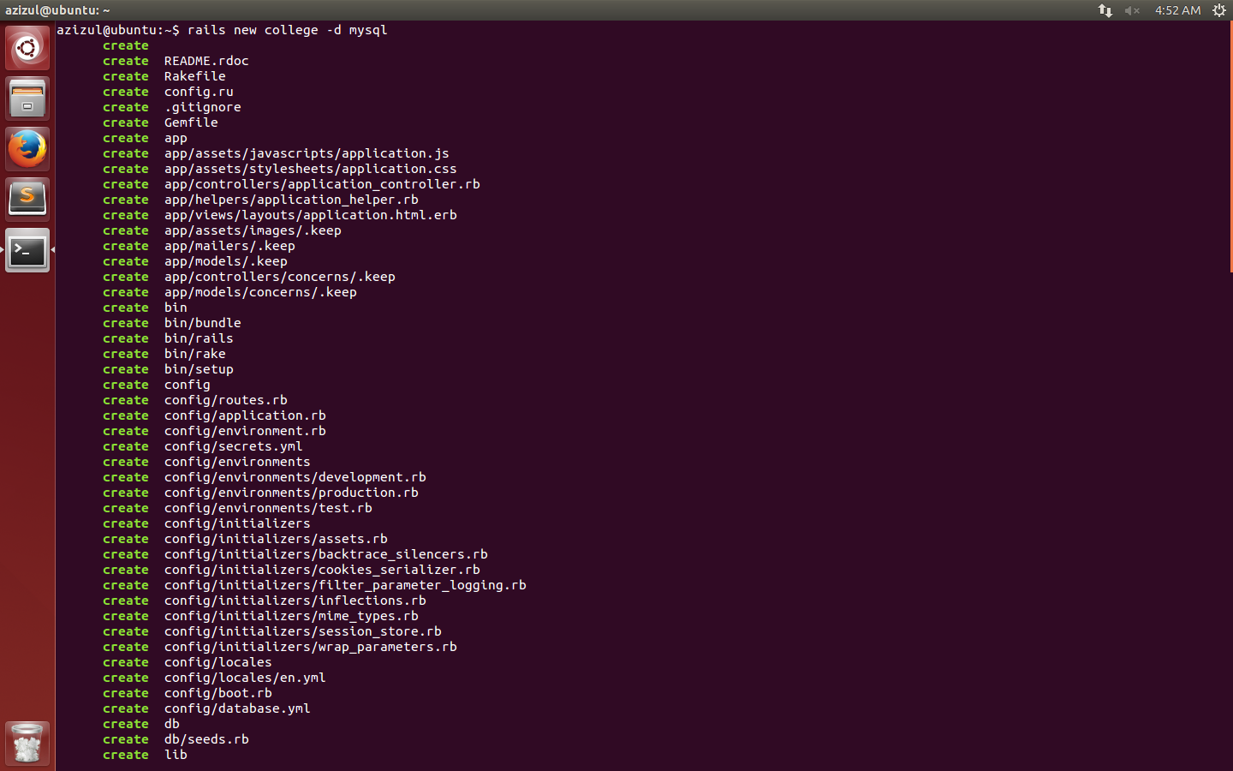

Open sublime text editor

Config database.ylml pwd to root

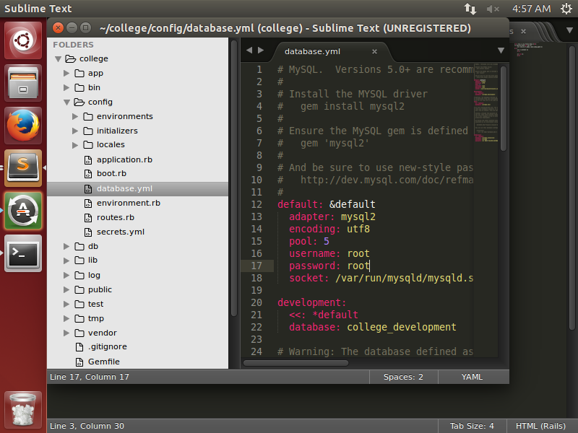

Now change directory to college and in prompt enter rake db:create

To see the data base enter in command as rails db and enter . it will ask for pwd

Mysql> prompt will appear.

Now command as show databases. Screen shot bellow  
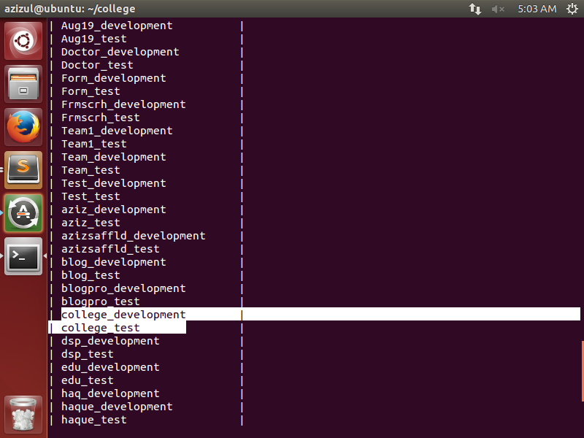

You can see the database high lighted. As of now no table is created. To create table we have to

Generate controller with some action name .here I create students as controller and actions name is registration and subject.

In command line

azizul@ubuntu:~/college$ rails g controller students registration subject

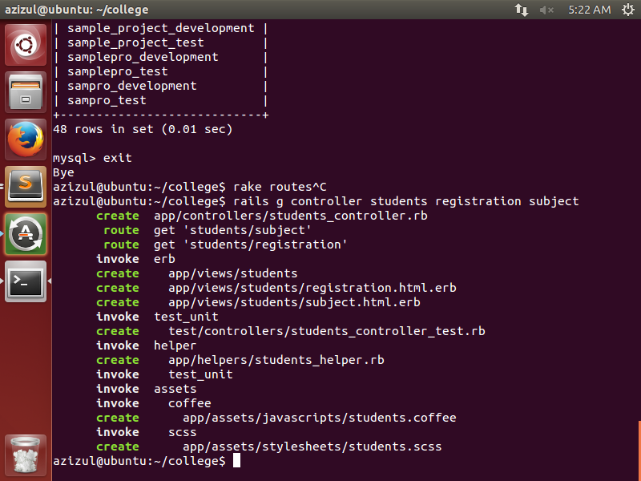

This will generate some files and routes we will see it in config routes file , this contains user friendly routes path. The routes file is in config folder .you can see those in sublime text editor

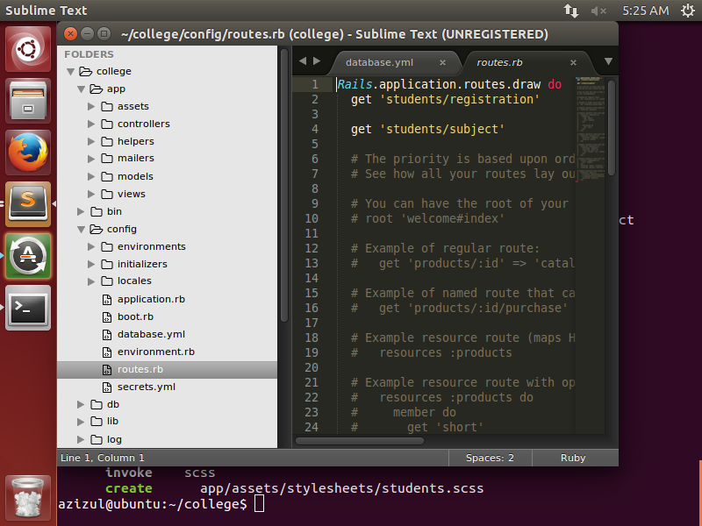

To see only the routes in command prompt

azizul@ubuntu:~/college$ rake routes

generate model (naming convention same as controller but in singular form and column name of the table .type is string in default)

azizul@ubuntu:~/college$ rails g model student name address

when you create model /table you have to enter command as

azizul@ubuntu:~/college$ rake db:migrate

you can see it in db folder migration file and in schema file in same db folder (sublime text).

To see the table

In cmd

azizul@ubuntu:~/college$ rails db

Enter password: root

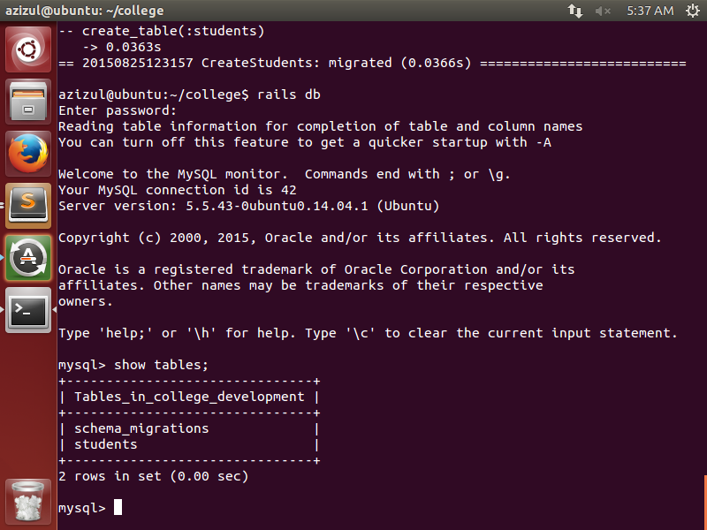

Exit the promt .

Now can we interact with data base directly.

In cmd college$ rails c

“mysql> exit

Bye

“azizul@ubuntu:~/college$ rails c

Loading development environment (Rails 4.2.2)

2.1.1 :001 > reload!

Reloading...

=> true

2.1.1 :002 >”

In cmd enter as this will create records

The print shot bellow.

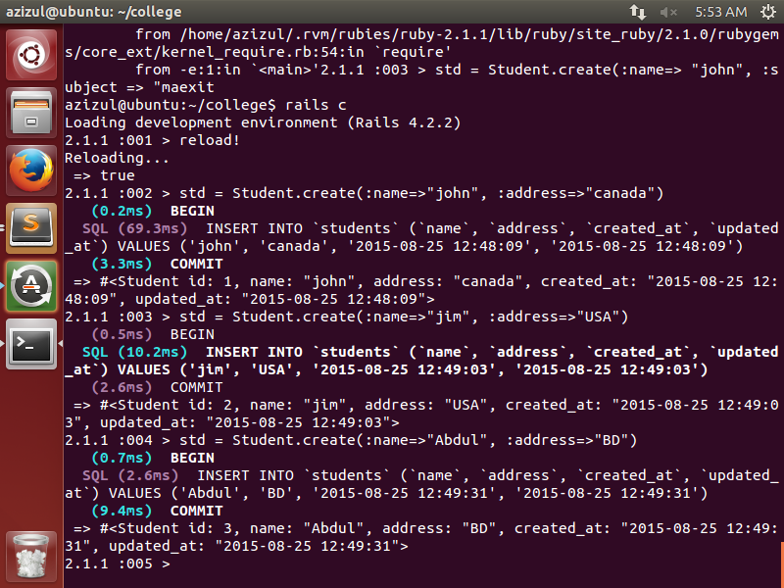

Can we see records from mysql ?

In command :

Exit

Rails db

Mysql> show tables;

Desc table students;

Select * from students ;

