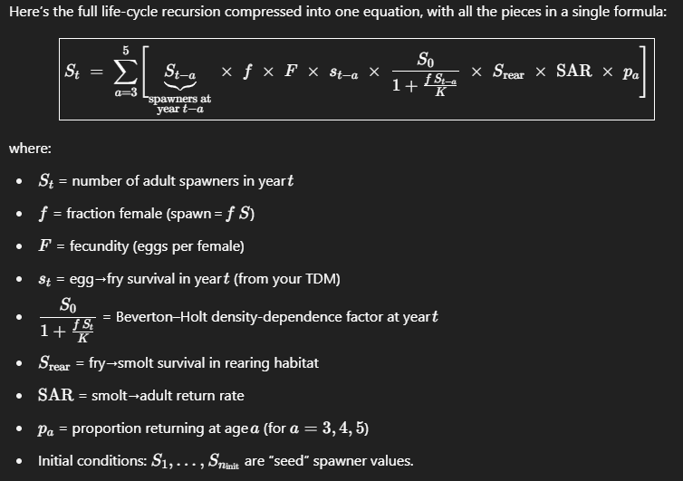

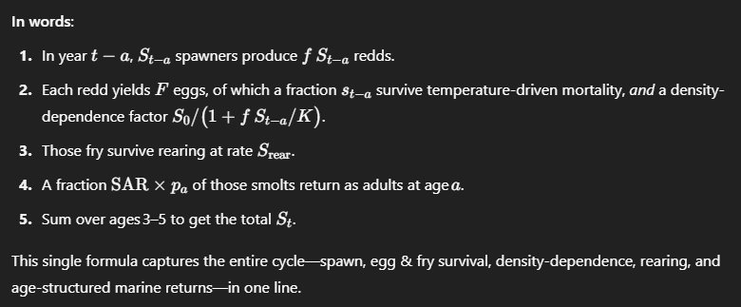

**Salmon Life-cycle Model Presentation**

**Slide 1: Introduction to the Salmon Life-cycle Model**

* **Goal:** Understand how populations respond to management or environmental changes.
* **Simple Life Stages:** Spawners → Eggs → Juveniles → Adults → Return to Spawn.

**Slide 2: Density Dependence Explained Simply**

* **Key Concept:** Survival decreases as populations get crowded.
* **Example:** If spawning beds can only support 100 nests, having 200 nests reduces survival.

**Slide 3: Example with Basic Math**

* **Spawning:** 100 adult fish spawn → each produces 5 eggs → 500 eggs total.
* **Density-dependent Survival:** Survival = S0 / (1 + Nests/K),
  + S0 = maximum survival (e.g., 0.8)
  + K = carrying capacity (e.g., 100 nests)
  + If we have 200 nests: survival = 0.8 / (1 + 200/100) = 0.8 / 3 ≈ 0.27 (27% survival).
  + If we have 50 nests: survival = 0.8 / (1 + 50/100) = 0.8 / 1.5 ≈ 0.53 (53% survival).

**Slide 4: Visualizing Density Dependence (Basic Figure)**

* Simple graph: X-axis = Number of nests, Y-axis = Survival.
* Curve slopes downward as number of nests increases.

**Slide 5: What Makes Alternatives Different?**

* **Density-dependent factors:**
  + Carrying capacity (available spawning/rearing habitat).
  + Survival rates at high densities.
* **Factors uniform across alternatives don't affect relative results:**
  + Example: Marine survival (if same in all alternatives).

**Slide 6: Basic R Example (Illustrating the Concept)**

library(tidyverse)

# Parameters

S0 <- 0.8 # Max survival

K <- 100 # Carrying capacity

nests <- seq(10, 300, by=10)

# Density-dependent survival function

survival <- S0 / (1 + nests/K)

data <- tibble(nests, survival)

ggplot(data, aes(x = nests, y = survival)) +

geom_line(size = 1.5, color="blue") +

labs(title="Density-dependent Survival",

x="Number of Nests",

y="Survival Rate") +

theme_minimal()

**Slide 7: Why Does This Matter?**

* Understanding density dependence helps predict effects of habitat restoration or changes in spawning conditions.
* Only factors that differ across alternatives (like habitat improvements affecting carrying capacity) change relative outcomes.

**Slide 8: Take-home Message**

* Density-dependent processes drive the differences between management scenarios.
* Uniform factors across scenarios influence total abundance but do not affect relative differences.

Model description according to my AI buddy

This function implements a deterministic, age-structured “scalar” life-cycle model for a salmon population, with Beverton–Holt density dependence acting on eggs, a rearing capacity constraint, and multi-year marine returns. Here’s exactly what happens, step by step:

1. **Inputs**
   * surv_vec: a length-years vector of **egg-to-fry** survival rates (temperature-dependent TDM outputs, without any density dependence). If you pass a single number, it’s replicated for every year.
   * P: a list of biological parameters:
     + female_fraction: fraction of spawners that are female
     + fec: eggs per female
     + S0, K_spawners: Beverton–Holt parameters (low-density survival, and half-saturation spawner density)
     + K_rear, S_rear, S_overflow: rearing habitat capacity and survival rates in/out of capacity
     + SAR: mean smolt-to-adult return rate
     + lag_probs: proportions returning at ages 3, 4, or 5
   * years: total number of simulated years
   * S_init: a vector of initial spawner abundances (length *n_init*) to “seed” the first years
2. **Initialization**
3. n_init <- length(S_init)
4. S <- numeric(years) # will hold annual spawner abundances
5. reared <- numeric(years) # will hold smolts leaving rearing each year
6. S[1:n_init] <- S_init # seed initial spawner years
7. **Annual loop**  
   For each year t from 1 to years:

a. **Spawning and egg production**

redds <- S[t] * P$female_fraction

eggs <- redds * P$fec

* + redds: number of redds (nests) = spawners × fraction female
  + eggs: total eggs laid

b. **Density-dependent egg/fry survival**

dd <- P$S0 / (1 + redds / P$K_spawners)

fry_dd <- eggs * surv_vec[t] * dd

* + dd is the Beverton–Holt density-dependence factor (≤ S0)
  + surv_vec[t] is the temperature-driven base survival
  + fry_dd is the number of fry surviving both TDM and density dependence

c. **Rearing habitat capacity**

in_cap <- pmin(fry_dd, P$K_rear) # fry within capacity

overflow <- pmax(fry_dd - P$K_rear, 0) # fry beyond capacity

reared[t]<- in_cap * P$S_rear + overflow * P$S_overflow

* + Fry up to K_rear survive at rate S_rear; overflow fry survive at lower S_overflow
  + reared[t] is the total smolts leaving rearing

d. **Marine return at age 3, 4, 5**

for(age in 3:5) {

ret_year <- t + age

if (ret_year <= years) {

S[ret_year] <- S[ret_year] +

reared[t] * P$SAR * P$lag_probs[as.character(age)]

}

}

* + Each year’s smolts contribute adult spawners in future years
  + P$SAR is the overall smolt-to-adult rate, split by lag_probs among ages 3–5

1. **Output**
2. tibble(year = 1:years, spawners = S)

A data frame of annual spawner abundances, fully accounting for:

* + temperature‐driven egg/fry survival (surv_vec[t])
  + density‐dependent egg mortality (Beverton–Holt)
  + rearing capacity and survival
  + multi‐year age structure with smolt‐to‐adult return rates

This is a classic “Ricker‐style” or “Beverton–Holt” scalar model extended to include realistic egg‐to‐smolt processes and a 3–5 year marine delay before spawning.