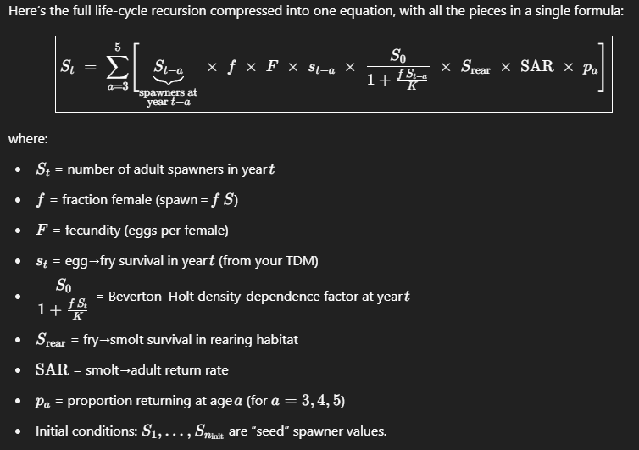
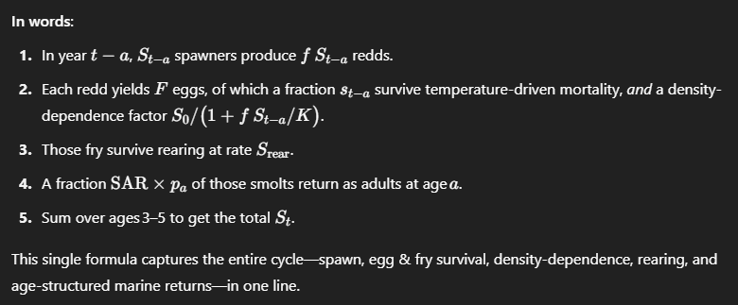
Salmon Life-cycle Model Presentation
Slide 1: Introduction to the Salmon Life-cycle Model
- Goal: Understand how populations respond to management or environmental changes.
- Simple Life Stages: Spawners → Eggs → Juveniles → Adults → Return to Spawn.
Slide 2: Density Dependence Explained Simply
- Key Concept: Survival decreases as populations get crowded.
- Example: If spawning beds can only support 100 nests, having 200 nests reduces survival.
Slide 3: Example with Basic Math
- Spawning: 100 adult fish spawn → each produces 5 eggs → 500 eggs total.
- Density-dependent Survival: Survival = S0 / (1 + Nests/K),
  - S0 = maximum survival (e.g., 0.8)
  - K = carrying capacity (e.g., 100 nests)
  - If we have 200 nests: survival = 0.8 / (1 + 200/100) = 0.8 / 3 ≈ 0.27 (27% survival).
  - If we have 50 nests: survival = 0.8 / (1 + 50/100) = 0.8 / 1.5 ≈ 0.53 (53% survival).
Slide 4: Visualizing Density Dependence (Basic Figure)
- Simple graph: X-axis = Number of nests, Y-axis = Survival.
- Curve slopes downward as number of nests increases.
Slide 5: What Makes Alternatives Different?
- Density-dependent factors:
  - Carrying capacity (available spawning/rearing habitat).
  - Survival rates at high densities.
- Factors uniform across alternatives don't affect relative results:
  - Example: Marine survival (if same in all alternatives).
Slide 6: Basic R Example (Illustrating the Concept)
library(tidyverse)

# Parameters
S0 <- 0.8 # Max survival
K <- 100 # Carrying capacity
nests <- seq(10, 300, by=10)

# Density-dependent survival function
survival <- S0 / (1 + nests/K)

data <- tibble(nests, survival)

ggplot(data, aes(x = nests, y = survival)) +
geom_line(size = 1.5, color="blue") +
labs(title="Density-dependent Survival",
x="Number of Nests",
y="Survival Rate") +
theme_minimal()
Slide 7: Why Does This Matter?
- Understanding density dependence helps predict effects of habitat restoration or changes in spawning conditions.
- Only factors that differ across alternatives (like habitat improvements affecting carrying capacity) change relative outcomes.
Slide 8: Take-home Message
- Density-dependent processes drive the differences between management scenarios.
- Uniform factors across scenarios influence total abundance but do not affect relative differences.

Model description according to my AI buddy
This function implements a deterministic, age-structured “scalar” life-cycle model for a salmon population, with Beverton–Holt density dependence acting on eggs, a rearing capacity constraint, and multi-year marine returns. Here’s exactly what happens, step by step:
- Inputs
  - surv_vec: a length-years vector of egg-to-fry survival rates (temperature-dependent TDM outputs, without any density dependence). If you pass a single number, it’s replicated for every year.
  - P: a list of biological parameters:
    - female_fraction: fraction of spawners that are female
    - fec: eggs per female
    - S0, K_spawners: Beverton–Holt parameters (low-density survival, and half-saturation spawner density)
    - K_rear, S_rear, S_overflow: rearing habitat capacity and survival rates in/out of capacity
    - SAR: mean smolt-to-adult return rate
    - lag_probs: proportions returning at ages 3, 4, or 5
  - years: total number of simulated years
  - S_init: a vector of initial spawner abundances (length n_init) to “seed” the first years
- Initialization
- n_init <- length(S_init)
- S <- numeric(years) # will hold annual spawner abundances
- reared <- numeric(years) # will hold smolts leaving rearing each year
- S[1:n_init] <- S_init # seed initial spawner years
- Annual loop
For each year t from 1 to years:
a. Spawning and egg production
redds <- S[t] * P$female_fraction
eggs <- redds * P$fec
  - redds: number of redds (nests) = spawners × fraction female
  - eggs: total eggs laid
b. Density-dependent egg/fry survival
dd <- P$S0 / (1 + redds / P$K_spawners)
fry_dd <- eggs * surv_vec[t] * dd
  - dd is the Beverton–Holt density-dependence factor (≤ S0)
  - surv_vec[t] is the temperature-driven base survival
  - fry_dd is the number of fry surviving both TDM and density dependence
c. Rearing habitat capacity
in_cap <- pmin(fry_dd, P$K_rear) # fry within capacity
overflow <- pmax(fry_dd - P$K_rear, 0) # fry beyond capacity
reared[t]<- in_cap * P$S_rear + overflow * P$S_overflow
  - Fry up to K_rear survive at rate S_rear; overflow fry survive at lower S_overflow
  - reared[t] is the total smolts leaving rearing
d. Marine return at age 3, 4, 5
for(age in 3:5) {
ret_year <- t + age
if (ret_year <= years) {
S[ret_year] <- S[ret_year] +
reared[t] * P$SAR * P$lag_probs[as.character(age)]
}
}
  - Each year’s smolts contribute adult spawners in future years
  - P$SAR is the overall smolt-to-adult rate, split by lag_probs among ages 3–5
- Output
- tibble(year = 1:years, spawners = S)
A data frame of annual spawner abundances, fully accounting for:
  - temperature‐driven egg/fry survival (surv_vec[t])
  - density‐dependent egg mortality (Beverton–Holt)
  - rearing capacity and survival
  - multi‐year age structure with smolt‐to‐adult return rates
This is a classic “Ricker‐style” or “Beverton–Holt” scalar model extended to include realistic egg‐to‐smolt processes and a 3–5 year marine delay before spawning.

