Delta Smelt LCME output

Brian Mahardja

2024-09-25

## New names:  
## Joining with `by = join_by(Year)`  
## • `` -> `...1`  
## • `Alt1` -> `Alt1...3`  
## • `Alt2v1wTUCP` -> `Alt2v1wTUCP...4`  
## • `Alt2v1woTUCP` -> `Alt2v1woTUCP...5`  
## • `Alt2v2noTUCP` -> `Alt2v2noTUCP...6`  
## • `Alt2v3noTUCP` -> `Alt2v3noTUCP...7`  
## • `Alt3` -> `Alt3...8`  
## • `Alt4` -> `Alt4...9`  
## • `EXP1` -> `EXP1...10`  
## • `EXP3` -> `EXP3...11`  
## • `` -> `...13`  
## • `` -> `...14`  
## • `Alt1` -> `Alt1...15`  
## • `Alt2v1wTUCP` -> `Alt2v1wTUCP...16`  
## • `Alt2v1woTUCP` -> `Alt2v1woTUCP...17`  
## • `Alt2v2noTUCP` -> `Alt2v2noTUCP...18`  
## • `Alt2v3noTUCP` -> `Alt2v3noTUCP...19`  
## • `Alt3` -> `Alt3...20`  
## • `Alt4` -> `Alt4...21`  
## • `EXP1` -> `EXP1...22`  
## • `EXP3` -> `EXP3...23`

Table 3. Predicted population growth rate (lambda) for each cohort year by alternatives.

| Year | Empirical | Alt1 | Alt2wTUCPwoVA | Alt2woTUCPwoVA | Alt2woTUCPDeltaVA | Alt2woTUCPAllVA | Alt3 | Alt4 | EXP1 | EXP3 | NAA | Sacramento Valley Water Year Index |
| --- | --- | --- | --- | --- | --- | --- | --- | --- | --- | --- | --- | --- |
| 1995 | 3.56 | 1.66 | 1.81 | 1.81 | 1.86 | 1.80 | 2.28 | 1.82 | 4.57 | 4.35 | 1.89 | Wet |
| 1996 | 1.37 | 0.66 | 0.64 | 0.63 | 0.64 | 0.64 | 1.07 | 0.63 | 1.20 | 1.47 | 0.73 | Wet |
| 1997 | 0.68 | 0.38 | 0.57 | 0.58 | 0.58 | 0.58 | 0.79 | 0.57 | 0.58 | 1.01 | 0.59 | Wet |
| 1998 | 4.78 | 1.74 | 1.67 | 1.65 | 1.66 | 1.65 | 3.02 | 1.73 | 5.18 | 4.91 | 1.81 | Wet |
| 1999 | 0.79 | 0.56 | 0.69 | 0.69 | 0.68 | 0.70 | 0.88 | 0.65 | 1.00 | 1.35 | 0.78 | Wet |
| 2000 | 0.69 | 0.42 | 0.80 | 0.79 | 0.84 | 0.86 | 0.78 | 0.72 | 0.77 | 1.15 | 0.86 | Above Normal |
| 2001 | 0.11 | 0.11 | 0.28 | 0.28 | 0.31 | 0.32 | 0.47 | 0.28 | 0.29 | 0.47 | 0.29 | Dry |
| 2002 | 0.55 | 0.69 | 0.92 | 0.93 | 1.00 | 1.00 | 1.20 | 0.92 | 0.74 | 1.23 | 0.90 | Dry |
| 2003 | 0.87 | 0.73 | 1.45 | 1.46 | 1.53 | 1.53 | 1.56 | 1.36 | 1.63 | 2.52 | 1.50 | Above Normal |
| 2004 | 0.44 | 0.43 | 0.79 | 0.79 | 0.82 | 0.82 | 0.91 | 0.74 | 0.65 | 1.11 | 0.82 | Below Normal |
| 2005 | 1.94 | 1.05 | 1.28 | 1.28 | 1.34 | 1.36 | 1.58 | 1.29 | 2.96 | 3.18 | 1.32 | Above Normal |
| 2006 | 3.37 | 1.87 | 2.09 | 2.12 | 2.19 | 2.22 | 2.79 | 1.99 | 3.15 | 3.46 | 2.21 | Wet |
| 2007 | 0.51 | 0.36 | 0.59 | 0.60 | 0.60 | 0.60 | 0.85 | 0.55 | 0.48 | 0.79 | 0.60 | Dry |
| 2008 | 0.95 | 0.92 | 1.01 | 1.00 | 1.07 | 1.08 | 1.37 | 1.01 | 0.64 | 1.02 | 1.01 | Critically Dry |
| 2009 | 0.64 | 0.49 | 0.73 | 0.73 | 0.73 | 0.72 | 0.81 | 0.71 | 0.62 | 1.16 | 0.73 | Dry |
| 2010 | 1.26 | 1.15 | 1.26 | 1.25 | 1.29 | 1.25 | 1.42 | 1.26 | 2.21 | 2.32 | 1.28 | Below Normal |
| 2011 | 3.65 | 2.66 | 2.77 | 2.76 | 2.76 | 2.77 | 2.60 | 2.80 | 4.78 | 4.69 | 2.74 | Wet |
| 2012 | 0.95 | 0.67 | 0.87 | 0.88 | 0.89 | 0.88 | 1.00 | 0.88 | 0.56 | 0.93 | 0.91 | Below Normal |
| 2013 | 0.90 | 0.79 | 0.83 | 0.83 | 0.84 | 0.84 | 1.01 | 0.83 | 0.44 | 0.73 | 0.83 | Dry |
| 2014 | 0.43 | 0.36 | 0.41 | 0.44 | 0.43 | 0.43 | 0.65 | 0.38 | 0.30 | 0.45 | 0.40 | Critically Dry |
| 2015 | 0.66 | 0.65 | 0.55 | 0.63 | 0.63 | 0.62 | 0.73 | 0.54 | 0.41 | 0.60 | 0.55 | Critically Dry |

## Joining with `by = join_by(Year)`  
## `summarise()` has grouped output by 'wet_vs_dry'. You can override using the  
## `.groups` argument.  
## `summarise()` has grouped output by 'TimePeriod'. You can override using the  
## `.groups` argument.

Table 4. Geometric mean of population growth rate (lambda) for each alternative.

| Category | Alt1 | Alt2woTUCPAllVA | Alt2woTUCPDeltaVA | Alt2woTUCPwoVA | Alt2wTUCPwoVA | Alt3 | Alt4 | Empirical | EXP1 | EXP3 | NAA |
| --- | --- | --- | --- | --- | --- | --- | --- | --- | --- | --- | --- |
| 1995-2015 | 0.69 | 0.94 | 0.94 | 0.91 | 0.90 | 1.16 | 0.88 | 0.96 | 1.02 | 1.42 | 0.93 |
| Below Normal, Dry, or Critically Dry years | 0.52 | 0.73 | 0.73 | 0.71 | 0.70 | 0.90 | 0.68 | 0.58 | 0.56 | 0.88 | 0.70 |
| Wet and Above Normal years | 0.96 | 1.24 | 1.23 | 1.21 | 1.21 | 1.53 | 1.18 | 1.68 | 1.98 | 2.40 | 1.28 |
| 1995-2005 | 0.61 | 0.91 | 0.91 | 0.87 | 0.87 | 1.16 | 0.85 | 0.91 | 1.22 | 1.65 | 0.93 |
| 2006-2015 | 0.80 | 0.97 | 0.97 | 0.96 | 0.94 | 1.17 | 0.92 | 1.02 | 0.85 | 1.20 | 0.94 |

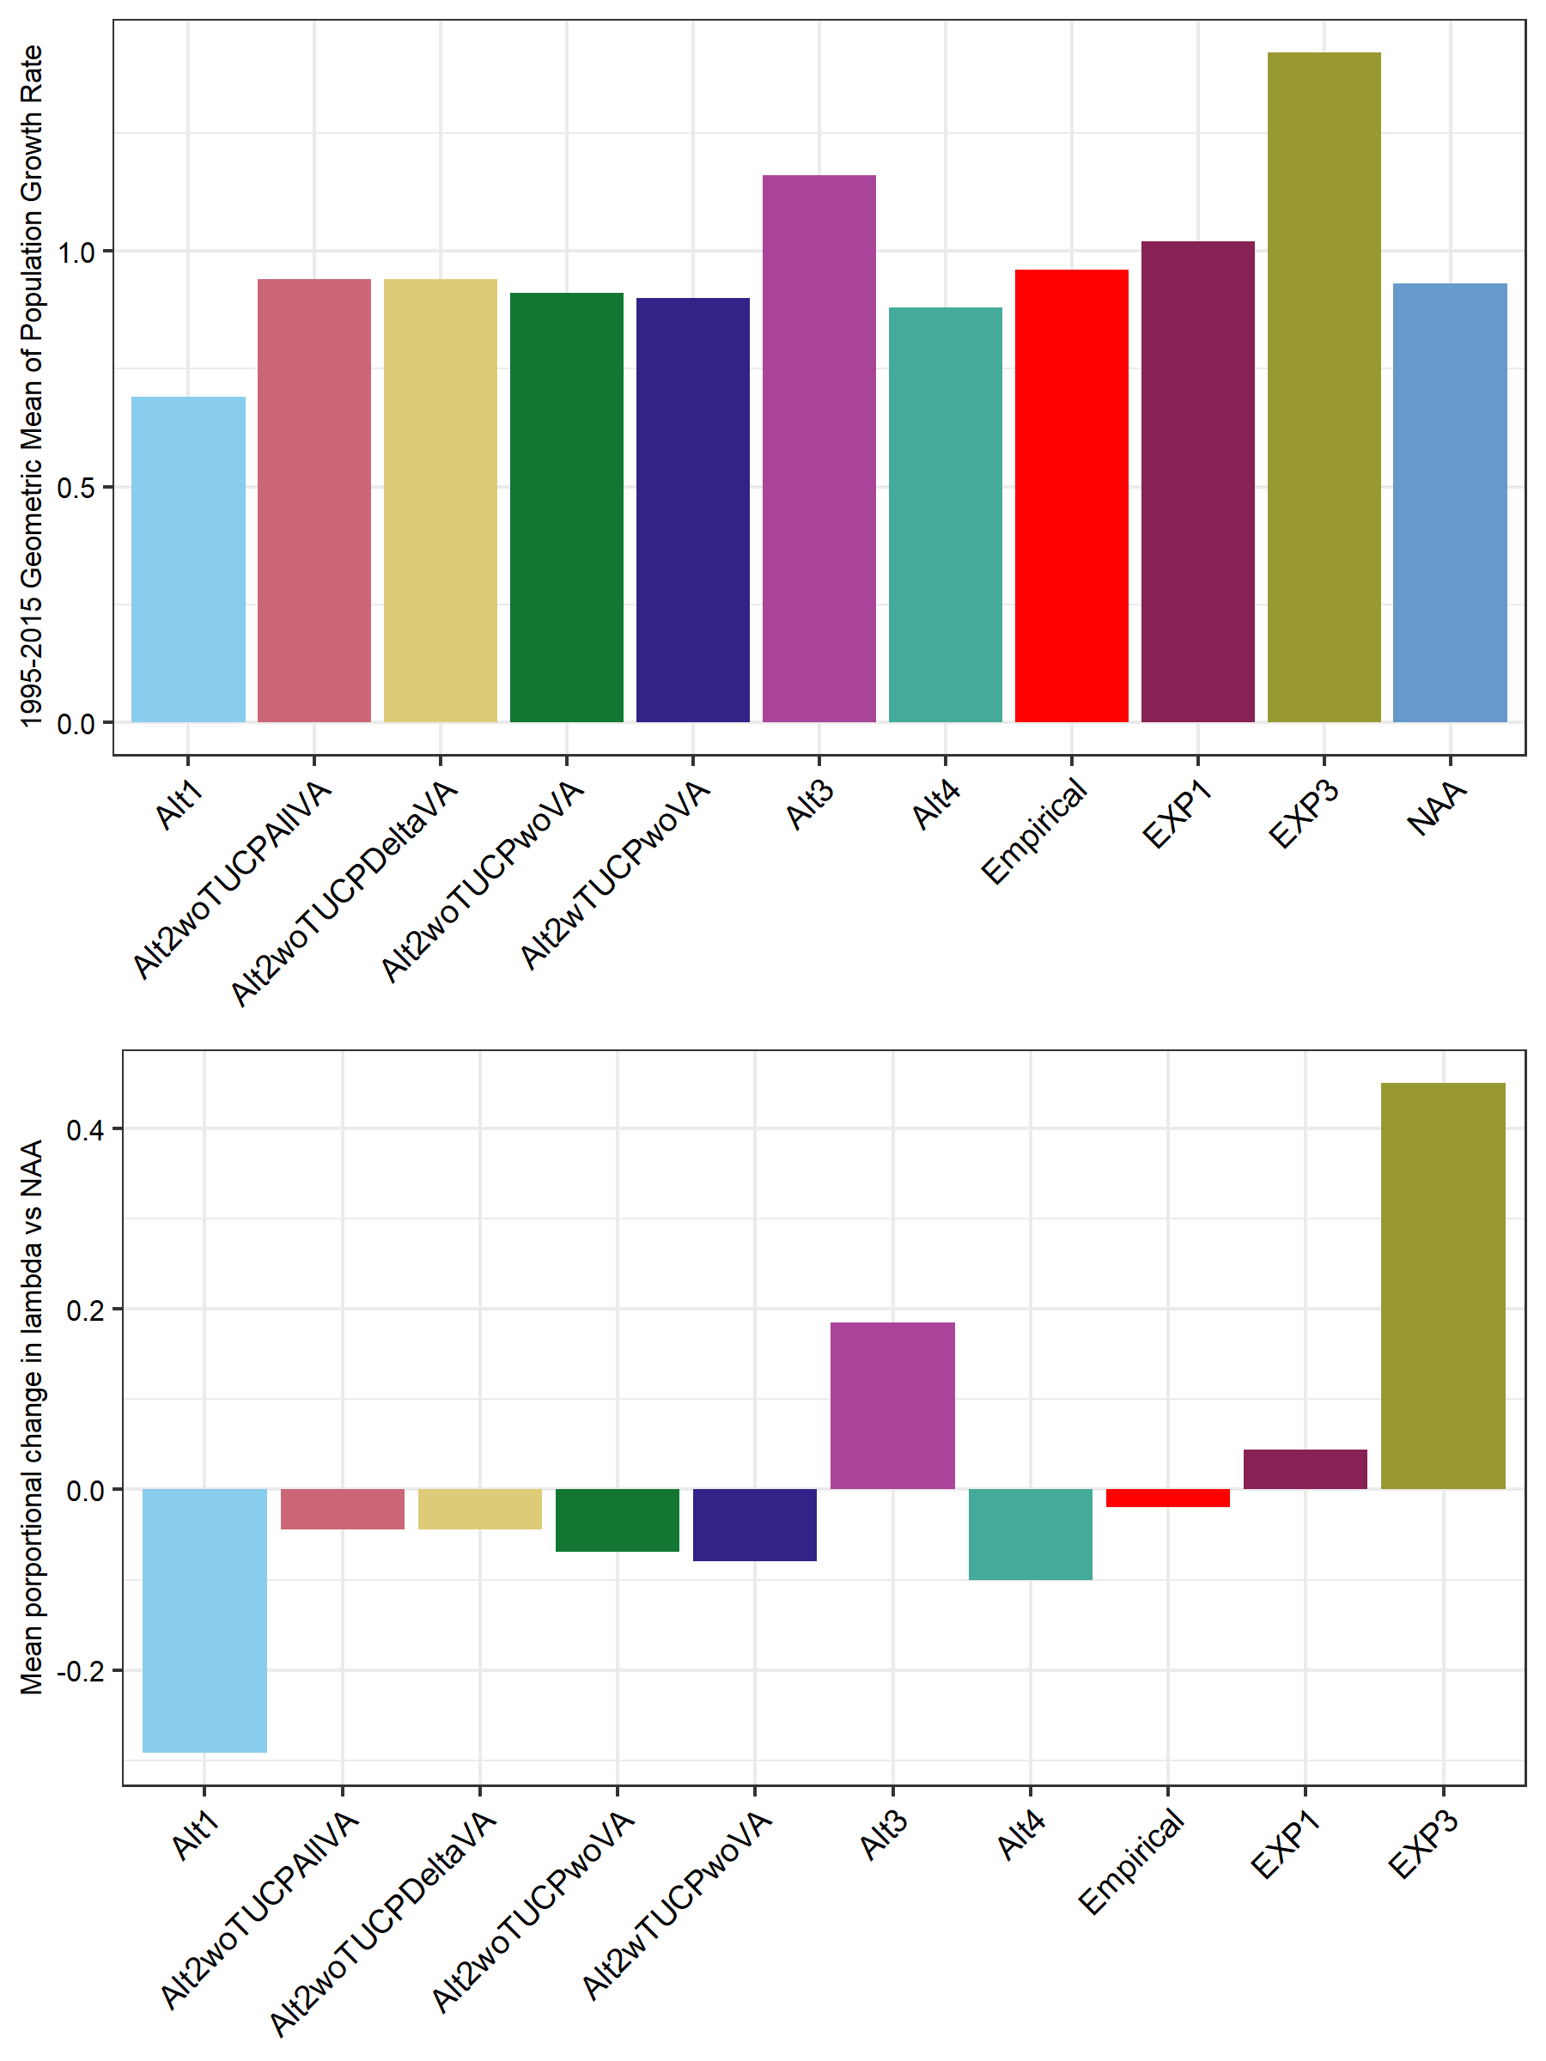 Figure 12. Top: Bar plot demonstrating the geometric mean of population growth rate (lambda) from 1995 to 2015 for the various alternatives as seen in Table 4. Bottom: Bar plot demonstrating the relative difference in geometric mean of population growth rate (1995-2015) for each alternative compared to the no action alternative 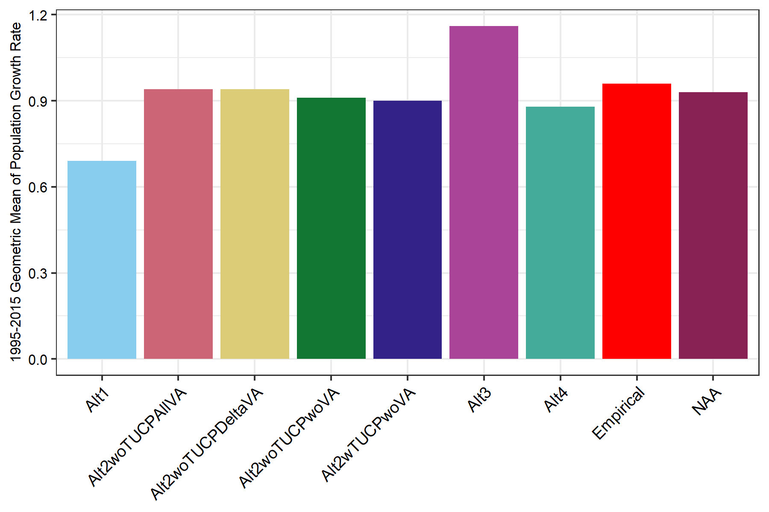

## Joining with `by = join_by(Year)`

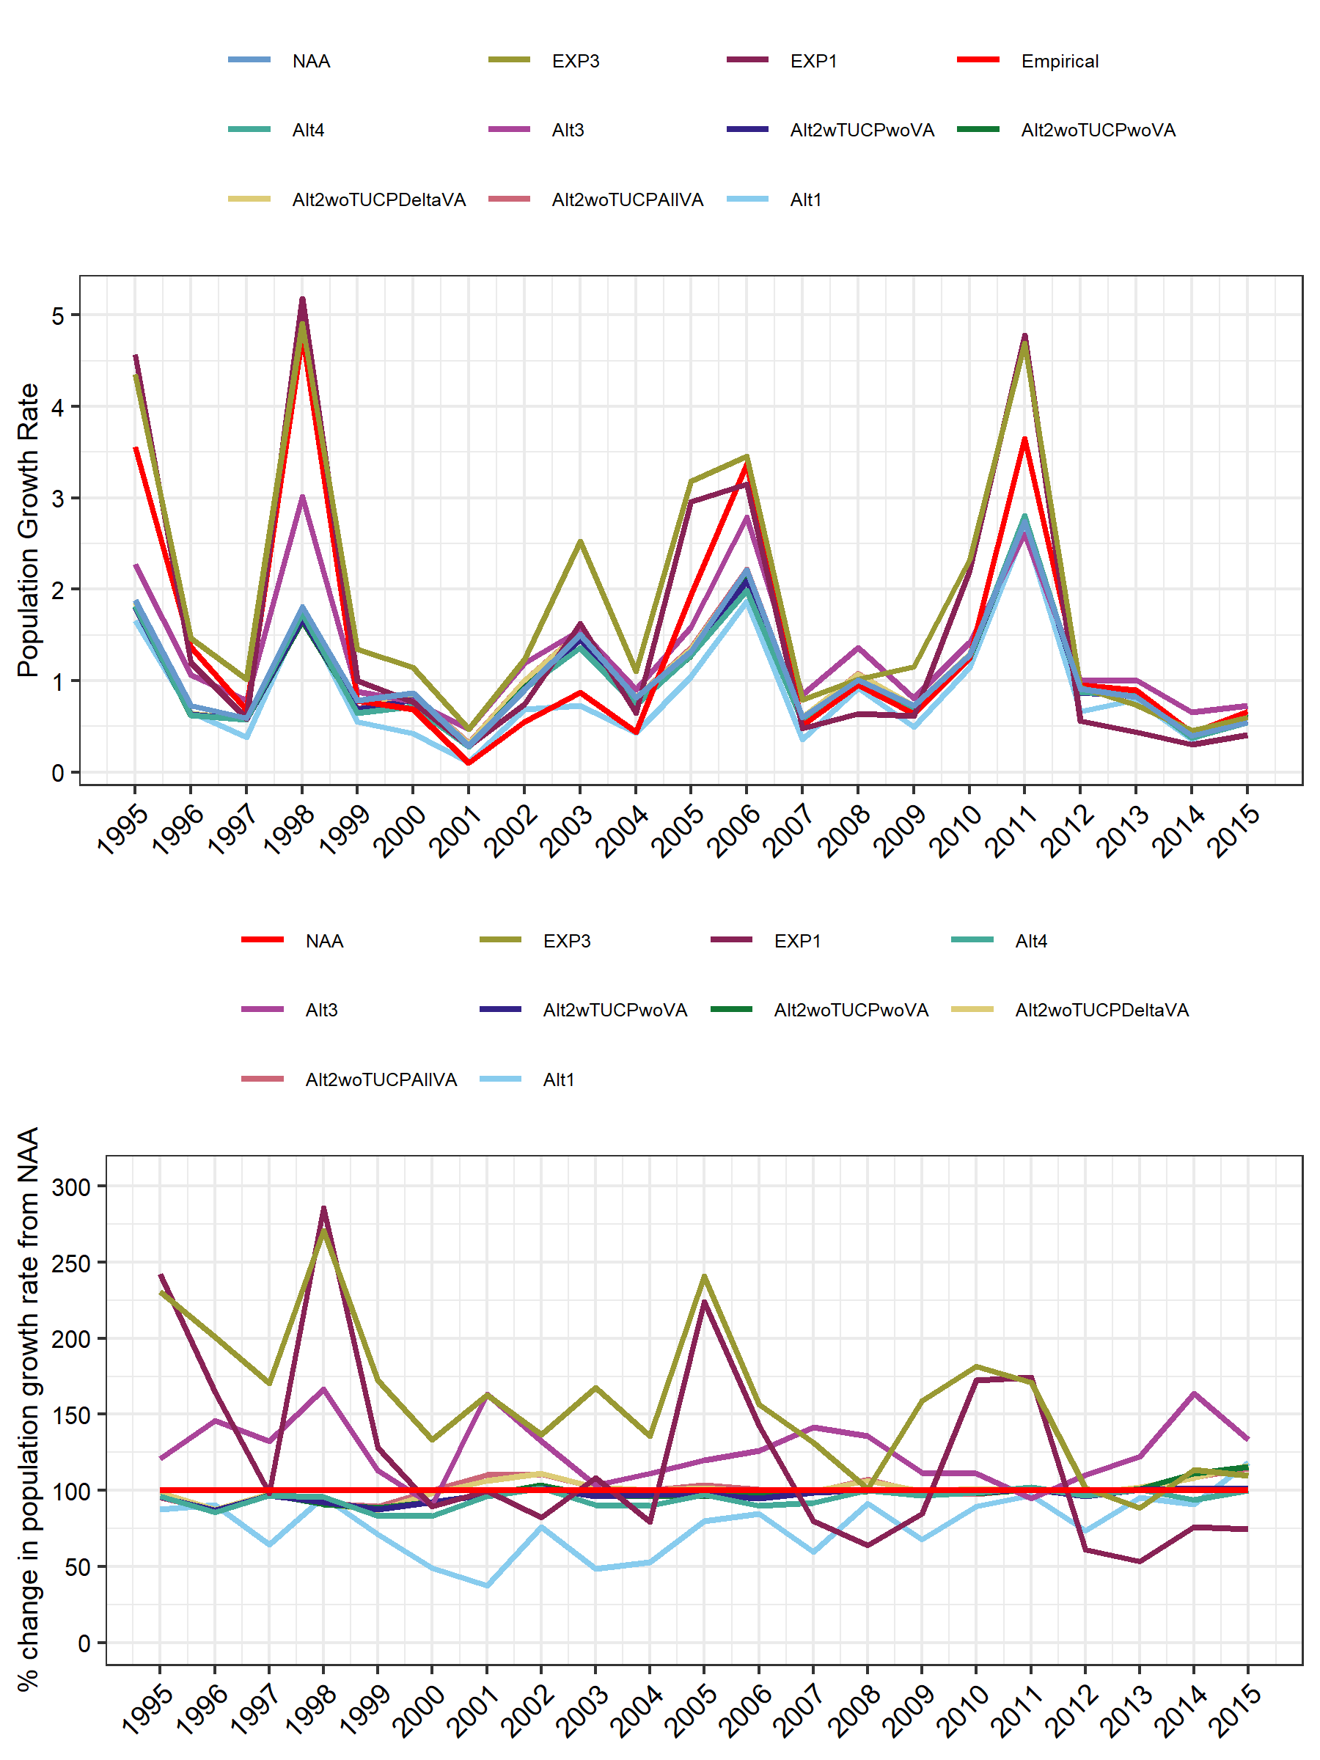

Figure 11. Top: Line plot of population growth rate (lambda) across alternatives as seen in Table 3. Bottom: Line plot showing % change calculated as lambda rate for a given alternative divided by estimated population growth rate for NAA (no action alternative). Note the color change for NAA in the bottom figure.

## [1] "Alt1" "Alt2v1wTUCP" "Alt2v1woTUCP" "Alt2v2noTUCP" "Alt2v3noTUCP"  
## [6] "Alt3" "Alt4" "EXP1" "EXP3" "NAA"

## 'data.frame': 220 obs. of 10 variables:  
## $ Cohort_Year : int 1995 1995 1995 1995 1995 1995 1995 1995 1995 1995 ...  
## $ ACM_BPUV_Feb1Feb1: num 846 846 846 846 846 ...  
## $ ACM_BPUV_Mar1Mar1: num 858 858 858 858 858 ...  
## $ Outflow_Jun0Aug0 : num 2230202 2334699 2334715 2319559 2319780 ...  
## $ OMR_AprMar : num -2605 -2479 -2487 -2280 -2279 ...  
## $ OMR_Jun : num -4663 -4501 -4501 -4514 -4512 ...  
## $ OMR_DecJan : num -8826 -4903 -4903 -4903 -4903 ...  
## $ OMR_Feb : num -301 -4625 -4625 -4625 -4625 ...  
## $ OMR_Mar : num -2636 -4302 -4302 -4303 -4003 ...  
## $ scenario : chr "Alt1" "Alt2wTUCPwoVA" "Alt2woTUCPwoVA" "Alt2woTUCPDeltaVA" ...

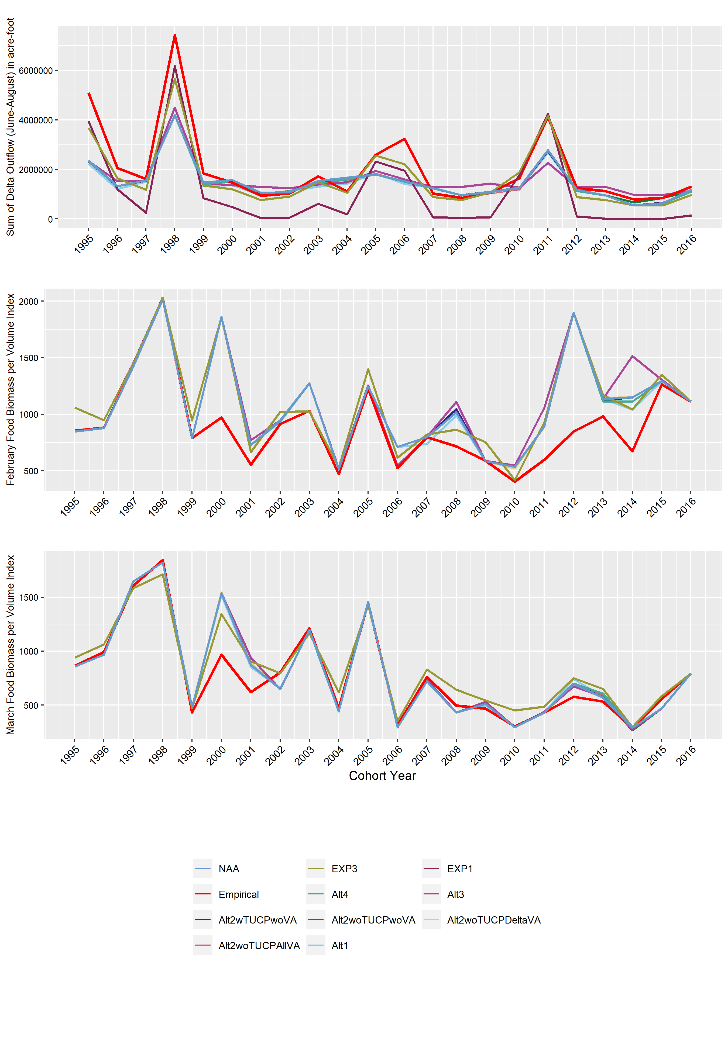 Figure 3. Outflow and prey metric data based on CalSim3 data and salinity-zooplankton model relative to the original dataset used to build the Delta Smelt LCME (labeled as “Empirical”): June-August sum of Delta outflow, February and March prey metric (biomass per volume) data composed of copepod adults, cladocerans, and mysids

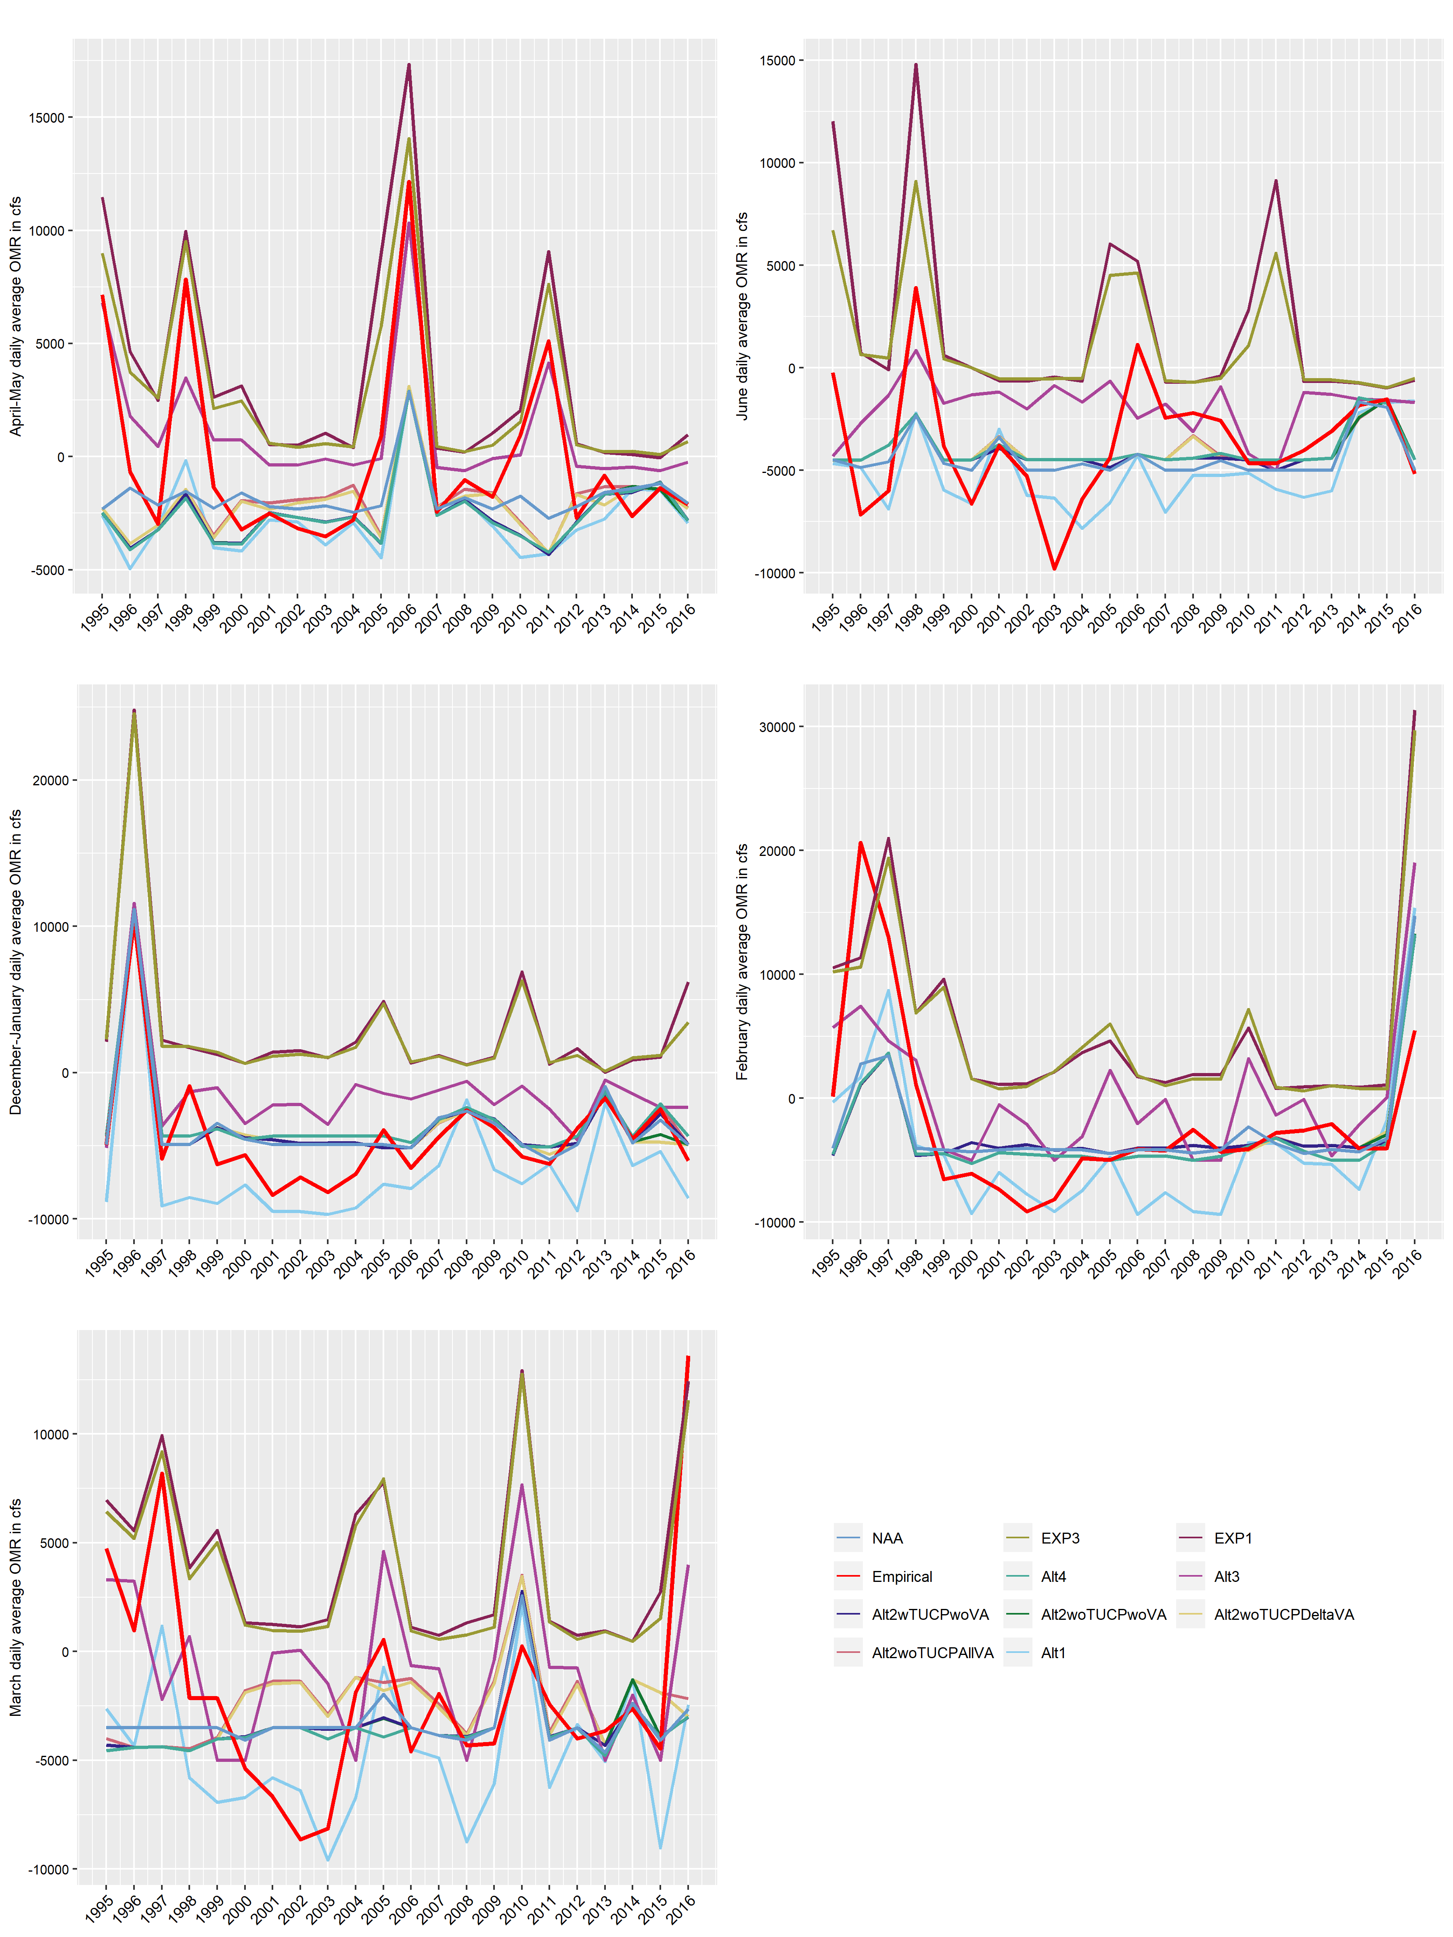

Figure 4. Daily average OMR flow data produced from CalSim3 relative to the original dataset used to build the Delta Smelt LCME (labeled as “Empirical”)

## Warning: The `size` argument of `element_rect()` is deprecated as of ggplot2 3.4.0.  
## ℹ Please use the `linewidth` argument instead.  
## This warning is displayed once every 8 hours.  
## Call `lifecycle::last_lifecycle_warnings()` to see where this warning was  
## generated.

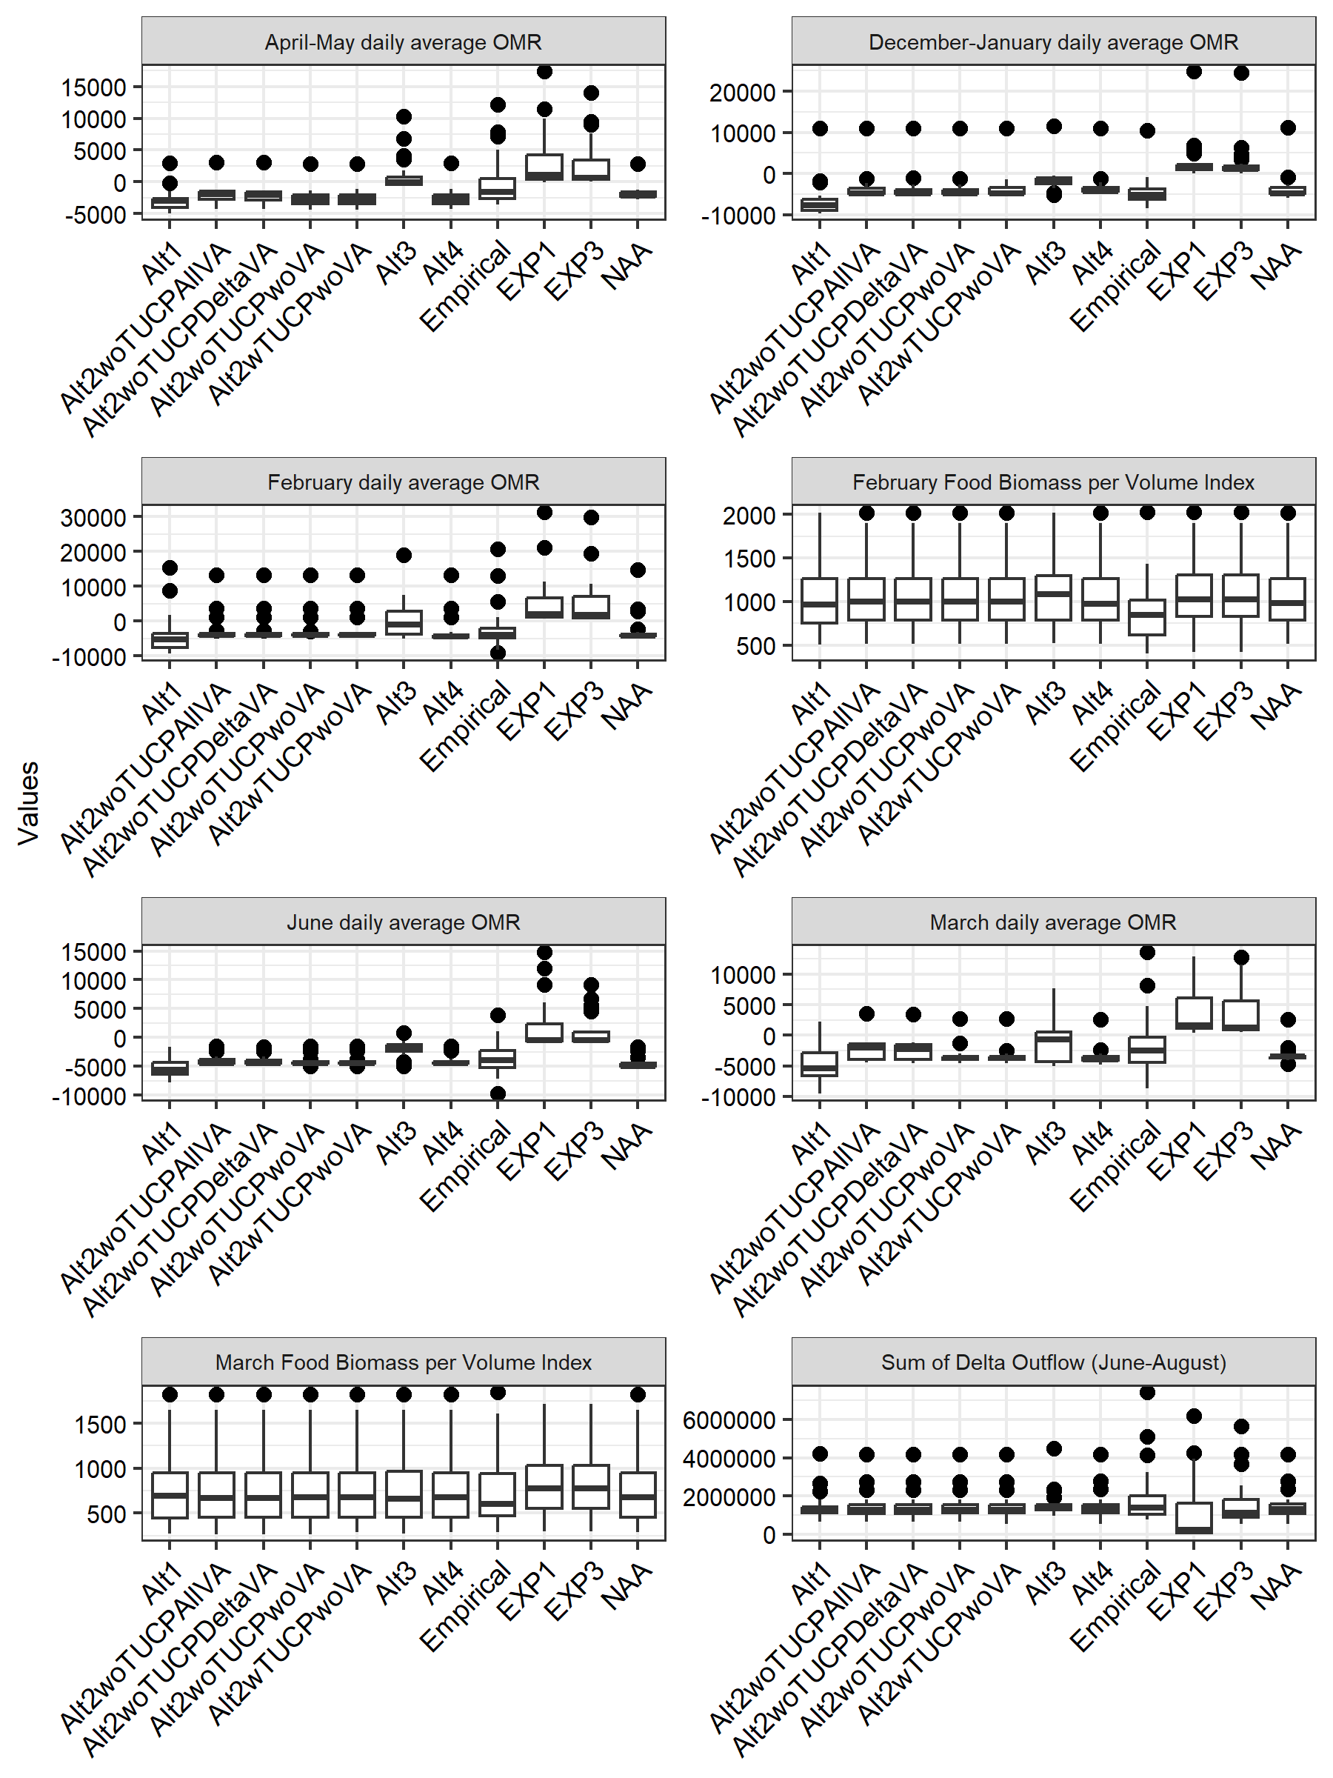

## `summarise()` has grouped output by 'scenario', 'Parameter'. You can override  
## using the `.groups` argument.

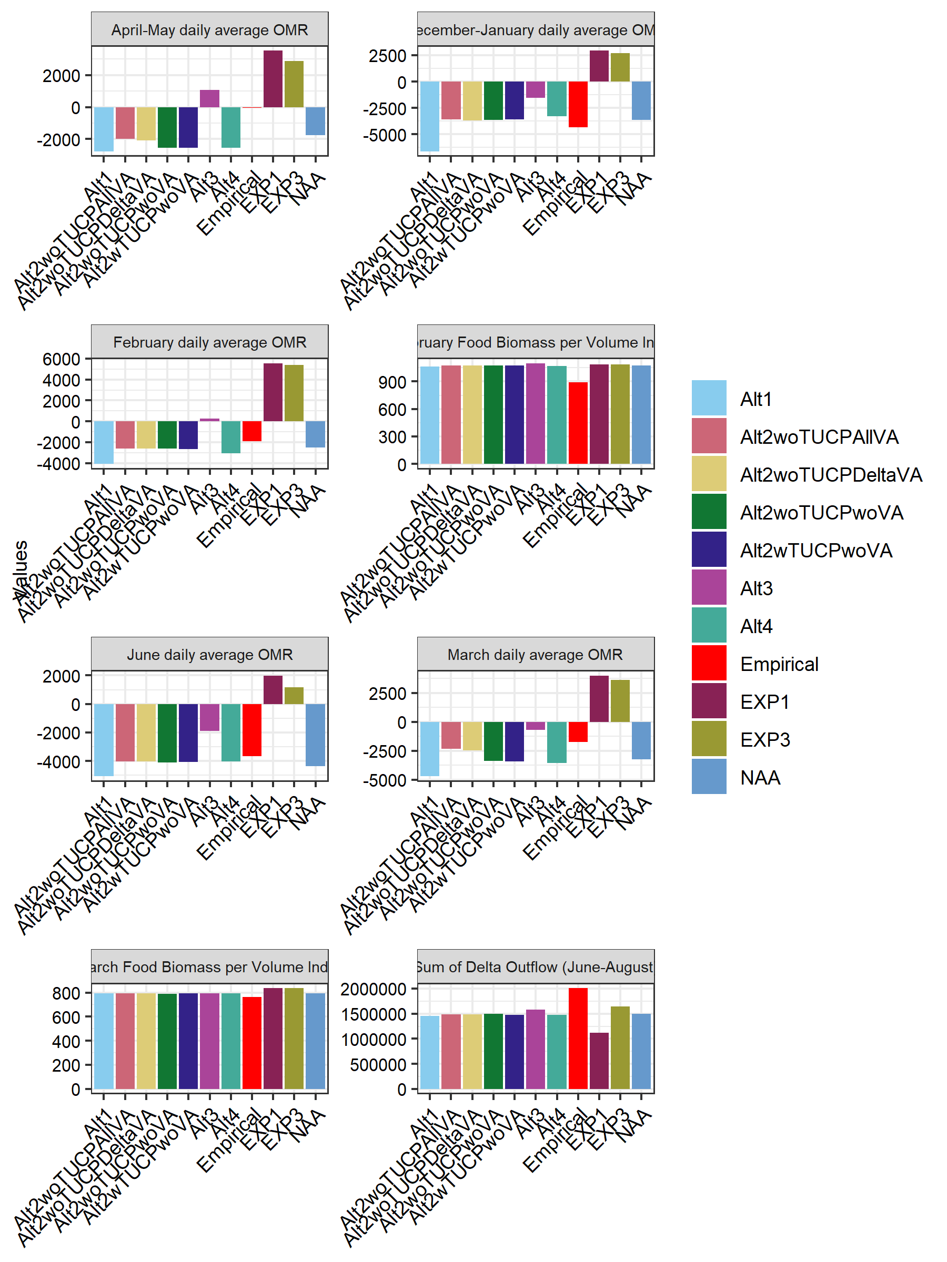

## Warning: `summarise_each()` was deprecated in dplyr 0.7.0.  
## ℹ Please use `across()` instead.  
## Call `lifecycle::last_lifecycle_warnings()` to see where this warning was  
## generated.

## Joining with `by = join_by(Cohort_Year)`

## Warning: `funs()` was deprecated in dplyr 0.8.0.  
## ℹ Please use a list of either functions or lambdas:  
##   
## # Simple named list: list(mean = mean, median = median)  
##   
## # Auto named with `tibble::lst()`: tibble::lst(mean, median)  
##   
## # Using lambdas list(~ mean(., trim = .2), ~ median(., na.rm = TRUE))  
## Call `lifecycle::last_lifecycle_warnings()` to see where this warning was  
## generated.

## Warning: `summarise_each()` was deprecated in dplyr 0.7.0.  
## ℹ Please use `across()` instead.  
## Call `lifecycle::last_lifecycle_warnings()` to see where this warning was  
## generated.

## Joining with `by = join_by(Cohort_Year)`

## Warning: `funs()` was deprecated in dplyr 0.8.0.  
## ℹ Please use a list of either functions or lambdas:  
##   
## # Simple named list: list(mean = mean, median = median)  
##   
## # Auto named with `tibble::lst()`: tibble::lst(mean, median)  
##   
## # Using lambdas list(~ mean(., trim = .2), ~ median(., na.rm = TRUE))  
## Call `lifecycle::last_lifecycle_warnings()` to see where this warning was  
## generated.

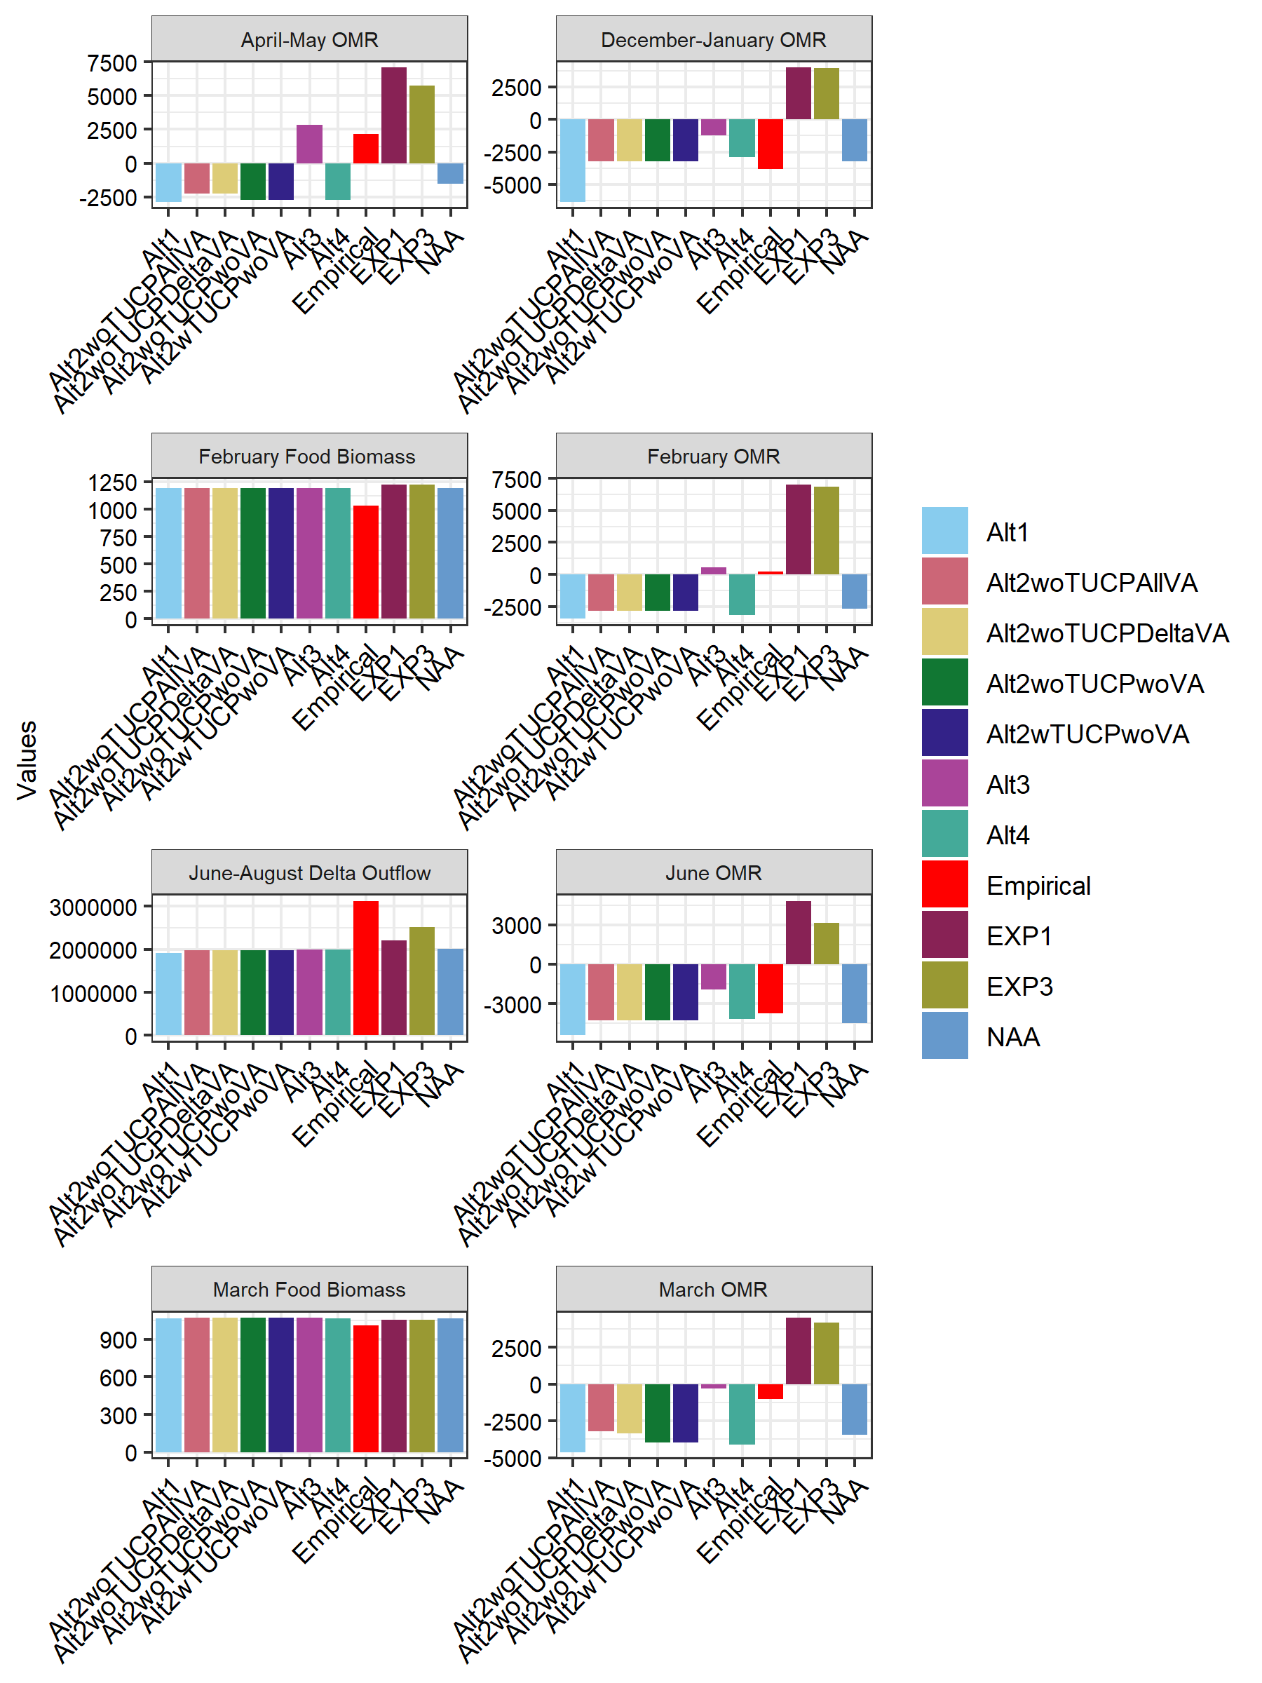 Figure Y1. Mean value of variables used in the LCME for Wet and Above Normal year types. Note that cohort year was matched with the water year that the cohort was born in (e.g., cohort year 1995 = water year 1995).

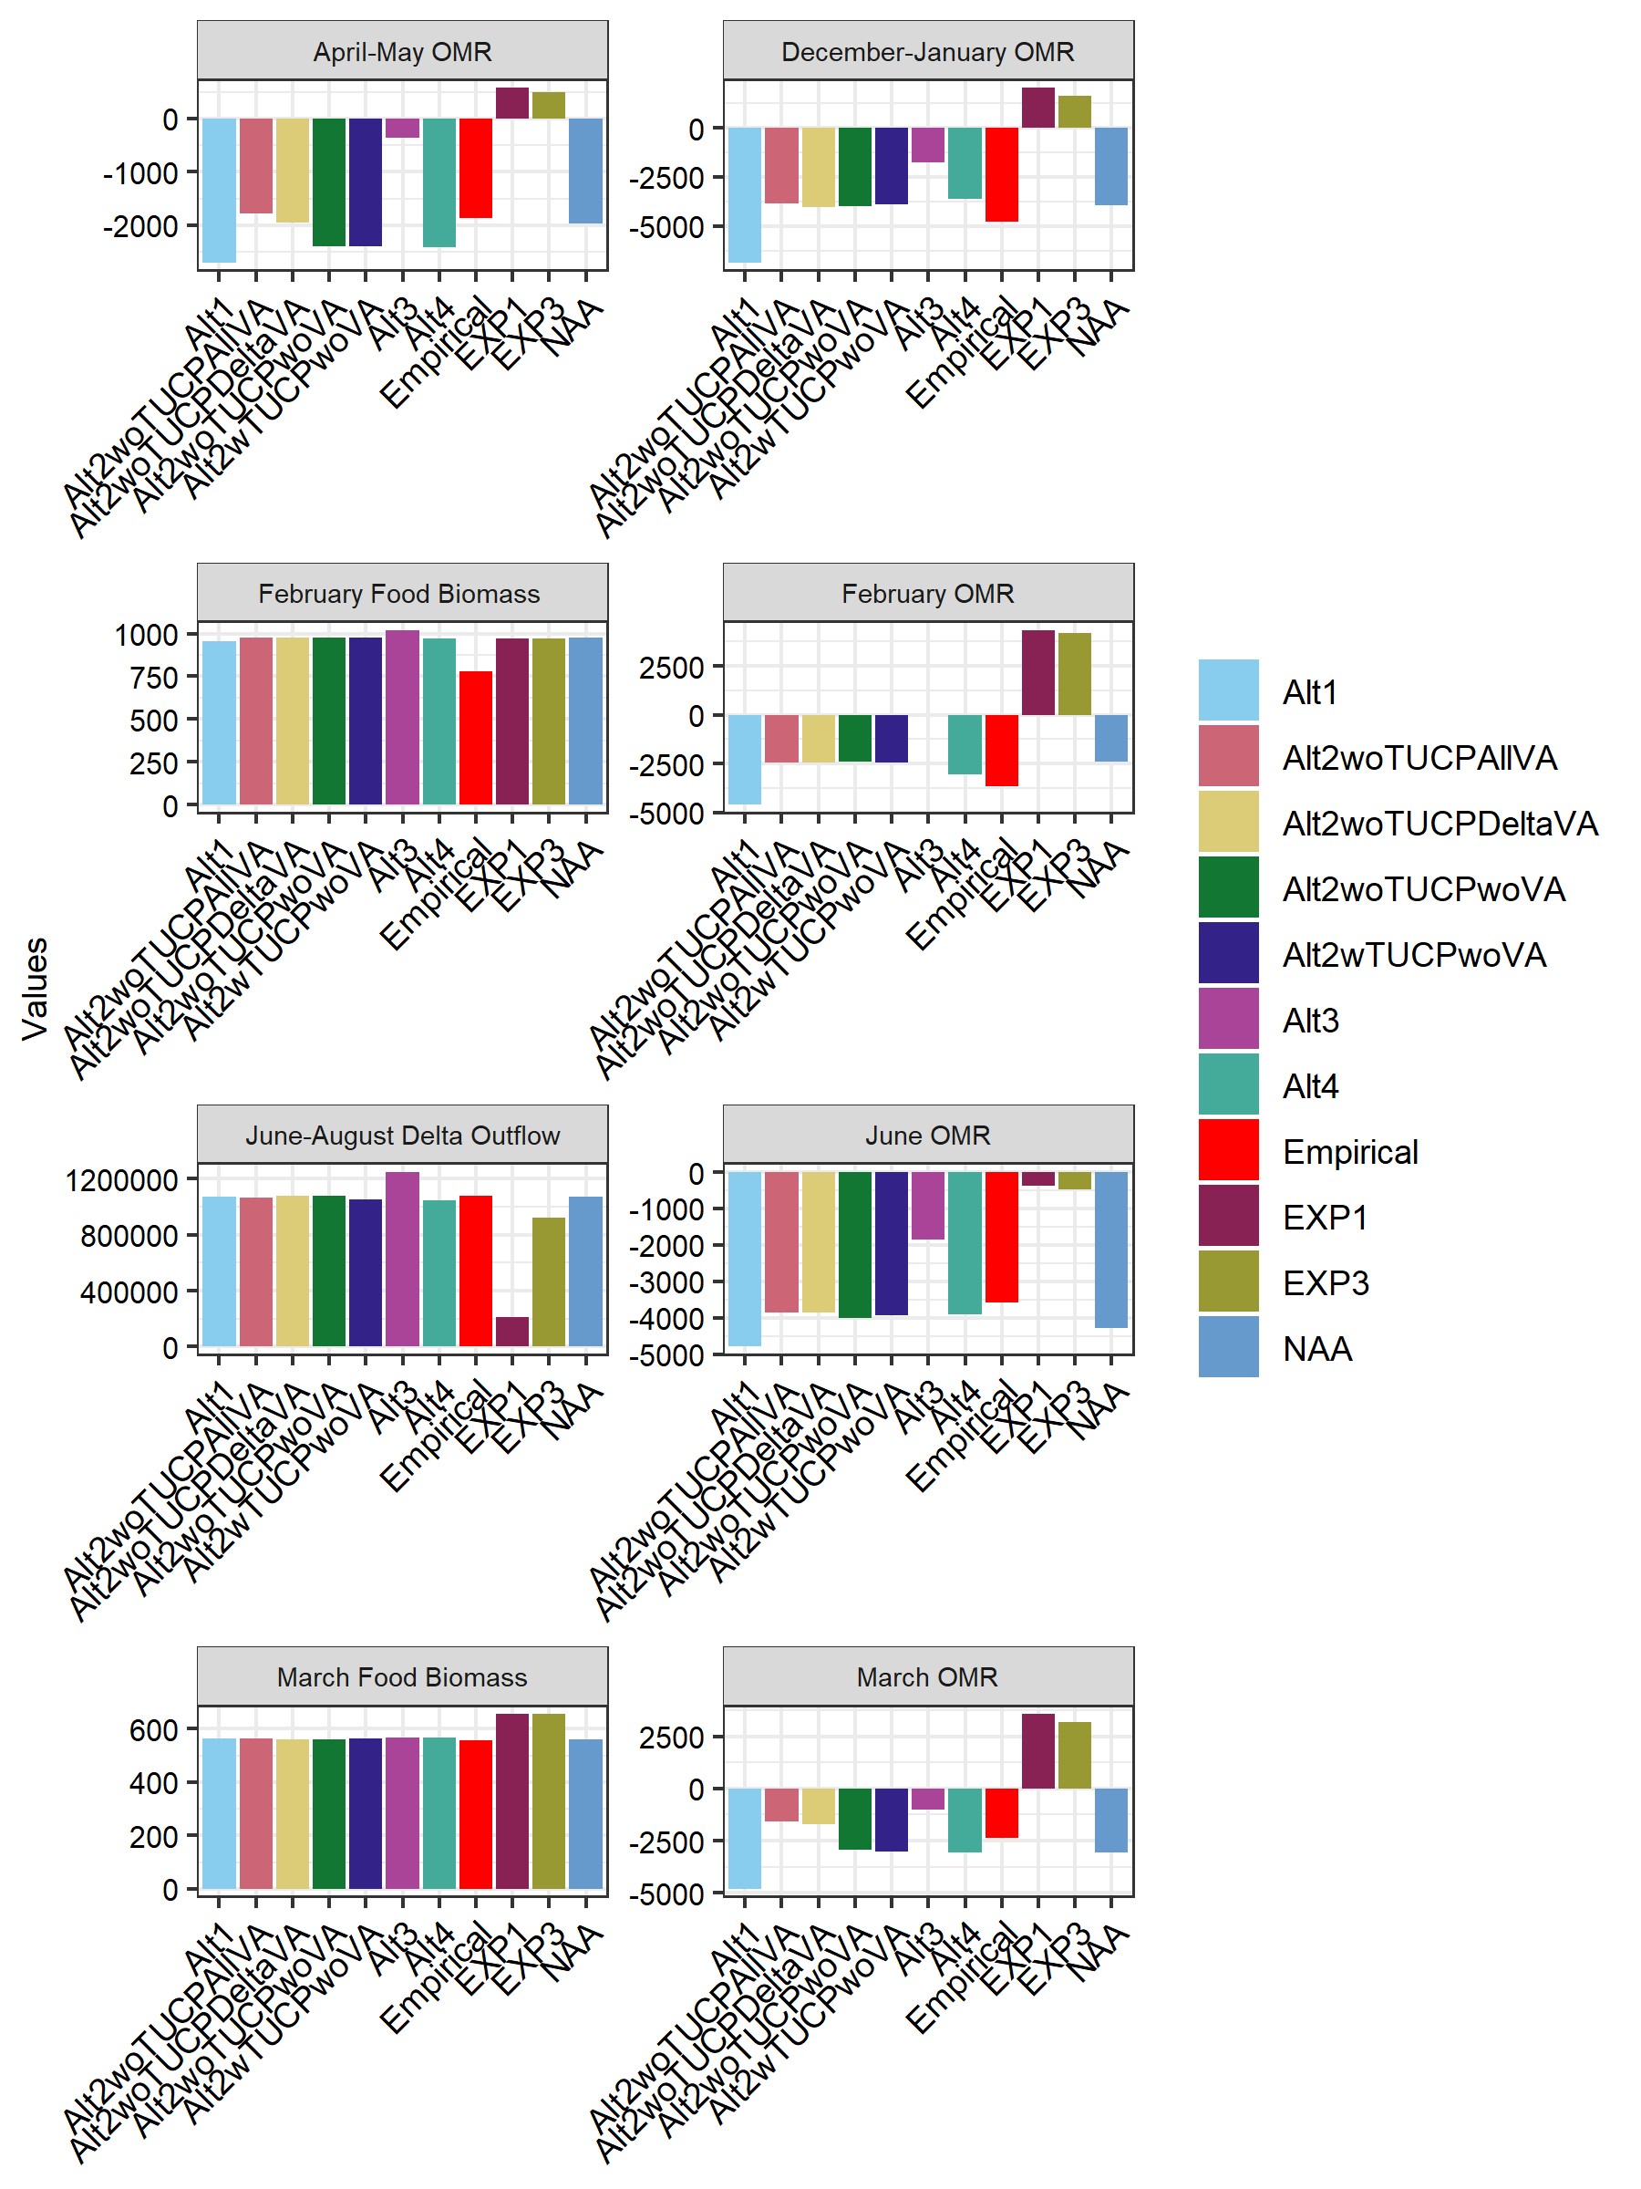

Figure Y2. Mean value of variables used in the LCME for Below Normal, Dry, or Critically Dry year Note that cohort year was matched with the water year that the cohort was born in (e.g., cohort year 1995 = water year 1995).