Expected zooplankton biomass change according to salinity

Brian Mahardja

2023-02-23

Original script and dataset packages was written by Sam Bashevkin and can be found here: <https://github.com/sbashevkin/FLOATDrought>

# Load packages

require(conflicted)  
require(MASS)  
require(dplyr)  
require(zooper)  
require(lubridate)  
require(readr)  
require(tidyr)  
require(ggplot2)  
require(sf)  
require(readxl)  
require(stringr)  
require(mgcv)  
require(purrr)  
require(deltamapr)  
require(scales)  
  
conflict_prefer("filter", "dplyr")  
conflict_prefer("select", "dplyr")

# Load and wrangle data

zoop_data<-Zoopsynther(Data_type="Community", Sources=c("EMP", "STN", "20mm", "FMWT"), Time_consistency = TRUE)

## [1] "These species have no relatives in their size class common to all datasets and have been removed from one or more size classes: Ostracoda Adult (Meso), Cumacea Undifferentiated (Meso), Annelida Adult (Meso), Gammarus Adult (Meso), Orientomysis aspera Adult (Meso), Chironomidae Larva (Meso), Insecta Larva (Meso)"

Read in zoop mass conversions

zoop_mass_conversions<-read_excel("Biomass conversions.xlsx", sheet="Micro and Meso-zooplankton") %>%  
 mutate(Taxname=case_when(Taxname=="Sinocalanus"~"Sinocalanus doerrii", # Change to help this match to zoop data  
 TRUE ~ Taxname),  
 Taxlifestage=paste(Taxname, Lifestage))%>%  
 select(Taxlifestage, CarbonWeight_ug)

Read in zoop groupings

zoop_groups<-read_csv("zoopcrosswalk2.csv", col_types=cols_only(Taxlifestage="c", IBMR="c"))%>%  
 distinct()

Load Mysid biomass data

zoop_mysid<-read_excel("1972-2020MysidBPUEMatrix.xlsx", # EMP  
 sheet="Mysid_BPUE_matrix_1972-2020", na = "NA",  
 col_types = c(rep("numeric", 4), "date", "text", "text", rep("text", 7), rep("numeric", 8)))%>%  
 select(Date=SampleDate, Station=StationNZ, BPUE=`Hyperacanthomysis longirostris`)%>% # Only select Hyperacanthomysis longirostris  
 mutate(Source="EMP")%>%  
 bind_rows(read_csv("FMWT STN 2007to2019 Mysid BPUE.csv", # FMWT/STN  
 col_types=cols_only(Station="c", SampleDate="c", Project="c", `Hyperacanthomysis longirostris`="d"))%>%   
 rename(Date=SampleDate, Source=Project, BPUE=`Hyperacanthomysis longirostris`)%>% # Only select Hyperacanthomysis longirostris  
 mutate(Date=mdy(Date),  
 Station=recode(Station, MONT="Mont", HONK="Honk")))%>% #Get station names to match to main dataset  
 mutate(BPUE_mysid=BPUE*1000, # Convert to ug  
 Taxlifestage="Hyperacanthomysis longirostris Adult",  
 SampleID=paste(Source, Station, Date),  
 SizeClass="Macro")%>%  
 select(SampleID, Taxlifestage, SizeClass, BPUE_mysid)

Start processing the zoop data

zoop_data_mass<-zoop_data%>%  
 mutate(Taxlifestage=str_remove(Taxlifestage, fixed("_UnID")))%>%  
 filter(  
 !(SizeClass=="Meso" & #eliminating species which are counted in meso and micro and retained better in the micro net from the meso calcs  
   
 Taxlifestage%in%c("Asplanchna Adult", "Copepoda Larva","Cyclopoida Juvenile", "Eurytemora Larva", "Harpacticoida Undifferentiated",  
 "Keratella Adult", "Limnoithona Adult", "Limnoithona Juvenile", "Limnoithona sinenesis Adult", "Limnoithona tetraspina  
 Adult", "Oithona Adult", "Oithona Juvenile", "Oithona davisae Adult", "Polyarthra Adult","Pseudodiaptomus Larva",   
 "Rotifera Adult", "Sinocalanus doerrii Larva", "Synchaeta Adult", "Synchaeta bicornis Adult", "Trichocerca Adult")) &  
   
 !(SizeClass=="Micro" &Taxlifestage%in%c("Cirripedia Larva", "Cyclopoida Adult", "Oithona similis")) & #removing categories better retained in meso net from micro net matrix  
 Order!="Amphipoda" & # Remove amphipods  
 (Order!="Mysida" | Taxlifestage=="Hyperacanthomysis longirostris Adult"))%>% #Only retain Hyperacanthomysis longirostris  
 mutate(Taxlifestage=recode(Taxlifestage, `Synchaeta bicornis Adult`="Synchaeta Adult", # Change some names to match to biomass conversion dataset  
 `Pseudodiaptomus Adult`="Pseudodiaptomus forbesi Adult",  
 `Acanthocyclops vernalis Adult`="Acanthocyclops Adult"))%>%  
 left_join(zoop_mass_conversions, by="Taxlifestage")%>% # Add biomass conversions  
 left_join(zoop_mysid, by=c("SampleID", "Taxlifestage", "SizeClass"))%>% # Add mysid biomass  
 left_join(zoop_groups, by="Taxlifestage")%>% # Add IBMR categories  
 mutate(BPUE=if_else(Taxlifestage=="Hyperacanthomysis longirostris Adult", BPUE_mysid, CPUE*CarbonWeight_ug))%>% # Create 1 BPUE variable  
 filter(!is.na(BPUE) & !is.na(Latitude) & !is.na(Longitude) & !is.na(SalSurf))%>% # Removes any data without BPUE, which is currently restricted to Decapod Larvae, and H. longirostris from STN. Also removes 20mm and EMP EZ stations without coordinates  
 group_by(IBMR)%>%  
 mutate(flag=if_else(all(c("Micro", "Meso")%in%SizeClass), "Remove", "Keep"))%>% # This and the next 2 lines are meant to ensure that all categories are consistent across the surveys. Since only EMP samples microzoops, only EMP data can be used for categories that include both micro and mesozoops.  
 ungroup()%>%  
 filter(!(flag=="Remove" & Source!="EMP"))%>%  
 select(SampleID, Station, Latitude, Longitude, SalSurf, Date, Year, IBMR, BPUE)%>%  
 group_by(across(-BPUE))%>%  
 summarise(BPUE=sum(BPUE), .groups="drop")%>% # Sum each IBMR categories  
 st_as_sf(coords=c("Longitude", "Latitude"), crs=4326)%>%  
 st_transform(crs=st_crs(deltamapr::R_DSIBM)) %>%   
 st_join(deltamapr::R_DSIBM %>%  
 select(SUBREGION)) %>%  
 st_drop_geometry() %>%   
 filter(SUBREGION %in% c("NW Suisun","SW Suisun","NE Suisun","SE Suisun","Confluence", "Suisun Marsh"))%>%  
 mutate(doy=yday(Date), #Day of year  
 Month=month(Date), # Month  
 Year_fac=factor(Year), # Factor year for model random effect  
 Station_fac=factor(Station), # Factor station for model random effect  
 across(c(SalSurf, doy), list(s=~(.x-mean(.x))/sd(.x))), # Center and standardize predictors  
 BPUE_log1p=log(BPUE+1)) # log1p transform BPUE for model

Check sample size

zoop_sample_size <- zoop_data_mass %>%   
 group_by(SampleID,Year,Month,SUBREGION,Station) %>%   
 summarise(BPUE=sum(BPUE)) %>%   
 mutate(Samplesize=1) %>%  
 group_by(Year, Month, SUBREGION) %>%   
 summarise(mean_BPUE=mean(BPUE),Samplesize=sum(Samplesize)) %>%  
 filter(Year>=1995)  
  
ggplot(zoop_sample_size, aes(x=Year, y=Month, fill=Samplesize))+  
 geom_tile()+  
 scale_y_continuous(breaks=1:12, labels=month(1:12, label=T))+  
 scale_fill_viridis_c(breaks=c(1,5,10,15,20))+  
 facet_wrap(~SUBREGION)+  
 theme_bw()

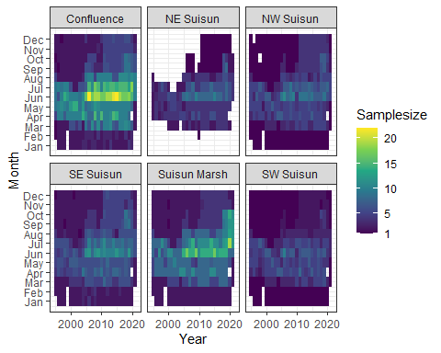

All the remaining brackish regions have sufficient sample size with the exception of NE Suisun. As such, NE Suisun is to be combined with SE Suisun while the rest of the regions are to be analyzed on their own.

Create a new column with IBMR edited regions to accomodate combination of NE and SE Suisun regions.

zoop_data_mass$Subregion_edit<-ifelse(zoop_data_mass$SUBREGION%in%c("NE Suisun", "SE Suisun"), "East Suisun", zoop_data_mass$SUBREGION)

# Model

## Prediction data

Set up prediction data for model

# Min year to start models  
year_min<-1995  
  
newdata_function<-function(region, data=zoop_data_mass, quant=0.99){  
   
 lower<-(1-quant)/(2)  
 upper<-1-lower  
   
 data_filt<-data%>%  
 filter(Subregion_edit%in%region & Year >= year_min)  
   
 # Calculate monthly quantiles of salinity  
 month_sal<-data_filt%>%  
 group_by(Month)%>%  
 summarise(l=quantile(SalSurf, lower),  
 u=quantile(SalSurf, upper), .groups="drop")  
   
 newdata<-expand_grid(date=mdy(paste(1:12, 15, 2001, sep="/")), # The 15th of each month on a non-leap year  
 SalSurf=seq(round(min(data_filt$SalSurf), 1),   
 round(max(data_filt$SalSurf), 1), by=0.1))%>% # Salinity sequence nicely rounded to 1 decimal  
 mutate(Month=month(date),  
 doy=yday(date), # Day of year  
 SalSurf_s=(SalSurf-mean(data$SalSurf))/sd(data$SalSurf), # center and standardize salinity to match data  
 doy_s=(doy-mean(data$doy))/sd(data$doy))%>% # center and standardize doy to match data  
 left_join(month_sal, by="Month")%>%  
 filter(SalSurf >= l & SalSurf <= u)%>% # Remove any salinity values outside the quantiles for each month  
 select(Month, doy, doy_s, SalSurf, SalSurf_s)  
   
}  
  
newdata<-map(set_names(unique(zoop_data_mass$Subregion_edit)), newdata_function)

## Posterior prediction function

# Function to generate posterior predictions from a gam model  
# From https://stats.stackexchange.com/questions/190348/can-i-use-bootstrapping-to-estimate-the-uncertainty-in-a-maximum-value-of-a-gam  
predict_posterior<-function(model, newdata, exclude, n=1e3, seed=999){  
 Xp <- predict(model, newdata=newdata, type="lpmatrix", exclude=exclude, newdata.guaranteed=TRUE) ## map coefs to fitted curves  
 beta <- coef(model)  
 Vb <- vcov(model) ## posterior mean and cov of coefs  
 set.seed(seed)  
 mrand <- mvrnorm(n, beta, Vb) ## simulate n rep coef vectors from posterior  
 pred<-matrix(nrow=nrow(newdata), ncol=n)  
 ilink <- family(model)$linkinv  
 for (i in seq_len(n)) {   
 pred[,i] <- ilink(Xp %*% mrand[i, ])  
 }  
 colnames(pred)<-paste("draw", 1:n, sep="_")  
 pred<-as_tibble(pred)  
 return(pred)  
}

## Model fitting

model

sal_model<-function(group,region,new_data=newdata){  
   
 cat("<<<<<<<<<<<<<<<<<<<<<<< modeling", group, region, ">>>>>>>>>>>>>>>>>>>>>>>>>\n\n")  
   
 new_data<-new_data[[region]]  
   
 data<-filter(zoop_data_mass, IBMR==group & Subregion_edit==region & Year>=year_min)  
   
 par(mfrow=c(2,2))  
   
 if(length(unique(data$Station_fac))>1){  
 model<-gam(BPUE_log1p ~ te(SalSurf_s, doy_s, k=c(5,5), bs=c("cs", "cc")) +   
 s(Year_fac, bs="re") + s(Station_fac, bs="re"),  
 data=data,   
 method="REML")  
   
 random_effects<-c("s(Year_fac)", "s(Station_fac)")  
   
 }else{  
   
 model<-gam(BPUE_log1p ~ te(SalSurf_s, doy_s, k=c(5,5), bs=c("cs", "cc")) +   
 s(Year_fac, bs="re"),  
 data=data,   
 method="REML")  
   
 random_effects<-c("s(Year_fac)")  
 }  
   
 cat("-------------gam check-------------\n")  
 gam.check(model)  
   
 cat("\n\n-------------summary-------------\n")  
 print(summary(model))  
   
 sal<-predict_posterior(model, new_data, random_effects)%>%  
 bind_cols(new_data%>% # Add covariate columns before these columns  
 select(-doy_s, -SalSurf_s),   
 .)  
 return(sal)  
}

Apply model to all groups and regions

model_factors<-expand_grid(IBMR=unique(zoop_data_mass$IBMR),  
 Subregion_edit=unique(zoop_data_mass$Subregion_edit))%>%  
 mutate(IBMR=set_names(IBMR, paste(IBMR, Subregion_edit)))  
  
sal_conversions<-pmap_dfr(model_factors, function(IBMR, Subregion_edit) sal_model(IBMR, Subregion_edit), .id = "IBMR_region")%>%  
 mutate(IBMR=sapply(IBMR_region, function(x) str_split(x, " ", n=2)[[1]][1]),  
 Region=factor(sapply(IBMR_region, function(x) str_split(x, " ", n=2)[[1]][2]),  
 levels=c("Confluence", "Suisun Marsh", "East Suisun",   
 "NW Suisun", "SW Suisun")),  
 Month=as.integer(Month))%>%  
 select(-IBMR_region, -doy)%>%  
 relocate(Region, Month, IBMR, SalSurf)

## <<<<<<<<<<<<<<<<<<<<<<< modeling acartela SW Suisun >>>>>>>>>>>>>>>>>>>>>>>>>  
##   
## -------------gam check-------------

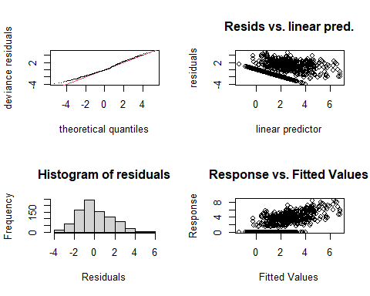

##   
## Method: REML Optimizer: outer newton  
## full convergence after 9 iterations.  
## Gradient range [-0.0008716295,0.0004190904]  
## (score 1715.145 & scale 2.632838).  
## Hessian positive definite, eigenvalue range [0.745521,435.8626].  
## Model rank = 52 / 52   
##   
## Basis dimension (k) checking results. Low p-value (k-index<1) may  
## indicate that k is too low, especially if edf is close to k'.  
##   
## k' edf k-index p-value  
## te(SalSurf_s,doy_s) 19.00 11.64 0.98 0.2  
## s(Year_fac) 27.00 23.14 NA NA  
## s(Station_fac) 5.00 3.62 NA NA  
##   
##   
## -------------summary-------------  
##   
## Family: gaussian   
## Link function: identity   
##   
## Formula:  
## BPUE_log1p ~ te(SalSurf_s, doy_s, k = c(5, 5), bs = c("cs", "cc")) +   
## s(Year_fac, bs = "re") + s(Station_fac, bs = "re")  
##   
## Parametric coefficients:  
## Estimate Std. Error t value Pr(>|t|)   
## (Intercept) 2.7432 0.7262 3.777 0.00017 ***  
## ---  
## Signif. codes: 0 '***' 0.001 '**' 0.01 '*' 0.05 '.' 0.1 ' ' 1  
##   
## Approximate significance of smooth terms:  
## edf Ref.df F p-value   
## te(SalSurf_s,doy_s) 11.636 19 765.56 < 0.0000000000000002 ***  
## s(Year_fac) 23.139 26 10.22 < 0.0000000000000002 ***  
## s(Station_fac) 3.621 4 11.92 0.00000148 ***  
## ---  
## Signif. codes: 0 '***' 0.001 '**' 0.01 '*' 0.05 '.' 0.1 ' ' 1  
##   
## R-sq.(adj) = 0.476 Deviance explained = 49.9%  
## -REML = 1715.1 Scale est. = 2.6328 n = 872  
## <<<<<<<<<<<<<<<<<<<<<<< modeling acartela NW Suisun >>>>>>>>>>>>>>>>>>>>>>>>>  
##   
## -------------gam check-------------

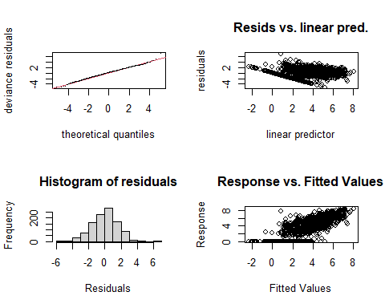

##   
## Method: REML Optimizer: outer newton  
## full convergence after 8 iterations.  
## Gradient range [-0.0000005608474,0.000000006506185]  
## (score 2045.78 & scale 2.45869).  
## Hessian positive definite, eigenvalue range [1.392725,526.3635].  
## Model rank = 52 / 52   
##   
## Basis dimension (k) checking results. Low p-value (k-index<1) may  
## indicate that k is too low, especially if edf is close to k'.  
##   
## k' edf k-index p-value   
## te(SalSurf_s,doy_s) 19.00 16.00 0.95 0.035 *  
## s(Year_fac) 27.00 24.70 NA NA   
## s(Station_fac) 5.00 3.65 NA NA   
## ---  
## Signif. codes: 0 '***' 0.001 '**' 0.01 '*' 0.05 '.' 0.1 ' ' 1  
##   
##   
## -------------summary-------------  
##   
## Family: gaussian   
## Link function: identity   
##   
## Formula:  
## BPUE_log1p ~ te(SalSurf_s, doy_s, k = c(5, 5), bs = c("cs", "cc")) +   
## s(Year_fac, bs = "re") + s(Station_fac, bs = "re")  
##   
## Parametric coefficients:  
## Estimate Std. Error t value Pr(>|t|)   
## (Intercept) 2.7000 0.4879 5.534 0.0000000399 ***  
## ---  
## Signif. codes: 0 '***' 0.001 '**' 0.01 '*' 0.05 '.' 0.1 ' ' 1  
##   
## Approximate significance of smooth terms:  
## edf Ref.df F p-value   
## te(SalSurf_s,doy_s) 16.002 19 242.22 <0.0000000000000002 ***  
## s(Year_fac) 24.696 26 22.22 <0.0000000000000002 ***  
## s(Station_fac) 3.647 4 31.48 <0.0000000000000002 ***  
## ---  
## Signif. codes: 0 '***' 0.001 '**' 0.01 '*' 0.05 '.' 0.1 ' ' 1  
##   
## R-sq.(adj) = 0.615 Deviance explained = 63.1%  
## -REML = 2045.8 Scale est. = 2.4587 n = 1053  
## <<<<<<<<<<<<<<<<<<<<<<< modeling acartela East Suisun >>>>>>>>>>>>>>>>>>>>>>>>>  
##   
## -------------gam check-------------

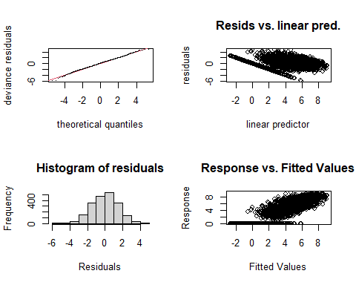

##   
## Method: REML Optimizer: outer newton  
## full convergence after 8 iterations.  
## Gradient range [-0.000008380611,0.000006853298]  
## (score 4083.025 & scale 2.415967).  
## Hessian positive definite, eigenvalue range [2.78405,1067.704].  
## Model rank = 57 / 57   
##   
## Basis dimension (k) checking results. Low p-value (k-index<1) may  
## indicate that k is too low, especially if edf is close to k'.  
##   
## k' edf k-index p-value   
## te(SalSurf_s,doy_s) 19.00 17.44 0.87 <0.0000000000000002 ***  
## s(Year_fac) 27.00 25.51 NA NA   
## s(Station_fac) 10.00 7.68 NA NA   
## ---  
## Signif. codes: 0 '***' 0.001 '**' 0.01 '*' 0.05 '.' 0.1 ' ' 1  
##   
##   
## -------------summary-------------  
##   
## Family: gaussian   
## Link function: identity   
##   
## Formula:  
## BPUE_log1p ~ te(SalSurf_s, doy_s, k = c(5, 5), bs = c("cs", "cc")) +   
## s(Year_fac, bs = "re") + s(Station_fac, bs = "re")  
##   
## Parametric coefficients:  
## Estimate Std. Error t value Pr(>|t|)   
## (Intercept) 4.1254 0.3596 11.47 <0.0000000000000002 ***  
## ---  
## Signif. codes: 0 '***' 0.001 '**' 0.01 '*' 0.05 '.' 0.1 ' ' 1  
##   
## Approximate significance of smooth terms:  
## edf Ref.df F p-value   
## te(SalSurf_s,doy_s) 17.441 19 918.26 <0.0000000000000002 ***  
## s(Year_fac) 25.507 26 52.52 <0.0000000000000002 ***  
## s(Station_fac) 7.681 9 14.49 <0.0000000000000002 ***  
## ---  
## Signif. codes: 0 '***' 0.001 '**' 0.01 '*' 0.05 '.' 0.1 ' ' 1  
##   
## R-sq.(adj) = 0.701 Deviance explained = 70.8%  
## -REML = 4083 Scale est. = 2.416 n = 2136  
## <<<<<<<<<<<<<<<<<<<<<<< modeling acartela Confluence >>>>>>>>>>>>>>>>>>>>>>>>>  
##   
## -------------gam check-------------

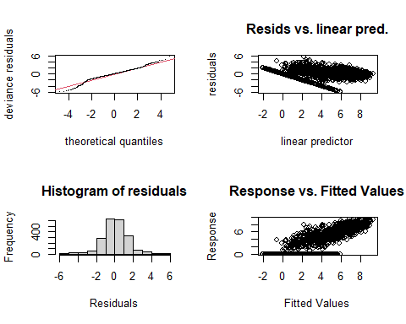

##   
## Method: REML Optimizer: outer newton  
## full convergence after 6 iterations.  
## Gradient range [-0.0007116881,0.000442029]  
## (score 3781.189 & scale 1.912601).  
## Hessian positive definite, eigenvalue range [2.621942,1054.7].  
## Model rank = 57 / 57   
##   
## Basis dimension (k) checking results. Low p-value (k-index<1) may  
## indicate that k is too low, especially if edf is close to k'.  
##   
## k' edf k-index p-value   
## te(SalSurf_s,doy_s) 19.00 16.83 0.92 <0.0000000000000002 ***  
## s(Year_fac) 27.00 25.21 NA NA   
## s(Station_fac) 10.00 7.32 NA NA   
## ---  
## Signif. codes: 0 '***' 0.001 '**' 0.01 '*' 0.05 '.' 0.1 ' ' 1  
##   
##   
## -------------summary-------------  
##   
## Family: gaussian   
## Link function: identity   
##   
## Formula:  
## BPUE_log1p ~ te(SalSurf_s, doy_s, k = c(5, 5), bs = c("cs", "cc")) +   
## s(Year_fac, bs = "re") + s(Station_fac, bs = "re")  
##   
## Parametric coefficients:  
## Estimate Std. Error t value Pr(>|t|)   
## (Intercept) 3.9822 0.2334 17.06 <0.0000000000000002 ***  
## ---  
## Signif. codes: 0 '***' 0.001 '**' 0.01 '*' 0.05 '.' 0.1 ' ' 1  
##   
## Approximate significance of smooth terms:  
## edf Ref.df F p-value   
## te(SalSurf_s,doy_s) 16.831 19 3379.16 <0.0000000000000002 ***  
## s(Year_fac) 25.208 26 35.19 <0.0000000000000002 ***  
## s(Station_fac) 7.324 9 12.67 <0.0000000000000002 ***  
## ---  
## Signif. codes: 0 '***' 0.001 '**' 0.01 '*' 0.05 '.' 0.1 ' ' 1  
##   
## R-sq.(adj) = 0.812 Deviance explained = 81.7%  
## -REML = 3781.2 Scale est. = 1.9126 n = 2110  
## <<<<<<<<<<<<<<<<<<<<<<< modeling acartela Suisun Marsh >>>>>>>>>>>>>>>>>>>>>>>>>  
##   
## -------------gam check-------------

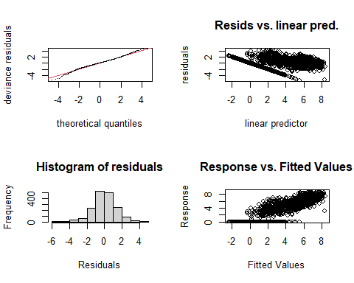

##   
## Method: REML Optimizer: outer newton  
## full convergence after 6 iterations.  
## Gradient range [-0.003409491,0.002637421]  
## (score 3082.202 & scale 1.829951).  
## Hessian positive definite, eigenvalue range [1.971613,868.2386].  
## Model rank = 55 / 55   
##   
## Basis dimension (k) checking results. Low p-value (k-index<1) may  
## indicate that k is too low, especially if edf is close to k'.  
##   
## k' edf k-index p-value   
## te(SalSurf_s,doy_s) 19.00 17.08 0.93 <0.0000000000000002 ***  
## s(Year_fac) 27.00 25.16 NA NA   
## s(Station_fac) 8.00 5.37 NA NA   
## ---  
## Signif. codes: 0 '***' 0.001 '**' 0.01 '*' 0.05 '.' 0.1 ' ' 1  
##   
##   
## -------------summary-------------  
##   
## Family: gaussian   
## Link function: identity   
##   
## Formula:  
## BPUE_log1p ~ te(SalSurf_s, doy_s, k = c(5, 5), bs = c("cs", "cc")) +   
## s(Year_fac, bs = "re") + s(Station_fac, bs = "re")  
##   
## Parametric coefficients:  
## Estimate Std. Error t value Pr(>|t|)   
## (Intercept) 3.4836 0.2261 15.4 <0.0000000000000002 ***  
## ---  
## Signif. codes: 0 '***' 0.001 '**' 0.01 '*' 0.05 '.' 0.1 ' ' 1  
##   
## Approximate significance of smooth terms:  
## edf Ref.df F p-value   
## te(SalSurf_s,doy_s) 17.081 19 1560.923 <0.0000000000000002 ***  
## s(Year_fac) 25.160 26 28.588 <0.0000000000000002 ***  
## s(Station_fac) 5.375 7 8.896 <0.0000000000000002 ***  
## ---  
## Signif. codes: 0 '***' 0.001 '**' 0.01 '*' 0.05 '.' 0.1 ' ' 1  
##   
## R-sq.(adj) = 0.792 Deviance explained = 79.7%  
## -REML = 3082.2 Scale est. = 1.83 n = 1737  
## <<<<<<<<<<<<<<<<<<<<<<< modeling daphnia SW Suisun >>>>>>>>>>>>>>>>>>>>>>>>>  
##   
## -------------gam check-------------

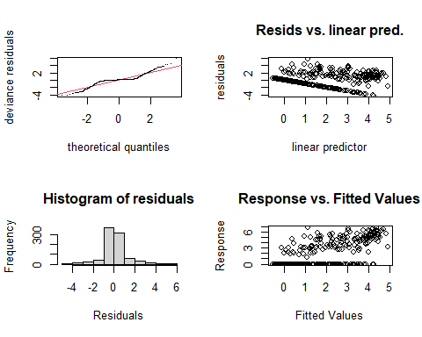

##   
## Method: REML Optimizer: outer newton  
## full convergence after 6 iterations.  
## Gradient range [-0.00005421563,0.00002834637]  
## (score 1372.149 & scale 1.251505).  
## Hessian positive definite, eigenvalue range [0.00005421382,435.7183].  
## Model rank = 52 / 52   
##   
## Basis dimension (k) checking results. Low p-value (k-index<1) may  
## indicate that k is too low, especially if edf is close to k'.  
##   
## k' edf k-index p-value   
## te(SalSurf_s,doy_s) 19.000000 13.854047 0.85 <0.0000000000000002 ***  
## s(Year_fac) 27.000000 16.722465 NA NA   
## s(Station_fac) 5.000000 0.000218 NA NA   
## ---  
## Signif. codes: 0 '***' 0.001 '**' 0.01 '*' 0.05 '.' 0.1 ' ' 1  
##   
##   
## -------------summary-------------  
##   
## Family: gaussian   
## Link function: identity   
##   
## Formula:  
## BPUE_log1p ~ te(SalSurf_s, doy_s, k = c(5, 5), bs = c("cs", "cc")) +   
## s(Year_fac, bs = "re") + s(Station_fac, bs = "re")  
##   
## Parametric coefficients:  
## Estimate Std. Error t value Pr(>|t|)   
## (Intercept) 0.70178 0.06577 10.67 <0.0000000000000002 ***  
## ---  
## Signif. codes: 0 '***' 0.001 '**' 0.01 '*' 0.05 '.' 0.1 ' ' 1  
##   
## Approximate significance of smooth terms:  
## edf Ref.df F p-value   
## te(SalSurf_s,doy_s) 13.8540466 19 81.357 < 0.0000000000000002 ***  
## s(Year_fac) 16.7224645 26 1.909 0.00000161 ***  
## s(Station_fac) 0.0002179 4 0.000 0.609   
## ---  
## Signif. codes: 0 '***' 0.001 '**' 0.01 '*' 0.05 '.' 0.1 ' ' 1  
##   
## R-sq.(adj) = 0.577 Deviance explained = 59.2%  
## -REML = 1372.1 Scale est. = 1.2515 n = 872  
## <<<<<<<<<<<<<<<<<<<<<<< modeling daphnia NW Suisun >>>>>>>>>>>>>>>>>>>>>>>>>  
##   
## -------------gam check-------------

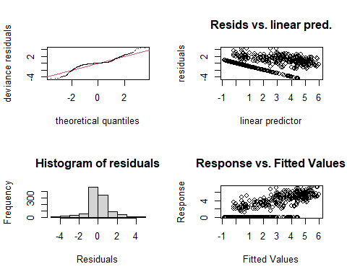

##   
## Method: REML Optimizer: outer newton  
## full convergence after 8 iterations.  
## Gradient range [-0.0002354796,0.0001667292]  
## (score 1643.394 & scale 1.195902).  
## Hessian positive definite, eigenvalue range [1.044054,526.264].  
## Model rank = 52 / 52   
##   
## Basis dimension (k) checking results. Low p-value (k-index<1) may  
## indicate that k is too low, especially if edf is close to k'.  
##   
## k' edf k-index p-value   
## te(SalSurf_s,doy_s) 19.00 16.02 0.9 <0.0000000000000002 ***  
## s(Year_fac) 27.00 20.36 NA NA   
## s(Station_fac) 5.00 2.41 NA NA   
## ---  
## Signif. codes: 0 '***' 0.001 '**' 0.01 '*' 0.05 '.' 0.1 ' ' 1  
##   
##   
## -------------summary-------------  
##   
## Family: gaussian   
## Link function: identity   
##   
## Formula:  
## BPUE_log1p ~ te(SalSurf_s, doy_s, k = c(5, 5), bs = c("cs", "cc")) +   
## s(Year_fac, bs = "re") + s(Station_fac, bs = "re")  
##   
## Parametric coefficients:  
## Estimate Std. Error t value Pr(>|t|)   
## (Intercept) 0.9538 0.1173 8.133 0.00000000000000122 ***  
## ---  
## Signif. codes: 0 '***' 0.001 '**' 0.01 '*' 0.05 '.' 0.1 ' ' 1  
##   
## Approximate significance of smooth terms:  
## edf Ref.df F p-value   
## te(SalSurf_s,doy_s) 16.025 19 207.332 < 0.0000000000000002 ***  
## s(Year_fac) 20.356 26 3.316 < 0.0000000000000002 ***  
## s(Station_fac) 2.411 4 4.598 0.000137 ***  
## ---  
## Signif. codes: 0 '***' 0.001 '**' 0.01 '*' 0.05 '.' 0.1 ' ' 1  
##   
## R-sq.(adj) = 0.696 Deviance explained = 70.7%  
## -REML = 1643.4 Scale est. = 1.1959 n = 1053  
## <<<<<<<<<<<<<<<<<<<<<<< modeling daphnia East Suisun >>>>>>>>>>>>>>>>>>>>>>>>>  
##   
## -------------gam check-------------

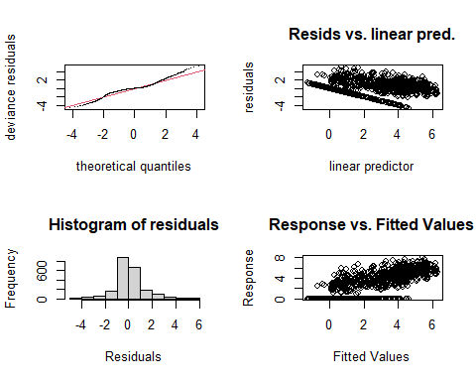

##   
## Method: REML Optimizer: outer newton  
## full convergence after 8 iterations.  
## Gradient range [-0.002248912,0.01393683]  
## (score 3502.017 & scale 1.447167).  
## Hessian positive definite, eigenvalue range [0.003379862,1067.659].  
## Model rank = 57 / 57   
##   
## Basis dimension (k) checking results. Low p-value (k-index<1) may  
## indicate that k is too low, especially if edf is close to k'.  
##   
## k' edf k-index p-value   
## te(SalSurf_s,doy_s) 19.000 17.040 0.87 <0.0000000000000002 ***  
## s(Year_fac) 27.000 24.208 NA NA   
## s(Station_fac) 10.000 0.108 NA NA   
## ---  
## Signif. codes: 0 '***' 0.001 '**' 0.01 '*' 0.05 '.' 0.1 ' ' 1  
##   
##   
## -------------summary-------------  
##   
## Family: gaussian   
## Link function: identity   
##   
## Formula:  
## BPUE_log1p ~ te(SalSurf_s, doy_s, k = c(5, 5), bs = c("cs", "cc")) +   
## s(Year_fac, bs = "re") + s(Station_fac, bs = "re")  
##   
## Parametric coefficients:  
## Estimate Std. Error t value Pr(>|t|)   
## (Intercept) 1.3707 0.1083 12.65 <0.0000000000000002 ***  
## ---  
## Signif. codes: 0 '***' 0.001 '**' 0.01 '*' 0.05 '.' 0.1 ' ' 1  
##   
## Approximate significance of smooth terms:  
## edf Ref.df F p-value   
## te(SalSurf_s,doy_s) 17.0401 19 876.233 <0.0000000000000002 ***  
## s(Year_fac) 24.2079 26 11.745 <0.0000000000000002 ***  
## s(Station_fac) 0.1083 9 0.012 0.429   
## ---  
## Signif. codes: 0 '***' 0.001 '**' 0.01 '*' 0.05 '.' 0.1 ' ' 1  
##   
## R-sq.(adj) = 0.703 Deviance explained = 70.9%  
## -REML = 3502 Scale est. = 1.4472 n = 2136  
## <<<<<<<<<<<<<<<<<<<<<<< modeling daphnia Confluence >>>>>>>>>>>>>>>>>>>>>>>>>  
##   
## -------------gam check-------------

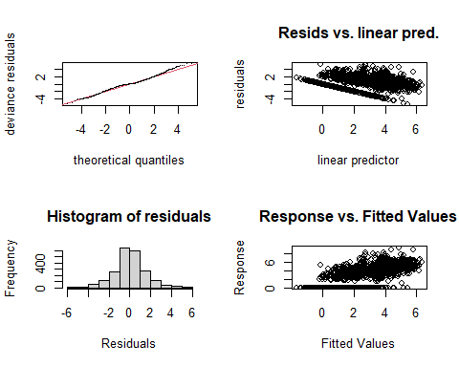

##   
## Method: REML Optimizer: outer newton  
## full convergence after 10 iterations.  
## Gradient range [-0.001255597,0.001799851]  
## (score 3901.874 & scale 2.207772).  
## Hessian positive definite, eigenvalue range [0.001255846,1054.665].  
## Model rank = 57 / 57   
##   
## Basis dimension (k) checking results. Low p-value (k-index<1) may  
## indicate that k is too low, especially if edf is close to k'.  
##   
## k' edf k-index p-value   
## te(SalSurf_s,doy_s) 19.00000 16.22696 0.85 <0.0000000000000002 ***  
## s(Year_fac) 27.00000 23.74698 NA NA   
## s(Station_fac) 10.00000 0.00614 NA NA   
## ---  
## Signif. codes: 0 '***' 0.001 '**' 0.01 '*' 0.05 '.' 0.1 ' ' 1  
##   
##   
## -------------summary-------------  
##   
## Family: gaussian   
## Link function: identity   
##   
## Formula:  
## BPUE_log1p ~ te(SalSurf_s, doy_s, k = c(5, 5), bs = c("cs", "cc")) +   
## s(Year_fac, bs = "re") + s(Station_fac, bs = "re")  
##   
## Parametric coefficients:  
## Estimate Std. Error t value Pr(>|t|)   
## (Intercept) 1.8587 0.1183 15.71 <0.0000000000000002 ***  
## ---  
## Signif. codes: 0 '***' 0.001 '**' 0.01 '*' 0.05 '.' 0.1 ' ' 1  
##   
## Approximate significance of smooth terms:  
## edf Ref.df F p-value   
## te(SalSurf_s,doy_s) 16.226957 19 507.24 <0.0000000000000002 ***  
## s(Year_fac) 23.746982 26 10.46 <0.0000000000000002 ***  
## s(Station_fac) 0.006139 9 0.00 0.731   
## ---  
## Signif. codes: 0 '***' 0.001 '**' 0.01 '*' 0.05 '.' 0.1 ' ' 1  
##   
## R-sq.(adj) = 0.612 Deviance explained = 62%  
## -REML = 3901.9 Scale est. = 2.2078 n = 2110  
## <<<<<<<<<<<<<<<<<<<<<<< modeling daphnia Suisun Marsh >>>>>>>>>>>>>>>>>>>>>>>>>  
##   
## -------------gam check-------------

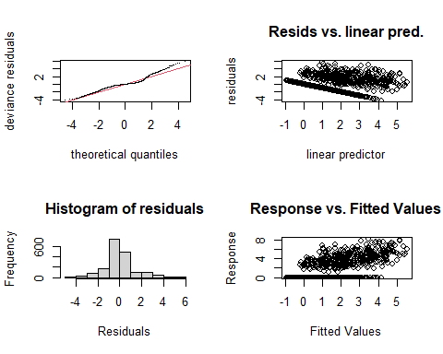

##   
## Method: REML Optimizer: outer newton  
## full convergence after 8 iterations.  
## Gradient range [-0.002942225,0.002626776]  
## (score 2999.595 & scale 1.730712).  
## Hessian positive definite, eigenvalue range [1.583553,868.1809].  
## Model rank = 55 / 55   
##   
## Basis dimension (k) checking results. Low p-value (k-index<1) may  
## indicate that k is too low, especially if edf is close to k'.  
##   
## k' edf k-index p-value   
## te(SalSurf_s,doy_s) 19.00 14.82 0.92 <0.0000000000000002 ***  
## s(Year_fac) 27.00 22.04 NA NA   
## s(Station_fac) 8.00 4.07 NA NA   
## ---  
## Signif. codes: 0 '***' 0.001 '**' 0.01 '*' 0.05 '.' 0.1 ' ' 1  
##   
##   
## -------------summary-------------  
##   
## Family: gaussian   
## Link function: identity   
##   
## Formula:  
## BPUE_log1p ~ te(SalSurf_s, doy_s, k = c(5, 5), bs = c("cs", "cc")) +   
## s(Year_fac, bs = "re") + s(Station_fac, bs = "re")  
##   
## Parametric coefficients:  
## Estimate Std. Error t value Pr(>|t|)   
## (Intercept) 0.9035 0.1074 8.415 <0.0000000000000002 ***  
## ---  
## Signif. codes: 0 '***' 0.001 '**' 0.01 '*' 0.05 '.' 0.1 ' ' 1  
##   
## Approximate significance of smooth terms:  
## edf Ref.df F p-value   
## te(SalSurf_s,doy_s) 14.817 19 117.699 < 0.0000000000000002 ***  
## s(Year_fac) 22.044 26 5.039 < 0.0000000000000002 ***  
## s(Station_fac) 4.072 7 3.154 0.0000781 ***  
## ---  
## Signif. codes: 0 '***' 0.001 '**' 0.01 '*' 0.05 '.' 0.1 ' ' 1  
##   
## R-sq.(adj) = 0.492 Deviance explained = 50.4%  
## -REML = 2999.6 Scale est. = 1.7307 n = 1737  
## <<<<<<<<<<<<<<<<<<<<<<< modeling eurytem SW Suisun >>>>>>>>>>>>>>>>>>>>>>>>>  
##   
## -------------gam check-------------

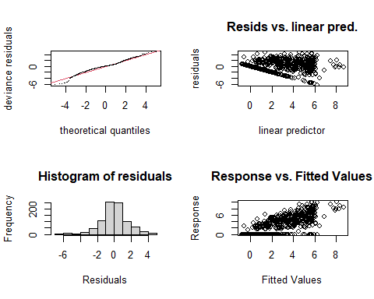

##   
## Method: REML Optimizer: outer newton  
## full convergence after 7 iterations.  
## Gradient range [-0.00002918423,0.00002499156]  
## (score 1666.547 & scale 2.454981).  
## Hessian positive definite, eigenvalue range [1.450192,435.6341].  
## Model rank = 52 / 52   
##   
## Basis dimension (k) checking results. Low p-value (k-index<1) may  
## indicate that k is too low, especially if edf is close to k'.  
##   
## k' edf k-index p-value   
## te(SalSurf_s,doy_s) 19.00 13.01 0.94 0.025 *  
## s(Year_fac) 27.00 11.48 NA NA   
## s(Station_fac) 5.00 3.65 NA NA   
## ---  
## Signif. codes: 0 '***' 0.001 '**' 0.01 '*' 0.05 '.' 0.1 ' ' 1  
##   
##   
## -------------summary-------------  
##   
## Family: gaussian   
## Link function: identity   
##   
## Formula:  
## BPUE_log1p ~ te(SalSurf_s, doy_s, k = c(5, 5), bs = c("cs", "cc")) +   
## s(Year_fac, bs = "re") + s(Station_fac, bs = "re")  
##   
## Parametric coefficients:  
## Estimate Std. Error t value Pr(>|t|)   
## (Intercept) 2.9138 0.7162 4.069 0.0000517 ***  
## ---  
## Signif. codes: 0 '***' 0.001 '**' 0.01 '*' 0.05 '.' 0.1 ' ' 1  
##   
## Approximate significance of smooth terms:  
## edf Ref.df F p-value   
## te(SalSurf_s,doy_s) 13.014 19 1218.972 <0.0000000000000002 ***  
## s(Year_fac) 11.485 26 0.799 0.0105 *   
## s(Station_fac) 3.655 4 11.772 <0.0000000000000002 ***  
## ---  
## Signif. codes: 0 '***' 0.001 '**' 0.01 '*' 0.05 '.' 0.1 ' ' 1  
##   
## R-sq.(adj) = 0.649 Deviance explained = 66%  
## -REML = 1666.5 Scale est. = 2.455 n = 872  
## <<<<<<<<<<<<<<<<<<<<<<< modeling eurytem NW Suisun >>>>>>>>>>>>>>>>>>>>>>>>>  
##   
## -------------gam check-------------

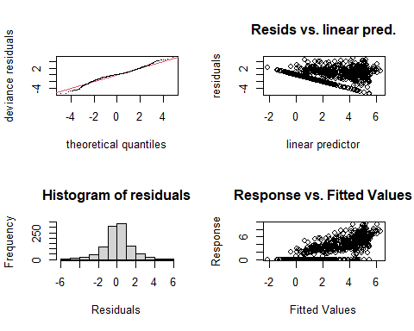

##   
## Method: REML Optimizer: outer newton  
## full convergence after 7 iterations.  
## Gradient range [-0.00002849287,0.00001875845]  
## (score 1957.782 & scale 2.169344).  
## Hessian positive definite, eigenvalue range [0.235629,526.2546].  
## Model rank = 52 / 52   
##   
## Basis dimension (k) checking results. Low p-value (k-index<1) may  
## indicate that k is too low, especially if edf is close to k'.  
##   
## k' edf k-index p-value   
## te(SalSurf_s,doy_s) 19.00 16.81 0.95 0.035 *  
## s(Year_fac) 27.00 19.66 NA NA   
## s(Station_fac) 5.00 1.18 NA NA   
## ---  
## Signif. codes: 0 '***' 0.001 '**' 0.01 '*' 0.05 '.' 0.1 ' ' 1  
##   
##   
## -------------summary-------------  
##   
## Family: gaussian   
## Link function: identity   
##   
## Formula:  
## BPUE_log1p ~ te(SalSurf_s, doy_s, k = c(5, 5), bs = c("cs", "cc")) +   
## s(Year_fac, bs = "re") + s(Station_fac, bs = "re")  
##   
## Parametric coefficients:  
## Estimate Std. Error t value Pr(>|t|)   
## (Intercept) 1.8925 0.1099 17.22 <0.0000000000000002 ***  
## ---  
## Signif. codes: 0 '***' 0.001 '**' 0.01 '*' 0.05 '.' 0.1 ' ' 1  
##   
## Approximate significance of smooth terms:  
## edf Ref.df F p-value   
## te(SalSurf_s,doy_s) 16.813 19 149.515 <0.0000000000000002 ***  
## s(Year_fac) 19.660 26 2.846 <0.0000000000000002 ***  
## s(Station_fac) 1.182 4 0.581 0.138   
## ---  
## Signif. codes: 0 '***' 0.001 '**' 0.01 '*' 0.05 '.' 0.1 ' ' 1  
##   
## R-sq.(adj) = 0.647 Deviance explained = 66%  
## -REML = 1957.8 Scale est. = 2.1693 n = 1053  
## <<<<<<<<<<<<<<<<<<<<<<< modeling eurytem East Suisun >>>>>>>>>>>>>>>>>>>>>>>>>  
##   
## -------------gam check-------------

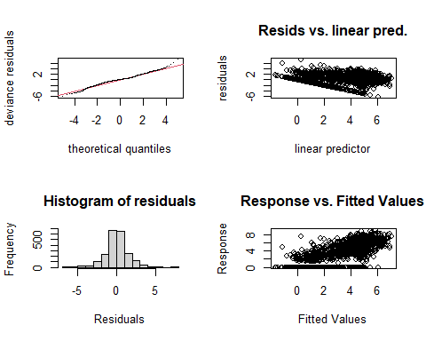

##   
## Method: REML Optimizer: outer newton  
## full convergence after 8 iterations.  
## Gradient range [-0.001657614,0.001595037]  
## (score 3886.496 & scale 2.07351).  
## Hessian positive definite, eigenvalue range [1.325601,1067.664].  
## Model rank = 57 / 57   
##   
## Basis dimension (k) checking results. Low p-value (k-index<1) may  
## indicate that k is too low, especially if edf is close to k'.  
##   
## k' edf k-index p-value   
## te(SalSurf_s,doy_s) 19.00 17.20 0.76 <0.0000000000000002 ***  
## s(Year_fac) 27.00 22.36 NA NA   
## s(Station_fac) 10.00 6.49 NA NA   
## ---  
## Signif. codes: 0 '***' 0.001 '**' 0.01 '*' 0.05 '.' 0.1 ' ' 1  
##   
##   
## -------------summary-------------  
##   
## Family: gaussian   
## Link function: identity   
##   
## Formula:  
## BPUE_log1p ~ te(SalSurf_s, doy_s, k = c(5, 5), bs = c("cs", "cc")) +   
## s(Year_fac, bs = "re") + s(Station_fac, bs = "re")  
##   
## Parametric coefficients:  
## Estimate Std. Error t value Pr(>|t|)   
## (Intercept) 2.227 0.150 14.85 <0.0000000000000002 ***  
## ---  
## Signif. codes: 0 '***' 0.001 '**' 0.01 '*' 0.05 '.' 0.1 ' ' 1  
##   
## Approximate significance of smooth terms:  
## edf Ref.df F p-value   
## te(SalSurf_s,doy_s) 17.199 19 444.675 < 0.0000000000000002 ***  
## s(Year_fac) 22.357 26 5.184 < 0.0000000000000002 ***  
## s(Station_fac) 6.486 9 3.499 0.0000508 ***  
## ---  
## Signif. codes: 0 '***' 0.001 '**' 0.01 '*' 0.05 '.' 0.1 ' ' 1  
##   
## R-sq.(adj) = 0.685 Deviance explained = 69.2%  
## -REML = 3886.5 Scale est. = 2.0735 n = 2136  
## <<<<<<<<<<<<<<<<<<<<<<< modeling eurytem Confluence >>>>>>>>>>>>>>>>>>>>>>>>>  
##   
## -------------gam check-------------

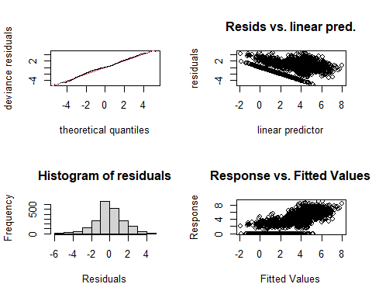

##   
## Method: REML Optimizer: outer newton  
## full convergence after 9 iterations.  
## Gradient range [-0.00001963028,0.00001875904]  
## (score 3932.873 & scale 2.26824).  
## Hessian positive definite, eigenvalue range [0.09758625,1054.656].  
## Model rank = 57 / 57   
##   
## Basis dimension (k) checking results. Low p-value (k-index<1) may  
## indicate that k is too low, especially if edf is close to k'.  
##   
## k' edf k-index p-value   
## te(SalSurf_s,doy_s) 19.00 17.27 0.73 <0.0000000000000002 ***  
## s(Year_fac) 27.00 22.40 NA NA   
## s(Station_fac) 10.00 1.07 NA NA   
## ---  
## Signif. codes: 0 '***' 0.001 '**' 0.01 '*' 0.05 '.' 0.1 ' ' 1  
##   
##   
## -------------summary-------------  
##   
## Family: gaussian   
## Link function: identity   
##   
## Formula:  
## BPUE_log1p ~ te(SalSurf_s, doy_s, k = c(5, 5), bs = c("cs", "cc")) +   
## s(Year_fac, bs = "re") + s(Station_fac, bs = "re")  
##   
## Parametric coefficients:  
## Estimate Std. Error t value Pr(>|t|)   
## (Intercept) 2.31702 0.09598 24.14 <0.0000000000000002 ***  
## ---  
## Signif. codes: 0 '***' 0.001 '**' 0.01 '*' 0.05 '.' 0.1 ' ' 1  
##   
## Approximate significance of smooth terms:  
## edf Ref.df F p-value   
## te(SalSurf_s,doy_s) 17.265 19 271.431 <0.0000000000000002 ***  
## s(Year_fac) 22.404 26 6.288 <0.0000000000000002 ***  
## s(Station_fac) 1.067 9 0.148 0.282   
## ---  
## Signif. codes: 0 '***' 0.001 '**' 0.01 '*' 0.05 '.' 0.1 ' ' 1  
##   
## R-sq.(adj) = 0.668 Deviance explained = 67.5%  
## -REML = 3932.9 Scale est. = 2.2682 n = 2110  
## <<<<<<<<<<<<<<<<<<<<<<< modeling eurytem Suisun Marsh >>>>>>>>>>>>>>>>>>>>>>>>>  
##   
## -------------gam check-------------

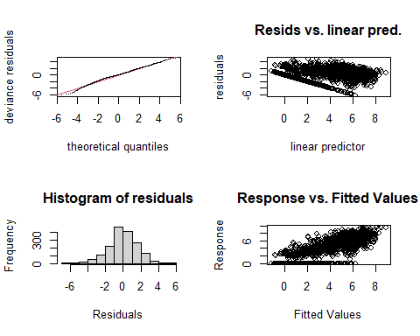

##   
## Method: REML Optimizer: outer newton  
## full convergence after 8 iterations.  
## Gradient range [-0.001657828,0.001185811]  
## (score 3360.674 & scale 2.604153).  
## Hessian positive definite, eigenvalue range [1.197695,868.1907].  
## Model rank = 55 / 55   
##   
## Basis dimension (k) checking results. Low p-value (k-index<1) may  
## indicate that k is too low, especially if edf is close to k'.  
##   
## k' edf k-index p-value   
## te(SalSurf_s,doy_s) 19.00 14.31 0.76 <0.0000000000000002 ***  
## s(Year_fac) 27.00 22.56 NA NA   
## s(Station_fac) 8.00 5.66 NA NA   
## ---  
## Signif. codes: 0 '***' 0.001 '**' 0.01 '*' 0.05 '.' 0.1 ' ' 1  
##   
##   
## -------------summary-------------  
##   
## Family: gaussian   
## Link function: identity   
##   
## Formula:  
## BPUE_log1p ~ te(SalSurf_s, doy_s, k = c(5, 5), bs = c("cs", "cc")) +   
## s(Year_fac, bs = "re") + s(Station_fac, bs = "re")  
##   
## Parametric coefficients:  
## Estimate Std. Error t value Pr(>|t|)   
## (Intercept) 3.3023 0.1916 17.23 <0.0000000000000002 ***  
## ---  
## Signif. codes: 0 '***' 0.001 '**' 0.01 '*' 0.05 '.' 0.1 ' ' 1  
##   
## Approximate significance of smooth terms:  
## edf Ref.df F p-value   
## te(SalSurf_s,doy_s) 14.306 19 405.659 <0.0000000000000002 ***  
## s(Year_fac) 22.561 26 5.804 <0.0000000000000002 ***  
## s(Station_fac) 5.661 7 12.992 <0.0000000000000002 ***  
## ---  
## Signif. codes: 0 '***' 0.001 '**' 0.01 '*' 0.05 '.' 0.1 ' ' 1  
##   
## R-sq.(adj) = 0.709 Deviance explained = 71.6%  
## -REML = 3360.7 Scale est. = 2.6042 n = 1737  
## <<<<<<<<<<<<<<<<<<<<<<< modeling othcalad SW Suisun >>>>>>>>>>>>>>>>>>>>>>>>>  
##   
## -------------gam check-------------

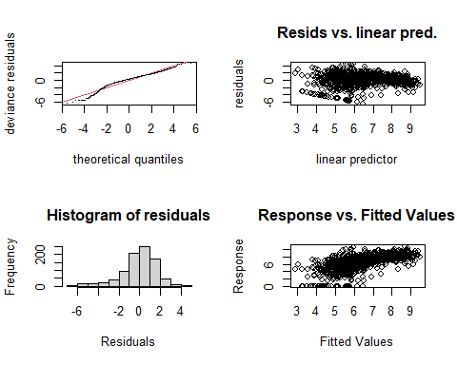

##   
## Method: REML Optimizer: outer newton  
## full convergence after 6 iterations.  
## Gradient range [-0.00000740484,0.000006403041]  
## (score 1748.119 & scale 2.921862).  
## Hessian positive definite, eigenvalue range [1.439647,435.7756].  
## Model rank = 52 / 52   
##   
## Basis dimension (k) checking results. Low p-value (k-index<1) may  
## indicate that k is too low, especially if edf is close to k'.  
##   
## k' edf k-index p-value  
## te(SalSurf_s,doy_s) 19.00 13.09 1.01 0.66  
## s(Year_fac) 27.00 19.50 NA NA  
## s(Station_fac) 5.00 2.86 NA NA  
##   
##   
## -------------summary-------------  
##   
## Family: gaussian   
## Link function: identity   
##   
## Formula:  
## BPUE_log1p ~ te(SalSurf_s, doy_s, k = c(5, 5), bs = c("cs", "cc")) +   
## s(Year_fac, bs = "re") + s(Station_fac, bs = "re")  
##   
## Parametric coefficients:  
## Estimate Std. Error t value Pr(>|t|)   
## (Intercept) 6.5462 0.3625 18.06 <0.0000000000000002 ***  
## ---  
## Signif. codes: 0 '***' 0.001 '**' 0.01 '*' 0.05 '.' 0.1 ' ' 1  
##   
## Approximate significance of smooth terms:  
## edf Ref.df F p-value   
## te(SalSurf_s,doy_s) 13.09 19 121.214 <0.0000000000000002 ***  
## s(Year_fac) 19.50 26 3.572 <0.0000000000000002 ***  
## s(Station_fac) 2.86 4 28.702 <0.0000000000000002 ***  
## ---  
## Signif. codes: 0 '***' 0.001 '**' 0.01 '*' 0.05 '.' 0.1 ' ' 1  
##   
## R-sq.(adj) = 0.405 Deviance explained = 43%  
## -REML = 1748.1 Scale est. = 2.9219 n = 872  
## <<<<<<<<<<<<<<<<<<<<<<< modeling othcalad NW Suisun >>>>>>>>>>>>>>>>>>>>>>>>>  
##   
## -------------gam check-------------

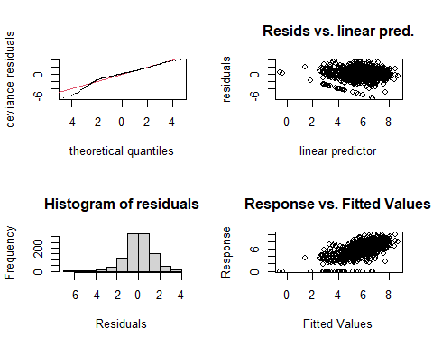

##   
## Method: REML Optimizer: outer newton  
## full convergence after 7 iterations.  
## Gradient range [-0.0007709091,0.0006190273]  
## (score 1898.882 & scale 1.993082).  
## Hessian positive definite, eigenvalue range [1.360136,526.0948].  
## Model rank = 52 / 52   
##   
## Basis dimension (k) checking results. Low p-value (k-index<1) may  
## indicate that k is too low, especially if edf is close to k'.  
##   
## k' edf k-index p-value   
## te(SalSurf_s,doy_s) 19.00 14.97 0.95 0.045 *  
## s(Year_fac) 27.00 8.34 NA NA   
## s(Station_fac) 5.00 3.91 NA NA   
## ---  
## Signif. codes: 0 '***' 0.001 '**' 0.01 '*' 0.05 '.' 0.1 ' ' 1  
##   
##   
## -------------summary-------------  
##   
## Family: gaussian   
## Link function: identity   
##   
## Formula:  
## BPUE_log1p ~ te(SalSurf_s, doy_s, k = c(5, 5), bs = c("cs", "cc")) +   
## s(Year_fac, bs = "re") + s(Station_fac, bs = "re")  
##   
## Parametric coefficients:  
## Estimate Std. Error t value Pr(>|t|)   
## (Intercept) 5.4053 0.7842 6.893 0.00000000000955 ***  
## ---  
## Signif. codes: 0 '***' 0.001 '**' 0.01 '*' 0.05 '.' 0.1 ' ' 1  
##   
## Approximate significance of smooth terms:  
## edf Ref.df F p-value   
## te(SalSurf_s,doy_s) 14.969 19 618.921 <0.0000000000000002 ***  
## s(Year_fac) 8.341 26 0.503 0.0463 *   
## s(Station_fac) 3.906 4 26.054 <0.0000000000000002 ***  
## ---  
## Signif. codes: 0 '***' 0.001 '**' 0.01 '*' 0.05 '.' 0.1 ' ' 1  
##   
## R-sq.(adj) = 0.431 Deviance explained = 44.6%  
## -REML = 1898.9 Scale est. = 1.9931 n = 1053  
## <<<<<<<<<<<<<<<<<<<<<<< modeling othcalad East Suisun >>>>>>>>>>>>>>>>>>>>>>>>>  
##   
## -------------gam check-------------

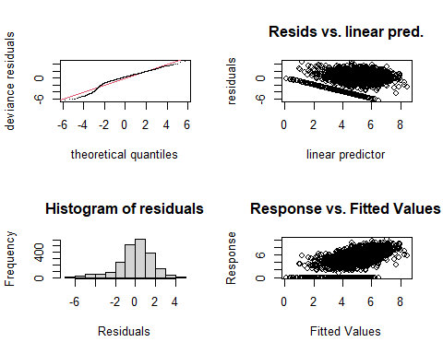

##   
## Method: REML Optimizer: outer newton  
## full convergence after 6 iterations.  
## Gradient range [-0.002786366,0.002340382]  
## (score 4161.448 & scale 2.727249).  
## Hessian positive definite, eigenvalue range [1.782847,1067.646].  
## Model rank = 57 / 57   
##   
## Basis dimension (k) checking results. Low p-value (k-index<1) may  
## indicate that k is too low, especially if edf is close to k'.  
##   
## k' edf k-index p-value   
## te(SalSurf_s,doy_s) 19.00 14.39 0.92 <0.0000000000000002 ***  
## s(Year_fac) 27.00 21.54 NA NA   
## s(Station_fac) 10.00 6.03 NA NA   
## ---  
## Signif. codes: 0 '***' 0.001 '**' 0.01 '*' 0.05 '.' 0.1 ' ' 1  
##   
##   
## -------------summary-------------  
##   
## Family: gaussian   
## Link function: identity   
##   
## Formula:  
## BPUE_log1p ~ te(SalSurf_s, doy_s, k = c(5, 5), bs = c("cs", "cc")) +   
## s(Year_fac, bs = "re") + s(Station_fac, bs = "re")  
##   
## Parametric coefficients:  
## Estimate Std. Error t value Pr(>|t|)   
## (Intercept) 5.298 0.147 36.03 <0.0000000000000002 ***  
## ---  
## Signif. codes: 0 '***' 0.001 '**' 0.01 '*' 0.05 '.' 0.1 ' ' 1  
##   
## Approximate significance of smooth terms:  
## edf Ref.df F p-value   
## te(SalSurf_s,doy_s) 14.387 19 125.917 <0.0000000000000002 ***  
## s(Year_fac) 21.540 26 5.456 <0.0000000000000002 ***  
## s(Station_fac) 6.031 9 7.154 <0.0000000000000002 ***  
## ---  
## Signif. codes: 0 '***' 0.001 '**' 0.01 '*' 0.05 '.' 0.1 ' ' 1  
##   
## R-sq.(adj) = 0.344 Deviance explained = 35.7%  
## -REML = 4161.4 Scale est. = 2.7272 n = 2136  
## <<<<<<<<<<<<<<<<<<<<<<< modeling othcalad Confluence >>>>>>>>>>>>>>>>>>>>>>>>>  
##   
## -------------gam check-------------

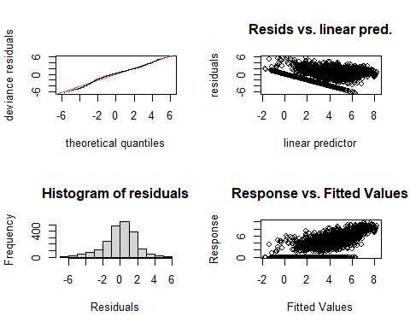

##   
## Method: REML Optimizer: outer newton  
## full convergence after 8 iterations.  
## Gradient range [-0.000001512857,0.00000005071482]  
## (score 4275.938 & scale 3.11497).  
## Hessian positive definite, eigenvalue range [0.8845194,1054.681].  
## Model rank = 57 / 57   
##   
## Basis dimension (k) checking results. Low p-value (k-index<1) may  
## indicate that k is too low, especially if edf is close to k'.  
##   
## k' edf k-index p-value   
## te(SalSurf_s,doy_s) 19.00 16.37 0.88 <0.0000000000000002 ***  
## s(Year_fac) 27.00 24.63 NA NA   
## s(Station_fac) 10.00 4.13 NA NA   
## ---  
## Signif. codes: 0 '***' 0.001 '**' 0.01 '*' 0.05 '.' 0.1 ' ' 1  
##   
##   
## -------------summary-------------  
##   
## Family: gaussian   
## Link function: identity   
##   
## Formula:  
## BPUE_log1p ~ te(SalSurf_s, doy_s, k = c(5, 5), bs = c("cs", "cc")) +   
## s(Year_fac, bs = "re") + s(Station_fac, bs = "re")  
##   
## Parametric coefficients:  
## Estimate Std. Error t value Pr(>|t|)   
## (Intercept) 4.227 0.190 22.25 <0.0000000000000002 ***  
## ---  
## Signif. codes: 0 '***' 0.001 '**' 0.01 '*' 0.05 '.' 0.1 ' ' 1  
##   
## Approximate significance of smooth terms:  
## edf Ref.df F p-value   
## te(SalSurf_s,doy_s) 16.366 19 272.859 <0.0000000000000002 ***  
## s(Year_fac) 24.633 26 17.693 <0.0000000000000002 ***  
## s(Station_fac) 4.131 9 1.246 0.0155 *   
## ---  
## Signif. codes: 0 '***' 0.001 '**' 0.01 '*' 0.05 '.' 0.1 ' ' 1  
##   
## R-sq.(adj) = 0.572 Deviance explained = 58.1%  
## -REML = 4275.9 Scale est. = 3.115 n = 2110  
## <<<<<<<<<<<<<<<<<<<<<<< modeling othcalad Suisun Marsh >>>>>>>>>>>>>>>>>>>>>>>>>  
##   
## -------------gam check-------------

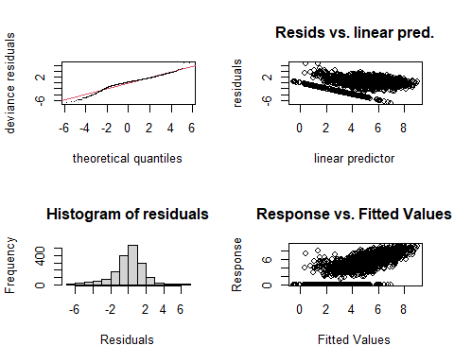

##   
## Method: REML Optimizer: outer newton  
## full convergence after 8 iterations.  
## Gradient range [-0.0002127979,0.0001948337]  
## (score 3435.893 & scale 2.814025).  
## Hessian positive definite, eigenvalue range [2.029276,868.2004].  
## Model rank = 55 / 55   
##   
## Basis dimension (k) checking results. Low p-value (k-index<1) may  
## indicate that k is too low, especially if edf is close to k'.  
##   
## k' edf k-index p-value   
## te(SalSurf_s,doy_s) 19.00 16.77 0.93 <0.0000000000000002 ***  
## s(Year_fac) 27.00 22.72 NA NA   
## s(Station_fac) 8.00 5.58 NA NA   
## ---  
## Signif. codes: 0 '***' 0.001 '**' 0.01 '*' 0.05 '.' 0.1 ' ' 1  
##   
##   
## -------------summary-------------  
##   
## Family: gaussian   
## Link function: identity   
##   
## Formula:  
## BPUE_log1p ~ te(SalSurf_s, doy_s, k = c(5, 5), bs = c("cs", "cc")) +   
## s(Year_fac, bs = "re") + s(Station_fac, bs = "re")  
##   
## Parametric coefficients:  
## Estimate Std. Error t value Pr(>|t|)   
## (Intercept) 5.2511 0.1961 26.77 <0.0000000000000002 ***  
## ---  
## Signif. codes: 0 '***' 0.001 '**' 0.01 '*' 0.05 '.' 0.1 ' ' 1  
##   
## Approximate significance of smooth terms:  
## edf Ref.df F p-value   
## te(SalSurf_s,doy_s) 16.768 19 236.684 <0.0000000000000002 ***  
## s(Year_fac) 22.717 26 8.645 <0.0000000000000002 ***  
## s(Station_fac) 5.578 7 10.806 <0.0000000000000002 ***  
## ---  
## Signif. codes: 0 '***' 0.001 '**' 0.01 '*' 0.05 '.' 0.1 ' ' 1  
##   
## R-sq.(adj) = 0.524 Deviance explained = 53.7%  
## -REML = 3435.9 Scale est. = 2.814 n = 1737  
## <<<<<<<<<<<<<<<<<<<<<<< modeling othcaljuv SW Suisun >>>>>>>>>>>>>>>>>>>>>>>>>  
##   
## -------------gam check-------------

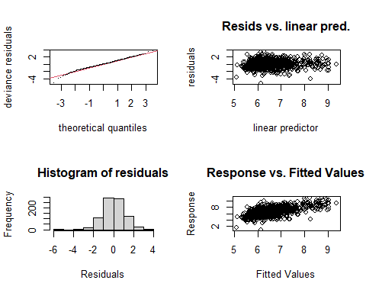

##   
## Method: REML Optimizer: outer newton  
## full convergence after 7 iterations.  
## Gradient range [-0.00003002771,0.00002698134]  
## (score 1347.676 & scale 1.182251).  
## Hessian positive definite, eigenvalue range [1.033518,435.6758].  
## Model rank = 52 / 52   
##   
## Basis dimension (k) checking results. Low p-value (k-index<1) may  
## indicate that k is too low, especially if edf is close to k'.  
##   
## k' edf k-index p-value  
## te(SalSurf_s,doy_s) 19.00 12.88 1.03 0.79  
## s(Year_fac) 27.00 14.48 NA NA  
## s(Station_fac) 5.00 3.39 NA NA  
##   
##   
## -------------summary-------------  
##   
## Family: gaussian   
## Link function: identity   
##   
## Formula:  
## BPUE_log1p ~ te(SalSurf_s, doy_s, k = c(5, 5), bs = c("cs", "cc")) +   
## s(Year_fac, bs = "re") + s(Station_fac, bs = "re")  
##   
## Parametric coefficients:  
## Estimate Std. Error t value Pr(>|t|)   
## (Intercept) 7.0229 0.3565 19.7 <0.0000000000000002 ***  
## ---  
## Signif. codes: 0 '***' 0.001 '**' 0.01 '*' 0.05 '.' 0.1 ' ' 1  
##   
## Approximate significance of smooth terms:  
## edf Ref.df F p-value   
## te(SalSurf_s,doy_s) 12.881 19 44.567 0.00172 **   
## s(Year_fac) 14.475 26 1.204 0.00101 **   
## s(Station_fac) 3.394 4 6.872 0.0000186 ***  
## ---  
## Signif. codes: 0 '***' 0.001 '**' 0.01 '*' 0.05 '.' 0.1 ' ' 1  
##   
## R-sq.(adj) = 0.336 Deviance explained = 36%  
## -REML = 1347.7 Scale est. = 1.1823 n = 872  
## <<<<<<<<<<<<<<<<<<<<<<< modeling othcaljuv NW Suisun >>>>>>>>>>>>>>>>>>>>>>>>>  
##   
## -------------gam check-------------

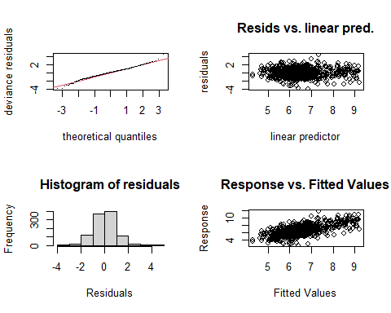

##   
## Method: REML Optimizer: outer newton  
## full convergence after 8 iterations.  
## Gradient range [-0.0004397659,0.00006630588]  
## (score 1546.86 & scale 0.9994358).  
## Hessian positive definite, eigenvalue range [0.1461839,526.2813].  
## Model rank = 52 / 52   
##   
## Basis dimension (k) checking results. Low p-value (k-index<1) may  
## indicate that k is too low, especially if edf is close to k'.  
##   
## k' edf k-index p-value   
## te(SalSurf_s,doy_s) 19.000 15.254 0.95 0.015 *  
## s(Year_fac) 27.000 21.608 NA NA   
## s(Station_fac) 5.000 0.933 NA NA   
## ---  
## Signif. codes: 0 '***' 0.001 '**' 0.01 '*' 0.05 '.' 0.1 ' ' 1  
##   
##   
## -------------summary-------------  
##   
## Family: gaussian   
## Link function: identity   
##   
## Formula:  
## BPUE_log1p ~ te(SalSurf_s, doy_s, k = c(5, 5), bs = c("cs", "cc")) +   
## s(Year_fac, bs = "re") + s(Station_fac, bs = "re")  
##   
## Parametric coefficients:  
## Estimate Std. Error t value Pr(>|t|)   
## (Intercept) 6.49101 0.08532 76.08 <0.0000000000000002 ***  
## ---  
## Signif. codes: 0 '***' 0.001 '**' 0.01 '*' 0.05 '.' 0.1 ' ' 1  
##   
## Approximate significance of smooth terms:  
## edf Ref.df F p-value   
## te(SalSurf_s,doy_s) 15.2536 19 68.619 <0.0000000000000002 ***  
## s(Year_fac) 21.6084 26 4.701 <0.0000000000000002 ***  
## s(Station_fac) 0.9327 4 0.387 0.194   
## ---  
## Signif. codes: 0 '***' 0.001 '**' 0.01 '*' 0.05 '.' 0.1 ' ' 1  
##   
## R-sq.(adj) = 0.402 Deviance explained = 42.4%  
## -REML = 1546.9 Scale est. = 0.99944 n = 1053  
## <<<<<<<<<<<<<<<<<<<<<<< modeling othcaljuv East Suisun >>>>>>>>>>>>>>>>>>>>>>>>>  
##   
## -------------gam check-------------

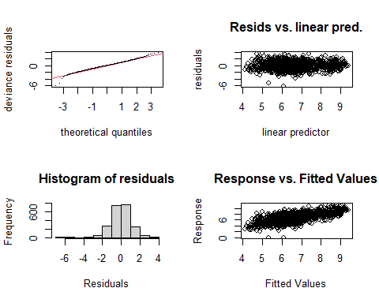

##   
## Method: REML Optimizer: outer newton  
## full convergence after 10 iterations.  
## Gradient range [-0.0009993936,0.0001906519]  
## (score 3114.095 & scale 1.009187).  
## Hessian positive definite, eigenvalue range [2.184908,1067.652].  
## Model rank = 57 / 57   
##   
## Basis dimension (k) checking results. Low p-value (k-index<1) may  
## indicate that k is too low, especially if edf is close to k'.  
##   
## k' edf k-index p-value   
## te(SalSurf_s,doy_s) 19.00 16.87 0.83 <0.0000000000000002 ***  
## s(Year_fac) 27.00 21.08 NA NA   
## s(Station_fac) 10.00 7.07 NA NA   
## ---  
## Signif. codes: 0 '***' 0.001 '**' 0.01 '*' 0.05 '.' 0.1 ' ' 1  
##   
##   
## -------------summary-------------  
##   
## Family: gaussian   
## Link function: identity   
##   
## Formula:  
## BPUE_log1p ~ te(SalSurf_s, doy_s, k = c(5, 5), bs = c("cs", "cc")) +   
## s(Year_fac, bs = "re") + s(Station_fac, bs = "re")  
##   
## Parametric coefficients:  
## Estimate Std. Error t value Pr(>|t|)   
## (Intercept) 6.6135 0.1213 54.53 <0.0000000000000002 ***  
## ---  
## Signif. codes: 0 '***' 0.001 '**' 0.01 '*' 0.05 '.' 0.1 ' ' 1  
##   
## Approximate significance of smooth terms:  
## edf Ref.df F p-value   
## te(SalSurf_s,doy_s) 16.87 19 247.718 <0.0000000000000002 ***  
## s(Year_fac) 21.08 26 5.007 <0.0000000000000002 ***  
## s(Station_fac) 7.07 9 8.499 <0.0000000000000002 ***  
## ---  
## Signif. codes: 0 '***' 0.001 '**' 0.01 '*' 0.05 '.' 0.1 ' ' 1  
##   
## R-sq.(adj) = 0.457 Deviance explained = 46.8%  
## -REML = 3114.1 Scale est. = 1.0092 n = 2136  
## <<<<<<<<<<<<<<<<<<<<<<< modeling othcaljuv Confluence >>>>>>>>>>>>>>>>>>>>>>>>>  
##   
## -------------gam check-------------

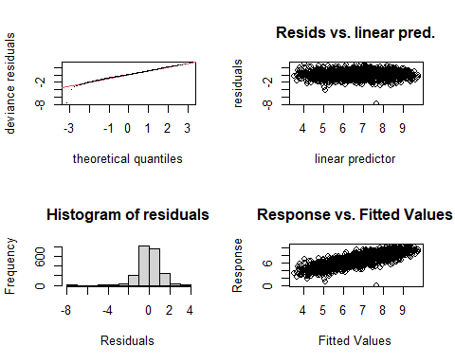

##   
## Method: REML Optimizer: outer newton  
## full convergence after 13 iterations.  
## Gradient range [-0.00002484854,0.000005750016]  
## (score 2857.83 & scale 0.8144757).  
## Hessian positive definite, eigenvalue range [2.78271,1054.664].  
## Model rank = 57 / 57   
##   
## Basis dimension (k) checking results. Low p-value (k-index<1) may  
## indicate that k is too low, especially if edf is close to k'.  
##   
## k' edf k-index p-value   
## te(SalSurf_s,doy_s) 19.00 16.78 0.77 <0.0000000000000002 ***  
## s(Year_fac) 27.00 22.18 NA NA   
## s(Station_fac) 10.00 7.25 NA NA   
## ---  
## Signif. codes: 0 '***' 0.001 '**' 0.01 '*' 0.05 '.' 0.1 ' ' 1  
##   
##   
## -------------summary-------------  
##   
## Family: gaussian   
## Link function: identity   
##   
## Formula:  
## BPUE_log1p ~ te(SalSurf_s, doy_s, k = c(5, 5), bs = c("cs", "cc")) +   
## s(Year_fac, bs = "re") + s(Station_fac, bs = "re")  
##   
## Parametric coefficients:  
## Estimate Std. Error t value Pr(>|t|)   
## (Intercept) 6.7913 0.1025 66.24 <0.0000000000000002 ***  
## ---  
## Signif. codes: 0 '***' 0.001 '**' 0.01 '*' 0.05 '.' 0.1 ' ' 1  
##   
## Approximate significance of smooth terms:  
## edf Ref.df F p-value   
## te(SalSurf_s,doy_s) 16.778 19 842.019 <0.0000000000000002 ***  
## s(Year_fac) 22.185 26 6.579 <0.0000000000000002 ***  
## s(Station_fac) 7.255 9 14.314 <0.0000000000000002 ***  
## ---  
## Signif. codes: 0 '***' 0.001 '**' 0.01 '*' 0.05 '.' 0.1 ' ' 1  
##   
## R-sq.(adj) = 0.662 Deviance explained = 66.9%  
## -REML = 2857.8 Scale est. = 0.81448 n = 2110  
## <<<<<<<<<<<<<<<<<<<<<<< modeling othcaljuv Suisun Marsh >>>>>>>>>>>>>>>>>>>>>>>>>  
##   
## -------------gam check-------------

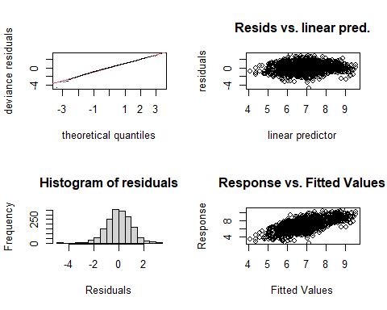

##   
## Method: REML Optimizer: outer newton  
## full convergence after 7 iterations.  
## Gradient range [-0.001746193,0.001381503]  
## (score 2504.624 & scale 0.9664801).  
## Hessian positive definite, eigenvalue range [2.16893,868.1696].  
## Model rank = 55 / 55   
##   
## Basis dimension (k) checking results. Low p-value (k-index<1) may  
## indicate that k is too low, especially if edf is close to k'.  
##   
## k' edf k-index p-value   
## te(SalSurf_s,doy_s) 19.0 16.7 0.91 <0.0000000000000002 ***  
## s(Year_fac) 27.0 19.9 NA NA   
## s(Station_fac) 8.0 6.6 NA NA   
## ---  
## Signif. codes: 0 '***' 0.001 '**' 0.01 '*' 0.05 '.' 0.1 ' ' 1  
##   
##   
## -------------summary-------------  
##   
## Family: gaussian   
## Link function: identity   
##   
## Formula:  
## BPUE_log1p ~ te(SalSurf_s, doy_s, k = c(5, 5), bs = c("cs", "cc")) +   
## s(Year_fac, bs = "re") + s(Station_fac, bs = "re")  
##   
## Parametric coefficients:  
## Estimate Std. Error t value Pr(>|t|)   
## (Intercept) 6.7287 0.1997 33.7 <0.0000000000000002 ***  
## ---  
## Signif. codes: 0 '***' 0.001 '**' 0.01 '*' 0.05 '.' 0.1 ' ' 1  
##   
## Approximate significance of smooth terms:  
## edf Ref.df F p-value   
## te(SalSurf_s,doy_s) 16.709 19 198.963 <0.0000000000000002 ***  
## s(Year_fac) 19.881 26 3.529 <0.0000000000000002 ***  
## s(Station_fac) 6.597 7 50.529 <0.0000000000000002 ***  
## ---  
## Signif. codes: 0 '***' 0.001 '**' 0.01 '*' 0.05 '.' 0.1 ' ' 1  
##   
## R-sq.(adj) = 0.413 Deviance explained = 42.7%  
## -REML = 2504.6 Scale est. = 0.96648 n = 1737  
## <<<<<<<<<<<<<<<<<<<<<<< modeling othclad SW Suisun >>>>>>>>>>>>>>>>>>>>>>>>>  
##   
## -------------gam check-------------

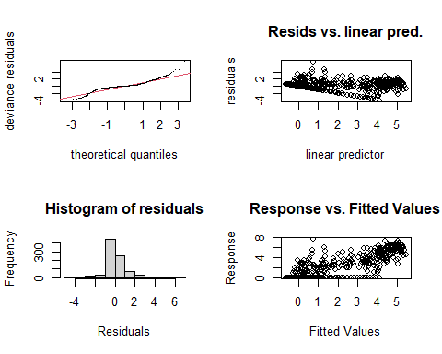

##   
## Method: REML Optimizer: outer newton  
## full convergence after 7 iterations.  
## Gradient range [-0.0002622482,0.0002063187]  
## (score 1324.978 & scale 1.103844).  
## Hessian positive definite, eigenvalue range [0.0002622413,435.8117].  
## Model rank = 52 / 52   
##   
## Basis dimension (k) checking results. Low p-value (k-index<1) may  
## indicate that k is too low, especially if edf is close to k'.  
##   
## k' edf k-index p-value  
## te(SalSurf_s,doy_s) 19.00000 11.73450 1.01 0.55  
## s(Year_fac) 27.00000 21.48516 NA NA  
## s(Station_fac) 5.00000 0.00102 NA NA  
##   
##   
## -------------summary-------------  
##   
## Family: gaussian   
## Link function: identity   
##   
## Formula:  
## BPUE_log1p ~ te(SalSurf_s, doy_s, k = c(5, 5), bs = c("cs", "cc")) +   
## s(Year_fac, bs = "re") + s(Station_fac, bs = "re")  
##   
## Parametric coefficients:  
## Estimate Std. Error t value Pr(>|t|)   
## (Intercept) 1.09715 0.08954 12.25 <0.0000000000000002 ***  
## ---  
## Signif. codes: 0 '***' 0.001 '**' 0.01 '*' 0.05 '.' 0.1 ' ' 1  
##   
## Approximate significance of smooth terms:  
## edf Ref.df F p-value   
## te(SalSurf_s,doy_s) 11.734497 19 229.46 <0.0000000000000002 ***  
## s(Year_fac) 21.485159 26 4.08 <0.0000000000000002 ***  
## s(Station_fac) 0.001016 4 0.00 0.619   
## ---  
## Signif. codes: 0 '***' 0.001 '**' 0.01 '*' 0.05 '.' 0.1 ' ' 1  
##   
## R-sq.(adj) = 0.709 Deviance explained = 72%  
## -REML = 1325 Scale est. = 1.1038 n = 872  
## <<<<<<<<<<<<<<<<<<<<<<< modeling othclad NW Suisun >>>>>>>>>>>>>>>>>>>>>>>>>  
##   
## -------------gam check-------------

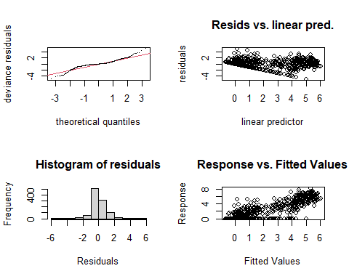

##   
## Method: REML Optimizer: outer newton  
## full convergence after 7 iterations.  
## Gradient range [-0.000001289951,0.000001085011]  
## (score 1544.096 & scale 0.9911362).  
## Hessian positive definite, eigenvalue range [0.8351677,526.2886].  
## Model rank = 52 / 52   
##   
## Basis dimension (k) checking results. Low p-value (k-index<1) may  
## indicate that k is too low, especially if edf is close to k'.  
##   
## k' edf k-index p-value   
## te(SalSurf_s,doy_s) 19.00 13.87 0.86 <0.0000000000000002 ***  
## s(Year_fac) 27.00 22.13 NA NA   
## s(Station_fac) 5.00 2.28 NA NA   
## ---  
## Signif. codes: 0 '***' 0.001 '**' 0.01 '*' 0.05 '.' 0.1 ' ' 1  
##   
##   
## -------------summary-------------  
##   
## Family: gaussian   
## Link function: identity   
##   
## Formula:  
## BPUE_log1p ~ te(SalSurf_s, doy_s, k = c(5, 5), bs = c("cs", "cc")) +   
## s(Year_fac, bs = "re") + s(Station_fac, bs = "re")  
##   
## Parametric coefficients:  
## Estimate Std. Error t value Pr(>|t|)   
## (Intercept) 1.2355 0.1124 10.99 <0.0000000000000002 ***  
## ---  
## Signif. codes: 0 '***' 0.001 '**' 0.01 '*' 0.05 '.' 0.1 ' ' 1  
##   
## Approximate significance of smooth terms:  
## edf Ref.df F p-value   
## te(SalSurf_s,doy_s) 13.870 19 471.136 < 0.0000000000000002 ***  
## s(Year_fac) 22.129 26 5.370 < 0.0000000000000002 ***  
## s(Station_fac) 2.285 4 3.515 0.00107 **   
## ---  
## Signif. codes: 0 '***' 0.001 '**' 0.01 '*' 0.05 '.' 0.1 ' ' 1  
##   
## R-sq.(adj) = 0.773 Deviance explained = 78.1%  
## -REML = 1544.1 Scale est. = 0.99114 n = 1053  
## <<<<<<<<<<<<<<<<<<<<<<< modeling othclad East Suisun >>>>>>>>>>>>>>>>>>>>>>>>>  
##   
## -------------gam check-------------

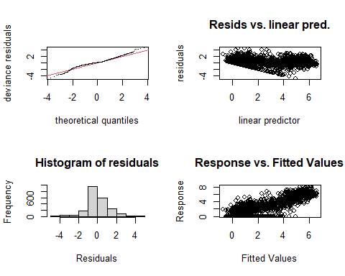

##   
## Method: REML Optimizer: outer newton  
## full convergence after 8 iterations.  
## Gradient range [-0.00002767437,0.00002421569]  
## (score 3266.821 & scale 1.154538).  
## Hessian positive definite, eigenvalue range [0.9006104,1067.682].  
## Model rank = 57 / 57   
##   
## Basis dimension (k) checking results. Low p-value (k-index<1) may  
## indicate that k is too low, especially if edf is close to k'.  
##   
## k' edf k-index p-value   
## te(SalSurf_s,doy_s) 19.00 16.28 0.83 <0.0000000000000002 ***  
## s(Year_fac) 27.00 24.66 NA NA   
## s(Station_fac) 10.00 4.63 NA NA   
## ---  
## Signif. codes: 0 '***' 0.001 '**' 0.01 '*' 0.05 '.' 0.1 ' ' 1  
##   
##   
## -------------summary-------------  
##   
## Family: gaussian   
## Link function: identity   
##   
## Formula:  
## BPUE_log1p ~ te(SalSurf_s, doy_s, k = c(5, 5), bs = c("cs", "cc")) +   
## s(Year_fac, bs = "re") + s(Station_fac, bs = "re")  
##   
## Parametric coefficients:  
## Estimate Std. Error t value Pr(>|t|)   
## (Intercept) 1.8052 0.1211 14.91 <0.0000000000000002 ***  
## ---  
## Signif. codes: 0 '***' 0.001 '**' 0.01 '*' 0.05 '.' 0.1 ' ' 1  
##   
## Approximate significance of smooth terms:  
## edf Ref.df F p-value   
## te(SalSurf_s,doy_s) 16.275 19 2273.622 < 0.0000000000000002 ***  
## s(Year_fac) 24.661 26 16.979 < 0.0000000000000002 ***  
## s(Station_fac) 4.628 9 1.952 0.00233 **   
## ---  
## Signif. codes: 0 '***' 0.001 '**' 0.01 '*' 0.05 '.' 0.1 ' ' 1  
##   
## R-sq.(adj) = 0.775 Deviance explained = 78%  
## -REML = 3266.8 Scale est. = 1.1545 n = 2136  
## <<<<<<<<<<<<<<<<<<<<<<< modeling othclad Confluence >>>>>>>>>>>>>>>>>>>>>>>>>  
##   
## -------------gam check-------------

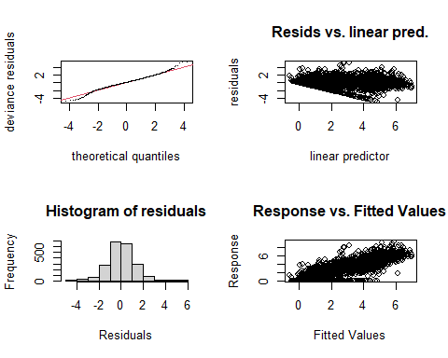

##   
## Method: REML Optimizer: outer newton  
## full convergence after 6 iterations.  
## Gradient range [-0.0009296275,0.0005881898]  
## (score 3492.962 & scale 1.496059).  
## Hessian positive definite, eigenvalue range [1.692354,1054.675].  
## Model rank = 57 / 57   
##   
## Basis dimension (k) checking results. Low p-value (k-index<1) may  
## indicate that k is too low, especially if edf is close to k'.  
##   
## k' edf k-index p-value   
## te(SalSurf_s,doy_s) 19.00 13.21 0.9 <0.0000000000000002 ***  
## s(Year_fac) 27.00 24.21 NA NA   
## s(Station_fac) 10.00 6.79 NA NA   
## ---  
## Signif. codes: 0 '***' 0.001 '**' 0.01 '*' 0.05 '.' 0.1 ' ' 1  
##   
##   
## -------------summary-------------  
##   
## Family: gaussian   
## Link function: identity   
##   
## Formula:  
## BPUE_log1p ~ te(SalSurf_s, doy_s, k = c(5, 5), bs = c("cs", "cc")) +   
## s(Year_fac, bs = "re") + s(Station_fac, bs = "re")  
##   
## Parametric coefficients:  
## Estimate Std. Error t value Pr(>|t|)   
## (Intercept) 2.8809 0.1436 20.06 <0.0000000000000002 ***  
## ---  
## Signif. codes: 0 '***' 0.001 '**' 0.01 '*' 0.05 '.' 0.1 ' ' 1  
##   
## Approximate significance of smooth terms:  
## edf Ref.df F p-value   
## te(SalSurf_s,doy_s) 13.213 19 1737.13 <0.0000000000000002 ***  
## s(Year_fac) 24.207 26 14.65 <0.0000000000000002 ***  
## s(Station_fac) 6.788 9 11.76 <0.0000000000000002 ***  
## ---  
## Signif. codes: 0 '***' 0.001 '**' 0.01 '*' 0.05 '.' 0.1 ' ' 1  
##   
## R-sq.(adj) = 0.692 Deviance explained = 69.9%  
## -REML = 3493 Scale est. = 1.4961 n = 2110  
## <<<<<<<<<<<<<<<<<<<<<<< modeling othclad Suisun Marsh >>>>>>>>>>>>>>>>>>>>>>>>>  
##   
## -------------gam check-------------

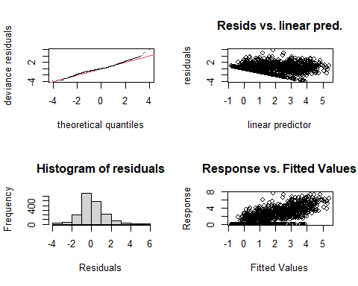

##   
## Method: REML Optimizer: outer newton  
## full convergence after 7 iterations.  
## Gradient range [-0.0008224294,0.000521716]  
## (score 2813.215 & scale 1.383136).  
## Hessian positive definite, eigenvalue range [1.692053,868.2037].  
## Model rank = 55 / 55   
##   
## Basis dimension (k) checking results. Low p-value (k-index<1) may  
## indicate that k is too low, especially if edf is close to k'.  
##   
## k' edf k-index p-value   
## te(SalSurf_s,doy_s) 19.00 13.42 0.97 0.045 *  
## s(Year_fac) 27.00 23.89 NA NA   
## s(Station_fac) 8.00 5.71 NA NA   
## ---  
## Signif. codes: 0 '***' 0.001 '**' 0.01 '*' 0.05 '.' 0.1 ' ' 1  
##   
##   
## -------------summary-------------  
##   
## Family: gaussian   
## Link function: identity   
##   
## Formula:  
## BPUE_log1p ~ te(SalSurf_s, doy_s, k = c(5, 5), bs = c("cs", "cc")) +   
## s(Year_fac, bs = "re") + s(Station_fac, bs = "re")  
##   
## Parametric coefficients:  
## Estimate Std. Error t value Pr(>|t|)   
## (Intercept) 1.3544 0.1568 8.639 <0.0000000000000002 ***  
## ---  
## Signif. codes: 0 '***' 0.001 '**' 0.01 '*' 0.05 '.' 0.1 ' ' 1  
##   
## Approximate significance of smooth terms:  
## edf Ref.df F p-value   
## te(SalSurf_s,doy_s) 13.419 19 487.05 <0.0000000000000002 ***  
## s(Year_fac) 23.893 26 11.63 <0.0000000000000002 ***  
## s(Station_fac) 5.711 7 15.26 <0.0000000000000002 ***  
## ---  
## Signif. codes: 0 '***' 0.001 '**' 0.01 '*' 0.05 '.' 0.1 ' ' 1  
##   
## R-sq.(adj) = 0.561 Deviance explained = 57.2%  
## -REML = 2813.2 Scale est. = 1.3831 n = 1737  
## <<<<<<<<<<<<<<<<<<<<<<< modeling pdiapfor SW Suisun >>>>>>>>>>>>>>>>>>>>>>>>>  
##   
## -------------gam check-------------

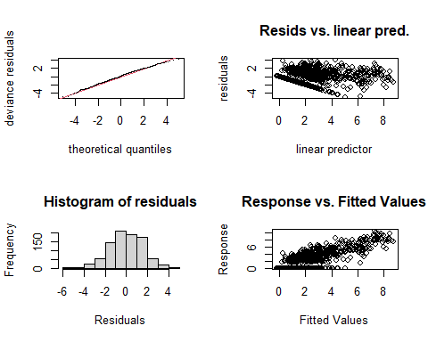

##   
## Method: REML Optimizer: outer newton  
## full convergence after 8 iterations.  
## Gradient range [-0.001209362,0.001061379]  
## (score 1678.197 & scale 2.439588).  
## Hessian positive definite, eigenvalue range [0.6670521,435.8292].  
## Model rank = 52 / 52   
##   
## Basis dimension (k) checking results. Low p-value (k-index<1) may  
## indicate that k is too low, especially if edf is close to k'.  
##   
## k' edf k-index p-value  
## te(SalSurf_s,doy_s) 19.00 13.45 0.97 0.12  
## s(Year_fac) 27.00 21.44 NA NA  
## s(Station_fac) 5.00 3.06 NA NA  
##   
##   
## -------------summary-------------  
##   
## Family: gaussian   
## Link function: identity   
##   
## Formula:  
## BPUE_log1p ~ te(SalSurf_s, doy_s, k = c(5, 5), bs = c("cs", "cc")) +   
## s(Year_fac, bs = "re") + s(Station_fac, bs = "re")  
##   
## Parametric coefficients:  
## Estimate Std. Error t value Pr(>|t|)   
## (Intercept) 3.120 0.393 7.94 0.00000000000000651 ***  
## ---  
## Signif. codes: 0 '***' 0.001 '**' 0.01 '*' 0.05 '.' 0.1 ' ' 1  
##   
## Approximate significance of smooth terms:  
## edf Ref.df F p-value   
## te(SalSurf_s,doy_s) 13.449 19 635.499 <0.0000000000000002 ***  
## s(Year_fac) 21.439 26 4.255 <0.0000000000000002 ***  
## s(Station_fac) 3.058 4 5.063 0.001 ***  
## ---  
## Signif. codes: 0 '***' 0.001 '**' 0.01 '*' 0.05 '.' 0.1 ' ' 1  
##   
## R-sq.(adj) = 0.586 Deviance explained = 60.4%  
## -REML = 1678.2 Scale est. = 2.4396 n = 872  
## <<<<<<<<<<<<<<<<<<<<<<< modeling pdiapfor NW Suisun >>>>>>>>>>>>>>>>>>>>>>>>>  
##   
## -------------gam check-------------

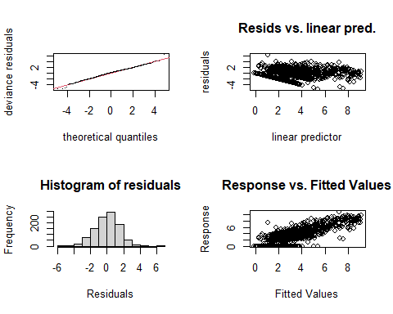

##   
## Method: REML Optimizer: outer newton  
## full convergence after 10 iterations.  
## Gradient range [-0.00007542177,0.0002550636]  
## (score 1950.179 & scale 2.164107).  
## Hessian positive definite, eigenvalue range [0.00007543682,526.2812].  
## Model rank = 52 / 52   
##   
## Basis dimension (k) checking results. Low p-value (k-index<1) may  
## indicate that k is too low, especially if edf is close to k'.  
##   
## k' edf k-index p-value   
## te(SalSurf_s,doy_s) 19.000000 12.265116 0.95 0.005 **  
## s(Year_fac) 27.000000 22.271044 NA NA   
## s(Station_fac) 5.000000 0.000674 NA NA   
## ---  
## Signif. codes: 0 '***' 0.001 '**' 0.01 '*' 0.05 '.' 0.1 ' ' 1  
##   
##   
## -------------summary-------------  
##   
## Family: gaussian   
## Link function: identity   
##   
## Formula:  
## BPUE_log1p ~ te(SalSurf_s, doy_s, k = c(5, 5), bs = c("cs", "cc")) +   
## s(Year_fac, bs = "re") + s(Station_fac, bs = "re")  
##   
## Parametric coefficients:  
## Estimate Std. Error t value Pr(>|t|)   
## (Intercept) 3.3517 0.1288 26.02 <0.0000000000000002 ***  
## ---  
## Signif. codes: 0 '***' 0.001 '**' 0.01 '*' 0.05 '.' 0.1 ' ' 1  
##   
## Approximate significance of smooth terms:  
## edf Ref.df F p-value   
## te(SalSurf_s,doy_s) 12.2651160 19 181.615 <0.0000000000000002 ***  
## s(Year_fac) 22.2710441 26 5.172 <0.0000000000000002 ***  
## s(Station_fac) 0.0006742 4 0.000 0.47   
## ---  
## Signif. codes: 0 '***' 0.001 '**' 0.01 '*' 0.05 '.' 0.1 ' ' 1  
##   
## R-sq.(adj) = 0.62 Deviance explained = 63.2%  
## -REML = 1950.2 Scale est. = 2.1641 n = 1053  
## <<<<<<<<<<<<<<<<<<<<<<< modeling pdiapfor East Suisun >>>>>>>>>>>>>>>>>>>>>>>>>  
##   
## -------------gam check-------------

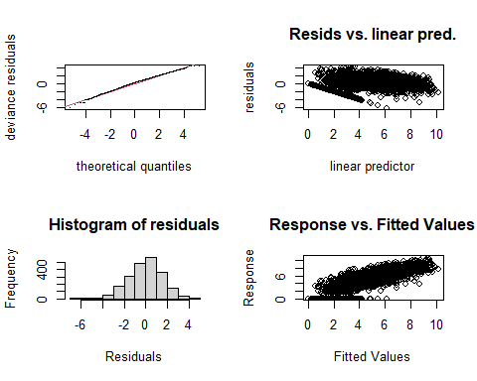

##   
## Method: REML Optimizer: outer newton  
## full convergence after 10 iterations.  
## Gradient range [-0.001934971,0.00185498]  
## (score 3995.704 & scale 2.313708).  
## Hessian positive definite, eigenvalue range [1.573728,1067.667].  
## Model rank = 57 / 57   
##   
## Basis dimension (k) checking results. Low p-value (k-index<1) may  
## indicate that k is too low, especially if edf is close to k'.  
##   
## k' edf k-index p-value   
## te(SalSurf_s,doy_s) 19.00 13.80 0.8 <0.0000000000000002 ***  
## s(Year_fac) 27.00 23.50 NA NA   
## s(Station_fac) 10.00 6.49 NA NA   
## ---  
## Signif. codes: 0 '***' 0.001 '**' 0.01 '*' 0.05 '.' 0.1 ' ' 1  
##   
##   
## -------------summary-------------  
##   
## Family: gaussian   
## Link function: identity   
##   
## Formula:  
## BPUE_log1p ~ te(SalSurf_s, doy_s, k = c(5, 5), bs = c("cs", "cc")) +   
## s(Year_fac, bs = "re") + s(Station_fac, bs = "re")  
##   
## Parametric coefficients:  
## Estimate Std. Error t value Pr(>|t|)   
## (Intercept) 4.2737 0.1712 24.96 <0.0000000000000002 ***  
## ---  
## Signif. codes: 0 '***' 0.001 '**' 0.01 '*' 0.05 '.' 0.1 ' ' 1  
##   
## Approximate significance of smooth terms:  
## edf Ref.df F p-value   
## te(SalSurf_s,doy_s) 13.797 19 857.975 <0.0000000000000002 ***  
## s(Year_fac) 23.498 26 9.554 <0.0000000000000002 ***  
## s(Station_fac) 6.491 9 7.949 <0.0000000000000002 ***  
## ---  
## Signif. codes: 0 '***' 0.001 '**' 0.01 '*' 0.05 '.' 0.1 ' ' 1  
##   
## R-sq.(adj) = 0.669 Deviance explained = 67.6%  
## -REML = 3995.7 Scale est. = 2.3137 n = 2136  
## <<<<<<<<<<<<<<<<<<<<<<< modeling pdiapfor Confluence >>>>>>>>>>>>>>>>>>>>>>>>>  
##   
## -------------gam check-------------

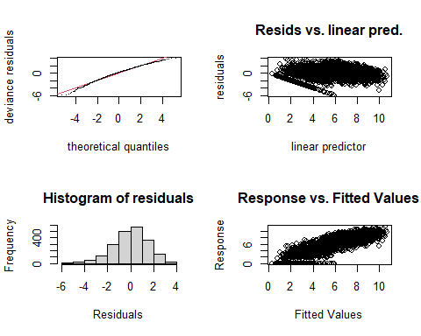

##   
## Method: REML Optimizer: outer newton  
## full convergence after 12 iterations.  
## Gradient range [-0.00002025915,0.00001873809]  
## (score 3930.686 & scale 2.268858).  
## Hessian positive definite, eigenvalue range [1.529428,1054.668].  
## Model rank = 57 / 57   
##   
## Basis dimension (k) checking results. Low p-value (k-index<1) may  
## indicate that k is too low, especially if edf is close to k'.  
##   
## k' edf k-index p-value   
## te(SalSurf_s,doy_s) 19.0 14.2 0.69 <0.0000000000000002 ***  
## s(Year_fac) 27.0 23.6 NA NA   
## s(Station_fac) 10.0 6.5 NA NA   
## ---  
## Signif. codes: 0 '***' 0.001 '**' 0.01 '*' 0.05 '.' 0.1 ' ' 1  
##   
##   
## -------------summary-------------  
##   
## Family: gaussian   
## Link function: identity   
##   
## Formula:  
## BPUE_log1p ~ te(SalSurf_s, doy_s, k = c(5, 5), bs = c("cs", "cc")) +   
## s(Year_fac, bs = "re") + s(Station_fac, bs = "re")  
##   
## Parametric coefficients:  
## Estimate Std. Error t value Pr(>|t|)   
## (Intercept) 5.970 0.153 39.01 <0.0000000000000002 ***  
## ---  
## Signif. codes: 0 '***' 0.001 '**' 0.01 '*' 0.05 '.' 0.1 ' ' 1  
##   
## Approximate significance of smooth terms:  
## edf Ref.df F p-value   
## te(SalSurf_s,doy_s) 14.157 19 513.999 <0.0000000000000002 ***  
## s(Year_fac) 23.571 26 9.920 <0.0000000000000002 ***  
## s(Station_fac) 6.498 9 6.875 <0.0000000000000002 ***  
## ---  
## Signif. codes: 0 '***' 0.001 '**' 0.01 '*' 0.05 '.' 0.1 ' ' 1  
##   
## R-sq.(adj) = 0.701 Deviance explained = 70.7%  
## -REML = 3930.7 Scale est. = 2.2689 n = 2110  
## <<<<<<<<<<<<<<<<<<<<<<< modeling pdiapfor Suisun Marsh >>>>>>>>>>>>>>>>>>>>>>>>>  
##   
## -------------gam check-------------

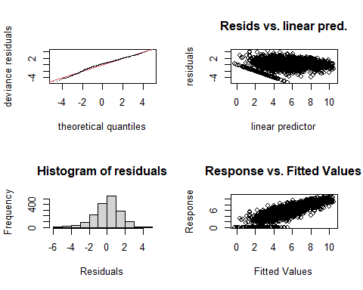

##   
## Method: REML Optimizer: outer newton  
## full convergence after 9 iterations.  
## Gradient range [-0.00004839245,0.00003978214]  
## (score 3157.63 & scale 2.004973).  
## Hessian positive definite, eigenvalue range [1.277001,868.2299].  
## Model rank = 55 / 55   
##   
## Basis dimension (k) checking results. Low p-value (k-index<1) may  
## indicate that k is too low, especially if edf is close to k'.  
##   
## k' edf k-index p-value   
## te(SalSurf_s,doy_s) 19.00 16.31 0.9 <0.0000000000000002 ***  
## s(Year_fac) 27.00 24.73 NA NA   
## s(Station_fac) 8.00 6.42 NA NA   
## ---  
## Signif. codes: 0 '***' 0.001 '**' 0.01 '*' 0.05 '.' 0.1 ' ' 1  
##   
##   
## -------------summary-------------  
##   
## Family: gaussian   
## Link function: identity   
##   
## Formula:  
## BPUE_log1p ~ te(SalSurf_s, doy_s, k = c(5, 5), bs = c("cs", "cc")) +   
## s(Year_fac, bs = "re") + s(Station_fac, bs = "re")  
##   
## Parametric coefficients:  
## Estimate Std. Error t value Pr(>|t|)   
## (Intercept) 5.2125 0.2825 18.45 <0.0000000000000002 ***  
## ---  
## Signif. codes: 0 '***' 0.001 '**' 0.01 '*' 0.05 '.' 0.1 ' ' 1  
##   
## Approximate significance of smooth terms:  
## edf Ref.df F p-value   
## te(SalSurf_s,doy_s) 16.312 19 2458.70 <0.0000000000000002 ***  
## s(Year_fac) 24.734 26 18.02 <0.0000000000000002 ***  
## s(Station_fac) 6.418 7 29.46 <0.0000000000000002 ***  
## ---  
## Signif. codes: 0 '***' 0.001 '**' 0.01 '*' 0.05 '.' 0.1 ' ' 1  
##   
## R-sq.(adj) = 0.7 Deviance explained = 70.8%  
## -REML = 3157.6 Scale est. = 2.005 n = 1737  
## <<<<<<<<<<<<<<<<<<<<<<< modeling allcopnaup SW Suisun >>>>>>>>>>>>>>>>>>>>>>>>>  
##   
## -------------gam check-------------

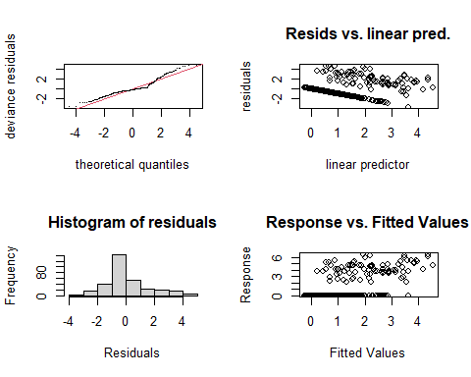

##   
## Method: REML Optimizer: outer newton  
## full convergence after 7 iterations.  
## Gradient range [-0.000154612,0.00007258112]  
## (score 601.3534 & scale 2.330002).  
## Hessian positive definite, eigenvalue range [0.0001545943,158.25].  
## Model rank = 50 / 50   
##   
## Basis dimension (k) checking results. Low p-value (k-index<1) may  
## indicate that k is too low, especially if edf is close to k'.  
##   
## k' edf k-index p-value  
## te(SalSurf_s,doy_s) 19.000000 7.843525 1.19 1  
## s(Year_fac) 27.000000 11.179917 NA NA  
## s(Station_fac) 3.000000 0.000455 NA NA  
##   
##   
## -------------summary-------------  
##   
## Family: gaussian   
## Link function: identity   
##   
## Formula:  
## BPUE_log1p ~ te(SalSurf_s, doy_s, k = c(5, 5), bs = c("cs", "cc")) +   
## s(Year_fac, bs = "re") + s(Station_fac, bs = "re")  
##   
## Parametric coefficients:  
## Estimate Std. Error t value Pr(>|t|)   
## (Intercept) 1.1026 0.1156 9.541 <0.0000000000000002 ***  
## ---  
## Signif. codes: 0 '***' 0.001 '**' 0.01 '*' 0.05 '.' 0.1 ' ' 1  
##   
## Approximate significance of smooth terms:  
## edf Ref.df F p-value   
## te(SalSurf_s,doy_s) 7.8435253 19 10.457 < 0.0000000000000002 ***  
## s(Year_fac) 11.1799165 26 0.784 0.00904 **   
## s(Station_fac) 0.0004546 2 0.000 0.69048   
## ---  
## Signif. codes: 0 '***' 0.001 '**' 0.01 '*' 0.05 '.' 0.1 ' ' 1  
##   
## R-sq.(adj) = 0.372 Deviance explained = 41%  
## -REML = 601.35 Scale est. = 2.33 n = 317  
## <<<<<<<<<<<<<<<<<<<<<<< modeling allcopnaup NW Suisun >>>>>>>>>>>>>>>>>>>>>>>>>  
##   
## -------------gam check-------------

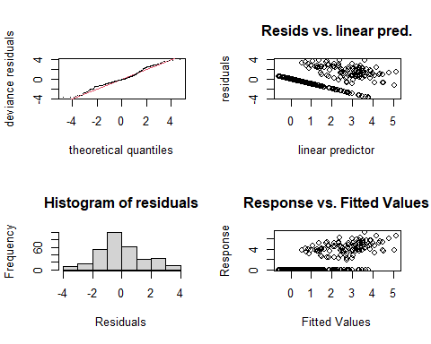

##   
## Method: REML Optimizer: outer newton  
## full convergence after 6 iterations.  
## Gradient range [-0.0000001103286,0.000000005068733]  
## (score 617.7484 & scale 2.599896).  
## Hessian positive definite, eigenvalue range [1.217475,155.1691].  
## Model rank = 47 / 47   
##   
## Basis dimension (k) checking results. Low p-value (k-index<1) may  
## indicate that k is too low, especially if edf is close to k'.  
##   
## k' edf k-index p-value  
## te(SalSurf_s,doy_s) 19.00 9.52 0.98 0.36  
## s(Year_fac) 27.00 18.80 NA NA  
##   
##   
## -------------summary-------------  
##   
## Family: gaussian   
## Link function: identity   
##   
## Formula:  
## BPUE_log1p ~ te(SalSurf_s, doy_s, k = c(5, 5), bs = c("cs", "cc")) +   
## s(Year_fac, bs = "re")  
##   
## Parametric coefficients:  
## Estimate Std. Error t value Pr(>|t|)   
## (Intercept) 1.4834 0.1786 8.304 0.00000000000000432 ***  
## ---  
## Signif. codes: 0 '***' 0.001 '**' 0.01 '*' 0.05 '.' 0.1 ' ' 1  
##   
## Approximate significance of smooth terms:  
## edf Ref.df F p-value   
## te(SalSurf_s,doy_s) 9.521 19 13.289 <0.0000000000000002 ***  
## s(Year_fac) 18.803 26 2.571 <0.0000000000000002 ***  
## ---  
## Signif. codes: 0 '***' 0.001 '**' 0.01 '*' 0.05 '.' 0.1 ' ' 1  
##   
## R-sq.(adj) = 0.443 Deviance explained = 49.4%  
## -REML = 617.75 Scale est. = 2.5999 n = 310  
## <<<<<<<<<<<<<<<<<<<<<<< modeling allcopnaup East Suisun >>>>>>>>>>>>>>>>>>>>>>>>>  
##   
## -------------gam check-------------

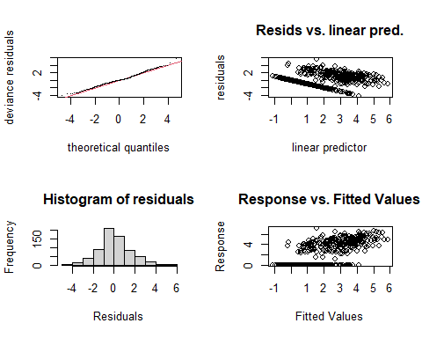

##   
## Method: REML Optimizer: outer newton  
## full convergence after 7 iterations.  
## Gradient range [-0.0003086585,0.0002553844]  
## (score 1262.904 & scale 2.221373).  
## Hessian positive definite, eigenvalue range [0.4256681,334.4252].  
## Model rank = 51 / 51   
##   
## Basis dimension (k) checking results. Low p-value (k-index<1) may  
## indicate that k is too low, especially if edf is close to k'.  
##   
## k' edf k-index p-value   
## te(SalSurf_s,doy_s) 19.00 12.91 0.91 <0.0000000000000002 ***  
## s(Year_fac) 27.00 21.63 NA NA   
## s(Station_fac) 4.00 1.84 NA NA   
## ---  
## Signif. codes: 0 '***' 0.001 '**' 0.01 '*' 0.05 '.' 0.1 ' ' 1  
##   
##   
## -------------summary-------------  
##   
## Family: gaussian   
## Link function: identity   
##   
## Formula:  
## BPUE_log1p ~ te(SalSurf_s, doy_s, k = c(5, 5), bs = c("cs", "cc")) +   
## s(Year_fac, bs = "re") + s(Station_fac, bs = "re")  
##   
## Parametric coefficients:  
## Estimate Std. Error t value Pr(>|t|)   
## (Intercept) 1.7264 0.2072 8.334 0.000000000000000489 ***  
## ---  
## Signif. codes: 0 '***' 0.001 '**' 0.01 '*' 0.05 '.' 0.1 ' ' 1  
##   
## Approximate significance of smooth terms:  
## edf Ref.df F p-value   
## te(SalSurf_s,doy_s) 12.909 19 49.826 <0.0000000000000002 ***  
## s(Year_fac) 21.634 26 5.032 <0.0000000000000002 ***  
## s(Station_fac) 1.841 3 2.151 0.0305 *   
## ---  
## Signif. codes: 0 '***' 0.001 '**' 0.01 '*' 0.05 '.' 0.1 ' ' 1  
##   
## R-sq.(adj) = 0.536 Deviance explained = 56.1%  
## -REML = 1262.9 Scale est. = 2.2214 n = 669  
## <<<<<<<<<<<<<<<<<<<<<<< modeling allcopnaup Confluence >>>>>>>>>>>>>>>>>>>>>>>>>  
##   
## -------------gam check-------------

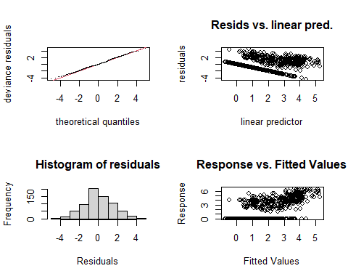

##   
## Method: REML Optimizer: outer newton  
## full convergence after 9 iterations.  
## Gradient range [-0.0004303728,0.00045683]  
## (score 1345.29 & scale 2.474344).  
## Hessian positive definite, eigenvalue range [0.1057984,347.3914].  
## Model rank = 52 / 52   
##   
## Basis dimension (k) checking results. Low p-value (k-index<1) may  
## indicate that k is too low, especially if edf is close to k'.  
##   
## k' edf k-index p-value   
## te(SalSurf_s,doy_s) 19.000 12.154 0.89 0.01 **  
## s(Year_fac) 27.000 21.371 NA NA   
## s(Station_fac) 5.000 0.522 NA NA   
## ---  
## Signif. codes: 0 '***' 0.001 '**' 0.01 '*' 0.05 '.' 0.1 ' ' 1  
##   
##   
## -------------summary-------------  
##   
## Family: gaussian   
## Link function: identity   
##   
## Formula:  
## BPUE_log1p ~ te(SalSurf_s, doy_s, k = c(5, 5), bs = c("cs", "cc")) +   
## s(Year_fac, bs = "re") + s(Station_fac, bs = "re")  
##   
## Parametric coefficients:  
## Estimate Std. Error t value Pr(>|t|)   
## (Intercept) 1.7959 0.1531 11.73 <0.0000000000000002 ***  
## ---  
## Signif. codes: 0 '***' 0.001 '**' 0.01 '*' 0.05 '.' 0.1 ' ' 1  
##   
## Approximate significance of smooth terms:  
## edf Ref.df F p-value   
## te(SalSurf_s,doy_s) 12.1538 19 29.248 <0.0000000000000002 ***  
## s(Year_fac) 21.3712 26 4.793 <0.0000000000000002 ***  
## s(Station_fac) 0.5224 4 0.207 0.197   
## ---  
## Signif. codes: 0 '***' 0.001 '**' 0.01 '*' 0.05 '.' 0.1 ' ' 1  
##   
## R-sq.(adj) = 0.468 Deviance explained = 49.4%  
## -REML = 1345.3 Scale est. = 2.4743 n = 695  
## <<<<<<<<<<<<<<<<<<<<<<< modeling allcopnaup Suisun Marsh >>>>>>>>>>>>>>>>>>>>>>>>>  
##   
## -------------gam check-------------

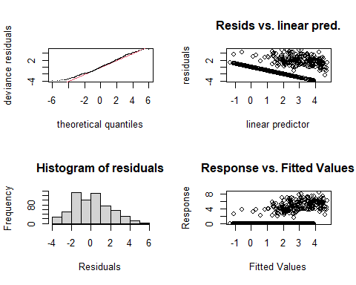

##   
## Method: REML Optimizer: outer newton  
## full convergence after 9 iterations.  
## Gradient range [-0.0002836337,0.0000007719298]  
## (score 1324.655 & scale 3.653853).  
## Hessian positive definite, eigenvalue range [0.0002834728,310.4626].  
## Model rank = 49 / 49   
##   
## Basis dimension (k) checking results. Low p-value (k-index<1) may  
## indicate that k is too low, especially if edf is close to k'.  
##   
## k' edf k-index p-value   
## te(SalSurf_s,doy_s) 19.000000 9.383887 0.89 <0.0000000000000002 ***  
## s(Year_fac) 27.000000 22.656783 NA NA   
## s(Station_fac) 2.000000 0.000568 NA NA   
## ---  
## Signif. codes: 0 '***' 0.001 '**' 0.01 '*' 0.05 '.' 0.1 ' ' 1  
##   
##   
## -------------summary-------------  
##   
## Family: gaussian   
## Link function: identity   
##   
## Formula:  
## BPUE_log1p ~ te(SalSurf_s, doy_s, k = c(5, 5), bs = c("cs", "cc")) +   
## s(Year_fac, bs = "re") + s(Station_fac, bs = "re")  
##   
## Parametric coefficients:  
## Estimate Std. Error t value Pr(>|t|)   
## (Intercept) 1.7121 0.2205 7.764 0.0000000000000368 ***  
## ---  
## Signif. codes: 0 '***' 0.001 '**' 0.01 '*' 0.05 '.' 0.1 ' ' 1  
##   
## Approximate significance of smooth terms:  
## edf Ref.df F p-value   
## te(SalSurf_s,doy_s) 9.3838866 19 17.06 <0.0000000000000002 ***  
## s(Year_fac) 22.6567829 26 6.76 <0.0000000000000002 ***  
## s(Station_fac) 0.0005682 1 0.00 0.968   
## ---  
## Signif. codes: 0 '***' 0.001 '**' 0.01 '*' 0.05 '.' 0.1 ' ' 1  
##   
## R-sq.(adj) = 0.399 Deviance explained = 43%  
## -REML = 1324.7 Scale est. = 3.6539 n = 621  
## <<<<<<<<<<<<<<<<<<<<<<< modeling limno SW Suisun >>>>>>>>>>>>>>>>>>>>>>>>>  
##   
## -------------gam check-------------

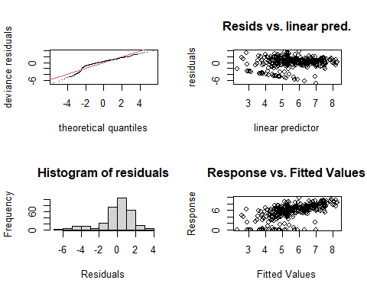

##   
## Method: REML Optimizer: outer newton  
## full convergence after 5 iterations.  
## Gradient range [-0.00005651404,0.00005859625]  
## (score 681.6302 & scale 3.422221).  
## Hessian positive definite, eigenvalue range [0.00004508318,161.4539].  
## Model rank = 50 / 50   
##   
## Basis dimension (k) checking results. Low p-value (k-index<1) may  
## indicate that k is too low, especially if edf is close to k'.  
##   
## k' edf k-index p-value   
## te(SalSurf_s,doy_s) 19.000000 9.333769 0.88 0.005 **  
## s(Year_fac) 27.000000 15.551463 NA NA   
## s(Station_fac) 3.000000 0.000172 NA NA   
## ---  
## Signif. codes: 0 '***' 0.001 '**' 0.01 '*' 0.05 '.' 0.1 ' ' 1  
##   
##   
## -------------summary-------------  
##   
## Family: gaussian   
## Link function: identity   
##   
## Formula:  
## BPUE_log1p ~ te(SalSurf_s, doy_s, k = c(5, 5), bs = c("cs", "cc")) +   
## s(Year_fac, bs = "re") + s(Station_fac, bs = "re")  
##   
## Parametric coefficients:  
## Estimate Std. Error t value Pr(>|t|)   
## (Intercept) 5.6536 0.1665 33.96 <0.0000000000000002 ***  
## ---  
## Signif. codes: 0 '***' 0.001 '**' 0.01 '*' 0.05 '.' 0.1 ' ' 1  
##   
## Approximate significance of smooth terms:  
## edf Ref.df F p-value   
## te(SalSurf_s,doy_s) 9.3337692 19 7.302 < 0.0000000000000002 ***  
## s(Year_fac) 15.5514628 26 1.494 0.000107 ***  
## s(Station_fac) 0.0001718 2 0.000 0.583339   
## ---  
## Signif. codes: 0 '***' 0.001 '**' 0.01 '*' 0.05 '.' 0.1 ' ' 1  
##   
## R-sq.(adj) = 0.343 Deviance explained = 39.4%  
## -REML = 681.63 Scale est. = 3.4222 n = 323  
## <<<<<<<<<<<<<<<<<<<<<<< modeling limno NW Suisun >>>>>>>>>>>>>>>>>>>>>>>>>  
##   
## -------------gam check-------------

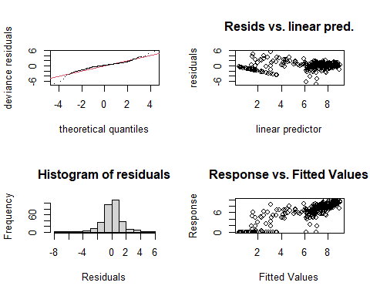

##   
## Method: REML Optimizer: outer newton  
## full convergence after 6 iterations.  
## Gradient range [-0.000150143,0.00009574354]  
## (score 600.4573 & scale 2.201123).  
## Hessian positive definite, eigenvalue range [1.593401,156.5484].  
## Model rank = 47 / 47   
##   
## Basis dimension (k) checking results. Low p-value (k-index<1) may  
## indicate that k is too low, especially if edf is close to k'.  
##   
## k' edf k-index p-value  
## te(SalSurf_s,doy_s) 19.0 11.7 0.98 0.3  
## s(Year_fac) 27.0 16.2 NA NA  
##   
##   
## -------------summary-------------  
##   
## Family: gaussian   
## Link function: identity   
##   
## Formula:  
## BPUE_log1p ~ te(SalSurf_s, doy_s, k = c(5, 5), bs = c("cs", "cc")) +   
## s(Year_fac, bs = "re")  
##   
## Parametric coefficients:  
## Estimate Std. Error t value Pr(>|t|)   
## (Intercept) 6.4074 0.1397 45.85 <0.0000000000000002 ***  
## ---  
## Signif. codes: 0 '***' 0.001 '**' 0.01 '*' 0.05 '.' 0.1 ' ' 1  
##   
## Approximate significance of smooth terms:  
## edf Ref.df F p-value   
## te(SalSurf_s,doy_s) 11.75 19 46.76 < 0.0000000000000002 ***  
## s(Year_fac) 16.17 26 1.67 0.0000324 ***  
## ---  
## Signif. codes: 0 '***' 0.001 '**' 0.01 '*' 0.05 '.' 0.1 ' ' 1  
##   
## R-sq.(adj) = 0.703 Deviance explained = 73%  
## -REML = 600.46 Scale est. = 2.2011 n = 313  
## <<<<<<<<<<<<<<<<<<<<<<< modeling limno East Suisun >>>>>>>>>>>>>>>>>>>>>>>>>  
##   
## -------------gam check-------------

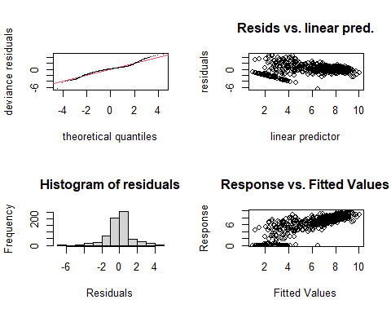

##   
## Method: REML Optimizer: outer newton  
## full convergence after 10 iterations.  
## Gradient range [-0.000000239289,0.0000001464564]  
## (score 1236.472 & scale 1.965841).  
## Hessian positive definite, eigenvalue range [0.8025186,335.9462].  
## Model rank = 51 / 51   
##   
## Basis dimension (k) checking results. Low p-value (k-index<1) may  
## indicate that k is too low, especially if edf is close to k'.  
##   
## k' edf k-index p-value   
## te(SalSurf_s,doy_s) 19.00 15.16 0.85 <0.0000000000000002 ***  
## s(Year_fac) 27.00 21.43 NA NA   
## s(Station_fac) 4.00 2.32 NA NA   
## ---  
## Signif. codes: 0 '***' 0.001 '**' 0.01 '*' 0.05 '.' 0.1 ' ' 1  
##   
##   
## -------------summary-------------  
##   
## Family: gaussian   
## Link function: identity   
##   
## Formula:  
## BPUE_log1p ~ te(SalSurf_s, doy_s, k = c(5, 5), bs = c("cs", "cc")) +   
## s(Year_fac, bs = "re") + s(Station_fac, bs = "re")  
##   
## Parametric coefficients:  
## Estimate Std. Error t value Pr(>|t|)   
## (Intercept) 6.765 0.245 27.62 <0.0000000000000002 ***  
## ---  
## Signif. codes: 0 '***' 0.001 '**' 0.01 '*' 0.05 '.' 0.1 ' ' 1  
##   
## Approximate significance of smooth terms:  
## edf Ref.df F p-value   
## te(SalSurf_s,doy_s) 15.158 19 123.851 < 0.0000000000000002 ***  
## s(Year_fac) 21.432 26 4.426 < 0.0000000000000002 ***  
## s(Station_fac) 2.319 3 5.541 0.000576 ***  
## ---  
## Signif. codes: 0 '***' 0.001 '**' 0.01 '*' 0.05 '.' 0.1 ' ' 1  
##   
## R-sq.(adj) = 0.703 Deviance explained = 72%  
## -REML = 1236.5 Scale est. = 1.9658 n = 672  
## <<<<<<<<<<<<<<<<<<<<<<< modeling limno Confluence >>>>>>>>>>>>>>>>>>>>>>>>>  
##   
## -------------gam check-------------

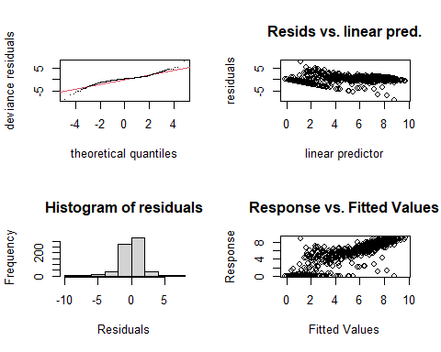

##   
## Method: REML Optimizer: outer newton  
## full convergence after 7 iterations.  
## Gradient range [-0.00004883231,0.000008133469]  
## (score 1345.344 & scale 2.325183).  
## Hessian positive definite, eigenvalue range [1.009805,350.4133].  
## Model rank = 52 / 52   
##   
## Basis dimension (k) checking results. Low p-value (k-index<1) may  
## indicate that k is too low, especially if edf is close to k'.  
##   
## k' edf k-index p-value   
## te(SalSurf_s,doy_s) 19.00 14.78 0.95 0.09 .  
## s(Year_fac) 27.00 21.16 NA NA   
## s(Station_fac) 5.00 2.34 NA NA   
## ---  
## Signif. codes: 0 '***' 0.001 '**' 0.01 '*' 0.05 '.' 0.1 ' ' 1  
##   
##   
## -------------summary-------------  
##   
## Family: gaussian   
## Link function: identity   
##   
## Formula:  
## BPUE_log1p ~ te(SalSurf_s, doy_s, k = c(5, 5), bs = c("cs", "cc")) +   
## s(Year_fac, bs = "re") + s(Station_fac, bs = "re")  
##   
## Parametric coefficients:  
## Estimate Std. Error t value Pr(>|t|)   
## (Intercept) 5.4572 0.2244 24.32 <0.0000000000000002 ***  
## ---  
## Signif. codes: 0 '***' 0.001 '**' 0.01 '*' 0.05 '.' 0.1 ' ' 1  
##   
## Approximate significance of smooth terms:  
## edf Ref.df F p-value   
## te(SalSurf_s,doy_s) 14.784 19 187.879 < 0.0000000000000002 ***  
## s(Year_fac) 21.155 26 4.447 < 0.0000000000000002 ***  
## s(Station_fac) 2.337 4 5.369 0.0000308 ***  
## ---  
## Signif. codes: 0 '***' 0.001 '**' 0.01 '*' 0.05 '.' 0.1 ' ' 1  
##   
## R-sq.(adj) = 0.748 Deviance explained = 76.2%  
## -REML = 1345.3 Scale est. = 2.3252 n = 701  
## <<<<<<<<<<<<<<<<<<<<<<< modeling limno Suisun Marsh >>>>>>>>>>>>>>>>>>>>>>>>>  
##   
## -------------gam check-------------

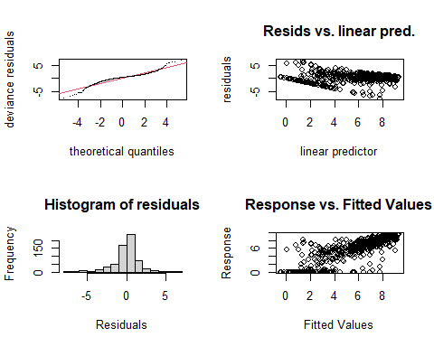

##   
## Method: REML Optimizer: outer newton  
## full convergence after 7 iterations.  
## Gradient range [-0.000001815078,0.000001657233]  
## (score 1260.726 & scale 2.853199).  
## Hessian positive definite, eigenvalue range [0.4726169,313.8115].  
## Model rank = 49 / 49   
##   
## Basis dimension (k) checking results. Low p-value (k-index<1) may  
## indicate that k is too low, especially if edf is close to k'.  
##   
## k' edf k-index p-value  
## te(SalSurf_s,doy_s) 19.000 13.894 0.96 0.13  
## s(Year_fac) 27.000 16.906 NA NA  
## s(Station_fac) 2.000 0.973 NA NA  
##   
##   
## -------------summary-------------  
##   
## Family: gaussian   
## Link function: identity   
##   
## Formula:  
## BPUE_log1p ~ te(SalSurf_s, doy_s, k = c(5, 5), bs = c("cs", "cc")) +   
## s(Year_fac, bs = "re") + s(Station_fac, bs = "re")  
##   
## Parametric coefficients:  
## Estimate Std. Error t value Pr(>|t|)   
## (Intercept) 5.8838 0.4269 13.78 <0.0000000000000002 ***  
## ---  
## Signif. codes: 0 '***' 0.001 '**' 0.01 '*' 0.05 '.' 0.1 ' ' 1  
##   
## Approximate significance of smooth terms:  
## edf Ref.df F p-value   
## te(SalSurf_s,doy_s) 13.8945 19 92.214 < 0.0000000000000002 ***  
## s(Year_fac) 16.9063 26 1.801 0.00000819 ***  
## s(Station_fac) 0.9731 1 36.475 < 0.0000000000000002 ***  
## ---  
## Signif. codes: 0 '***' 0.001 '**' 0.01 '*' 0.05 '.' 0.1 ' ' 1  
##   
## R-sq.(adj) = 0.693 Deviance explained = 70.8%  
## -REML = 1260.7 Scale est. = 2.8532 n = 628  
## <<<<<<<<<<<<<<<<<<<<<<< modeling mysid SW Suisun >>>>>>>>>>>>>>>>>>>>>>>>>  
##   
## -------------gam check-------------

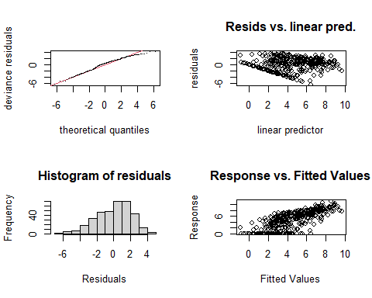

##   
## Method: REML Optimizer: outer newton  
## full convergence after 5 iterations.  
## Gradient range [-0.0003850967,0.0002974669]  
## (score 800.589 & scale 4.432278).  
## Hessian positive definite, eigenvalue range [0.1906857,177.1153].  
## Model rank = 50 / 50   
##   
## Basis dimension (k) checking results. Low p-value (k-index<1) may  
## indicate that k is too low, especially if edf is close to k'.  
##   
## k' edf k-index p-value  
## te(SalSurf_s,doy_s) 19.000 10.192 1.03 0.71  
## s(Year_fac) 26.000 19.153 NA NA  
## s(Station_fac) 4.000 0.968 NA NA  
##   
##   
## -------------summary-------------  
##   
## Family: gaussian   
## Link function: identity   
##   
## Formula:  
## BPUE_log1p ~ te(SalSurf_s, doy_s, k = c(5, 5), bs = c("cs", "cc")) +   
## s(Year_fac, bs = "re") + s(Station_fac, bs = "re")  
##   
## Parametric coefficients:  
## Estimate Std. Error t value Pr(>|t|)   
## (Intercept) 4.3767 0.3914 11.18 <0.0000000000000002 ***  
## ---  
## Signif. codes: 0 '***' 0.001 '**' 0.01 '*' 0.05 '.' 0.1 ' ' 1  
##   
## Approximate significance of smooth terms:  
## edf Ref.df F p-value   
## te(SalSurf_s,doy_s) 10.1924 19 25.218 <0.0000000000000002 ***  
## s(Year_fac) 19.1528 25 3.255 <0.0000000000000002 ***  
## s(Station_fac) 0.9676 3 0.933 0.12   
## ---  
## Signif. codes: 0 '***' 0.001 '**' 0.01 '*' 0.05 '.' 0.1 ' ' 1  
##   
## R-sq.(adj) = 0.544 Deviance explained = 58.3%  
## -REML = 800.59 Scale est. = 4.4323 n = 354  
## <<<<<<<<<<<<<<<<<<<<<<< modeling mysid NW Suisun >>>>>>>>>>>>>>>>>>>>>>>>>  
##   
## -------------gam check-------------

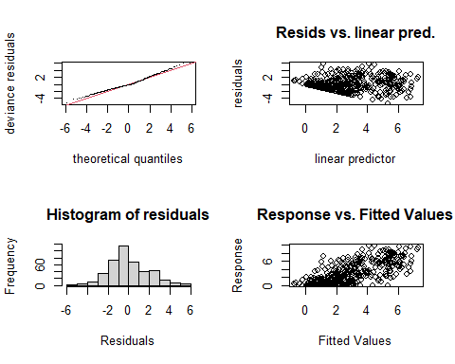

##   
## Method: REML Optimizer: outer newton  
## full convergence after 7 iterations.  
## Gradient range [-0.0000008772582,0.0000008332563]  
## (score 905.1353 & scale 3.788971).  
## Hessian positive definite, eigenvalue range [0.927108,208.44].  
## Model rank = 50 / 50   
##   
## Basis dimension (k) checking results. Low p-value (k-index<1) may  
## indicate that k is too low, especially if edf is close to k'.  
##   
## k' edf k-index p-value   
## te(SalSurf_s,doy_s) 19.00 9.72 0.93 0.045 *  
## s(Year_fac) 26.00 17.38 NA NA   
## s(Station_fac) 4.00 2.94 NA NA   
## ---  
## Signif. codes: 0 '***' 0.001 '**' 0.01 '*' 0.05 '.' 0.1 ' ' 1  
##   
##   
## -------------summary-------------  
##   
## Family: gaussian   
## Link function: identity   
##   
## Formula:  
## BPUE_log1p ~ te(SalSurf_s, doy_s, k = c(5, 5), bs = c("cs", "cc")) +   
## s(Year_fac, bs = "re") + s(Station_fac, bs = "re")  
##   
## Parametric coefficients:  
## Estimate Std. Error t value Pr(>|t|)   
## (Intercept) 4.450 1.089 4.084 0.0000538 ***  
## ---  
## Signif. codes: 0 '***' 0.001 '**' 0.01 '*' 0.05 '.' 0.1 ' ' 1  
##   
## Approximate significance of smooth terms:  
## edf Ref.df F p-value   
## te(SalSurf_s,doy_s) 9.717 19 12.094 0.00571 **   
## s(Year_fac) 17.383 25 2.461 < 0.0000000000000002 ***  
## s(Station_fac) 2.942 3 93.494 < 0.0000000000000002 ***  
## ---  
## Signif. codes: 0 '***' 0.001 '**' 0.01 '*' 0.05 '.' 0.1 ' ' 1  
##   
## R-sq.(adj) = 0.498 Deviance explained = 53.4%  
## -REML = 905.14 Scale est. = 3.789 n = 417  
## <<<<<<<<<<<<<<<<<<<<<<< modeling mysid East Suisun >>>>>>>>>>>>>>>>>>>>>>>>>  
##   
## -------------gam check-------------

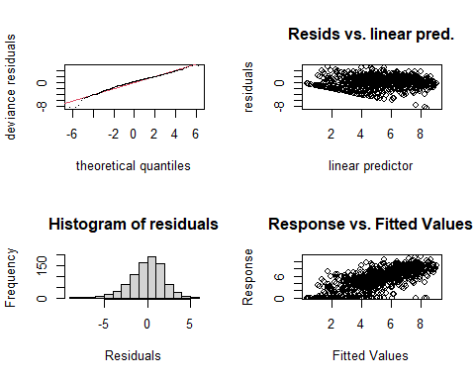

##   
## Method: REML Optimizer: outer newton  
## full convergence after 5 iterations.  
## Gradient range [-0.0009278945,0.0005095288]  
## (score 1797.217 & scale 3.738696).  
## Hessian positive definite, eigenvalue range [2.018086,417.8264].  
## Model rank = 56 / 56   
##   
## Basis dimension (k) checking results. Low p-value (k-index<1) may  
## indicate that k is too low, especially if edf is close to k'.  
##   
## k' edf k-index p-value   
## te(SalSurf_s,doy_s) 19.00 14.78 0.92 0.01 **  
## s(Year_fac) 26.00 19.00 NA NA   
## s(Station_fac) 10.00 8.11 NA NA   
## ---  
## Signif. codes: 0 '***' 0.001 '**' 0.01 '*' 0.05 '.' 0.1 ' ' 1  
##   
##   
## -------------summary-------------  
##   
## Family: gaussian   
## Link function: identity   
##   
## Formula:  
## BPUE_log1p ~ te(SalSurf_s, doy_s, k = c(5, 5), bs = c("cs", "cc")) +   
## s(Year_fac, bs = "re") + s(Station_fac, bs = "re")  
##   
## Parametric coefficients:  
## Estimate Std. Error t value Pr(>|t|)   
## (Intercept) 5.2058 0.4966 10.48 <0.0000000000000002 ***  
## ---  
## Signif. codes: 0 '***' 0.001 '**' 0.01 '*' 0.05 '.' 0.1 ' ' 1  
##   
## Approximate significance of smooth terms:  
## edf Ref.df F p-value   
## te(SalSurf_s,doy_s) 14.785 19 66.931 <0.0000000000000002 ***  
## s(Year_fac) 18.997 25 3.894 <0.0000000000000002 ***  
## s(Station_fac) 8.105 9 15.436 <0.0000000000000002 ***  
## ---  
## Signif. codes: 0 '***' 0.001 '**' 0.01 '*' 0.05 '.' 0.1 ' ' 1  
##   
## R-sq.(adj) = 0.52 Deviance explained = 54.4%  
## -REML = 1797.2 Scale est. = 3.7387 n = 836  
## <<<<<<<<<<<<<<<<<<<<<<< modeling mysid Confluence >>>>>>>>>>>>>>>>>>>>>>>>>  
##   
## -------------gam check-------------

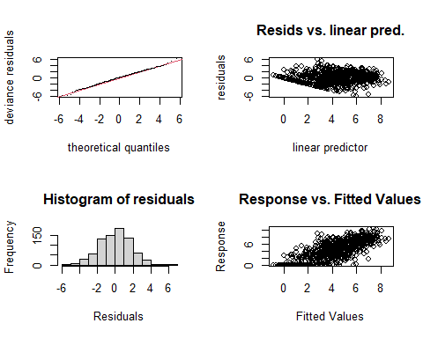

##   
## Method: REML Optimizer: outer newton  
## full convergence after 5 iterations.  
## Gradient range [-0.0005055385,0.0003473337]  
## (score 1647.357 & scale 3.17049).  
## Hessian positive definite, eigenvalue range [2.158402,397.3703].  
## Model rank = 55 / 55   
##   
## Basis dimension (k) checking results. Low p-value (k-index<1) may  
## indicate that k is too low, especially if edf is close to k'.  
##   
## k' edf k-index p-value   
## te(SalSurf_s,doy_s) 19.00 15.08 0.92 <0.0000000000000002 ***  
## s(Year_fac) 26.00 20.56 NA NA   
## s(Station_fac) 9.00 5.98 NA NA   
## ---  
## Signif. codes: 0 '***' 0.001 '**' 0.01 '*' 0.05 '.' 0.1 ' ' 1  
##   
##   
## -------------summary-------------  
##   
## Family: gaussian   
## Link function: identity   
##   
## Formula:  
## BPUE_log1p ~ te(SalSurf_s, doy_s, k = c(5, 5), bs = c("cs", "cc")) +   
## s(Year_fac, bs = "re") + s(Station_fac, bs = "re")  
##   
## Parametric coefficients:  
## Estimate Std. Error t value Pr(>|t|)   
## (Intercept) 4.2493 0.3046 13.95 <0.0000000000000002 ***  
## ---  
## Signif. codes: 0 '***' 0.001 '**' 0.01 '*' 0.05 '.' 0.1 ' ' 1  
##   
## Approximate significance of smooth terms:  
## edf Ref.df F p-value   
## te(SalSurf_s,doy_s) 15.081 19 94.522 <0.0000000000000002 ***  
## s(Year_fac) 20.563 25 4.866 <0.0000000000000002 ***  
## s(Station_fac) 5.975 8 8.510 <0.0000000000000002 ***  
## ---  
## Signif. codes: 0 '***' 0.001 '**' 0.01 '*' 0.05 '.' 0.1 ' ' 1  
##   
## R-sq.(adj) = 0.564 Deviance explained = 58.7%  
## -REML = 1647.4 Scale est. = 3.1705 n = 795  
## <<<<<<<<<<<<<<<<<<<<<<< modeling mysid Suisun Marsh >>>>>>>>>>>>>>>>>>>>>>>>>  
##   
## -------------gam check-------------

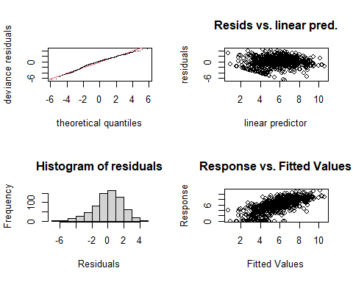

##   
## Method: REML Optimizer: outer newton  
## full convergence after 6 iterations.  
## Gradient range [-0.000000295379,0.0000002097751]  
## (score 1484.766 & scale 3.363607).  
## Hessian positive definite, eigenvalue range [1.725115,350.4737].  
## Model rank = 53 / 53   
##   
## Basis dimension (k) checking results. Low p-value (k-index<1) may  
## indicate that k is too low, especially if edf is close to k'.  
##   
## k' edf k-index p-value   
## te(SalSurf_s,doy_s) 19.00 14.96 0.92 0.005 **  
## s(Year_fac) 26.00 22.50 NA NA   
## s(Station_fac) 7.00 5.46 NA NA   
## ---  
## Signif. codes: 0 '***' 0.001 '**' 0.01 '*' 0.05 '.' 0.1 ' ' 1  
##   
##   
## -------------summary-------------  
##   
## Family: gaussian   
## Link function: identity   
##   
## Formula:  
## BPUE_log1p ~ te(SalSurf_s, doy_s, k = c(5, 5), bs = c("cs", "cc")) +   
## s(Year_fac, bs = "re") + s(Station_fac, bs = "re")  
##   
## Parametric coefficients:  
## Estimate Std. Error t value Pr(>|t|)   
## (Intercept) 5.2432 0.6501 8.065 0.00000000000000347 ***  
## ---  
## Signif. codes: 0 '***' 0.001 '**' 0.01 '*' 0.05 '.' 0.1 ' ' 1  
##   
## Approximate significance of smooth terms:  
## edf Ref.df F p-value   
## te(SalSurf_s,doy_s) 14.965 19 73.968 <0.0000000000000002 ***  
## s(Year_fac) 22.501 25 8.827 <0.0000000000000002 ***  
## s(Station_fac) 5.455 6 18.013 <0.0000000000000002 ***  
## ---  
## Signif. codes: 0 '***' 0.001 '**' 0.01 '*' 0.05 '.' 0.1 ' ' 1  
##   
## R-sq.(adj) = 0.482 Deviance explained = 51.4%  
## -REML = 1484.8 Scale est. = 3.3636 n = 701  
## <<<<<<<<<<<<<<<<<<<<<<< modeling othcyc SW Suisun >>>>>>>>>>>>>>>>>>>>>>>>>  
##   
## -------------gam check-------------

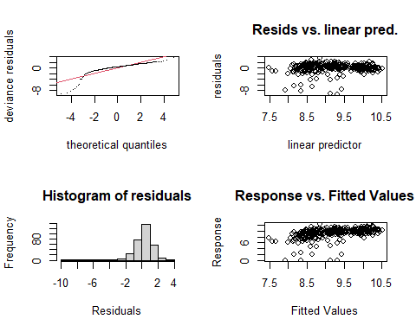

##   
## Method: REML Optimizer: outer newton  
## full convergence after 9 iterations.  
## Gradient range [-0.00005964002,0.0001712767]  
## (score 629.7834 & scale 2.730939).  
## Hessian positive definite, eigenvalue range [0.1459018,161.0396].  
## Model rank = 50 / 50   
##   
## Basis dimension (k) checking results. Low p-value (k-index<1) may  
## indicate that k is too low, especially if edf is close to k'.  
##   
## k' edf k-index p-value  
## te(SalSurf_s,doy_s) 19.00 5.00 1.03 0.6  
## s(Year_fac) 27.00 2.90 NA NA  
## s(Station_fac) 3.00 1.46 NA NA  
##   
##   
## -------------summary-------------  
##   
## Family: gaussian   
## Link function: identity   
##   
## Formula:  
## BPUE_log1p ~ te(SalSurf_s, doy_s, k = c(5, 5), bs = c("cs", "cc")) +   
## s(Year_fac, bs = "re") + s(Station_fac, bs = "re")  
##   
## Parametric coefficients:  
## Estimate Std. Error t value Pr(>|t|)   
## (Intercept) 8.4562 0.7175 11.79 <0.0000000000000002 ***  
## ---  
## Signif. codes: 0 '***' 0.001 '**' 0.01 '*' 0.05 '.' 0.1 ' ' 1  
##   
## Approximate significance of smooth terms:  
## edf Ref.df F p-value   
## te(SalSurf_s,doy_s) 5.000 19 2.808 <0.0000000000000002 ***  
## s(Year_fac) 2.903 26 0.126 0.2963   
## s(Station_fac) 1.460 2 2.714 0.0256 *   
## ---  
## Signif. codes: 0 '***' 0.001 '**' 0.01 '*' 0.05 '.' 0.1 ' ' 1  
##   
## R-sq.(adj) = 0.161 Deviance explained = 18.6%  
## -REML = 629.78 Scale est. = 2.7309 n = 323  
## <<<<<<<<<<<<<<<<<<<<<<< modeling othcyc NW Suisun >>>>>>>>>>>>>>>>>>>>>>>>>  
##   
## -------------gam check-------------

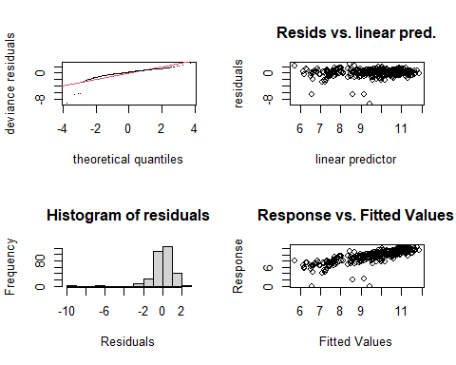

##   
## Method: REML Optimizer: outer newton  
## full convergence after 6 iterations.  
## Gradient range [-0.000002878506,0.0000001083962]  
## (score 555.2359 & scale 1.622412).  
## Hessian positive definite, eigenvalue range [1.065636,156.7009].  
## Model rank = 47 / 47   
##   
## Basis dimension (k) checking results. Low p-value (k-index<1) may  
## indicate that k is too low, especially if edf is close to k'.  
##   
## k' edf k-index p-value  
## te(SalSurf_s,doy_s) 19.0 11.9 1.02 0.59  
## s(Year_fac) 27.0 18.8 NA NA  
##   
##   
## -------------summary-------------  
##   
## Family: gaussian   
## Link function: identity   
##   
## Formula:  
## BPUE_log1p ~ te(SalSurf_s, doy_s, k = c(5, 5), bs = c("cs", "cc")) +   
## s(Year_fac, bs = "re")  
##   
## Parametric coefficients:  
## Estimate Std. Error t value Pr(>|t|)   
## (Intercept) 9.5795 0.1406 68.14 <0.0000000000000002 ***  
## ---  
## Signif. codes: 0 '***' 0.001 '**' 0.01 '*' 0.05 '.' 0.1 ' ' 1  
##   
## Approximate significance of smooth terms:  
## edf Ref.df F p-value   
## te(SalSurf_s,doy_s) 11.88 19 27.467 <0.0000000000000002 ***  
## s(Year_fac) 18.76 26 2.627 <0.0000000000000002 ***  
## ---  
## Signif. codes: 0 '***' 0.001 '**' 0.01 '*' 0.05 '.' 0.1 ' ' 1  
##   
## R-sq.(adj) = 0.575 Deviance explained = 61.7%  
## -REML = 555.24 Scale est. = 1.6224 n = 313  
## <<<<<<<<<<<<<<<<<<<<<<< modeling othcyc East Suisun >>>>>>>>>>>>>>>>>>>>>>>>>  
##   
## -------------gam check-------------

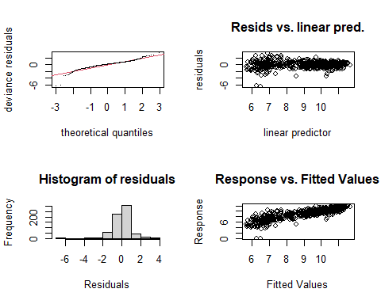

##   
## Method: REML Optimizer: outer newton  
## full convergence after 8 iterations.  
## Gradient range [-0.00004830024,-0.0000008165355]  
## (score 972.7094 & scale 0.8931744).  
## Hessian positive definite, eigenvalue range [0.3911845,335.9375].  
## Model rank = 51 / 51   
##   
## Basis dimension (k) checking results. Low p-value (k-index<1) may  
## indicate that k is too low, especially if edf is close to k'.  
##   
## k' edf k-index p-value   
## te(SalSurf_s,doy_s) 19.00 15.80 0.86 <0.0000000000000002 ***  
## s(Year_fac) 27.00 20.89 NA NA   
## s(Station_fac) 4.00 2.02 NA NA   
## ---  
## Signif. codes: 0 '***' 0.001 '**' 0.01 '*' 0.05 '.' 0.1 ' ' 1  
##   
##   
## -------------summary-------------  
##   
## Family: gaussian   
## Link function: identity   
##   
## Formula:  
## BPUE_log1p ~ te(SalSurf_s, doy_s, k = c(5, 5), bs = c("cs", "cc")) +   
## s(Year_fac, bs = "re") + s(Station_fac, bs = "re")  
##   
## Parametric coefficients:  
## Estimate Std. Error t value Pr(>|t|)   
## (Intercept) 9.1882 0.1375 66.81 <0.0000000000000002 ***  
## ---  
## Signif. codes: 0 '***' 0.001 '**' 0.01 '*' 0.05 '.' 0.1 ' ' 1  
##   
## Approximate significance of smooth terms:  
## edf Ref.df F p-value   
## te(SalSurf_s,doy_s) 15.802 19 166.886 <0.0000000000000002 ***  
## s(Year_fac) 20.895 26 4.228 <0.0000000000000002 ***  
## s(Station_fac) 2.024 3 2.841 0.0135 *   
## ---  
## Signif. codes: 0 '***' 0.001 '**' 0.01 '*' 0.05 '.' 0.1 ' ' 1  
##   
## R-sq.(adj) = 0.731 Deviance explained = 74.7%  
## -REML = 972.71 Scale est. = 0.89317 n = 672  
## <<<<<<<<<<<<<<<<<<<<<<< modeling othcyc Confluence >>>>>>>>>>>>>>>>>>>>>>>>>  
##   
## -------------gam check-------------

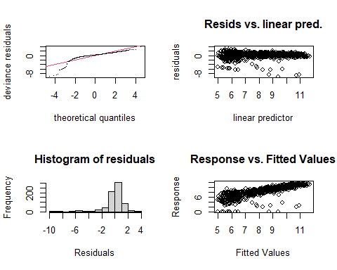

##   
## Method: REML Optimizer: outer newton  
## full convergence after 6 iterations.  
## Gradient range [-0.0000008461604,0.0000004443807]  
## (score 1290.695 & scale 2.038263).  
## Hessian positive definite, eigenvalue range [0.5739996,350.308].  
## Model rank = 52 / 52   
##   
## Basis dimension (k) checking results. Low p-value (k-index<1) may  
## indicate that k is too low, especially if edf is close to k'.  
##   
## k' edf k-index p-value  
## te(SalSurf_s,doy_s) 19.00 15.03 0.98 0.37  
## s(Year_fac) 27.00 17.51 NA NA  
## s(Station_fac) 5.00 1.71 NA NA  
##   
##   
## -------------summary-------------  
##   
## Family: gaussian   
## Link function: identity   
##   
## Formula:  
## BPUE_log1p ~ te(SalSurf_s, doy_s, k = c(5, 5), bs = c("cs", "cc")) +   
## s(Year_fac, bs = "re") + s(Station_fac, bs = "re")  
##   
## Parametric coefficients:  
## Estimate Std. Error t value Pr(>|t|)   
## (Intercept) 8.2805 0.1446 57.27 <0.0000000000000002 ***  
## ---  
## Signif. codes: 0 '***' 0.001 '**' 0.01 '*' 0.05 '.' 0.1 ' ' 1  
##   
## Approximate significance of smooth terms:  
## edf Ref.df F p-value   
## te(SalSurf_s,doy_s) 15.029 19 81.877 < 0.0000000000000002 ***  
## s(Year_fac) 17.515 26 2.014 0.00000169 ***  
## s(Station_fac) 1.707 4 1.779 0.0112 *   
## ---  
## Signif. codes: 0 '***' 0.001 '**' 0.01 '*' 0.05 '.' 0.1 ' ' 1  
##   
## R-sq.(adj) = 0.619 Deviance explained = 63.7%  
## -REML = 1290.7 Scale est. = 2.0383 n = 701  
## <<<<<<<<<<<<<<<<<<<<<<< modeling othcyc Suisun Marsh >>>>>>>>>>>>>>>>>>>>>>>>>  
##   
## -------------gam check-------------

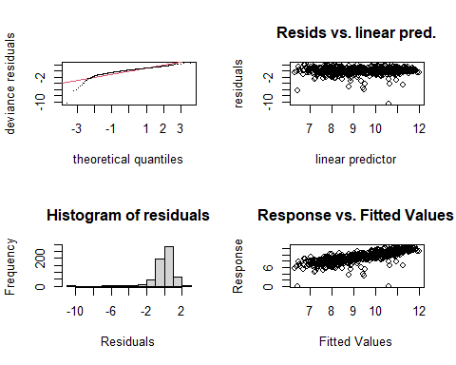

##   
## Method: REML Optimizer: outer newton  
## full convergence after 7 iterations.  
## Gradient range [-0.0002591165,0.0001804243]  
## (score 1009.343 & scale 1.285178).  
## Hessian positive definite, eigenvalue range [0.4796187,313.777].  
## Model rank = 49 / 49   
##   
## Basis dimension (k) checking results. Low p-value (k-index<1) may  
## indicate that k is too low, especially if edf is close to k'.  
##   
## k' edf k-index p-value  
## te(SalSurf_s,doy_s) 19.00 14.08 0.97 0.27  
## s(Year_fac) 27.00 15.53 NA NA  
## s(Station_fac) 2.00 0.98 NA NA  
##   
##   
## -------------summary-------------  
##   
## Family: gaussian   
## Link function: identity   
##   
## Formula:  
## BPUE_log1p ~ te(SalSurf_s, doy_s, k = c(5, 5), bs = c("cs", "cc")) +   
## s(Year_fac, bs = "re") + s(Station_fac, bs = "re")  
##   
## Parametric coefficients:  
## Estimate Std. Error t value Pr(>|t|)   
## (Intercept) 9.3300 0.3297 28.3 <0.0000000000000002 ***  
## ---  
## Signif. codes: 0 '***' 0.001 '**' 0.01 '*' 0.05 '.' 0.1 ' ' 1  
##   
## Approximate significance of smooth terms:  
## edf Ref.df F p-value   
## te(SalSurf_s,doy_s) 14.0845 19 57.45 <0.0000000000000002 ***  
## s(Year_fac) 15.5314 26 1.46 0.0001 ***  
## s(Station_fac) 0.9801 1 49.66 <0.0000000000000002 ***  
## ---  
## Signif. codes: 0 '***' 0.001 '**' 0.01 '*' 0.05 '.' 0.1 ' ' 1  
##   
## R-sq.(adj) = 0.594 Deviance explained = 61.4%  
## -REML = 1009.3 Scale est. = 1.2852 n = 628  
## <<<<<<<<<<<<<<<<<<<<<<< modeling other SW Suisun >>>>>>>>>>>>>>>>>>>>>>>>>  
##   
## -------------gam check-------------

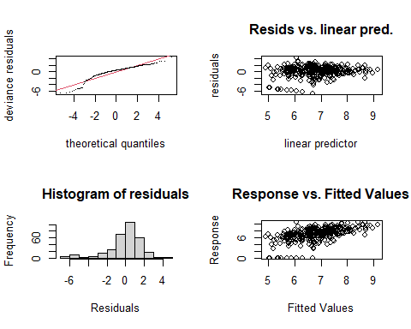

##   
## Method: REML Optimizer: outer newton  
## full convergence after 7 iterations.  
## Gradient range [-0.0001181306,0.00003164694]  
## (score 657.8992 & scale 3.184574).  
## Hessian positive definite, eigenvalue range [0.0001180994,158.5305].  
## Model rank = 50 / 50   
##   
## Basis dimension (k) checking results. Low p-value (k-index<1) may  
## indicate that k is too low, especially if edf is close to k'.  
##   
## k' edf k-index p-value   
## te(SalSurf_s,doy_s) 19.000000 7.106973 0.89 0.02 *  
## s(Year_fac) 27.000000 17.271773 NA NA   
## s(Station_fac) 3.000000 0.000388 NA NA   
## ---  
## Signif. codes: 0 '***' 0.001 '**' 0.01 '*' 0.05 '.' 0.1 ' ' 1  
##   
##   
## -------------summary-------------  
##   
## Family: gaussian   
## Link function: identity   
##   
## Formula:  
## BPUE_log1p ~ te(SalSurf_s, doy_s, k = c(5, 5), bs = c("cs", "cc")) +   
## s(Year_fac, bs = "re") + s(Station_fac, bs = "re")  
##   
## Parametric coefficients:  
## Estimate Std. Error t value Pr(>|t|)   
## (Intercept) 6.8324 0.1769 38.62 <0.0000000000000002 ***  
## ---  
## Signif. codes: 0 '***' 0.001 '**' 0.01 '*' 0.05 '.' 0.1 ' ' 1  
##   
## Approximate significance of smooth terms:  
## edf Ref.df F p-value   
## te(SalSurf_s,doy_s) 7.1069729 19 2.572 0.000245 ***  
## s(Year_fac) 17.2717731 26 2.036 0.00000223 ***  
## s(Station_fac) 0.0003876 2 0.000 0.637914   
## ---  
## Signif. codes: 0 '***' 0.001 '**' 0.01 '*' 0.05 '.' 0.1 ' ' 1  
##   
## R-sq.(adj) = 0.23 Deviance explained = 28.9%  
## -REML = 657.9 Scale est. = 3.1846 n = 317  
## <<<<<<<<<<<<<<<<<<<<<<< modeling other NW Suisun >>>>>>>>>>>>>>>>>>>>>>>>>  
##   
## -------------gam check-------------

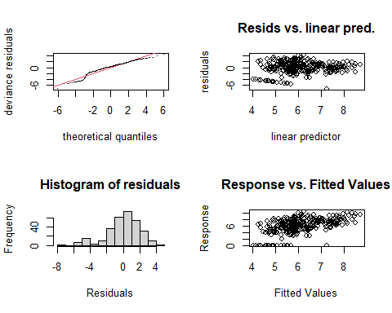

##   
## Method: REML Optimizer: outer newton  
## full convergence after 9 iterations.  
## Gradient range [-0.0000647543,0.0000307289]  
## (score 680.149 & scale 4.224548).  
## Hessian positive definite, eigenvalue range [0.08988397,154.8601].  
## Model rank = 47 / 47   
##   
## Basis dimension (k) checking results. Low p-value (k-index<1) may  
## indicate that k is too low, especially if edf is close to k'.  
##   
## k' edf k-index p-value  
## te(SalSurf_s,doy_s) 19.0 5.2 0.95 0.14  
## s(Year_fac) 27.0 14.1 NA NA  
##   
##   
## -------------summary-------------  
##   
## Family: gaussian   
## Link function: identity   
##   
## Formula:  
## BPUE_log1p ~ te(SalSurf_s, doy_s, k = c(5, 5), bs = c("cs", "cc")) +   
## s(Year_fac, bs = "re")  
##   
## Parametric coefficients:  
## Estimate Std. Error t value Pr(>|t|)   
## (Intercept) 6.0952 0.1736 35.11 <0.0000000000000002 ***  
## ---  
## Signif. codes: 0 '***' 0.001 '**' 0.01 '*' 0.05 '.' 0.1 ' ' 1  
##   
## Approximate significance of smooth terms:  
## edf Ref.df F p-value   
## te(SalSurf_s,doy_s) 5.203 19 3.012 < 0.0000000000000002 ***  
## s(Year_fac) 14.064 26 1.183 0.000926 ***  
## ---  
## Signif. codes: 0 '***' 0.001 '**' 0.01 '*' 0.05 '.' 0.1 ' ' 1  
##   
## R-sq.(adj) = 0.219 Deviance explained = 26.8%  
## -REML = 680.15 Scale est. = 4.2245 n = 310  
## <<<<<<<<<<<<<<<<<<<<<<< modeling other East Suisun >>>>>>>>>>>>>>>>>>>>>>>>>  
##   
## -------------gam check-------------

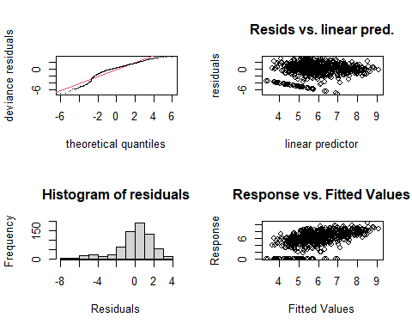

##   
## Method: REML Optimizer: outer newton  
## full convergence after 7 iterations.  
## Gradient range [-0.0009663949,0.0005020085]  
## (score 1416.959 & scale 3.606287).  
## Hessian positive definite, eigenvalue range [0.3912403,334.3088].  
## Model rank = 51 / 51   
##   
## Basis dimension (k) checking results. Low p-value (k-index<1) may  
## indicate that k is too low, especially if edf is close to k'.  
##   
## k' edf k-index p-value   
## te(SalSurf_s,doy_s) 19.00 13.45 0.84 <0.0000000000000002 ***  
## s(Year_fac) 27.00 17.70 NA NA   
## s(Station_fac) 4.00 1.53 NA NA   
## ---  
## Signif. codes: 0 '***' 0.001 '**' 0.01 '*' 0.05 '.' 0.1 ' ' 1  
##   
##   
## -------------summary-------------  
##   
## Family: gaussian   
## Link function: identity   
##   
## Formula:  
## BPUE_log1p ~ te(SalSurf_s, doy_s, k = c(5, 5), bs = c("cs", "cc")) +   
## s(Year_fac, bs = "re") + s(Station_fac, bs = "re")  
##   
## Parametric coefficients:  
## Estimate Std. Error t value Pr(>|t|)   
## (Intercept) 5.9111 0.1991 29.69 <0.0000000000000002 ***  
## ---  
## Signif. codes: 0 '***' 0.001 '**' 0.01 '*' 0.05 '.' 0.1 ' ' 1  
##   
## Approximate significance of smooth terms:  
## edf Ref.df F p-value   
## te(SalSurf_s,doy_s) 13.455 19 11.270 < 0.0000000000000002 ***  
## s(Year_fac) 17.696 26 1.993 0.00000251 ***  
## s(Station_fac) 1.529 3 1.954 0.0193 *   
## ---  
## Signif. codes: 0 '***' 0.001 '**' 0.01 '*' 0.05 '.' 0.1 ' ' 1  
##   
## R-sq.(adj) = 0.277 Deviance explained = 31.2%  
## -REML = 1417 Scale est. = 3.6063 n = 669  
## <<<<<<<<<<<<<<<<<<<<<<< modeling other Confluence >>>>>>>>>>>>>>>>>>>>>>>>>  
##   
## -------------gam check-------------

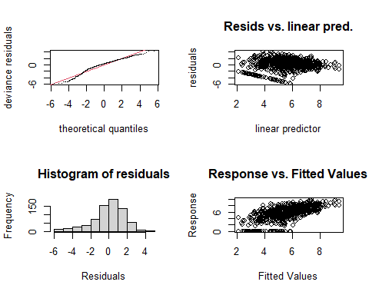

##   
## Method: REML Optimizer: outer newton  
## full convergence after 9 iterations.  
## Gradient range [-0.0005075893,0.0001711053]  
## (score 1439.908 & scale 3.172422).  
## Hessian positive definite, eigenvalue range [0.0005072981,347.4243].  
## Model rank = 52 / 52   
##   
## Basis dimension (k) checking results. Low p-value (k-index<1) may  
## indicate that k is too low, especially if edf is close to k'.  
##   
## k' edf k-index p-value   
## te(SalSurf_s,doy_s) 19.00000 14.77973 0.9 0.005 **  
## s(Year_fac) 27.00000 21.63427 NA NA   
## s(Station_fac) 5.00000 0.00136 NA NA   
## ---  
## Signif. codes: 0 '***' 0.001 '**' 0.01 '*' 0.05 '.' 0.1 ' ' 1  
##   
##   
## -------------summary-------------  
##   
## Family: gaussian   
## Link function: identity   
##   
## Formula:  
## BPUE_log1p ~ te(SalSurf_s, doy_s, k = c(5, 5), bs = c("cs", "cc")) +   
## s(Year_fac, bs = "re") + s(Station_fac, bs = "re")  
##   
## Parametric coefficients:  
## Estimate Std. Error t value Pr(>|t|)   
## (Intercept) 5.5934 0.1717 32.57 <0.0000000000000002 ***  
## ---  
## Signif. codes: 0 '***' 0.001 '**' 0.01 '*' 0.05 '.' 0.1 ' ' 1  
##   
## Approximate significance of smooth terms:  
## edf Ref.df F p-value   
## te(SalSurf_s,doy_s) 14.779732 19 19.038 <0.0000000000000002 ***  
## s(Year_fac) 21.634272 26 4.142 <0.0000000000000002 ***  
## s(Station_fac) 0.001358 4 0.000 0.789   
## ---  
## Signif. codes: 0 '***' 0.001 '**' 0.01 '*' 0.05 '.' 0.1 ' ' 1  
##   
## R-sq.(adj) = 0.383 Deviance explained = 41.5%  
## -REML = 1439.9 Scale est. = 3.1724 n = 695  
## <<<<<<<<<<<<<<<<<<<<<<< modeling other Suisun Marsh >>>>>>>>>>>>>>>>>>>>>>>>>  
##   
## -------------gam check-------------

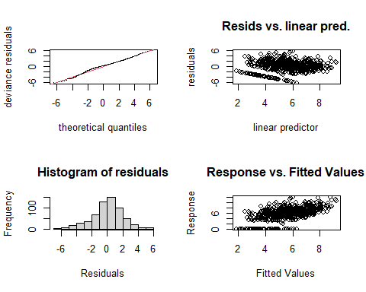

##   
## Method: REML Optimizer: outer newton  
## full convergence after 8 iterations.  
## Gradient range [-0.0005072905,0.0001734405]  
## (score 1360.184 & scale 4.147165).  
## Hessian positive definite, eigenvalue range [0.0005067784,310.3929].  
## Model rank = 49 / 49   
##   
## Basis dimension (k) checking results. Low p-value (k-index<1) may  
## indicate that k is too low, especially if edf is close to k'.  
##   
## k' edf k-index p-value  
## te(SalSurf_s,doy_s) 19.00000 11.13474 0.98 0.28  
## s(Year_fac) 27.00000 20.34580 NA NA  
## s(Station_fac) 2.00000 0.00109 NA NA  
##   
##   
## -------------summary-------------  
##   
## Family: gaussian   
## Link function: identity   
##   
## Formula:  
## BPUE_log1p ~ te(SalSurf_s, doy_s, k = c(5, 5), bs = c("cs", "cc")) +   
## s(Year_fac, bs = "re") + s(Station_fac, bs = "re")  
##   
## Parametric coefficients:  
## Estimate Std. Error t value Pr(>|t|)   
## (Intercept) 5.6270 0.1806 31.17 <0.0000000000000002 ***  
## ---  
## Signif. codes: 0 '***' 0.001 '**' 0.01 '*' 0.05 '.' 0.1 ' ' 1  
##   
## Approximate significance of smooth terms:  
## edf Ref.df F p-value   
## te(SalSurf_s,doy_s) 11.134744 19 12.288 <0.0000000000000002 ***  
## s(Year_fac) 20.345798 26 3.618 <0.0000000000000002 ***  
## s(Station_fac) 0.001089 1 0.000 0.793   
## ---  
## Signif. codes: 0 '***' 0.001 '**' 0.01 '*' 0.05 '.' 0.1 ' ' 1  
##   
## R-sq.(adj) = 0.353 Deviance explained = 38.6%  
## -REML = 1360.2 Scale est. = 4.1472 n = 621

sal_conversions

## # A tibble: 88,728 × 1,004  
## Region Month IBMR SalSurf draw_1 draw_2 draw_3 draw_4 draw_5 draw_6 draw_7  
## <fct> <int> <chr> <dbl> <dbl> <dbl> <dbl> <dbl> <dbl> <dbl> <dbl>  
## 1 SW Suis… 1 acar… 0.1 5.23 3.30 5.58 5.05 3.90 3.70 3.65  
## 2 SW Suis… 1 acar… 0.2 5.21 3.32 5.60 5.06 3.92 3.72 3.66  
## 3 SW Suis… 1 acar… 0.3 5.18 3.33 5.62 5.06 3.93 3.74 3.67  
## 4 SW Suis… 1 acar… 0.4 5.16 3.35 5.64 5.07 3.95 3.77 3.68  
## 5 SW Suis… 1 acar… 0.5 5.14 3.36 5.66 5.07 3.97 3.79 3.68  
## 6 SW Suis… 1 acar… 0.6 5.12 3.38 5.68 5.08 3.99 3.81 3.69  
## 7 SW Suis… 1 acar… 0.7 5.09 3.39 5.70 5.08 4.00 3.83 3.70  
## 8 SW Suis… 1 acar… 0.8 5.07 3.41 5.72 5.09 4.02 3.85 3.71  
## 9 SW Suis… 1 acar… 0.9 5.05 3.42 5.74 5.09 4.04 3.87 3.71  
## 10 SW Suis… 1 acar… 1 5.03 3.43 5.76 5.09 4.06 3.89 3.72  
## # … with 88,718 more rows, and 993 more variables: draw_8 <dbl>, draw_9 <dbl>,  
## # draw_10 <dbl>, draw_11 <dbl>, draw_12 <dbl>, draw_13 <dbl>, draw_14 <dbl>,  
## # draw_15 <dbl>, draw_16 <dbl>, draw_17 <dbl>, draw_18 <dbl>, draw_19 <dbl>,  
## # draw_20 <dbl>, draw_21 <dbl>, draw_22 <dbl>, draw_23 <dbl>, draw_24 <dbl>,  
## # draw_25 <dbl>, draw_26 <dbl>, draw_27 <dbl>, draw_28 <dbl>, draw_29 <dbl>,  
## # draw_30 <dbl>, draw_31 <dbl>, draw_32 <dbl>, draw_33 <dbl>, draw_34 <dbl>,  
## # draw_35 <dbl>, draw_36 <dbl>, draw_37 <dbl>, draw_38 <dbl>, …

Plot salinity-biomass relationships

sal_conversions_sum<-apply(select(sal_conversions, starts_with("draw_")), 1,   
 function(x) quantile(x, c(0.025, 0.5, 0.975)))  
  
sal_conversions_plot<-sal_conversions%>%  
 select(-starts_with("draw_"))%>%  
 bind_cols(tibble(l95=sal_conversions_sum["2.5%",],   
 median=sal_conversions_sum["50%",],   
 u95=sal_conversions_sum["97.5%",]))  
plot_sal_conversions<-function(group, data=sal_conversions_plot){  
   
 if(group!="All"){  
 data<-filter(data, IBMR%in%group)  
   
 ggplot(data, aes(x=SalSurf, y=median, ymin=l95, ymax=u95))+  
 geom_ribbon(alpha=0.4, fill="chartreuse4")+  
 ylab("Zooplankton biomass (log scale)")+  
 facet_grid(Region~month(Month, label=T))+  
 theme_bw()+  
 theme(axis.text.x=element_text(angle=45, hjust=1))  
 }else{  
 ggplot(data, aes(x=SalSurf, y=median, ymin=l95, ymax=u95, fill=IBMR))+  
 geom_ribbon(alpha=0.4)+  
 ylab("Zooplankton biomass (log scale)")+  
 facet_grid(Region~month(Month, label=T))+  
 scale_fill_viridis_d()+  
 theme_bw()+  
 theme(axis.text.x=element_text(angle=45, hjust=1))  
 }  
}

# Create plots for each IBMR group  
sal_conversion_plots <- tibble(group=c("All", unique(model_factors$IBMR)))%>%  
 mutate(plot=map(group, plot_sal_conversions))

## Salinity-biomass plots

### All

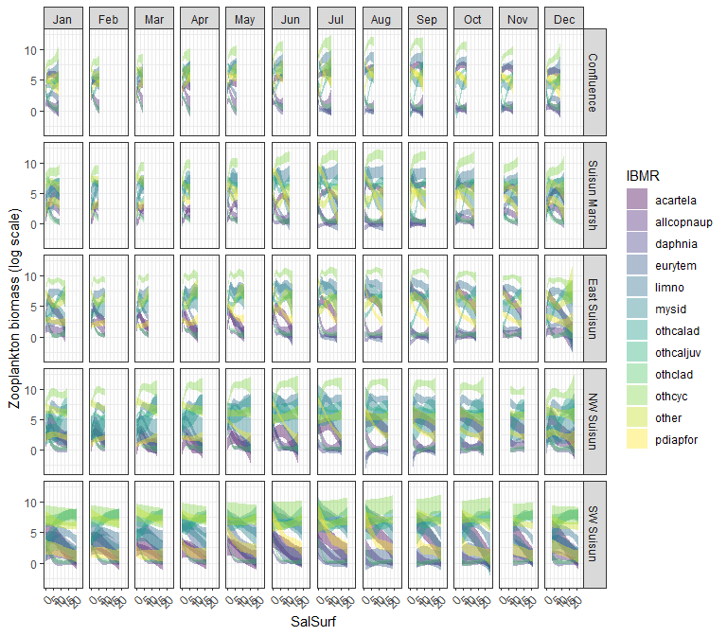

### acartela

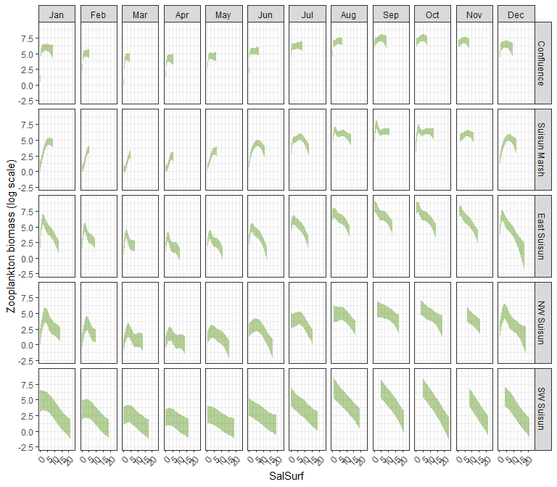

### daphnia

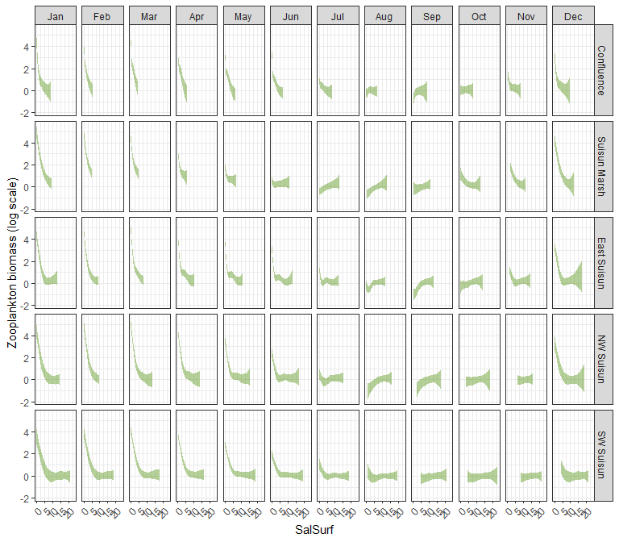

### eurytem

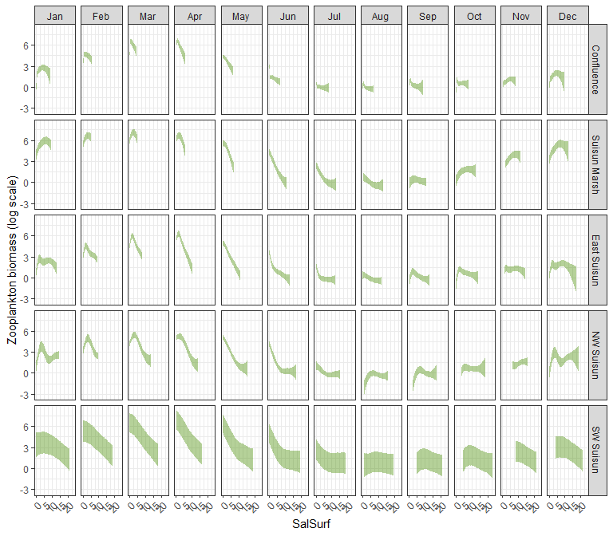

### othcalad

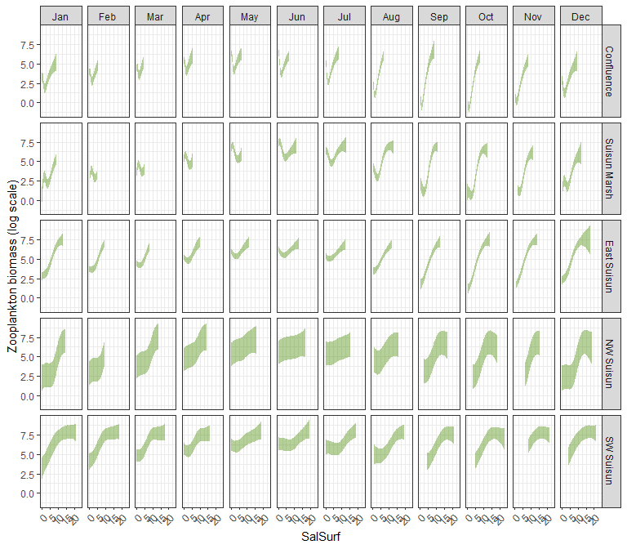

### othcaljuv

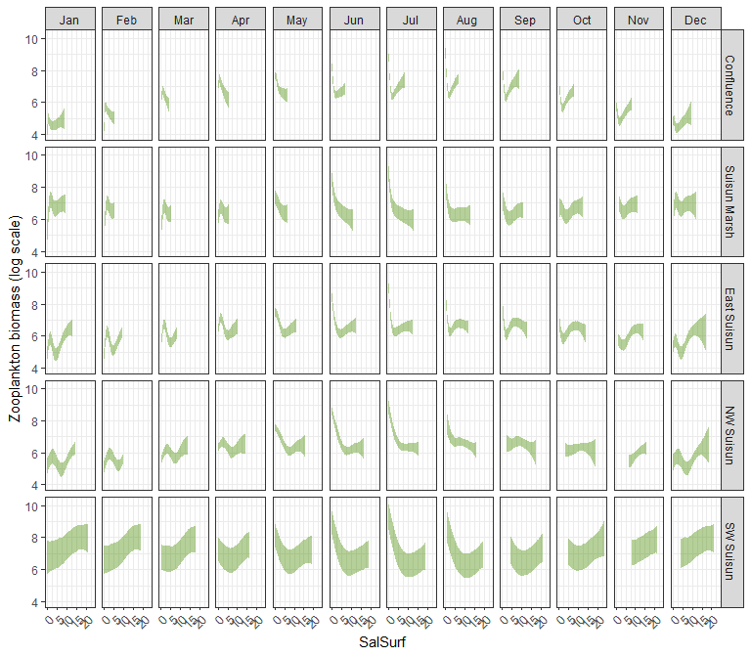

### othclad

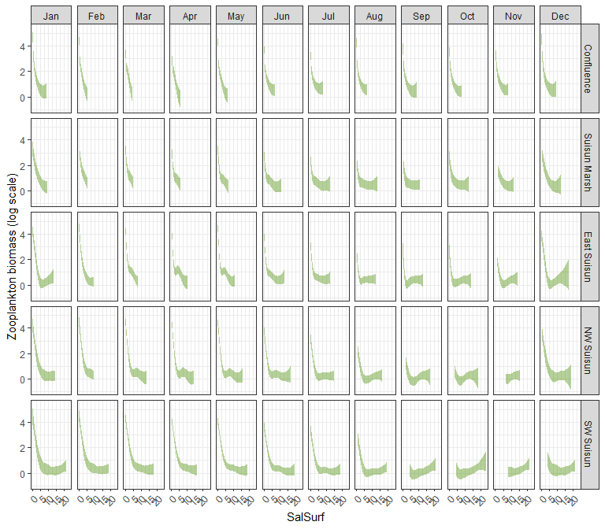

### pdiapfor

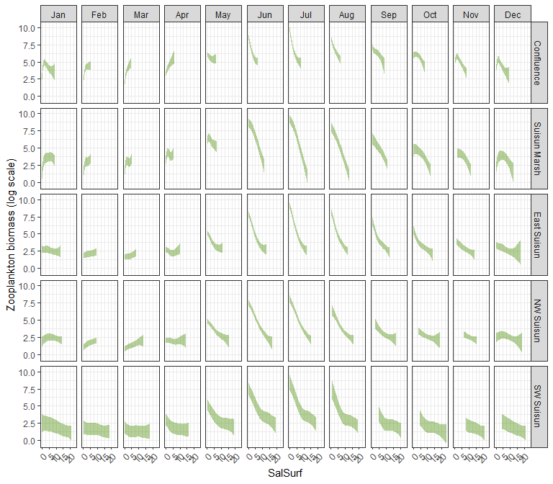

### allcopnaup

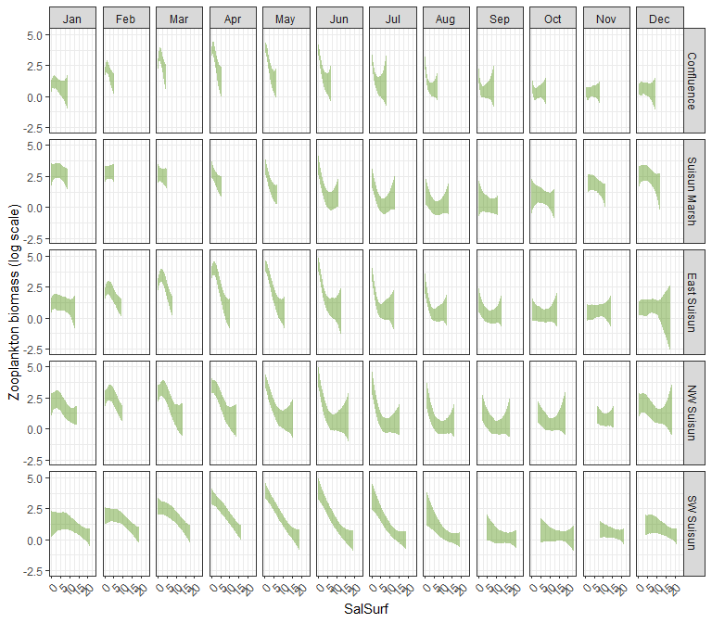

### limno

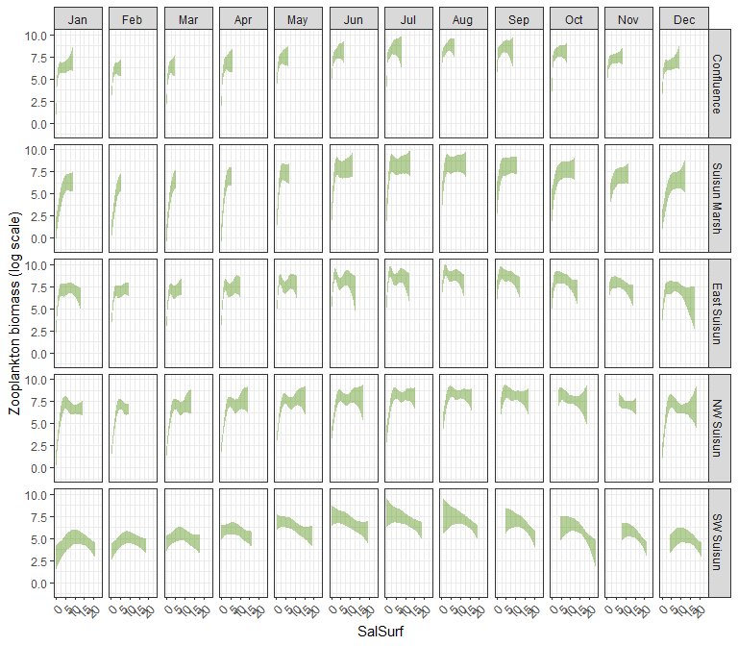

### mysid

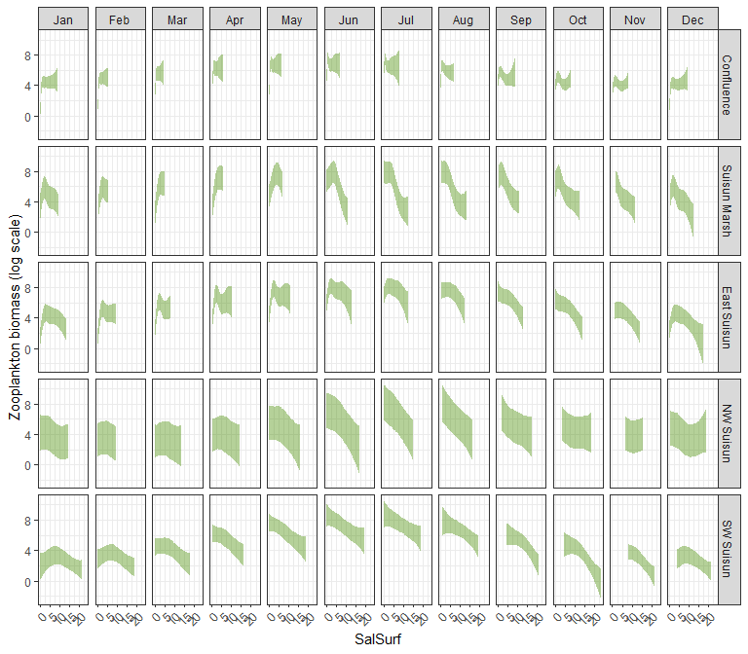

### othcyc

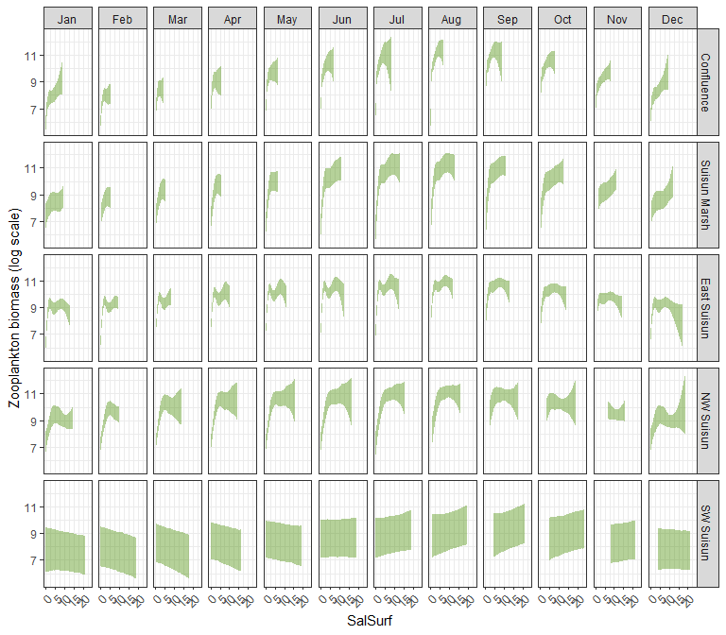

### other

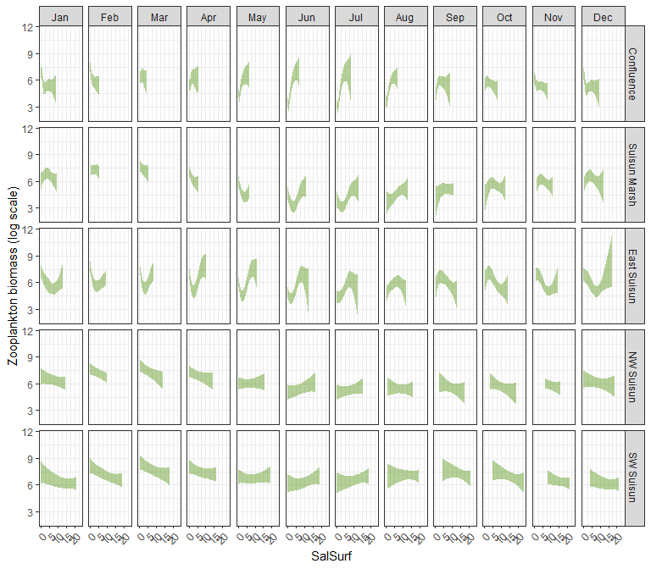

# Read salinity data

salinity_data<-read.csv("../X2_salinity_analysis/converted_salinity_data.csv")   
  
#Original file from CSAMP SDM  
original_scenario_file<-read.csv("../X2_salinity_analysis/base_salinity_data.csv")  
  
#Join the two datasets  
scenario_file <- original_scenario_file %>% select(c(2:5)) %>% left_join(salinity_data)

# Apply model

Load in the modeled salinity

scenario_names<-tibble(name=colnames(scenario_file))%>%  
 filter(str_detect(name, "sal_"))%>%  
 rev()  
  
scenario_sal<-scenario_file%>%  
 select(region, year, month, starts_with("sal_"))%>%  
 mutate(across(c(year, month), as.integer),  
 across(starts_with("sal_"), ~if_else(is.na(.x), sal_base, .x)))%>%  
 filter(region%in%unique(zoop_data_mass$SUBREGION))%>%  
 mutate(region=factor(region,   
 levels=c("Confluence", "Suisun Marsh", "NE Suisun",   
 "SE Suisun", "NW Suisun", "SW Suisun")))%>%  
 pivot_longer(cols=starts_with("sal_"), names_to="Scenario", values_to="Salinity")%>% # Prepare data for easier plotting  
 mutate(Scenario=factor(Scenario,   
 levels=scenario_names$name),  
 Salinity=round(Salinity, 1))

Plot modeled salinity

ggplot(scenario_sal,   
 aes(x=year, y=Salinity, color=Scenario))+  
 geom_line()+  
 scale_color_viridis_d(direction=-1)+  
 facet_grid(region ~ month(month, label=T))+  
 theme_bw()+  
 theme(legend.position = "bottom", axis.text.x=element_text(angle=45, hjust=1))

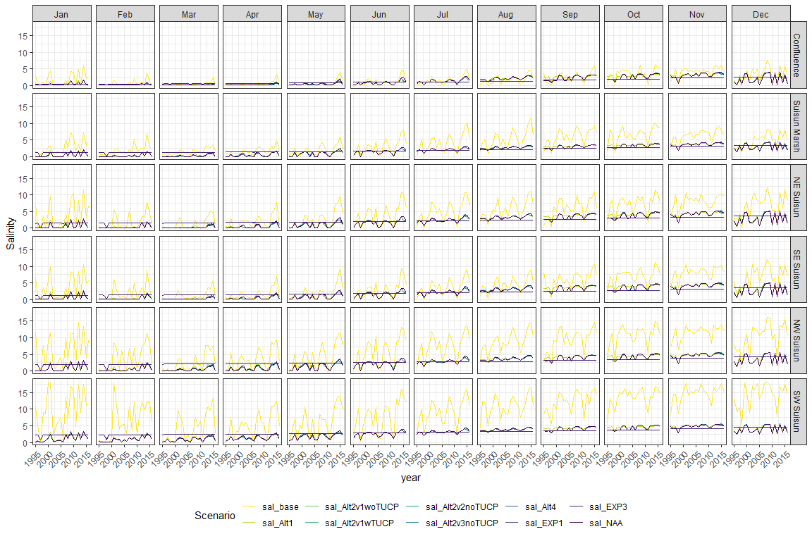

Calculate zoop abundance difference between each scenario and the baseline

zoop_saladjusted<-scenario_sal%>%  
 mutate(Salinity=as.character(Salinity),  
 IBMR=unique(model_factors$IBMR)[1])%>%  
 complete(region, year, month, Scenario, IBMR=unique(model_factors$IBMR))%>%  
 group_by(region, year, month, Scenario)%>%  
 mutate(Salinity=na.exclude(Salinity),  
 region2=if_else(region%in%c("NE Suisun", "SE Suisun"), "East Suisun", as.character(region)))%>%  
 ungroup()%>%  
 left_join(sal_conversions%>%  
 mutate(SalSurf=as.character(SalSurf)),  
 by=c("region2"="Region",  
 "month"="Month",  
 "Salinity"="SalSurf",  
 "IBMR"="IBMR"))%>%  
 select(-Salinity, -region2)%>%  
 mutate(across(starts_with("draw_"), ~exp(.x)-1))%>%  
 pivot_longer(starts_with("draw_"), names_prefix="draw_", names_to="draw", values_to="fit")%>%  
 mutate(fit=if_else(fit<0, 0, fit))%>%  
 pivot_wider(names_from="Scenario", values_from="fit")%>%  
 mutate(across(starts_with("sal_"), ~.x/sal_base))%>%  
 group_by(region, year, month, IBMR)%>%  
 summarise(across(starts_with("sal_"),   
 list(median=~median(.x, na.rm=T),   
 l95=~quantile(.x, 0.025, na.rm=T),   
 u95=~quantile(.x, 0.975, na.rm=T))),   
 .groups="drop")  
  
write_csv(zoop_saladjusted, "zoop sal adjustments.csv")

You can find the final zoop salinity adjustments [here](https://github.com/sbashevkin/FLOATDrought/blob/main/Outputs/CSAMP%20zoop%20sal%20adjustments.csv)

## Prepare plots

Plot the missing model results resulting from out-of-range salinity values in the inputs

missing_adjusted_data<-zoop_saladjusted%>%  
 select(-ends_with("l95"), -ends_with("u95"))%>%  
 filter(IBMR=="acartela")%>%  
 pivot_longer(cols=starts_with("sal_"), names_to="Scenario", values_to="zoop_change")%>%  
 mutate(Scenario=str_remove(Scenario, fixed("_median")))  
  
ggplot(missing_adjusted_data,  
 aes(x=year, y=Scenario, fill=is.na(zoop_change)))+  
 geom_tile()+  
 scale_fill_viridis_d(name="Are the model results missing due to out-of-range salinity values?")+  
 facet_grid(region ~ month(month, label=T))+  
 theme_bw()+  
 theme(legend.position = "bottom", axis.text.x=element_text(angle=45, hjust=1))

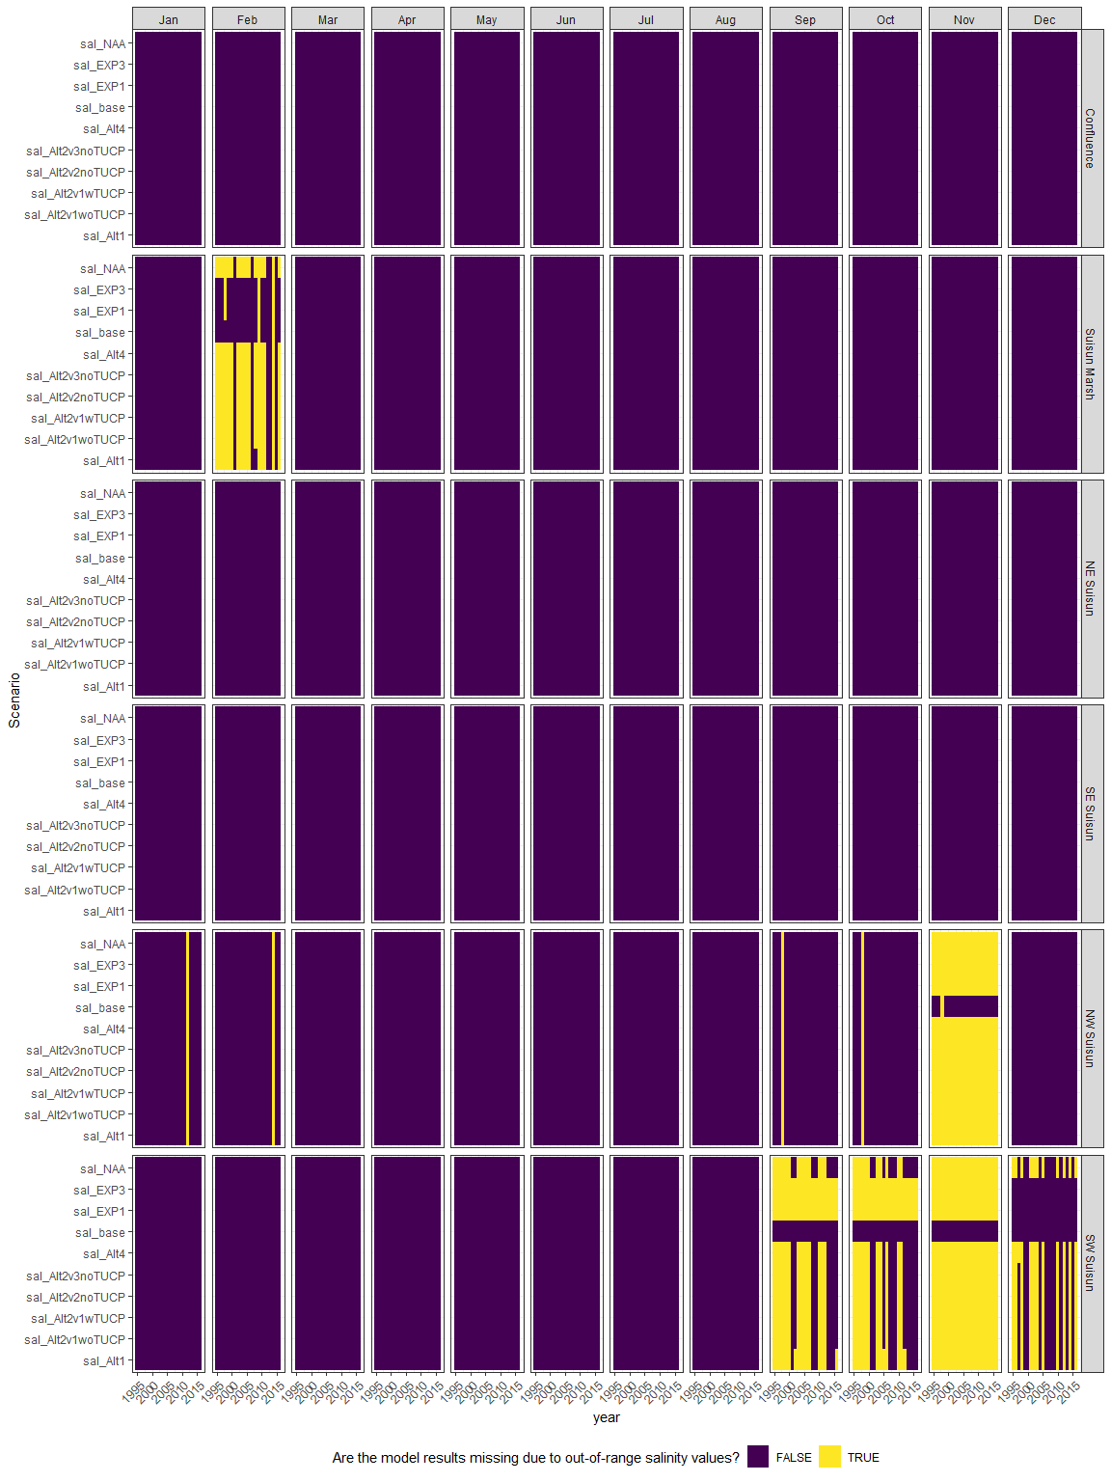

Plot the result

Create some plotting functions

neglop1p<-trans_new("neglop1p", transform=function(x) sign(x)*log(abs(x)+1), inverse=function(x) sign(x)*(exp(abs(x))-1))  
plot_scenario_result <- function(scenario, group) {  
   
 plot_data<-zoop_saladjusted%>%  
 filter(IBMR%in%group)  
   
 ggplot(plot_data,  
 aes(x=year, y=.data[[paste0(scenario, "_median")]], ymin=.data[[paste0(scenario, "_l95")]], ymax=.data[[paste0(scenario, "_u95")]]))+  
 geom_ribbon(alpha=0.4, fill="darkorchid4")+  
 geom_line(alpha=0.4, color="darkorchid4")+  
 scale_y_continuous(trans=neglop1p, breaks=c(-1000, -100, -10, -1, 0, 1, 10, 100, 1000))+  
 ylab("Scenario/baseline (log scale)")+  
 facet_grid(region ~ month(month, label=T))+  
 theme_bw()+  
 theme(legend.position = "bottom", axis.text.x=element_text(angle=45, hjust=1))  
}

# Create plots for each Parameter  
scenario_result_plots <- expand_grid(Scenario=unique(scenario_sal$Scenario)[-1],  
 IBMR=unique(model_factors$IBMR))%>%  
 mutate(plot=map2(Scenario, IBMR, ~plot_scenario_result(.x, .y)))

## Result plots

### sal_Alt1

#### acartela

## Warning in max(ids, na.rm = TRUE): no non-missing arguments to max; returning  
## -Inf  
  
## Warning in max(ids, na.rm = TRUE): no non-missing arguments to max; returning  
## -Inf

## Warning: Removed 1 row containing missing values (`geom_line()`).

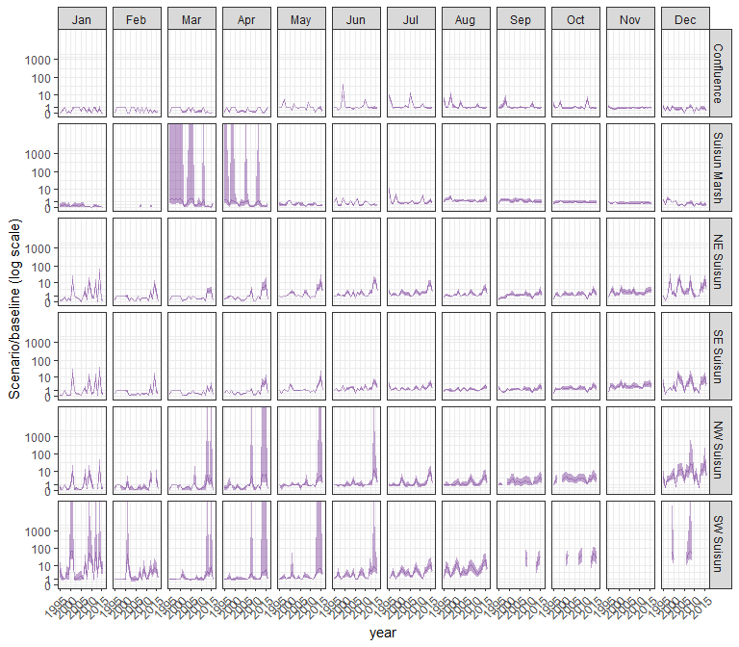

#### daphnia

## Warning in max(ids, na.rm = TRUE): no non-missing arguments to max; returning  
## -Inf

## Warning in max(ids, na.rm = TRUE): no non-missing arguments to max; returning  
## -Inf

## Warning: Removed 1 row containing missing values (`geom_line()`).

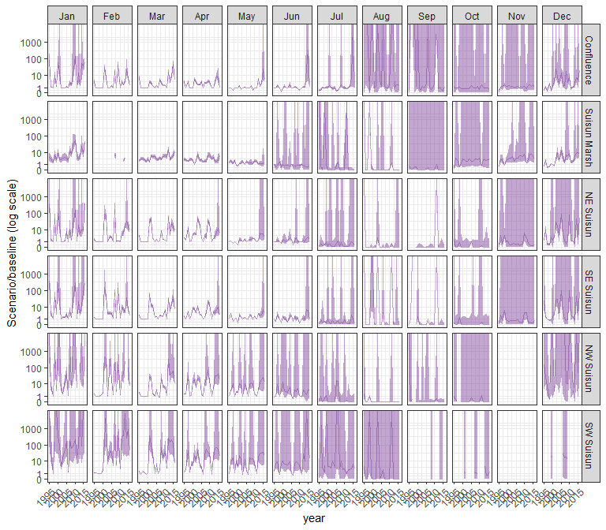

#### eurytem

## Warning in max(ids, na.rm = TRUE): no non-missing arguments to max; returning  
## -Inf

## Warning in max(ids, na.rm = TRUE): no non-missing arguments to max; returning  
## -Inf

## Warning: Removed 1 row containing missing values (`geom_line()`).

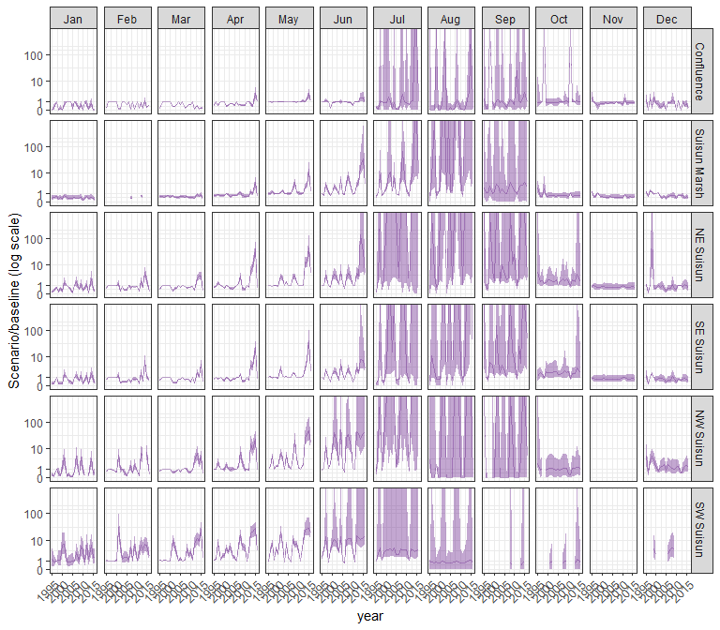

#### othcalad

## Warning in max(ids, na.rm = TRUE): no non-missing arguments to max; returning  
## -Inf

## Warning in max(ids, na.rm = TRUE): no non-missing arguments to max; returning  
## -Inf

## Warning: Removed 1 row containing missing values (`geom_line()`).

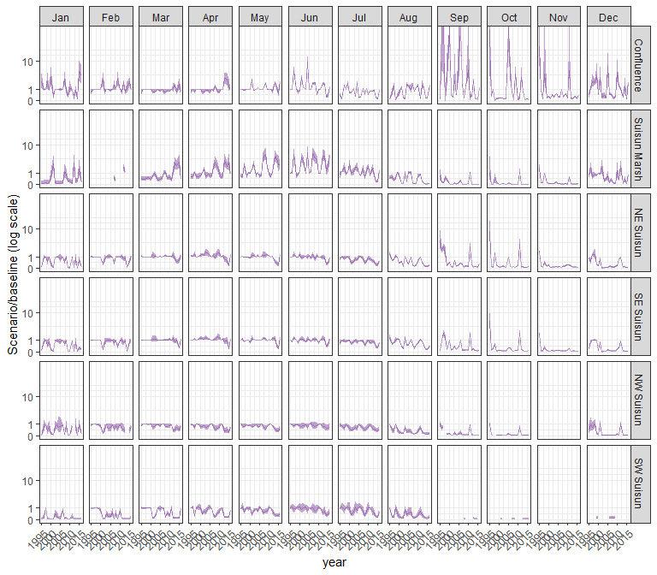

#### othcaljuv

## Warning in max(ids, na.rm = TRUE): no non-missing arguments to max; returning  
## -Inf

## Warning in max(ids, na.rm = TRUE): no non-missing arguments to max; returning  
## -Inf

## Warning: Removed 1 row containing missing values (`geom_line()`).

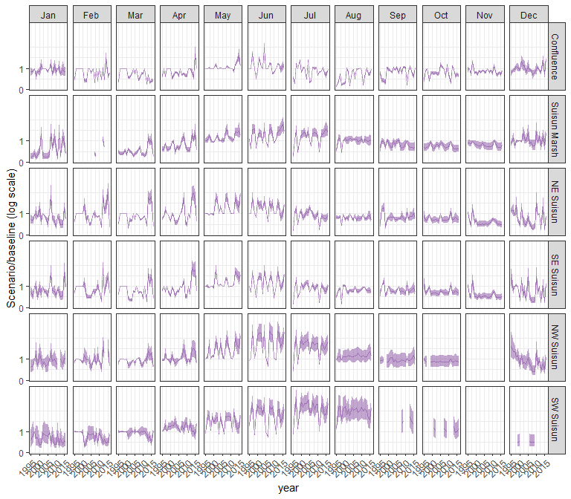

#### othclad

## Warning in max(ids, na.rm = TRUE): no non-missing arguments to max; returning  
## -Inf

## Warning in max(ids, na.rm = TRUE): no non-missing arguments to max; returning  
## -Inf

## Warning: Removed 1 row containing missing values (`geom_line()`).

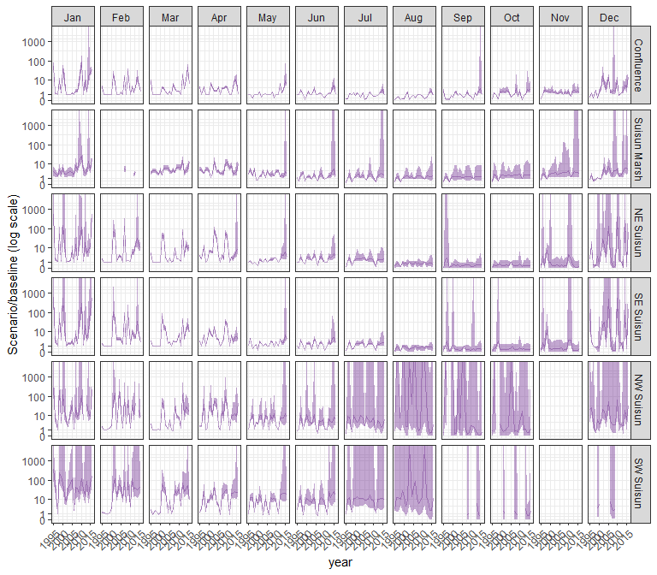

#### pdiapfor

## Warning in max(ids, na.rm = TRUE): no non-missing arguments to max; returning  
## -Inf

## Warning in max(ids, na.rm = TRUE): no non-missing arguments to max; returning  
## -Inf

## Warning: Removed 1 row containing missing values (`geom_line()`).

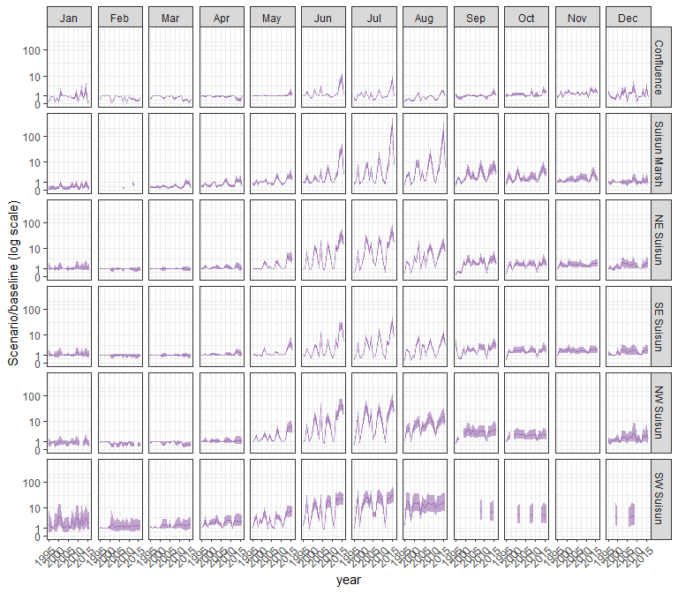

#### allcopnaup

## Warning in max(ids, na.rm = TRUE): no non-missing arguments to max; returning  
## -Inf

## Warning in max(ids, na.rm = TRUE): no non-missing arguments to max; returning  
## -Inf

## Warning: Removed 1 row containing missing values (`geom_line()`).

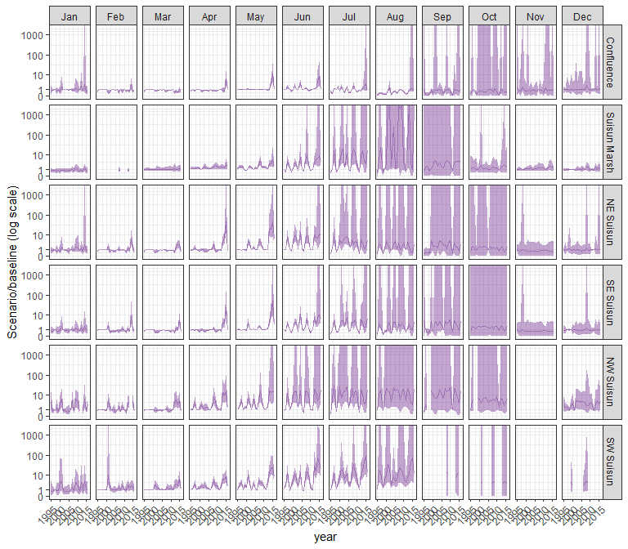

#### limno

## Warning in max(ids, na.rm = TRUE): no non-missing arguments to max; returning  
## -Inf

## Warning in max(ids, na.rm = TRUE): no non-missing arguments to max; returning  
## -Inf

## Warning: Removed 1 row containing missing values (`geom_line()`).

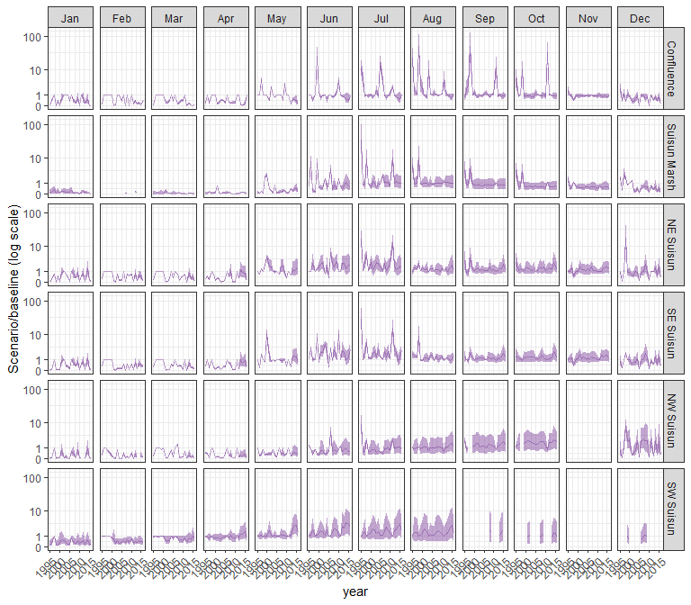

#### mysid

## Warning in max(ids, na.rm = TRUE): no non-missing arguments to max; returning  
## -Inf

## Warning in max(ids, na.rm = TRUE): no non-missing arguments to max; returning  
## -Inf

## Warning: Removed 1 row containing missing values (`geom_line()`).

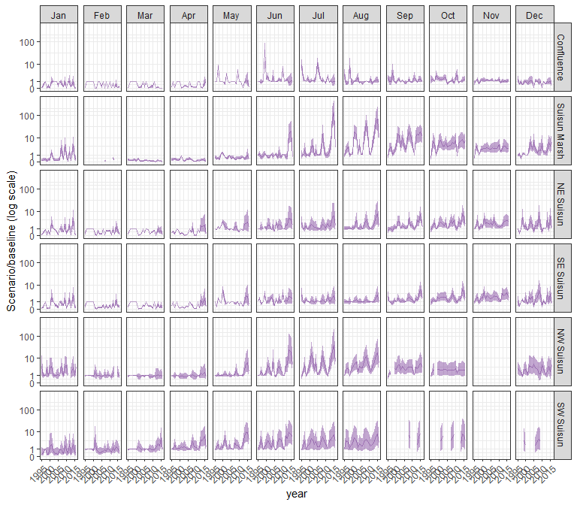

#### othcyc

## Warning in max(ids, na.rm = TRUE): no non-missing arguments to max; returning  
## -Inf

## Warning in max(ids, na.rm = TRUE): no non-missing arguments to max; returning  
## -Inf

## Warning: Removed 1 row containing missing values (`geom_line()`).

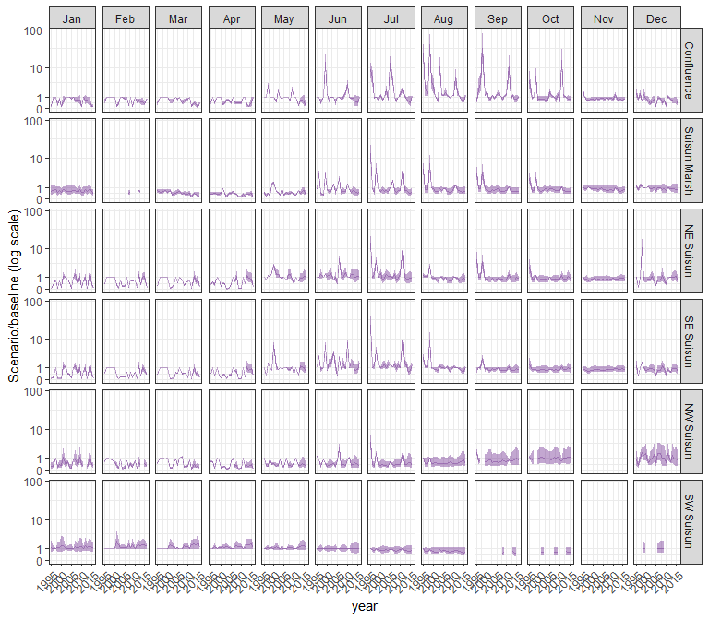

#### other

## Warning in max(ids, na.rm = TRUE): no non-missing arguments to max; returning  
## -Inf

## Warning in max(ids, na.rm = TRUE): no non-missing arguments to max; returning  
## -Inf

## Warning: Removed 1 row containing missing values (`geom_line()`).

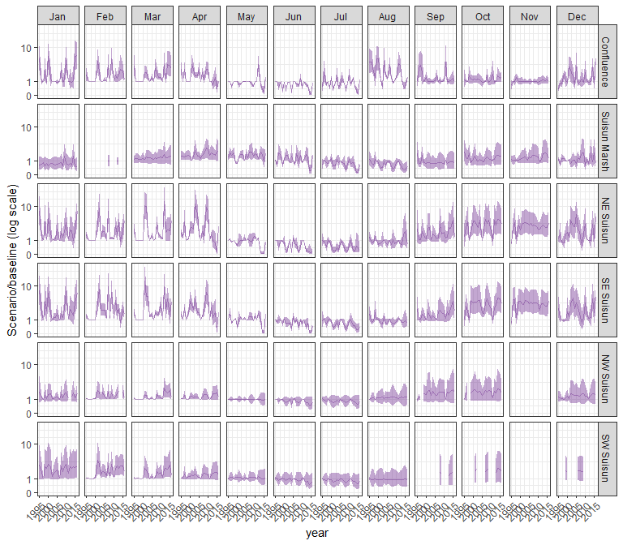

### sal_Alt2v1woTUCP

#### acartela

## Warning in max(ids, na.rm = TRUE): no non-missing arguments to max; returning  
## -Inf

## Warning in max(ids, na.rm = TRUE): no non-missing arguments to max; returning  
## -Inf

## Warning: Removed 1 row containing missing values (`geom_line()`).

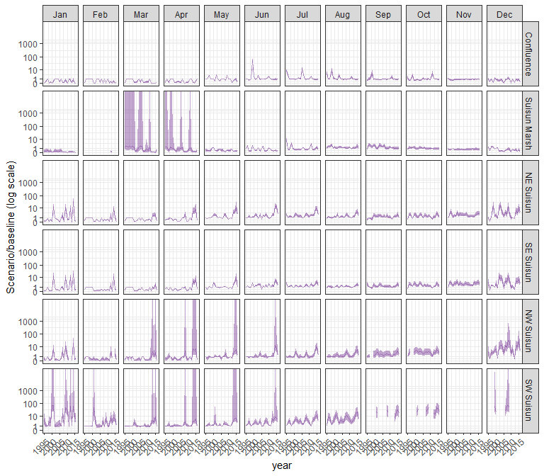

#### daphnia

## Warning in max(ids, na.rm = TRUE): no non-missing arguments to max; returning  
## -Inf

## Warning in max(ids, na.rm = TRUE): no non-missing arguments to max; returning  
## -Inf

## Warning: Removed 1 row containing missing values (`geom_line()`).

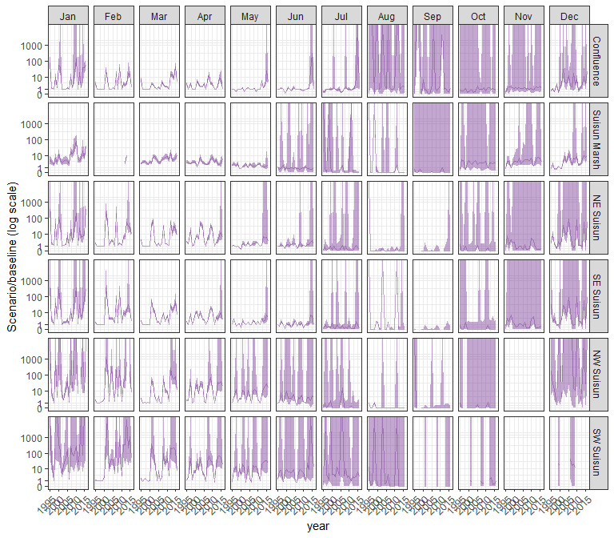

#### eurytem

## Warning in max(ids, na.rm = TRUE): no non-missing arguments to max; returning  
## -Inf

## Warning in max(ids, na.rm = TRUE): no non-missing arguments to max; returning  
## -Inf

## Warning: Removed 1 row containing missing values (`geom_line()`).

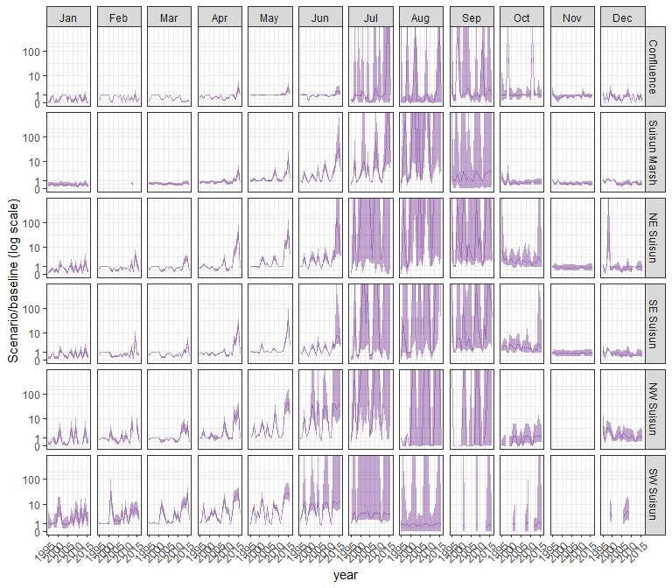

#### othcalad

## Warning in max(ids, na.rm = TRUE): no non-missing arguments to max; returning  
## -Inf

## Warning in max(ids, na.rm = TRUE): no non-missing arguments to max; returning  
## -Inf

## Warning: Removed 1 row containing missing values (`geom_line()`).

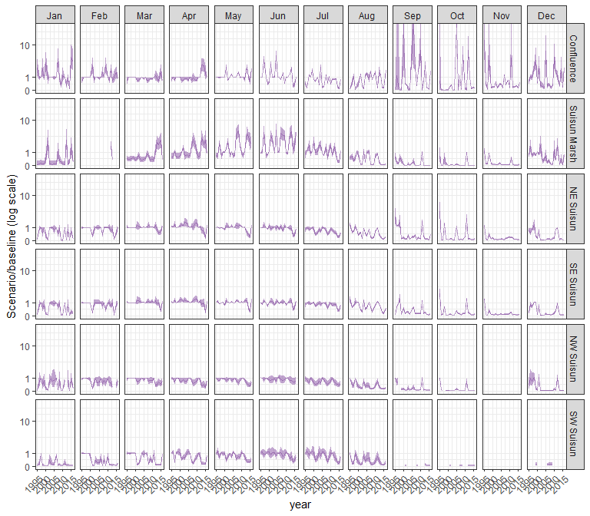

#### othcaljuv

## Warning in max(ids, na.rm = TRUE): no non-missing arguments to max; returning  
## -Inf

## Warning in max(ids, na.rm = TRUE): no non-missing arguments to max; returning  
## -Inf

## Warning: Removed 1 row containing missing values (`geom_line()`).

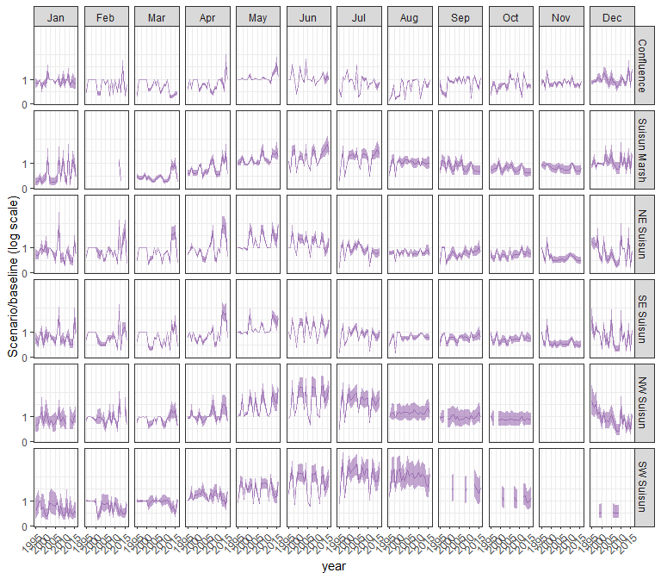

#### othclad

## Warning in max(ids, na.rm = TRUE): no non-missing arguments to max; returning  
## -Inf

## Warning in max(ids, na.rm = TRUE): no non-missing arguments to max; returning  
## -Inf

## Warning: Removed 1 row containing missing values (`geom_line()`).

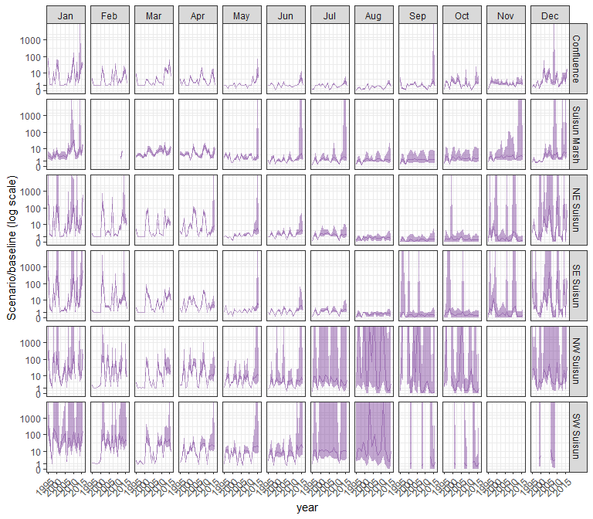

#### pdiapfor

## Warning in max(ids, na.rm = TRUE): no non-missing arguments to max; returning  
## -Inf

## Warning in max(ids, na.rm = TRUE): no non-missing arguments to max; returning  
## -Inf

## Warning: Removed 1 row containing missing values (`geom_line()`).

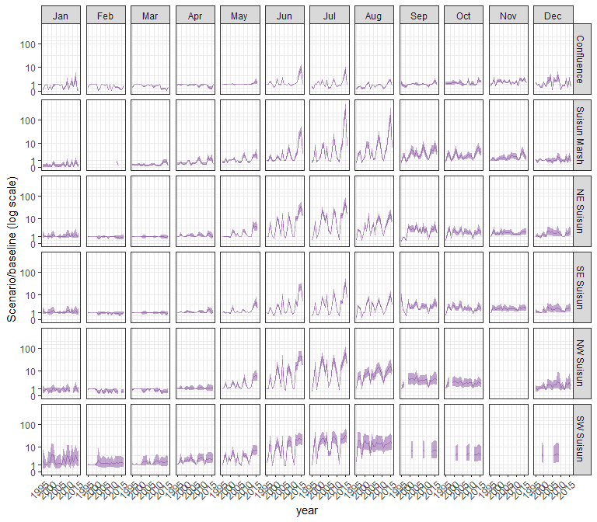

#### allcopnaup

## Warning in max(ids, na.rm = TRUE): no non-missing arguments to max; returning  
## -Inf

## Warning in max(ids, na.rm = TRUE): no non-missing arguments to max; returning  
## -Inf

## Warning: Removed 1 row containing missing values (`geom_line()`).

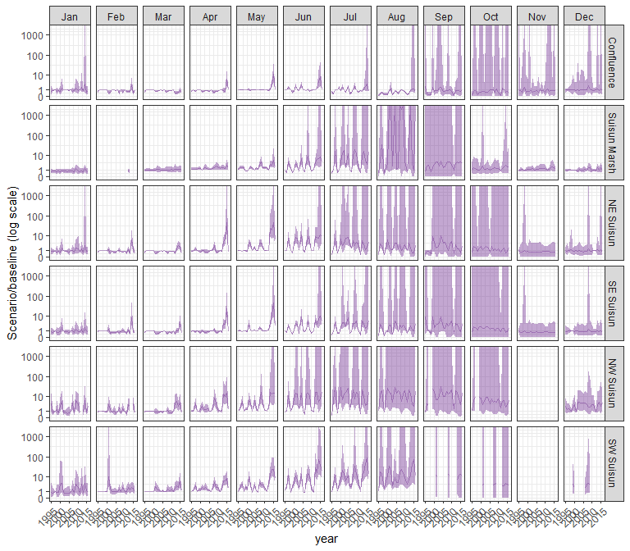

#### limno

## Warning in max(ids, na.rm = TRUE): no non-missing arguments to max; returning  
## -Inf

## Warning in max(ids, na.rm = TRUE): no non-missing arguments to max; returning  
## -Inf

## Warning: Removed 1 row containing missing values (`geom_line()`).

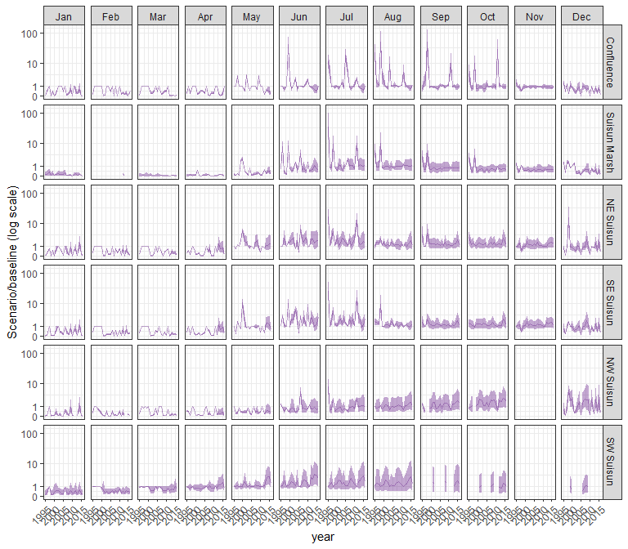

#### mysid

## Warning in max(ids, na.rm = TRUE): no non-missing arguments to max; returning  
## -Inf

## Warning in max(ids, na.rm = TRUE): no non-missing arguments to max; returning  
## -Inf

## Warning: Removed 1 row containing missing values (`geom_line()`).

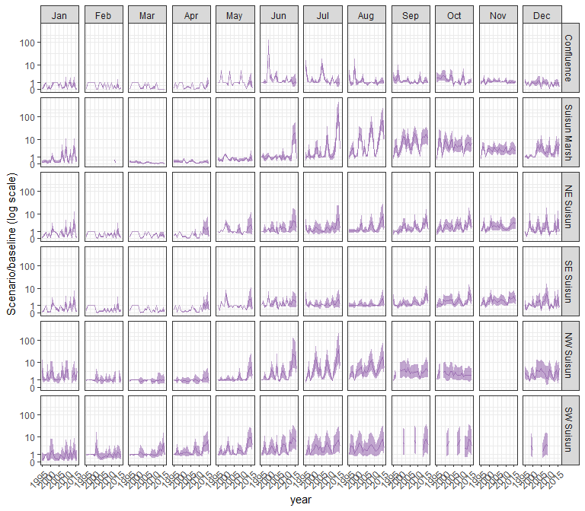

#### othcyc

## Warning in max(ids, na.rm = TRUE): no non-missing arguments to max; returning  
## -Inf

## Warning in max(ids, na.rm = TRUE): no non-missing arguments to max; returning  
## -Inf

## Warning: Removed 1 row containing missing values (`geom_line()`).

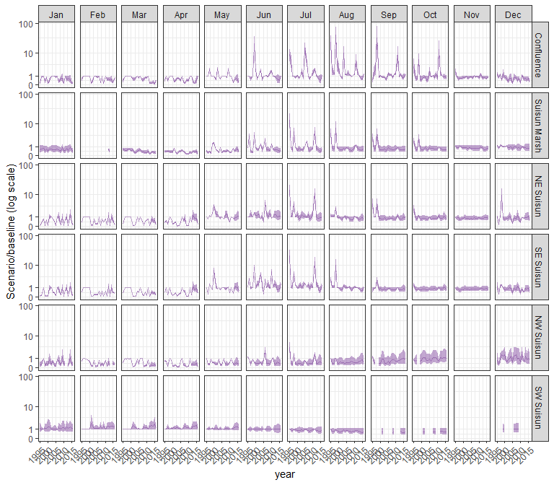

#### other

## Warning in max(ids, na.rm = TRUE): no non-missing arguments to max; returning  
## -Inf

## Warning in max(ids, na.rm = TRUE): no non-missing arguments to max; returning  
## -Inf

## Warning: Removed 1 row containing missing values (`geom_line()`).

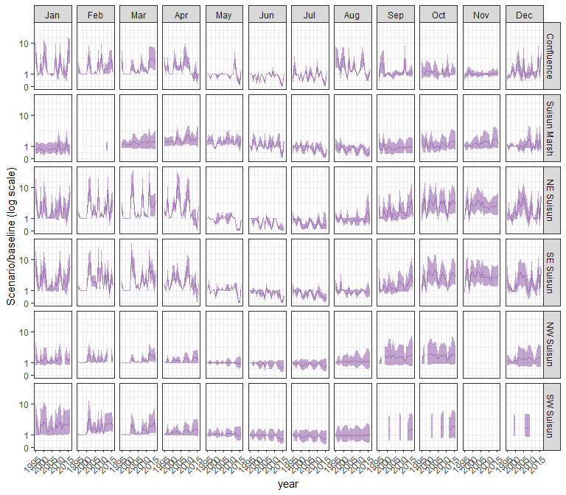

### sal_Alt2v1wTUCP

#### acartela

## Warning in max(ids, na.rm = TRUE): no non-missing arguments to max; returning  
## -Inf

## Warning in max(ids, na.rm = TRUE): no non-missing arguments to max; returning  
## -Inf

## Warning: Removed 1 row containing missing values (`geom_line()`).

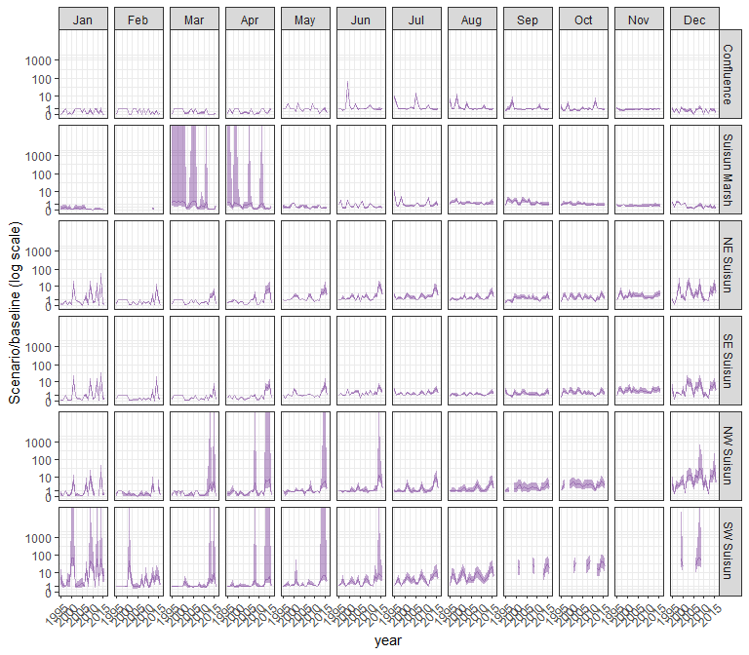

#### daphnia

## Warning in max(ids, na.rm = TRUE): no non-missing arguments to max; returning  
## -Inf

## Warning in max(ids, na.rm = TRUE): no non-missing arguments to max; returning  
## -Inf

## Warning: Removed 1 row containing missing values (`geom_line()`).

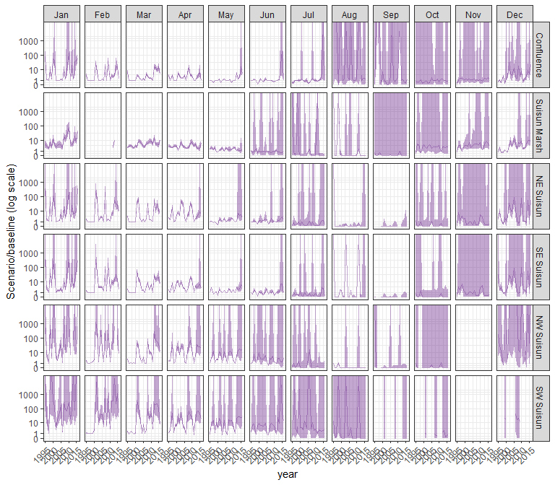

#### eurytem

## Warning in max(ids, na.rm = TRUE): no non-missing arguments to max; returning  
## -Inf

## Warning in max(ids, na.rm = TRUE): no non-missing arguments to max; returning  
## -Inf

## Warning: Removed 1 row containing missing values (`geom_line()`).

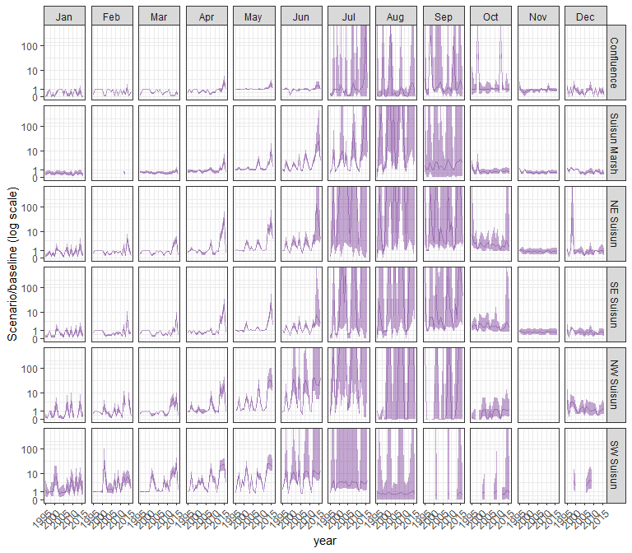

#### othcalad

## Warning in max(ids, na.rm = TRUE): no non-missing arguments to max; returning  
## -Inf

## Warning in max(ids, na.rm = TRUE): no non-missing arguments to max; returning  
## -Inf

## Warning: Removed 1 row containing missing values (`geom_line()`).

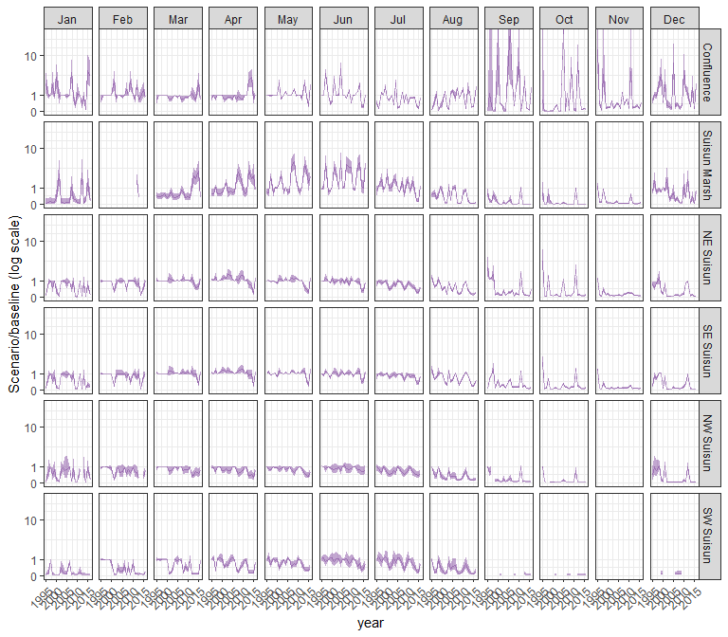

#### othcaljuv

## Warning in max(ids, na.rm = TRUE): no non-missing arguments to max; returning  
## -Inf

## Warning in max(ids, na.rm = TRUE): no non-missing arguments to max; returning  
## -Inf

## Warning: Removed 1 row containing missing values (`geom_line()`).

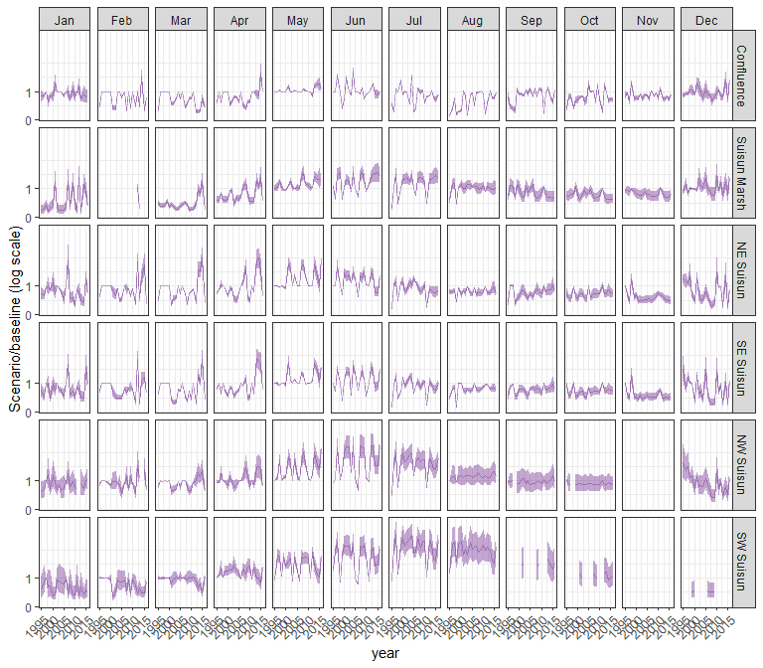

#### othclad

## Warning in max(ids, na.rm = TRUE): no non-missing arguments to max; returning  
## -Inf

## Warning in max(ids, na.rm = TRUE): no non-missing arguments to max; returning  
## -Inf

## Warning: Removed 1 row containing missing values (`geom_line()`).

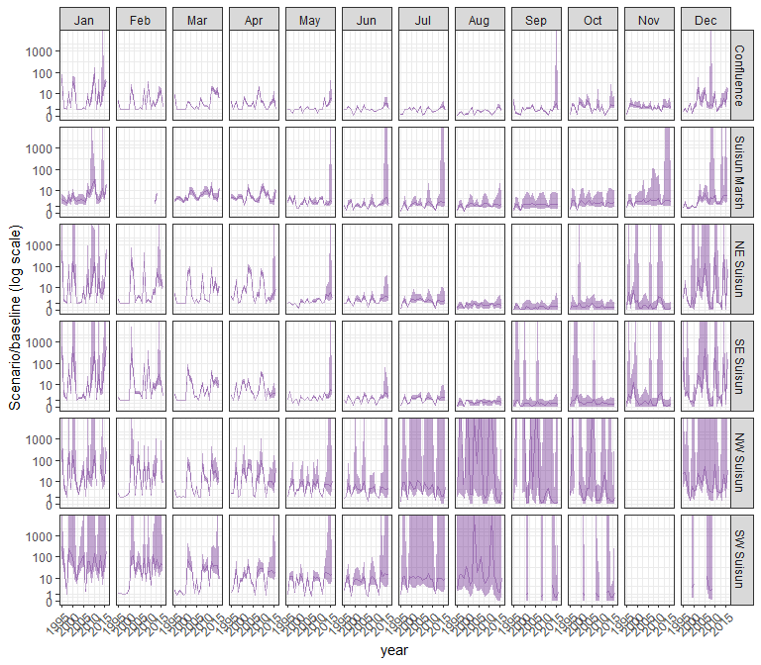

#### pdiapfor

## Warning in max(ids, na.rm = TRUE): no non-missing arguments to max; returning  
## -Inf

## Warning in max(ids, na.rm = TRUE): no non-missing arguments to max; returning  
## -Inf

## Warning: Removed 1 row containing missing values (`geom_line()`).

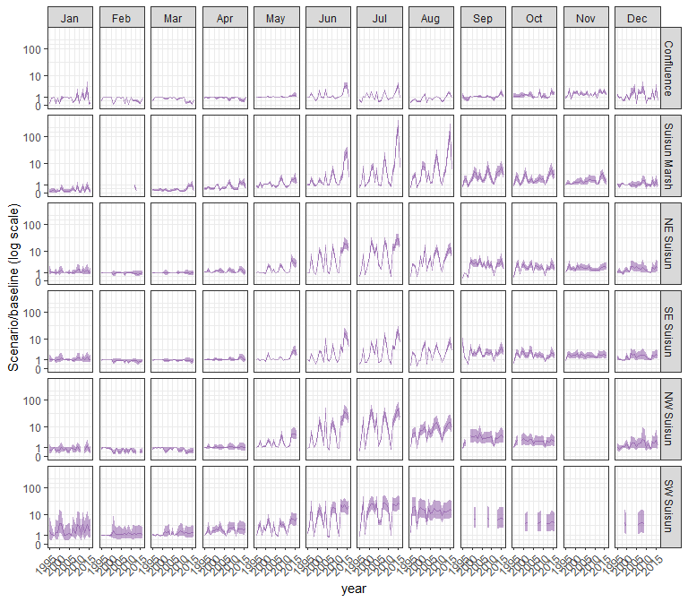

#### allcopnaup

## Warning in max(ids, na.rm = TRUE): no non-missing arguments to max; returning  
## -Inf

## Warning in max(ids, na.rm = TRUE): no non-missing arguments to max; returning  
## -Inf

## Warning: Removed 1 row containing missing values (`geom_line()`).

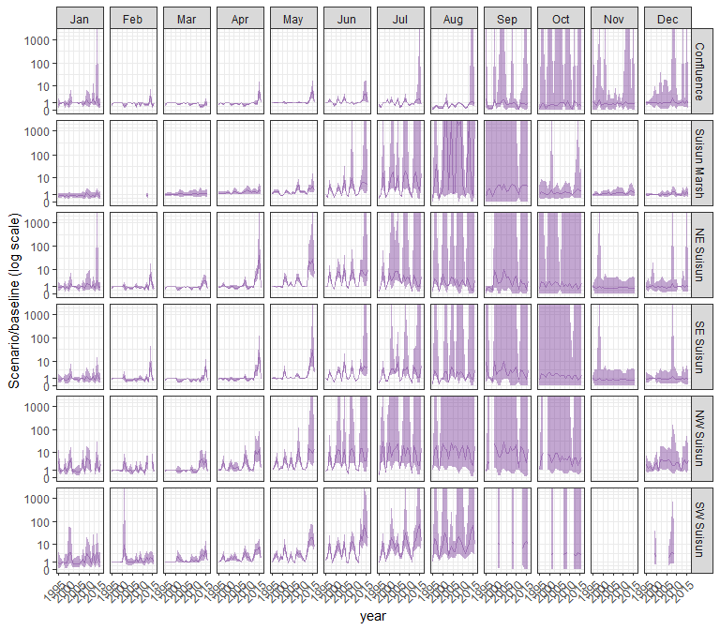

#### limno

## Warning in max(ids, na.rm = TRUE): no non-missing arguments to max; returning  
## -Inf

## Warning in max(ids, na.rm = TRUE): no non-missing arguments to max; returning  
## -Inf

## Warning: Removed 1 row containing missing values (`geom_line()`).

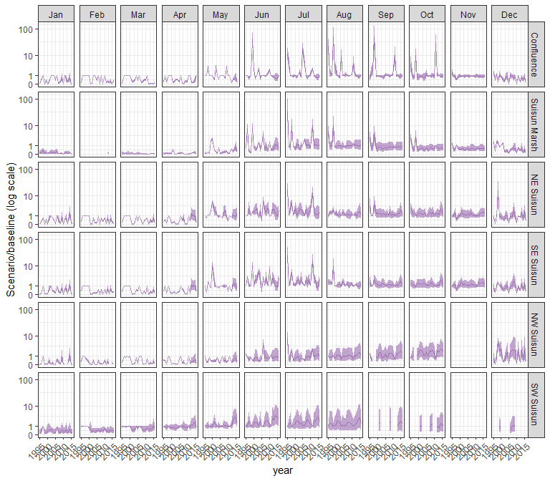

#### mysid

## Warning in max(ids, na.rm = TRUE): no non-missing arguments to max; returning  
## -Inf

## Warning in max(ids, na.rm = TRUE): no non-missing arguments to max; returning  
## -Inf

## Warning: Removed 1 row containing missing values (`geom_line()`).

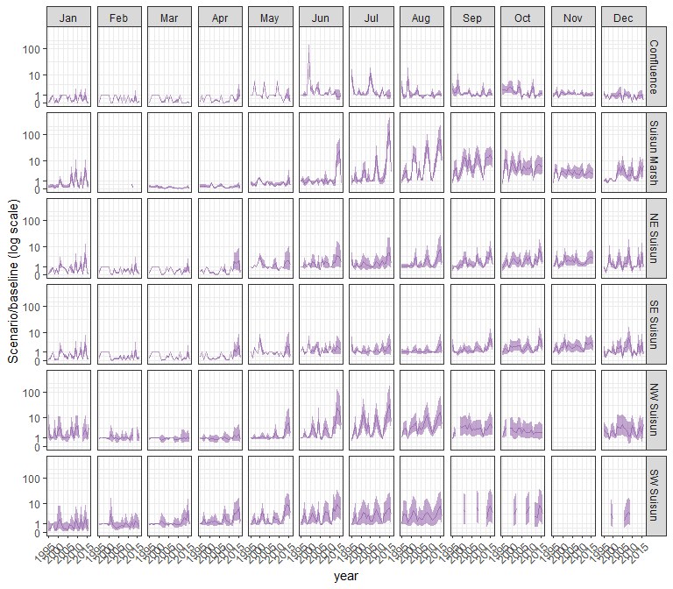

#### othcyc

## Warning in max(ids, na.rm = TRUE): no non-missing arguments to max; returning  
## -Inf

## Warning in max(ids, na.rm = TRUE): no non-missing arguments to max; returning  
## -Inf

## Warning: Removed 1 row containing missing values (`geom_line()`).

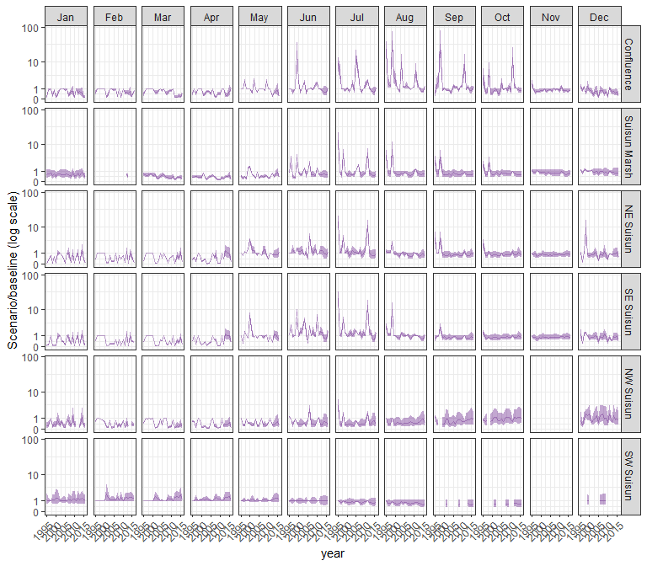

#### other

## Warning in max(ids, na.rm = TRUE): no non-missing arguments to max; returning  
## -Inf

## Warning in max(ids, na.rm = TRUE): no non-missing arguments to max; returning  
## -Inf

## Warning: Removed 1 row containing missing values (`geom_line()`).

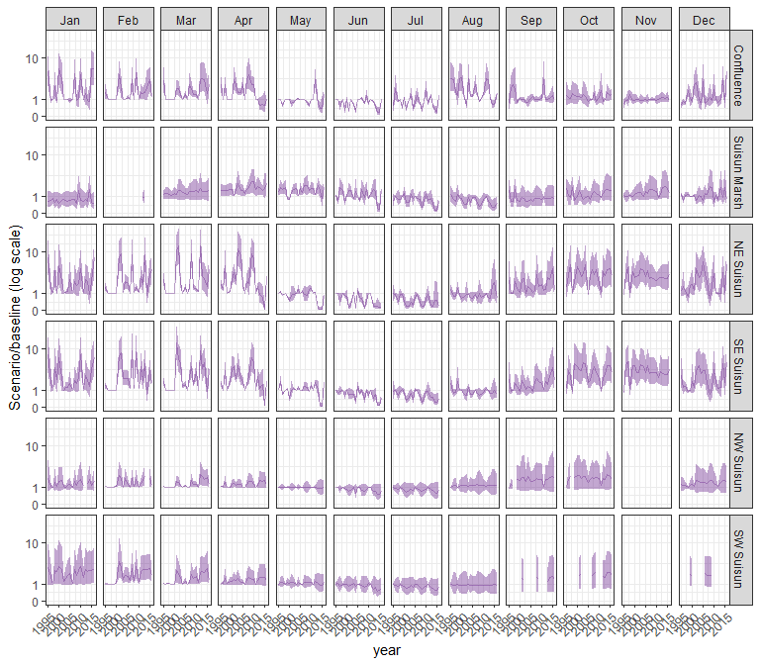

### sal_Alt2v2noTUCP

#### acartela

## Warning in max(ids, na.rm = TRUE): no non-missing arguments to max; returning  
## -Inf

## Warning in max(ids, na.rm = TRUE): no non-missing arguments to max; returning  
## -Inf

## Warning: Removed 1 row containing missing values (`geom_line()`).

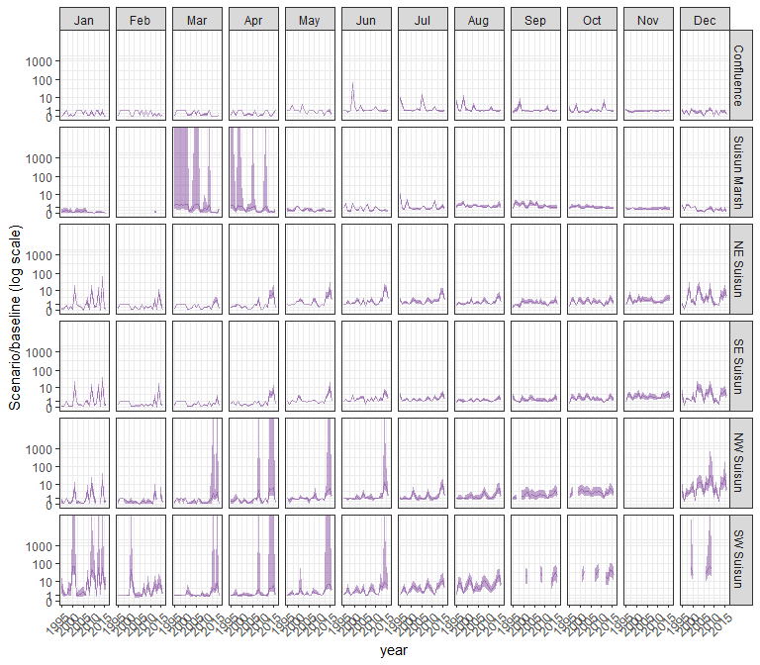

#### daphnia

## Warning in max(ids, na.rm = TRUE): no non-missing arguments to max; returning  
## -Inf

## Warning in max(ids, na.rm = TRUE): no non-missing arguments to max; returning  
## -Inf

## Warning: Removed 1 row containing missing values (`geom_line()`).

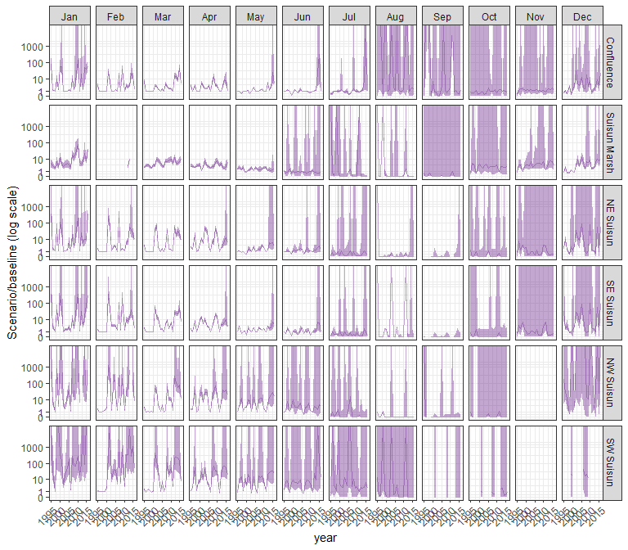

#### eurytem

## Warning in max(ids, na.rm = TRUE): no non-missing arguments to max; returning  
## -Inf

## Warning in max(ids, na.rm = TRUE): no non-missing arguments to max; returning  
## -Inf

## Warning: Removed 1 row containing missing values (`geom_line()`).

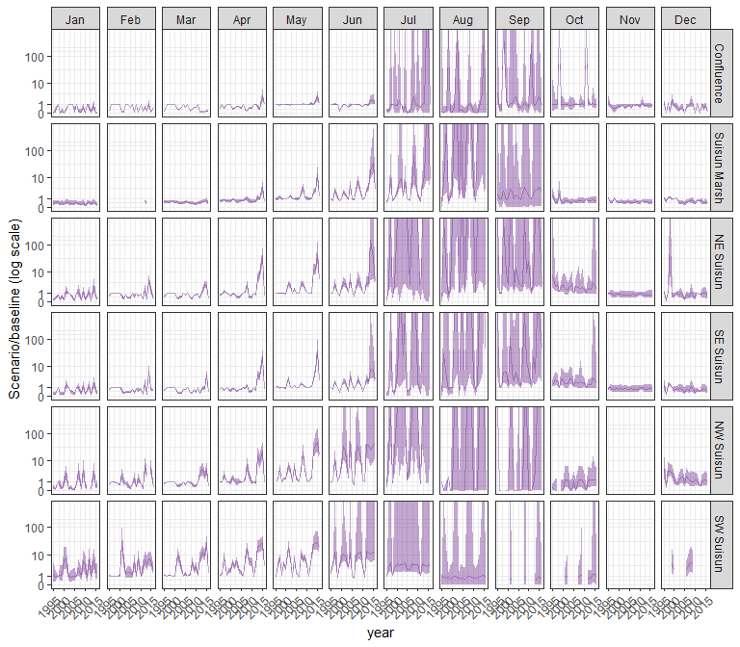

#### othcalad

## Warning in max(ids, na.rm = TRUE): no non-missing arguments to max; returning  
## -Inf

## Warning in max(ids, na.rm = TRUE): no non-missing arguments to max; returning  
## -Inf

## Warning: Removed 1 row containing missing values (`geom_line()`).

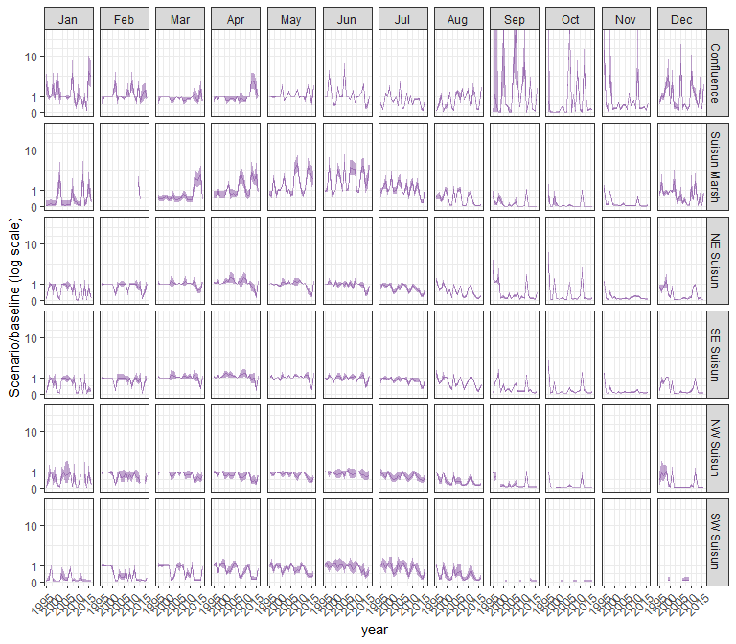

#### othcaljuv

## Warning in max(ids, na.rm = TRUE): no non-missing arguments to max; returning  
## -Inf

## Warning in max(ids, na.rm = TRUE): no non-missing arguments to max; returning  
## -Inf

## Warning: Removed 1 row containing missing values (`geom_line()`).

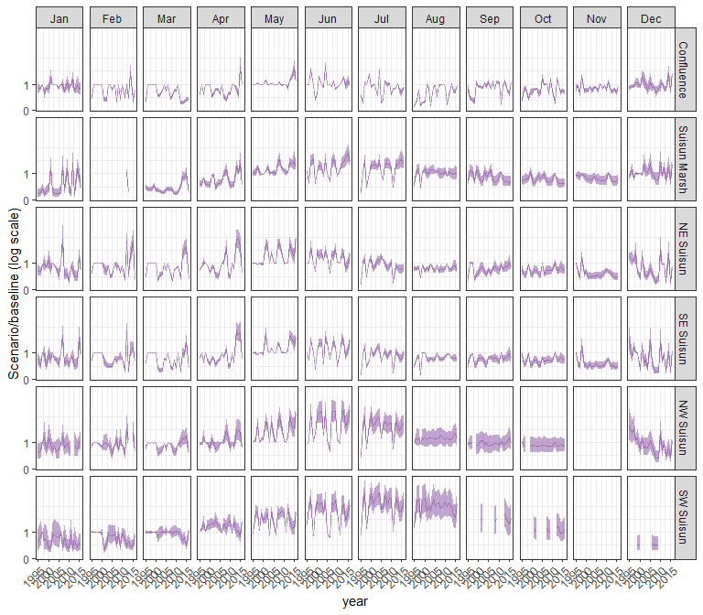

#### othclad

## Warning in max(ids, na.rm = TRUE): no non-missing arguments to max; returning  
## -Inf

## Warning in max(ids, na.rm = TRUE): no non-missing arguments to max; returning  
## -Inf

## Warning: Removed 1 row containing missing values (`geom_line()`).

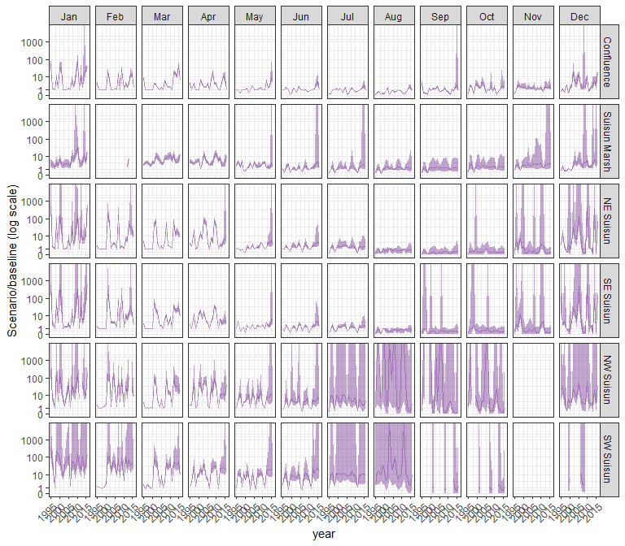

#### pdiapfor

## Warning in max(ids, na.rm = TRUE): no non-missing arguments to max; returning  
## -Inf

## Warning in max(ids, na.rm = TRUE): no non-missing arguments to max; returning  
## -Inf

## Warning: Removed 1 row containing missing values (`geom_line()`).

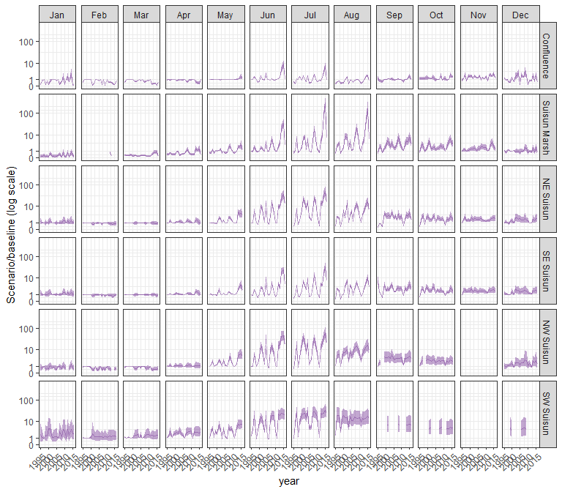

#### allcopnaup

## Warning in max(ids, na.rm = TRUE): no non-missing arguments to max; returning  
## -Inf

## Warning in max(ids, na.rm = TRUE): no non-missing arguments to max; returning  
## -Inf

## Warning: Removed 1 row containing missing values (`geom_line()`).

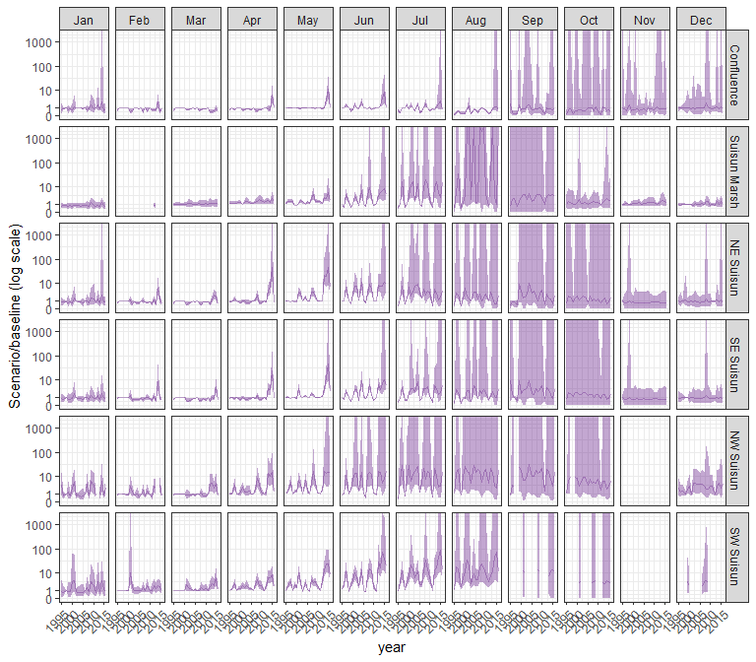

#### limno

## Warning in max(ids, na.rm = TRUE): no non-missing arguments to max; returning  
## -Inf

## Warning in max(ids, na.rm = TRUE): no non-missing arguments to max; returning  
## -Inf

## Warning: Removed 1 row containing missing values (`geom_line()`).

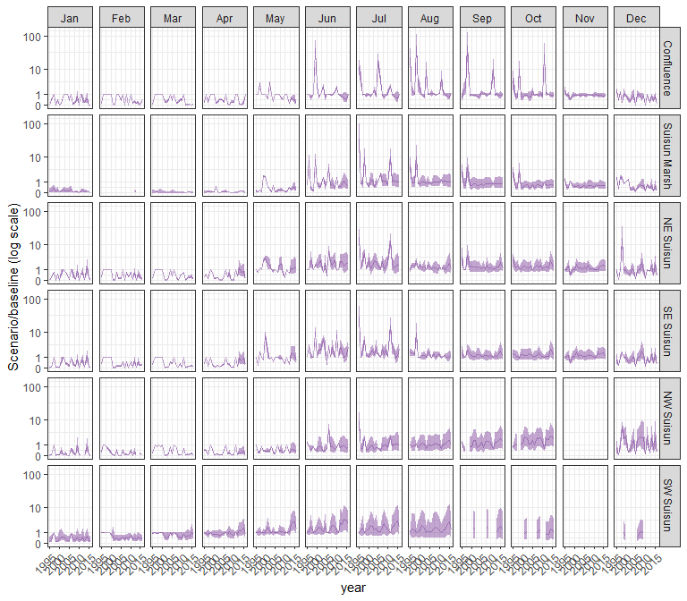

#### mysid

## Warning in max(ids, na.rm = TRUE): no non-missing arguments to max; returning  
## -Inf

## Warning in max(ids, na.rm = TRUE): no non-missing arguments to max; returning  
## -Inf

## Warning: Removed 1 row containing missing values (`geom_line()`).

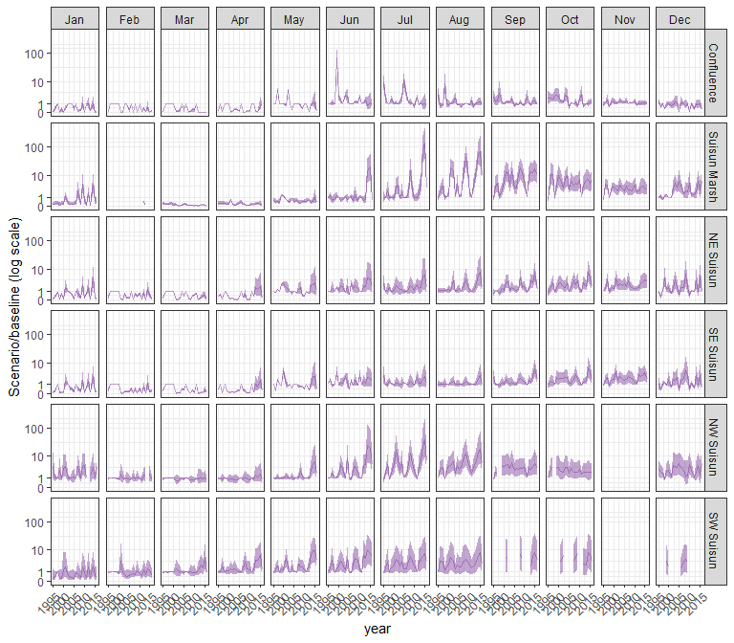

#### othcyc

## Warning in max(ids, na.rm = TRUE): no non-missing arguments to max; returning  
## -Inf

## Warning in max(ids, na.rm = TRUE): no non-missing arguments to max; returning  
## -Inf

## Warning: Removed 1 row containing missing values (`geom_line()`).

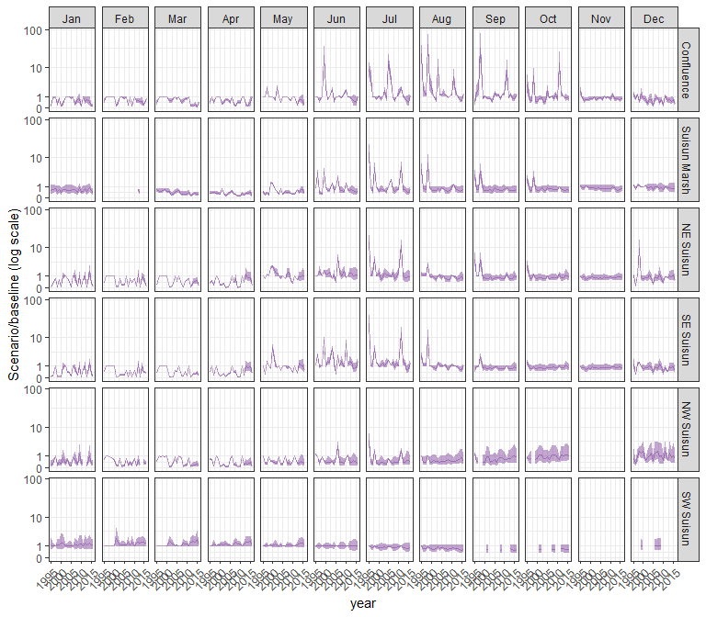

#### other

## Warning in max(ids, na.rm = TRUE): no non-missing arguments to max; returning  
## -Inf

## Warning in max(ids, na.rm = TRUE): no non-missing arguments to max; returning  
## -Inf

## Warning: Removed 1 row containing missing values (`geom_line()`).

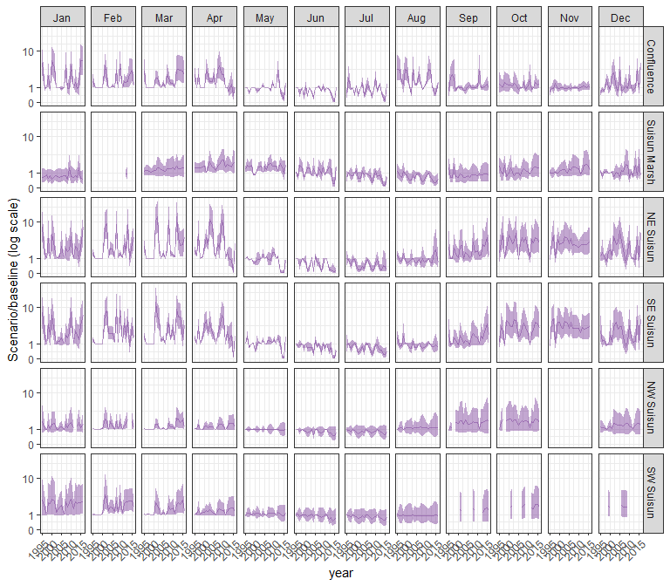

### sal_Alt2v3noTUCP

#### acartela

## Warning in max(ids, na.rm = TRUE): no non-missing arguments to max; returning  
## -Inf

## Warning in max(ids, na.rm = TRUE): no non-missing arguments to max; returning  
## -Inf

## Warning: Removed 1 row containing missing values (`geom_line()`).

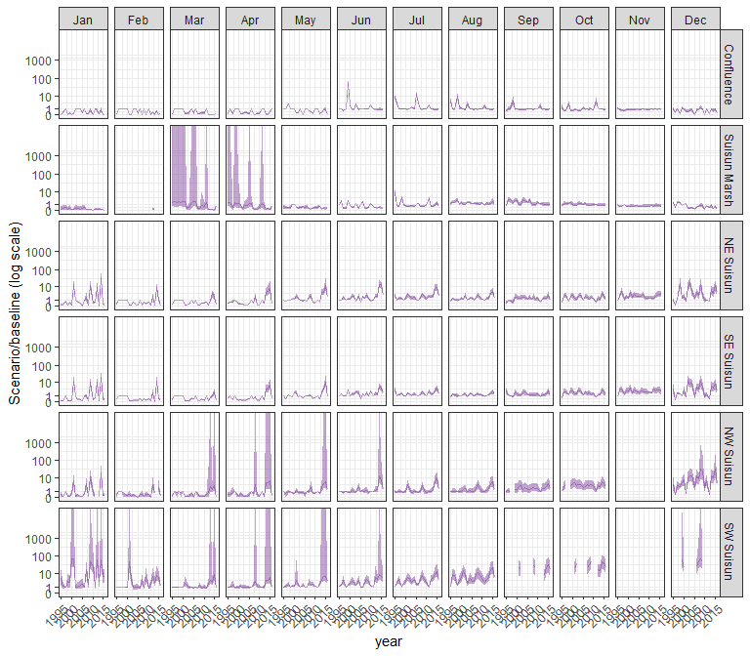

#### daphnia

## Warning in max(ids, na.rm = TRUE): no non-missing arguments to max; returning  
## -Inf

## Warning in max(ids, na.rm = TRUE): no non-missing arguments to max; returning  
## -Inf

## Warning: Removed 1 row containing missing values (`geom_line()`).

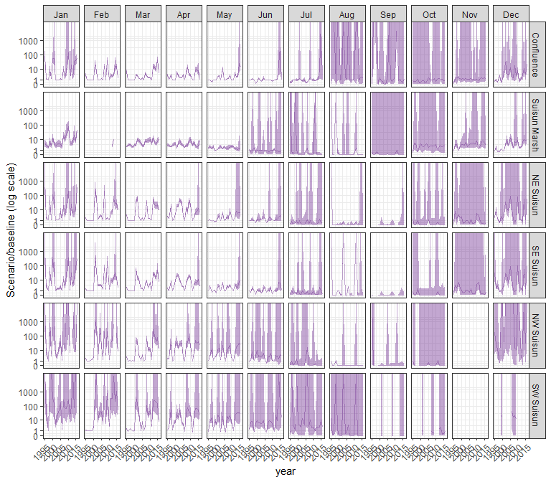

#### eurytem

## Warning in max(ids, na.rm = TRUE): no non-missing arguments to max; returning  
## -Inf

## Warning in max(ids, na.rm = TRUE): no non-missing arguments to max; returning  
## -Inf

## Warning: Removed 1 row containing missing values (`geom_line()`).

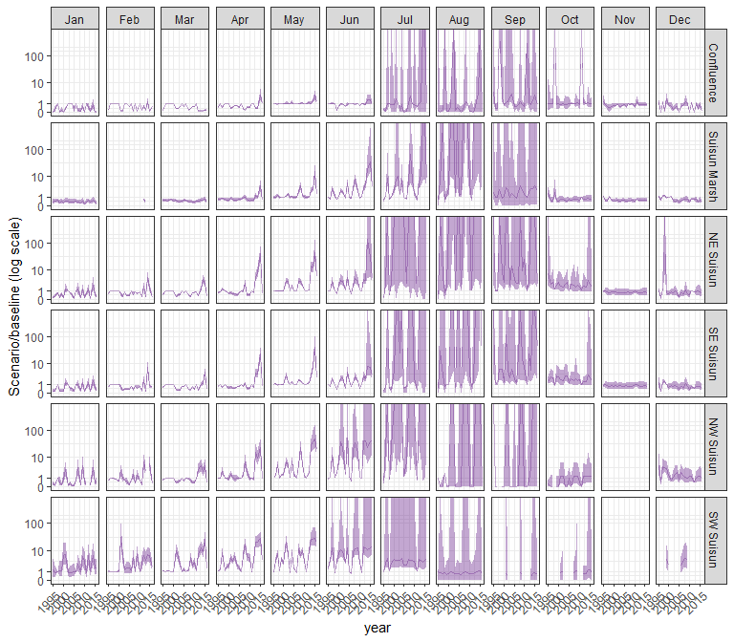

#### othcalad

## Warning in max(ids, na.rm = TRUE): no non-missing arguments to max; returning  
## -Inf

## Warning in max(ids, na.rm = TRUE): no non-missing arguments to max; returning  
## -Inf

## Warning: Removed 1 row containing missing values (`geom_line()`).

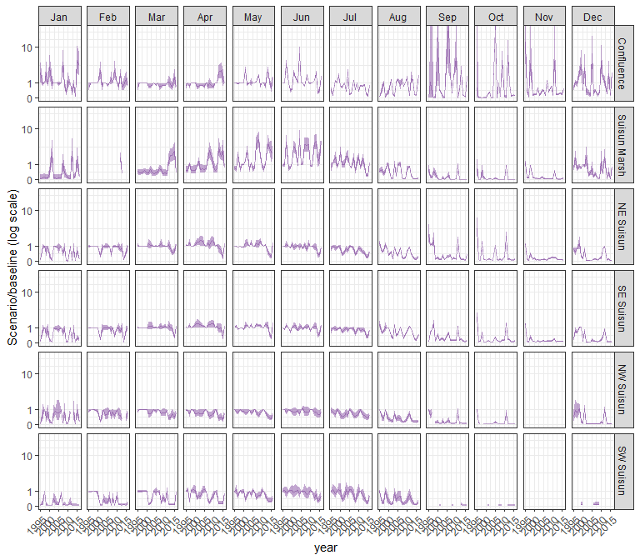

#### othcaljuv

## Warning in max(ids, na.rm = TRUE): no non-missing arguments to max; returning  
## -Inf

## Warning in max(ids, na.rm = TRUE): no non-missing arguments to max; returning  
## -Inf

## Warning: Removed 1 row containing missing values (`geom_line()`).

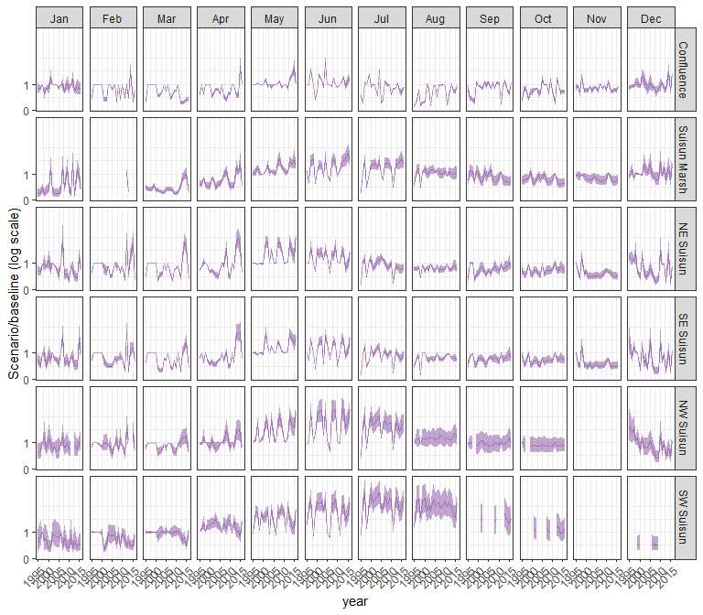

#### othclad

## Warning in max(ids, na.rm = TRUE): no non-missing arguments to max; returning  
## -Inf

## Warning in max(ids, na.rm = TRUE): no non-missing arguments to max; returning  
## -Inf

## Warning: Removed 1 row containing missing values (`geom_line()`).

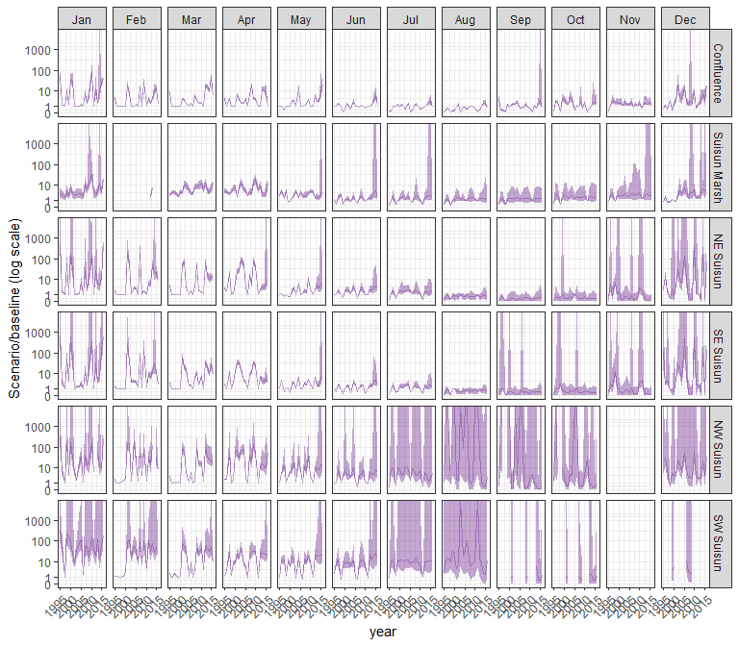

#### pdiapfor

## Warning in max(ids, na.rm = TRUE): no non-missing arguments to max; returning  
## -Inf

## Warning in max(ids, na.rm = TRUE): no non-missing arguments to max; returning  
## -Inf

## Warning: Removed 1 row containing missing values (`geom_line()`).

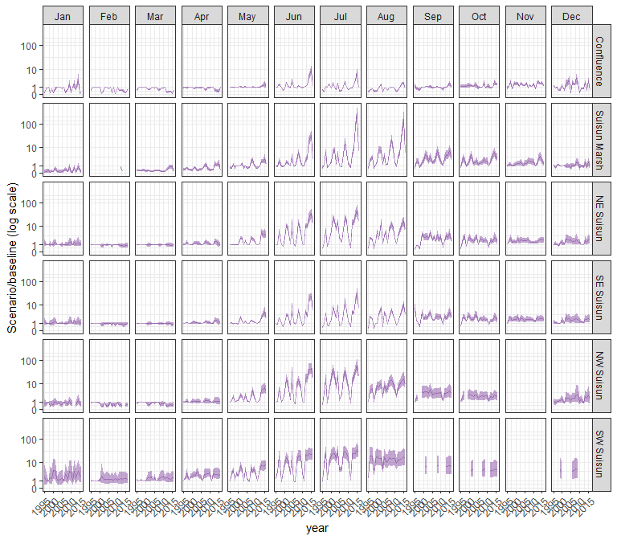

#### allcopnaup

## Warning in max(ids, na.rm = TRUE): no non-missing arguments to max; returning  
## -Inf

## Warning in max(ids, na.rm = TRUE): no non-missing arguments to max; returning  
## -Inf

## Warning: Removed 1 row containing missing values (`geom_line()`).

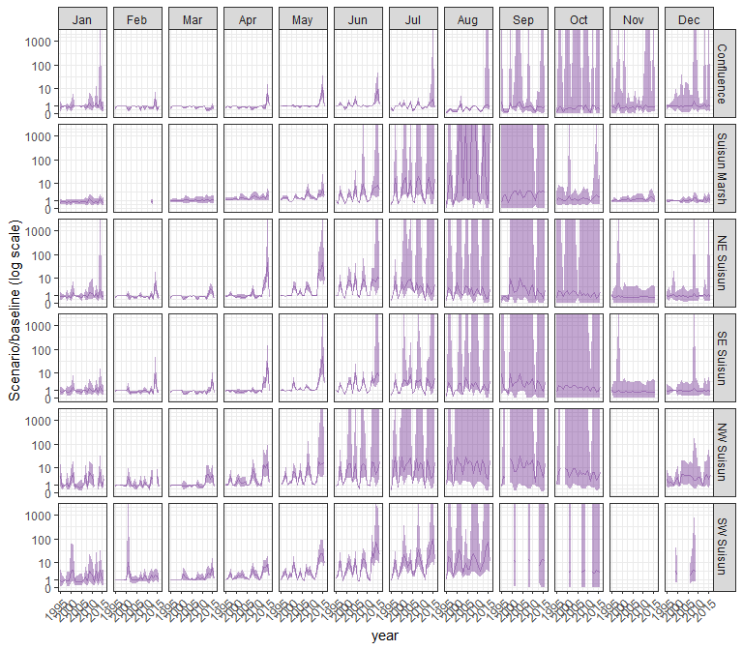

#### limno

## Warning in max(ids, na.rm = TRUE): no non-missing arguments to max; returning  
## -Inf

## Warning in max(ids, na.rm = TRUE): no non-missing arguments to max; returning  
## -Inf

## Warning: Removed 1 row containing missing values (`geom_line()`).

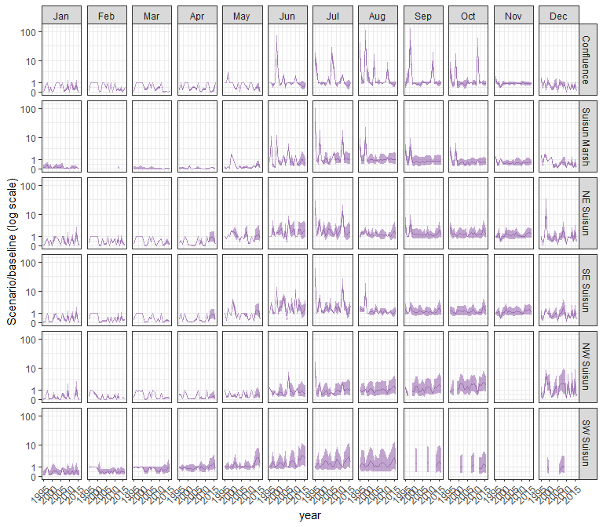

#### mysid

## Warning in max(ids, na.rm = TRUE): no non-missing arguments to max; returning  
## -Inf

## Warning in max(ids, na.rm = TRUE): no non-missing arguments to max; returning  
## -Inf

## Warning: Removed 1 row containing missing values (`geom_line()`).

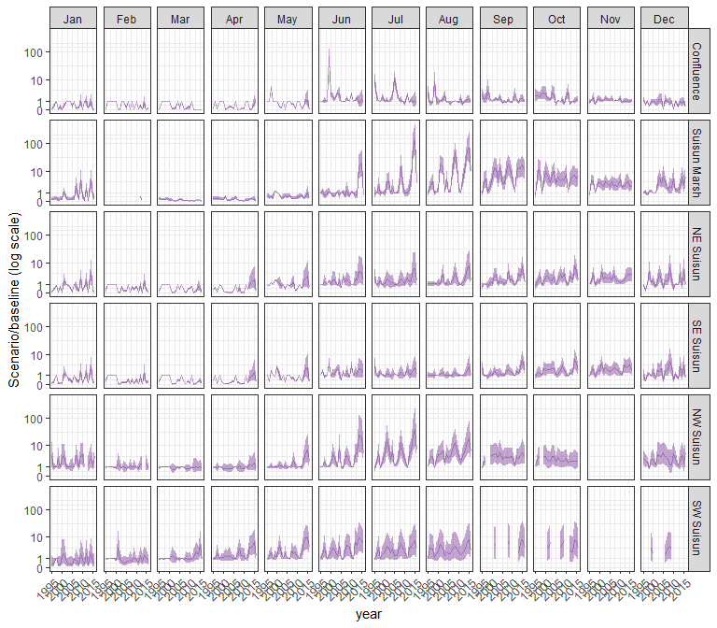

#### othcyc

## Warning in max(ids, na.rm = TRUE): no non-missing arguments to max; returning  
## -Inf

## Warning in max(ids, na.rm = TRUE): no non-missing arguments to max; returning  
## -Inf

## Warning: Removed 1 row containing missing values (`geom_line()`).

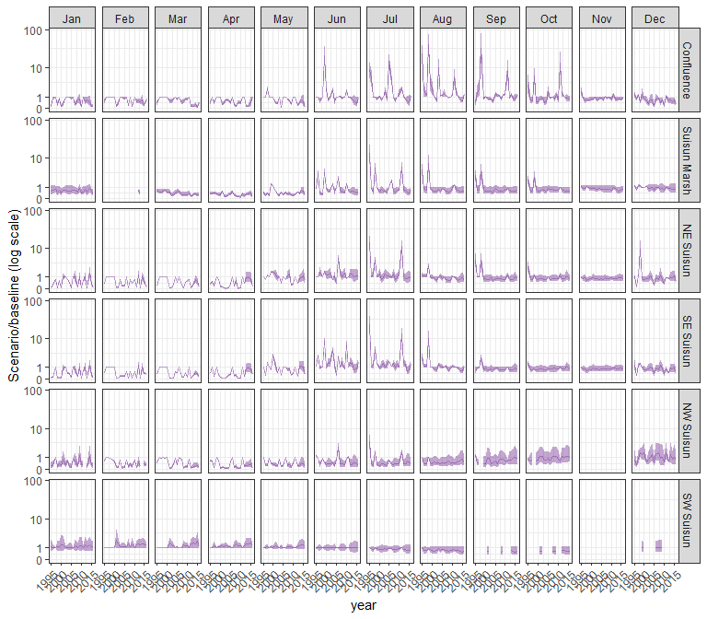

#### other

## Warning in max(ids, na.rm = TRUE): no non-missing arguments to max; returning  
## -Inf

## Warning in max(ids, na.rm = TRUE): no non-missing arguments to max; returning  
## -Inf

## Warning: Removed 1 row containing missing values (`geom_line()`).

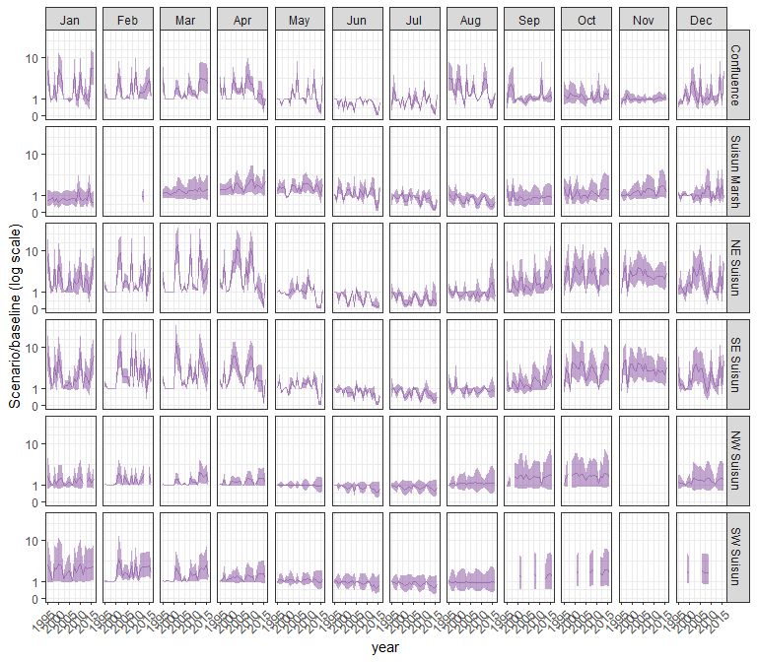

### sal_Alt4

#### acartela

## Warning in max(ids, na.rm = TRUE): no non-missing arguments to max; returning  
## -Inf

## Warning in max(ids, na.rm = TRUE): no non-missing arguments to max; returning  
## -Inf

## Warning: Removed 1 row containing missing values (`geom_line()`).

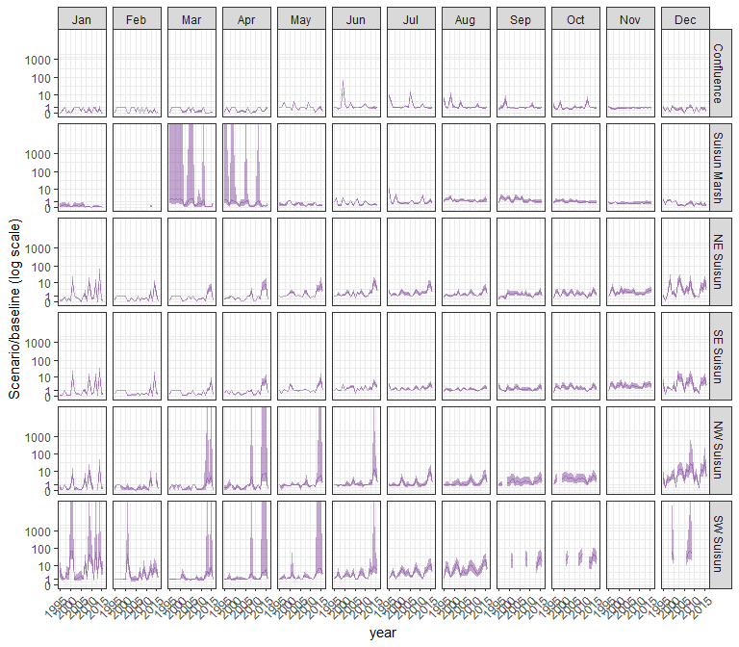

#### daphnia

## Warning in max(ids, na.rm = TRUE): no non-missing arguments to max; returning  
## -Inf

## Warning in max(ids, na.rm = TRUE): no non-missing arguments to max; returning  
## -Inf

## Warning: Removed 1 row containing missing values (`geom_line()`).

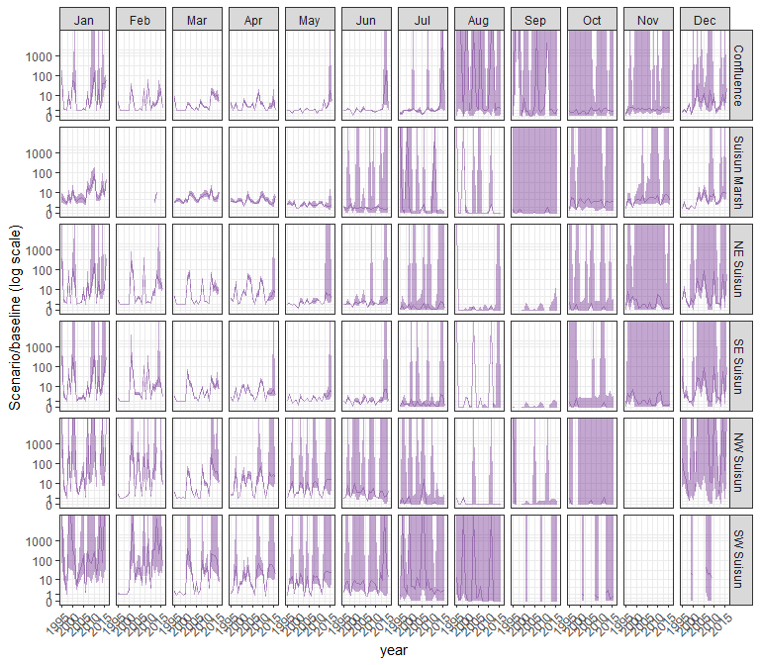

#### eurytem

## Warning in max(ids, na.rm = TRUE): no non-missing arguments to max; returning  
## -Inf

## Warning in max(ids, na.rm = TRUE): no non-missing arguments to max; returning  
## -Inf

## Warning: Removed 1 row containing missing values (`geom_line()`).

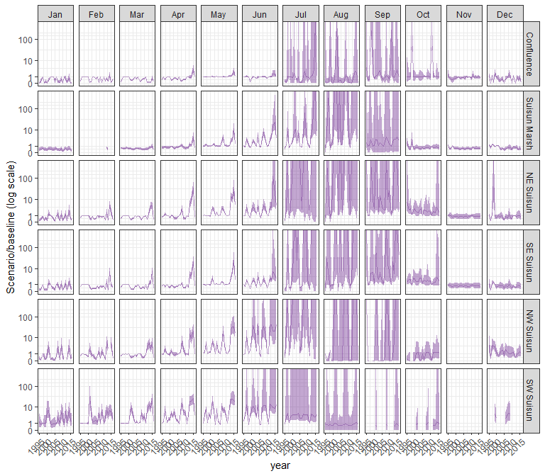

#### othcalad

## Warning in max(ids, na.rm = TRUE): no non-missing arguments to max; returning  
## -Inf

## Warning in max(ids, na.rm = TRUE): no non-missing arguments to max; returning  
## -Inf

## Warning: Removed 1 row containing missing values (`geom_line()`).

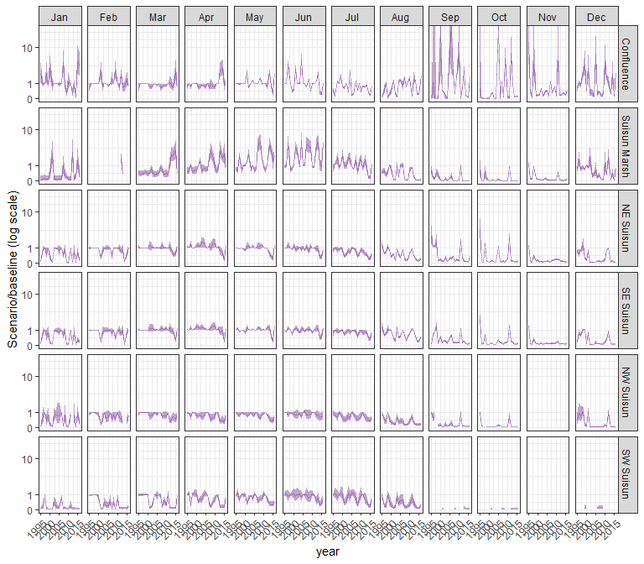

#### othcaljuv

## Warning in max(ids, na.rm = TRUE): no non-missing arguments to max; returning  
## -Inf

## Warning in max(ids, na.rm = TRUE): no non-missing arguments to max; returning  
## -Inf

## Warning: Removed 1 row containing missing values (`geom_line()`).

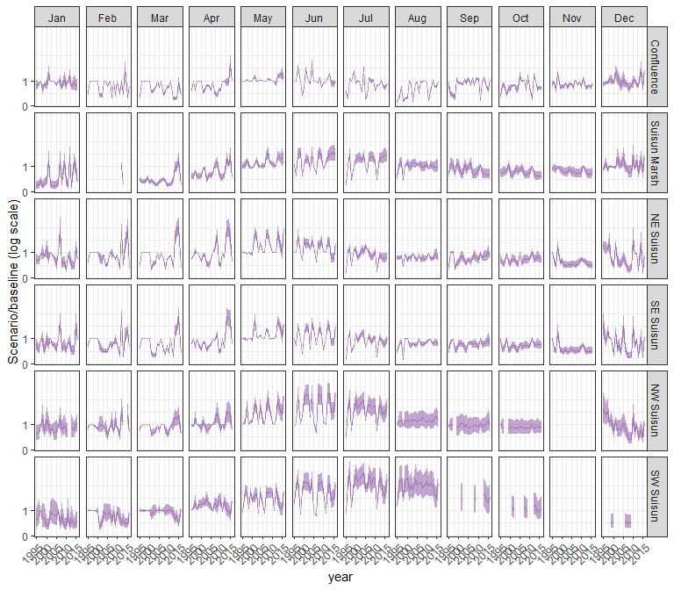

#### othclad

## Warning in max(ids, na.rm = TRUE): no non-missing arguments to max; returning  
## -Inf

## Warning in max(ids, na.rm = TRUE): no non-missing arguments to max; returning  
## -Inf

## Warning: Removed 1 row containing missing values (`geom_line()`).

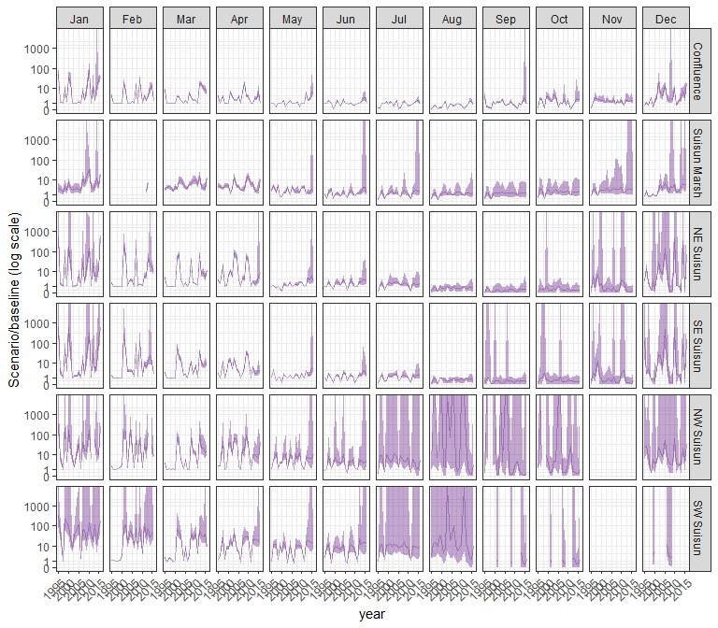

#### pdiapfor

## Warning in max(ids, na.rm = TRUE): no non-missing arguments to max; returning  
## -Inf

## Warning in max(ids, na.rm = TRUE): no non-missing arguments to max; returning  
## -Inf

## Warning: Removed 1 row containing missing values (`geom_line()`).

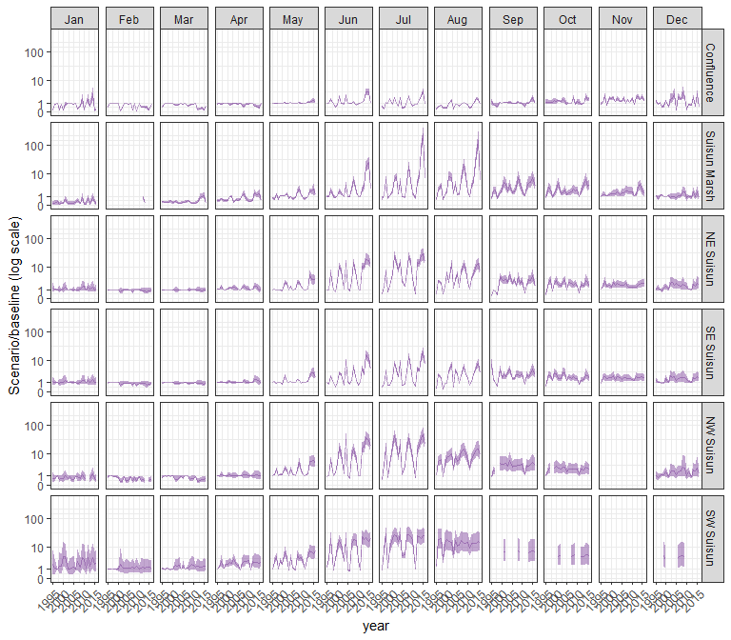

#### allcopnaup

## Warning in max(ids, na.rm = TRUE): no non-missing arguments to max; returning  
## -Inf

## Warning in max(ids, na.rm = TRUE): no non-missing arguments to max; returning  
## -Inf

## Warning: Removed 1 row containing missing values (`geom_line()`).

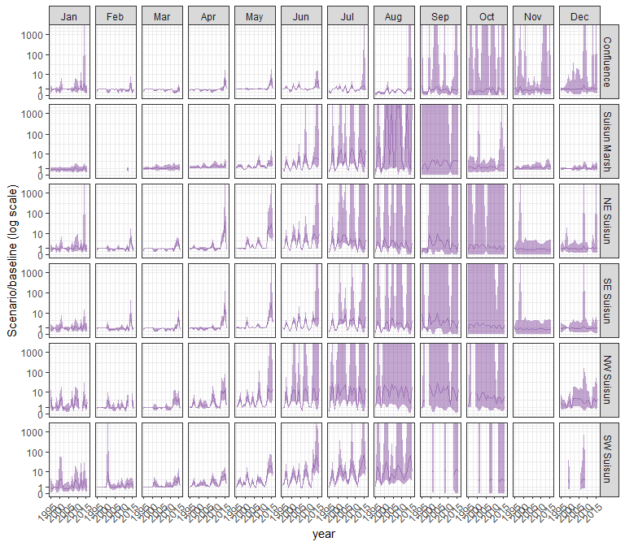

#### limno

## Warning in max(ids, na.rm = TRUE): no non-missing arguments to max; returning  
## -Inf

## Warning in max(ids, na.rm = TRUE): no non-missing arguments to max; returning  
## -Inf

## Warning: Removed 1 row containing missing values (`geom_line()`).

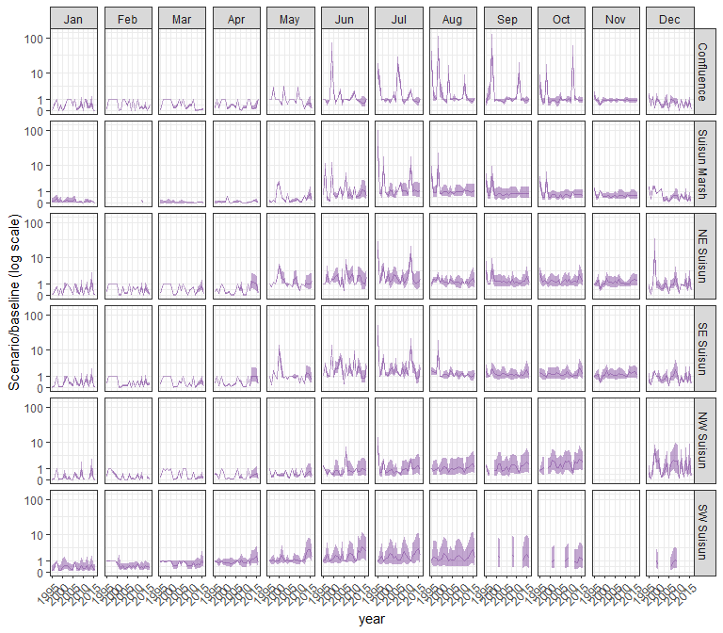

#### mysid

## Warning in max(ids, na.rm = TRUE): no non-missing arguments to max; returning  
## -Inf

## Warning in max(ids, na.rm = TRUE): no non-missing arguments to max; returning  
## -Inf

## Warning: Removed 1 row containing missing values (`geom_line()`).

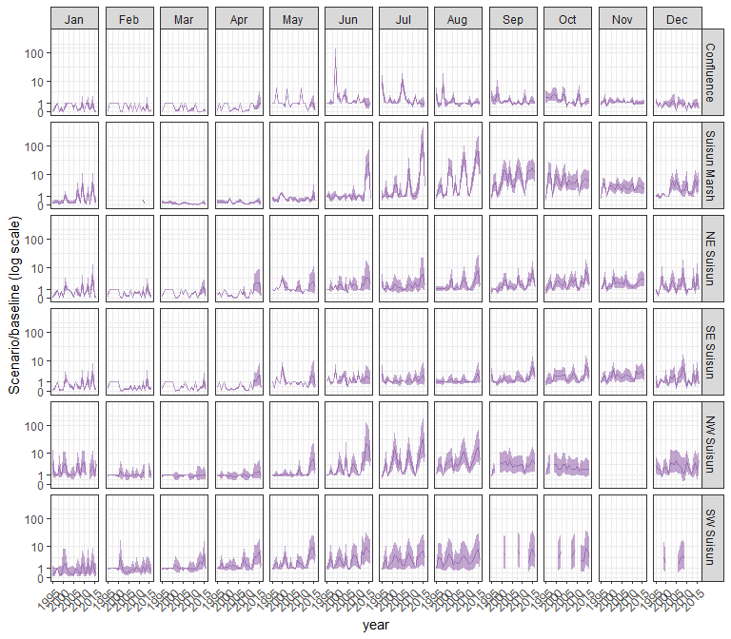

#### othcyc

## Warning in max(ids, na.rm = TRUE): no non-missing arguments to max; returning  
## -Inf

## Warning in max(ids, na.rm = TRUE): no non-missing arguments to max; returning  
## -Inf

## Warning: Removed 1 row containing missing values (`geom_line()`).

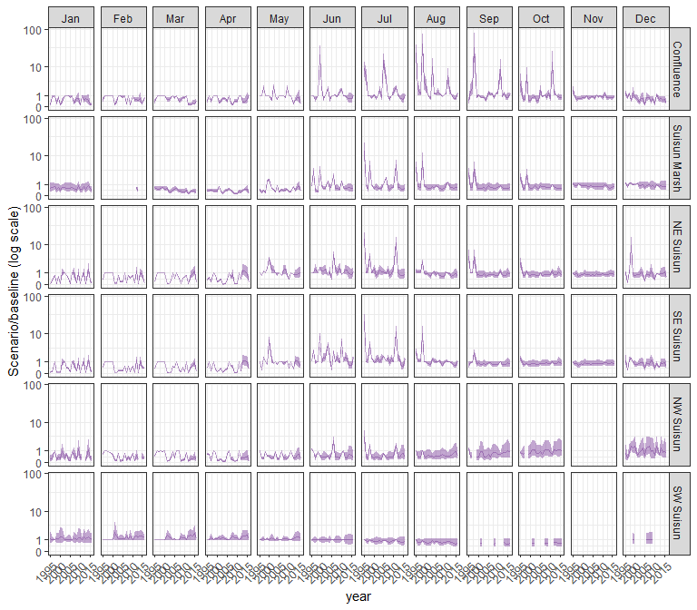

#### other

## Warning in max(ids, na.rm = TRUE): no non-missing arguments to max; returning  
## -Inf

## Warning in max(ids, na.rm = TRUE): no non-missing arguments to max; returning  
## -Inf

## Warning: Removed 1 row containing missing values (`geom_line()`).

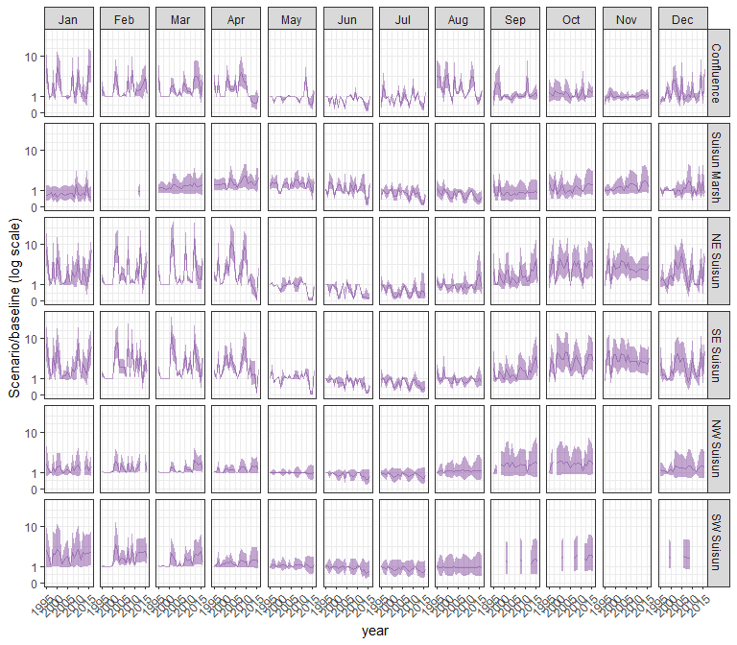

### sal_EXP1

#### acartela

## Warning in max(ids, na.rm = TRUE): no non-missing arguments to max; returning  
## -Inf

## Warning in max(ids, na.rm = TRUE): no non-missing arguments to max; returning  
## -Inf  
  
## Warning in max(ids, na.rm = TRUE): no non-missing arguments to max; returning  
## -Inf  
  
## Warning in max(ids, na.rm = TRUE): no non-missing arguments to max; returning  
## -Inf

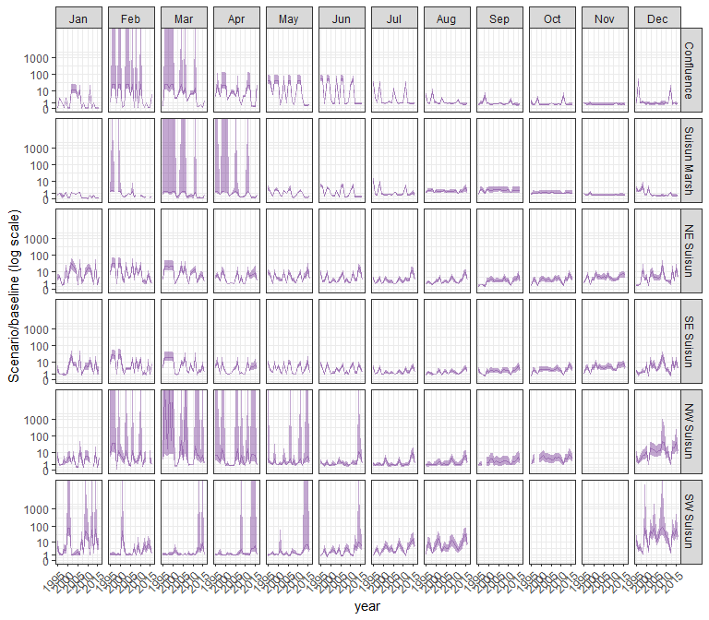

#### daphnia

## Warning in max(ids, na.rm = TRUE): no non-missing arguments to max; returning  
## -Inf  
  
## Warning in max(ids, na.rm = TRUE): no non-missing arguments to max; returning  
## -Inf  
  
## Warning in max(ids, na.rm = TRUE): no non-missing arguments to max; returning  
## -Inf  
  
## Warning in max(ids, na.rm = TRUE): no non-missing arguments to max; returning  
## -Inf

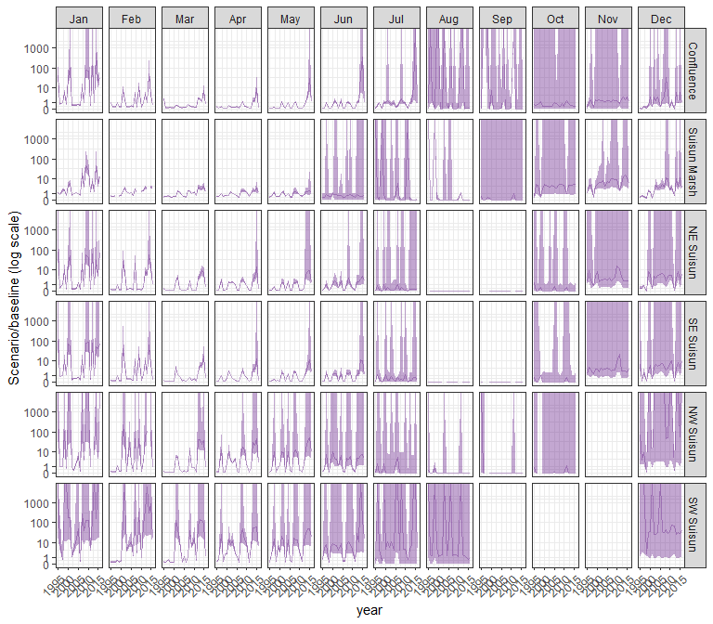

#### eurytem

## Warning in max(ids, na.rm = TRUE): no non-missing arguments to max; returning  
## -Inf  
  
## Warning in max(ids, na.rm = TRUE): no non-missing arguments to max; returning  
## -Inf  
  
## Warning in max(ids, na.rm = TRUE): no non-missing arguments to max; returning  
## -Inf  
  
## Warning in max(ids, na.rm = TRUE): no non-missing arguments to max; returning  
## -Inf

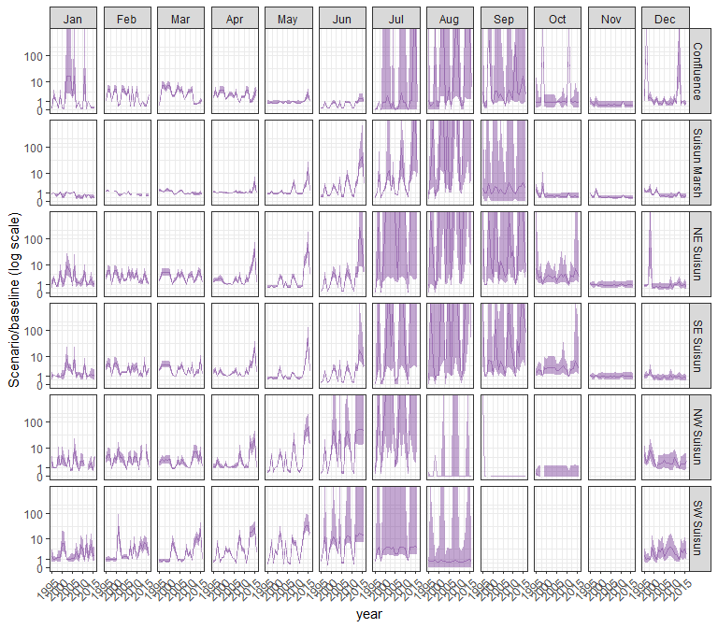

#### othcalad

## Warning in max(ids, na.rm = TRUE): no non-missing arguments to max; returning  
## -Inf  
  
## Warning in max(ids, na.rm = TRUE): no non-missing arguments to max; returning  
## -Inf  
  
## Warning in max(ids, na.rm = TRUE): no non-missing arguments to max; returning  
## -Inf  
  
## Warning in max(ids, na.rm = TRUE): no non-missing arguments to max; returning  
## -Inf

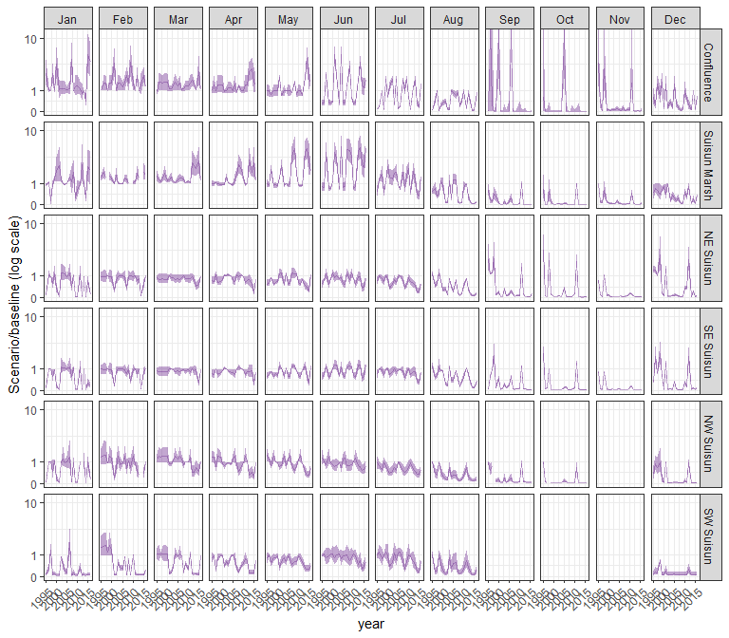

#### othcaljuv

## Warning in max(ids, na.rm = TRUE): no non-missing arguments to max; returning  
## -Inf  
  
## Warning in max(ids, na.rm = TRUE): no non-missing arguments to max; returning  
## -Inf  
  
## Warning in max(ids, na.rm = TRUE): no non-missing arguments to max; returning  
## -Inf  
  
## Warning in max(ids, na.rm = TRUE): no non-missing arguments to max; returning  
## -Inf

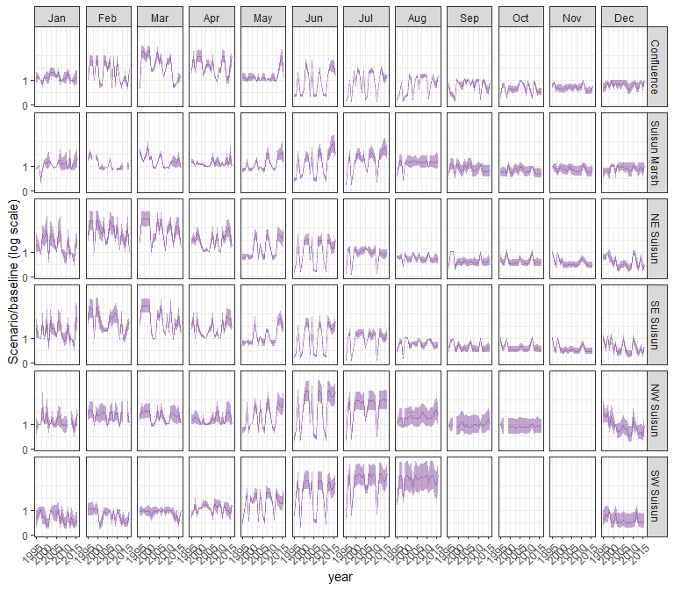

#### othclad

## Warning in max(ids, na.rm = TRUE): no non-missing arguments to max; returning  
## -Inf  
  
## Warning in max(ids, na.rm = TRUE): no non-missing arguments to max; returning  
## -Inf  
  
## Warning in max(ids, na.rm = TRUE): no non-missing arguments to max; returning  
## -Inf  
  
## Warning in max(ids, na.rm = TRUE): no non-missing arguments to max; returning  
## -Inf

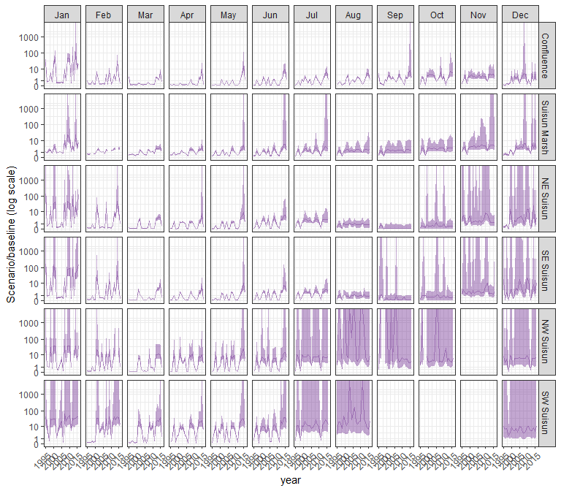

#### pdiapfor

## Warning in max(ids, na.rm = TRUE): no non-missing arguments to max; returning  
## -Inf  
  
## Warning in max(ids, na.rm = TRUE): no non-missing arguments to max; returning  
## -Inf  
  
## Warning in max(ids, na.rm = TRUE): no non-missing arguments to max; returning  
## -Inf  
  
## Warning in max(ids, na.rm = TRUE): no non-missing arguments to max; returning  
## -Inf

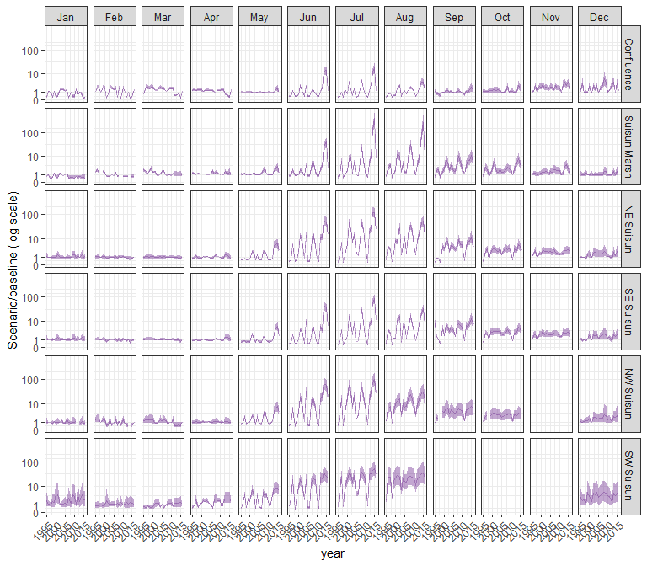

#### allcopnaup

## Warning in max(ids, na.rm = TRUE): no non-missing arguments to max; returning  
## -Inf  
  
## Warning in max(ids, na.rm = TRUE): no non-missing arguments to max; returning  
## -Inf  
  
## Warning in max(ids, na.rm = TRUE): no non-missing arguments to max; returning  
## -Inf  
  
## Warning in max(ids, na.rm = TRUE): no non-missing arguments to max; returning  
## -Inf

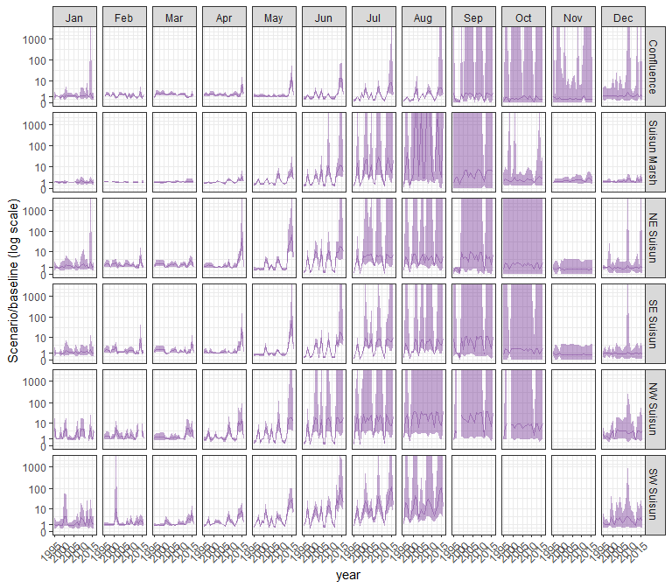

#### limno

## Warning in max(ids, na.rm = TRUE): no non-missing arguments to max; returning  
## -Inf  
  
## Warning in max(ids, na.rm = TRUE): no non-missing arguments to max; returning  
## -Inf  
  
## Warning in max(ids, na.rm = TRUE): no non-missing arguments to max; returning  
## -Inf  
  
## Warning in max(ids, na.rm = TRUE): no non-missing arguments to max; returning  
## -Inf

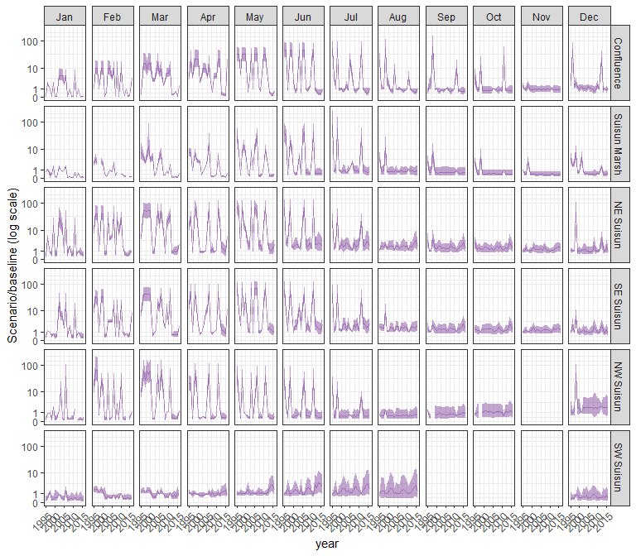

#### mysid

## Warning in max(ids, na.rm = TRUE): no non-missing arguments to max; returning  
## -Inf  
  
## Warning in max(ids, na.rm = TRUE): no non-missing arguments to max; returning  
## -Inf  
  
## Warning in max(ids, na.rm = TRUE): no non-missing arguments to max; returning  
## -Inf  
  
## Warning in max(ids, na.rm = TRUE): no non-missing arguments to max; returning  
## -Inf

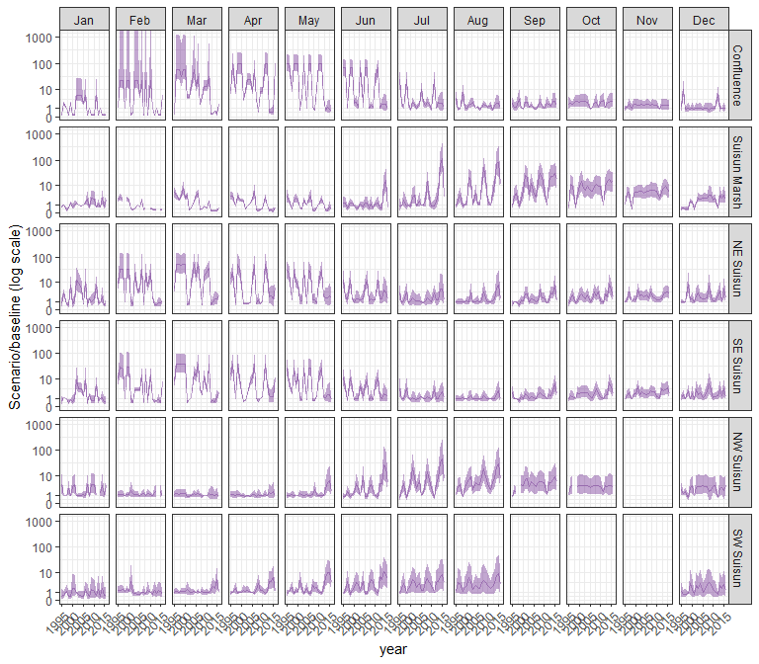

#### othcyc

## Warning in max(ids, na.rm = TRUE): no non-missing arguments to max; returning  
## -Inf  
  
## Warning in max(ids, na.rm = TRUE): no non-missing arguments to max; returning  
## -Inf  
  
## Warning in max(ids, na.rm = TRUE): no non-missing arguments to max; returning  
## -Inf  
  
## Warning in max(ids, na.rm = TRUE): no non-missing arguments to max; returning  
## -Inf

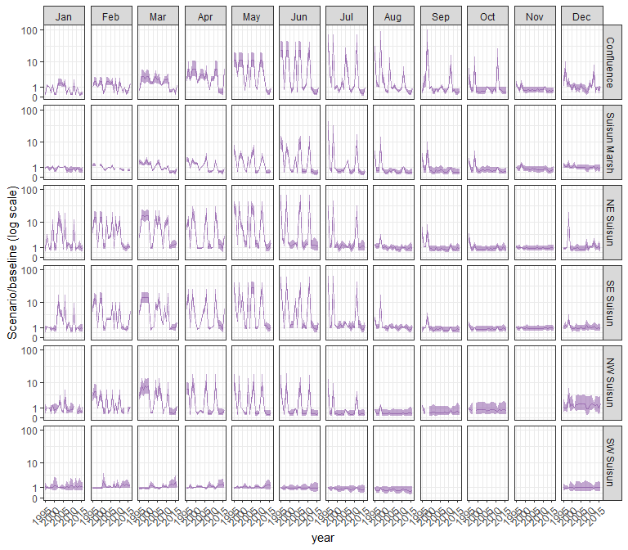

#### other

## Warning in max(ids, na.rm = TRUE): no non-missing arguments to max; returning  
## -Inf  
  
## Warning in max(ids, na.rm = TRUE): no non-missing arguments to max; returning  
## -Inf  
  
## Warning in max(ids, na.rm = TRUE): no non-missing arguments to max; returning  
## -Inf  
  
## Warning in max(ids, na.rm = TRUE): no non-missing arguments to max; returning  
## -Inf

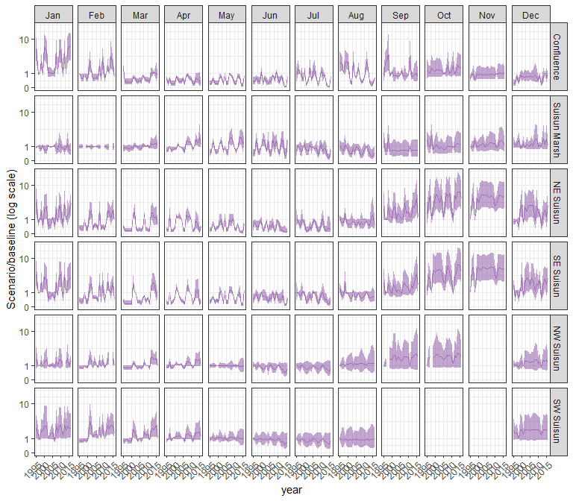

### sal_EXP3

#### acartela

## Warning in max(ids, na.rm = TRUE): no non-missing arguments to max; returning  
## -Inf  
  
## Warning in max(ids, na.rm = TRUE): no non-missing arguments to max; returning  
## -Inf  
  
## Warning in max(ids, na.rm = TRUE): no non-missing arguments to max; returning  
## -Inf  
  
## Warning in max(ids, na.rm = TRUE): no non-missing arguments to max; returning  
## -Inf

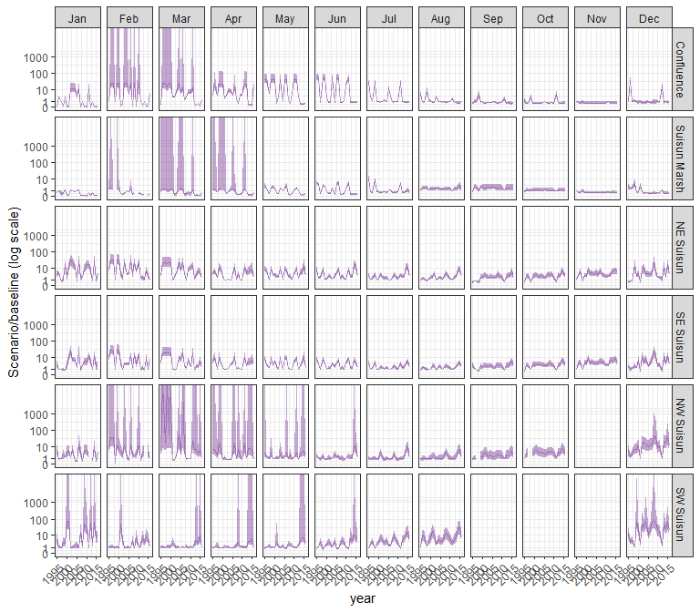

#### daphnia

## Warning in max(ids, na.rm = TRUE): no non-missing arguments to max; returning  
## -Inf  
  
## Warning in max(ids, na.rm = TRUE): no non-missing arguments to max; returning  
## -Inf  
  
## Warning in max(ids, na.rm = TRUE): no non-missing arguments to max; returning  
## -Inf  
  
## Warning in max(ids, na.rm = TRUE): no non-missing arguments to max; returning  
## -Inf

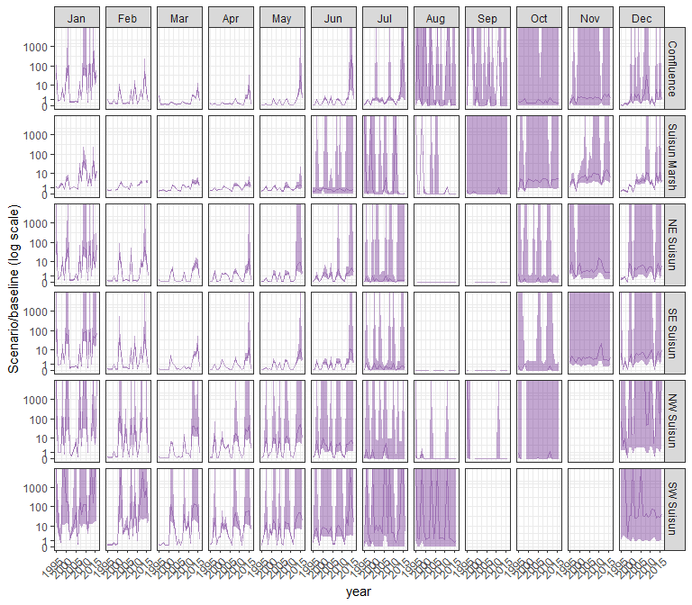

#### eurytem

## Warning in max(ids, na.rm = TRUE): no non-missing arguments to max; returning  
## -Inf  
  
## Warning in max(ids, na.rm = TRUE): no non-missing arguments to max; returning  
## -Inf  
  
## Warning in max(ids, na.rm = TRUE): no non-missing arguments to max; returning  
## -Inf  
  
## Warning in max(ids, na.rm = TRUE): no non-missing arguments to max; returning  
## -Inf

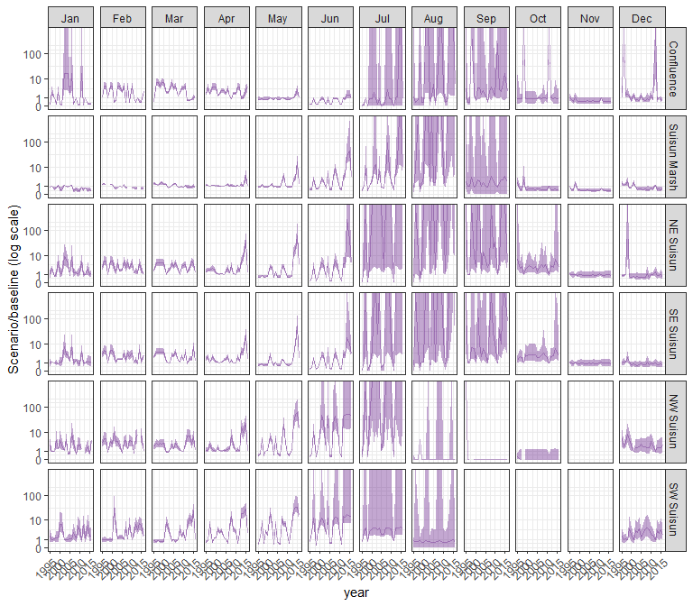

#### othcalad

## Warning in max(ids, na.rm = TRUE): no non-missing arguments to max; returning  
## -Inf  
  
## Warning in max(ids, na.rm = TRUE): no non-missing arguments to max; returning  
## -Inf  
  
## Warning in max(ids, na.rm = TRUE): no non-missing arguments to max; returning  
## -Inf  
  
## Warning in max(ids, na.rm = TRUE): no non-missing arguments to max; returning  
## -Inf

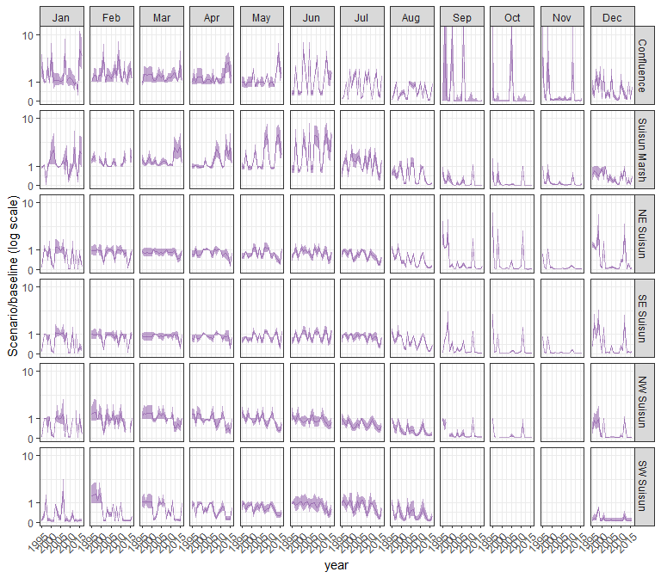

#### othcaljuv

## Warning in max(ids, na.rm = TRUE): no non-missing arguments to max; returning  
## -Inf  
  
## Warning in max(ids, na.rm = TRUE): no non-missing arguments to max; returning  
## -Inf  
  
## Warning in max(ids, na.rm = TRUE): no non-missing arguments to max; returning  
## -Inf  
  
## Warning in max(ids, na.rm = TRUE): no non-missing arguments to max; returning  
## -Inf

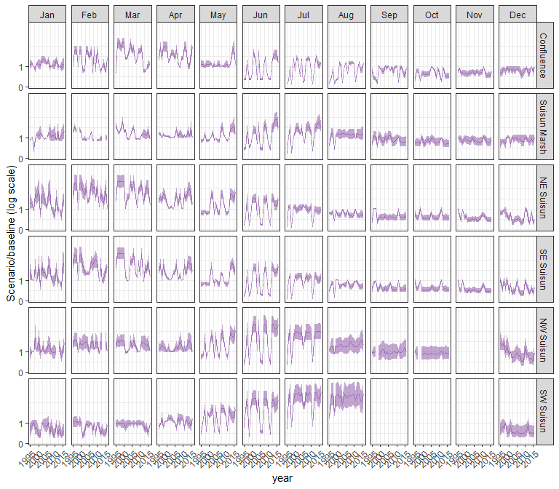

#### othclad

## Warning in max(ids, na.rm = TRUE): no non-missing arguments to max; returning  
## -Inf  
  
## Warning in max(ids, na.rm = TRUE): no non-missing arguments to max; returning  
## -Inf  
  
## Warning in max(ids, na.rm = TRUE): no non-missing arguments to max; returning  
## -Inf  
  
## Warning in max(ids, na.rm = TRUE): no non-missing arguments to max; returning  
## -Inf

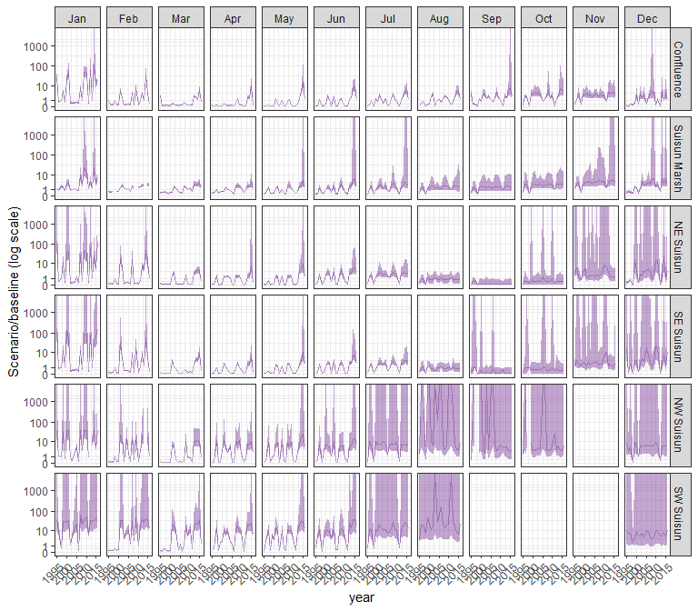

#### pdiapfor

## Warning in max(ids, na.rm = TRUE): no non-missing arguments to max; returning  
## -Inf  
  
## Warning in max(ids, na.rm = TRUE): no non-missing arguments to max; returning  
## -Inf  
  
## Warning in max(ids, na.rm = TRUE): no non-missing arguments to max; returning  
## -Inf  
  
## Warning in max(ids, na.rm = TRUE): no non-missing arguments to max; returning  
## -Inf

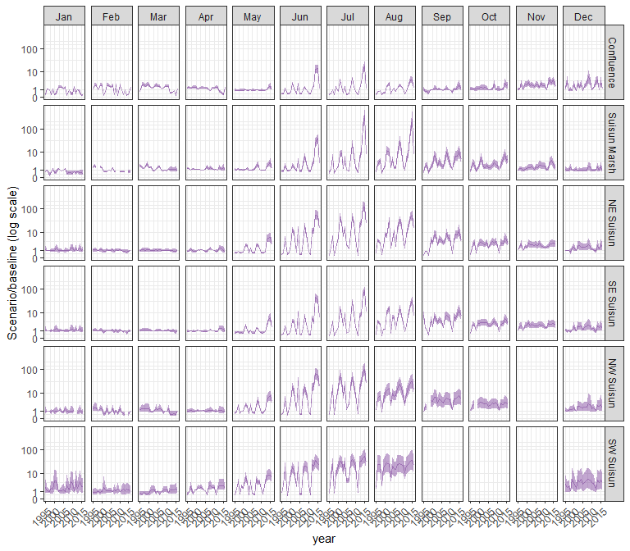

#### allcopnaup

## Warning in max(ids, na.rm = TRUE): no non-missing arguments to max; returning  
## -Inf  
  
## Warning in max(ids, na.rm = TRUE): no non-missing arguments to max; returning  
## -Inf  
  
## Warning in max(ids, na.rm = TRUE): no non-missing arguments to max; returning  
## -Inf  
  
## Warning in max(ids, na.rm = TRUE): no non-missing arguments to max; returning  
## -Inf



#### limno

## Warning in max(ids, na.rm = TRUE): no non-missing arguments to max; returning  
## -Inf  
  
## Warning in max(ids, na.rm = TRUE): no non-missing arguments to max; returning  
## -Inf  
  
## Warning in max(ids, na.rm = TRUE): no non-missing arguments to max; returning  
## -Inf  
  
## Warning in max(ids, na.rm = TRUE): no non-missing arguments to max; returning  
## -Inf

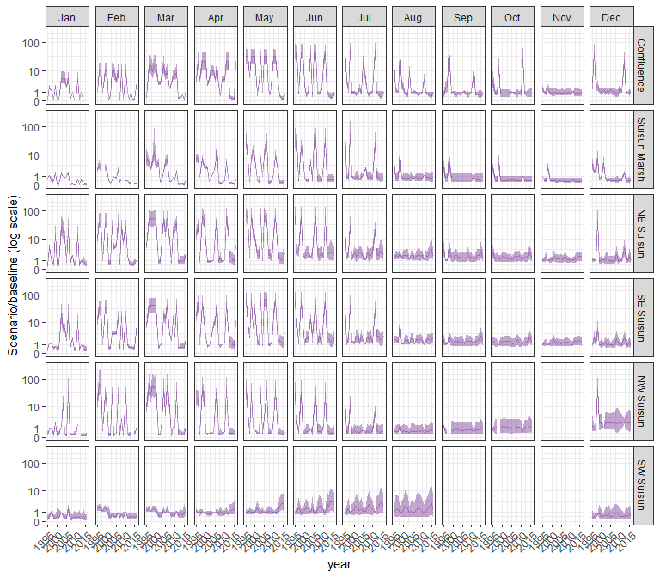

#### mysid

## Warning in max(ids, na.rm = TRUE): no non-missing arguments to max; returning  
## -Inf  
  
## Warning in max(ids, na.rm = TRUE): no non-missing arguments to max; returning  
## -Inf  
  
## Warning in max(ids, na.rm = TRUE): no non-missing arguments to max; returning  
## -Inf  
  
## Warning in max(ids, na.rm = TRUE): no non-missing arguments to max; returning  
## -Inf

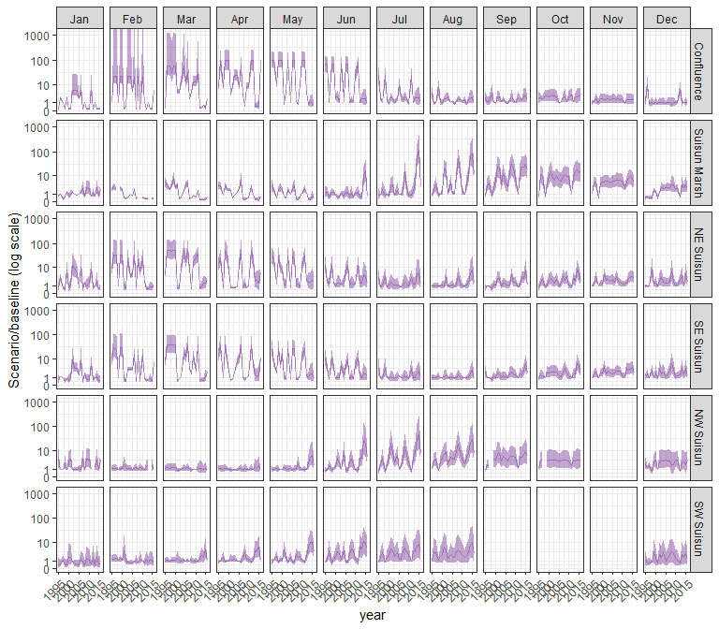

#### othcyc

## Warning in max(ids, na.rm = TRUE): no non-missing arguments to max; returning  
## -Inf  
  
## Warning in max(ids, na.rm = TRUE): no non-missing arguments to max; returning  
## -Inf  
  
## Warning in max(ids, na.rm = TRUE): no non-missing arguments to max; returning  
## -Inf  
  
## Warning in max(ids, na.rm = TRUE): no non-missing arguments to max; returning  
## -Inf

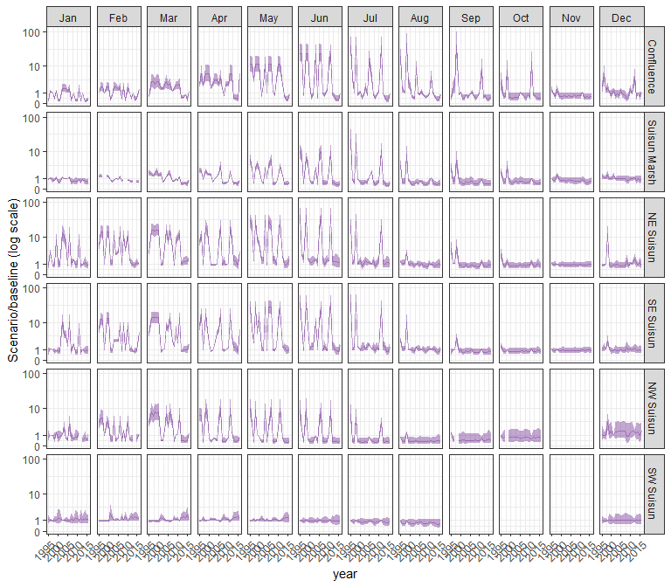

#### other

## Warning in max(ids, na.rm = TRUE): no non-missing arguments to max; returning  
## -Inf  
  
## Warning in max(ids, na.rm = TRUE): no non-missing arguments to max; returning  
## -Inf  
  
## Warning in max(ids, na.rm = TRUE): no non-missing arguments to max; returning  
## -Inf  
  
## Warning in max(ids, na.rm = TRUE): no non-missing arguments to max; returning  
## -Inf

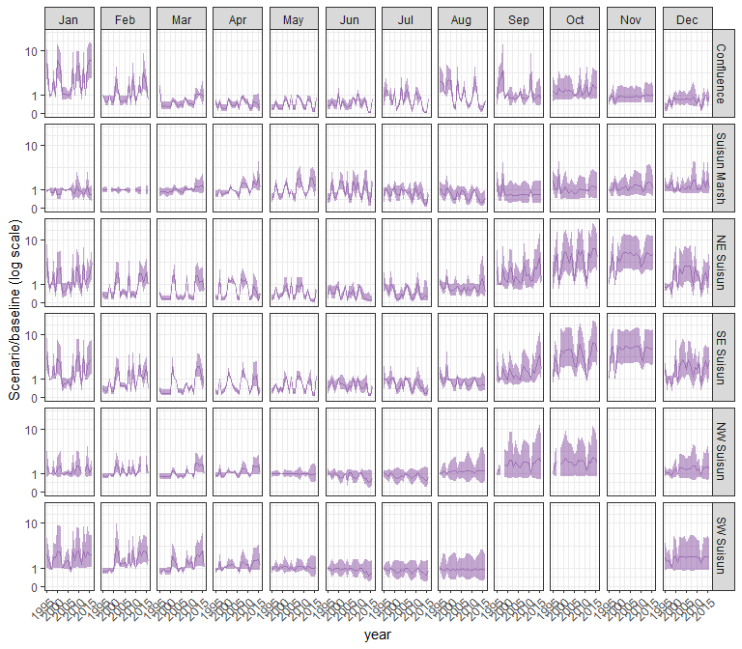

### sal_NAA

#### acartela

## Warning in max(ids, na.rm = TRUE): no non-missing arguments to max; returning  
## -Inf  
  
## Warning in max(ids, na.rm = TRUE): no non-missing arguments to max; returning  
## -Inf

## Warning: Removed 1 row containing missing values (`geom_line()`).

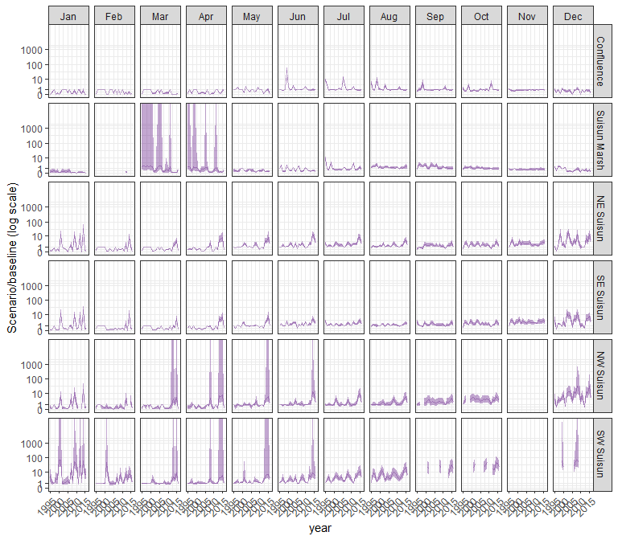

#### daphnia

## Warning in max(ids, na.rm = TRUE): no non-missing arguments to max; returning  
## -Inf

## Warning in max(ids, na.rm = TRUE): no non-missing arguments to max; returning  
## -Inf

## Warning: Removed 1 row containing missing values (`geom_line()`).

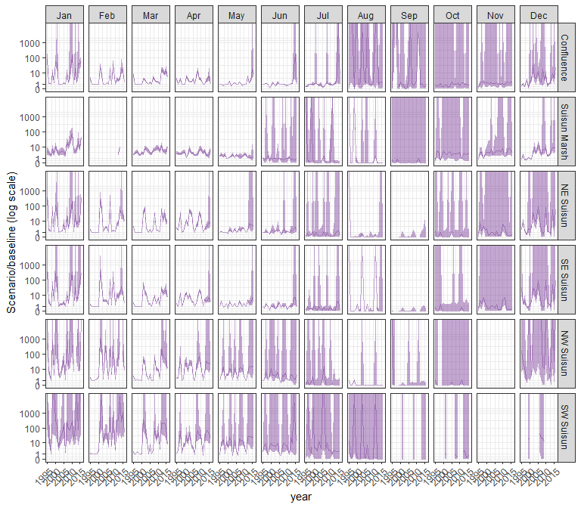

#### eurytem

## Warning in max(ids, na.rm = TRUE): no non-missing arguments to max; returning  
## -Inf

## Warning in max(ids, na.rm = TRUE): no non-missing arguments to max; returning  
## -Inf

## Warning: Removed 1 row containing missing values (`geom_line()`).

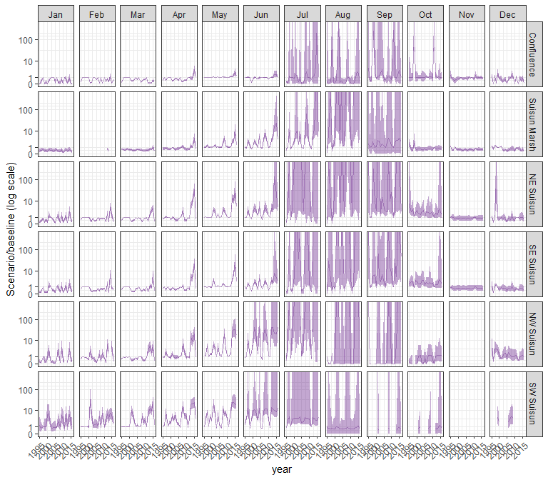

#### othcalad

## Warning in max(ids, na.rm = TRUE): no non-missing arguments to max; returning  
## -Inf

## Warning in max(ids, na.rm = TRUE): no non-missing arguments to max; returning  
## -Inf

## Warning: Removed 1 row containing missing values (`geom_line()`).

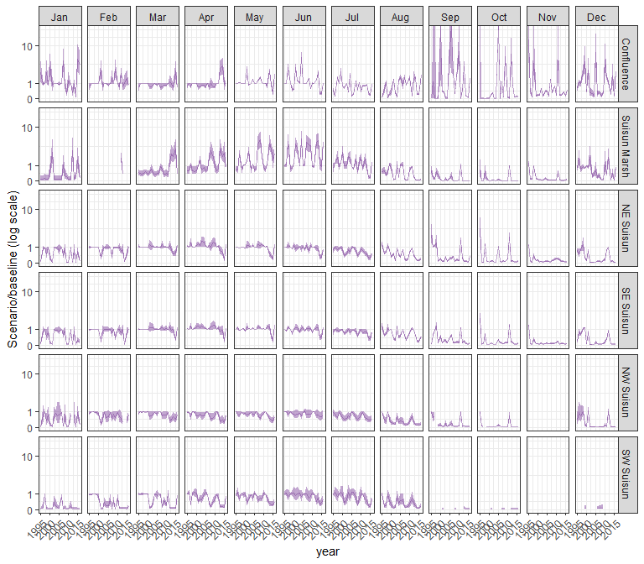

#### othcaljuv

## Warning in max(ids, na.rm = TRUE): no non-missing arguments to max; returning  
## -Inf

## Warning in max(ids, na.rm = TRUE): no non-missing arguments to max; returning  
## -Inf

## Warning: Removed 1 row containing missing values (`geom_line()`).

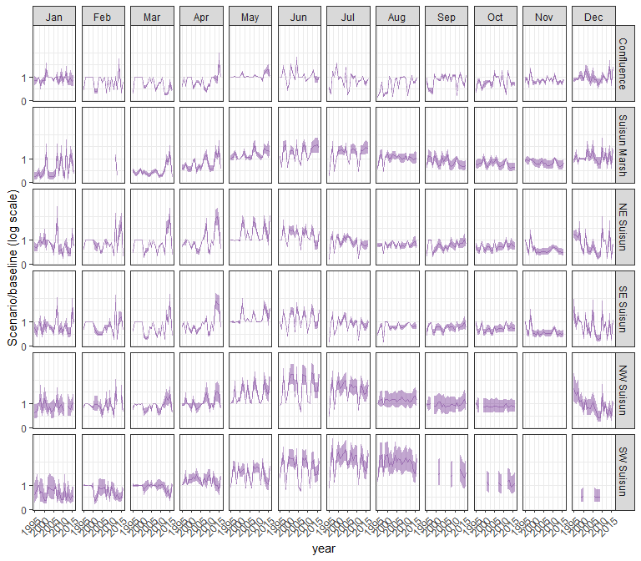

#### othclad

## Warning in max(ids, na.rm = TRUE): no non-missing arguments to max; returning  
## -Inf

## Warning in max(ids, na.rm = TRUE): no non-missing arguments to max; returning  
## -Inf

## Warning: Removed 1 row containing missing values (`geom_line()`).

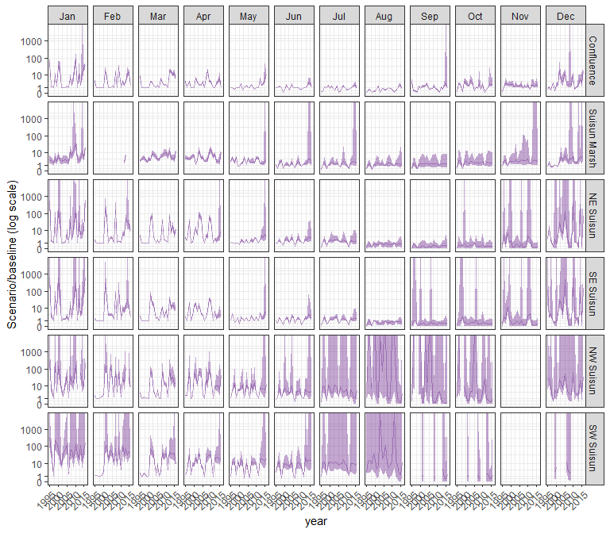

#### pdiapfor

## Warning in max(ids, na.rm = TRUE): no non-missing arguments to max; returning  
## -Inf

## Warning in max(ids, na.rm = TRUE): no non-missing arguments to max; returning  
## -Inf

## Warning: Removed 1 row containing missing values (`geom_line()`).

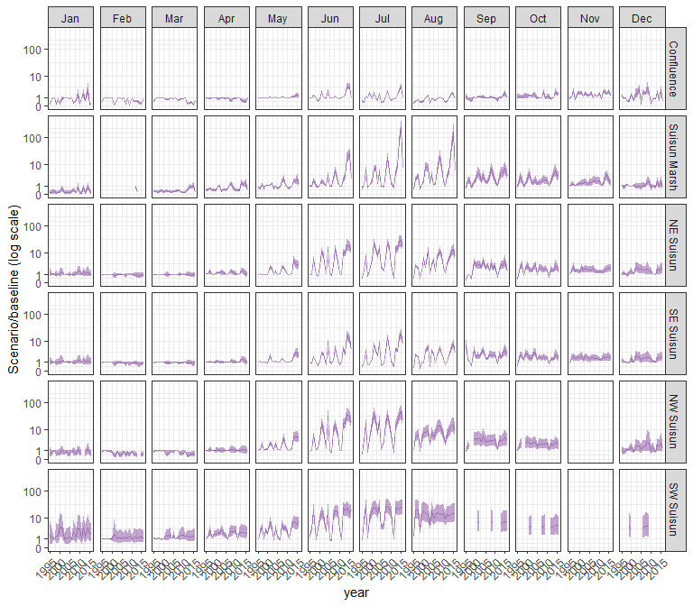

#### allcopnaup

## Warning in max(ids, na.rm = TRUE): no non-missing arguments to max; returning  
## -Inf

## Warning in max(ids, na.rm = TRUE): no non-missing arguments to max; returning  
## -Inf

## Warning: Removed 1 row containing missing values (`geom_line()`).

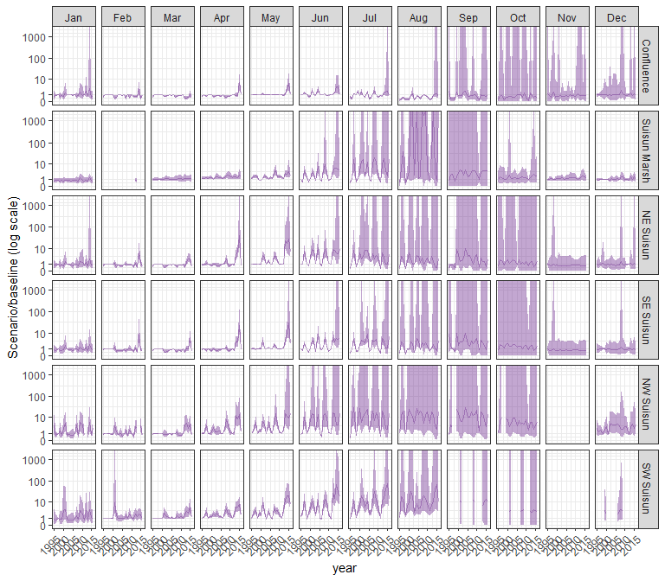

#### limno

## Warning in max(ids, na.rm = TRUE): no non-missing arguments to max; returning  
## -Inf

## Warning in max(ids, na.rm = TRUE): no non-missing arguments to max; returning  
## -Inf

## Warning: Removed 1 row containing missing values (`geom_line()`).

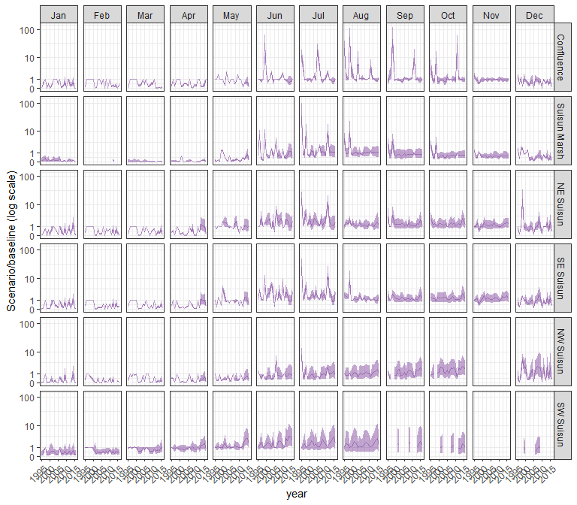

#### mysid

## Warning in max(ids, na.rm = TRUE): no non-missing arguments to max; returning  
## -Inf

## Warning in max(ids, na.rm = TRUE): no non-missing arguments to max; returning  
## -Inf

## Warning: Removed 1 row containing missing values (`geom_line()`).

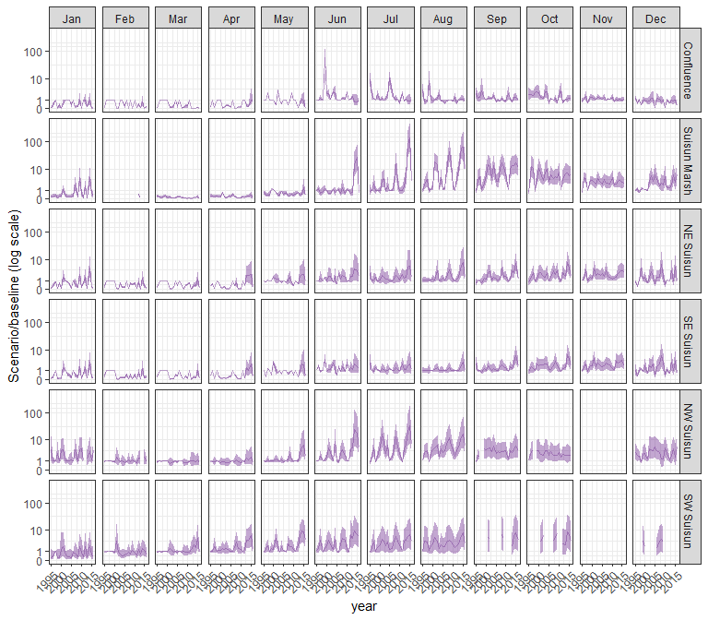

#### othcyc

## Warning in max(ids, na.rm = TRUE): no non-missing arguments to max; returning  
## -Inf

## Warning in max(ids, na.rm = TRUE): no non-missing arguments to max; returning  
## -Inf

## Warning: Removed 1 row containing missing values (`geom_line()`).

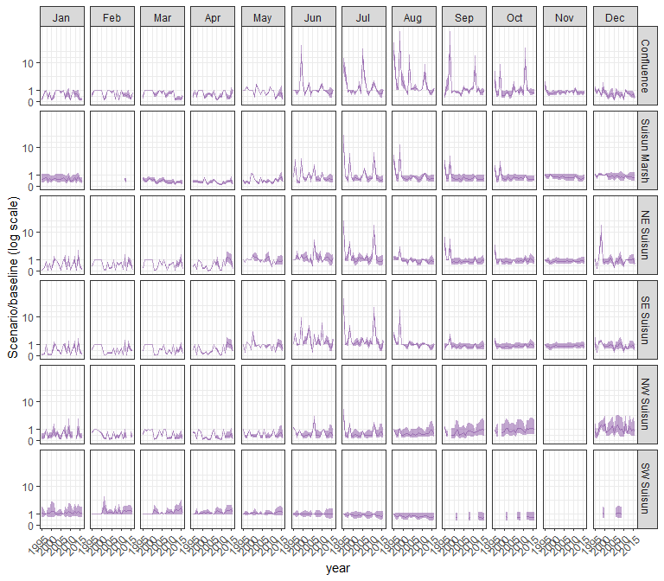

#### other

## Warning in max(ids, na.rm = TRUE): no non-missing arguments to max; returning  
## -Inf

## Warning in max(ids, na.rm = TRUE): no non-missing arguments to max; returning  
## -Inf

## Warning: Removed 1 row containing missing values (`geom_line()`).

