Expected zooplankton biomass change according to salinity

Brian Mahardja

2024-09-25

Original script and dataset packages was written by Sam Bashevkin and can be found here: <https://github.com/sbashevkin/FLOATDrought>

# Load packages

require(conflicted)  
require(MASS)  
require(dplyr)  
require(zooper)  
require(lubridate)  
require(readr)  
require(tidyr)  
require(ggplot2)  
require(sf)  
require(readxl)  
require(stringr)  
require(mgcv)  
require(purrr)  
require(deltamapr)  
require(scales)  
  
conflict_prefer("filter", "dplyr")  
conflict_prefer("select", "dplyr")

# Load and wrangle data

zoop_data<-Zoopsynther(Data_type="Community", Sources=c("EMP", "STN", "20mm", "FMWT"), Time_consistency = FALSE)

## [1] "These species have no relatives in their size class common to all datasets and have been removed from one or more size classes: Ostracoda Adult (Meso), Cumacea Undifferentiated (Meso), Annelida Adult (Meso), Gammarus Adult (Meso), Orientomysis aspera Adult (Meso), Chironomidae Larva (Meso), Insecta Larva (Meso)"

Read in zoop mass conversions

zoop_mass_conversions<-read_excel("Biomass conversions.xlsx", sheet="Micro and Meso-zooplankton") %>%  
 mutate(Taxname=case_when(Taxname=="Sinocalanus"~"Sinocalanus doerrii", # Change to help this match to zoop data  
 TRUE ~ Taxname),  
 Taxlifestage=paste(Taxname, Lifestage))%>%  
 select(Taxlifestage, CarbonWeight_ug)

Read in zoop groupings

zoop_groups<-read_csv("zoopcrosswalk3.csv", col_types=cols_only(Taxlifestage="c", IBMR="c"))%>%  
 distinct()

Load Mysid biomass data

zoop_mysid<-read_excel("1972-2020MysidBPUEMatrix.xlsx", # EMP  
 sheet="Mysid_BPUE_matrix_1972-2020", na = "NA",  
 col_types = c(rep("numeric", 4), "date", "text", "text", rep("text", 7), rep("numeric", 8)))%>%  
 select(Date=SampleDate, Station=StationNZ, BPUE=`Hyperacanthomysis longirostris`)%>% # Only select Hyperacanthomysis longirostris  
 mutate(Source="EMP")%>%  
 bind_rows(read_csv("FMWT STN 2007to2019 Mysid BPUE.csv", # FMWT/STN  
 col_types=cols_only(Station="c", SampleDate="c", Project="c", `Hyperacanthomysis longirostris`="d"))%>%   
 rename(Date=SampleDate, Source=Project, BPUE=`Hyperacanthomysis longirostris`)%>% # Only select Hyperacanthomysis longirostris  
 mutate(Date=mdy(Date),  
 Station=recode(Station, MONT="Mont", HONK="Honk")))%>% #Get station names to match to main dataset  
 mutate(BPUE_mysid=BPUE*1000, # Convert to ug  
 Taxlifestage="Hyperacanthomysis longirostris Adult",  
 SampleID=paste(Source, Station, Date),  
 SizeClass="Macro")%>%  
 select(SampleID, Taxlifestage, SizeClass, BPUE_mysid)

Start processing the zoop data

zoop_data_mass<-zoop_data%>%  
 mutate(Taxlifestage=str_remove(Taxlifestage, fixed("_UnID")))%>%  
 filter(  
 !(SizeClass=="Meso" & #eliminating species which are counted in meso and micro and retained better in the micro net from the meso calcs  
   
 Taxlifestage%in%c("Asplanchna Adult", "Copepoda Larva","Cyclopoida Juvenile", "Eurytemora Larva", "Harpacticoida Undifferentiated",  
 "Keratella Adult", "Limnoithona Adult", "Limnoithona Juvenile", "Limnoithona sinenesis Adult", "Limnoithona tetraspina  
 Adult", "Oithona Adult", "Oithona Juvenile", "Oithona davisae Adult", "Polyarthra Adult","Pseudodiaptomus Larva",   
 "Rotifera Adult", "Sinocalanus doerrii Larva", "Synchaeta Adult", "Synchaeta bicornis Adult", "Trichocerca Adult")) &  
   
 !(SizeClass=="Micro" &Taxlifestage%in%c("Cirripedia Larva", "Cyclopoida Adult", "Oithona similis")) & #removing categories better retained in meso net from micro net matrix  
 Order!="Amphipoda" & # Remove amphipods  
 (Order!="Mysida" | Taxlifestage=="Hyperacanthomysis longirostris Adult"))%>% #Only retain Hyperacanthomysis longirostris  
 mutate(Taxlifestage=recode(Taxlifestage, `Synchaeta bicornis Adult`="Synchaeta Adult", # Change some names to match to biomass conversion dataset  
 `Pseudodiaptomus Adult`="Pseudodiaptomus forbesi Adult",  
 `Acanthocyclops vernalis Adult`="Acanthocyclops Adult"))%>%  
 left_join(zoop_mass_conversions, by="Taxlifestage")%>% # Add biomass conversions  
 left_join(zoop_mysid, by=c("SampleID", "Taxlifestage", "SizeClass"))%>% # Add mysid biomass  
 left_join(zoop_groups, by="Taxlifestage")%>% # Add IBMR categories  
 mutate(BPUE=if_else(Taxlifestage=="Hyperacanthomysis longirostris Adult", BPUE_mysid, CPUE*CarbonWeight_ug))%>% # Create 1 BPUE variable  
 filter(!is.na(BPUE) & !is.na(Latitude) & !is.na(Longitude) & !is.na(SalSurf))%>% # Removes any data without BPUE, which is currently restricted to Decapod Larvae, and H. longirostris from STN. Also removes 20mm and EMP EZ stations without coordinates  
 group_by(IBMR)%>%  
 mutate(flag=if_else(all(c("Micro", "Meso")%in%SizeClass), "Remove", "Keep"))%>% # This and the next 2 lines are meant to ensure that all categories are consistent across the surveys. Since only EMP samples microzoops, only EMP data can be used for categories that include both micro and mesozoops.  
 ungroup()%>%  
 filter(!(flag=="Remove" & Source!="EMP"))%>%  
 select(SampleID, Station, Latitude, Longitude, SalSurf, Date, Year, IBMR, BPUE)%>%  
 group_by(across(-BPUE))%>%  
 summarise(BPUE=sum(BPUE), .groups="drop")%>% # Sum each IBMR categories  
 st_as_sf(coords=c("Longitude", "Latitude"), crs=4326)%>%  
 st_transform(crs=st_crs(deltamapr::R_DSIBM)) %>%   
 st_join(deltamapr::R_DSIBM %>%  
 select(SUBREGION)) %>%  
 st_drop_geometry() %>%   
 filter(SUBREGION %in% c("NW Suisun","SW Suisun","NE Suisun","SE Suisun","Confluence", "Suisun Marsh"))%>%  
 mutate(doy=yday(Date), #Day of year  
 Month=month(Date), # Month  
 Year_fac=factor(Year), # Factor year for model random effect  
 Station_fac=factor(Station), # Factor station for model random effect  
 across(c(SalSurf, doy), list(s=~(.x-mean(.x))/sd(.x))), # Center and standardize predictors  
 BPUE_log1p=log(BPUE+1)) # log1p transform BPUE for model

Check sample size

zoop_sample_size <- zoop_data_mass %>%   
 group_by(SampleID,Year,Month,SUBREGION,Station) %>%   
 summarise(BPUE=sum(BPUE)) %>%   
 mutate(Samplesize=1) %>%  
 group_by(Year, Month, SUBREGION) %>%   
 summarise(mean_BPUE=mean(BPUE),Samplesize=sum(Samplesize)) %>%  
 filter(Year>=1995)  
  
ggplot(zoop_sample_size, aes(x=Year, y=Month, fill=Samplesize))+  
 geom_tile()+  
 scale_y_continuous(breaks=1:12, labels=month(1:12, label=T))+  
 scale_fill_viridis_c(breaks=c(1,5,10,15,20))+  
 facet_wrap(~SUBREGION)+  
 theme_bw()

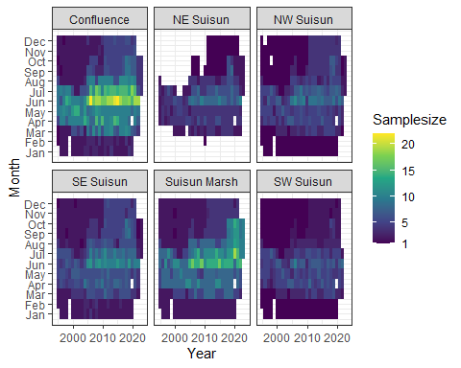

All the remaining brackish regions have sufficient sample size with the exception of NE Suisun. As such, NE Suisun is to be combined with SE Suisun while the rest of the regions are to be analyzed on their own.

Create a new column with IBMR edited regions to accomodate combination of NE and SE Suisun regions.

zoop_data_mass$Subregion_edit<-ifelse(zoop_data_mass$SUBREGION%in%c("NE Suisun", "SE Suisun"), "East Suisun", zoop_data_mass$SUBREGION)

# Model

## Prediction data

Set up prediction data for model

# Min year to start models  
year_min<-1995  
  
newdata_function<-function(region, data=zoop_data_mass, quant=0.99){  
   
 lower<-(1-quant)/(2)  
 upper<-1-lower  
   
 data_filt<-data%>%  
 filter(Subregion_edit%in%region & Year >= year_min)  
   
 # Calculate monthly quantiles of salinity  
 month_sal<-data_filt%>%  
 group_by(Month)%>%  
 summarise(l=quantile(SalSurf, lower),  
 u=quantile(SalSurf, upper), .groups="drop")  
   
 newdata<-expand_grid(date=mdy(paste(1:12, 15, 2001, sep="/")), # The 15th of each month on a non-leap year  
 SalSurf=seq(round(min(data_filt$SalSurf), 1),   
 round(max(data_filt$SalSurf), 1), by=0.1))%>% # Salinity sequence nicely rounded to 1 decimal  
 mutate(Month=month(date),  
 doy=yday(date), # Day of year  
 SalSurf_s=(SalSurf-mean(data$SalSurf))/sd(data$SalSurf), # center and standardize salinity to match data  
 doy_s=(doy-mean(data$doy))/sd(data$doy))%>% # center and standardize doy to match data  
 left_join(month_sal, by="Month")%>%  
 filter(SalSurf >= l & SalSurf <= u)%>% # Remove any salinity values outside the quantiles for each month  
 select(Month, doy, doy_s, SalSurf, SalSurf_s)  
   
}  
  
newdata<-map(set_names(unique(zoop_data_mass$Subregion_edit)), newdata_function)

## Posterior prediction function

# Function to generate posterior predictions from a gam model  
# From https://stats.stackexchange.com/questions/190348/can-i-use-bootstrapping-to-estimate-the-uncertainty-in-a-maximum-value-of-a-gam  
predict_posterior<-function(model, newdata, exclude, n=1e3, seed=999){  
 Xp <- predict(model, newdata=newdata, type="lpmatrix", exclude=exclude, newdata.guaranteed=TRUE) ## map coefs to fitted curves  
 beta <- coef(model)  
 Vb <- vcov(model) ## posterior mean and cov of coefs  
 set.seed(seed)  
 mrand <- mvrnorm(n, beta, Vb) ## simulate n rep coef vectors from posterior  
 pred<-matrix(nrow=nrow(newdata), ncol=n)  
 ilink <- family(model)$linkinv  
 for (i in seq_len(n)) {   
 pred[,i] <- ilink(Xp %*% mrand[i, ])  
 }  
 colnames(pred)<-paste("draw", 1:n, sep="_")  
 pred<-as_tibble(pred)  
 return(pred)  
}

## Model fitting

model

sal_model<-function(group,region,new_data=newdata){  
   
 cat("<<<<<<<<<<<<<<<<<<<<<<< modeling", group, region, ">>>>>>>>>>>>>>>>>>>>>>>>>\n\n")  
   
 new_data<-new_data[[region]]  
   
 data<-filter(zoop_data_mass, IBMR==group & Subregion_edit==region & Year>=year_min)  
   
 par(mfrow=c(2,2))  
   
 if(length(unique(data$Station_fac))>1){  
 model<-gam(BPUE_log1p ~ te(SalSurf_s, doy_s, k=c(5,5), bs=c("cs", "cc")) +   
 s(Year_fac, bs="re") + s(Station_fac, bs="re"),  
 data=data,   
 method="REML")  
   
 random_effects<-c("s(Year_fac)", "s(Station_fac)")  
   
 }else{  
   
 model<-gam(BPUE_log1p ~ te(SalSurf_s, doy_s, k=c(5,5), bs=c("cs", "cc")) +   
 s(Year_fac, bs="re"),  
 data=data,   
 method="REML")  
   
 random_effects<-c("s(Year_fac)")  
 }  
   
 cat("-------------gam check-------------\n")  
 gam.check(model)  
   
 cat("\n\n-------------summary-------------\n")  
 print(summary(model))  
   
 sal<-predict_posterior(model, new_data, random_effects)%>%  
 bind_cols(new_data%>% # Add covariate columns before these columns  
 select(-doy_s, -SalSurf_s),   
 .)  
 return(sal)  
}

Apply model to all groups and regions

model_factors<-expand_grid(IBMR=unique(zoop_data_mass$IBMR),  
 Subregion_edit=unique(zoop_data_mass$Subregion_edit))%>%  
 mutate(IBMR=set_names(IBMR, paste(IBMR, Subregion_edit)))  
  
sal_conversions<-pmap_dfr(model_factors, function(IBMR, Subregion_edit) sal_model(IBMR, Subregion_edit), .id = "IBMR_region")%>%  
 mutate(IBMR=sapply(IBMR_region, function(x) str_split(x, " ", n=2)[[1]][1]),  
 Region=factor(sapply(IBMR_region, function(x) str_split(x, " ", n=2)[[1]][2]),  
 levels=c("Confluence", "Suisun Marsh", "East Suisun",   
 "NW Suisun", "SW Suisun")),  
 Month=as.integer(Month))%>%  
 select(-IBMR_region, -doy)%>%  
 relocate(Region, Month, IBMR, SalSurf)

## <<<<<<<<<<<<<<<<<<<<<<< modeling acartela SW Suisun >>>>>>>>>>>>>>>>>>>>>>>>>  
##   
## -------------gam check-------------

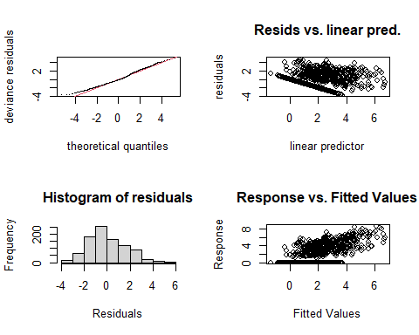

##   
## Method: REML Optimizer: outer newton  
## full convergence after 9 iterations.  
## Gradient range [-0.00003172463,0.00001663401]  
## (score 1794.806 & scale 2.634577).  
## Hessian positive definite, eigenvalue range [1.313236,455.8766].  
## Model rank = 53 / 53   
##   
## Basis dimension (k) checking results. Low p-value (k-index<1) may  
## indicate that k is too low, especially if edf is close to k'.  
##   
## k' edf k-index p-value  
## te(SalSurf_s,doy_s) 19.00 12.96 0.98 0.24  
## s(Year_fac) 28.00 23.98 NA NA  
## s(Station_fac) 5.00 3.62 NA NA  
##   
##   
## -------------summary-------------  
##   
## Family: gaussian   
## Link function: identity   
##   
## Formula:  
## BPUE_log1p ~ te(SalSurf_s, doy_s, k = c(5, 5), bs = c("cs", "cc")) +   
## s(Year_fac, bs = "re") + s(Station_fac, bs = "re")  
##   
## Parametric coefficients:  
## Estimate Std. Error t value Pr(>|t|)   
## (Intercept) 2.7462 0.7286 3.769 0.000175 ***  
## ---  
## Signif. codes: 0 '***' 0.001 '**' 0.01 '*' 0.05 '.' 0.1 ' ' 1  
##   
## Approximate significance of smooth terms:  
## edf Ref.df F p-value   
## te(SalSurf_s,doy_s) 12.964 19 660.027 < 0.0000000000000002 ***  
## s(Year_fac) 23.979 27 9.632 < 0.0000000000000002 ***  
## s(Station_fac) 3.625 4 11.525 0.0000017 ***  
## ---  
## Signif. codes: 0 '***' 0.001 '**' 0.01 '*' 0.05 '.' 0.1 ' ' 1  
##   
## R-sq.(adj) = 0.466 Deviance explained = 48.9%  
## -REML = 1794.8 Scale est. = 2.6346 n = 912  
## <<<<<<<<<<<<<<<<<<<<<<< modeling acartela NW Suisun >>>>>>>>>>>>>>>>>>>>>>>>>  
##   
## -------------gam check-------------

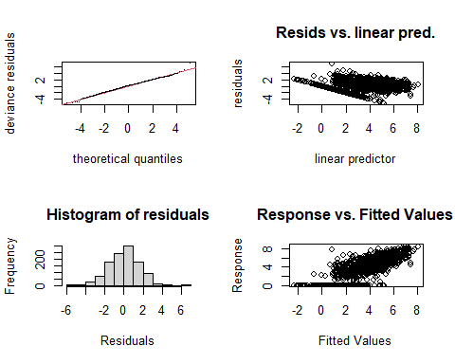

##   
## Method: REML Optimizer: outer newton  
## full convergence after 8 iterations.  
## Gradient range [-0.001942177,0.0009222772]  
## (score 2150.983 & scale 2.461951).  
## Hessian positive definite, eigenvalue range [1.409033,553.8878].  
## Model rank = 54 / 54   
##   
## Basis dimension (k) checking results. Low p-value (k-index<1) may  
## indicate that k is too low, especially if edf is close to k'.  
##   
## k' edf k-index p-value   
## te(SalSurf_s,doy_s) 19.00 16.03 0.95 0.05 *  
## s(Year_fac) 29.00 26.40 NA NA   
## s(Station_fac) 5.00 3.66 NA NA   
## ---  
## Signif. codes: 0 '***' 0.001 '**' 0.01 '*' 0.05 '.' 0.1 ' ' 1  
##   
##   
## -------------summary-------------  
##   
## Family: gaussian   
## Link function: identity   
##   
## Formula:  
## BPUE_log1p ~ te(SalSurf_s, doy_s, k = c(5, 5), bs = c("cs", "cc")) +   
## s(Year_fac, bs = "re") + s(Station_fac, bs = "re")  
##   
## Parametric coefficients:  
## Estimate Std. Error t value Pr(>|t|)   
## (Intercept) 2.7394 0.4822 5.681 0.0000000172 ***  
## ---  
## Signif. codes: 0 '***' 0.001 '**' 0.01 '*' 0.05 '.' 0.1 ' ' 1  
##   
## Approximate significance of smooth terms:  
## edf Ref.df F p-value   
## te(SalSurf_s,doy_s) 16.032 19 284.19 <0.0000000000000002 ***  
## s(Year_fac) 26.397 28 21.54 <0.0000000000000002 ***  
## s(Station_fac) 3.655 4 31.93 <0.0000000000000002 ***  
## ---  
## Signif. codes: 0 '***' 0.001 '**' 0.01 '*' 0.05 '.' 0.1 ' ' 1  
##   
## R-sq.(adj) = 0.612 Deviance explained = 62.8%  
## -REML = 2151 Scale est. = 2.462 n = 1108  
## <<<<<<<<<<<<<<<<<<<<<<< modeling acartela East Suisun >>>>>>>>>>>>>>>>>>>>>>>>>  
##   
## -------------gam check-------------

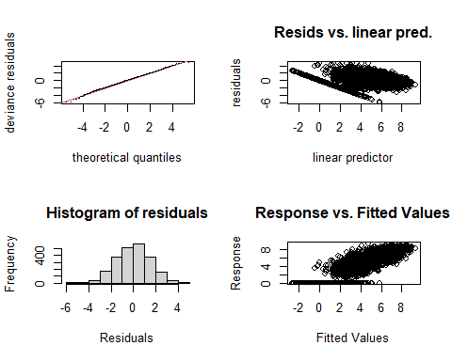

##   
## Method: REML Optimizer: outer newton  
## full convergence after 8 iterations.  
## Gradient range [-0.0007368473,0.0006003538]  
## (score 4298.725 & scale 2.414573).  
## Hessian positive definite, eigenvalue range [2.822869,1125.217].  
## Model rank = 59 / 59   
##   
## Basis dimension (k) checking results. Low p-value (k-index<1) may  
## indicate that k is too low, especially if edf is close to k'.  
##   
## k' edf k-index p-value   
## te(SalSurf_s,doy_s) 19.00 17.45 0.87 <0.0000000000000002 ***  
## s(Year_fac) 29.00 27.40 NA NA   
## s(Station_fac) 10.00 7.68 NA NA   
## ---  
## Signif. codes: 0 '***' 0.001 '**' 0.01 '*' 0.05 '.' 0.1 ' ' 1  
##   
##   
## -------------summary-------------  
##   
## Family: gaussian   
## Link function: identity   
##   
## Formula:  
## BPUE_log1p ~ te(SalSurf_s, doy_s, k = c(5, 5), bs = c("cs", "cc")) +   
## s(Year_fac, bs = "re") + s(Station_fac, bs = "re")  
##   
## Parametric coefficients:  
## Estimate Std. Error t value Pr(>|t|)   
## (Intercept) 4.1724 0.3483 11.98 <0.0000000000000002 ***  
## ---  
## Signif. codes: 0 '***' 0.001 '**' 0.01 '*' 0.05 '.' 0.1 ' ' 1  
##   
## Approximate significance of smooth terms:  
## edf Ref.df F p-value   
## te(SalSurf_s,doy_s) 17.449 19 986.64 <0.0000000000000002 ***  
## s(Year_fac) 27.401 28 52.02 <0.0000000000000002 ***  
## s(Station_fac) 7.677 9 15.04 <0.0000000000000002 ***  
## ---  
## Signif. codes: 0 '***' 0.001 '**' 0.01 '*' 0.05 '.' 0.1 ' ' 1  
##   
## R-sq.(adj) = 0.694 Deviance explained = 70.1%  
## -REML = 4298.7 Scale est. = 2.4146 n = 2251  
## <<<<<<<<<<<<<<<<<<<<<<< modeling acartela Confluence >>>>>>>>>>>>>>>>>>>>>>>>>  
##   
## -------------gam check-------------

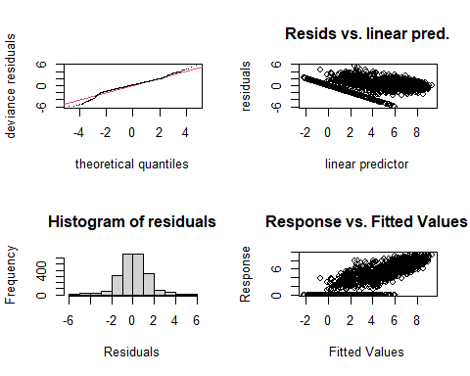

##   
## Method: REML Optimizer: outer newton  
## full convergence after 7 iterations.  
## Gradient range [-0.0004711907,0.0003868032]  
## (score 3972.72 & scale 1.888799).  
## Hessian positive definite, eigenvalue range [2.687996,1112.213].  
## Model rank = 59 / 59   
##   
## Basis dimension (k) checking results. Low p-value (k-index<1) may  
## indicate that k is too low, especially if edf is close to k'.  
##   
## k' edf k-index p-value   
## te(SalSurf_s,doy_s) 19.00 16.91 0.93 <0.0000000000000002 ***  
## s(Year_fac) 29.00 27.13 NA NA   
## s(Station_fac) 10.00 7.41 NA NA   
## ---  
## Signif. codes: 0 '***' 0.001 '**' 0.01 '*' 0.05 '.' 0.1 ' ' 1  
##   
##   
## -------------summary-------------  
##   
## Family: gaussian   
## Link function: identity   
##   
## Formula:  
## BPUE_log1p ~ te(SalSurf_s, doy_s, k = c(5, 5), bs = c("cs", "cc")) +   
## s(Year_fac, bs = "re") + s(Station_fac, bs = "re")  
##   
## Parametric coefficients:  
## Estimate Std. Error t value Pr(>|t|)   
## (Intercept) 4.1031 0.2345 17.5 <0.0000000000000002 ***  
## ---  
## Signif. codes: 0 '***' 0.001 '**' 0.01 '*' 0.05 '.' 0.1 ' ' 1  
##   
## Approximate significance of smooth terms:  
## edf Ref.df F p-value   
## te(SalSurf_s,doy_s) 16.910 19 3552.53 <0.0000000000000002 ***  
## s(Year_fac) 27.127 28 37.04 <0.0000000000000002 ***  
## s(Station_fac) 7.412 9 14.79 <0.0000000000000002 ***  
## ---  
## Signif. codes: 0 '***' 0.001 '**' 0.01 '*' 0.05 '.' 0.1 ' ' 1  
##   
## R-sq.(adj) = 0.811 Deviance explained = 81.5%  
## -REML = 3972.7 Scale est. = 1.8888 n = 2225  
## <<<<<<<<<<<<<<<<<<<<<<< modeling acartela Suisun Marsh >>>>>>>>>>>>>>>>>>>>>>>>>  
##   
## -------------gam check-------------

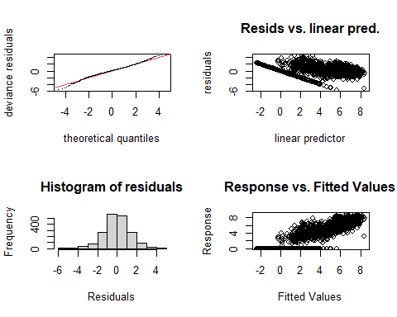

##   
## Method: REML Optimizer: outer newton  
## full convergence after 8 iterations.  
## Gradient range [-0.0003582384,0.0002955844]  
## (score 3309.542 & scale 1.805059).  
## Hessian positive definite, eigenvalue range [2.027954,936.7478].  
## Model rank = 58 / 58   
##   
## Basis dimension (k) checking results. Low p-value (k-index<1) may  
## indicate that k is too low, especially if edf is close to k'.  
##   
## k' edf k-index p-value   
## te(SalSurf_s,doy_s) 19.00 16.95 0.93 <0.0000000000000002 ***  
## s(Year_fac) 29.00 27.14 NA NA   
## s(Station_fac) 9.00 6.02 NA NA   
## ---  
## Signif. codes: 0 '***' 0.001 '**' 0.01 '*' 0.05 '.' 0.1 ' ' 1  
##   
##   
## -------------summary-------------  
##   
## Family: gaussian   
## Link function: identity   
##   
## Formula:  
## BPUE_log1p ~ te(SalSurf_s, doy_s, k = c(5, 5), bs = c("cs", "cc")) +   
## s(Year_fac, bs = "re") + s(Station_fac, bs = "re")  
##   
## Parametric coefficients:  
## Estimate Std. Error t value Pr(>|t|)   
## (Intercept) 3.5908 0.2271 15.81 <0.0000000000000002 ***  
## ---  
## Signif. codes: 0 '***' 0.001 '**' 0.01 '*' 0.05 '.' 0.1 ' ' 1  
##   
## Approximate significance of smooth terms:  
## edf Ref.df F p-value   
## te(SalSurf_s,doy_s) 16.948 19 1741.10 <0.0000000000000002 ***  
## s(Year_fac) 27.136 28 31.42 <0.0000000000000002 ***  
## s(Station_fac) 6.017 8 11.23 <0.0000000000000002 ***  
## ---  
## Signif. codes: 0 '***' 0.001 '**' 0.01 '*' 0.05 '.' 0.1 ' ' 1  
##   
## R-sq.(adj) = 0.79 Deviance explained = 79.6%  
## -REML = 3309.5 Scale est. = 1.8051 n = 1874  
## <<<<<<<<<<<<<<<<<<<<<<< modeling daphnia SW Suisun >>>>>>>>>>>>>>>>>>>>>>>>>  
##   
## -------------gam check-------------

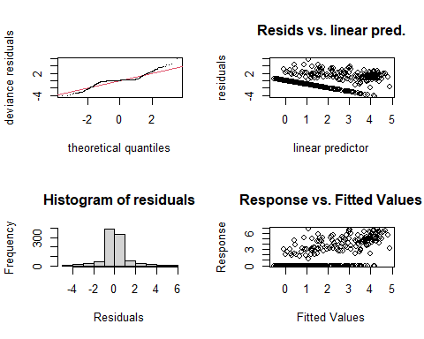

##   
## Method: REML Optimizer: outer newton  
## full convergence after 6 iterations.  
## Gradient range [-0.0001240198,0.00008142966]  
## (score 1423.136 & scale 1.218295).  
## Hessian positive definite, eigenvalue range [0.00008317993,455.7354].  
## Model rank = 53 / 53   
##   
## Basis dimension (k) checking results. Low p-value (k-index<1) may  
## indicate that k is too low, especially if edf is close to k'.  
##   
## k' edf k-index p-value   
## te(SalSurf_s,doy_s) 19.000000 14.024769 0.83 <0.0000000000000002 ***  
## s(Year_fac) 28.000000 18.029159 NA NA   
## s(Station_fac) 5.000000 0.000489 NA NA   
## ---  
## Signif. codes: 0 '***' 0.001 '**' 0.01 '*' 0.05 '.' 0.1 ' ' 1  
##   
##   
## -------------summary-------------  
##   
## Family: gaussian   
## Link function: identity   
##   
## Formula:  
## BPUE_log1p ~ te(SalSurf_s, doy_s, k = c(5, 5), bs = c("cs", "cc")) +   
## s(Year_fac, bs = "re") + s(Station_fac, bs = "re")  
##   
## Parametric coefficients:  
## Estimate Std. Error t value Pr(>|t|)   
## (Intercept) 0.67054 0.06566 10.21 <0.0000000000000002 ***  
## ---  
## Signif. codes: 0 '***' 0.001 '**' 0.01 '*' 0.05 '.' 0.1 ' ' 1  
##   
## Approximate significance of smooth terms:  
## edf Ref.df F p-value   
## te(SalSurf_s,doy_s) 14.0247692 19 83.557 < 0.0000000000000002 ***  
## s(Year_fac) 18.0291591 27 2.089 0.000000393 ***  
## s(Station_fac) 0.0004891 4 0.000 0.516   
## ---  
## Signif. codes: 0 '***' 0.001 '**' 0.01 '*' 0.05 '.' 0.1 ' ' 1  
##   
## R-sq.(adj) = 0.573 Deviance explained = 58.8%  
## -REML = 1423.1 Scale est. = 1.2183 n = 912  
## <<<<<<<<<<<<<<<<<<<<<<< modeling daphnia NW Suisun >>>>>>>>>>>>>>>>>>>>>>>>>  
##   
## -------------gam check-------------

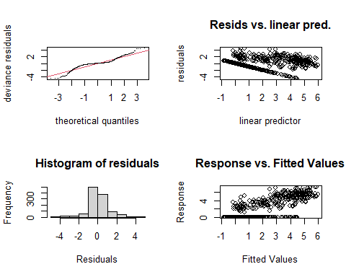

##   
## Method: REML Optimizer: outer newton  
## full convergence after 8 iterations.  
## Gradient range [-0.000194362,0.0001389984]  
## (score 1712.205 & scale 1.159603).  
## Hessian positive definite, eigenvalue range [1.094337,553.7822].  
## Model rank = 54 / 54   
##   
## Basis dimension (k) checking results. Low p-value (k-index<1) may  
## indicate that k is too low, especially if edf is close to k'.  
##   
## k' edf k-index p-value   
## te(SalSurf_s,doy_s) 19.00 16.32 0.9 <0.0000000000000002 ***  
## s(Year_fac) 29.00 21.85 NA NA   
## s(Station_fac) 5.00 2.46 NA NA   
## ---  
## Signif. codes: 0 '***' 0.001 '**' 0.01 '*' 0.05 '.' 0.1 ' ' 1  
##   
##   
## -------------summary-------------  
##   
## Family: gaussian   
## Link function: identity   
##   
## Formula:  
## BPUE_log1p ~ te(SalSurf_s, doy_s, k = c(5, 5), bs = c("cs", "cc")) +   
## s(Year_fac, bs = "re") + s(Station_fac, bs = "re")  
##   
## Parametric coefficients:  
## Estimate Std. Error t value Pr(>|t|)   
## (Intercept) 0.9169 0.1154 7.943 0.00000000000000497 ***  
## ---  
## Signif. codes: 0 '***' 0.001 '**' 0.01 '*' 0.05 '.' 0.1 ' ' 1  
##   
## Approximate significance of smooth terms:  
## edf Ref.df F p-value   
## te(SalSurf_s,doy_s) 16.322 19 214.604 < 0.0000000000000002 ***  
## s(Year_fac) 21.848 28 3.428 < 0.0000000000000002 ***  
## s(Station_fac) 2.457 4 4.900 0.0000868 ***  
## ---  
## Signif. codes: 0 '***' 0.001 '**' 0.01 '*' 0.05 '.' 0.1 ' ' 1  
##   
## R-sq.(adj) = 0.694 Deviance explained = 70.5%  
## -REML = 1712.2 Scale est. = 1.1596 n = 1108  
## <<<<<<<<<<<<<<<<<<<<<<< modeling daphnia East Suisun >>>>>>>>>>>>>>>>>>>>>>>>>  
##   
## -------------gam check-------------

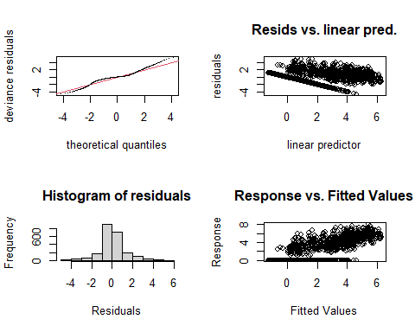

##   
## Method: REML Optimizer: outer newton  
## full convergence after 8 iterations.  
## Gradient range [-0.001571207,0.005874486]  
## (score 3656.413 & scale 1.405088).  
## Hessian positive definite, eigenvalue range [0.01246569,1125.179].  
## Model rank = 59 / 59   
##   
## Basis dimension (k) checking results. Low p-value (k-index<1) may  
## indicate that k is too low, especially if edf is close to k'.  
##   
## k' edf k-index p-value   
## te(SalSurf_s,doy_s) 19.000 17.128 0.86 <0.0000000000000002 ***  
## s(Year_fac) 29.000 26.047 NA NA   
## s(Station_fac) 10.000 0.337 NA NA   
## ---  
## Signif. codes: 0 '***' 0.001 '**' 0.01 '*' 0.05 '.' 0.1 ' ' 1  
##   
##   
## -------------summary-------------  
##   
## Family: gaussian   
## Link function: identity   
##   
## Formula:  
## BPUE_log1p ~ te(SalSurf_s, doy_s, k = c(5, 5), bs = c("cs", "cc")) +   
## s(Year_fac, bs = "re") + s(Station_fac, bs = "re")  
##   
## Parametric coefficients:  
## Estimate Std. Error t value Pr(>|t|)   
## (Intercept) 1.3110 0.1066 12.3 <0.0000000000000002 ***  
## ---  
## Signif. codes: 0 '***' 0.001 '**' 0.01 '*' 0.05 '.' 0.1 ' ' 1  
##   
## Approximate significance of smooth terms:  
## edf Ref.df F p-value   
## te(SalSurf_s,doy_s) 17.128 19 927.79 <0.0000000000000002 ***  
## s(Year_fac) 26.047 28 12.15 <0.0000000000000002 ***  
## s(Station_fac) 0.337 9 0.04 0.38   
## ---  
## Signif. codes: 0 '***' 0.001 '**' 0.01 '*' 0.05 '.' 0.1 ' ' 1  
##   
## R-sq.(adj) = 0.702 Deviance explained = 70.8%  
## -REML = 3656.4 Scale est. = 1.4051 n = 2251  
## <<<<<<<<<<<<<<<<<<<<<<< modeling daphnia Confluence >>>>>>>>>>>>>>>>>>>>>>>>>  
##   
## -------------gam check-------------

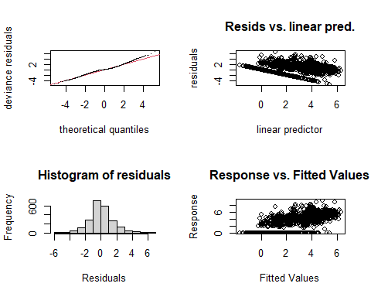

##   
## Method: REML Optimizer: outer newton  
## full convergence after 10 iterations.  
## Gradient range [-0.001249956,0.003627092]  
## (score 4117.481 & scale 2.216329).  
## Hessian positive definite, eigenvalue range [0.001253064,1112.172].  
## Model rank = 59 / 59   
##   
## Basis dimension (k) checking results. Low p-value (k-index<1) may  
## indicate that k is too low, especially if edf is close to k'.  
##   
## k' edf k-index p-value   
## te(SalSurf_s,doy_s) 19.00000 16.39678 0.86 <0.0000000000000002 ***  
## s(Year_fac) 29.00000 25.32049 NA NA   
## s(Station_fac) 10.00000 0.00996 NA NA   
## ---  
## Signif. codes: 0 '***' 0.001 '**' 0.01 '*' 0.05 '.' 0.1 ' ' 1  
##   
##   
## -------------summary-------------  
##   
## Family: gaussian   
## Link function: identity   
##   
## Formula:  
## BPUE_log1p ~ te(SalSurf_s, doy_s, k = c(5, 5), bs = c("cs", "cc")) +   
## s(Year_fac, bs = "re") + s(Station_fac, bs = "re")  
##   
## Parametric coefficients:  
## Estimate Std. Error t value Pr(>|t|)   
## (Intercept) 1.803 0.113 15.96 <0.0000000000000002 ***  
## ---  
## Signif. codes: 0 '***' 0.001 '**' 0.01 '*' 0.05 '.' 0.1 ' ' 1  
##   
## Approximate significance of smooth terms:  
## edf Ref.df F p-value   
## te(SalSurf_s,doy_s) 16.39678 19 506.141 <0.0000000000000002 ***  
## s(Year_fac) 25.32049 28 9.973 <0.0000000000000002 ***  
## s(Station_fac) 0.00996 9 0.001 0.599   
## ---  
## Signif. codes: 0 '***' 0.001 '**' 0.01 '*' 0.05 '.' 0.1 ' ' 1  
##   
## R-sq.(adj) = 0.604 Deviance explained = 61.1%  
## -REML = 4117.5 Scale est. = 2.2163 n = 2225  
## <<<<<<<<<<<<<<<<<<<<<<< modeling daphnia Suisun Marsh >>>>>>>>>>>>>>>>>>>>>>>>>  
##   
## -------------gam check-------------

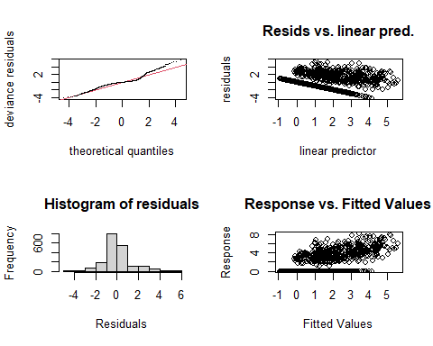

##   
## Method: REML Optimizer: outer newton  
## full convergence after 9 iterations.  
## Gradient range [-0.000003489322,0.000003123207]  
## (score 3183.588 & scale 1.638552).  
## Hessian positive definite, eigenvalue range [1.762512,936.6886].  
## Model rank = 58 / 58   
##   
## Basis dimension (k) checking results. Low p-value (k-index<1) may  
## indicate that k is too low, especially if edf is close to k'.  
##   
## k' edf k-index p-value   
## te(SalSurf_s,doy_s) 19.00 15.10 0.94 <0.0000000000000002 ***  
## s(Year_fac) 29.00 23.81 NA NA   
## s(Station_fac) 9.00 4.36 NA NA   
## ---  
## Signif. codes: 0 '***' 0.001 '**' 0.01 '*' 0.05 '.' 0.1 ' ' 1  
##   
##   
## -------------summary-------------  
##   
## Family: gaussian   
## Link function: identity   
##   
## Formula:  
## BPUE_log1p ~ te(SalSurf_s, doy_s, k = c(5, 5), bs = c("cs", "cc")) +   
## s(Year_fac, bs = "re") + s(Station_fac, bs = "re")  
##   
## Parametric coefficients:  
## Estimate Std. Error t value Pr(>|t|)   
## (Intercept) 0.8610 0.1018 8.462 <0.0000000000000002 ***  
## ---  
## Signif. codes: 0 '***' 0.001 '**' 0.01 '*' 0.05 '.' 0.1 ' ' 1  
##   
## Approximate significance of smooth terms:  
## edf Ref.df F p-value   
## te(SalSurf_s,doy_s) 15.101 19 134.456 < 0.0000000000000002 ***  
## s(Year_fac) 23.811 28 5.241 < 0.0000000000000002 ***  
## s(Station_fac) 4.363 8 3.233 0.00002 ***  
## ---  
## Signif. codes: 0 '***' 0.001 '**' 0.01 '*' 0.05 '.' 0.1 ' ' 1  
##   
## R-sq.(adj) = 0.492 Deviance explained = 50.4%  
## -REML = 3183.6 Scale est. = 1.6386 n = 1874  
## <<<<<<<<<<<<<<<<<<<<<<< modeling eurytem SW Suisun >>>>>>>>>>>>>>>>>>>>>>>>>  
##   
## -------------gam check-------------

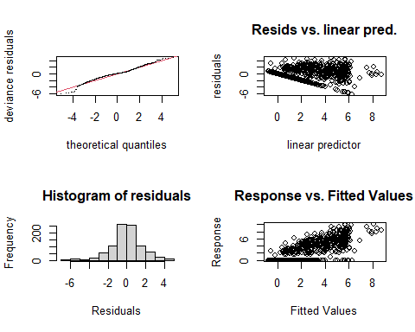

##   
## Method: REML Optimizer: outer newton  
## full convergence after 7 iterations.  
## Gradient range [-0.000001277369,0.000001084004]  
## (score 1739.937 & scale 2.440263).  
## Hessian positive definite, eigenvalue range [1.464355,455.64].  
## Model rank = 53 / 53   
##   
## Basis dimension (k) checking results. Low p-value (k-index<1) may  
## indicate that k is too low, especially if edf is close to k'.  
##   
## k' edf k-index p-value   
## te(SalSurf_s,doy_s) 19.00 13.32 0.95 0.045 *  
## s(Year_fac) 28.00 12.22 NA NA   
## s(Station_fac) 5.00 3.67 NA NA   
## ---  
## Signif. codes: 0 '***' 0.001 '**' 0.01 '*' 0.05 '.' 0.1 ' ' 1  
##   
##   
## -------------summary-------------  
##   
## Family: gaussian   
## Link function: identity   
##   
## Formula:  
## BPUE_log1p ~ te(SalSurf_s, doy_s, k = c(5, 5), bs = c("cs", "cc")) +   
## s(Year_fac, bs = "re") + s(Station_fac, bs = "re")  
##   
## Parametric coefficients:  
## Estimate Std. Error t value Pr(>|t|)   
## (Intercept) 2.9007 0.7258 3.997 0.0000696 ***  
## ---  
## Signif. codes: 0 '***' 0.001 '**' 0.01 '*' 0.05 '.' 0.1 ' ' 1  
##   
## Approximate significance of smooth terms:  
## edf Ref.df F p-value   
## te(SalSurf_s,doy_s) 13.318 19 1186.015 < 0.0000000000000002 ***  
## s(Year_fac) 12.219 27 0.828 0.00809 **   
## s(Station_fac) 3.665 4 12.072 < 0.0000000000000002 ***  
## ---  
## Signif. codes: 0 '***' 0.001 '**' 0.01 '*' 0.05 '.' 0.1 ' ' 1  
##   
## R-sq.(adj) = 0.643 Deviance explained = 65.4%  
## -REML = 1739.9 Scale est. = 2.4403 n = 912  
## <<<<<<<<<<<<<<<<<<<<<<< modeling eurytem NW Suisun >>>>>>>>>>>>>>>>>>>>>>>>>  
##   
## -------------gam check-------------

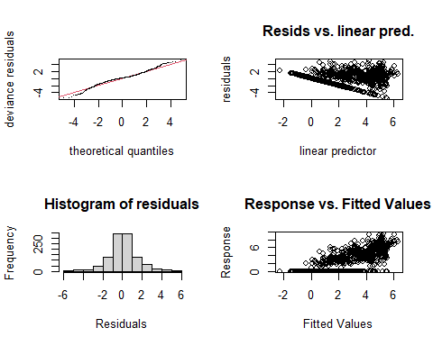

##   
## Method: REML Optimizer: outer newton  
## full convergence after 9 iterations.  
## Gradient range [-0.0002364081,0.0001378661]  
## (score 2053.916 & scale 2.153944).  
## Hessian positive definite, eigenvalue range [0.0848522,553.763].  
## Model rank = 54 / 54   
##   
## Basis dimension (k) checking results. Low p-value (k-index<1) may  
## indicate that k is too low, especially if edf is close to k'.  
##   
## k' edf k-index p-value   
## te(SalSurf_s,doy_s) 19.000 16.942 0.96 0.075 .  
## s(Year_fac) 29.000 20.762 NA NA   
## s(Station_fac) 5.000 0.683 NA NA   
## ---  
## Signif. codes: 0 '***' 0.001 '**' 0.01 '*' 0.05 '.' 0.1 ' ' 1  
##   
##   
## -------------summary-------------  
##   
## Family: gaussian   
## Link function: identity   
##   
## Formula:  
## BPUE_log1p ~ te(SalSurf_s, doy_s, k = c(5, 5), bs = c("cs", "cc")) +   
## s(Year_fac, bs = "re") + s(Station_fac, bs = "re")  
##   
## Parametric coefficients:  
## Estimate Std. Error t value Pr(>|t|)   
## (Intercept) 1.84006 0.09952 18.49 <0.0000000000000002 ***  
## ---  
## Signif. codes: 0 '***' 0.001 '**' 0.01 '*' 0.05 '.' 0.1 ' ' 1  
##   
## Approximate significance of smooth terms:  
## edf Ref.df F p-value   
## te(SalSurf_s,doy_s) 16.9415 19 154.523 <0.0000000000000002 ***  
## s(Year_fac) 20.7623 28 2.784 <0.0000000000000002 ***  
## s(Station_fac) 0.6829 4 0.244 0.241   
## ---  
## Signif. codes: 0 '***' 0.001 '**' 0.01 '*' 0.05 '.' 0.1 ' ' 1  
##   
## R-sq.(adj) = 0.642 Deviance explained = 65.5%  
## -REML = 2053.9 Scale est. = 2.1539 n = 1108  
## <<<<<<<<<<<<<<<<<<<<<<< modeling eurytem East Suisun >>>>>>>>>>>>>>>>>>>>>>>>>  
##   
## -------------gam check-------------

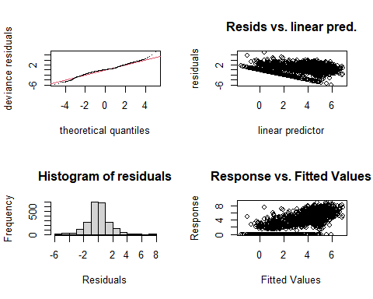

##   
## Method: REML Optimizer: outer newton  
## full convergence after 10 iterations.  
## Gradient range [-0.0001935674,0.0001790197]  
## (score 4080.627 & scale 2.05502).  
## Hessian positive definite, eigenvalue range [1.361564,1125.163].  
## Model rank = 59 / 59   
##   
## Basis dimension (k) checking results. Low p-value (k-index<1) may  
## indicate that k is too low, especially if edf is close to k'.  
##   
## k' edf k-index p-value   
## te(SalSurf_s,doy_s) 19.00 17.21 0.77 <0.0000000000000002 ***  
## s(Year_fac) 29.00 23.16 NA NA   
## s(Station_fac) 10.00 6.58 NA NA   
## ---  
## Signif. codes: 0 '***' 0.001 '**' 0.01 '*' 0.05 '.' 0.1 ' ' 1  
##   
##   
## -------------summary-------------  
##   
## Family: gaussian   
## Link function: identity   
##   
## Formula:  
## BPUE_log1p ~ te(SalSurf_s, doy_s, k = c(5, 5), bs = c("cs", "cc")) +   
## s(Year_fac, bs = "re") + s(Station_fac, bs = "re")  
##   
## Parametric coefficients:  
## Estimate Std. Error t value Pr(>|t|)   
## (Intercept) 2.1980 0.1474 14.92 <0.0000000000000002 ***  
## ---  
## Signif. codes: 0 '***' 0.001 '**' 0.01 '*' 0.05 '.' 0.1 ' ' 1  
##   
## Approximate significance of smooth terms:  
## edf Ref.df F p-value   
## te(SalSurf_s,doy_s) 17.210 19 418.858 < 0.0000000000000002 ***  
## s(Year_fac) 23.159 28 4.410 < 0.0000000000000002 ***  
## s(Station_fac) 6.585 9 3.389 0.0000779 ***  
## ---  
## Signif. codes: 0 '***' 0.001 '**' 0.01 '*' 0.05 '.' 0.1 ' ' 1  
##   
## R-sq.(adj) = 0.685 Deviance explained = 69.1%  
## -REML = 4080.6 Scale est. = 2.055 n = 2251  
## <<<<<<<<<<<<<<<<<<<<<<< modeling eurytem Confluence >>>>>>>>>>>>>>>>>>>>>>>>>  
##   
## -------------gam check-------------

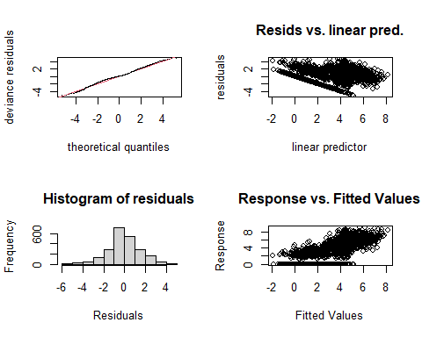

##   
## Method: REML Optimizer: outer newton  
## full convergence after 14 iterations.  
## Gradient range [-0.0000326011,0.00000987371]  
## (score 4132.992 & scale 2.24016).  
## Hessian positive definite, eigenvalue range [0.5357827,1112.166].  
## Model rank = 59 / 59   
##   
## Basis dimension (k) checking results. Low p-value (k-index<1) may  
## indicate that k is too low, especially if edf is close to k'.  
##   
## k' edf k-index p-value   
## te(SalSurf_s,doy_s) 19.00 17.34 0.73 <0.0000000000000002 ***  
## s(Year_fac) 29.00 24.03 NA NA   
## s(Station_fac) 10.00 2.49 NA NA   
## ---  
## Signif. codes: 0 '***' 0.001 '**' 0.01 '*' 0.05 '.' 0.1 ' ' 1  
##   
##   
## -------------summary-------------  
##   
## Family: gaussian   
## Link function: identity   
##   
## Formula:  
## BPUE_log1p ~ te(SalSurf_s, doy_s, k = c(5, 5), bs = c("cs", "cc")) +   
## s(Year_fac, bs = "re") + s(Station_fac, bs = "re")  
##   
## Parametric coefficients:  
## Estimate Std. Error t value Pr(>|t|)   
## (Intercept) 2.3400 0.0969 24.15 <0.0000000000000002 ***  
## ---  
## Signif. codes: 0 '***' 0.001 '**' 0.01 '*' 0.05 '.' 0.1 ' ' 1  
##   
## Approximate significance of smooth terms:  
## edf Ref.df F p-value   
## te(SalSurf_s,doy_s) 17.341 19 292.786 <0.0000000000000002 ***  
## s(Year_fac) 24.030 28 6.446 <0.0000000000000002 ***  
## s(Station_fac) 2.489 9 0.501 0.099 .   
## ---  
## Signif. codes: 0 '***' 0.001 '**' 0.01 '*' 0.05 '.' 0.1 ' ' 1  
##   
## R-sq.(adj) = 0.68 Deviance explained = 68.6%  
## -REML = 4133 Scale est. = 2.2402 n = 2225  
## <<<<<<<<<<<<<<<<<<<<<<< modeling eurytem Suisun Marsh >>>>>>>>>>>>>>>>>>>>>>>>>  
##   
## -------------gam check-------------

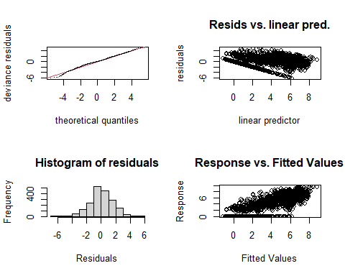

##   
## Method: REML Optimizer: outer newton  
## full convergence after 8 iterations.  
## Gradient range [-0.001682974,0.001277211]  
## (score 3609.187 & scale 2.569982).  
## Hessian positive definite, eigenvalue range [1.342356,936.6963].  
## Model rank = 58 / 58   
##   
## Basis dimension (k) checking results. Low p-value (k-index<1) may  
## indicate that k is too low, especially if edf is close to k'.  
##   
## k' edf k-index p-value   
## te(SalSurf_s,doy_s) 19.00 14.16 0.78 <0.0000000000000002 ***  
## s(Year_fac) 29.00 24.06 NA NA   
## s(Station_fac) 9.00 6.03 NA NA   
## ---  
## Signif. codes: 0 '***' 0.001 '**' 0.01 '*' 0.05 '.' 0.1 ' ' 1  
##   
##   
## -------------summary-------------  
##   
## Family: gaussian   
## Link function: identity   
##   
## Formula:  
## BPUE_log1p ~ te(SalSurf_s, doy_s, k = c(5, 5), bs = c("cs", "cc")) +   
## s(Year_fac, bs = "re") + s(Station_fac, bs = "re")  
##   
## Parametric coefficients:  
## Estimate Std. Error t value Pr(>|t|)   
## (Intercept) 3.2125 0.1776 18.09 <0.0000000000000002 ***  
## ---  
## Signif. codes: 0 '***' 0.001 '**' 0.01 '*' 0.05 '.' 0.1 ' ' 1  
##   
## Approximate significance of smooth terms:  
## edf Ref.df F p-value   
## te(SalSurf_s,doy_s) 14.157 19 462.46 <0.0000000000000002 ***  
## s(Year_fac) 24.056 28 5.56 <0.0000000000000002 ***  
## s(Station_fac) 6.031 8 11.27 <0.0000000000000002 ***  
## ---  
## Signif. codes: 0 '***' 0.001 '**' 0.01 '*' 0.05 '.' 0.1 ' ' 1  
##   
## R-sq.(adj) = 0.713 Deviance explained = 71.9%  
## -REML = 3609.2 Scale est. = 2.57 n = 1874  
## <<<<<<<<<<<<<<<<<<<<<<< modeling othcalad SW Suisun >>>>>>>>>>>>>>>>>>>>>>>>>  
##   
## -------------gam check-------------

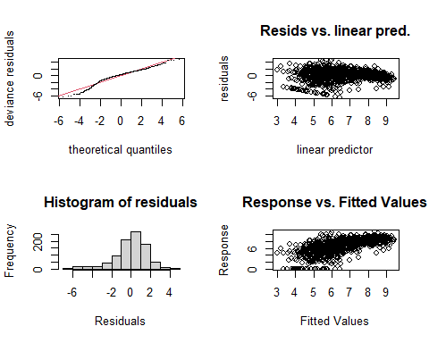

##   
## Method: REML Optimizer: outer newton  
## full convergence after 8 iterations.  
## Gradient range [-0.0003970968,0.0003520175]  
## (score 1840.53 & scale 3.027121).  
## Hessian positive definite, eigenvalue range [1.507427,455.7519].  
## Model rank = 53 / 53   
##   
## Basis dimension (k) checking results. Low p-value (k-index<1) may  
## indicate that k is too low, especially if edf is close to k'.  
##   
## k' edf k-index p-value  
## te(SalSurf_s,doy_s) 19.00 12.88 0.99 0.31  
## s(Year_fac) 28.00 19.01 NA NA  
## s(Station_fac) 5.00 2.94 NA NA  
##   
##   
## -------------summary-------------  
##   
## Family: gaussian   
## Link function: identity   
##   
## Formula:  
## BPUE_log1p ~ te(SalSurf_s, doy_s, k = c(5, 5), bs = c("cs", "cc")) +   
## s(Year_fac, bs = "re") + s(Station_fac, bs = "re")  
##   
## Parametric coefficients:  
## Estimate Std. Error t value Pr(>|t|)   
## (Intercept) 6.5357 0.3848 16.98 <0.0000000000000002 ***  
## ---  
## Signif. codes: 0 '***' 0.001 '**' 0.01 '*' 0.05 '.' 0.1 ' ' 1  
##   
## Approximate significance of smooth terms:  
## edf Ref.df F p-value   
## te(SalSurf_s,doy_s) 12.885 19 86.81 <0.0000000000000002 ***  
## s(Year_fac) 19.007 27 2.73 <0.0000000000000002 ***  
## s(Station_fac) 2.935 4 35.01 <0.0000000000000002 ***  
## ---  
## Signif. codes: 0 '***' 0.001 '**' 0.01 '*' 0.05 '.' 0.1 ' ' 1  
##   
## R-sq.(adj) = 0.382 Deviance explained = 40.5%  
## -REML = 1840.5 Scale est. = 3.0271 n = 912  
## <<<<<<<<<<<<<<<<<<<<<<< modeling othcalad NW Suisun >>>>>>>>>>>>>>>>>>>>>>>>>  
##   
## -------------gam check-------------

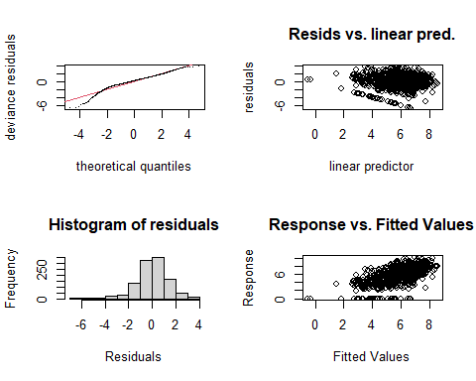

##   
## Method: REML Optimizer: outer newton  
## full convergence after 7 iterations.  
## Gradient range [-0.0005007208,0.0004246103]  
## (score 2012.9 & scale 2.049666).  
## Hessian positive definite, eigenvalue range [1.697628,553.6139].  
## Model rank = 54 / 54   
##   
## Basis dimension (k) checking results. Low p-value (k-index<1) may  
## indicate that k is too low, especially if edf is close to k'.  
##   
## k' edf k-index p-value   
## te(SalSurf_s,doy_s) 19.00 14.83 0.95 0.075 .  
## s(Year_fac) 29.00 11.16 NA NA   
## s(Station_fac) 5.00 3.91 NA NA   
## ---  
## Signif. codes: 0 '***' 0.001 '**' 0.01 '*' 0.05 '.' 0.1 ' ' 1  
##   
##   
## -------------summary-------------  
##   
## Family: gaussian   
## Link function: identity   
##   
## Formula:  
## BPUE_log1p ~ te(SalSurf_s, doy_s, k = c(5, 5), bs = c("cs", "cc")) +   
## s(Year_fac, bs = "re") + s(Station_fac, bs = "re")  
##   
## Parametric coefficients:  
## Estimate Std. Error t value Pr(>|t|)   
## (Intercept) 5.4486 0.7877 6.917 0.0000000000079 ***  
## ---  
## Signif. codes: 0 '***' 0.001 '**' 0.01 '*' 0.05 '.' 0.1 ' ' 1  
##   
## Approximate significance of smooth terms:  
## edf Ref.df F p-value   
## te(SalSurf_s,doy_s) 14.828 19 591.471 < 0.0000000000000002 ***  
## s(Year_fac) 11.159 28 0.747 0.00694 **   
## s(Station_fac) 3.905 4 28.105 < 0.0000000000000002 ***  
## ---  
## Signif. codes: 0 '***' 0.001 '**' 0.01 '*' 0.05 '.' 0.1 ' ' 1  
##   
## R-sq.(adj) = 0.419 Deviance explained = 43.5%  
## -REML = 2012.9 Scale est. = 2.0497 n = 1108  
## <<<<<<<<<<<<<<<<<<<<<<< modeling othcalad East Suisun >>>>>>>>>>>>>>>>>>>>>>>>>  
##   
## -------------gam check-------------

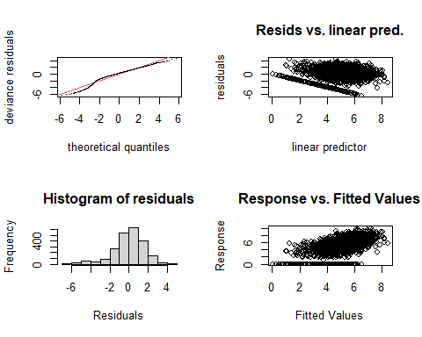

##   
## Method: REML Optimizer: outer newton  
## full convergence after 7 iterations.  
## Gradient range [-0.002395014,0.001980715]  
## (score 4376.691 & scale 2.708589).  
## Hessian positive definite, eigenvalue range [1.733493,1125.153].  
## Model rank = 59 / 59   
##   
## Basis dimension (k) checking results. Low p-value (k-index<1) may  
## indicate that k is too low, especially if edf is close to k'.  
##   
## k' edf k-index p-value   
## te(SalSurf_s,doy_s) 19.00 14.66 0.92 <0.0000000000000002 ***  
## s(Year_fac) 29.00 23.00 NA NA   
## s(Station_fac) 10.00 6.09 NA NA   
## ---  
## Signif. codes: 0 '***' 0.001 '**' 0.01 '*' 0.05 '.' 0.1 ' ' 1  
##   
##   
## -------------summary-------------  
##   
## Family: gaussian   
## Link function: identity   
##   
## Formula:  
## BPUE_log1p ~ te(SalSurf_s, doy_s, k = c(5, 5), bs = c("cs", "cc")) +   
## s(Year_fac, bs = "re") + s(Station_fac, bs = "re")  
##   
## Parametric coefficients:  
## Estimate Std. Error t value Pr(>|t|)   
## (Intercept) 5.3496 0.1464 36.53 <0.0000000000000002 ***  
## ---  
## Signif. codes: 0 '***' 0.001 '**' 0.01 '*' 0.05 '.' 0.1 ' ' 1  
##   
## Approximate significance of smooth terms:  
## edf Ref.df F p-value   
## te(SalSurf_s,doy_s) 14.657 19 141.396 <0.0000000000000002 ***  
## s(Year_fac) 22.996 28 5.501 <0.0000000000000002 ***  
## s(Station_fac) 6.087 9 7.686 <0.0000000000000002 ***  
## ---  
## Signif. codes: 0 '***' 0.001 '**' 0.01 '*' 0.05 '.' 0.1 ' ' 1  
##   
## R-sq.(adj) = 0.354 Deviance explained = 36.7%  
## -REML = 4376.7 Scale est. = 2.7086 n = 2251  
## <<<<<<<<<<<<<<<<<<<<<<< modeling othcalad Confluence >>>>>>>>>>>>>>>>>>>>>>>>>  
##   
## -------------gam check-------------

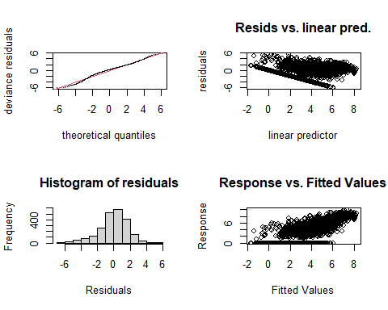

##   
## Method: REML Optimizer: outer newton  
## full convergence after 8 iterations.  
## Gradient range [-0.0001108826,0.000007505018]  
## (score 4509.38 & scale 3.118616).  
## Hessian positive definite, eigenvalue range [1.092886,1112.194].  
## Model rank = 59 / 59   
##   
## Basis dimension (k) checking results. Low p-value (k-index<1) may  
## indicate that k is too low, especially if edf is close to k'.  
##   
## k' edf k-index p-value   
## te(SalSurf_s,doy_s) 19.00 16.40 0.86 <0.0000000000000002 ***  
## s(Year_fac) 29.00 26.39 NA NA   
## s(Station_fac) 10.00 4.98 NA NA   
## ---  
## Signif. codes: 0 '***' 0.001 '**' 0.01 '*' 0.05 '.' 0.1 ' ' 1  
##   
##   
## -------------summary-------------  
##   
## Family: gaussian   
## Link function: identity   
##   
## Formula:  
## BPUE_log1p ~ te(SalSurf_s, doy_s, k = c(5, 5), bs = c("cs", "cc")) +   
## s(Year_fac, bs = "re") + s(Station_fac, bs = "re")  
##   
## Parametric coefficients:  
## Estimate Std. Error t value Pr(>|t|)   
## (Intercept) 4.2123 0.1881 22.39 <0.0000000000000002 ***  
## ---  
## Signif. codes: 0 '***' 0.001 '**' 0.01 '*' 0.05 '.' 0.1 ' ' 1  
##   
## Approximate significance of smooth terms:  
## edf Ref.df F p-value   
## te(SalSurf_s,doy_s) 16.403 19 309.568 < 0.0000000000000002 ***  
## s(Year_fac) 26.388 28 17.649 < 0.0000000000000002 ***  
## s(Station_fac) 4.978 9 1.885 0.00315 **   
## ---  
## Signif. codes: 0 '***' 0.001 '**' 0.01 '*' 0.05 '.' 0.1 ' ' 1  
##   
## R-sq.(adj) = 0.567 Deviance explained = 57.7%  
## -REML = 4509.4 Scale est. = 3.1186 n = 2225  
## <<<<<<<<<<<<<<<<<<<<<<< modeling othcalad Suisun Marsh >>>>>>>>>>>>>>>>>>>>>>>>>  
##   
## -------------gam check-------------

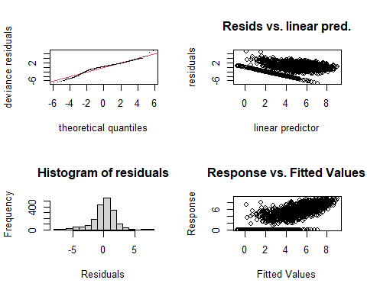

##   
## Method: REML Optimizer: outer newton  
## full convergence after 8 iterations.  
## Gradient range [-0.0000643455,0.00005829407]  
## (score 3737.208 & scale 2.908612).  
## Hessian positive definite, eigenvalue range [2.294222,936.7132].  
## Model rank = 58 / 58   
##   
## Basis dimension (k) checking results. Low p-value (k-index<1) may  
## indicate that k is too low, especially if edf is close to k'.  
##   
## k' edf k-index p-value   
## te(SalSurf_s,doy_s) 19.00 16.94 0.94 <0.0000000000000002 ***  
## s(Year_fac) 29.00 24.64 NA NA   
## s(Station_fac) 9.00 6.28 NA NA   
## ---  
## Signif. codes: 0 '***' 0.001 '**' 0.01 '*' 0.05 '.' 0.1 ' ' 1  
##   
##   
## -------------summary-------------  
##   
## Family: gaussian   
## Link function: identity   
##   
## Formula:  
## BPUE_log1p ~ te(SalSurf_s, doy_s, k = c(5, 5), bs = c("cs", "cc")) +   
## s(Year_fac, bs = "re") + s(Station_fac, bs = "re")  
##   
## Parametric coefficients:  
## Estimate Std. Error t value Pr(>|t|)   
## (Intercept) 5.1938 0.2112 24.59 <0.0000000000000002 ***  
## ---  
## Signif. codes: 0 '***' 0.001 '**' 0.01 '*' 0.05 '.' 0.1 ' ' 1  
##   
## Approximate significance of smooth terms:  
## edf Ref.df F p-value   
## te(SalSurf_s,doy_s) 16.944 19 289.060 <0.0000000000000002 ***  
## s(Year_fac) 24.644 28 9.396 <0.0000000000000002 ***  
## s(Station_fac) 6.285 8 10.941 <0.0000000000000002 ***  
## ---  
## Signif. codes: 0 '***' 0.001 '**' 0.01 '*' 0.05 '.' 0.1 ' ' 1  
##   
## R-sq.(adj) = 0.527 Deviance explained = 53.9%  
## -REML = 3737.2 Scale est. = 2.9086 n = 1874  
## <<<<<<<<<<<<<<<<<<<<<<< modeling othcaljuv SW Suisun >>>>>>>>>>>>>>>>>>>>>>>>>  
##   
## -------------gam check-------------

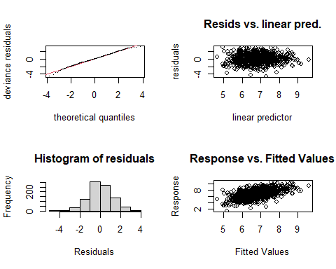

##   
## Method: REML Optimizer: outer newton  
## full convergence after 8 iterations.  
## Gradient range [-0.0001102212,0.0000566722]  
## (score 1494.757 & scale 1.382336).  
## Hessian positive definite, eigenvalue range [1.075734,455.8083].  
## Model rank = 53 / 53   
##   
## Basis dimension (k) checking results. Low p-value (k-index<1) may  
## indicate that k is too low, especially if edf is close to k'.  
##   
## k' edf k-index p-value  
## te(SalSurf_s,doy_s) 19.00 14.88 0.98 0.21  
## s(Year_fac) 28.00 20.76 NA NA  
## s(Station_fac) 5.00 3.36 NA NA  
##   
##   
## -------------summary-------------  
##   
## Family: gaussian   
## Link function: identity   
##   
## Formula:  
## BPUE_log1p ~ te(SalSurf_s, doy_s, k = c(5, 5), bs = c("cs", "cc")) +   
## s(Year_fac, bs = "re") + s(Station_fac, bs = "re")  
##   
## Parametric coefficients:  
## Estimate Std. Error t value Pr(>|t|)   
## (Intercept) 7.2604 0.3776 19.23 <0.0000000000000002 ***  
## ---  
## Signif. codes: 0 '***' 0.001 '**' 0.01 '*' 0.05 '.' 0.1 ' ' 1  
##   
## Approximate significance of smooth terms:  
## edf Ref.df F p-value   
## te(SalSurf_s,doy_s) 14.88 19 117.554 0.00000053 ***  
## s(Year_fac) 20.76 27 3.126 < 0.0000000000000002 ***  
## s(Station_fac) 3.36 4 14.165 < 0.0000000000000002 ***  
## ---  
## Signif. codes: 0 '***' 0.001 '**' 0.01 '*' 0.05 '.' 0.1 ' ' 1  
##   
## R-sq.(adj) = 0.311 Deviance explained = 34.1%  
## -REML = 1494.8 Scale est. = 1.3823 n = 912  
## <<<<<<<<<<<<<<<<<<<<<<< modeling othcaljuv NW Suisun >>>>>>>>>>>>>>>>>>>>>>>>>  
##   
## -------------gam check-------------

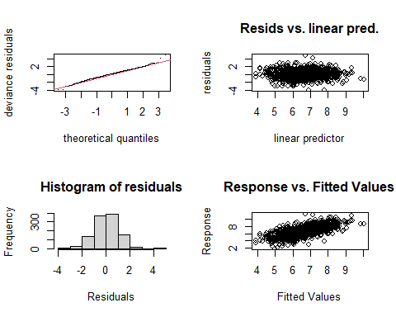

##   
## Method: REML Optimizer: outer newton  
## full convergence after 7 iterations.  
## Gradient range [-0.000001318061,0.000001112305]  
## (score 1698.681 & scale 1.109952).  
## Hessian positive definite, eigenvalue range [0.1806273,553.855].  
## Model rank = 54 / 54   
##   
## Basis dimension (k) checking results. Low p-value (k-index<1) may  
## indicate that k is too low, especially if edf is close to k'.  
##   
## k' edf k-index p-value   
## te(SalSurf_s,doy_s) 19.00 15.98 0.96 0.065 .  
## s(Year_fac) 29.00 25.24 NA NA   
## s(Station_fac) 5.00 2.65 NA NA   
## ---  
## Signif. codes: 0 '***' 0.001 '**' 0.01 '*' 0.05 '.' 0.1 ' ' 1  
##   
##   
## -------------summary-------------  
##   
## Family: gaussian   
## Link function: identity   
##   
## Formula:  
## BPUE_log1p ~ te(SalSurf_s, doy_s, k = c(5, 5), bs = c("cs", "cc")) +   
## s(Year_fac, bs = "re") + s(Station_fac, bs = "re")  
##   
## Parametric coefficients:  
## Estimate Std. Error t value Pr(>|t|)   
## (Intercept) 6.7214 0.1509 44.54 <0.0000000000000002 ***  
## ---  
## Signif. codes: 0 '***' 0.001 '**' 0.01 '*' 0.05 '.' 0.1 ' ' 1  
##   
## Approximate significance of smooth terms:  
## edf Ref.df F p-value   
## te(SalSurf_s,doy_s) 15.975 19 82.993 < 0.0000000000000002 ***  
## s(Year_fac) 25.241 28 9.201 < 0.0000000000000002 ***  
## s(Station_fac) 2.655 4 3.606 0.00292 **   
## ---  
## Signif. codes: 0 '***' 0.001 '**' 0.01 '*' 0.05 '.' 0.1 ' ' 1  
##   
## R-sq.(adj) = 0.484 Deviance explained = 50.5%  
## -REML = 1698.7 Scale est. = 1.11 n = 1108  
## <<<<<<<<<<<<<<<<<<<<<<< modeling othcaljuv East Suisun >>>>>>>>>>>>>>>>>>>>>>>>>  
##   
## -------------gam check-------------

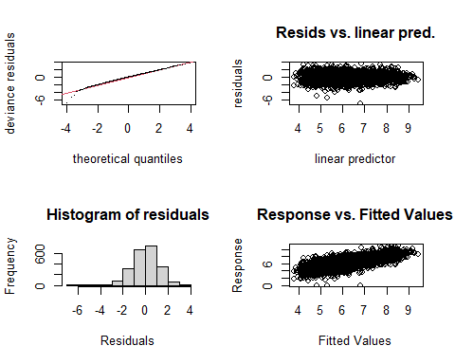

##   
## Method: REML Optimizer: outer newton  
## full convergence after 8 iterations.  
## Gradient range [-0.000002713304,0.000002680241]  
## (score 3553.013 & scale 1.294976).  
## Hessian positive definite, eigenvalue range [1.998543,1125.143].  
## Model rank = 59 / 59   
##   
## Basis dimension (k) checking results. Low p-value (k-index<1) may  
## indicate that k is too low, especially if edf is close to k'.  
##   
## k' edf k-index p-value   
## te(SalSurf_s,doy_s) 19.00 16.54 0.88 <0.0000000000000002 ***  
## s(Year_fac) 29.00 21.31 NA NA   
## s(Station_fac) 10.00 6.47 NA NA   
## ---  
## Signif. codes: 0 '***' 0.001 '**' 0.01 '*' 0.05 '.' 0.1 ' ' 1  
##   
##   
## -------------summary-------------  
##   
## Family: gaussian   
## Link function: identity   
##   
## Formula:  
## BPUE_log1p ~ te(SalSurf_s, doy_s, k = c(5, 5), bs = c("cs", "cc")) +   
## s(Year_fac, bs = "re") + s(Station_fac, bs = "re")  
##   
## Parametric coefficients:  
## Estimate Std. Error t value Pr(>|t|)   
## (Intercept) 6.2761 0.1077 58.29 <0.0000000000000002 ***  
## ---  
## Signif. codes: 0 '***' 0.001 '**' 0.01 '*' 0.05 '.' 0.1 ' ' 1  
##   
## Approximate significance of smooth terms:  
## edf Ref.df F p-value   
## te(SalSurf_s,doy_s) 16.542 19 250.782 <0.0000000000000002 ***  
## s(Year_fac) 21.311 28 3.397 <0.0000000000000002 ***  
## s(Station_fac) 6.474 9 7.289 <0.0000000000000002 ***  
## ---  
## Signif. codes: 0 '***' 0.001 '**' 0.01 '*' 0.05 '.' 0.1 ' ' 1  
##   
## R-sq.(adj) = 0.498 Deviance explained = 50.8%  
## -REML = 3553 Scale est. = 1.295 n = 2251  
## <<<<<<<<<<<<<<<<<<<<<<< modeling othcaljuv Confluence >>>>>>>>>>>>>>>>>>>>>>>>>  
##   
## -------------gam check-------------

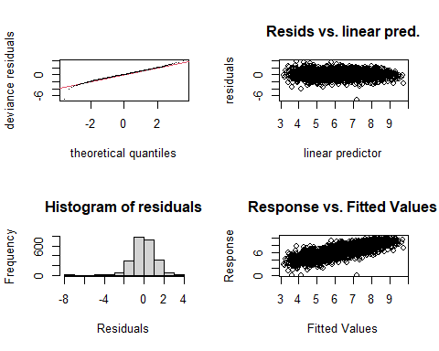

##   
## Method: REML Optimizer: outer newton  
## full convergence after 12 iterations.  
## Gradient range [-0.000394338,0.0002689788]  
## (score 3301.787 & scale 1.059305).  
## Hessian positive definite, eigenvalue range [2.756503,1112.174].  
## Model rank = 59 / 59   
##   
## Basis dimension (k) checking results. Low p-value (k-index<1) may  
## indicate that k is too low, especially if edf is close to k'.  
##   
## k' edf k-index p-value   
## te(SalSurf_s,doy_s) 19.00 16.42 0.77 <0.0000000000000002 ***  
## s(Year_fac) 29.00 24.05 NA NA   
## s(Station_fac) 10.00 7.22 NA NA   
## ---  
## Signif. codes: 0 '***' 0.001 '**' 0.01 '*' 0.05 '.' 0.1 ' ' 1  
##   
##   
## -------------summary-------------  
##   
## Family: gaussian   
## Link function: identity   
##   
## Formula:  
## BPUE_log1p ~ te(SalSurf_s, doy_s, k = c(5, 5), bs = c("cs", "cc")) +   
## s(Year_fac, bs = "re") + s(Station_fac, bs = "re")  
##   
## Parametric coefficients:  
## Estimate Std. Error t value Pr(>|t|)   
## (Intercept) 6.3002 0.1145 55.01 <0.0000000000000002 ***  
## ---  
## Signif. codes: 0 '***' 0.001 '**' 0.01 '*' 0.05 '.' 0.1 ' ' 1  
##   
## Approximate significance of smooth terms:  
## edf Ref.df F p-value   
## te(SalSurf_s,doy_s) 16.423 19 831.794 <0.0000000000000002 ***  
## s(Year_fac) 24.050 28 7.091 <0.0000000000000002 ***  
## s(Station_fac) 7.224 9 16.184 <0.0000000000000002 ***  
## ---  
## Signif. codes: 0 '***' 0.001 '**' 0.01 '*' 0.05 '.' 0.1 ' ' 1  
##   
## R-sq.(adj) = 0.65 Deviance explained = 65.8%  
## -REML = 3301.8 Scale est. = 1.0593 n = 2225  
## <<<<<<<<<<<<<<<<<<<<<<< modeling othcaljuv Suisun Marsh >>>>>>>>>>>>>>>>>>>>>>>>>  
##   
## -------------gam check-------------

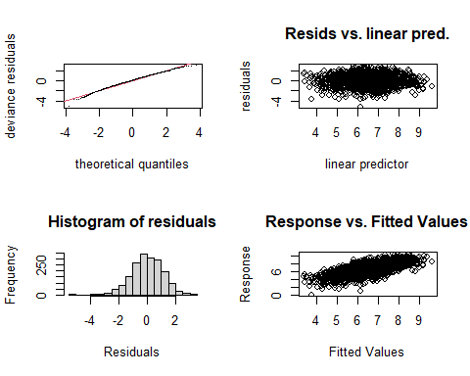

##   
## Method: REML Optimizer: outer newton  
## full convergence after 8 iterations.  
## Gradient range [-0.00007064264,0.00005878927]  
## (score 2908.218 & scale 1.207559).  
## Hessian positive definite, eigenvalue range [2.162593,936.6741].  
## Model rank = 58 / 58   
##   
## Basis dimension (k) checking results. Low p-value (k-index<1) may  
## indicate that k is too low, especially if edf is close to k'.  
##   
## k' edf k-index p-value   
## te(SalSurf_s,doy_s) 19.00 16.75 0.92 <0.0000000000000002 ***  
## s(Year_fac) 29.00 21.28 NA NA   
## s(Station_fac) 9.00 7.36 NA NA   
## ---  
## Signif. codes: 0 '***' 0.001 '**' 0.01 '*' 0.05 '.' 0.1 ' ' 1  
##   
##   
## -------------summary-------------  
##   
## Family: gaussian   
## Link function: identity   
##   
## Formula:  
## BPUE_log1p ~ te(SalSurf_s, doy_s, k = c(5, 5), bs = c("cs", "cc")) +   
## s(Year_fac, bs = "re") + s(Station_fac, bs = "re")  
##   
## Parametric coefficients:  
## Estimate Std. Error t value Pr(>|t|)   
## (Intercept) 6.4410 0.2364 27.25 <0.0000000000000002 ***  
## ---  
## Signif. codes: 0 '***' 0.001 '**' 0.01 '*' 0.05 '.' 0.1 ' ' 1  
##   
## Approximate significance of smooth terms:  
## edf Ref.df F p-value   
## te(SalSurf_s,doy_s) 16.750 19 164.862 <0.0000000000000002 ***  
## s(Year_fac) 21.284 28 3.496 <0.0000000000000002 ***  
## s(Station_fac) 7.356 8 46.718 <0.0000000000000002 ***  
## ---  
## Signif. codes: 0 '***' 0.001 '**' 0.01 '*' 0.05 '.' 0.1 ' ' 1  
##   
## R-sq.(adj) = 0.45 Deviance explained = 46.3%  
## -REML = 2908.2 Scale est. = 1.2076 n = 1874  
## <<<<<<<<<<<<<<<<<<<<<<< modeling othclad SW Suisun >>>>>>>>>>>>>>>>>>>>>>>>>  
##   
## -------------gam check-------------

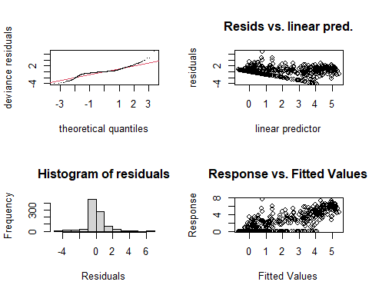

##   
## Method: REML Optimizer: outer newton  
## full convergence after 9 iterations.  
## Gradient range [-0.00006711014,0.00001310101]  
## (score 1379.287 & scale 1.083642).  
## Hessian positive definite, eigenvalue range [0.00006726322,455.8394].  
## Model rank = 53 / 53   
##   
## Basis dimension (k) checking results. Low p-value (k-index<1) may  
## indicate that k is too low, especially if edf is close to k'.  
##   
## k' edf k-index p-value  
## te(SalSurf_s,doy_s) 19.000000 12.280069 1 0.56  
## s(Year_fac) 28.000000 22.992100 NA NA  
## s(Station_fac) 5.000000 0.000889 NA NA  
##   
##   
## -------------summary-------------  
##   
## Family: gaussian   
## Link function: identity   
##   
## Formula:  
## BPUE_log1p ~ te(SalSurf_s, doy_s, k = c(5, 5), bs = c("cs", "cc")) +   
## s(Year_fac, bs = "re") + s(Station_fac, bs = "re")  
##   
## Parametric coefficients:  
## Estimate Std. Error t value Pr(>|t|)   
## (Intercept) 1.05365 0.09361 11.26 <0.0000000000000002 ***  
## ---  
## Signif. codes: 0 '***' 0.001 '**' 0.01 '*' 0.05 '.' 0.1 ' ' 1  
##   
## Approximate significance of smooth terms:  
## edf Ref.df F p-value   
## te(SalSurf_s,doy_s) 12.2800690 19 244.005 <0.0000000000000002 ***  
## s(Year_fac) 22.9920999 27 4.681 <0.0000000000000002 ***  
## s(Station_fac) 0.0008888 4 0.000 0.421   
## ---  
## Signif. codes: 0 '***' 0.001 '**' 0.01 '*' 0.05 '.' 0.1 ' ' 1  
##   
## R-sq.(adj) = 0.706 Deviance explained = 71.7%  
## -REML = 1379.3 Scale est. = 1.0836 n = 912  
## <<<<<<<<<<<<<<<<<<<<<<< modeling othclad NW Suisun >>>>>>>>>>>>>>>>>>>>>>>>>  
##   
## -------------gam check-------------

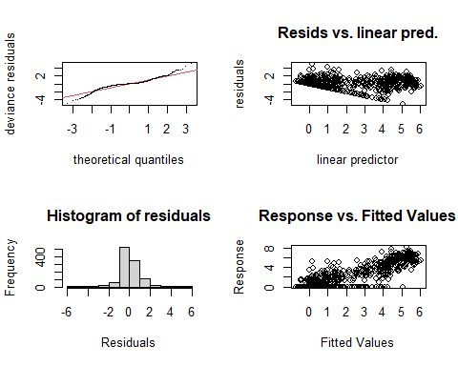

##   
## Method: REML Optimizer: outer newton  
## full convergence after 7 iterations.  
## Gradient range [-0.00001435124,0.00001207577]  
## (score 1622.655 & scale 0.9833315).  
## Hessian positive definite, eigenvalue range [0.9025138,553.8209].  
## Model rank = 54 / 54   
##   
## Basis dimension (k) checking results. Low p-value (k-index<1) may  
## indicate that k is too low, especially if edf is close to k'.  
##   
## k' edf k-index p-value   
## te(SalSurf_s,doy_s) 19.00 14.68 0.85 <0.0000000000000002 ***  
## s(Year_fac) 29.00 24.08 NA NA   
## s(Station_fac) 5.00 2.32 NA NA   
## ---  
## Signif. codes: 0 '***' 0.001 '**' 0.01 '*' 0.05 '.' 0.1 ' ' 1  
##   
##   
## -------------summary-------------  
##   
## Family: gaussian   
## Link function: identity   
##   
## Formula:  
## BPUE_log1p ~ te(SalSurf_s, doy_s, k = c(5, 5), bs = c("cs", "cc")) +   
## s(Year_fac, bs = "re") + s(Station_fac, bs = "re")  
##   
## Parametric coefficients:  
## Estimate Std. Error t value Pr(>|t|)   
## (Intercept) 1.1876 0.1143 10.39 <0.0000000000000002 ***  
## ---  
## Signif. codes: 0 '***' 0.001 '**' 0.01 '*' 0.05 '.' 0.1 ' ' 1  
##   
## Approximate significance of smooth terms:  
## edf Ref.df F p-value   
## te(SalSurf_s,doy_s) 14.675 19 481.443 < 0.0000000000000002 ***  
## s(Year_fac) 24.079 28 6.052 < 0.0000000000000002 ***  
## s(Station_fac) 2.324 4 3.779 0.000763 ***  
## ---  
## Signif. codes: 0 '***' 0.001 '**' 0.01 '*' 0.05 '.' 0.1 ' ' 1  
##   
## R-sq.(adj) = 0.767 Deviance explained = 77.5%  
## -REML = 1622.7 Scale est. = 0.98333 n = 1108  
## <<<<<<<<<<<<<<<<<<<<<<< modeling othclad East Suisun >>>>>>>>>>>>>>>>>>>>>>>>>  
##   
## -------------gam check-------------

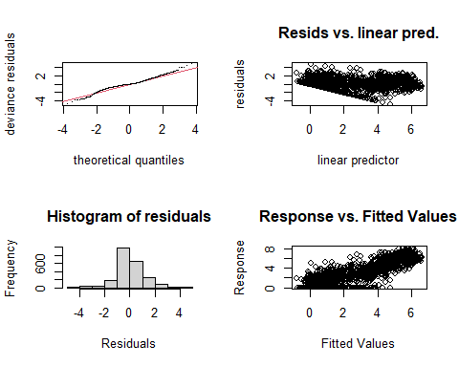

##   
## Method: REML Optimizer: outer newton  
## full convergence after 8 iterations.  
## Gradient range [-0.000005249218,0.000004573773]  
## (score 3446.975 & scale 1.156756).  
## Hessian positive definite, eigenvalue range [1.103649,1125.198].  
## Model rank = 59 / 59   
##   
## Basis dimension (k) checking results. Low p-value (k-index<1) may  
## indicate that k is too low, especially if edf is close to k'.  
##   
## k' edf k-index p-value   
## te(SalSurf_s,doy_s) 19.00 16.48 0.84 <0.0000000000000002 ***  
## s(Year_fac) 29.00 26.74 NA NA   
## s(Station_fac) 10.00 5.03 NA NA   
## ---  
## Signif. codes: 0 '***' 0.001 '**' 0.01 '*' 0.05 '.' 0.1 ' ' 1  
##   
##   
## -------------summary-------------  
##   
## Family: gaussian   
## Link function: identity   
##   
## Formula:  
## BPUE_log1p ~ te(SalSurf_s, doy_s, k = c(5, 5), bs = c("cs", "cc")) +   
## s(Year_fac, bs = "re") + s(Station_fac, bs = "re")  
##   
## Parametric coefficients:  
## Estimate Std. Error t value Pr(>|t|)   
## (Intercept) 1.7501 0.1314 13.32 <0.0000000000000002 ***  
## ---  
## Signif. codes: 0 '***' 0.001 '**' 0.01 '*' 0.05 '.' 0.1 ' ' 1  
##   
## Approximate significance of smooth terms:  
## edf Ref.df F p-value   
## te(SalSurf_s,doy_s) 16.483 19 2550.751 < 0.0000000000000002 ***  
## s(Year_fac) 26.736 28 18.895 < 0.0000000000000002 ***  
## s(Station_fac) 5.029 9 2.827 0.00018 ***  
## ---  
## Signif. codes: 0 '***' 0.001 '**' 0.01 '*' 0.05 '.' 0.1 ' ' 1  
##   
## R-sq.(adj) = 0.77 Deviance explained = 77.5%  
## -REML = 3447 Scale est. = 1.1568 n = 2251  
## <<<<<<<<<<<<<<<<<<<<<<< modeling othclad Confluence >>>>>>>>>>>>>>>>>>>>>>>>>  
##   
## -------------gam check-------------

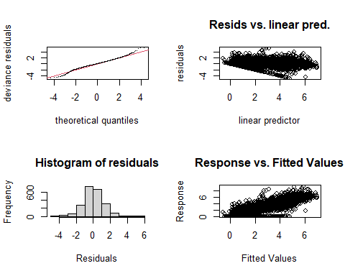

##   
## Method: REML Optimizer: outer newton  
## full convergence after 7 iterations.  
## Gradient range [-0.0003534397,0.0002814771]  
## (score 3701.329 & scale 1.52369).  
## Hessian positive definite, eigenvalue range [1.598087,1112.183].  
## Model rank = 59 / 59   
##   
## Basis dimension (k) checking results. Low p-value (k-index<1) may  
## indicate that k is too low, especially if edf is close to k'.  
##   
## k' edf k-index p-value   
## te(SalSurf_s,doy_s) 19.00 13.40 0.9 <0.0000000000000002 ***  
## s(Year_fac) 29.00 25.78 NA NA   
## s(Station_fac) 10.00 6.77 NA NA   
## ---  
## Signif. codes: 0 '***' 0.001 '**' 0.01 '*' 0.05 '.' 0.1 ' ' 1  
##   
##   
## -------------summary-------------  
##   
## Family: gaussian   
## Link function: identity   
##   
## Formula:  
## BPUE_log1p ~ te(SalSurf_s, doy_s, k = c(5, 5), bs = c("cs", "cc")) +   
## s(Year_fac, bs = "re") + s(Station_fac, bs = "re")  
##   
## Parametric coefficients:  
## Estimate Std. Error t value Pr(>|t|)   
## (Intercept) 2.8210 0.1377 20.49 <0.0000000000000002 ***  
## ---  
## Signif. codes: 0 '***' 0.001 '**' 0.01 '*' 0.05 '.' 0.1 ' ' 1  
##   
## Approximate significance of smooth terms:  
## edf Ref.df F p-value   
## te(SalSurf_s,doy_s) 13.397 19 1678.90 <0.0000000000000002 ***  
## s(Year_fac) 25.780 28 13.27 <0.0000000000000002 ***  
## s(Station_fac) 6.767 9 11.84 <0.0000000000000002 ***  
## ---  
## Signif. codes: 0 '***' 0.001 '**' 0.01 '*' 0.05 '.' 0.1 ' ' 1  
##   
## R-sq.(adj) = 0.686 Deviance explained = 69.2%  
## -REML = 3701.3 Scale est. = 1.5237 n = 2225  
## <<<<<<<<<<<<<<<<<<<<<<< modeling othclad Suisun Marsh >>>>>>>>>>>>>>>>>>>>>>>>>  
##   
## -------------gam check-------------

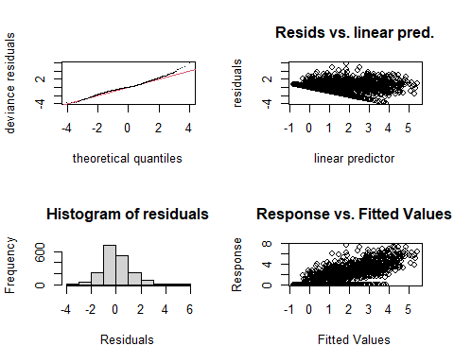

##   
## Method: REML Optimizer: outer newton  
## full convergence after 7 iterations.  
## Gradient range [-0.0002353919,0.0001313737]  
## (score 3031.664 & scale 1.378255).  
## Hessian positive definite, eigenvalue range [1.772875,936.719].  
## Model rank = 58 / 58   
##   
## Basis dimension (k) checking results. Low p-value (k-index<1) may  
## indicate that k is too low, especially if edf is close to k'.  
##   
## k' edf k-index p-value   
## te(SalSurf_s,doy_s) 19.00 13.56 0.97 0.025 *  
## s(Year_fac) 29.00 26.00 NA NA   
## s(Station_fac) 9.00 6.34 NA NA   
## ---  
## Signif. codes: 0 '***' 0.001 '**' 0.01 '*' 0.05 '.' 0.1 ' ' 1  
##   
##   
## -------------summary-------------  
##   
## Family: gaussian   
## Link function: identity   
##   
## Formula:  
## BPUE_log1p ~ te(SalSurf_s, doy_s, k = c(5, 5), bs = c("cs", "cc")) +   
## s(Year_fac, bs = "re") + s(Station_fac, bs = "re")  
##   
## Parametric coefficients:  
## Estimate Std. Error t value Pr(>|t|)   
## (Intercept) 1.3651 0.1634 8.352 <0.0000000000000002 ***  
## ---  
## Signif. codes: 0 '***' 0.001 '**' 0.01 '*' 0.05 '.' 0.1 ' ' 1  
##   
## Approximate significance of smooth terms:  
## edf Ref.df F p-value   
## te(SalSurf_s,doy_s) 13.556 19 507.79 <0.0000000000000002 ***  
## s(Year_fac) 26.000 28 12.51 <0.0000000000000002 ***  
## s(Station_fac) 6.337 8 18.00 <0.0000000000000002 ***  
## ---  
## Signif. codes: 0 '***' 0.001 '**' 0.01 '*' 0.05 '.' 0.1 ' ' 1  
##   
## R-sq.(adj) = 0.554 Deviance explained = 56.5%  
## -REML = 3031.7 Scale est. = 1.3783 n = 1874  
## <<<<<<<<<<<<<<<<<<<<<<< modeling pdiapfor SW Suisun >>>>>>>>>>>>>>>>>>>>>>>>>  
##   
## -------------gam check-------------

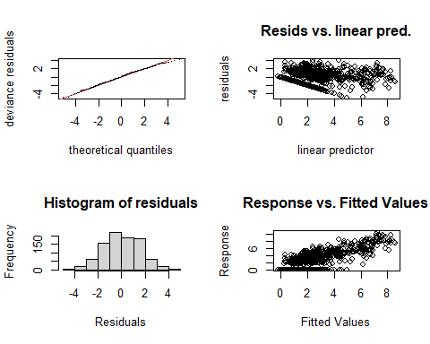

##   
## Method: REML Optimizer: outer newton  
## full convergence after 9 iterations.  
## Gradient range [-0.0002333585,0.0002023407]  
## (score 1756.769 & scale 2.453075).  
## Hessian positive definite, eigenvalue range [0.6919156,455.8383].  
## Model rank = 53 / 53   
##   
## Basis dimension (k) checking results. Low p-value (k-index<1) may  
## indicate that k is too low, especially if edf is close to k'.  
##   
## k' edf k-index p-value  
## te(SalSurf_s,doy_s) 19.00 13.45 0.97 0.12  
## s(Year_fac) 28.00 22.43 NA NA  
## s(Station_fac) 5.00 3.07 NA NA  
##   
##   
## -------------summary-------------  
##   
## Family: gaussian   
## Link function: identity   
##   
## Formula:  
## BPUE_log1p ~ te(SalSurf_s, doy_s, k = c(5, 5), bs = c("cs", "cc")) +   
## s(Year_fac, bs = "re") + s(Station_fac, bs = "re")  
##   
## Parametric coefficients:  
## Estimate Std. Error t value Pr(>|t|)   
## (Intercept) 3.0785 0.3979 7.737 0.0000000000000281 ***  
## ---  
## Signif. codes: 0 '***' 0.001 '**' 0.01 '*' 0.05 '.' 0.1 ' ' 1  
##   
## Approximate significance of smooth terms:  
## edf Ref.df F p-value   
## te(SalSurf_s,doy_s) 13.452 19 616.873 < 0.0000000000000002 ***  
## s(Year_fac) 22.435 27 4.481 < 0.0000000000000002 ***  
## s(Station_fac) 3.074 4 5.826 0.000315 ***  
## ---  
## Signif. codes: 0 '***' 0.001 '**' 0.01 '*' 0.05 '.' 0.1 ' ' 1  
##   
## R-sq.(adj) = 0.581 Deviance explained = 59.9%  
## -REML = 1756.8 Scale est. = 2.4531 n = 912  
## <<<<<<<<<<<<<<<<<<<<<<< modeling pdiapfor NW Suisun >>>>>>>>>>>>>>>>>>>>>>>>>  
##   
## -------------gam check-------------

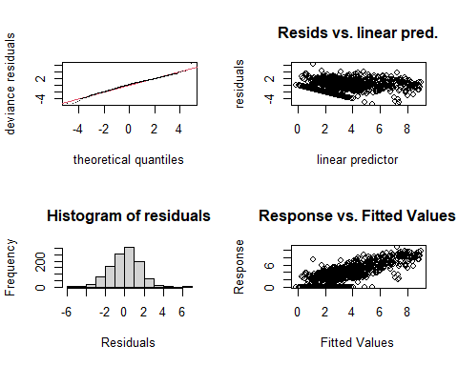

##   
## Method: REML Optimizer: outer newton  
## full convergence after 8 iterations.  
## Gradient range [-0.0003749406,0.001126984]  
## (score 2064.631 & scale 2.207119).  
## Hessian positive definite, eigenvalue range [0.0003761138,553.8107].  
## Model rank = 54 / 54   
##   
## Basis dimension (k) checking results. Low p-value (k-index<1) may  
## indicate that k is too low, especially if edf is close to k'.  
##   
## k' edf k-index p-value   
## te(SalSurf_s,doy_s) 19.00000 12.79733 0.93 0.01 **  
## s(Year_fac) 29.00000 24.21144 NA NA   
## s(Station_fac) 5.00000 0.00408 NA NA   
## ---  
## Signif. codes: 0 '***' 0.001 '**' 0.01 '*' 0.05 '.' 0.1 ' ' 1  
##   
##   
## -------------summary-------------  
##   
## Family: gaussian   
## Link function: identity   
##   
## Formula:  
## BPUE_log1p ~ te(SalSurf_s, doy_s, k = c(5, 5), bs = c("cs", "cc")) +   
## s(Year_fac, bs = "re") + s(Station_fac, bs = "re")  
##   
## Parametric coefficients:  
## Estimate Std. Error t value Pr(>|t|)   
## (Intercept) 3.2666 0.1343 24.32 <0.0000000000000002 ***  
## ---  
## Signif. codes: 0 '***' 0.001 '**' 0.01 '*' 0.05 '.' 0.1 ' ' 1  
##   
## Approximate significance of smooth terms:  
## edf Ref.df F p-value   
## te(SalSurf_s,doy_s) 12.797326 19 183.211 <0.0000000000000002 ***  
## s(Year_fac) 24.211438 28 5.599 <0.0000000000000002 ***  
## s(Station_fac) 0.004081 4 0.001 0.45   
## ---  
## Signif. codes: 0 '***' 0.001 '**' 0.01 '*' 0.05 '.' 0.1 ' ' 1  
##   
## R-sq.(adj) = 0.609 Deviance explained = 62.2%  
## -REML = 2064.6 Scale est. = 2.2071 n = 1108  
## <<<<<<<<<<<<<<<<<<<<<<< modeling pdiapfor East Suisun >>>>>>>>>>>>>>>>>>>>>>>>>  
##   
## -------------gam check-------------

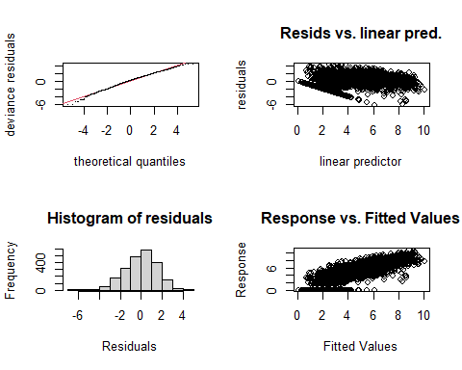

##   
## Method: REML Optimizer: outer newton  
## full convergence after 11 iterations.  
## Gradient range [-0.0006346738,0.0006116255]  
## (score 4241.887 & scale 2.38615).  
## Hessian positive definite, eigenvalue range [1.348857,1125.173].  
## Model rank = 59 / 59   
##   
## Basis dimension (k) checking results. Low p-value (k-index<1) may  
## indicate that k is too low, especially if edf is close to k'.  
##   
## k' edf k-index p-value   
## te(SalSurf_s,doy_s) 19.00 13.21 0.8 <0.0000000000000002 ***  
## s(Year_fac) 29.00 25.07 NA NA   
## s(Station_fac) 10.00 6.54 NA NA   
## ---  
## Signif. codes: 0 '***' 0.001 '**' 0.01 '*' 0.05 '.' 0.1 ' ' 1  
##   
##   
## -------------summary-------------  
##   
## Family: gaussian   
## Link function: identity   
##   
## Formula:  
## BPUE_log1p ~ te(SalSurf_s, doy_s, k = c(5, 5), bs = c("cs", "cc")) +   
## s(Year_fac, bs = "re") + s(Station_fac, bs = "re")  
##   
## Parametric coefficients:  
## Estimate Std. Error t value Pr(>|t|)   
## (Intercept) 4.1945 0.1722 24.36 <0.0000000000000002 ***  
## ---  
## Signif. codes: 0 '***' 0.001 '**' 0.01 '*' 0.05 '.' 0.1 ' ' 1  
##   
## Approximate significance of smooth terms:  
## edf Ref.df F p-value   
## te(SalSurf_s,doy_s) 13.21 19 800.289 <0.0000000000000002 ***  
## s(Year_fac) 25.07 28 9.261 <0.0000000000000002 ***  
## s(Station_fac) 6.54 9 8.689 <0.0000000000000002 ***  
## ---  
## Signif. codes: 0 '***' 0.001 '**' 0.01 '*' 0.05 '.' 0.1 ' ' 1  
##   
## R-sq.(adj) = 0.656 Deviance explained = 66.3%  
## -REML = 4241.9 Scale est. = 2.3862 n = 2251  
## <<<<<<<<<<<<<<<<<<<<<<< modeling pdiapfor Confluence >>>>>>>>>>>>>>>>>>>>>>>>>  
##   
## -------------gam check-------------

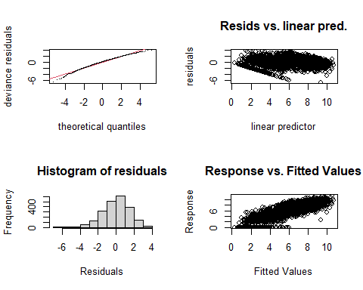

##   
## Method: REML Optimizer: outer newton  
## full convergence after 13 iterations.  
## Gradient range [-0.0001030802,0.00009426189]  
## (score 4150.988 & scale 2.283131).  
## Hessian positive definite, eigenvalue range [1.451437,1112.178].  
## Model rank = 59 / 59   
##   
## Basis dimension (k) checking results. Low p-value (k-index<1) may  
## indicate that k is too low, especially if edf is close to k'.  
##   
## k' edf k-index p-value   
## te(SalSurf_s,doy_s) 19.00 14.48 0.7 <0.0000000000000002 ***  
## s(Year_fac) 29.00 25.07 NA NA   
## s(Station_fac) 10.00 6.68 NA NA   
## ---  
## Signif. codes: 0 '***' 0.001 '**' 0.01 '*' 0.05 '.' 0.1 ' ' 1  
##   
##   
## -------------summary-------------  
##   
## Family: gaussian   
## Link function: identity   
##   
## Formula:  
## BPUE_log1p ~ te(SalSurf_s, doy_s, k = c(5, 5), bs = c("cs", "cc")) +   
## s(Year_fac, bs = "re") + s(Station_fac, bs = "re")  
##   
## Parametric coefficients:  
## Estimate Std. Error t value Pr(>|t|)   
## (Intercept) 5.9524 0.1529 38.94 <0.0000000000000002 ***  
## ---  
## Signif. codes: 0 '***' 0.001 '**' 0.01 '*' 0.05 '.' 0.1 ' ' 1  
##   
## Approximate significance of smooth terms:  
## edf Ref.df F p-value   
## te(SalSurf_s,doy_s) 14.480 19 526.102 <0.0000000000000002 ***  
## s(Year_fac) 25.072 28 9.330 <0.0000000000000002 ***  
## s(Station_fac) 6.683 9 8.168 <0.0000000000000002 ***  
## ---  
## Signif. codes: 0 '***' 0.001 '**' 0.01 '*' 0.05 '.' 0.1 ' ' 1  
##   
## R-sq.(adj) = 0.694 Deviance explained = 70.1%  
## -REML = 4151 Scale est. = 2.2831 n = 2225  
## <<<<<<<<<<<<<<<<<<<<<<< modeling pdiapfor Suisun Marsh >>>>>>>>>>>>>>>>>>>>>>>>>  
##   
## -------------gam check-------------

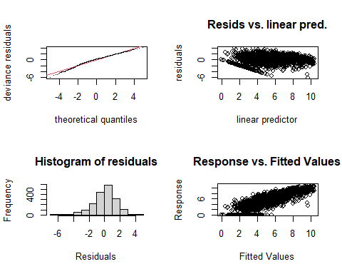

##   
## Method: REML Optimizer: outer newton  
## full convergence after 9 iterations.  
## Gradient range [-0.00001270527,0.00001029299]  
## (score 3437.24 & scale 2.079712).  
## Hessian positive definite, eigenvalue range [1.338652,936.7405].  
## Model rank = 58 / 58   
##   
## Basis dimension (k) checking results. Low p-value (k-index<1) may  
## indicate that k is too low, especially if edf is close to k'.  
##   
## k' edf k-index p-value   
## te(SalSurf_s,doy_s) 19.00 16.72 0.88 <0.0000000000000002 ***  
## s(Year_fac) 29.00 26.49 NA NA   
## s(Station_fac) 9.00 6.88 NA NA   
## ---  
## Signif. codes: 0 '***' 0.001 '**' 0.01 '*' 0.05 '.' 0.1 ' ' 1  
##   
##   
## -------------summary-------------  
##   
## Family: gaussian   
## Link function: identity   
##   
## Formula:  
## BPUE_log1p ~ te(SalSurf_s, doy_s, k = c(5, 5), bs = c("cs", "cc")) +   
## s(Year_fac, bs = "re") + s(Station_fac, bs = "re")  
##   
## Parametric coefficients:  
## Estimate Std. Error t value Pr(>|t|)   
## (Intercept) 5.2246 0.2585 20.21 <0.0000000000000002 ***  
## ---  
## Signif. codes: 0 '***' 0.001 '**' 0.01 '*' 0.05 '.' 0.1 ' ' 1  
##   
## Approximate significance of smooth terms:  
## edf Ref.df F p-value   
## te(SalSurf_s,doy_s) 16.718 19 1996.99 <0.0000000000000002 ***  
## s(Year_fac) 26.492 28 15.90 <0.0000000000000002 ***  
## s(Station_fac) 6.878 8 28.73 <0.0000000000000002 ***  
## ---  
## Signif. codes: 0 '***' 0.001 '**' 0.01 '*' 0.05 '.' 0.1 ' ' 1  
##   
## R-sq.(adj) = 0.684 Deviance explained = 69.3%  
## -REML = 3437.2 Scale est. = 2.0797 n = 1874  
## <<<<<<<<<<<<<<<<<<<<<<< modeling allcopnaup SW Suisun >>>>>>>>>>>>>>>>>>>>>>>>>  
##   
## -------------gam check-------------

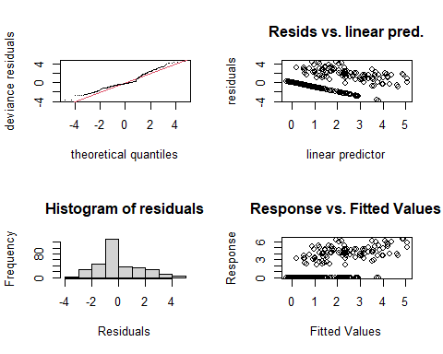

##   
## Method: REML Optimizer: outer newton  
## full convergence after 6 iterations.  
## Gradient range [-0.0001072196,0.0001130805]  
## (score 626.2984 & scale 2.626461).  
## Hessian positive definite, eigenvalue range [0.0001072313,158.5161].  
## Model rank = 50 / 50   
##   
## Basis dimension (k) checking results. Low p-value (k-index<1) may  
## indicate that k is too low, especially if edf is close to k'.  
##   
## k' edf k-index p-value  
## te(SalSurf_s,doy_s) 19.000000 7.184974 1.14 1  
## s(Year_fac) 27.000000 17.036708 NA NA  
## s(Station_fac) 3.000000 0.000442 NA NA  
##   
##   
## -------------summary-------------  
##   
## Family: gaussian   
## Link function: identity   
##   
## Formula:  
## BPUE_log1p ~ te(SalSurf_s, doy_s, k = c(5, 5), bs = c("cs", "cc")) +   
## s(Year_fac, bs = "re") + s(Station_fac, bs = "re")  
##   
## Parametric coefficients:  
## Estimate Std. Error t value Pr(>|t|)   
## (Intercept) 1.3651 0.1589 8.588 0.000000000000000539 ***  
## ---  
## Signif. codes: 0 '***' 0.001 '**' 0.01 '*' 0.05 '.' 0.1 ' ' 1  
##   
## Approximate significance of smooth terms:  
## edf Ref.df F p-value   
## te(SalSurf_s,doy_s) 7.1849738 19 12.23 < 0.0000000000000002 ***  
## s(Year_fac) 17.0367082 26 1.97 0.00000328 ***  
## s(Station_fac) 0.0004418 2 0.00 0.557   
## ---  
## Signif. codes: 0 '***' 0.001 '**' 0.01 '*' 0.05 '.' 0.1 ' ' 1  
##   
## R-sq.(adj) = 0.39 Deviance explained = 43.7%  
## -REML = 626.3 Scale est. = 2.6265 n = 317  
## <<<<<<<<<<<<<<<<<<<<<<< modeling allcopnaup NW Suisun >>>>>>>>>>>>>>>>>>>>>>>>>  
##   
## -------------gam check-------------

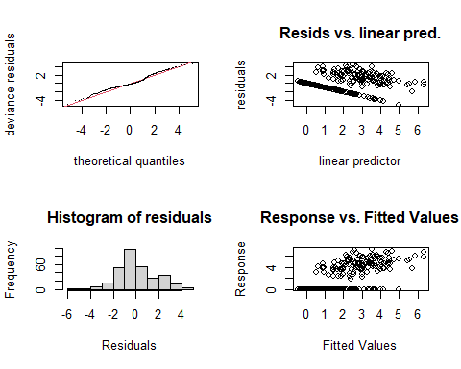

##   
## Method: REML Optimizer: outer newton  
## full convergence after 6 iterations.  
## Gradient range [-0.000009243147,0.000001259638]  
## (score 646.3905 & scale 3.1024).  
## Hessian positive definite, eigenvalue range [0.8984986,155.2844].  
## Model rank = 47 / 47   
##   
## Basis dimension (k) checking results. Low p-value (k-index<1) may  
## indicate that k is too low, especially if edf is close to k'.  
##   
## k' edf k-index p-value  
## te(SalSurf_s,doy_s) 19.0 7.8 0.95 0.11  
## s(Year_fac) 27.0 20.8 NA NA  
##   
##   
## -------------summary-------------  
##   
## Family: gaussian   
## Link function: identity   
##   
## Formula:  
## BPUE_log1p ~ te(SalSurf_s, doy_s, k = c(5, 5), bs = c("cs", "cc")) +   
## s(Year_fac, bs = "re")  
##   
## Parametric coefficients:  
## Estimate Std. Error t value Pr(>|t|)   
## (Intercept) 1.7455 0.2292 7.615 0.000000000000406 ***  
## ---  
## Signif. codes: 0 '***' 0.001 '**' 0.01 '*' 0.05 '.' 0.1 ' ' 1  
##   
## Approximate significance of smooth terms:  
## edf Ref.df F p-value   
## te(SalSurf_s,doy_s) 7.80 19 13.147 <0.0000000000000002 ***  
## s(Year_fac) 20.79 26 4.061 <0.0000000000000002 ***  
## ---  
## Signif. codes: 0 '***' 0.001 '**' 0.01 '*' 0.05 '.' 0.1 ' ' 1  
##   
## R-sq.(adj) = 0.44 Deviance explained = 49.2%  
## -REML = 646.39 Scale est. = 3.1024 n = 310  
## <<<<<<<<<<<<<<<<<<<<<<< modeling allcopnaup East Suisun >>>>>>>>>>>>>>>>>>>>>>>>>  
##   
## -------------gam check-------------

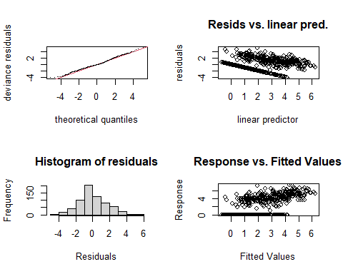

##   
## Method: REML Optimizer: outer newton  
## full convergence after 8 iterations.  
## Gradient range [-0.0004954652,-0.00001010831]  
## (score 1324.118 & scale 2.697151).  
## Hessian positive definite, eigenvalue range [0.3010848,334.4011].  
## Model rank = 51 / 51   
##   
## Basis dimension (k) checking results. Low p-value (k-index<1) may  
## indicate that k is too low, especially if edf is close to k'.  
##   
## k' edf k-index p-value   
## te(SalSurf_s,doy_s) 19.00 12.04 0.95 0.035 *  
## s(Year_fac) 27.00 21.20 NA NA   
## s(Station_fac) 4.00 1.51 NA NA   
## ---  
## Signif. codes: 0 '***' 0.001 '**' 0.01 '*' 0.05 '.' 0.1 ' ' 1  
##   
##   
## -------------summary-------------  
##   
## Family: gaussian   
## Link function: identity   
##   
## Formula:  
## BPUE_log1p ~ te(SalSurf_s, doy_s, k = c(5, 5), bs = c("cs", "cc")) +   
## s(Year_fac, bs = "re") + s(Station_fac, bs = "re")  
##   
## Parametric coefficients:  
## Estimate Std. Error t value Pr(>|t|)   
## (Intercept) 1.9557 0.1984 9.859 <0.0000000000000002 ***  
## ---  
## Signif. codes: 0 '***' 0.001 '**' 0.01 '*' 0.05 '.' 0.1 ' ' 1  
##   
## Approximate significance of smooth terms:  
## edf Ref.df F p-value   
## te(SalSurf_s,doy_s) 12.036 19 41.977 <0.0000000000000002 ***  
## s(Year_fac) 21.198 26 4.344 <0.0000000000000002 ***  
## s(Station_fac) 1.506 3 1.497 0.0515 .   
## ---  
## Signif. codes: 0 '***' 0.001 '**' 0.01 '*' 0.05 '.' 0.1 ' ' 1  
##   
## R-sq.(adj) = 0.502 Deviance explained = 52.8%  
## -REML = 1324.1 Scale est. = 2.6972 n = 669  
## <<<<<<<<<<<<<<<<<<<<<<< modeling allcopnaup Confluence >>>>>>>>>>>>>>>>>>>>>>>>>  
##   
## -------------gam check-------------

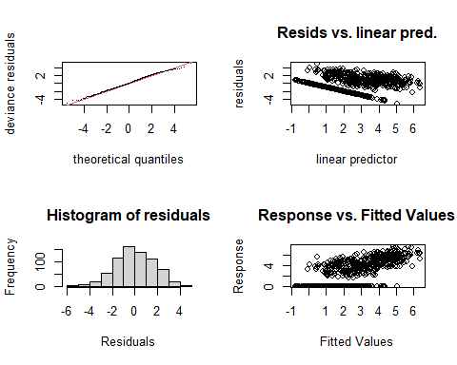

##   
## Method: REML Optimizer: outer newton  
## full convergence after 9 iterations.  
## Gradient range [-0.0002402798,0.001394055]  
## (score 1404.192 & scale 2.965962).  
## Hessian positive definite, eigenvalue range [0.0002438232,347.3781].  
## Model rank = 52 / 52   
##   
## Basis dimension (k) checking results. Low p-value (k-index<1) may  
## indicate that k is too low, especially if edf is close to k'.  
##   
## k' edf k-index p-value   
## te(SalSurf_s,doy_s) 19.00000 10.66432 0.93 0.005 **  
## s(Year_fac) 27.00000 21.40941 NA NA   
## s(Station_fac) 5.00000 0.00361 NA NA   
## ---  
## Signif. codes: 0 '***' 0.001 '**' 0.01 '*' 0.05 '.' 0.1 ' ' 1  
##   
##   
## -------------summary-------------  
##   
## Family: gaussian   
## Link function: identity   
##   
## Formula:  
## BPUE_log1p ~ te(SalSurf_s, doy_s, k = c(5, 5), bs = c("cs", "cc")) +   
## s(Year_fac, bs = "re") + s(Station_fac, bs = "re")  
##   
## Parametric coefficients:  
## Estimate Std. Error t value Pr(>|t|)   
## (Intercept) 2.4086 0.1607 14.99 <0.0000000000000002 ***  
## ---  
## Signif. codes: 0 '***' 0.001 '**' 0.01 '*' 0.05 '.' 0.1 ' ' 1  
##   
## Approximate significance of smooth terms:  
## edf Ref.df F p-value   
## te(SalSurf_s,doy_s) 10.664321 19 34.480 <0.0000000000000002 ***  
## s(Year_fac) 21.409407 26 4.660 <0.0000000000000002 ***  
## s(Station_fac) 0.003608 4 0.001 0.386   
## ---  
## Signif. codes: 0 '***' 0.001 '**' 0.01 '*' 0.05 '.' 0.1 ' ' 1  
##   
## R-sq.(adj) = 0.476 Deviance explained = 50%  
## -REML = 1404.2 Scale est. = 2.966 n = 695  
## <<<<<<<<<<<<<<<<<<<<<<< modeling allcopnaup Suisun Marsh >>>>>>>>>>>>>>>>>>>>>>>>>  
##   
## -------------gam check-------------

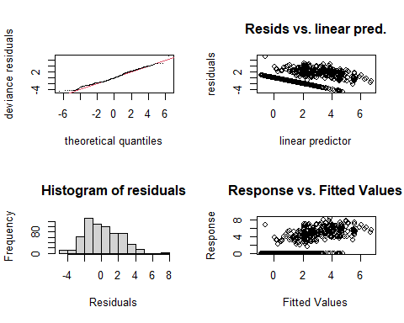

##   
## Method: REML Optimizer: outer newton  
## full convergence after 9 iterations.  
## Gradient range [-0.000297875,0.00006039964]  
## (score 1366.52 & scale 4.182628).  
## Hessian positive definite, eigenvalue range [0.0002977048,310.4781].  
## Model rank = 49 / 49   
##   
## Basis dimension (k) checking results. Low p-value (k-index<1) may  
## indicate that k is too low, especially if edf is close to k'.  
##   
## k' edf k-index p-value   
## te(SalSurf_s,doy_s) 19.000000 7.676102 0.94 0.04 *  
## s(Year_fac) 27.000000 23.310881 NA NA   
## s(Station_fac) 2.000000 0.000717 NA NA   
## ---  
## Signif. codes: 0 '***' 0.001 '**' 0.01 '*' 0.05 '.' 0.1 ' ' 1  
##   
##   
## -------------summary-------------  
##   
## Family: gaussian   
## Link function: identity   
##   
## Formula:  
## BPUE_log1p ~ te(SalSurf_s, doy_s, k = c(5, 5), bs = c("cs", "cc")) +   
## s(Year_fac, bs = "re") + s(Station_fac, bs = "re")  
##   
## Parametric coefficients:  
## Estimate Std. Error t value Pr(>|t|)   
## (Intercept) 2.1816 0.2619 8.331 0.000000000000000563 ***  
## ---  
## Signif. codes: 0 '***' 0.001 '**' 0.01 '*' 0.05 '.' 0.1 ' ' 1  
##   
## Approximate significance of smooth terms:  
## edf Ref.df F p-value   
## te(SalSurf_s,doy_s) 7.6761019 19 14.44 <0.0000000000000002 ***  
## s(Year_fac) 23.3108813 26 8.87 <0.0000000000000002 ***  
## s(Station_fac) 0.0007166 1 0.00 0.681   
## ---  
## Signif. codes: 0 '***' 0.001 '**' 0.01 '*' 0.05 '.' 0.1 ' ' 1  
##   
## R-sq.(adj) = 0.392 Deviance explained = 42.2%  
## -REML = 1366.5 Scale est. = 4.1826 n = 621  
## <<<<<<<<<<<<<<<<<<<<<<< modeling limno SW Suisun >>>>>>>>>>>>>>>>>>>>>>>>>  
##   
## -------------gam check-------------

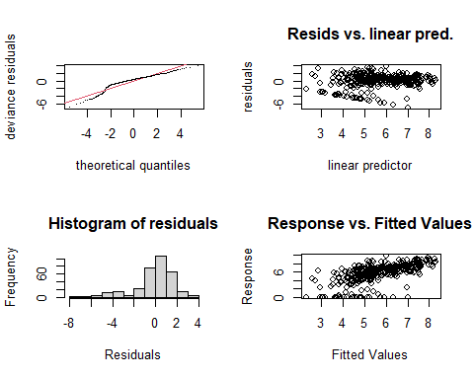

##   
## Method: REML Optimizer: outer newton  
## full convergence after 5 iterations.  
## Gradient range [-0.0001041989,0.00009834495]  
## (score 681.8699 & scale 3.423087).  
## Hessian positive definite, eigenvalue range [0.00004447807,161.454].  
## Model rank = 50 / 50   
##   
## Basis dimension (k) checking results. Low p-value (k-index<1) may  
## indicate that k is too low, especially if edf is close to k'.  
##   
## k' edf k-index p-value   
## te(SalSurf_s,doy_s) 19.000000 9.269681 0.88 0.005 **  
## s(Year_fac) 27.000000 15.572609 NA NA   
## s(Station_fac) 3.000000 0.000165 NA NA   
## ---  
## Signif. codes: 0 '***' 0.001 '**' 0.01 '*' 0.05 '.' 0.1 ' ' 1  
##   
##   
## -------------summary-------------  
##   
## Family: gaussian   
## Link function: identity   
##   
## Formula:  
## BPUE_log1p ~ te(SalSurf_s, doy_s, k = c(5, 5), bs = c("cs", "cc")) +   
## s(Year_fac, bs = "re") + s(Station_fac, bs = "re")  
##   
## Parametric coefficients:  
## Estimate Std. Error t value Pr(>|t|)   
## (Intercept) 5.6535 0.1667 33.92 <0.0000000000000002 ***  
## ---  
## Signif. codes: 0 '***' 0.001 '**' 0.01 '*' 0.05 '.' 0.1 ' ' 1  
##   
## Approximate significance of smooth terms:  
## edf Ref.df F p-value   
## te(SalSurf_s,doy_s) 9.2696808 19 7.295 < 0.0000000000000002 ***  
## s(Year_fac) 15.5726093 26 1.500 0.000103 ***  
## s(Station_fac) 0.0001648 2 0.000 0.593029   
## ---  
## Signif. codes: 0 '***' 0.001 '**' 0.01 '*' 0.05 '.' 0.1 ' ' 1  
##   
## R-sq.(adj) = 0.343 Deviance explained = 39.4%  
## -REML = 681.87 Scale est. = 3.4231 n = 323  
## <<<<<<<<<<<<<<<<<<<<<<< modeling limno NW Suisun >>>>>>>>>>>>>>>>>>>>>>>>>  
##   
## -------------gam check-------------

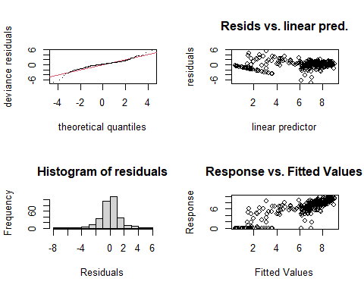

##   
## Method: REML Optimizer: outer newton  
## full convergence after 7 iterations.  
## Gradient range [-0.0003405178,0.0002167835]  
## (score 600.3333 & scale 2.201127).  
## Hessian positive definite, eigenvalue range [1.592647,156.5486].  
## Model rank = 47 / 47   
##   
## Basis dimension (k) checking results. Low p-value (k-index<1) may  
## indicate that k is too low, especially if edf is close to k'.  
##   
## k' edf k-index p-value  
## te(SalSurf_s,doy_s) 19.0 11.7 0.98 0.3  
## s(Year_fac) 27.0 16.2 NA NA  
##   
##   
## -------------summary-------------  
##   
## Family: gaussian   
## Link function: identity   
##   
## Formula:  
## BPUE_log1p ~ te(SalSurf_s, doy_s, k = c(5, 5), bs = c("cs", "cc")) +   
## s(Year_fac, bs = "re")  
##   
## Parametric coefficients:  
## Estimate Std. Error t value Pr(>|t|)   
## (Intercept) 6.4074 0.1397 45.85 <0.0000000000000002 ***  
## ---  
## Signif. codes: 0 '***' 0.001 '**' 0.01 '*' 0.05 '.' 0.1 ' ' 1  
##   
## Approximate significance of smooth terms:  
## edf Ref.df F p-value   
## te(SalSurf_s,doy_s) 11.75 19 46.76 < 0.0000000000000002 ***  
## s(Year_fac) 16.17 26 1.67 0.0000324 ***  
## ---  
## Signif. codes: 0 '***' 0.001 '**' 0.01 '*' 0.05 '.' 0.1 ' ' 1  
##   
## R-sq.(adj) = 0.703 Deviance explained = 73%  
## -REML = 600.33 Scale est. = 2.2011 n = 313  
## <<<<<<<<<<<<<<<<<<<<<<< modeling limno East Suisun >>>>>>>>>>>>>>>>>>>>>>>>>  
##   
## -------------gam check-------------

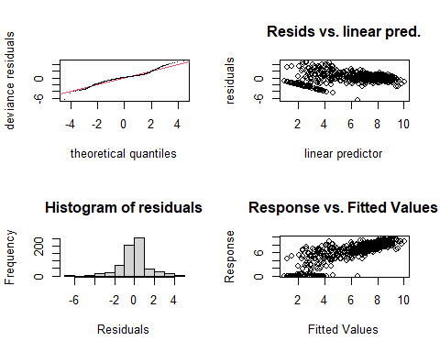

##   
## Method: REML Optimizer: outer newton  
## full convergence after 10 iterations.  
## Gradient range [-0.000000239289,0.0000001464564]  
## (score 1236.472 & scale 1.965841).  
## Hessian positive definite, eigenvalue range [0.8025186,335.9462].  
## Model rank = 51 / 51   
##   
## Basis dimension (k) checking results. Low p-value (k-index<1) may  
## indicate that k is too low, especially if edf is close to k'.  
##   
## k' edf k-index p-value   
## te(SalSurf_s,doy_s) 19.00 15.16 0.85 <0.0000000000000002 ***  
## s(Year_fac) 27.00 21.43 NA NA   
## s(Station_fac) 4.00 2.32 NA NA   
## ---  
## Signif. codes: 0 '***' 0.001 '**' 0.01 '*' 0.05 '.' 0.1 ' ' 1  
##   
##   
## -------------summary-------------  
##   
## Family: gaussian   
## Link function: identity   
##   
## Formula:  
## BPUE_log1p ~ te(SalSurf_s, doy_s, k = c(5, 5), bs = c("cs", "cc")) +   
## s(Year_fac, bs = "re") + s(Station_fac, bs = "re")  
##   
## Parametric coefficients:  
## Estimate Std. Error t value Pr(>|t|)   
## (Intercept) 6.765 0.245 27.62 <0.0000000000000002 ***  
## ---  
## Signif. codes: 0 '***' 0.001 '**' 0.01 '*' 0.05 '.' 0.1 ' ' 1  
##   
## Approximate significance of smooth terms:  
## edf Ref.df F p-value   
## te(SalSurf_s,doy_s) 15.158 19 123.851 < 0.0000000000000002 ***  
## s(Year_fac) 21.432 26 4.426 < 0.0000000000000002 ***  
## s(Station_fac) 2.319 3 5.541 0.000576 ***  
## ---  
## Signif. codes: 0 '***' 0.001 '**' 0.01 '*' 0.05 '.' 0.1 ' ' 1  
##   
## R-sq.(adj) = 0.703 Deviance explained = 72%  
## -REML = 1236.5 Scale est. = 1.9658 n = 672  
## <<<<<<<<<<<<<<<<<<<<<<< modeling limno Confluence >>>>>>>>>>>>>>>>>>>>>>>>>  
##   
## -------------gam check-------------

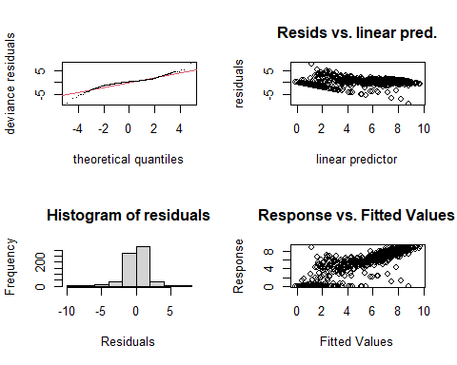

##   
## Method: REML Optimizer: outer newton  
## full convergence after 7 iterations.  
## Gradient range [-0.00004883231,0.000008133469]  
## (score 1345.344 & scale 2.325183).  
## Hessian positive definite, eigenvalue range [1.009805,350.4133].  
## Model rank = 52 / 52   
##   
## Basis dimension (k) checking results. Low p-value (k-index<1) may  
## indicate that k is too low, especially if edf is close to k'.  
##   
## k' edf k-index p-value   
## te(SalSurf_s,doy_s) 19.00 14.78 0.95 0.085 .  
## s(Year_fac) 27.00 21.16 NA NA   
## s(Station_fac) 5.00 2.34 NA NA   
## ---  
## Signif. codes: 0 '***' 0.001 '**' 0.01 '*' 0.05 '.' 0.1 ' ' 1  
##   
##   
## -------------summary-------------  
##   
## Family: gaussian   
## Link function: identity   
##   
## Formula:  
## BPUE_log1p ~ te(SalSurf_s, doy_s, k = c(5, 5), bs = c("cs", "cc")) +   
## s(Year_fac, bs = "re") + s(Station_fac, bs = "re")  
##   
## Parametric coefficients:  
## Estimate Std. Error t value Pr(>|t|)   
## (Intercept) 5.4572 0.2244 24.32 <0.0000000000000002 ***  
## ---  
## Signif. codes: 0 '***' 0.001 '**' 0.01 '*' 0.05 '.' 0.1 ' ' 1  
##   
## Approximate significance of smooth terms:  
## edf Ref.df F p-value   
## te(SalSurf_s,doy_s) 14.784 19 187.879 < 0.0000000000000002 ***  
## s(Year_fac) 21.155 26 4.447 < 0.0000000000000002 ***  
## s(Station_fac) 2.337 4 5.369 0.0000308 ***  
## ---  
## Signif. codes: 0 '***' 0.001 '**' 0.01 '*' 0.05 '.' 0.1 ' ' 1  
##   
## R-sq.(adj) = 0.748 Deviance explained = 76.2%  
## -REML = 1345.3 Scale est. = 2.3252 n = 701  
## <<<<<<<<<<<<<<<<<<<<<<< modeling limno Suisun Marsh >>>>>>>>>>>>>>>>>>>>>>>>>  
##   
## -------------gam check-------------

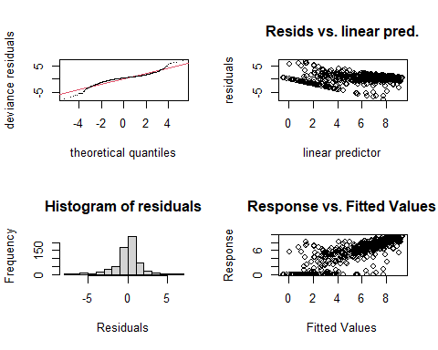

##   
## Method: REML Optimizer: outer newton  
## full convergence after 7 iterations.  
## Gradient range [-0.000001770403,0.000001619472]  
## (score 1260.551 & scale 2.853194).  
## Hessian positive definite, eigenvalue range [0.472618,313.8114].  
## Model rank = 49 / 49   
##   
## Basis dimension (k) checking results. Low p-value (k-index<1) may  
## indicate that k is too low, especially if edf is close to k'.  
##   
## k' edf k-index p-value  
## te(SalSurf_s,doy_s) 19.000 13.889 0.95 0.12  
## s(Year_fac) 27.000 16.907 NA NA  
## s(Station_fac) 2.000 0.973 NA NA  
##   
##   
## -------------summary-------------  
##   
## Family: gaussian   
## Link function: identity   
##   
## Formula:  
## BPUE_log1p ~ te(SalSurf_s, doy_s, k = c(5, 5), bs = c("cs", "cc")) +   
## s(Year_fac, bs = "re") + s(Station_fac, bs = "re")  
##   
## Parametric coefficients:  
## Estimate Std. Error t value Pr(>|t|)   
## (Intercept) 5.8838 0.4269 13.78 <0.0000000000000002 ***  
## ---  
## Signif. codes: 0 '***' 0.001 '**' 0.01 '*' 0.05 '.' 0.1 ' ' 1  
##   
## Approximate significance of smooth terms:  
## edf Ref.df F p-value   
## te(SalSurf_s,doy_s) 13.8895 19 92.212 < 0.0000000000000002 ***  
## s(Year_fac) 16.9071 26 1.801 0.00000818 ***  
## s(Station_fac) 0.9731 1 36.476 < 0.0000000000000002 ***  
## ---  
## Signif. codes: 0 '***' 0.001 '**' 0.01 '*' 0.05 '.' 0.1 ' ' 1  
##   
## R-sq.(adj) = 0.693 Deviance explained = 70.8%  
## -REML = 1260.6 Scale est. = 2.8532 n = 628  
## <<<<<<<<<<<<<<<<<<<<<<< modeling mysid SW Suisun >>>>>>>>>>>>>>>>>>>>>>>>>  
##   
## -------------gam check-------------

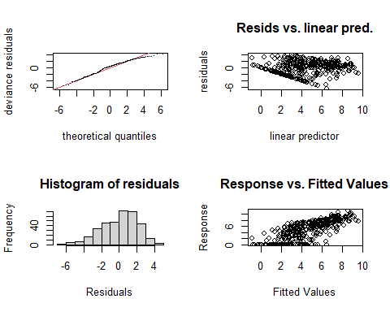

##   
## Method: REML Optimizer: outer newton  
## full convergence after 6 iterations.  
## Gradient range [-0.0000003404905,0.0000002395553]  
## (score 800.1647 & scale 4.434461).  
## Hessian positive definite, eigenvalue range [0.1595374,177.112].  
## Model rank = 50 / 50   
##   
## Basis dimension (k) checking results. Low p-value (k-index<1) may  
## indicate that k is too low, especially if edf is close to k'.  
##   
## k' edf k-index p-value  
## te(SalSurf_s,doy_s) 19.000 9.994 1.03 0.7  
## s(Year_fac) 26.000 19.152 NA NA  
## s(Station_fac) 4.000 0.893 NA NA  
##   
##   
## -------------summary-------------  
##   
## Family: gaussian   
## Link function: identity   
##   
## Formula:  
## BPUE_log1p ~ te(SalSurf_s, doy_s, k = c(5, 5), bs = c("cs", "cc")) +   
## s(Year_fac, bs = "re") + s(Station_fac, bs = "re")  
##   
## Parametric coefficients:  
## Estimate Std. Error t value Pr(>|t|)   
## (Intercept) 4.3850 0.3773 11.62 <0.0000000000000002 ***  
## ---  
## Signif. codes: 0 '***' 0.001 '**' 0.01 '*' 0.05 '.' 0.1 ' ' 1  
##   
## Approximate significance of smooth terms:  
## edf Ref.df F p-value   
## te(SalSurf_s,doy_s) 9.994 19 24.886 <0.0000000000000002 ***  
## s(Year_fac) 19.152 25 3.248 <0.0000000000000002 ***  
## s(Station_fac) 0.893 3 0.791 0.136   
## ---  
## Signif. codes: 0 '***' 0.001 '**' 0.01 '*' 0.05 '.' 0.1 ' ' 1  
##   
## R-sq.(adj) = 0.544 Deviance explained = 58.3%  
## -REML = 800.16 Scale est. = 4.4345 n = 354  
## <<<<<<<<<<<<<<<<<<<<<<< modeling mysid NW Suisun >>>>>>>>>>>>>>>>>>>>>>>>>  
##   
## -------------gam check-------------

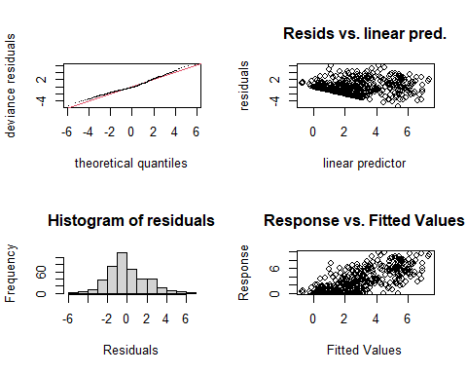

##   
## Method: REML Optimizer: outer newton  
## full convergence after 7 iterations.  
## Gradient range [-0.0000009010017,0.0000008562909]  
## (score 904.7591 & scale 3.798664).  
## Hessian positive definite, eigenvalue range [0.5287766,208.4357].  
## Model rank = 50 / 50   
##   
## Basis dimension (k) checking results. Low p-value (k-index<1) may  
## indicate that k is too low, especially if edf is close to k'.  
##   
## k' edf k-index p-value   
## te(SalSurf_s,doy_s) 19.00 8.97 0.93 0.05 *  
## s(Year_fac) 26.00 17.48 NA NA   
## s(Station_fac) 4.00 2.94 NA NA   
## ---  
## Signif. codes: 0 '***' 0.001 '**' 0.01 '*' 0.05 '.' 0.1 ' ' 1  
##   
##   
## -------------summary-------------  
##   
## Family: gaussian   
## Link function: identity   
##   
## Formula:  
## BPUE_log1p ~ te(SalSurf_s, doy_s, k = c(5, 5), bs = c("cs", "cc")) +   
## s(Year_fac, bs = "re") + s(Station_fac, bs = "re")  
##   
## Parametric coefficients:  
## Estimate Std. Error t value Pr(>|t|)   
## (Intercept) 4.460 1.094 4.078 0.0000552 ***  
## ---  
## Signif. codes: 0 '***' 0.001 '**' 0.01 '*' 0.05 '.' 0.1 ' ' 1  
##   
## Approximate significance of smooth terms:  
## edf Ref.df F p-value   
## te(SalSurf_s,doy_s) 8.966 19 12.325 0.0047 **   
## s(Year_fac) 17.480 25 2.516 <0.0000000000000002 ***  
## s(Station_fac) 2.943 3 95.083 <0.0000000000000002 ***  
## ---  
## Signif. codes: 0 '***' 0.001 '**' 0.01 '*' 0.05 '.' 0.1 ' ' 1  
##   
## R-sq.(adj) = 0.497 Deviance explained = 53.2%  
## -REML = 904.76 Scale est. = 3.7987 n = 417  
## <<<<<<<<<<<<<<<<<<<<<<< modeling mysid East Suisun >>>>>>>>>>>>>>>>>>>>>>>>>  
##   
## -------------gam check-------------

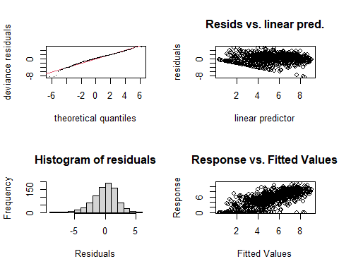

##   
## Method: REML Optimizer: outer newton  
## full convergence after 5 iterations.  
## Gradient range [-0.0009278945,0.0005095288]  
## (score 1797.217 & scale 3.738696).  
## Hessian positive definite, eigenvalue range [2.018086,417.8264].  
## Model rank = 56 / 56   
##   
## Basis dimension (k) checking results. Low p-value (k-index<1) may  
## indicate that k is too low, especially if edf is close to k'.  
##   
## k' edf k-index p-value   
## te(SalSurf_s,doy_s) 19.00 14.78 0.92 0.01 **  
## s(Year_fac) 26.00 19.00 NA NA   
## s(Station_fac) 10.00 8.11 NA NA   
## ---  
## Signif. codes: 0 '***' 0.001 '**' 0.01 '*' 0.05 '.' 0.1 ' ' 1  
##   
##   
## -------------summary-------------  
##   
## Family: gaussian   
## Link function: identity   
##   
## Formula:  
## BPUE_log1p ~ te(SalSurf_s, doy_s, k = c(5, 5), bs = c("cs", "cc")) +   
## s(Year_fac, bs = "re") + s(Station_fac, bs = "re")  
##   
## Parametric coefficients:  
## Estimate Std. Error t value Pr(>|t|)   
## (Intercept) 5.2058 0.4966 10.48 <0.0000000000000002 ***  
## ---  
## Signif. codes: 0 '***' 0.001 '**' 0.01 '*' 0.05 '.' 0.1 ' ' 1  
##   
## Approximate significance of smooth terms:  
## edf Ref.df F p-value   
## te(SalSurf_s,doy_s) 14.785 19 66.931 <0.0000000000000002 ***  
## s(Year_fac) 18.997 25 3.894 <0.0000000000000002 ***  
## s(Station_fac) 8.105 9 15.436 <0.0000000000000002 ***  
## ---  
## Signif. codes: 0 '***' 0.001 '**' 0.01 '*' 0.05 '.' 0.1 ' ' 1  
##   
## R-sq.(adj) = 0.52 Deviance explained = 54.4%  
## -REML = 1797.2 Scale est. = 3.7387 n = 836  
## <<<<<<<<<<<<<<<<<<<<<<< modeling mysid Confluence >>>>>>>>>>>>>>>>>>>>>>>>>  
##   
## -------------gam check-------------

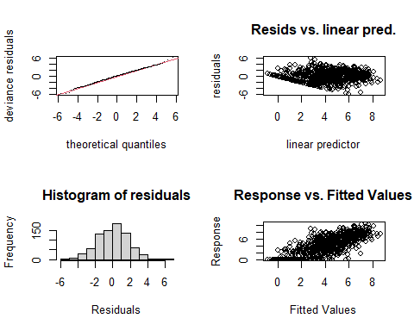

##   
## Method: REML Optimizer: outer newton  
## full convergence after 5 iterations.  
## Gradient range [-0.0005055385,0.0003473337]  
## (score 1647.357 & scale 3.17049).  
## Hessian positive definite, eigenvalue range [2.158402,397.3703].  
## Model rank = 55 / 55   
##   
## Basis dimension (k) checking results. Low p-value (k-index<1) may  
## indicate that k is too low, especially if edf is close to k'.  
##   
## k' edf k-index p-value   
## te(SalSurf_s,doy_s) 19.00 15.08 0.92 <0.0000000000000002 ***  
## s(Year_fac) 26.00 20.56 NA NA   
## s(Station_fac) 9.00 5.98 NA NA   
## ---  
## Signif. codes: 0 '***' 0.001 '**' 0.01 '*' 0.05 '.' 0.1 ' ' 1  
##   
##   
## -------------summary-------------  
##   
## Family: gaussian   
## Link function: identity   
##   
## Formula:  
## BPUE_log1p ~ te(SalSurf_s, doy_s, k = c(5, 5), bs = c("cs", "cc")) +   
## s(Year_fac, bs = "re") + s(Station_fac, bs = "re")  
##   
## Parametric coefficients:  
## Estimate Std. Error t value Pr(>|t|)   
## (Intercept) 4.2493 0.3046 13.95 <0.0000000000000002 ***  
## ---  
## Signif. codes: 0 '***' 0.001 '**' 0.01 '*' 0.05 '.' 0.1 ' ' 1  
##   
## Approximate significance of smooth terms:  
## edf Ref.df F p-value   
## te(SalSurf_s,doy_s) 15.081 19 94.522 <0.0000000000000002 ***  
## s(Year_fac) 20.563 25 4.866 <0.0000000000000002 ***  
## s(Station_fac) 5.975 8 8.510 <0.0000000000000002 ***  
## ---  
## Signif. codes: 0 '***' 0.001 '**' 0.01 '*' 0.05 '.' 0.1 ' ' 1  
##   
## R-sq.(adj) = 0.564 Deviance explained = 58.7%  
## -REML = 1647.4 Scale est. = 3.1705 n = 795  
## <<<<<<<<<<<<<<<<<<<<<<< modeling mysid Suisun Marsh >>>>>>>>>>>>>>>>>>>>>>>>>  
##   
## -------------gam check-------------

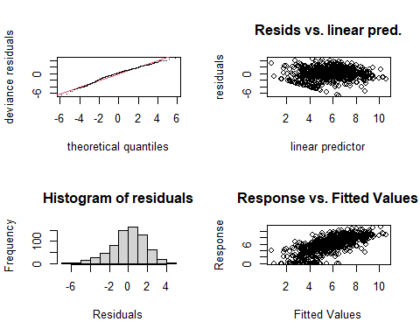

##   
## Method: REML Optimizer: outer newton  
## full convergence after 6 iterations.  
## Gradient range [-0.0000002953791,0.0000002097751]  
## (score 1484.766 & scale 3.363607).  
## Hessian positive definite, eigenvalue range [1.725115,350.4737].  
## Model rank = 53 / 53   
##   
## Basis dimension (k) checking results. Low p-value (k-index<1) may  
## indicate that k is too low, especially if edf is close to k'.  
##   
## k' edf k-index p-value   
## te(SalSurf_s,doy_s) 19.00 14.96 0.92 0.005 **  
## s(Year_fac) 26.00 22.50 NA NA   
## s(Station_fac) 7.00 5.46 NA NA   
## ---  
## Signif. codes: 0 '***' 0.001 '**' 0.01 '*' 0.05 '.' 0.1 ' ' 1  
##   
##   
## -------------summary-------------  
##   
## Family: gaussian   
## Link function: identity   
##   
## Formula:  
## BPUE_log1p ~ te(SalSurf_s, doy_s, k = c(5, 5), bs = c("cs", "cc")) +   
## s(Year_fac, bs = "re") + s(Station_fac, bs = "re")  
##   
## Parametric coefficients:  
## Estimate Std. Error t value Pr(>|t|)   
## (Intercept) 5.2432 0.6501 8.065 0.00000000000000347 ***  
## ---  
## Signif. codes: 0 '***' 0.001 '**' 0.01 '*' 0.05 '.' 0.1 ' ' 1  
##   
## Approximate significance of smooth terms:  
## edf Ref.df F p-value   
## te(SalSurf_s,doy_s) 14.965 19 73.968 <0.0000000000000002 ***  
## s(Year_fac) 22.501 25 8.827 <0.0000000000000002 ***  
## s(Station_fac) 5.455 6 18.013 <0.0000000000000002 ***  
## ---  
## Signif. codes: 0 '***' 0.001 '**' 0.01 '*' 0.05 '.' 0.1 ' ' 1  
##   
## R-sq.(adj) = 0.482 Deviance explained = 51.4%  
## -REML = 1484.8 Scale est. = 3.3636 n = 701  
## <<<<<<<<<<<<<<<<<<<<<<< modeling othcyc SW Suisun >>>>>>>>>>>>>>>>>>>>>>>>>  
##   
## -------------gam check-------------

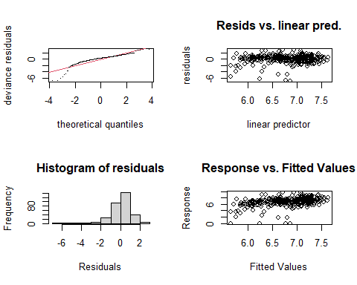

##   
## Method: REML Optimizer: outer newton  
## full convergence after 13 iterations.  
## Gradient range [-0.0002017452,0.000949099]  
## (score 547.798 & scale 1.638293).  
## Hessian positive definite, eigenvalue range [0.0002017947,161.0378].  
## Model rank = 50 / 50   
##   
## Basis dimension (k) checking results. Low p-value (k-index<1) may  
## indicate that k is too low, especially if edf is close to k'.  
##   
## k' edf k-index p-value  
## te(SalSurf_s,doy_s) 19.00000 6.95873 0.99 0.32  
## s(Year_fac) 27.00000 0.00231 NA NA  
## s(Station_fac) 3.00000 0.74286 NA NA  
##   
##   
## -------------summary-------------  
##   
## Family: gaussian   
## Link function: identity   
##   
## Formula:  
## BPUE_log1p ~ te(SalSurf_s, doy_s, k = c(5, 5), bs = c("cs", "cc")) +   
## s(Year_fac, bs = "re") + s(Station_fac, bs = "re")  
##   
## Parametric coefficients:  
## Estimate Std. Error t value Pr(>|t|)   
## (Intercept) 6.5758 0.3049 21.57 <0.0000000000000002 ***  
## ---  
## Signif. codes: 0 '***' 0.001 '**' 0.01 '*' 0.05 '.' 0.1 ' ' 1  
##   
## Approximate significance of smooth terms:  
## edf Ref.df F p-value   
## te(SalSurf_s,doy_s) 6.958726 19 2.637 <0.0000000000000002 ***  
## s(Year_fac) 0.002307 26 0.000 0.701   
## s(Station_fac) 0.742859 2 0.636 0.173   
## ---  
## Signif. codes: 0 '***' 0.001 '**' 0.01 '*' 0.05 '.' 0.1 ' ' 1  
##   
## R-sq.(adj) = 0.132 Deviance explained = 15.3%  
## -REML = 547.8 Scale est. = 1.6383 n = 323  
## <<<<<<<<<<<<<<<<<<<<<<< modeling othcyc NW Suisun >>>>>>>>>>>>>>>>>>>>>>>>>  
##   
## -------------gam check-------------

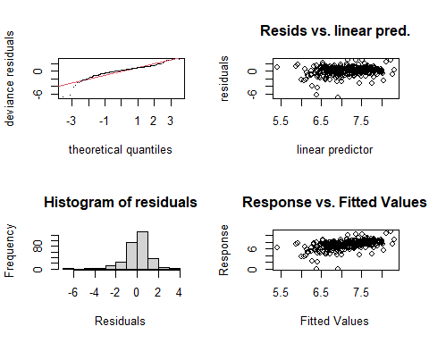

##   
## Method: REML Optimizer: outer newton  
## full convergence after 6 iterations.  
## Gradient range [-0.000003658726,0.00000007542045]  
## (score 521.3249 & scale 1.443972).  
## Hessian positive definite, eigenvalue range [0.3782888,156.3477].  
## Model rank = 47 / 47   
##   
## Basis dimension (k) checking results. Low p-value (k-index<1) may  
## indicate that k is too low, especially if edf is close to k'.  
##   
## k' edf k-index p-value  
## te(SalSurf_s,doy_s) 19.00 7.57 0.96 0.21  
## s(Year_fac) 27.00 13.57 NA NA  
##   
##   
## -------------summary-------------  
##   
## Family: gaussian   
## Link function: identity   
##   
## Formula:  
## BPUE_log1p ~ te(SalSurf_s, doy_s, k = c(5, 5), bs = c("cs", "cc")) +   
## s(Year_fac, bs = "re")  
##   
## Parametric coefficients:  
## Estimate Std. Error t value Pr(>|t|)   
## (Intercept) 7.12207 0.09958 71.52 <0.0000000000000002 ***  
## ---  
## Signif. codes: 0 '***' 0.001 '**' 0.01 '*' 0.05 '.' 0.1 ' ' 1  
##   
## Approximate significance of smooth terms:  
## edf Ref.df F p-value   
## te(SalSurf_s,doy_s) 7.566 19 2.91 0.00000323 ***  
## s(Year_fac) 13.572 26 1.12 0.0012 **   
## ---  
## Signif. codes: 0 '***' 0.001 '**' 0.01 '*' 0.05 '.' 0.1 ' ' 1  
##   
## R-sq.(adj) = 0.2 Deviance explained = 25.4%  
## -REML = 521.32 Scale est. = 1.444 n = 313  
## <<<<<<<<<<<<<<<<<<<<<<< modeling othcyc East Suisun >>>>>>>>>>>>>>>>>>>>>>>>>  
##   
## -------------gam check-------------

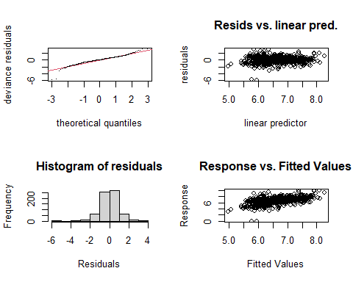

##   
## Method: REML Optimizer: outer newton  
## full convergence after 7 iterations.  
## Gradient range [-0.0000003757981,0.00000004154157]  
## (score 950.8421 & scale 0.8857205).  
## Hessian positive definite, eigenvalue range [0.1253222,335.8621].  
## Model rank = 51 / 51   
##   
## Basis dimension (k) checking results. Low p-value (k-index<1) may  
## indicate that k is too low, especially if edf is close to k'.  
##   
## k' edf k-index p-value   
## te(SalSurf_s,doy_s) 19.00 10.64 0.91 0.005 **  
## s(Year_fac) 27.00 20.44 NA NA   
## s(Station_fac) 4.00 1.13 NA NA   
## ---  
## Signif. codes: 0 '***' 0.001 '**' 0.01 '*' 0.05 '.' 0.1 ' ' 1  
##   
##   
## -------------summary-------------  
##   
## Family: gaussian   
## Link function: identity   
##   
## Formula:  
## BPUE_log1p ~ te(SalSurf_s, doy_s, k = c(5, 5), bs = c("cs", "cc")) +   
## s(Year_fac, bs = "re") + s(Station_fac, bs = "re")  
##   
## Parametric coefficients:  
## Estimate Std. Error t value Pr(>|t|)   
## (Intercept) 6.69141 0.09706 68.94 <0.0000000000000002 ***  
## ---  
## Signif. codes: 0 '***' 0.001 '**' 0.01 '*' 0.05 '.' 0.1 ' ' 1  
##   
## Approximate significance of smooth terms:  
## edf Ref.df F p-value   
## te(SalSurf_s,doy_s) 10.64 19 10.156 <0.0000000000000002 ***  
## s(Year_fac) 20.44 26 3.932 <0.0000000000000002 ***  
## s(Station_fac) 1.13 3 0.795 0.122   
## ---  
## Signif. codes: 0 '***' 0.001 '**' 0.01 '*' 0.05 '.' 0.1 ' ' 1  
##   
## R-sq.(adj) = 0.29 Deviance explained = 32.4%  
## -REML = 950.84 Scale est. = 0.88572 n = 672  
## <<<<<<<<<<<<<<<<<<<<<<< modeling othcyc Confluence >>>>>>>>>>>>>>>>>>>>>>>>>  
##   
## -------------gam check-------------

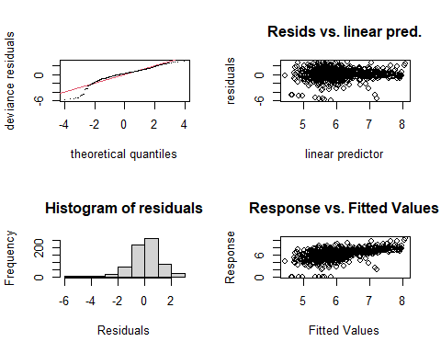

##   
## Method: REML Optimizer: outer newton  
## full convergence after 7 iterations.  
## Gradient range [-0.0000005407004,0.0000002814948]  
## (score 1184.537 & scale 1.558617).  
## Hessian positive definite, eigenvalue range [0.8820017,350.307].  
## Model rank = 52 / 52   
##   
## Basis dimension (k) checking results. Low p-value (k-index<1) may  
## indicate that k is too low, especially if edf is close to k'.  
##   
## k' edf k-index p-value  
## te(SalSurf_s,doy_s) 19.00 9.79 1 0.58  
## s(Year_fac) 27.00 19.25 NA NA  
## s(Station_fac) 5.00 1.92 NA NA  
##   
##   
## -------------summary-------------  
##   
## Family: gaussian   
## Link function: identity   
##   
## Formula:  
## BPUE_log1p ~ te(SalSurf_s, doy_s, k = c(5, 5), bs = c("cs", "cc")) +   
## s(Year_fac, bs = "re") + s(Station_fac, bs = "re")  
##   
## Parametric coefficients:  
## Estimate Std. Error t value Pr(>|t|)   
## (Intercept) 6.1620 0.1411 43.66 <0.0000000000000002 ***  
## ---  
## Signif. codes: 0 '***' 0.001 '**' 0.01 '*' 0.05 '.' 0.1 ' ' 1  
##   
## Approximate significance of smooth terms:  
## edf Ref.df F p-value   
## te(SalSurf_s,doy_s) 9.795 19 13.366 < 0.0000000000000002 ***  
## s(Year_fac) 19.249 26 2.874 < 0.0000000000000002 ***  
## s(Station_fac) 1.916 4 3.208 0.000602 ***  
## ---  
## Signif. codes: 0 '***' 0.001 '**' 0.01 '*' 0.05 '.' 0.1 ' ' 1  
##   
## R-sq.(adj) = 0.278 Deviance explained = 31%  
## -REML = 1184.5 Scale est. = 1.5586 n = 701  
## <<<<<<<<<<<<<<<<<<<<<<< modeling othcyc Suisun Marsh >>>>>>>>>>>>>>>>>>>>>>>>>  
##   
## -------------gam check-------------

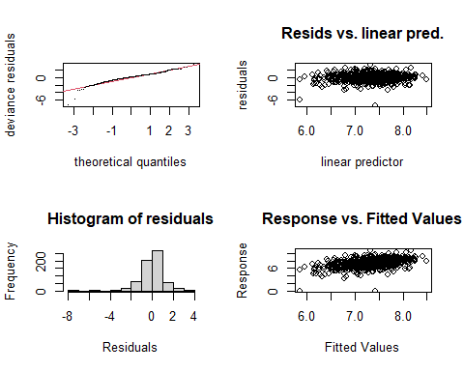

##   
## Method: REML Optimizer: outer newton  
## full convergence after 9 iterations.  
## Gradient range [-0.000007110302,0.000002166729]  
## (score 949.5123 & scale 1.100501).  
## Hessian positive definite, eigenvalue range [0.440909,313.748].  
## Model rank = 49 / 49   
##   
## Basis dimension (k) checking results. Low p-value (k-index<1) may  
## indicate that k is too low, especially if edf is close to k'.  
##   
## k' edf k-index p-value  
## te(SalSurf_s,doy_s) 19.000 9.614 0.96 0.2  
## s(Year_fac) 27.000 16.120 NA NA  
## s(Station_fac) 2.000 0.946 NA NA  
##   
##   
## -------------summary-------------  
##   
## Family: gaussian   
## Link function: identity   
##   
## Formula:  
## BPUE_log1p ~ te(SalSurf_s, doy_s, k = c(5, 5), bs = c("cs", "cc")) +   
## s(Year_fac, bs = "re") + s(Station_fac, bs = "re")  
##   
## Parametric coefficients:  
## Estimate Std. Error t value Pr(>|t|)   
## (Intercept) 7.3649 0.1898 38.8 <0.0000000000000002 ***  
## ---  
## Signif. codes: 0 '***' 0.001 '**' 0.01 '*' 0.05 '.' 0.1 ' ' 1  
##   
## Approximate significance of smooth terms:  
## edf Ref.df F p-value   
## te(SalSurf_s,doy_s) 9.6144 19 5.962 < 0.0000000000000002 ***  
## s(Year_fac) 16.1204 26 1.615 0.0000270 ***  
## s(Station_fac) 0.9463 1 17.689 0.0000184 ***  
## ---  
## Signif. codes: 0 '***' 0.001 '**' 0.01 '*' 0.05 '.' 0.1 ' ' 1  
##   
## R-sq.(adj) = 0.191 Deviance explained = 22.6%  
## -REML = 949.51 Scale est. = 1.1005 n = 628  
## <<<<<<<<<<<<<<<<<<<<<<< modeling other SW Suisun >>>>>>>>>>>>>>>>>>>>>>>>>  
##   
## -------------gam check-------------

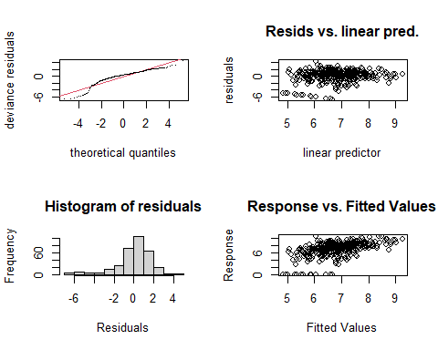

##   
## Method: REML Optimizer: outer newton  
## full convergence after 12 iterations.  
## Gradient range [-0.0004030652,0.0001987653]  
## (score 655.4655 & scale 3.202072).  
## Hessian positive definite, eigenvalue range [0.000005932248,158.5364].  
## Model rank = 50 / 50   
##   
## Basis dimension (k) checking results. Low p-value (k-index<1) may  
## indicate that k is too low, especially if edf is close to k'.  
##   
## k' edf k-index p-value   
## te(SalSurf_s,doy_s) 19.0000000 5.2870802 0.88 0.015 *  
## s(Year_fac) 27.0000000 17.3306953 NA NA   
## s(Station_fac) 3.0000000 0.0000197 NA NA   
## ---  
## Signif. codes: 0 '***' 0.001 '**' 0.01 '*' 0.05 '.' 0.1 ' ' 1  
##   
##   
## -------------summary-------------  
##   
## Family: gaussian   
## Link function: identity   
##   
## Formula:  
## BPUE_log1p ~ te(SalSurf_s, doy_s, k = c(5, 5), bs = c("cs", "cc")) +   
## s(Year_fac, bs = "re") + s(Station_fac, bs = "re")  
##   
## Parametric coefficients:  
## Estimate Std. Error t value Pr(>|t|)   
## (Intercept) 6.8322 0.1767 38.66 <0.0000000000000002 ***  
## ---  
## Signif. codes: 0 '***' 0.001 '**' 0.01 '*' 0.05 '.' 0.1 ' ' 1  
##   
## Approximate significance of smooth terms:  
## edf Ref.df F p-value   
## te(SalSurf_s,doy_s) 5.28708019 19 2.438 0.00000268 ***  
## s(Year_fac) 17.33069525 26 2.048 0.00000214 ***  
## s(Station_fac) 0.00001972 2 0.000 0.631   
## ---  
## Signif. codes: 0 '***' 0.001 '**' 0.01 '*' 0.05 '.' 0.1 ' ' 1  
##   
## R-sq.(adj) = 0.226 Deviance explained = 28.1%  
## -REML = 655.47 Scale est. = 3.2021 n = 317  
## <<<<<<<<<<<<<<<<<<<<<<< modeling other NW Suisun >>>>>>>>>>>>>>>>>>>>>>>>>  
##   
## -------------gam check-------------

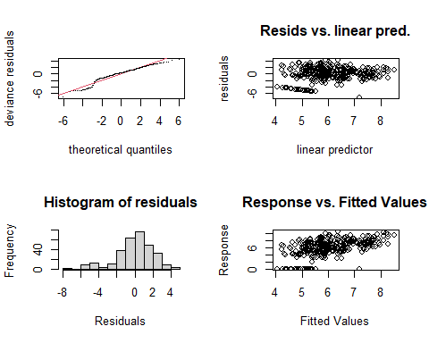

##   
## Method: REML Optimizer: outer newton  
## full convergence after 7 iterations.  
## Gradient range [-0.0005107396,0.0001649552]  
## (score 681.1145 & scale 4.221794).  
## Hessian positive definite, eigenvalue range [0.3661494,154.8462].  
## Model rank = 47 / 47   
##   
## Basis dimension (k) checking results. Low p-value (k-index<1) may  
## indicate that k is too low, especially if edf is close to k'.  
##   
## k' edf k-index p-value  
## te(SalSurf_s,doy_s) 19.00 6.33 0.96 0.2  
## s(Year_fac) 27.00 13.74 NA NA  
##   
##   
## -------------summary-------------  
##   
## Family: gaussian   
## Link function: identity   
##   
## Formula:  
## BPUE_log1p ~ te(SalSurf_s, doy_s, k = c(5, 5), bs = c("cs", "cc")) +   
## s(Year_fac, bs = "re")  
##   
## Parametric coefficients:  
## Estimate Std. Error t value Pr(>|t|)   
## (Intercept) 6.0950 0.1717 35.49 <0.0000000000000002 ***  
## ---  
## Signif. codes: 0 '***' 0.001 '**' 0.01 '*' 0.05 '.' 0.1 ' ' 1  
##   
## Approximate significance of smooth terms:  
## edf Ref.df F p-value   
## te(SalSurf_s,doy_s) 6.328 19 3.101 0.000000538 ***  
## s(Year_fac) 13.735 26 1.133 0.00125 **   
## ---  
## Signif. codes: 0 '***' 0.001 '**' 0.01 '*' 0.05 '.' 0.1 ' ' 1  
##   
## R-sq.(adj) = 0.22 Deviance explained = 27%  
## -REML = 681.11 Scale est. = 4.2218 n = 310  
## <<<<<<<<<<<<<<<<<<<<<<< modeling other East Suisun >>>>>>>>>>>>>>>>>>>>>>>>>  
##   
## -------------gam check-------------

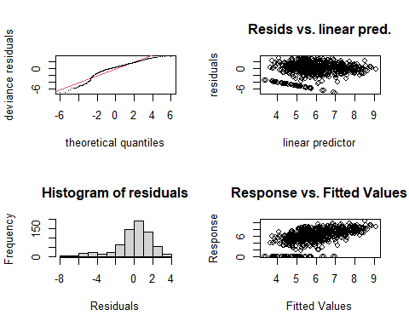

##   
## Method: REML Optimizer: outer newton  
## full convergence after 7 iterations.  
## Gradient range [-0.0009663949,0.0005020085]  
## (score 1416.959 & scale 3.606287).  
## Hessian positive definite, eigenvalue range [0.3912403,334.3088].  
## Model rank = 51 / 51   
##   
## Basis dimension (k) checking results. Low p-value (k-index<1) may  
## indicate that k is too low, especially if edf is close to k'.  
##   
## k' edf k-index p-value   
## te(SalSurf_s,doy_s) 19.00 13.45 0.84 <0.0000000000000002 ***  
## s(Year_fac) 27.00 17.70 NA NA   
## s(Station_fac) 4.00 1.53 NA NA   
## ---  
## Signif. codes: 0 '***' 0.001 '**' 0.01 '*' 0.05 '.' 0.1 ' ' 1  
##   
##   
## -------------summary-------------  
##   
## Family: gaussian   
## Link function: identity   
##   
## Formula:  
## BPUE_log1p ~ te(SalSurf_s, doy_s, k = c(5, 5), bs = c("cs", "cc")) +   
## s(Year_fac, bs = "re") + s(Station_fac, bs = "re")  
##   
## Parametric coefficients:  
## Estimate Std. Error t value Pr(>|t|)   
## (Intercept) 5.9111 0.1991 29.69 <0.0000000000000002 ***  
## ---  
## Signif. codes: 0 '***' 0.001 '**' 0.01 '*' 0.05 '.' 0.1 ' ' 1  
##   
## Approximate significance of smooth terms:  
## edf Ref.df F p-value   
## te(SalSurf_s,doy_s) 13.455 19 11.270 < 0.0000000000000002 ***  
## s(Year_fac) 17.696 26 1.993 0.00000251 ***  
## s(Station_fac) 1.529 3 1.954 0.0193 *   
## ---  
## Signif. codes: 0 '***' 0.001 '**' 0.01 '*' 0.05 '.' 0.1 ' ' 1  
##   
## R-sq.(adj) = 0.277 Deviance explained = 31.2%  
## -REML = 1417 Scale est. = 3.6063 n = 669  
## <<<<<<<<<<<<<<<<<<<<<<< modeling other Confluence >>>>>>>>>>>>>>>>>>>>>>>>>  
##   
## -------------gam check-------------

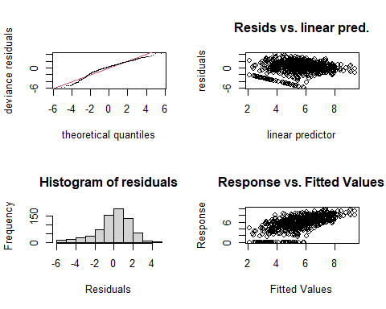

##   
## Method: REML Optimizer: outer newton  
## full convergence after 9 iterations.  
## Gradient range [-0.0005169733,0.0001741309]  
## (score 1439.189 & scale 3.172422).  
## Hessian positive definite, eigenvalue range [0.0005166712,347.4243].  
## Model rank = 52 / 52   
##   
## Basis dimension (k) checking results. Low p-value (k-index<1) may  
## indicate that k is too low, especially if edf is close to k'.  
##   
## k' edf k-index p-value   
## te(SalSurf_s,doy_s) 19.00000 14.77493 0.9 0.005 **  
## s(Year_fac) 27.00000 21.63479 NA NA   
## s(Station_fac) 5.00000 0.00138 NA NA   
## ---  
## Signif. codes: 0 '***' 0.001 '**' 0.01 '*' 0.05 '.' 0.1 ' ' 1  
##   
##   
## -------------summary-------------  
##   
## Family: gaussian   
## Link function: identity   
##   
## Formula:  
## BPUE_log1p ~ te(SalSurf_s, doy_s, k = c(5, 5), bs = c("cs", "cc")) +   
## s(Year_fac, bs = "re") + s(Station_fac, bs = "re")  
##   
## Parametric coefficients:  
## Estimate Std. Error t value Pr(>|t|)   
## (Intercept) 5.5934 0.1718 32.57 <0.0000000000000002 ***  
## ---  
## Signif. codes: 0 '***' 0.001 '**' 0.01 '*' 0.05 '.' 0.1 ' ' 1  
##   
## Approximate significance of smooth terms:  
## edf Ref.df F p-value   
## te(SalSurf_s,doy_s) 14.774930 19 19.038 <0.0000000000000002 ***  
## s(Year_fac) 21.634793 26 4.143 <0.0000000000000002 ***  
## s(Station_fac) 0.001382 4 0.000 0.789   
## ---  
## Signif. codes: 0 '***' 0.001 '**' 0.01 '*' 0.05 '.' 0.1 ' ' 1  
##   
## R-sq.(adj) = 0.383 Deviance explained = 41.5%  
## -REML = 1439.2 Scale est. = 3.1724 n = 695  
## <<<<<<<<<<<<<<<<<<<<<<< modeling other Suisun Marsh >>>>>>>>>>>>>>>>>>>>>>>>>  
##   
## -------------gam check-------------

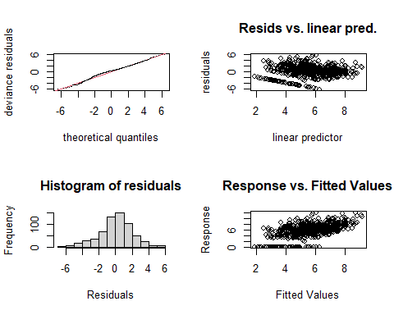

##   
## Method: REML Optimizer: outer newton  
## full convergence after 8 iterations.  
## Gradient range [-0.0005359542,0.0001920192]  
## (score 1360.445 & scale 4.14572).  
## Hessian positive definite, eigenvalue range [0.0005353824,310.394].  
## Model rank = 49 / 49   
##   
## Basis dimension (k) checking results. Low p-value (k-index<1) may  
## indicate that k is too low, especially if edf is close to k'.  
##   
## k' edf k-index p-value  
## te(SalSurf_s,doy_s) 19.00000 11.31243 0.98 0.3  
## s(Year_fac) 27.00000 20.32838 NA NA  
## s(Station_fac) 2.00000 0.00115 NA NA  
##   
##   
## -------------summary-------------  
##   
## Family: gaussian   
## Link function: identity   
##   
## Formula:  
## BPUE_log1p ~ te(SalSurf_s, doy_s, k = c(5, 5), bs = c("cs", "cc")) +   
## s(Year_fac, bs = "re") + s(Station_fac, bs = "re")  
##   
## Parametric coefficients:  
## Estimate Std. Error t value Pr(>|t|)   
## (Intercept) 5.6270 0.1803 31.21 <0.0000000000000002 ***  
## ---  
## Signif. codes: 0 '***' 0.001 '**' 0.01 '*' 0.05 '.' 0.1 ' ' 1  
##   
## Approximate significance of smooth terms:  
## edf Ref.df F p-value   
## te(SalSurf_s,doy_s) 11.312432 19 12.325 <0.0000000000000002 ***  
## s(Year_fac) 20.328382 26 3.602 <0.0000000000000002 ***  
## s(Station_fac) 0.001147 1 0.000 0.797   
## ---  
## Signif. codes: 0 '***' 0.001 '**' 0.01 '*' 0.05 '.' 0.1 ' ' 1  
##   
## R-sq.(adj) = 0.354 Deviance explained = 38.7%  
## -REML = 1360.4 Scale est. = 4.1457 n = 621

sal_conversions

## # A tibble: 89,520 × 1,004  
## Region Month IBMR SalSurf draw_1 draw_2 draw_3 draw_4 draw_5 draw_6 draw_7  
## <fct> <int> <chr> <dbl> <dbl> <dbl> <dbl> <dbl> <dbl> <dbl> <dbl>  
## 1 SW Suis… 1 acar… 0.1 3.93 3.55 6.30 4.29 3.20 3.46 3.28  
## 2 SW Suis… 1 acar… 0.2 3.98 3.57 6.32 4.32 3.23 3.50 3.29  
## 3 SW Suis… 1 acar… 0.3 4.02 3.60 6.33 4.35 3.26 3.55 3.30  
## 4 SW Suis… 1 acar… 0.4 4.06 3.62 6.35 4.37 3.29 3.59 3.31  
## 5 SW Suis… 1 acar… 0.5 4.10 3.64 6.37 4.40 3.32 3.64 3.32  
## 6 SW Suis… 1 acar… 0.6 4.14 3.66 6.39 4.42 3.35 3.68 3.33  
## 7 SW Suis… 1 acar… 0.7 4.18 3.68 6.40 4.45 3.38 3.73 3.34  
## 8 SW Suis… 1 acar… 0.8 4.23 3.71 6.42 4.47 3.41 3.77 3.35  
## 9 SW Suis… 1 acar… 0.9 4.27 3.73 6.44 4.50 3.44 3.81 3.36  
## 10 SW Suis… 1 acar… 1 4.31 3.75 6.45 4.52 3.47 3.86 3.37  
## # ℹ 89,510 more rows  
## # ℹ 993 more variables: draw_8 <dbl>, draw_9 <dbl>, draw_10 <dbl>,  
## # draw_11 <dbl>, draw_12 <dbl>, draw_13 <dbl>, draw_14 <dbl>, draw_15 <dbl>,  
## # draw_16 <dbl>, draw_17 <dbl>, draw_18 <dbl>, draw_19 <dbl>, draw_20 <dbl>,  
## # draw_21 <dbl>, draw_22 <dbl>, draw_23 <dbl>, draw_24 <dbl>, draw_25 <dbl>,  
## # draw_26 <dbl>, draw_27 <dbl>, draw_28 <dbl>, draw_29 <dbl>, draw_30 <dbl>,  
## # draw_31 <dbl>, draw_32 <dbl>, draw_33 <dbl>, draw_34 <dbl>, …

Plot salinity-biomass relationships

sal_conversions_sum<-apply(select(sal_conversions, starts_with("draw_")), 1,   
 function(x) quantile(x, c(0.025, 0.5, 0.975)))  
  
sal_conversions_plot<-sal_conversions%>%  
 select(-starts_with("draw_"))%>%  
 bind_cols(tibble(l95=sal_conversions_sum["2.5%",],   
 median=sal_conversions_sum["50%",],   
 u95=sal_conversions_sum["97.5%",]))  
plot_sal_conversions<-function(group, data=sal_conversions_plot){  
   
 if(group!="All"){  
 data<-filter(data, IBMR%in%group)  
   
 ggplot(data, aes(x=SalSurf, y=median, ymin=l95, ymax=u95))+  
 geom_ribbon(alpha=0.4, fill="chartreuse4")+  
 ylab("Zooplankton biomass (log scale)")+  
 facet_grid(Region~month(Month, label=T))+  
 theme_bw()+  
 theme(axis.text.x=element_text(angle=45, hjust=1))  
 }else{  
 ggplot(data, aes(x=SalSurf, y=median, ymin=l95, ymax=u95, fill=IBMR))+  
 geom_ribbon(alpha=0.4)+  
 ylab("Zooplankton biomass (log scale)")+  
 facet_grid(Region~month(Month, label=T))+  
 scale_fill_viridis_d()+  
 theme_bw()+  
 theme(axis.text.x=element_text(angle=45, hjust=1))  
 }  
}

# Create plots for each IBMR group  
sal_conversion_plots <- tibble(group=c("All", unique(model_factors$IBMR)))%>%  
 mutate(plot=map(group, plot_sal_conversions))

## Salinity-biomass plots

### All

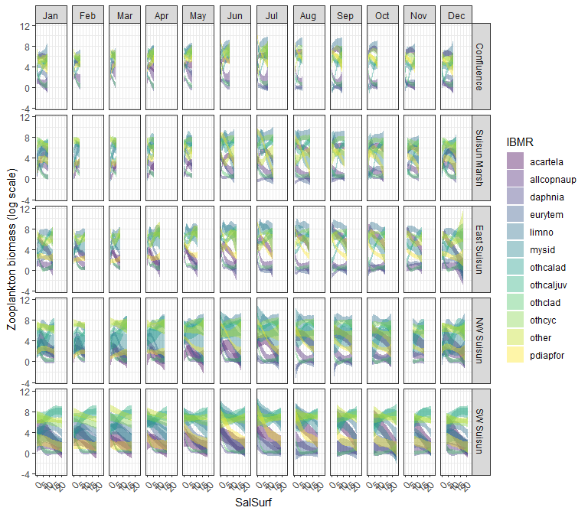

### acartela

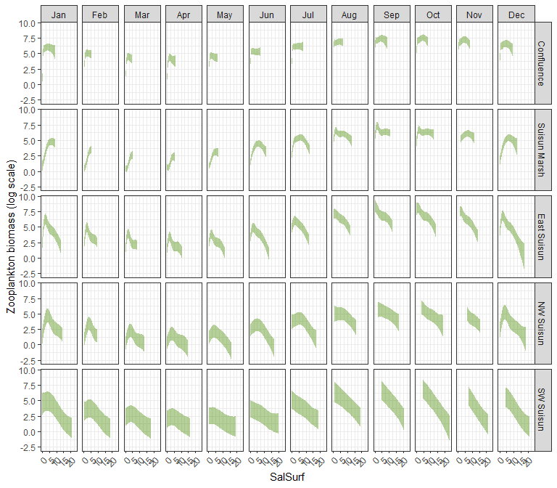

### daphnia

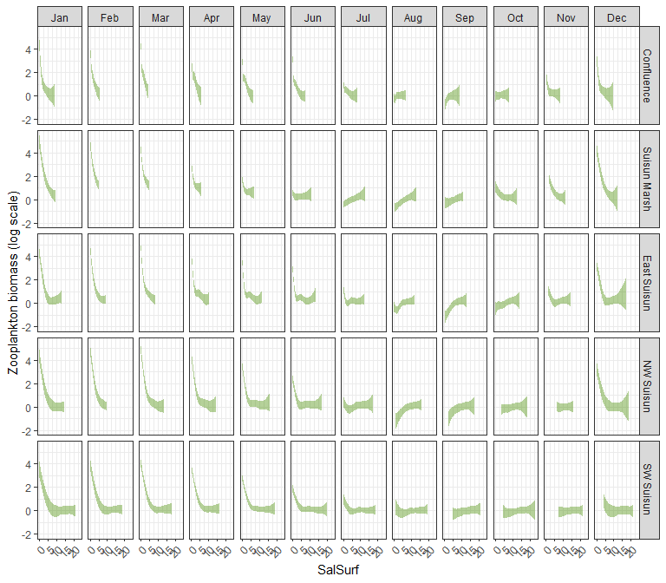

### eurytem

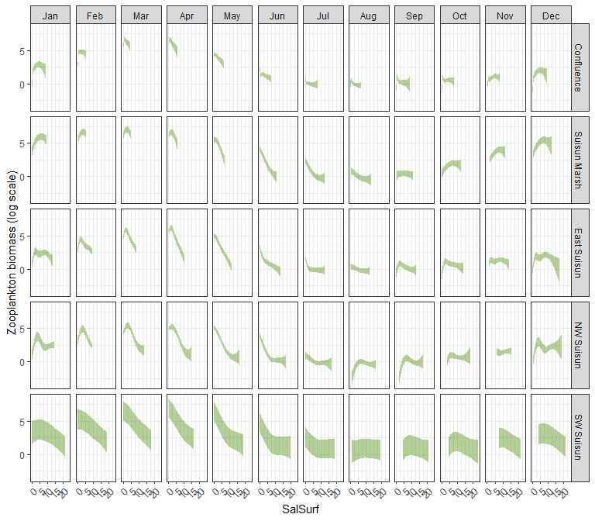

### othcalad

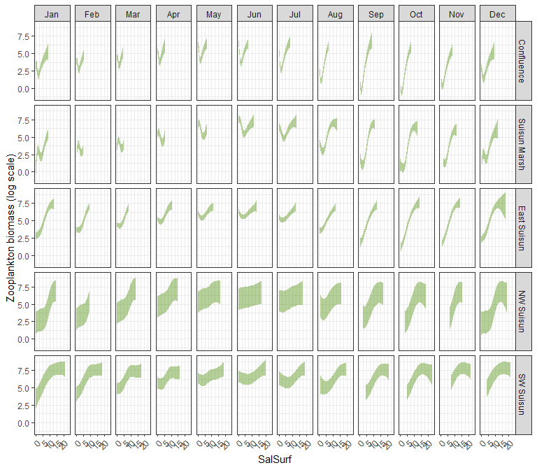

### othcaljuv

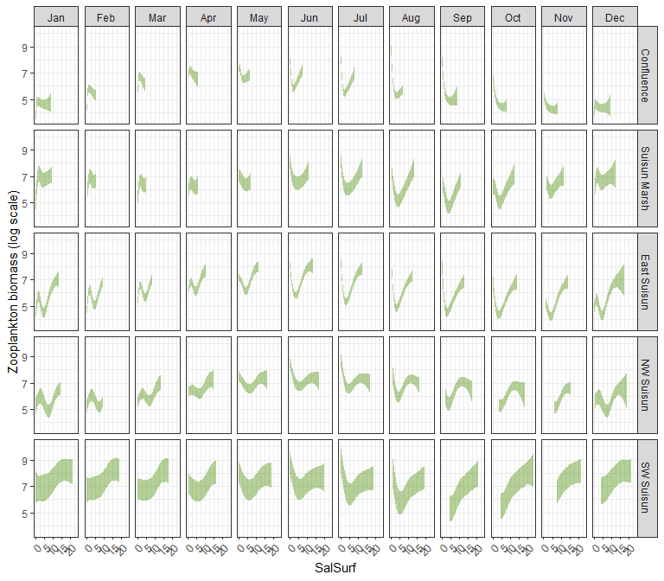

### othclad

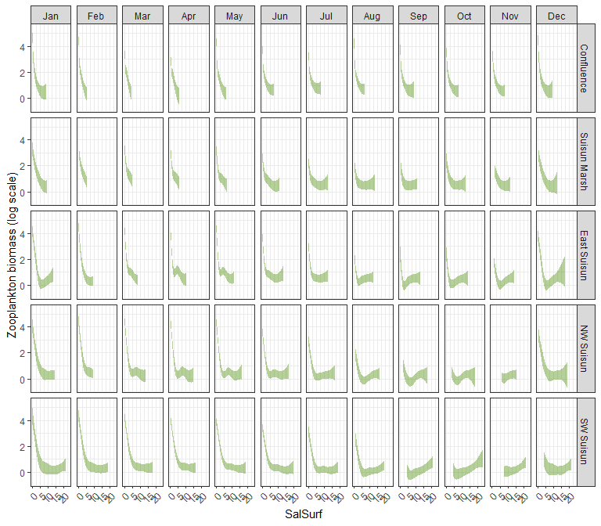

### pdiapfor

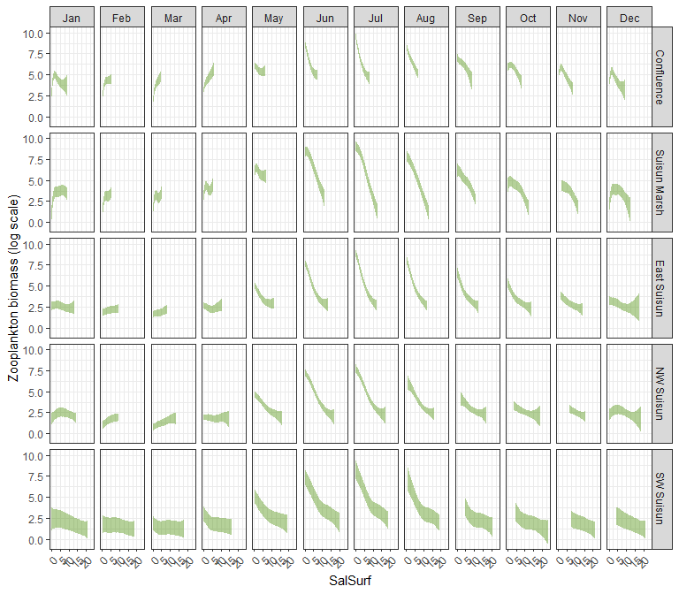

### allcopnaup

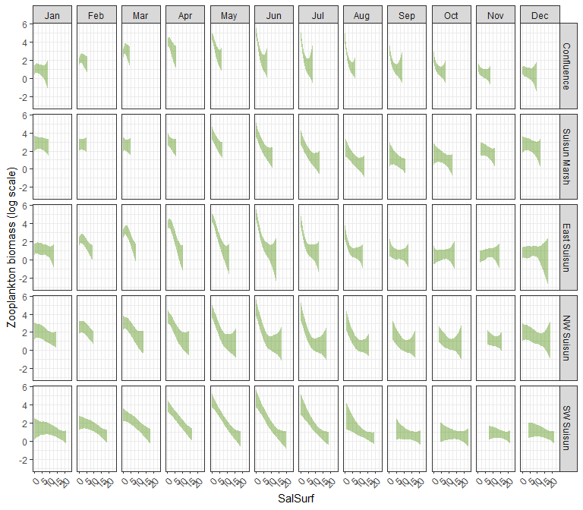

### limno

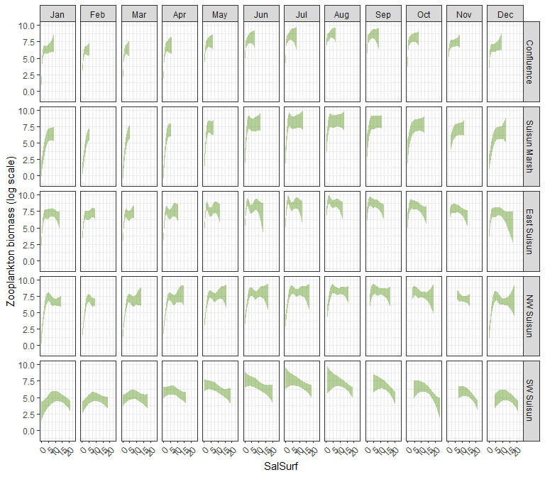

### mysid

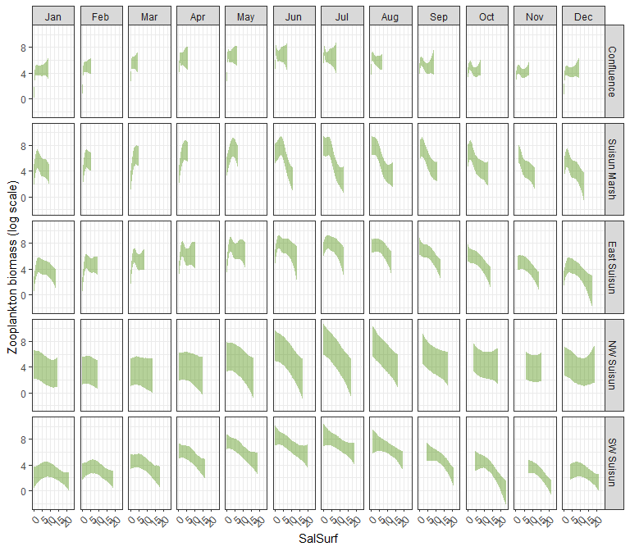

### othcyc

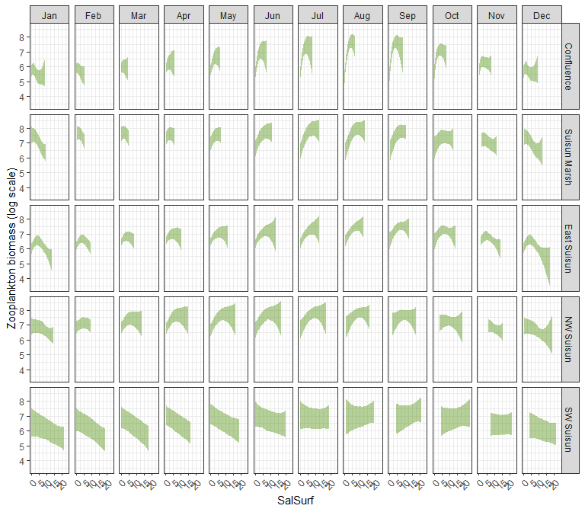

### other

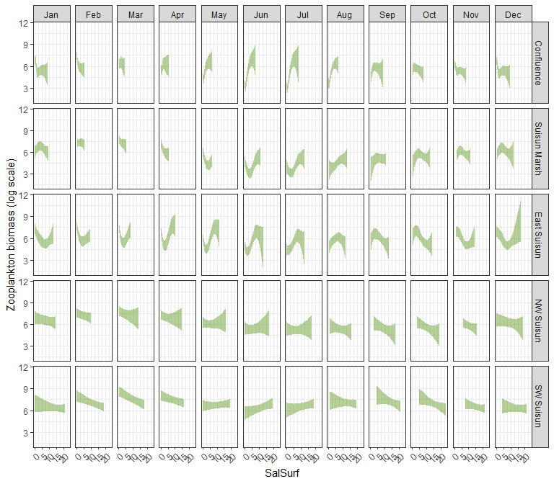

# Read salinity data

salinity_data<-read.csv("../X2_salinity_analysis/converted_salinity_data.csv")   
  
#Original file from CSAMP SDM  
original_scenario_file<-read.csv("../X2_salinity_analysis/base_salinity_data.csv")  
  
#Join the two datasets  
scenario_file <- original_scenario_file %>% select(c(2:5)) %>% left_join(salinity_data)

# Apply model

Load in the modeled salinity

scenario_names<-tibble(name=colnames(scenario_file))%>%  
 filter(str_detect(name, "sal_"))%>%  
 rev()  
  
scenario_sal<-scenario_file%>%  
 select(region, year, month, starts_with("sal_"))%>%  
 mutate(across(c(year, month), as.integer),  
 across(starts_with("sal_"), ~if_else(is.na(.x), sal_base, .x)))%>%  
 filter(region%in%unique(zoop_data_mass$SUBREGION))%>%  
 mutate(region=factor(region,   
 levels=c("Confluence", "Suisun Marsh", "NE Suisun",   
 "SE Suisun", "NW Suisun", "SW Suisun")))%>%  
 pivot_longer(cols=starts_with("sal_"), names_to="Scenario", values_to="Salinity")%>% # Prepare data for easier plotting  
 mutate(Scenario=factor(Scenario,   
 levels=scenario_names$name),  
 Salinity=round(Salinity, 1))

Plot modeled salinity

ggplot(scenario_sal,   
 aes(x=year, y=Salinity, color=Scenario))+  
 geom_line()+  
 scale_color_viridis_d(direction=-1)+  
 facet_grid(region ~ month(month, label=T))+  
 theme_bw()+  
 theme(legend.position = "bottom", axis.text.x=element_text(angle=45, hjust=1))

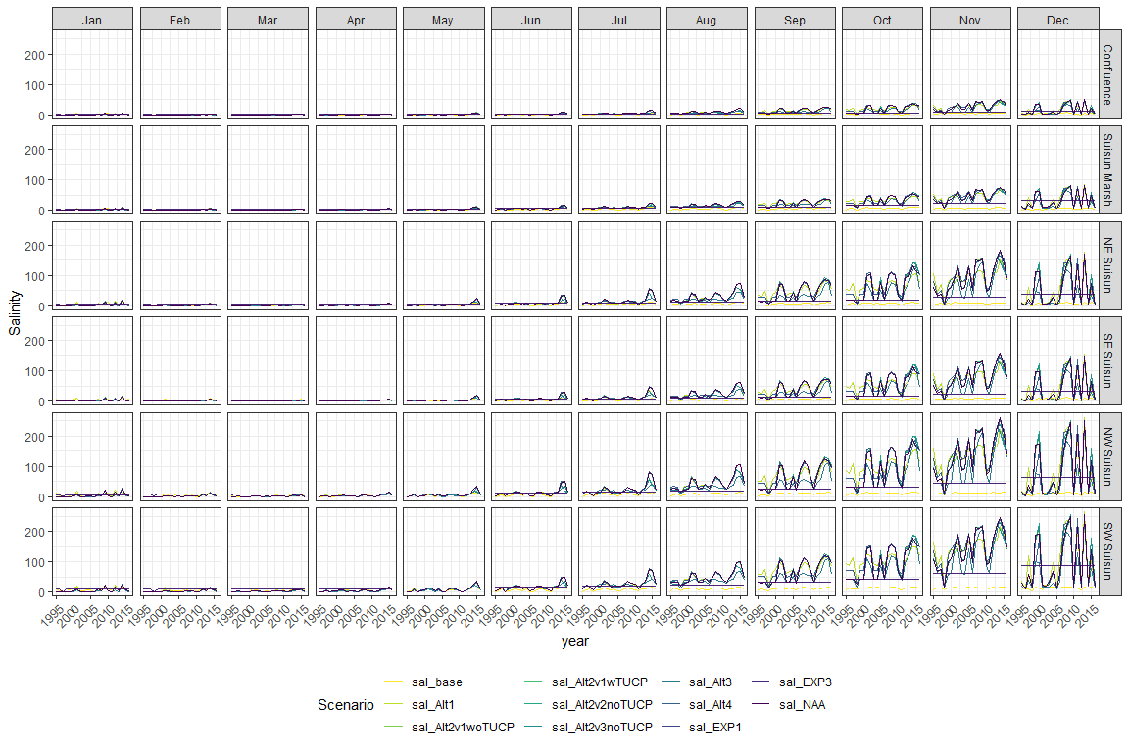

Calculate zoop abundance difference between each scenario and the baseline

zoop_saladjusted<-scenario_sal%>%  
 mutate(Salinity=as.character(Salinity),  
 IBMR=unique(model_factors$IBMR)[1])%>%  
 complete(region, year, month, Scenario, IBMR=unique(model_factors$IBMR))%>%  
 group_by(region, year, month, Scenario)%>%  
 mutate(Salinity=na.exclude(Salinity),  
 region2=if_else(region%in%c("NE Suisun", "SE Suisun"), "East Suisun", as.character(region)))%>%  
 ungroup()%>%  
 left_join(sal_conversions%>%  
 mutate(SalSurf=as.character(SalSurf)),  
 by=c("region2"="Region",  
 "month"="Month",  
 "Salinity"="SalSurf",  
 "IBMR"="IBMR"))%>%  
 select(-Salinity, -region2)%>%  
 mutate(across(starts_with("draw_"), ~exp(.x)-1))%>%  
 pivot_longer(starts_with("draw_"), names_prefix="draw_", names_to="draw", values_to="fit")%>%  
 mutate(fit=if_else(fit<0, 0, fit))%>%  
 pivot_wider(names_from="Scenario", values_from="fit")%>%  
 mutate(across(starts_with("sal_"), ~.x/sal_base))%>%  
 group_by(region, year, month, IBMR)%>%  
 summarise(across(starts_with("sal_"),   
 list(median=~median(.x, na.rm=T),   
 l95=~quantile(.x, 0.025, na.rm=T),   
 u95=~quantile(.x, 0.975, na.rm=T))),   
 .groups="drop")  
  
write_csv(zoop_saladjusted, "zoop sal adjustments.csv")

You can find the final zoop salinity adjustments [here](https://github.com/sbashevkin/FLOATDrought/blob/main/Outputs/CSAMP%20zoop%20sal%20adjustments.csv)

## Prepare plots

Plot the missing model results resulting from out-of-range salinity values in the inputs

missing_adjusted_data<-zoop_saladjusted%>%  
 select(-ends_with("l95"), -ends_with("u95"))%>%  
 filter(IBMR=="acartela")%>%  
 pivot_longer(cols=starts_with("sal_"), names_to="Scenario", values_to="zoop_change")%>%  
 mutate(Scenario=str_remove(Scenario, fixed("_median")))  
  
ggplot(missing_adjusted_data,  
 aes(x=year, y=Scenario, fill=is.na(zoop_change)))+  
 geom_tile()+  
 scale_fill_viridis_d(name="Are the model results missing due to out-of-range salinity values?")+  
 facet_grid(region ~ month(month, label=T))+  
 theme_bw()+  
 theme(legend.position = "bottom", axis.text.x=element_text(angle=45, hjust=1))

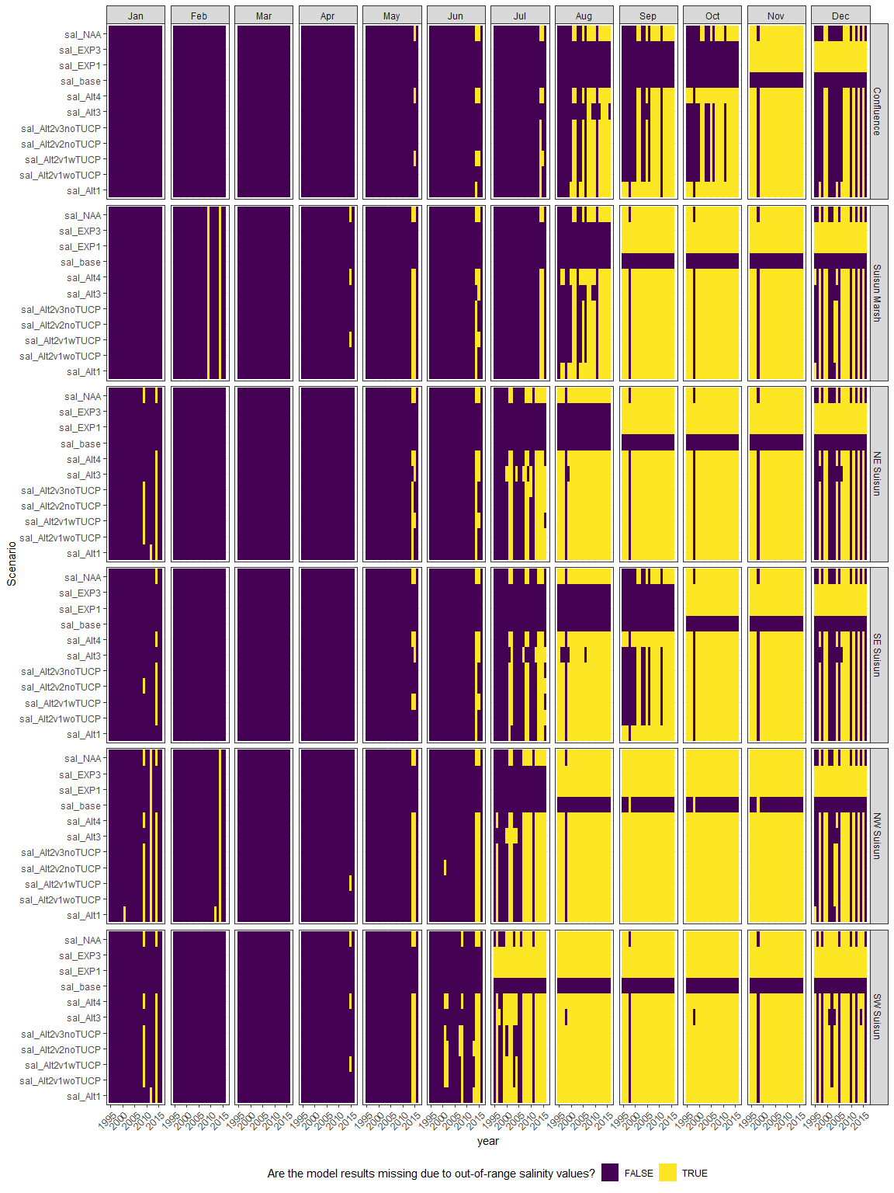

Plot the result

Create some plotting functions

neglop1p<-trans_new("neglop1p", transform=function(x) sign(x)*log(abs(x)+1), inverse=function(x) sign(x)*(exp(abs(x))-1))  
plot_scenario_result <- function(scenario, group) {  
   
 plot_data<-zoop_saladjusted%>%  
 filter(IBMR%in%group)  
   
 ggplot(plot_data,  
 aes(x=year, y=.data[[paste0(scenario, "_median")]], ymin=.data[[paste0(scenario, "_l95")]], ymax=.data[[paste0(scenario, "_u95")]]))+  
 geom_ribbon(alpha=0.4, fill="darkorchid4")+  
 geom_line(alpha=0.4, color="darkorchid4")+  
 scale_y_continuous(trans=neglop1p, breaks=c(-1000, -100, -10, -1, 0, 1, 10, 100, 1000))+  
 ylab("Scenario/baseline (log scale)")+  
 facet_grid(region ~ month(month, label=T))+  
 theme_bw()+  
 theme(legend.position = "bottom", axis.text.x=element_text(angle=45, hjust=1))  
}

# Create plots for each Parameter  
scenario_result_plots <- expand_grid(Scenario=unique(scenario_sal$Scenario)[-1],  
 IBMR=unique(model_factors$IBMR))%>%  
 mutate(plot=map2(Scenario, IBMR, ~plot_scenario_result(.x, .y)))

## Result plots

### sal_Alt1

#### acartela

## Warning in max(ids, na.rm = TRUE): no non-missing arguments to max; returning  
## -Inf  
  
## Warning in max(ids, na.rm = TRUE): no non-missing arguments to max; returning  
## -Inf  
  
## Warning in max(ids, na.rm = TRUE): no non-missing arguments to max; returning  
## -Inf  
  
## Warning in max(ids, na.rm = TRUE): no non-missing arguments to max; returning  
## -Inf  
  
## Warning in max(ids, na.rm = TRUE): no non-missing arguments to max; returning  
## -Inf

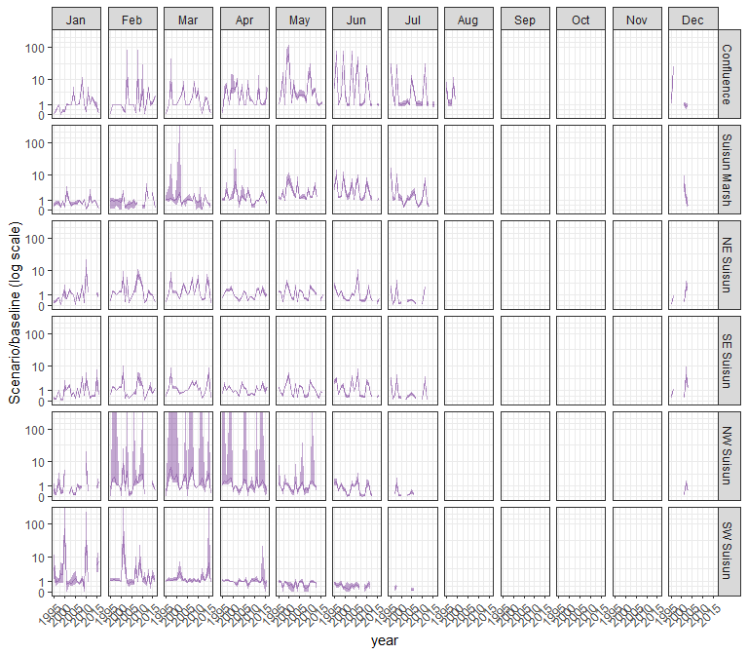

#### daphnia

## Warning in max(ids, na.rm = TRUE): no non-missing arguments to max; returning  
## -Inf  
  
## Warning in max(ids, na.rm = TRUE): no non-missing arguments to max; returning  
## -Inf  
  
## Warning in max(ids, na.rm = TRUE): no non-missing arguments to max; returning  
## -Inf  
  
## Warning in max(ids, na.rm = TRUE): no non-missing arguments to max; returning  
## -Inf  
  
## Warning in max(ids, na.rm = TRUE): no non-missing arguments to max; returning  
## -Inf

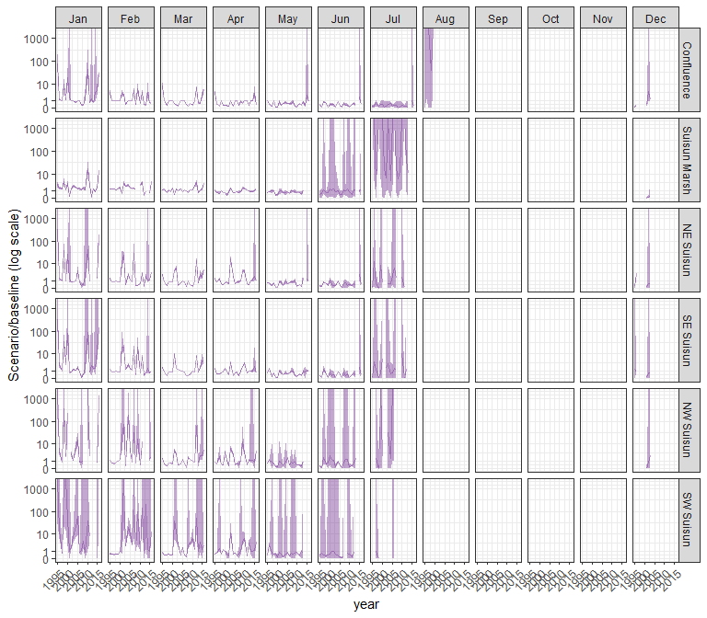

#### eurytem

## Warning in max(ids, na.rm = TRUE): no non-missing arguments to max; returning  
## -Inf  
  
## Warning in max(ids, na.rm = TRUE): no non-missing arguments to max; returning  
## -Inf  
  
## Warning in max(ids, na.rm = TRUE): no non-missing arguments to max; returning  
## -Inf  
  
## Warning in max(ids, na.rm = TRUE): no non-missing arguments to max; returning  
## -Inf  
  
## Warning in max(ids, na.rm = TRUE): no non-missing arguments to max; returning  
## -Inf

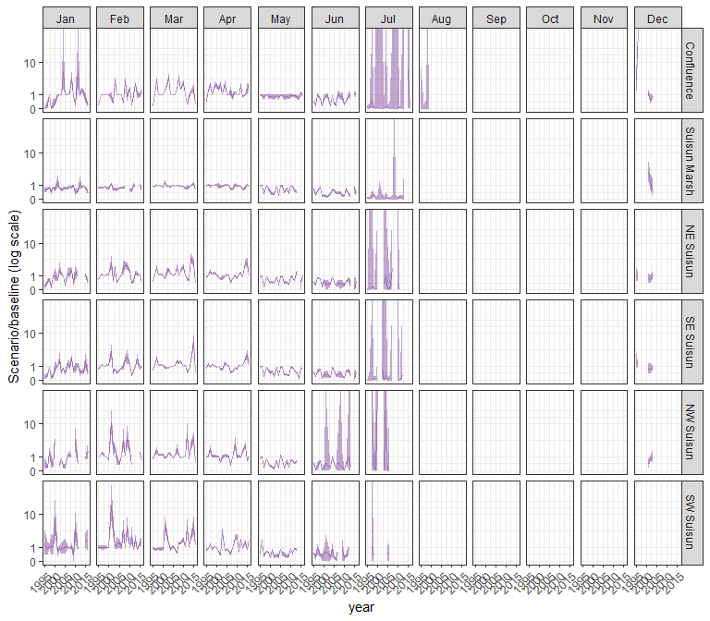

#### othcalad

## Warning in max(ids, na.rm = TRUE): no non-missing arguments to max; returning  
## -Inf  
  
## Warning in max(ids, na.rm = TRUE): no non-missing arguments to max; returning  
## -Inf  
  
## Warning in max(ids, na.rm = TRUE): no non-missing arguments to max; returning  
## -Inf  
  
## Warning in max(ids, na.rm = TRUE): no non-missing arguments to max; returning  
## -Inf  
  
## Warning in max(ids, na.rm = TRUE): no non-missing arguments to max; returning  
## -Inf

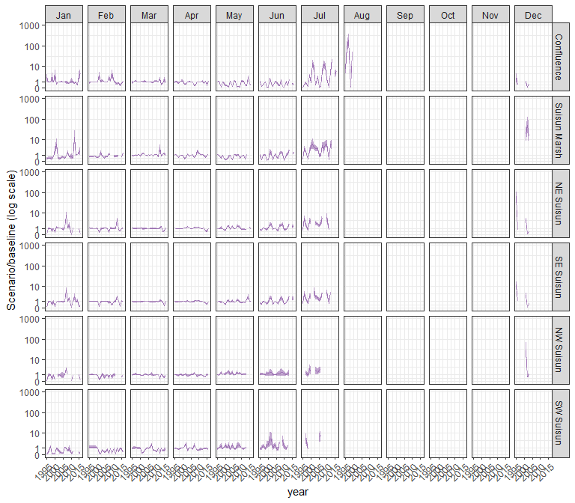

#### othcaljuv

## Warning in max(ids, na.rm = TRUE): no non-missing arguments to max; returning  
## -Inf  
  
## Warning in max(ids, na.rm = TRUE): no non-missing arguments to max; returning  
## -Inf  
  
## Warning in max(ids, na.rm = TRUE): no non-missing arguments to max; returning  
## -Inf  
  
## Warning in max(ids, na.rm = TRUE): no non-missing arguments to max; returning  
## -Inf  
  
## Warning in max(ids, na.rm = TRUE): no non-missing arguments to max; returning  
## -Inf

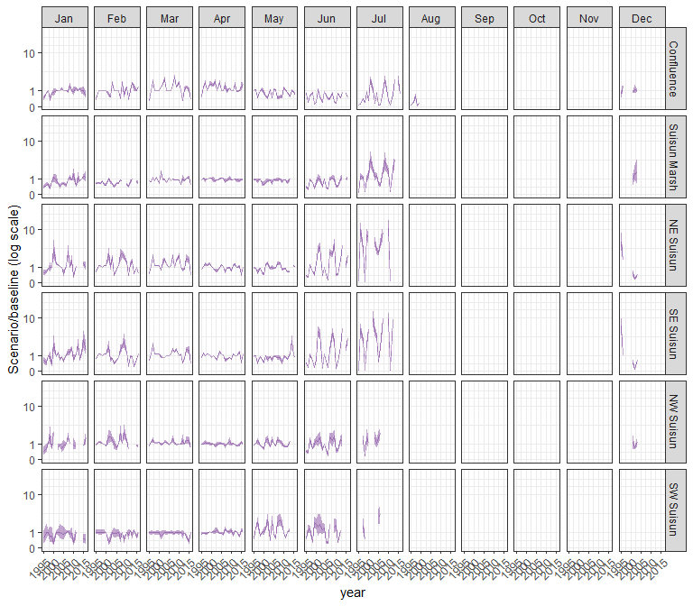

#### othclad

## Warning in max(ids, na.rm = TRUE): no non-missing arguments to max; returning  
## -Inf  
  
## Warning in max(ids, na.rm = TRUE): no non-missing arguments to max; returning  
## -Inf  
  
## Warning in max(ids, na.rm = TRUE): no non-missing arguments to max; returning  
## -Inf  
  
## Warning in max(ids, na.rm = TRUE): no non-missing arguments to max; returning  
## -Inf  
  
## Warning in max(ids, na.rm = TRUE): no non-missing arguments to max; returning  
## -Inf

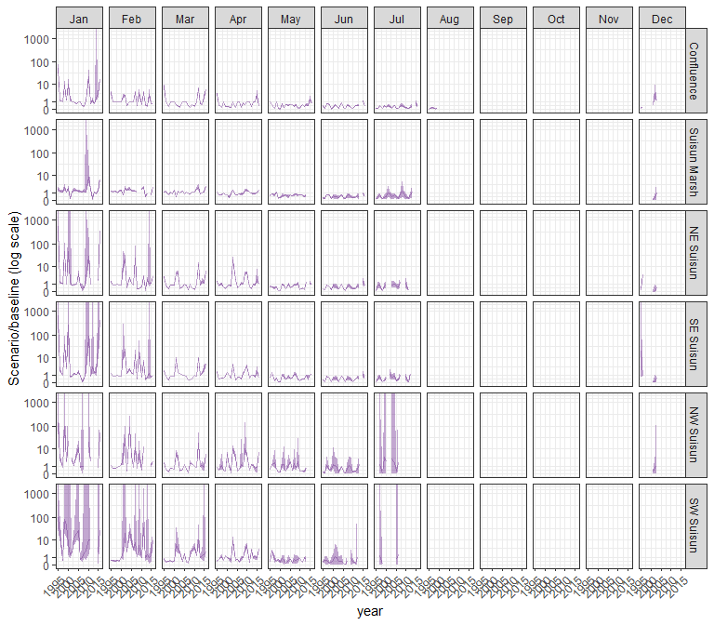

#### pdiapfor

## Warning in max(ids, na.rm = TRUE): no non-missing arguments to max; returning  
## -Inf  
  
## Warning in max(ids, na.rm = TRUE): no non-missing arguments to max; returning  
## -Inf  
  
## Warning in max(ids, na.rm = TRUE): no non-missing arguments to max; returning  
## -Inf  
  
## Warning in max(ids, na.rm = TRUE): no non-missing arguments to max; returning  
## -Inf  
  
## Warning in max(ids, na.rm = TRUE): no non-missing arguments to max; returning  
## -Inf

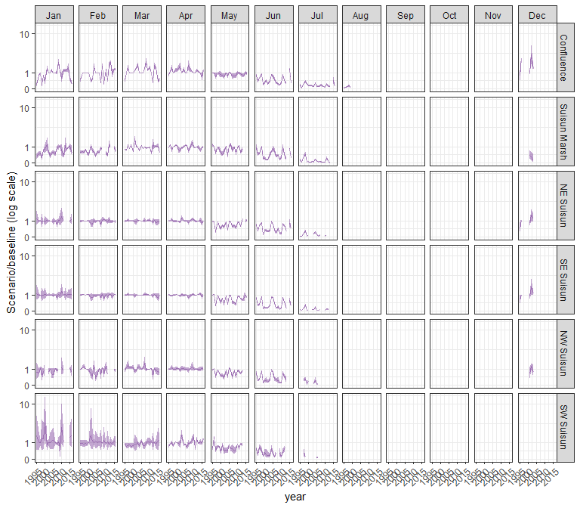

#### allcopnaup

## Warning in max(ids, na.rm = TRUE): no non-missing arguments to max; returning  
## -Inf  
  
## Warning in max(ids, na.rm = TRUE): no non-missing arguments to max; returning  
## -Inf  
  
## Warning in max(ids, na.rm = TRUE): no non-missing arguments to max; returning  
## -Inf  
  
## Warning in max(ids, na.rm = TRUE): no non-missing arguments to max; returning  
## -Inf  
  
## Warning in max(ids, na.rm = TRUE): no non-missing arguments to max; returning  
## -Inf

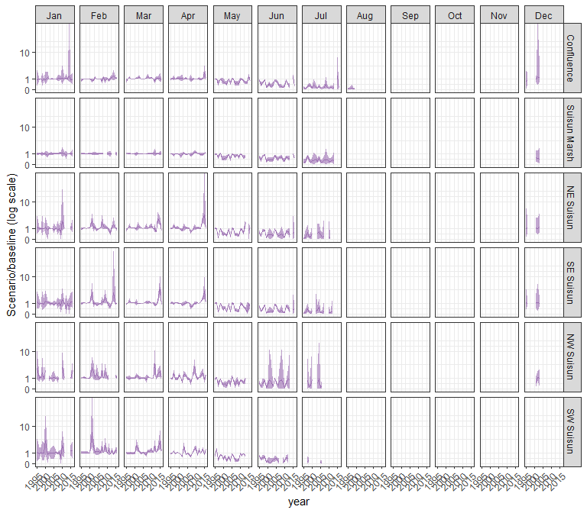

#### limno

## Warning in max(ids, na.rm = TRUE): no non-missing arguments to max; returning  
## -Inf  
  
## Warning in max(ids, na.rm = TRUE): no non-missing arguments to max; returning  
## -Inf  
  
## Warning in max(ids, na.rm = TRUE): no non-missing arguments to max; returning  
## -Inf  
  
## Warning in max(ids, na.rm = TRUE): no non-missing arguments to max; returning  
## -Inf  
  
## Warning in max(ids, na.rm = TRUE): no non-missing arguments to max; returning  
## -Inf

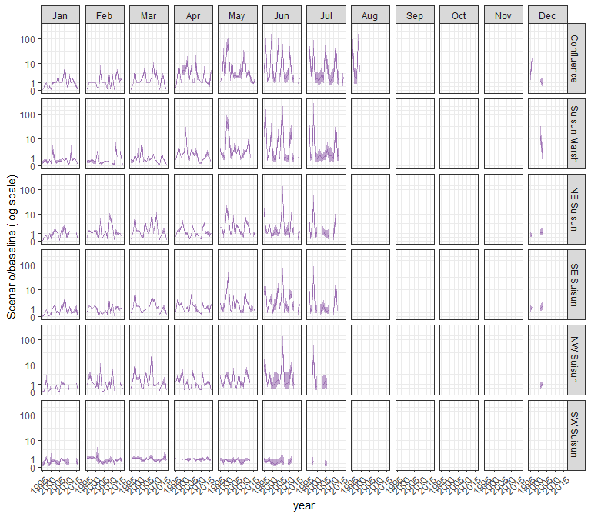

#### mysid

## Warning in max(ids, na.rm = TRUE): no non-missing arguments to max; returning  
## -Inf  
  
## Warning in max(ids, na.rm = TRUE): no non-missing arguments to max; returning  
## -Inf  
  
## Warning in max(ids, na.rm = TRUE): no non-missing arguments to max; returning  
## -Inf  
  
## Warning in max(ids, na.rm = TRUE): no non-missing arguments to max; returning  
## -Inf  
  
## Warning in max(ids, na.rm = TRUE): no non-missing arguments to max; returning  
## -Inf

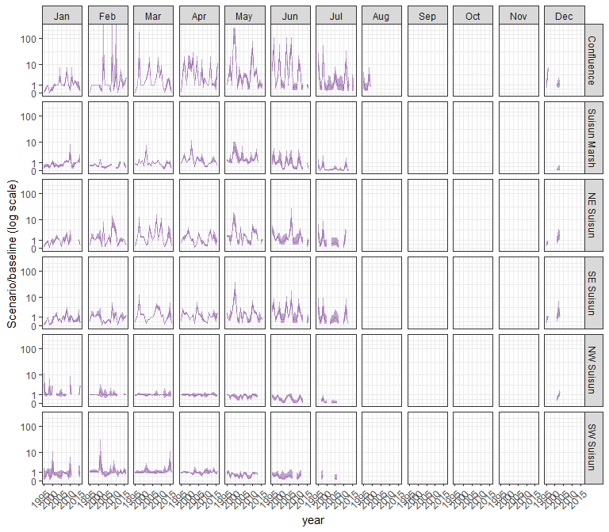

#### othcyc

## Warning in max(ids, na.rm = TRUE): no non-missing arguments to max; returning  
## -Inf  
  
## Warning in max(ids, na.rm = TRUE): no non-missing arguments to max; returning  
## -Inf  
  
## Warning in max(ids, na.rm = TRUE): no non-missing arguments to max; returning  
## -Inf  
  
## Warning in max(ids, na.rm = TRUE): no non-missing arguments to max; returning  
## -Inf  
  
## Warning in max(ids, na.rm = TRUE): no non-missing arguments to max; returning  
## -Inf

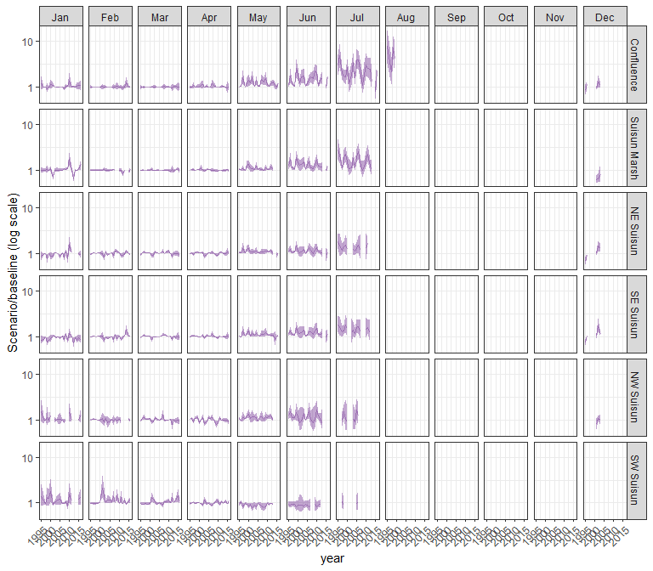

#### other

## Warning in max(ids, na.rm = TRUE): no non-missing arguments to max; returning  
## -Inf  
  
## Warning in max(ids, na.rm = TRUE): no non-missing arguments to max; returning  
## -Inf  
  
## Warning in max(ids, na.rm = TRUE): no non-missing arguments to max; returning  
## -Inf  
  
## Warning in max(ids, na.rm = TRUE): no non-missing arguments to max; returning  
## -Inf  
  
## Warning in max(ids, na.rm = TRUE): no non-missing arguments to max; returning  
## -Inf

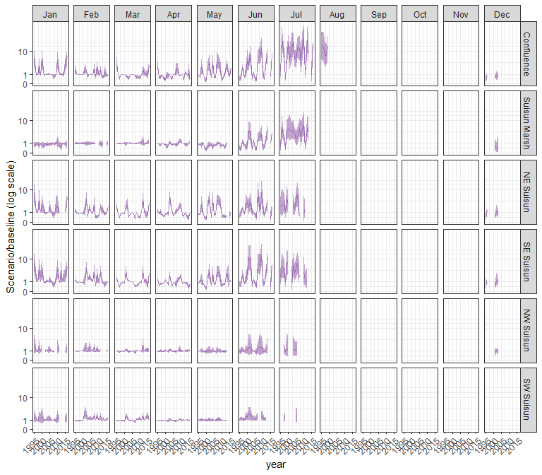

### sal_Alt2v1woTUCP

#### acartela

## Warning in max(ids, na.rm = TRUE): no non-missing arguments to max; returning  
## -Inf  
  
## Warning in max(ids, na.rm = TRUE): no non-missing arguments to max; returning  
## -Inf  
  
## Warning in max(ids, na.rm = TRUE): no non-missing arguments to max; returning  
## -Inf  
  
## Warning in max(ids, na.rm = TRUE): no non-missing arguments to max; returning  
## -Inf  
  
## Warning in max(ids, na.rm = TRUE): no non-missing arguments to max; returning  
## -Inf

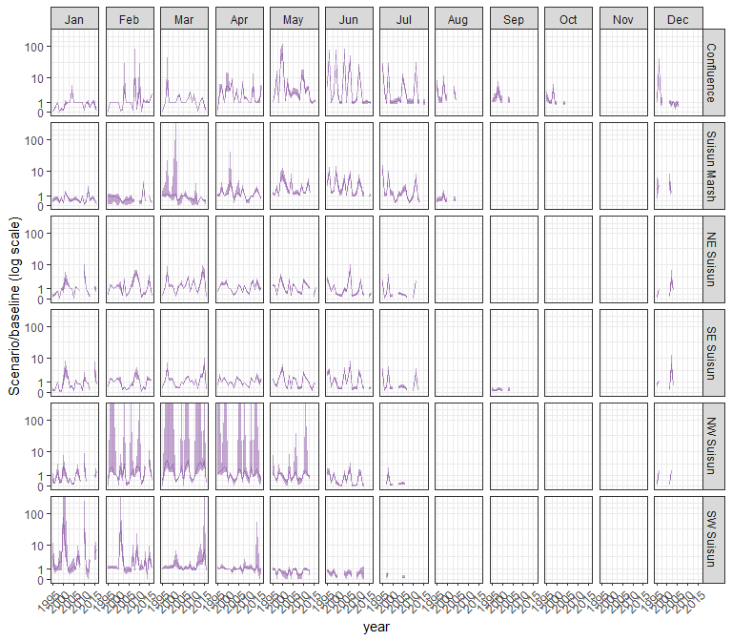

#### daphnia

## Warning in max(ids, na.rm = TRUE): no non-missing arguments to max; returning  
## -Inf  
  
## Warning in max(ids, na.rm = TRUE): no non-missing arguments to max; returning  
## -Inf  
  
## Warning in max(ids, na.rm = TRUE): no non-missing arguments to max; returning  
## -Inf  
  
## Warning in max(ids, na.rm = TRUE): no non-missing arguments to max; returning  
## -Inf  
  
## Warning in max(ids, na.rm = TRUE): no non-missing arguments to max; returning  
## -Inf

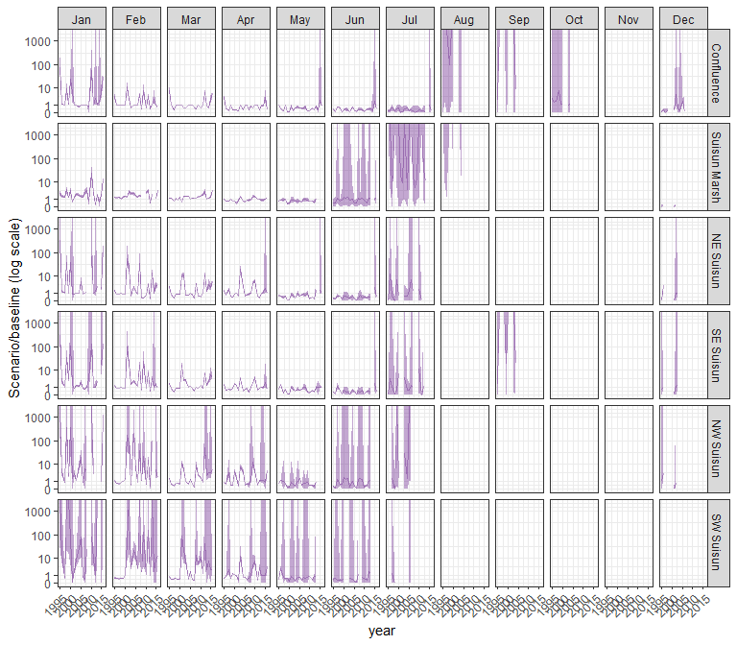

#### eurytem

## Warning in max(ids, na.rm = TRUE): no non-missing arguments to max; returning  
## -Inf  
  
## Warning in max(ids, na.rm = TRUE): no non-missing arguments to max; returning  
## -Inf  
  
## Warning in max(ids, na.rm = TRUE): no non-missing arguments to max; returning  
## -Inf  
  
## Warning in max(ids, na.rm = TRUE): no non-missing arguments to max; returning  
## -Inf  
  
## Warning in max(ids, na.rm = TRUE): no non-missing arguments to max; returning  
## -Inf

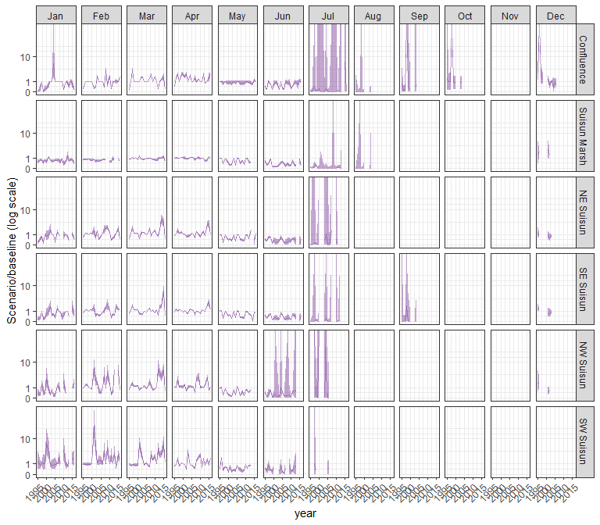

#### othcalad

## Warning in max(ids, na.rm = TRUE): no non-missing arguments to max; returning  
## -Inf  
  
## Warning in max(ids, na.rm = TRUE): no non-missing arguments to max; returning  
## -Inf  
  
## Warning in max(ids, na.rm = TRUE): no non-missing arguments to max; returning  
## -Inf  
  
## Warning in max(ids, na.rm = TRUE): no non-missing arguments to max; returning  
## -Inf  
  
## Warning in max(ids, na.rm = TRUE): no non-missing arguments to max; returning  
## -Inf

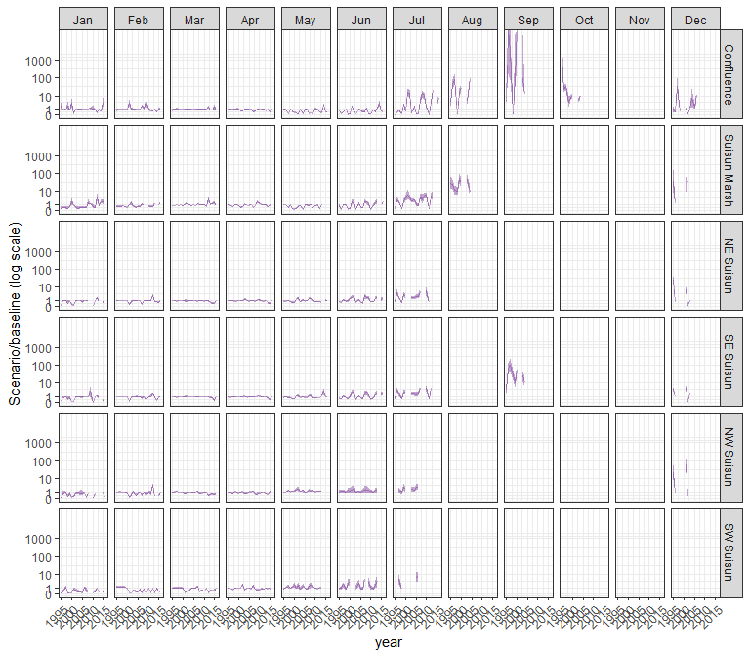

#### othcaljuv

## Warning in max(ids, na.rm = TRUE): no non-missing arguments to max; returning  
## -Inf  
  
## Warning in max(ids, na.rm = TRUE): no non-missing arguments to max; returning  
## -Inf  
  
## Warning in max(ids, na.rm = TRUE): no non-missing arguments to max; returning  
## -Inf  
  
## Warning in max(ids, na.rm = TRUE): no non-missing arguments to max; returning  
## -Inf  
  
## Warning in max(ids, na.rm = TRUE): no non-missing arguments to max; returning  
## -Inf

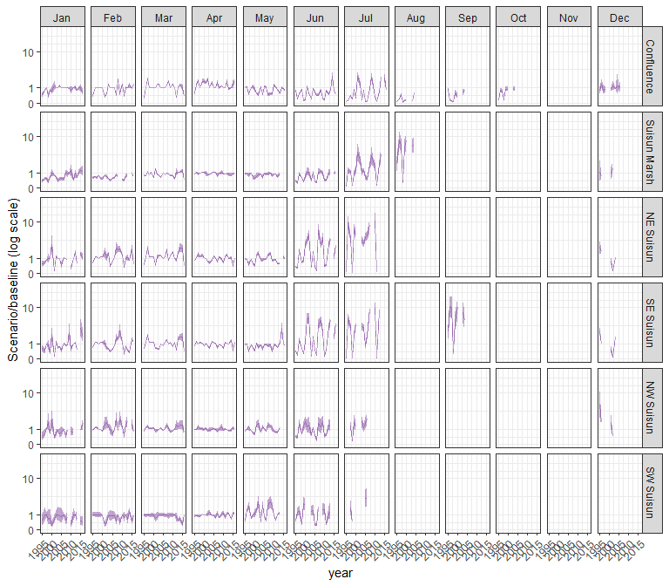

#### othclad

## Warning in max(ids, na.rm = TRUE): no non-missing arguments to max; returning  
## -Inf  
  
## Warning in max(ids, na.rm = TRUE): no non-missing arguments to max; returning  
## -Inf  
  
## Warning in max(ids, na.rm = TRUE): no non-missing arguments to max; returning  
## -Inf  
  
## Warning in max(ids, na.rm = TRUE): no non-missing arguments to max; returning  
## -Inf  
  
## Warning in max(ids, na.rm = TRUE): no non-missing arguments to max; returning  
## -Inf

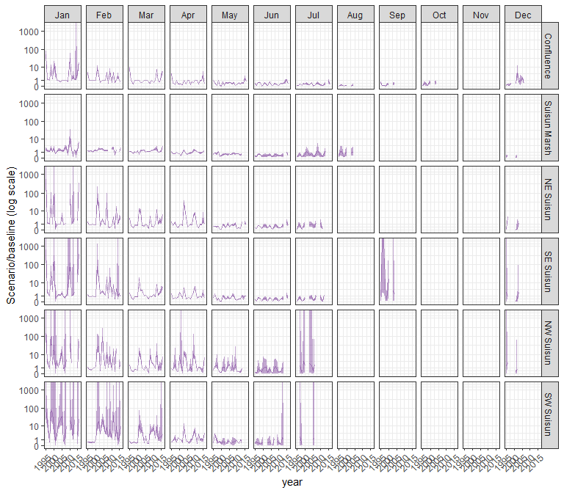

#### pdiapfor

## Warning in max(ids, na.rm = TRUE): no non-missing arguments to max; returning  
## -Inf  
  
## Warning in max(ids, na.rm = TRUE): no non-missing arguments to max; returning  
## -Inf  
  
## Warning in max(ids, na.rm = TRUE): no non-missing arguments to max; returning  
## -Inf  
  
## Warning in max(ids, na.rm = TRUE): no non-missing arguments to max; returning  
## -Inf  
  
## Warning in max(ids, na.rm = TRUE): no non-missing arguments to max; returning  
## -Inf

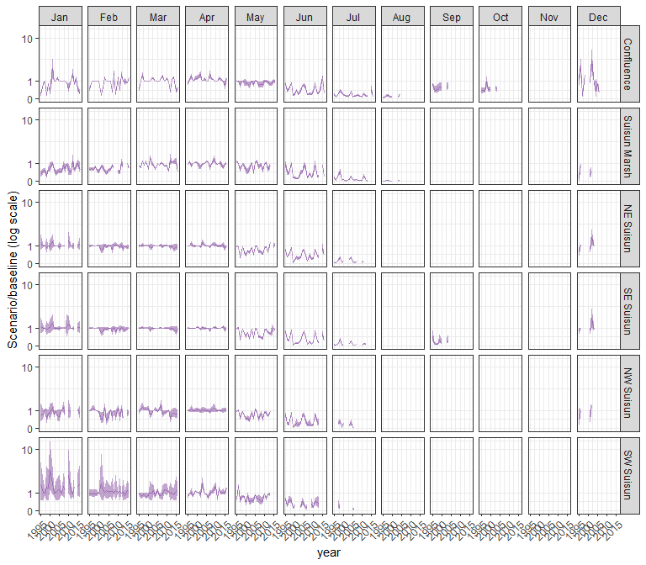

#### allcopnaup

## Warning in max(ids, na.rm = TRUE): no non-missing arguments to max; returning  
## -Inf  
  
## Warning in max(ids, na.rm = TRUE): no non-missing arguments to max; returning  
## -Inf  
  
## Warning in max(ids, na.rm = TRUE): no non-missing arguments to max; returning  
## -Inf  
  
## Warning in max(ids, na.rm = TRUE): no non-missing arguments to max; returning  
## -Inf  
  
## Warning in max(ids, na.rm = TRUE): no non-missing arguments to max; returning  
## -Inf

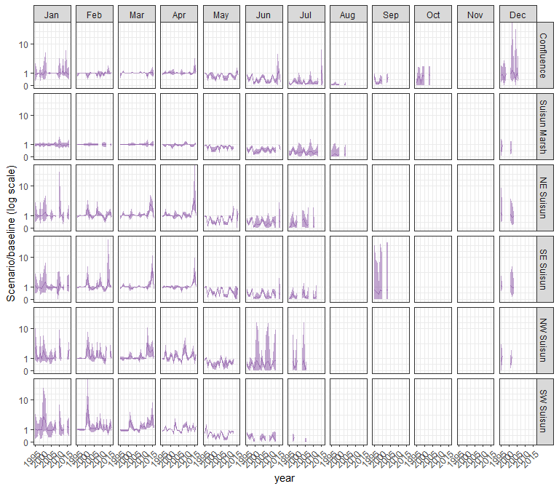

#### limno

## Warning in max(ids, na.rm = TRUE): no non-missing arguments to max; returning  
## -Inf  
  
## Warning in max(ids, na.rm = TRUE): no non-missing arguments to max; returning  
## -Inf  
  
## Warning in max(ids, na.rm = TRUE): no non-missing arguments to max; returning  
## -Inf  
  
## Warning in max(ids, na.rm = TRUE): no non-missing arguments to max; returning  
## -Inf  
  
## Warning in max(ids, na.rm = TRUE): no non-missing arguments to max; returning  
## -Inf

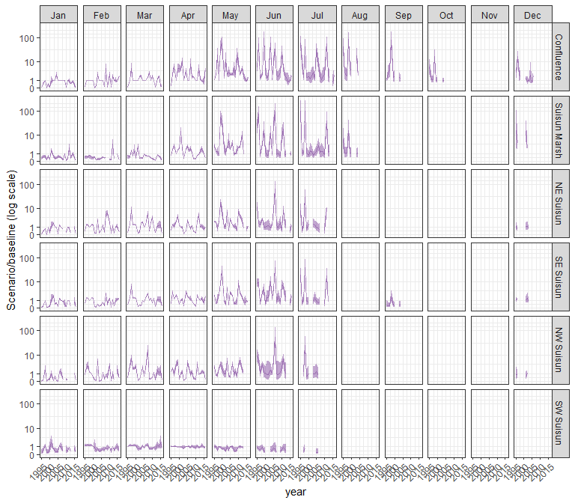

#### mysid

## Warning in max(ids, na.rm = TRUE): no non-missing arguments to max; returning  
## -Inf  
  
## Warning in max(ids, na.rm = TRUE): no non-missing arguments to max; returning  
## -Inf  
  
## Warning in max(ids, na.rm = TRUE): no non-missing arguments to max; returning  
## -Inf  
  
## Warning in max(ids, na.rm = TRUE): no non-missing arguments to max; returning  
## -Inf  
  
## Warning in max(ids, na.rm = TRUE): no non-missing arguments to max; returning  
## -Inf

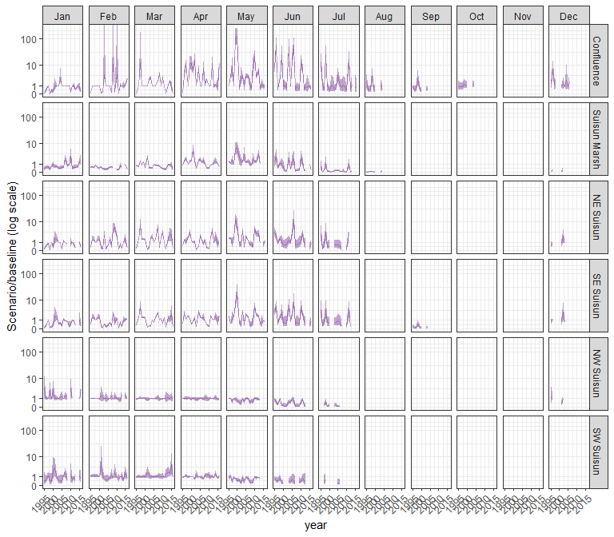

#### othcyc

## Warning in max(ids, na.rm = TRUE): no non-missing arguments to max; returning  
## -Inf  
  
## Warning in max(ids, na.rm = TRUE): no non-missing arguments to max; returning  
## -Inf  
  
## Warning in max(ids, na.rm = TRUE): no non-missing arguments to max; returning  
## -Inf  
  
## Warning in max(ids, na.rm = TRUE): no non-missing arguments to max; returning  
## -Inf  
  
## Warning in max(ids, na.rm = TRUE): no non-missing arguments to max; returning  
## -Inf

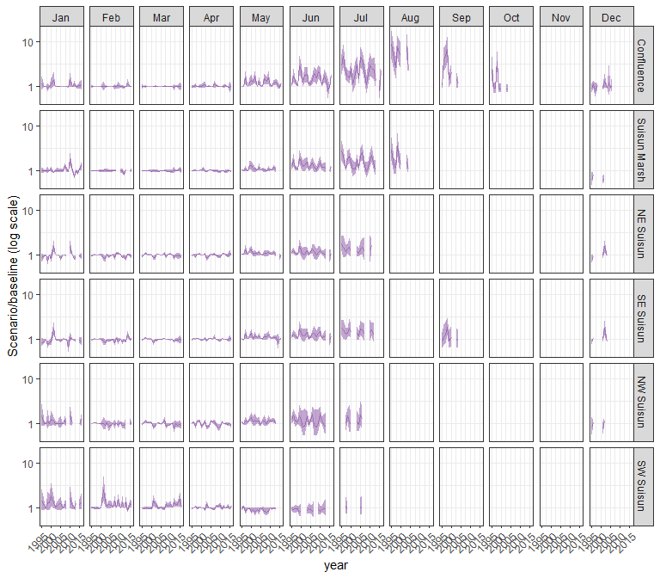

#### other

## Warning in max(ids, na.rm = TRUE): no non-missing arguments to max; returning  
## -Inf  
  
## Warning in max(ids, na.rm = TRUE): no non-missing arguments to max; returning  
## -Inf  
  
## Warning in max(ids, na.rm = TRUE): no non-missing arguments to max; returning  
## -Inf  
  
## Warning in max(ids, na.rm = TRUE): no non-missing arguments to max; returning  
## -Inf  
  
## Warning in max(ids, na.rm = TRUE): no non-missing arguments to max; returning  
## -Inf

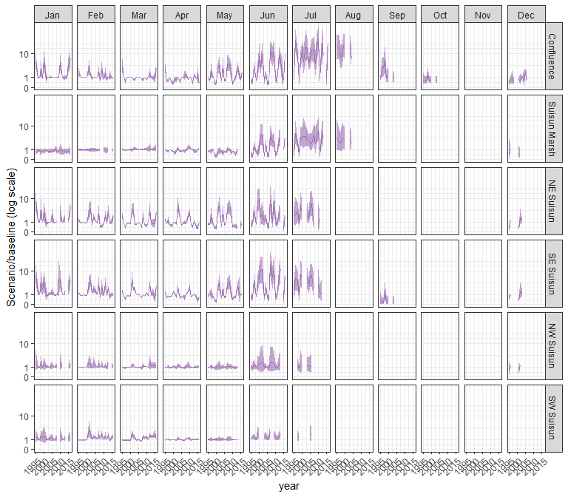

### sal_Alt2v1wTUCP

#### acartela

## Warning in max(ids, na.rm = TRUE): no non-missing arguments to max; returning  
## -Inf  
  
## Warning in max(ids, na.rm = TRUE): no non-missing arguments to max; returning  
## -Inf  
  
## Warning in max(ids, na.rm = TRUE): no non-missing arguments to max; returning  
## -Inf  
  
## Warning in max(ids, na.rm = TRUE): no non-missing arguments to max; returning  
## -Inf  
  
## Warning in max(ids, na.rm = TRUE): no non-missing arguments to max; returning  
## -Inf

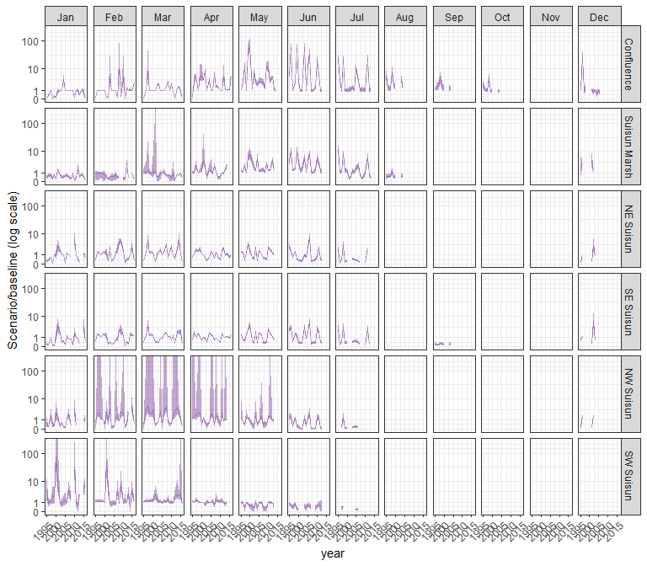

#### daphnia

## Warning in max(ids, na.rm = TRUE): no non-missing arguments to max; returning  
## -Inf  
  
## Warning in max(ids, na.rm = TRUE): no non-missing arguments to max; returning  
## -Inf  
  
## Warning in max(ids, na.rm = TRUE): no non-missing arguments to max; returning  
## -Inf  
  
## Warning in max(ids, na.rm = TRUE): no non-missing arguments to max; returning  
## -Inf  
  
## Warning in max(ids, na.rm = TRUE): no non-missing arguments to max; returning  
## -Inf

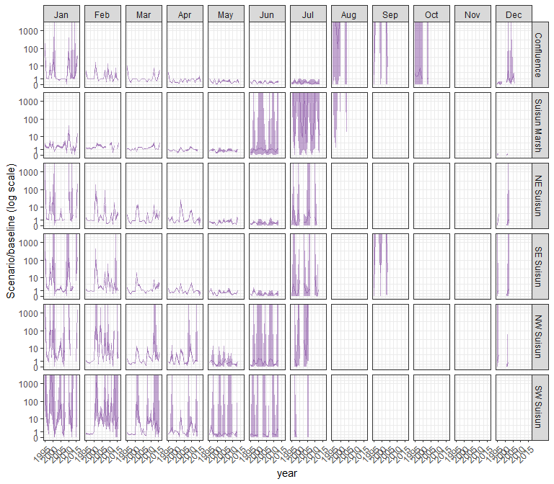

#### eurytem

## Warning in max(ids, na.rm = TRUE): no non-missing arguments to max; returning  
## -Inf  
  
## Warning in max(ids, na.rm = TRUE): no non-missing arguments to max; returning  
## -Inf  
  
## Warning in max(ids, na.rm = TRUE): no non-missing arguments to max; returning  
## -Inf  
  
## Warning in max(ids, na.rm = TRUE): no non-missing arguments to max; returning  
## -Inf  
  
## Warning in max(ids, na.rm = TRUE): no non-missing arguments to max; returning  
## -Inf

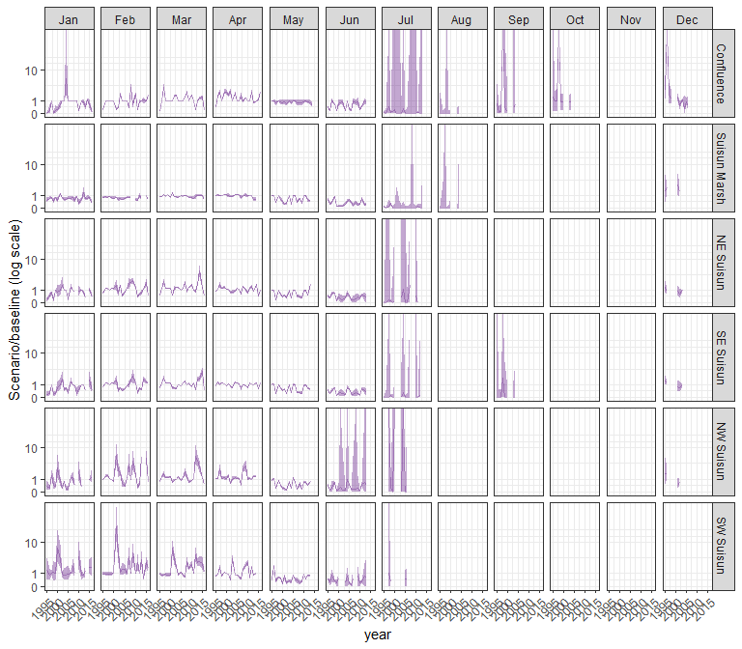

#### othcalad

## Warning in max(ids, na.rm = TRUE): no non-missing arguments to max; returning  
## -Inf  
  
## Warning in max(ids, na.rm = TRUE): no non-missing arguments to max; returning  
## -Inf  
  
## Warning in max(ids, na.rm = TRUE): no non-missing arguments to max; returning  
## -Inf  
  
## Warning in max(ids, na.rm = TRUE): no non-missing arguments to max; returning  
## -Inf  
  
## Warning in max(ids, na.rm = TRUE): no non-missing arguments to max; returning  
## -Inf

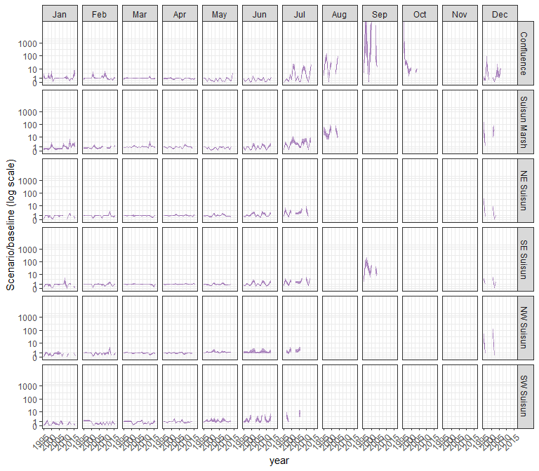

#### othcaljuv

## Warning in max(ids, na.rm = TRUE): no non-missing arguments to max; returning  
## -Inf  
  
## Warning in max(ids, na.rm = TRUE): no non-missing arguments to max; returning  
## -Inf  
  
## Warning in max(ids, na.rm = TRUE): no non-missing arguments to max; returning  
## -Inf  
  
## Warning in max(ids, na.rm = TRUE): no non-missing arguments to max; returning  
## -Inf  
  
## Warning in max(ids, na.rm = TRUE): no non-missing arguments to max; returning  
## -Inf

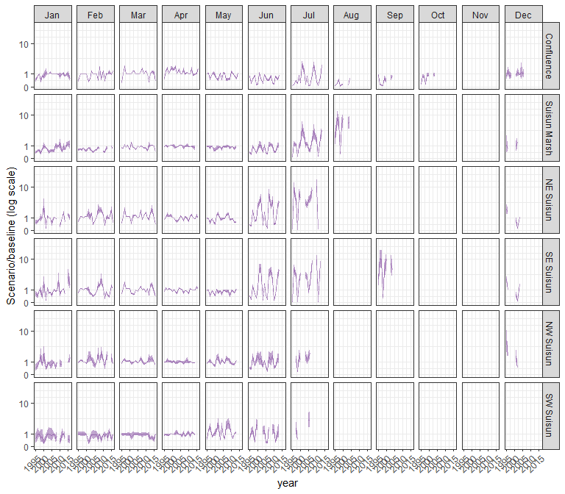

#### othclad

## Warning in max(ids, na.rm = TRUE): no non-missing arguments to max; returning  
## -Inf  
  
## Warning in max(ids, na.rm = TRUE): no non-missing arguments to max; returning  
## -Inf  
  
## Warning in max(ids, na.rm = TRUE): no non-missing arguments to max; returning  
## -Inf  
  
## Warning in max(ids, na.rm = TRUE): no non-missing arguments to max; returning  
## -Inf  
  
## Warning in max(ids, na.rm = TRUE): no non-missing arguments to max; returning  
## -Inf

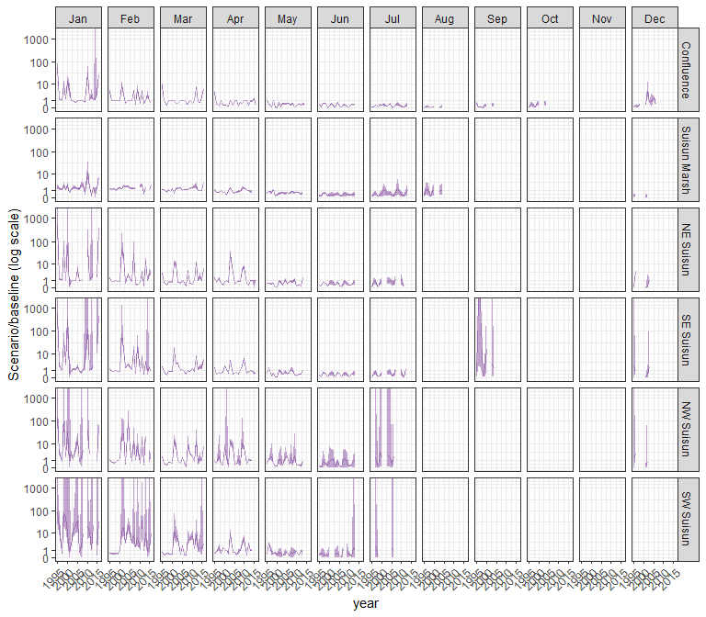

#### pdiapfor

## Warning in max(ids, na.rm = TRUE): no non-missing arguments to max; returning  
## -Inf  
  
## Warning in max(ids, na.rm = TRUE): no non-missing arguments to max; returning  
## -Inf  
  
## Warning in max(ids, na.rm = TRUE): no non-missing arguments to max; returning  
## -Inf  
  
## Warning in max(ids, na.rm = TRUE): no non-missing arguments to max; returning  
## -Inf  
  
## Warning in max(ids, na.rm = TRUE): no non-missing arguments to max; returning  
## -Inf

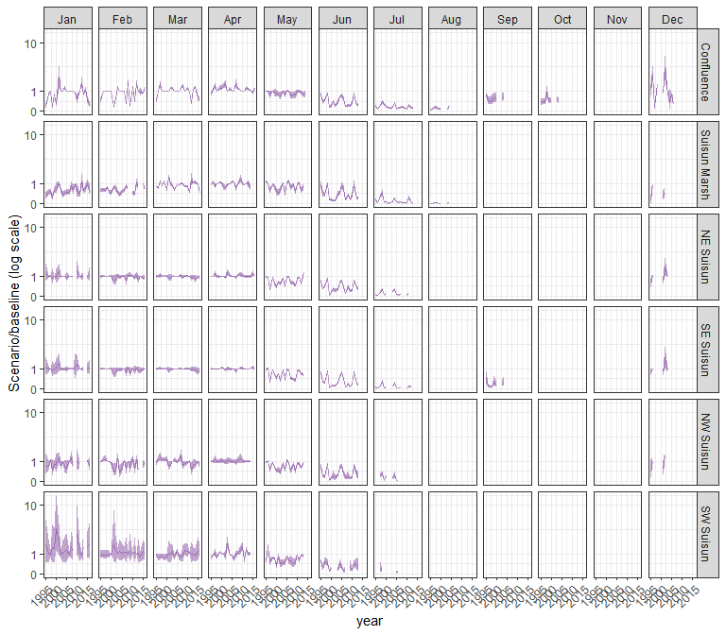

#### allcopnaup

## Warning in max(ids, na.rm = TRUE): no non-missing arguments to max; returning  
## -Inf  
  
## Warning in max(ids, na.rm = TRUE): no non-missing arguments to max; returning  
## -Inf  
  
## Warning in max(ids, na.rm = TRUE): no non-missing arguments to max; returning  
## -Inf  
  
## Warning in max(ids, na.rm = TRUE): no non-missing arguments to max; returning  
## -Inf  
  
## Warning in max(ids, na.rm = TRUE): no non-missing arguments to max; returning  
## -Inf

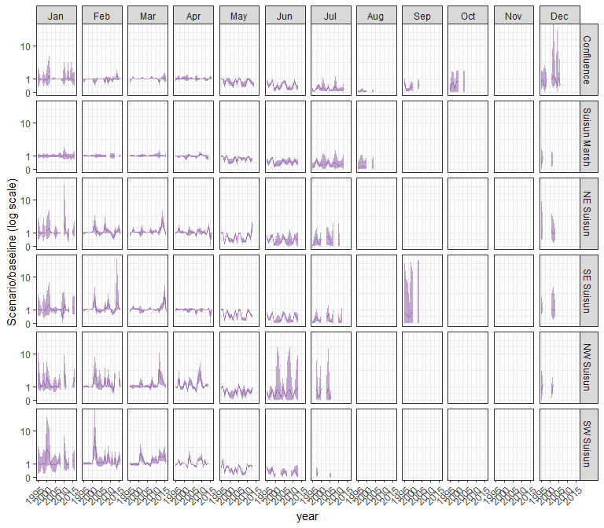

#### limno

## Warning in max(ids, na.rm = TRUE): no non-missing arguments to max; returning  
## -Inf  
  
## Warning in max(ids, na.rm = TRUE): no non-missing arguments to max; returning  
## -Inf  
  
## Warning in max(ids, na.rm = TRUE): no non-missing arguments to max; returning  
## -Inf  
  
## Warning in max(ids, na.rm = TRUE): no non-missing arguments to max; returning  
## -Inf  
  
## Warning in max(ids, na.rm = TRUE): no non-missing arguments to max; returning  
## -Inf

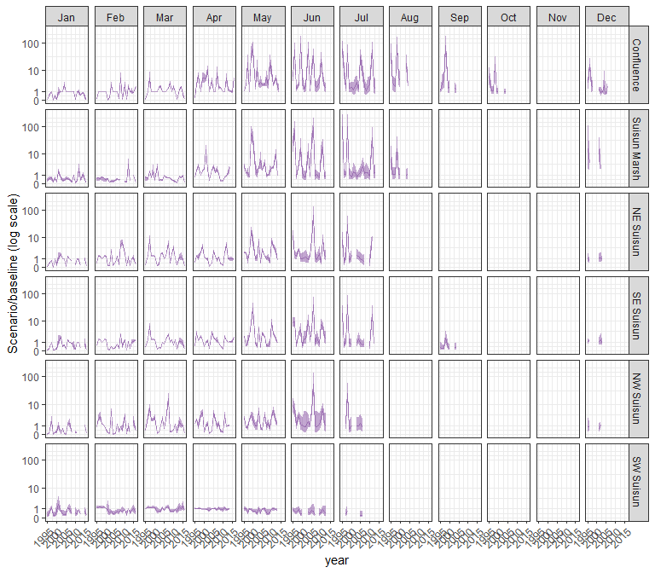

#### mysid

## Warning in max(ids, na.rm = TRUE): no non-missing arguments to max; returning  
## -Inf  
  
## Warning in max(ids, na.rm = TRUE): no non-missing arguments to max; returning  
## -Inf  
  
## Warning in max(ids, na.rm = TRUE): no non-missing arguments to max; returning  
## -Inf  
  
## Warning in max(ids, na.rm = TRUE): no non-missing arguments to max; returning  
## -Inf  
  
## Warning in max(ids, na.rm = TRUE): no non-missing arguments to max; returning  
## -Inf

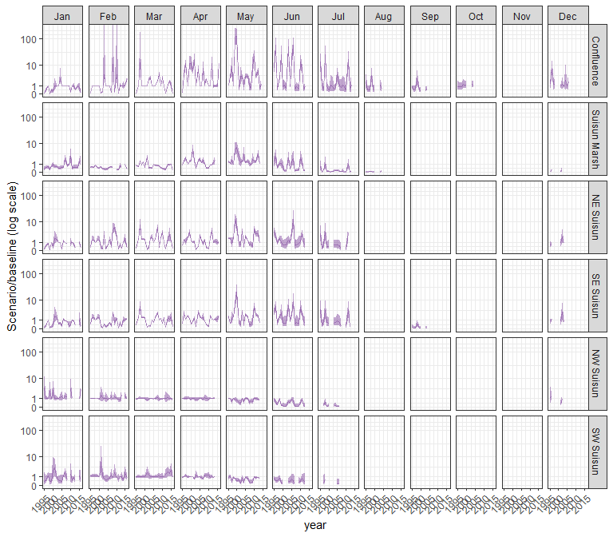

#### othcyc

## Warning in max(ids, na.rm = TRUE): no non-missing arguments to max; returning  
## -Inf  
  
## Warning in max(ids, na.rm = TRUE): no non-missing arguments to max; returning  
## -Inf  
  
## Warning in max(ids, na.rm = TRUE): no non-missing arguments to max; returning  
## -Inf  
  
## Warning in max(ids, na.rm = TRUE): no non-missing arguments to max; returning  
## -Inf  
  
## Warning in max(ids, na.rm = TRUE): no non-missing arguments to max; returning  
## -Inf

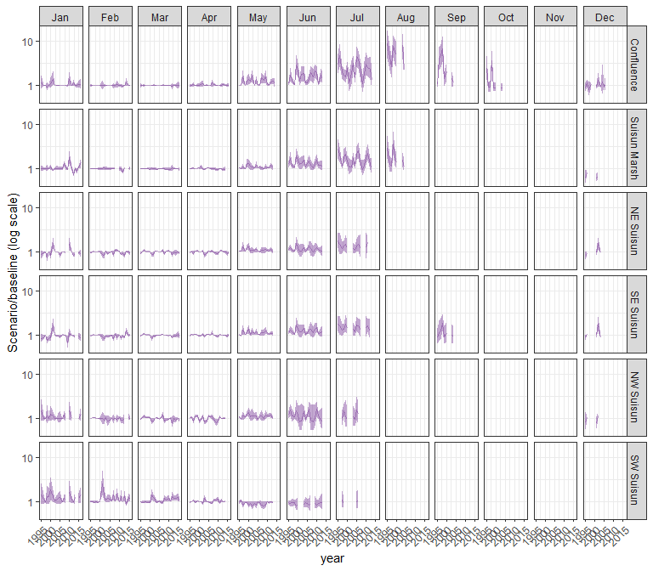

#### other

## Warning in max(ids, na.rm = TRUE): no non-missing arguments to max; returning  
## -Inf  
  
## Warning in max(ids, na.rm = TRUE): no non-missing arguments to max; returning  
## -Inf  
  
## Warning in max(ids, na.rm = TRUE): no non-missing arguments to max; returning  
## -Inf  
  
## Warning in max(ids, na.rm = TRUE): no non-missing arguments to max; returning  
## -Inf  
  
## Warning in max(ids, na.rm = TRUE): no non-missing arguments to max; returning  
## -Inf

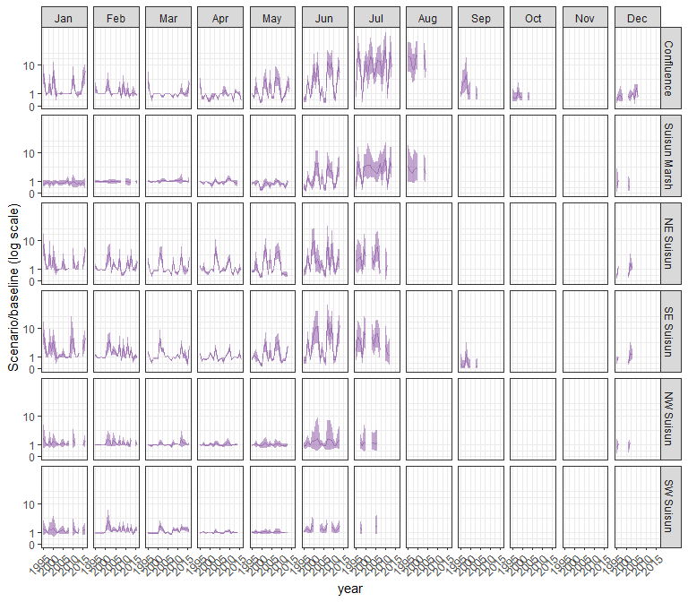

### sal_Alt2v2noTUCP

#### acartela

## Warning in max(ids, na.rm = TRUE): no non-missing arguments to max; returning  
## -Inf  
  
## Warning in max(ids, na.rm = TRUE): no non-missing arguments to max; returning  
## -Inf  
  
## Warning in max(ids, na.rm = TRUE): no non-missing arguments to max; returning  
## -Inf  
  
## Warning in max(ids, na.rm = TRUE): no non-missing arguments to max; returning  
## -Inf  
  
## Warning in max(ids, na.rm = TRUE): no non-missing arguments to max; returning  
## -Inf

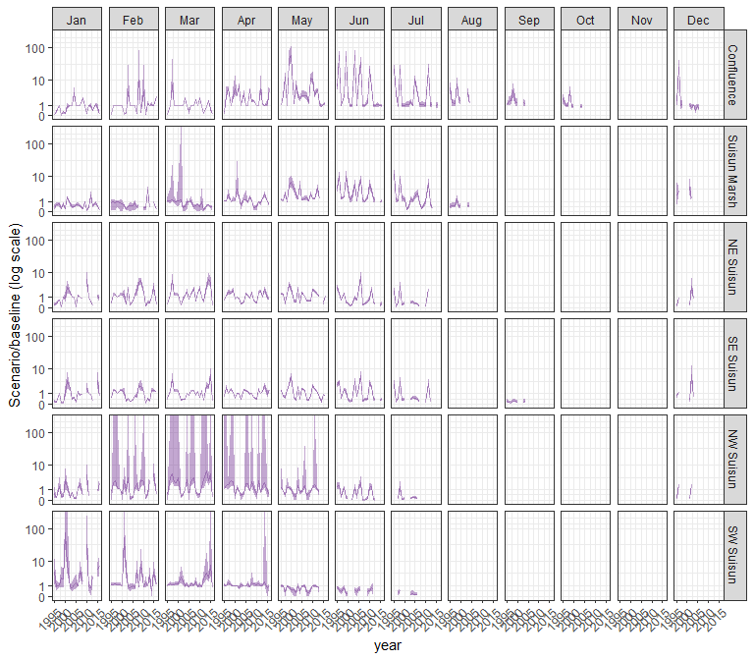

#### daphnia

## Warning in max(ids, na.rm = TRUE): no non-missing arguments to max; returning  
## -Inf  
  
## Warning in max(ids, na.rm = TRUE): no non-missing arguments to max; returning  
## -Inf  
  
## Warning in max(ids, na.rm = TRUE): no non-missing arguments to max; returning  
## -Inf  
  
## Warning in max(ids, na.rm = TRUE): no non-missing arguments to max; returning  
## -Inf  
  
## Warning in max(ids, na.rm = TRUE): no non-missing arguments to max; returning  
## -Inf

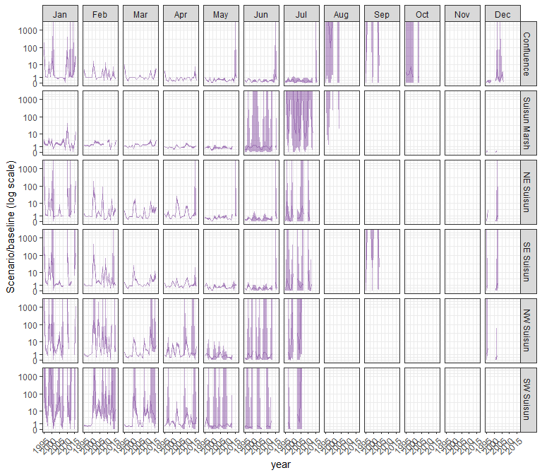

#### eurytem

## Warning in max(ids, na.rm = TRUE): no non-missing arguments to max; returning  
## -Inf  
  
## Warning in max(ids, na.rm = TRUE): no non-missing arguments to max; returning  
## -Inf  
  
## Warning in max(ids, na.rm = TRUE): no non-missing arguments to max; returning  
## -Inf  
  
## Warning in max(ids, na.rm = TRUE): no non-missing arguments to max; returning  
## -Inf  
  
## Warning in max(ids, na.rm = TRUE): no non-missing arguments to max; returning  
## -Inf

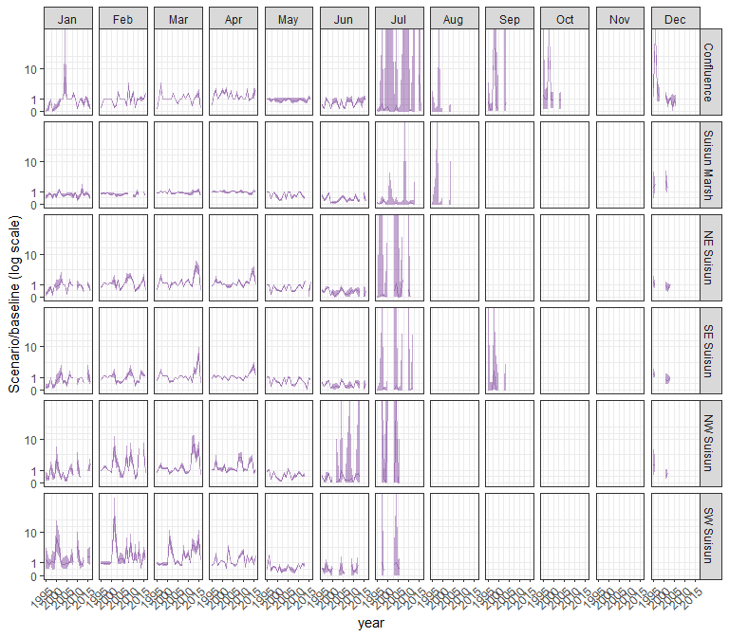

#### othcalad

## Warning in max(ids, na.rm = TRUE): no non-missing arguments to max; returning  
## -Inf  
  
## Warning in max(ids, na.rm = TRUE): no non-missing arguments to max; returning  
## -Inf  
  
## Warning in max(ids, na.rm = TRUE): no non-missing arguments to max; returning  
## -Inf  
  
## Warning in max(ids, na.rm = TRUE): no non-missing arguments to max; returning  
## -Inf  
  
## Warning in max(ids, na.rm = TRUE): no non-missing arguments to max; returning  
## -Inf

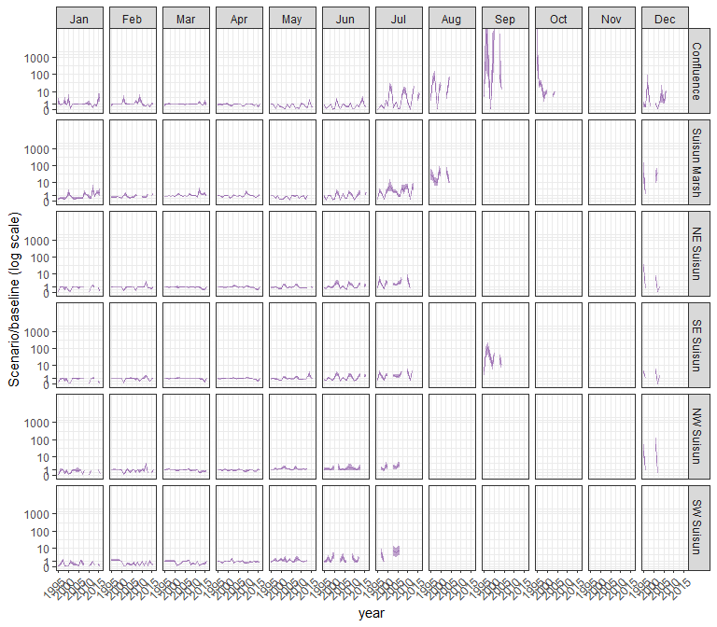

#### othcaljuv

## Warning in max(ids, na.rm = TRUE): no non-missing arguments to max; returning  
## -Inf  
  
## Warning in max(ids, na.rm = TRUE): no non-missing arguments to max; returning  
## -Inf  
  
## Warning in max(ids, na.rm = TRUE): no non-missing arguments to max; returning  
## -Inf  
  
## Warning in max(ids, na.rm = TRUE): no non-missing arguments to max; returning  
## -Inf  
  
## Warning in max(ids, na.rm = TRUE): no non-missing arguments to max; returning  
## -Inf

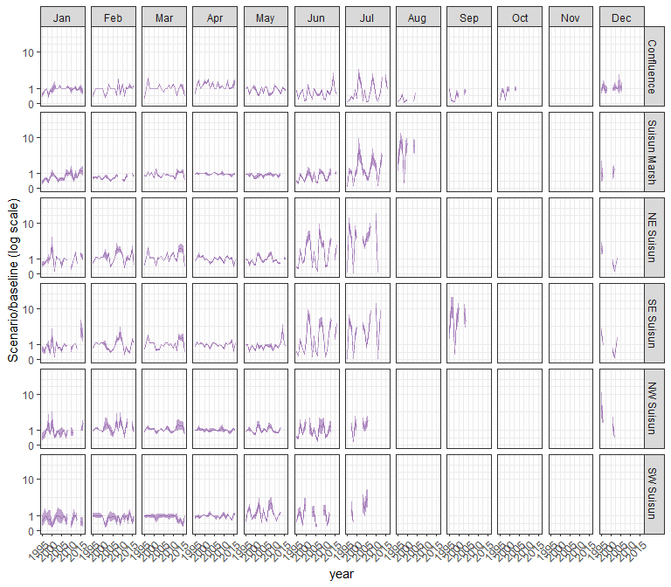

#### othclad

## Warning in max(ids, na.rm = TRUE): no non-missing arguments to max; returning  
## -Inf  
  
## Warning in max(ids, na.rm = TRUE): no non-missing arguments to max; returning  
## -Inf  
  
## Warning in max(ids, na.rm = TRUE): no non-missing arguments to max; returning  
## -Inf  
  
## Warning in max(ids, na.rm = TRUE): no non-missing arguments to max; returning  
## -Inf  
  
## Warning in max(ids, na.rm = TRUE): no non-missing arguments to max; returning  
## -Inf

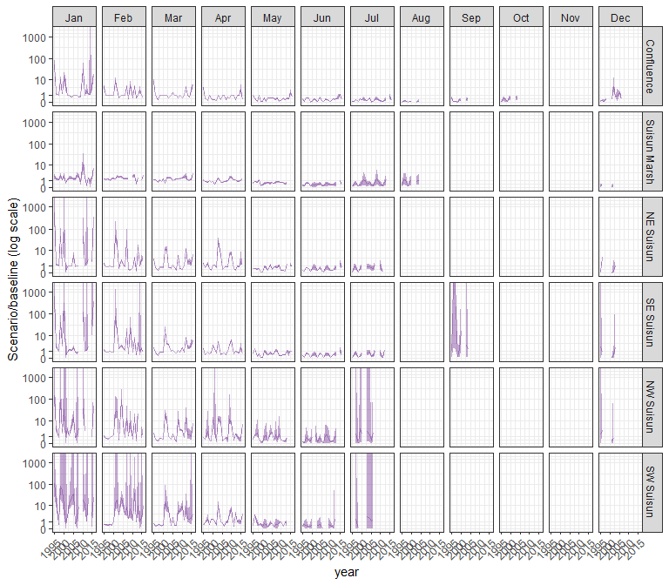

#### pdiapfor

## Warning in max(ids, na.rm = TRUE): no non-missing arguments to max; returning  
## -Inf  
  
## Warning in max(ids, na.rm = TRUE): no non-missing arguments to max; returning  
## -Inf  
  
## Warning in max(ids, na.rm = TRUE): no non-missing arguments to max; returning  
## -Inf  
  
## Warning in max(ids, na.rm = TRUE): no non-missing arguments to max; returning  
## -Inf  
  
## Warning in max(ids, na.rm = TRUE): no non-missing arguments to max; returning  
## -Inf

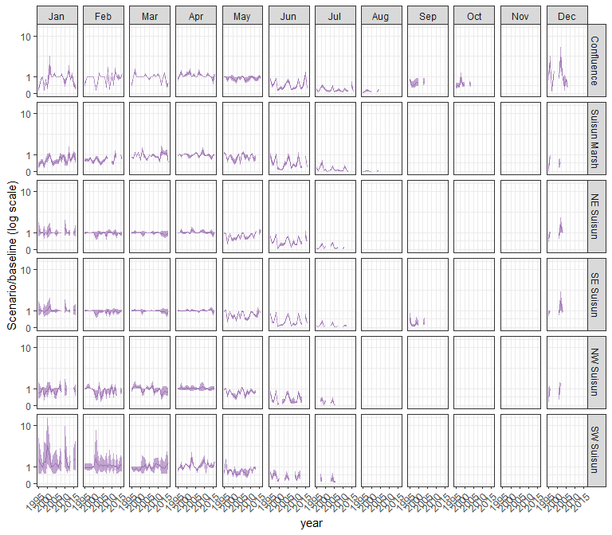

#### allcopnaup

## Warning in max(ids, na.rm = TRUE): no non-missing arguments to max; returning  
## -Inf  
  
## Warning in max(ids, na.rm = TRUE): no non-missing arguments to max; returning  
## -Inf  
  
## Warning in max(ids, na.rm = TRUE): no non-missing arguments to max; returning  
## -Inf  
  
## Warning in max(ids, na.rm = TRUE): no non-missing arguments to max; returning  
## -Inf  
  
## Warning in max(ids, na.rm = TRUE): no non-missing arguments to max; returning  
## -Inf

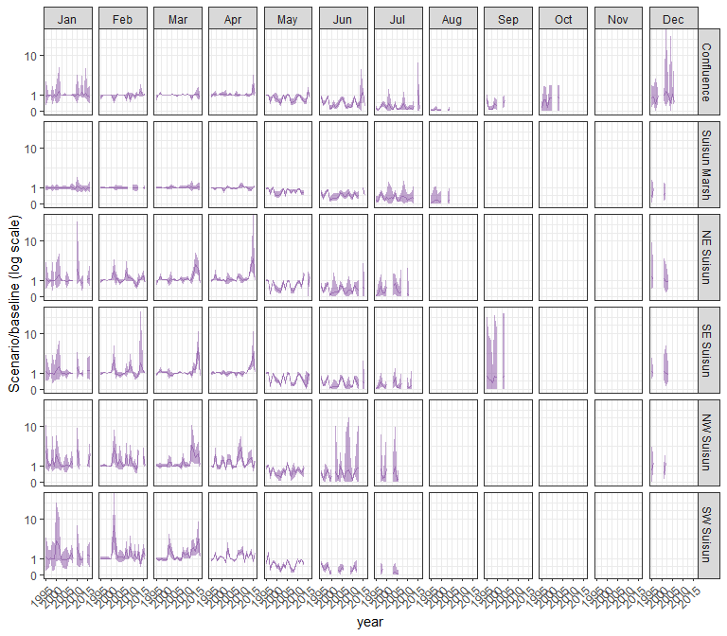

#### limno

## Warning in max(ids, na.rm = TRUE): no non-missing arguments to max; returning  
## -Inf  
  
## Warning in max(ids, na.rm = TRUE): no non-missing arguments to max; returning  
## -Inf  
  
## Warning in max(ids, na.rm = TRUE): no non-missing arguments to max; returning  
## -Inf  
  
## Warning in max(ids, na.rm = TRUE): no non-missing arguments to max; returning  
## -Inf  
  
## Warning in max(ids, na.rm = TRUE): no non-missing arguments to max; returning  
## -Inf

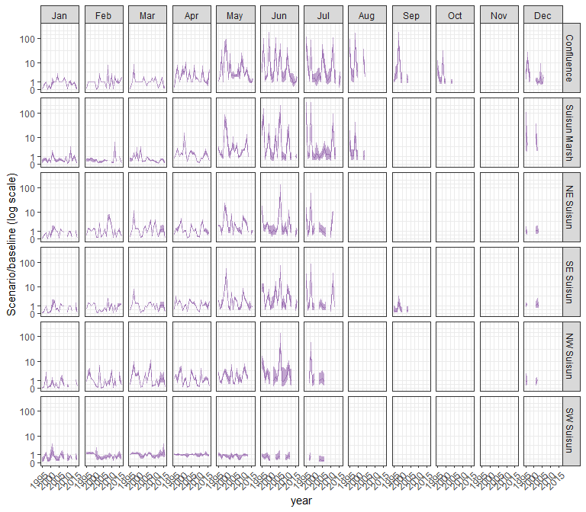

#### mysid

## Warning in max(ids, na.rm = TRUE): no non-missing arguments to max; returning  
## -Inf  
  
## Warning in max(ids, na.rm = TRUE): no non-missing arguments to max; returning  
## -Inf  
  
## Warning in max(ids, na.rm = TRUE): no non-missing arguments to max; returning  
## -Inf  
  
## Warning in max(ids, na.rm = TRUE): no non-missing arguments to max; returning  
## -Inf  
  
## Warning in max(ids, na.rm = TRUE): no non-missing arguments to max; returning  
## -Inf

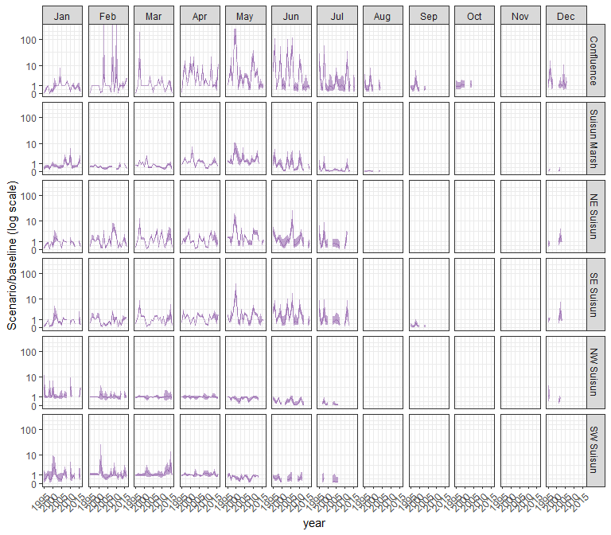

#### othcyc

## Warning in max(ids, na.rm = TRUE): no non-missing arguments to max; returning  
## -Inf  
  
## Warning in max(ids, na.rm = TRUE): no non-missing arguments to max; returning  
## -Inf  
  
## Warning in max(ids, na.rm = TRUE): no non-missing arguments to max; returning  
## -Inf  
  
## Warning in max(ids, na.rm = TRUE): no non-missing arguments to max; returning  
## -Inf  
  
## Warning in max(ids, na.rm = TRUE): no non-missing arguments to max; returning  
## -Inf

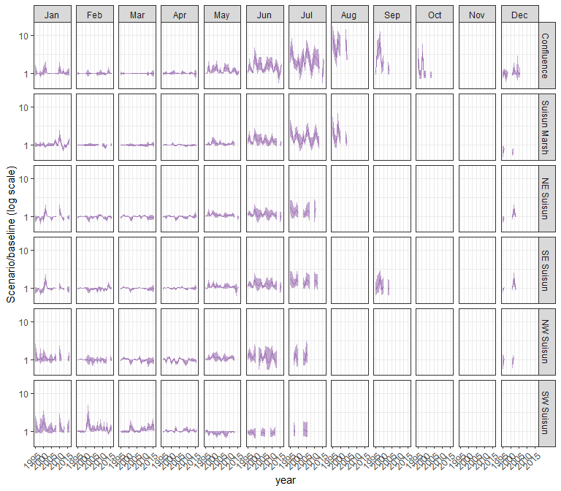

#### other

## Warning in max(ids, na.rm = TRUE): no non-missing arguments to max; returning  
## -Inf  
  
## Warning in max(ids, na.rm = TRUE): no non-missing arguments to max; returning  
## -Inf  
  
## Warning in max(ids, na.rm = TRUE): no non-missing arguments to max; returning  
## -Inf  
  
## Warning in max(ids, na.rm = TRUE): no non-missing arguments to max; returning  
## -Inf  
  
## Warning in max(ids, na.rm = TRUE): no non-missing arguments to max; returning  
## -Inf

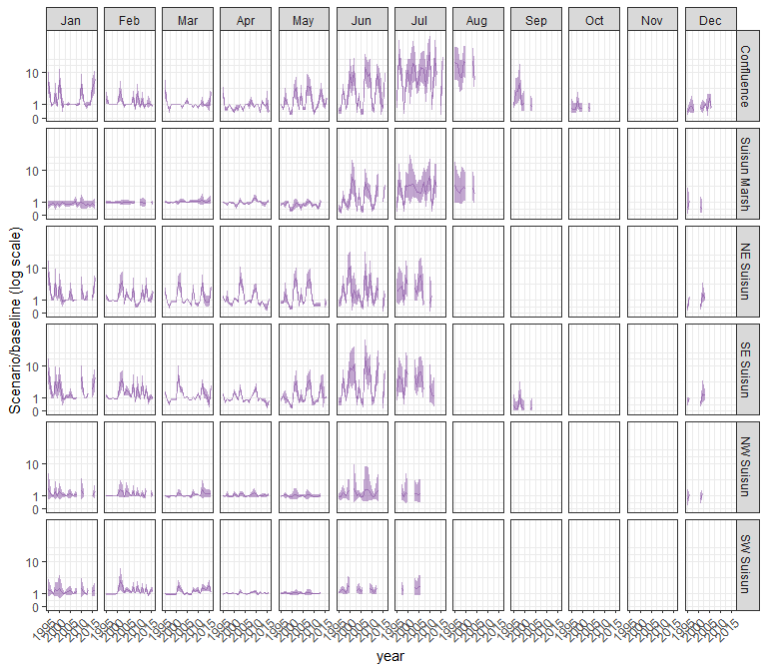

### sal_Alt2v3noTUCP

#### acartela

## Warning in max(ids, na.rm = TRUE): no non-missing arguments to max; returning  
## -Inf  
  
## Warning in max(ids, na.rm = TRUE): no non-missing arguments to max; returning  
## -Inf  
  
## Warning in max(ids, na.rm = TRUE): no non-missing arguments to max; returning  
## -Inf  
  
## Warning in max(ids, na.rm = TRUE): no non-missing arguments to max; returning  
## -Inf  
  
## Warning in max(ids, na.rm = TRUE): no non-missing arguments to max; returning  
## -Inf

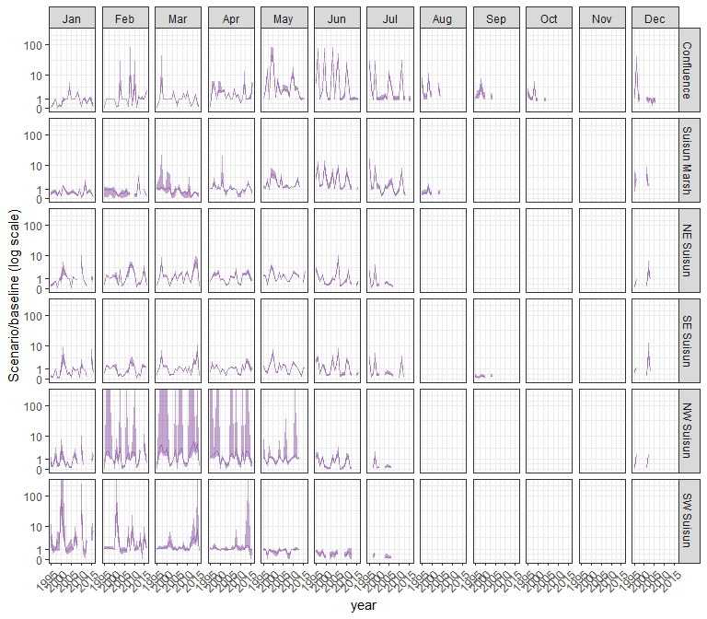

#### daphnia

## Warning in max(ids, na.rm = TRUE): no non-missing arguments to max; returning  
## -Inf  
  
## Warning in max(ids, na.rm = TRUE): no non-missing arguments to max; returning  
## -Inf  
  
## Warning in max(ids, na.rm = TRUE): no non-missing arguments to max; returning  
## -Inf  
  
## Warning in max(ids, na.rm = TRUE): no non-missing arguments to max; returning  
## -Inf  
  
## Warning in max(ids, na.rm = TRUE): no non-missing arguments to max; returning  
## -Inf

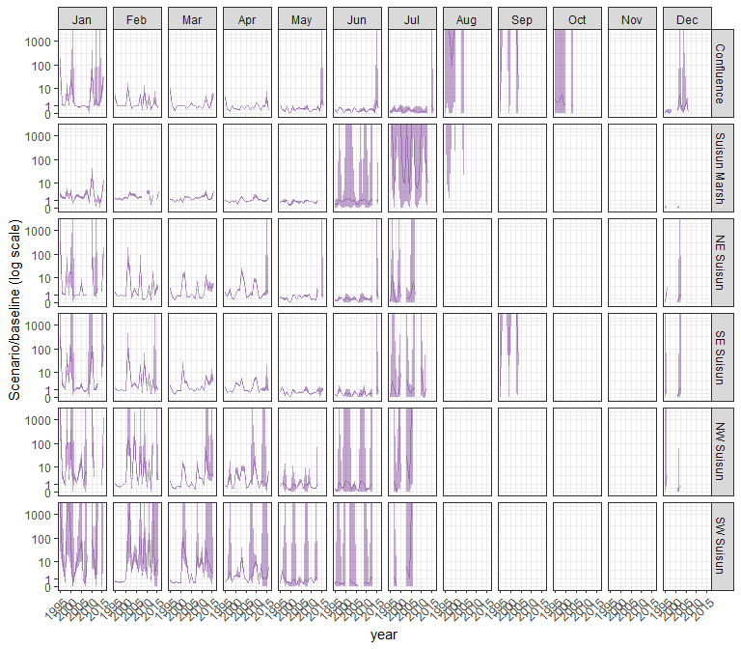

#### eurytem

## Warning in max(ids, na.rm = TRUE): no non-missing arguments to max; returning  
## -Inf  
  
## Warning in max(ids, na.rm = TRUE): no non-missing arguments to max; returning  
## -Inf  
  
## Warning in max(ids, na.rm = TRUE): no non-missing arguments to max; returning  
## -Inf  
  
## Warning in max(ids, na.rm = TRUE): no non-missing arguments to max; returning  
## -Inf  
  
## Warning in max(ids, na.rm = TRUE): no non-missing arguments to max; returning  
## -Inf

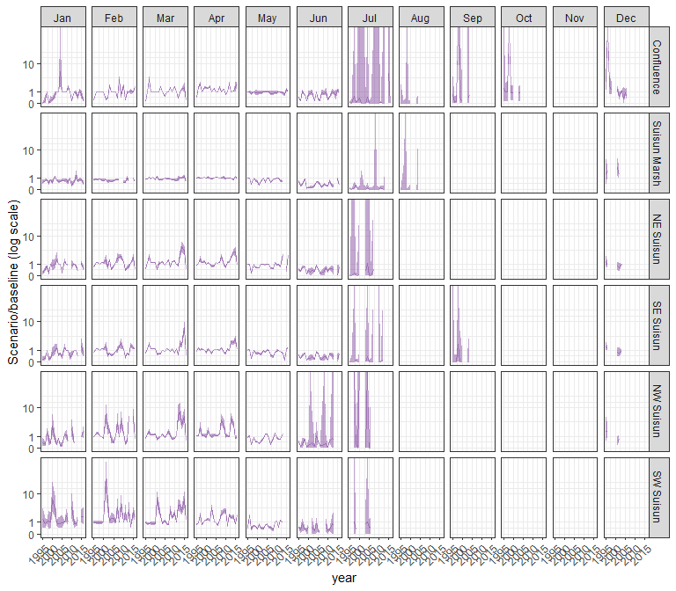

#### othcalad

## Warning in max(ids, na.rm = TRUE): no non-missing arguments to max; returning  
## -Inf  
  
## Warning in max(ids, na.rm = TRUE): no non-missing arguments to max; returning  
## -Inf  
  
## Warning in max(ids, na.rm = TRUE): no non-missing arguments to max; returning  
## -Inf  
  
## Warning in max(ids, na.rm = TRUE): no non-missing arguments to max; returning  
## -Inf  
  
## Warning in max(ids, na.rm = TRUE): no non-missing arguments to max; returning  
## -Inf

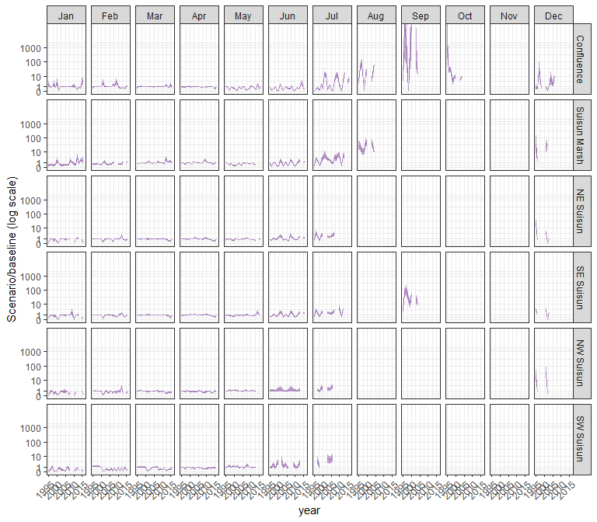

#### othcaljuv

## Warning in max(ids, na.rm = TRUE): no non-missing arguments to max; returning  
## -Inf  
  
## Warning in max(ids, na.rm = TRUE): no non-missing arguments to max; returning  
## -Inf  
  
## Warning in max(ids, na.rm = TRUE): no non-missing arguments to max; returning  
## -Inf  
  
## Warning in max(ids, na.rm = TRUE): no non-missing arguments to max; returning  
## -Inf  
  
## Warning in max(ids, na.rm = TRUE): no non-missing arguments to max; returning  
## -Inf

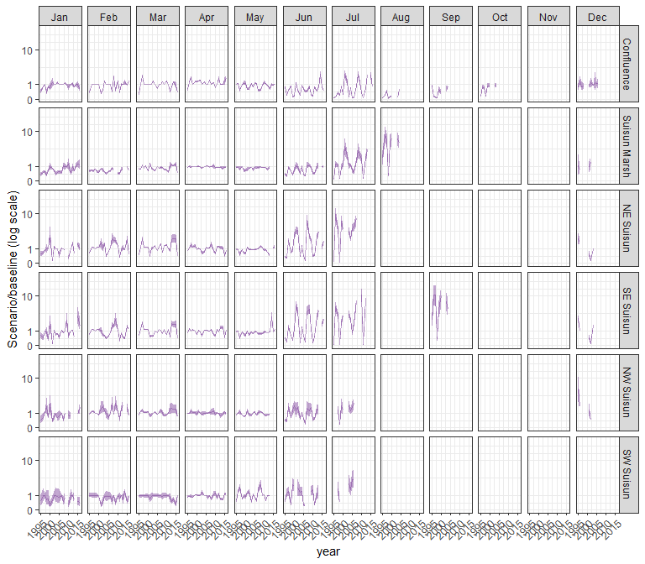

#### othclad

## Warning in max(ids, na.rm = TRUE): no non-missing arguments to max; returning  
## -Inf  
  
## Warning in max(ids, na.rm = TRUE): no non-missing arguments to max; returning  
## -Inf  
  
## Warning in max(ids, na.rm = TRUE): no non-missing arguments to max; returning  
## -Inf  
  
## Warning in max(ids, na.rm = TRUE): no non-missing arguments to max; returning  
## -Inf  
  
## Warning in max(ids, na.rm = TRUE): no non-missing arguments to max; returning  
## -Inf

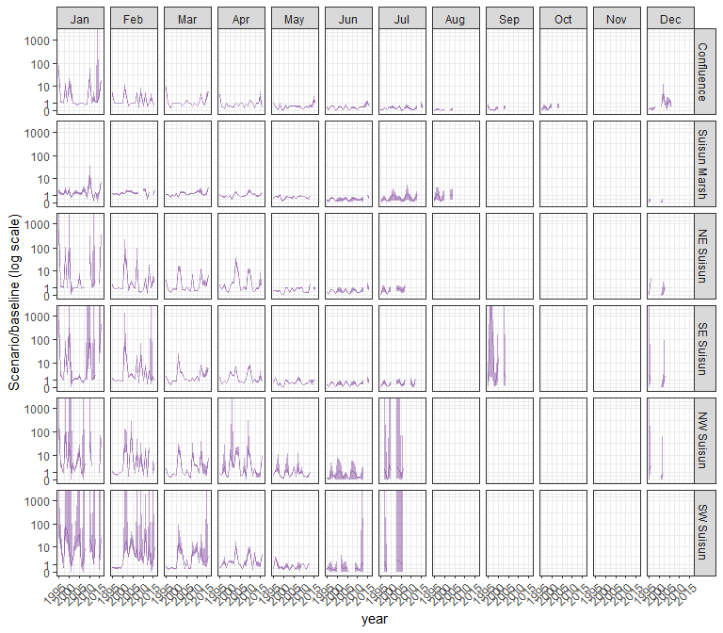

#### pdiapfor

## Warning in max(ids, na.rm = TRUE): no non-missing arguments to max; returning  
## -Inf  
  
## Warning in max(ids, na.rm = TRUE): no non-missing arguments to max; returning  
## -Inf  
  
## Warning in max(ids, na.rm = TRUE): no non-missing arguments to max; returning  
## -Inf  
  
## Warning in max(ids, na.rm = TRUE): no non-missing arguments to max; returning  
## -Inf  
  
## Warning in max(ids, na.rm = TRUE): no non-missing arguments to max; returning  
## -Inf

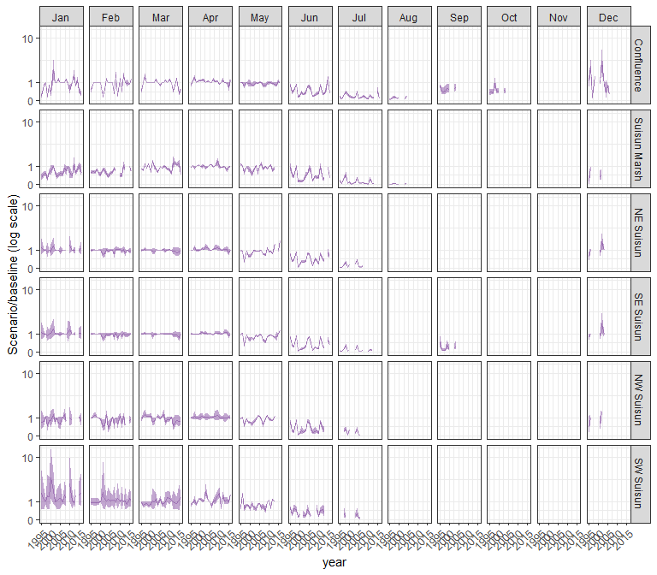

#### allcopnaup

## Warning in max(ids, na.rm = TRUE): no non-missing arguments to max; returning  
## -Inf  
  
## Warning in max(ids, na.rm = TRUE): no non-missing arguments to max; returning  
## -Inf  
  
## Warning in max(ids, na.rm = TRUE): no non-missing arguments to max; returning  
## -Inf  
  
## Warning in max(ids, na.rm = TRUE): no non-missing arguments to max; returning  
## -Inf  
  
## Warning in max(ids, na.rm = TRUE): no non-missing arguments to max; returning  
## -Inf

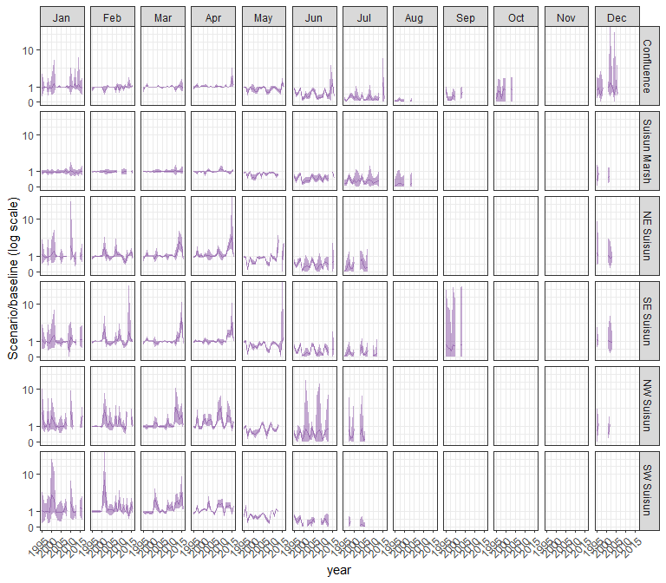

#### limno

## Warning in max(ids, na.rm = TRUE): no non-missing arguments to max; returning  
## -Inf  
  
## Warning in max(ids, na.rm = TRUE): no non-missing arguments to max; returning  
## -Inf  
  
## Warning in max(ids, na.rm = TRUE): no non-missing arguments to max; returning  
## -Inf  
  
## Warning in max(ids, na.rm = TRUE): no non-missing arguments to max; returning  
## -Inf  
  
## Warning in max(ids, na.rm = TRUE): no non-missing arguments to max; returning  
## -Inf

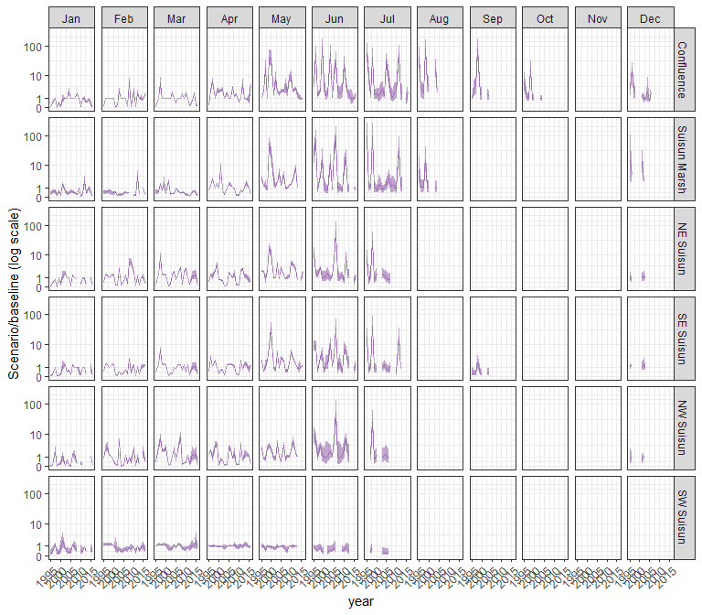

#### mysid

## Warning in max(ids, na.rm = TRUE): no non-missing arguments to max; returning  
## -Inf  
  
## Warning in max(ids, na.rm = TRUE): no non-missing arguments to max; returning  
## -Inf  
  
## Warning in max(ids, na.rm = TRUE): no non-missing arguments to max; returning  
## -Inf  
  
## Warning in max(ids, na.rm = TRUE): no non-missing arguments to max; returning  
## -Inf  
  
## Warning in max(ids, na.rm = TRUE): no non-missing arguments to max; returning  
## -Inf

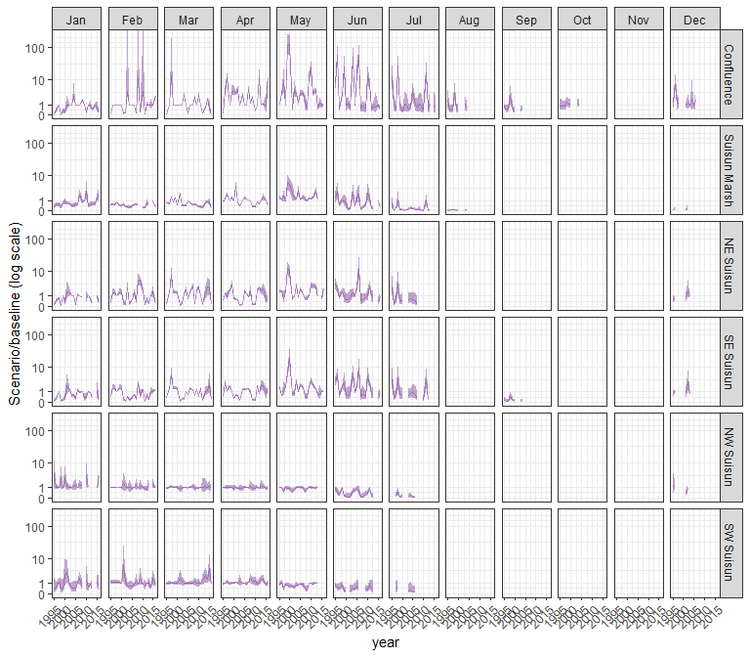

#### othcyc

## Warning in max(ids, na.rm = TRUE): no non-missing arguments to max; returning  
## -Inf  
  
## Warning in max(ids, na.rm = TRUE): no non-missing arguments to max; returning  
## -Inf  
  
## Warning in max(ids, na.rm = TRUE): no non-missing arguments to max; returning  
## -Inf  
  
## Warning in max(ids, na.rm = TRUE): no non-missing arguments to max; returning  
## -Inf  
  
## Warning in max(ids, na.rm = TRUE): no non-missing arguments to max; returning  
## -Inf

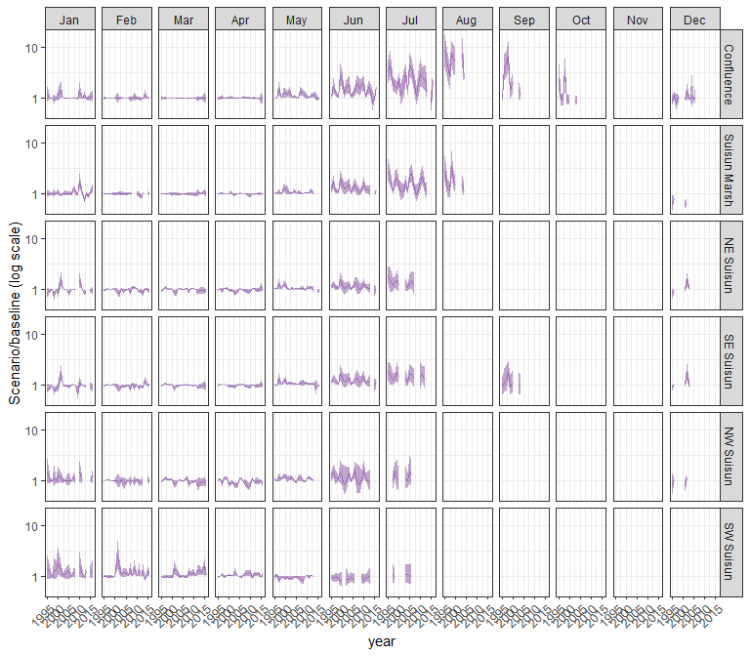

#### other

## Warning in max(ids, na.rm = TRUE): no non-missing arguments to max; returning  
## -Inf  
  
## Warning in max(ids, na.rm = TRUE): no non-missing arguments to max; returning  
## -Inf  
  
## Warning in max(ids, na.rm = TRUE): no non-missing arguments to max; returning  
## -Inf  
  
## Warning in max(ids, na.rm = TRUE): no non-missing arguments to max; returning  
## -Inf  
  
## Warning in max(ids, na.rm = TRUE): no non-missing arguments to max; returning  
## -Inf

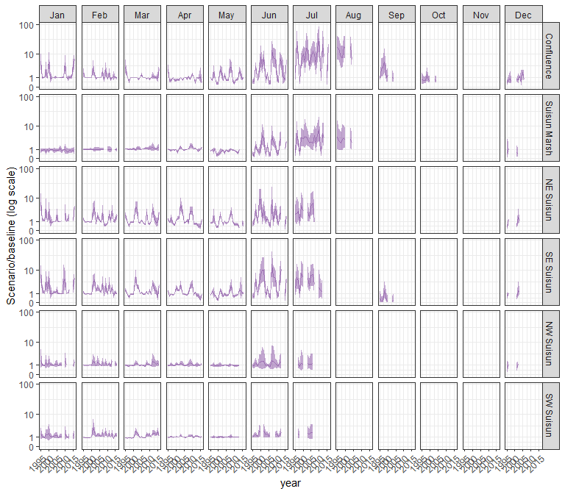

### sal_Alt3

#### acartela

## Warning in max(ids, na.rm = TRUE): no non-missing arguments to max; returning  
## -Inf  
  
## Warning in max(ids, na.rm = TRUE): no non-missing arguments to max; returning  
## -Inf  
  
## Warning in max(ids, na.rm = TRUE): no non-missing arguments to max; returning  
## -Inf

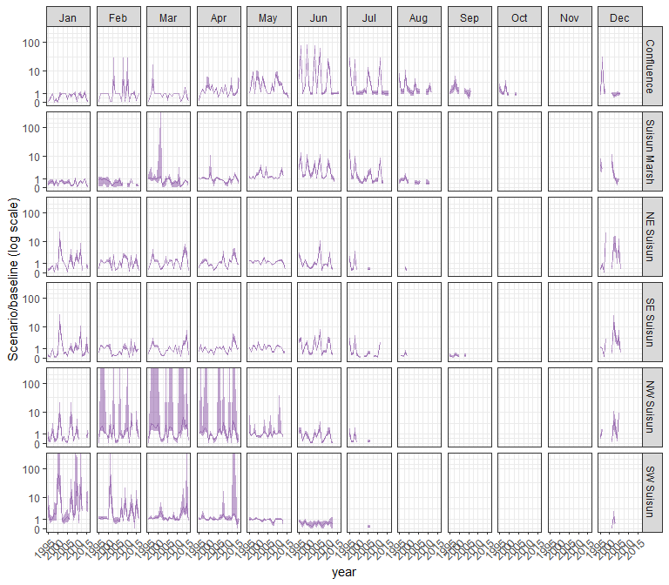

#### daphnia

## Warning in max(ids, na.rm = TRUE): no non-missing arguments to max; returning  
## -Inf  
  
## Warning in max(ids, na.rm = TRUE): no non-missing arguments to max; returning  
## -Inf  
  
## Warning in max(ids, na.rm = TRUE): no non-missing arguments to max; returning  
## -Inf

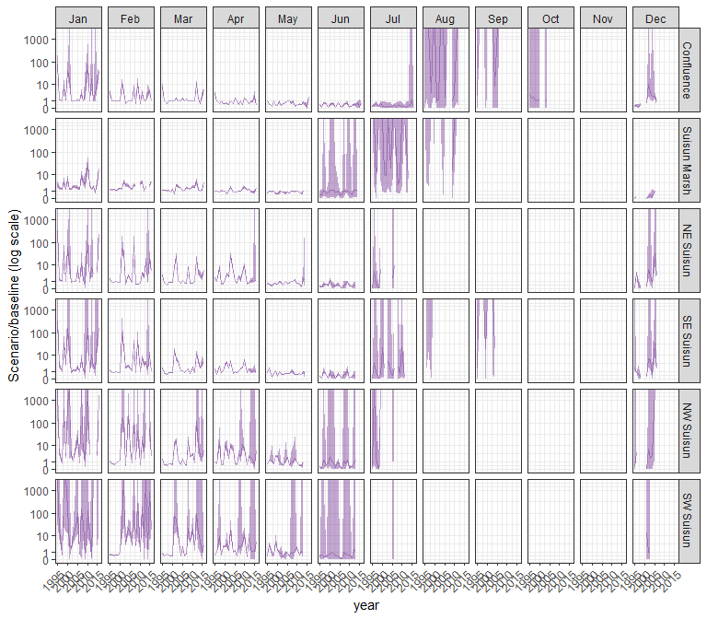

#### eurytem

## Warning in max(ids, na.rm = TRUE): no non-missing arguments to max; returning  
## -Inf  
  
## Warning in max(ids, na.rm = TRUE): no non-missing arguments to max; returning  
## -Inf  
  
## Warning in max(ids, na.rm = TRUE): no non-missing arguments to max; returning  
## -Inf

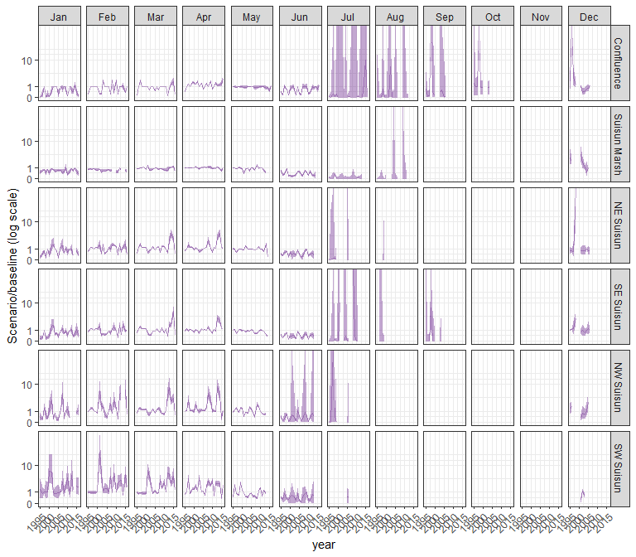

#### othcalad

## Warning in max(ids, na.rm = TRUE): no non-missing arguments to max; returning  
## -Inf  
  
## Warning in max(ids, na.rm = TRUE): no non-missing arguments to max; returning  
## -Inf  
  
## Warning in max(ids, na.rm = TRUE): no non-missing arguments to max; returning  
## -Inf

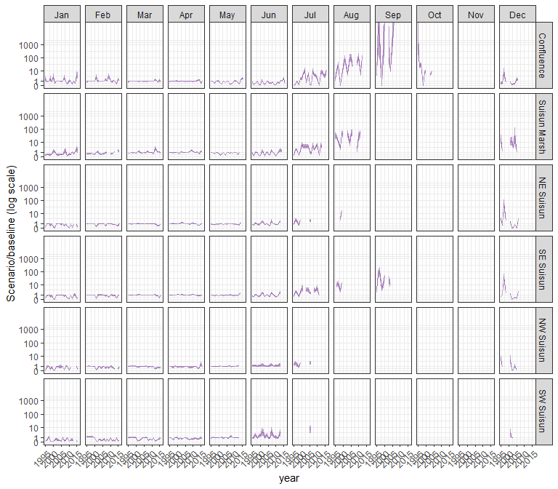

#### othcaljuv

## Warning in max(ids, na.rm = TRUE): no non-missing arguments to max; returning  
## -Inf  
  
## Warning in max(ids, na.rm = TRUE): no non-missing arguments to max; returning  
## -Inf  
  
## Warning in max(ids, na.rm = TRUE): no non-missing arguments to max; returning  
## -Inf

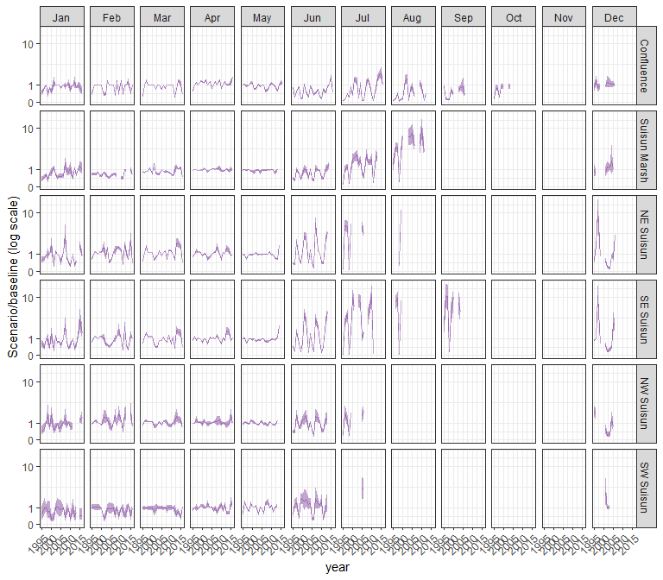

#### othclad

## Warning in max(ids, na.rm = TRUE): no non-missing arguments to max; returning  
## -Inf  
  
## Warning in max(ids, na.rm = TRUE): no non-missing arguments to max; returning  
## -Inf  
  
## Warning in max(ids, na.rm = TRUE): no non-missing arguments to max; returning  
## -Inf

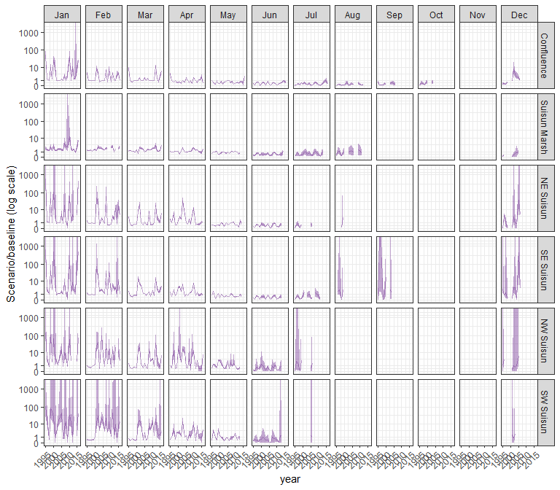

#### pdiapfor

## Warning in max(ids, na.rm = TRUE): no non-missing arguments to max; returning  
## -Inf  
  
## Warning in max(ids, na.rm = TRUE): no non-missing arguments to max; returning  
## -Inf  
  
## Warning in max(ids, na.rm = TRUE): no non-missing arguments to max; returning  
## -Inf

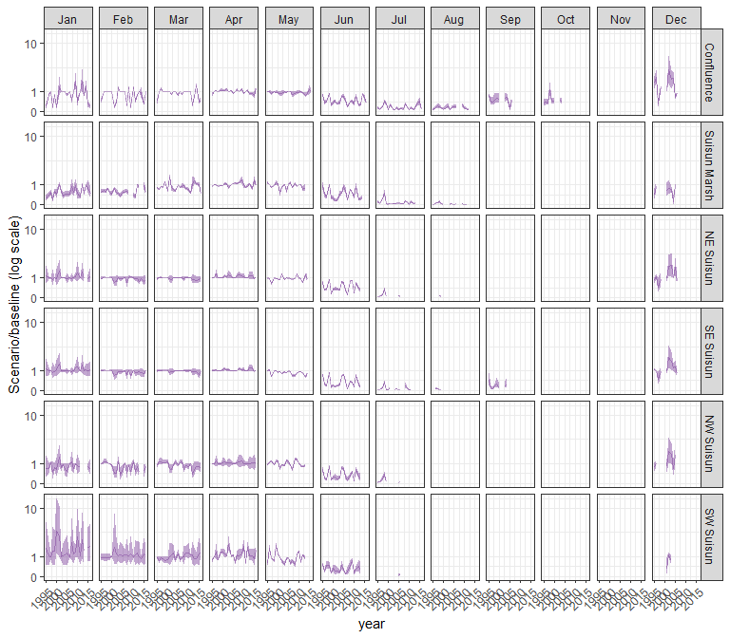

#### allcopnaup

## Warning in max(ids, na.rm = TRUE): no non-missing arguments to max; returning  
## -Inf  
  
## Warning in max(ids, na.rm = TRUE): no non-missing arguments to max; returning  
## -Inf  
  
## Warning in max(ids, na.rm = TRUE): no non-missing arguments to max; returning  
## -Inf

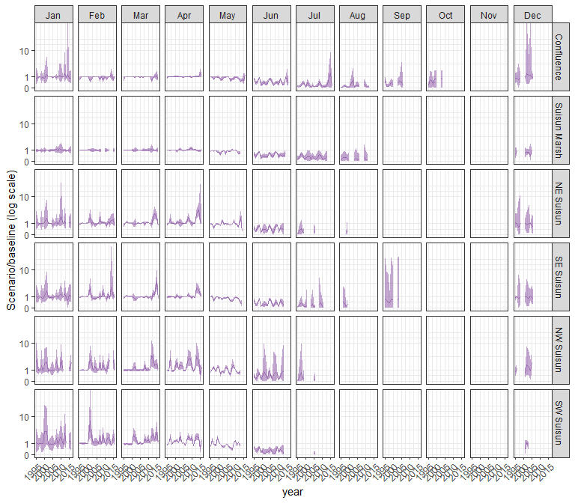

#### limno

## Warning in max(ids, na.rm = TRUE): no non-missing arguments to max; returning  
## -Inf  
  
## Warning in max(ids, na.rm = TRUE): no non-missing arguments to max; returning  
## -Inf  
  
## Warning in max(ids, na.rm = TRUE): no non-missing arguments to max; returning  
## -Inf

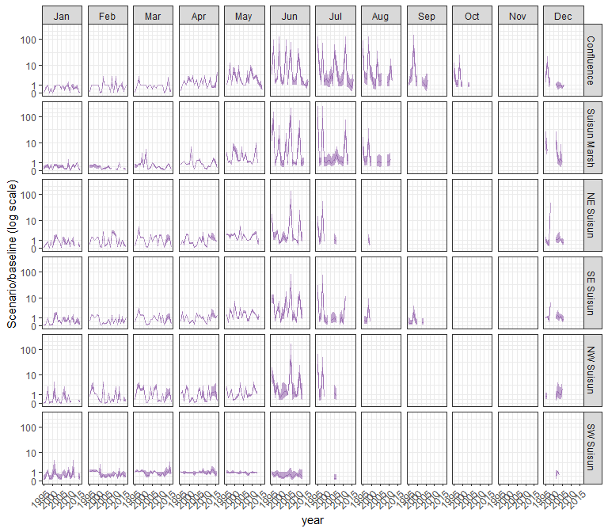

#### mysid

## Warning in max(ids, na.rm = TRUE): no non-missing arguments to max; returning  
## -Inf  
  
## Warning in max(ids, na.rm = TRUE): no non-missing arguments to max; returning  
## -Inf  
  
## Warning in max(ids, na.rm = TRUE): no non-missing arguments to max; returning  
## -Inf

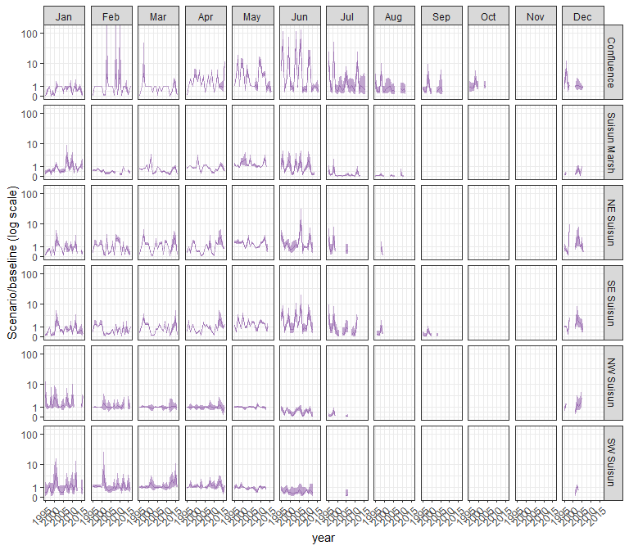

#### othcyc

## Warning in max(ids, na.rm = TRUE): no non-missing arguments to max; returning  
## -Inf  
  
## Warning in max(ids, na.rm = TRUE): no non-missing arguments to max; returning  
## -Inf  
  
## Warning in max(ids, na.rm = TRUE): no non-missing arguments to max; returning  
## -Inf

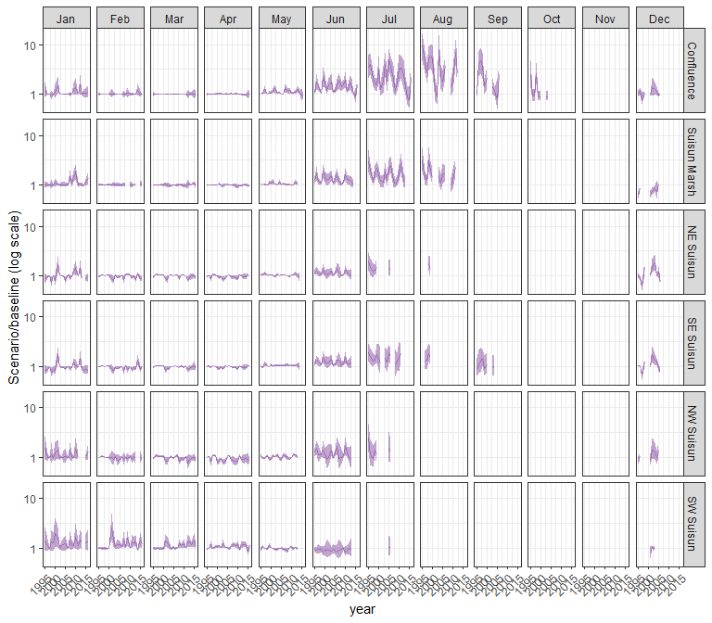

#### other

## Warning in max(ids, na.rm = TRUE): no non-missing arguments to max; returning  
## -Inf  
  
## Warning in max(ids, na.rm = TRUE): no non-missing arguments to max; returning  
## -Inf  
  
## Warning in max(ids, na.rm = TRUE): no non-missing arguments to max; returning  
## -Inf

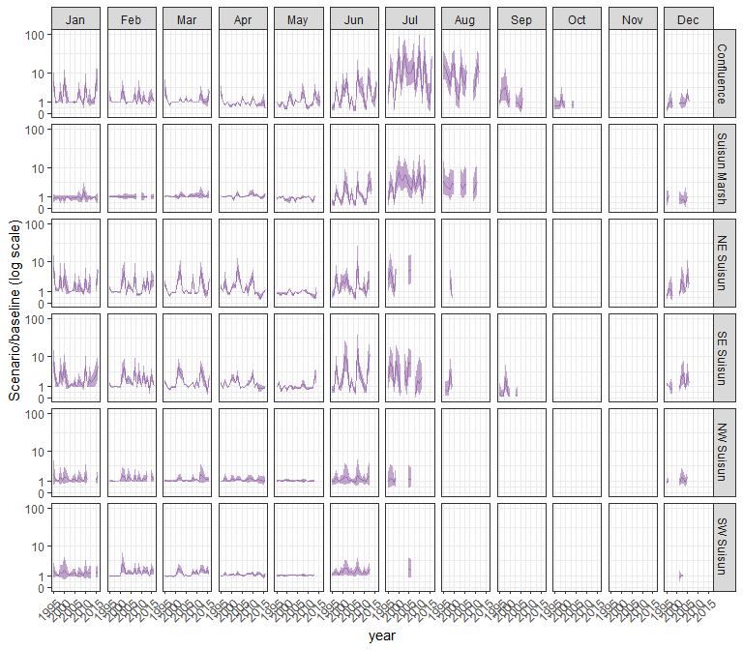

### sal_Alt4

#### acartela

## Warning in max(ids, na.rm = TRUE): no non-missing arguments to max; returning  
## -Inf  
  
## Warning in max(ids, na.rm = TRUE): no non-missing arguments to max; returning  
## -Inf  
  
## Warning in max(ids, na.rm = TRUE): no non-missing arguments to max; returning  
## -Inf  
  
## Warning in max(ids, na.rm = TRUE): no non-missing arguments to max; returning  
## -Inf  
  
## Warning in max(ids, na.rm = TRUE): no non-missing arguments to max; returning  
## -Inf

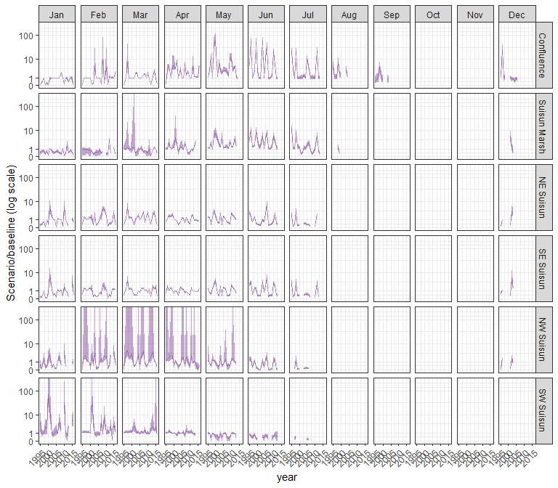

#### daphnia

## Warning in max(ids, na.rm = TRUE): no non-missing arguments to max; returning  
## -Inf  
  
## Warning in max(ids, na.rm = TRUE): no non-missing arguments to max; returning  
## -Inf  
  
## Warning in max(ids, na.rm = TRUE): no non-missing arguments to max; returning  
## -Inf  
  
## Warning in max(ids, na.rm = TRUE): no non-missing arguments to max; returning  
## -Inf  
  
## Warning in max(ids, na.rm = TRUE): no non-missing arguments to max; returning  
## -Inf

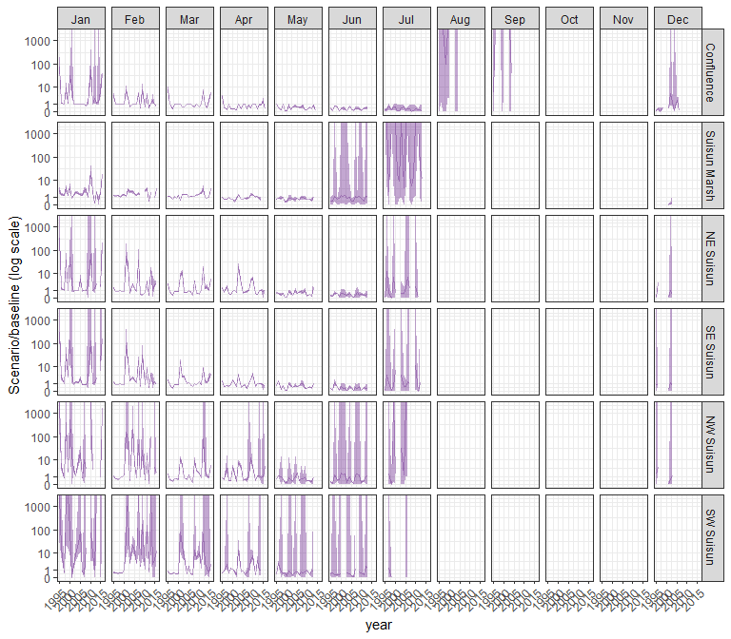

#### eurytem

## Warning in max(ids, na.rm = TRUE): no non-missing arguments to max; returning  
## -Inf  
  
## Warning in max(ids, na.rm = TRUE): no non-missing arguments to max; returning  
## -Inf  
  
## Warning in max(ids, na.rm = TRUE): no non-missing arguments to max; returning  
## -Inf  
  
## Warning in max(ids, na.rm = TRUE): no non-missing arguments to max; returning  
## -Inf  
  
## Warning in max(ids, na.rm = TRUE): no non-missing arguments to max; returning  
## -Inf

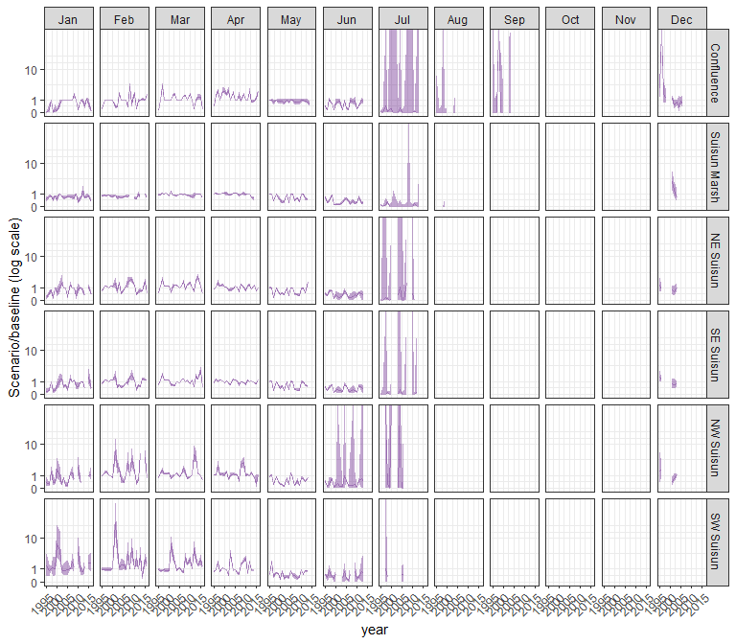

#### othcalad

## Warning in max(ids, na.rm = TRUE): no non-missing arguments to max; returning  
## -Inf  
  
## Warning in max(ids, na.rm = TRUE): no non-missing arguments to max; returning  
## -Inf  
  
## Warning in max(ids, na.rm = TRUE): no non-missing arguments to max; returning  
## -Inf  
  
## Warning in max(ids, na.rm = TRUE): no non-missing arguments to max; returning  
## -Inf  
  
## Warning in max(ids, na.rm = TRUE): no non-missing arguments to max; returning  
## -Inf

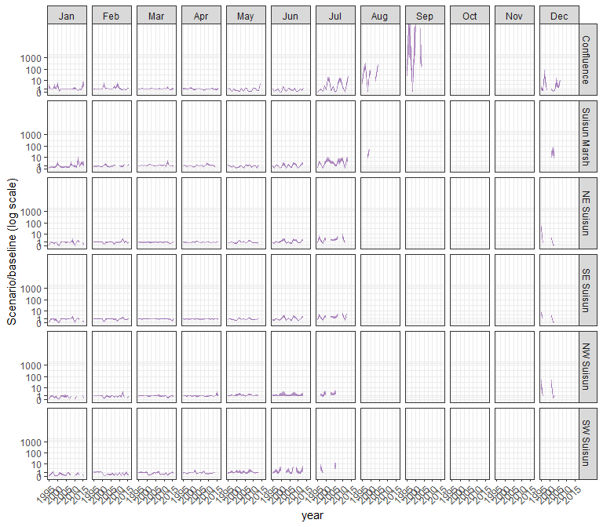

#### othcaljuv

## Warning in max(ids, na.rm = TRUE): no non-missing arguments to max; returning  
## -Inf  
  
## Warning in max(ids, na.rm = TRUE): no non-missing arguments to max; returning  
## -Inf  
  
## Warning in max(ids, na.rm = TRUE): no non-missing arguments to max; returning  
## -Inf  
  
## Warning in max(ids, na.rm = TRUE): no non-missing arguments to max; returning  
## -Inf  
  
## Warning in max(ids, na.rm = TRUE): no non-missing arguments to max; returning  
## -Inf

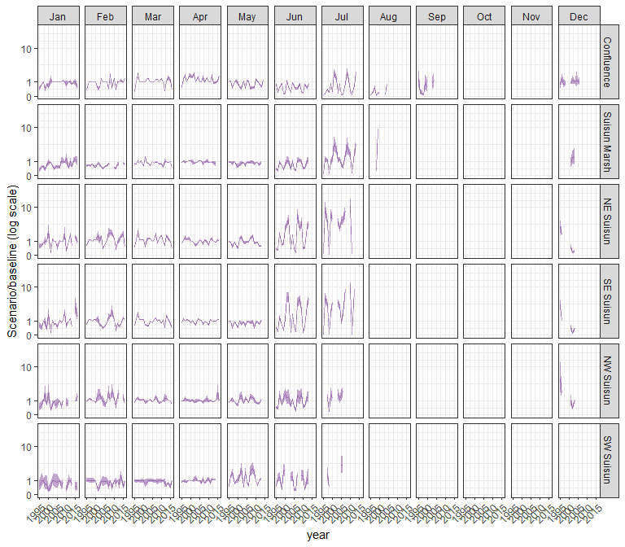

#### othclad

## Warning in max(ids, na.rm = TRUE): no non-missing arguments to max; returning  
## -Inf  
  
## Warning in max(ids, na.rm = TRUE): no non-missing arguments to max; returning  
## -Inf  
  
## Warning in max(ids, na.rm = TRUE): no non-missing arguments to max; returning  
## -Inf  
  
## Warning in max(ids, na.rm = TRUE): no non-missing arguments to max; returning  
## -Inf  
  
## Warning in max(ids, na.rm = TRUE): no non-missing arguments to max; returning  
## -Inf

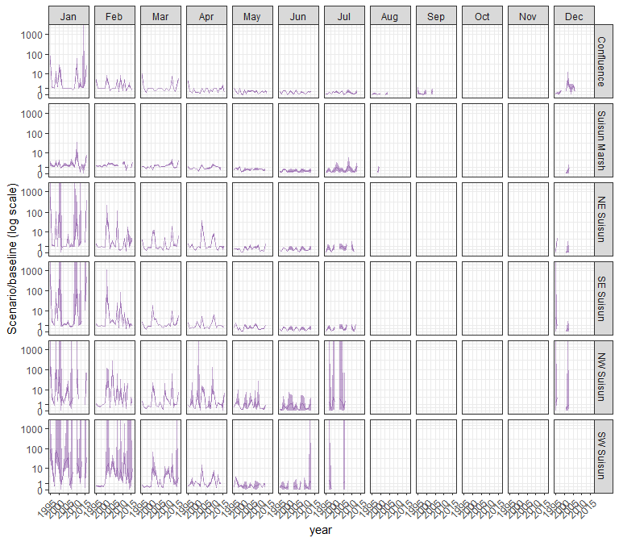

#### pdiapfor

## Warning in max(ids, na.rm = TRUE): no non-missing arguments to max; returning  
## -Inf  
  
## Warning in max(ids, na.rm = TRUE): no non-missing arguments to max; returning  
## -Inf  
  
## Warning in max(ids, na.rm = TRUE): no non-missing arguments to max; returning  
## -Inf  
  
## Warning in max(ids, na.rm = TRUE): no non-missing arguments to max; returning  
## -Inf  
  
## Warning in max(ids, na.rm = TRUE): no non-missing arguments to max; returning  
## -Inf

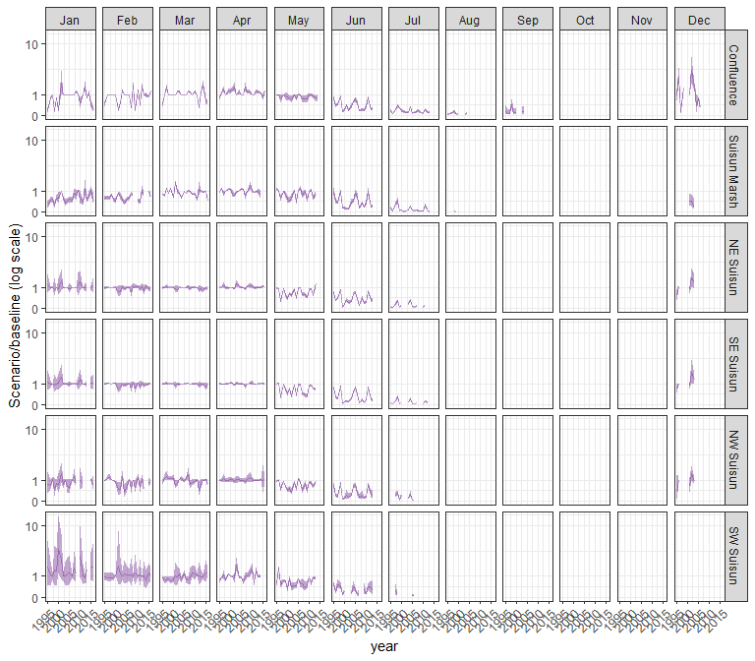

#### allcopnaup

## Warning in max(ids, na.rm = TRUE): no non-missing arguments to max; returning  
## -Inf  
  
## Warning in max(ids, na.rm = TRUE): no non-missing arguments to max; returning  
## -Inf  
  
## Warning in max(ids, na.rm = TRUE): no non-missing arguments to max; returning  
## -Inf  
  
## Warning in max(ids, na.rm = TRUE): no non-missing arguments to max; returning  
## -Inf  
  
## Warning in max(ids, na.rm = TRUE): no non-missing arguments to max; returning  
## -Inf

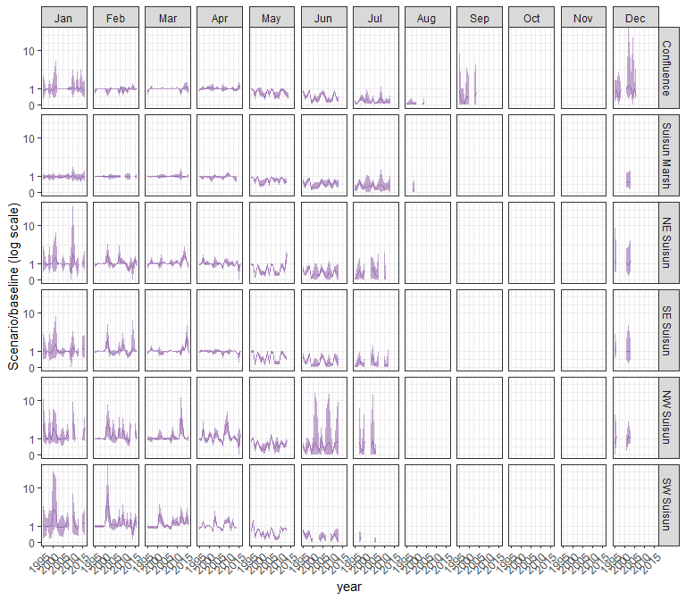

#### limno

## Warning in max(ids, na.rm = TRUE): no non-missing arguments to max; returning  
## -Inf  
  
## Warning in max(ids, na.rm = TRUE): no non-missing arguments to max; returning  
## -Inf  
  
## Warning in max(ids, na.rm = TRUE): no non-missing arguments to max; returning  
## -Inf  
  
## Warning in max(ids, na.rm = TRUE): no non-missing arguments to max; returning  
## -Inf  
  
## Warning in max(ids, na.rm = TRUE): no non-missing arguments to max; returning  
## -Inf

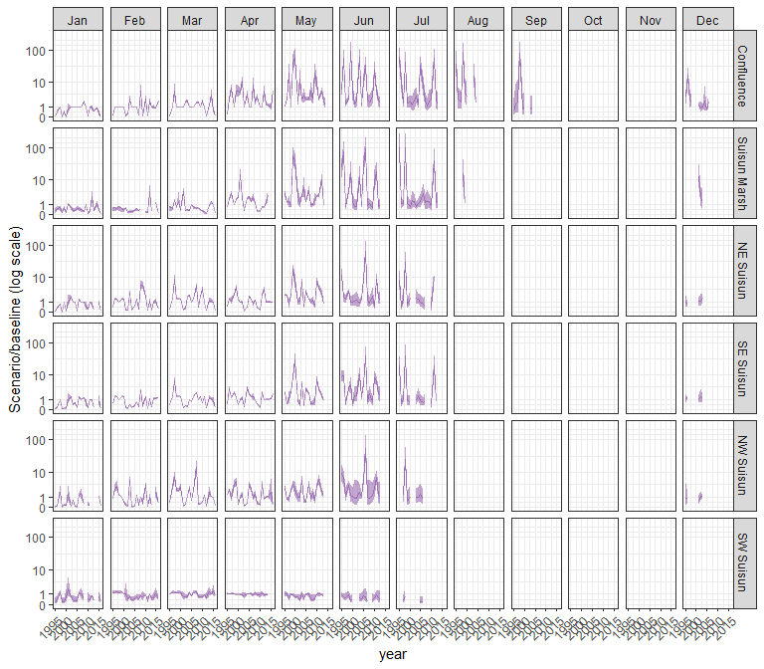

#### mysid

## Warning in max(ids, na.rm = TRUE): no non-missing arguments to max; returning  
## -Inf  
  
## Warning in max(ids, na.rm = TRUE): no non-missing arguments to max; returning  
## -Inf  
  
## Warning in max(ids, na.rm = TRUE): no non-missing arguments to max; returning  
## -Inf  
  
## Warning in max(ids, na.rm = TRUE): no non-missing arguments to max; returning  
## -Inf  
  
## Warning in max(ids, na.rm = TRUE): no non-missing arguments to max; returning  
## -Inf

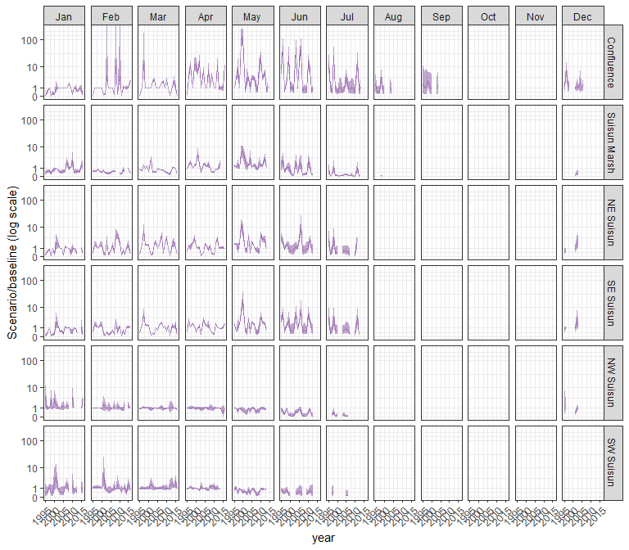

#### othcyc

## Warning in max(ids, na.rm = TRUE): no non-missing arguments to max; returning  
## -Inf  
  
## Warning in max(ids, na.rm = TRUE): no non-missing arguments to max; returning  
## -Inf  
  
## Warning in max(ids, na.rm = TRUE): no non-missing arguments to max; returning  
## -Inf  
  
## Warning in max(ids, na.rm = TRUE): no non-missing arguments to max; returning  
## -Inf  
  
## Warning in max(ids, na.rm = TRUE): no non-missing arguments to max; returning  
## -Inf

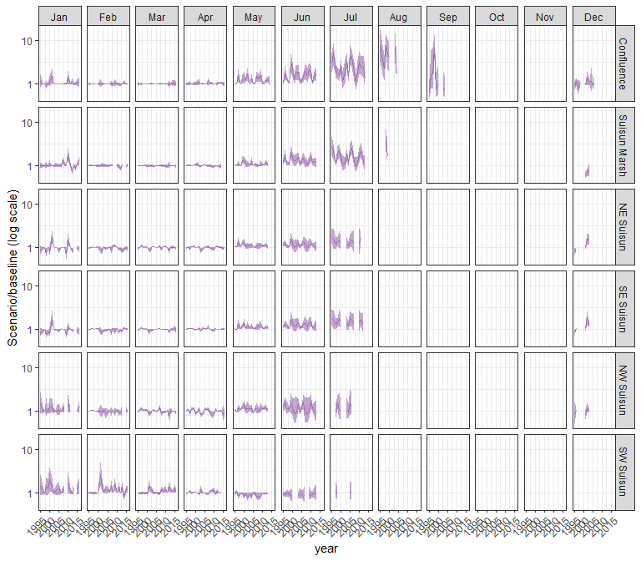

#### other

## Warning in max(ids, na.rm = TRUE): no non-missing arguments to max; returning  
## -Inf  
  
## Warning in max(ids, na.rm = TRUE): no non-missing arguments to max; returning  
## -Inf  
  
## Warning in max(ids, na.rm = TRUE): no non-missing arguments to max; returning  
## -Inf  
  
## Warning in max(ids, na.rm = TRUE): no non-missing arguments to max; returning  
## -Inf  
  
## Warning in max(ids, na.rm = TRUE): no non-missing arguments to max; returning  
## -Inf

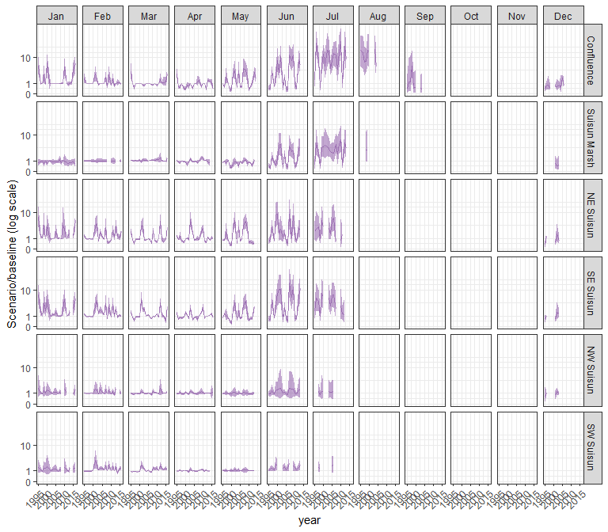

### sal_EXP1

#### acartela

## Warning in max(ids, na.rm = TRUE): no non-missing arguments to max; returning  
## -Inf  
  
## Warning in max(ids, na.rm = TRUE): no non-missing arguments to max; returning  
## -Inf  
  
## Warning in max(ids, na.rm = TRUE): no non-missing arguments to max; returning  
## -Inf  
  
## Warning in max(ids, na.rm = TRUE): no non-missing arguments to max; returning  
## -Inf  
  
## Warning in max(ids, na.rm = TRUE): no non-missing arguments to max; returning  
## -Inf  
  
## Warning in max(ids, na.rm = TRUE): no non-missing arguments to max; returning  
## -Inf  
  
## Warning in max(ids, na.rm = TRUE): no non-missing arguments to max; returning  
## -Inf  
  
## Warning in max(ids, na.rm = TRUE): no non-missing arguments to max; returning  
## -Inf  
  
## Warning in max(ids, na.rm = TRUE): no non-missing arguments to max; returning  
## -Inf  
  
## Warning in max(ids, na.rm = TRUE): no non-missing arguments to max; returning  
## -Inf  
  
## Warning in max(ids, na.rm = TRUE): no non-missing arguments to max; returning  
## -Inf  
  
## Warning in max(ids, na.rm = TRUE): no non-missing arguments to max; returning  
## -Inf  
  
## Warning in max(ids, na.rm = TRUE): no non-missing arguments to max; returning  
## -Inf  
  
## Warning in max(ids, na.rm = TRUE): no non-missing arguments to max; returning  
## -Inf  
  
## Warning in max(ids, na.rm = TRUE): no non-missing arguments to max; returning  
## -Inf  
  
## Warning in max(ids, na.rm = TRUE): no non-missing arguments to max; returning  
## -Inf  
  
## Warning in max(ids, na.rm = TRUE): no non-missing arguments to max; returning  
## -Inf  
  
## Warning in max(ids, na.rm = TRUE): no non-missing arguments to max; returning  
## -Inf  
  
## Warning in max(ids, na.rm = TRUE): no non-missing arguments to max; returning  
## -Inf  
  
## Warning in max(ids, na.rm = TRUE): no non-missing arguments to max; returning  
## -Inf  
  
## Warning in max(ids, na.rm = TRUE): no non-missing arguments to max; returning  
## -Inf  
  
## Warning in max(ids, na.rm = TRUE): no non-missing arguments to max; returning  
## -Inf  
  
## Warning in max(ids, na.rm = TRUE): no non-missing arguments to max; returning  
## -Inf  
  
## Warning in max(ids, na.rm = TRUE): no non-missing arguments to max; returning  
## -Inf

## Warning: Removed 132 rows containing missing values (`geom_line()`).

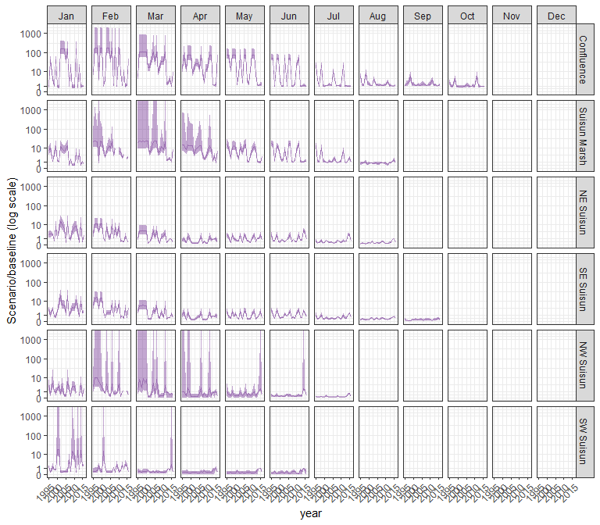

#### daphnia

## Warning in max(ids, na.rm = TRUE): no non-missing arguments to max; returning  
## -Inf

## Warning in max(ids, na.rm = TRUE): no non-missing arguments to max; returning  
## -Inf  
  
## Warning in max(ids, na.rm = TRUE): no non-missing arguments to max; returning  
## -Inf  
  
## Warning in max(ids, na.rm = TRUE): no non-missing arguments to max; returning  
## -Inf  
  
## Warning in max(ids, na.rm = TRUE): no non-missing arguments to max; returning  
## -Inf  
  
## Warning in max(ids, na.rm = TRUE): no non-missing arguments to max; returning  
## -Inf  
  
## Warning in max(ids, na.rm = TRUE): no non-missing arguments to max; returning  
## -Inf  
  
## Warning in max(ids, na.rm = TRUE): no non-missing arguments to max; returning  
## -Inf  
  
## Warning in max(ids, na.rm = TRUE): no non-missing arguments to max; returning  
## -Inf  
  
## Warning in max(ids, na.rm = TRUE): no non-missing arguments to max; returning  
## -Inf  
  
## Warning in max(ids, na.rm = TRUE): no non-missing arguments to max; returning  
## -Inf  
  
## Warning in max(ids, na.rm = TRUE): no non-missing arguments to max; returning  
## -Inf  
  
## Warning in max(ids, na.rm = TRUE): no non-missing arguments to max; returning  
## -Inf  
  
## Warning in max(ids, na.rm = TRUE): no non-missing arguments to max; returning  
## -Inf  
  
## Warning in max(ids, na.rm = TRUE): no non-missing arguments to max; returning  
## -Inf  
  
## Warning in max(ids, na.rm = TRUE): no non-missing arguments to max; returning  
## -Inf  
  
## Warning in max(ids, na.rm = TRUE): no non-missing arguments to max; returning  
## -Inf  
  
## Warning in max(ids, na.rm = TRUE): no non-missing arguments to max; returning  
## -Inf  
  
## Warning in max(ids, na.rm = TRUE): no non-missing arguments to max; returning  
## -Inf  
  
## Warning in max(ids, na.rm = TRUE): no non-missing arguments to max; returning  
## -Inf  
  
## Warning in max(ids, na.rm = TRUE): no non-missing arguments to max; returning  
## -Inf  
  
## Warning in max(ids, na.rm = TRUE): no non-missing arguments to max; returning  
## -Inf  
  
## Warning in max(ids, na.rm = TRUE): no non-missing arguments to max; returning  
## -Inf  
  
## Warning in max(ids, na.rm = TRUE): no non-missing arguments to max; returning  
## -Inf

## Warning: Removed 132 rows containing missing values (`geom_line()`).

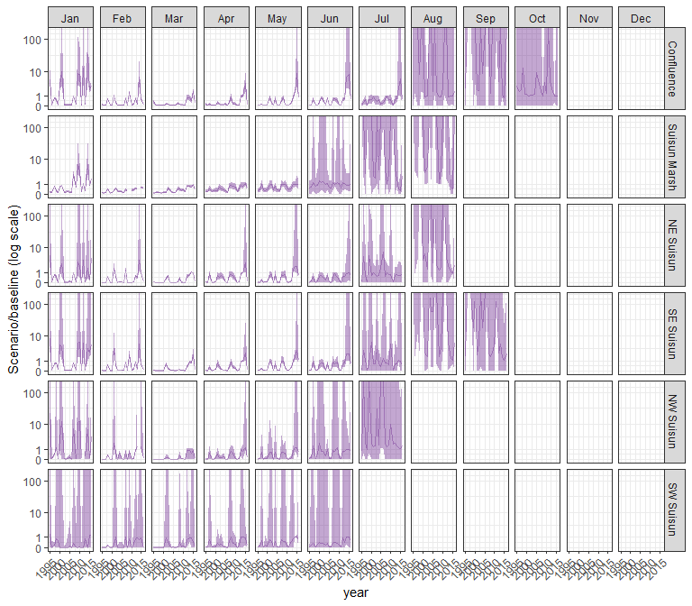

#### eurytem

## Warning in max(ids, na.rm = TRUE): no non-missing arguments to max; returning  
## -Inf

## Warning in max(ids, na.rm = TRUE): no non-missing arguments to max; returning  
## -Inf  
  
## Warning in max(ids, na.rm = TRUE): no non-missing arguments to max; returning  
## -Inf  
  
## Warning in max(ids, na.rm = TRUE): no non-missing arguments to max; returning  
## -Inf  
  
## Warning in max(ids, na.rm = TRUE): no non-missing arguments to max; returning  
## -Inf  
  
## Warning in max(ids, na.rm = TRUE): no non-missing arguments to max; returning  
## -Inf  
  
## Warning in max(ids, na.rm = TRUE): no non-missing arguments to max; returning  
## -Inf  
  
## Warning in max(ids, na.rm = TRUE): no non-missing arguments to max; returning  
## -Inf  
  
## Warning in max(ids, na.rm = TRUE): no non-missing arguments to max; returning  
## -Inf  
  
## Warning in max(ids, na.rm = TRUE): no non-missing arguments to max; returning  
## -Inf  
  
## Warning in max(ids, na.rm = TRUE): no non-missing arguments to max; returning  
## -Inf  
  
## Warning in max(ids, na.rm = TRUE): no non-missing arguments to max; returning  
## -Inf  
  
## Warning in max(ids, na.rm = TRUE): no non-missing arguments to max; returning  
## -Inf  
  
## Warning in max(ids, na.rm = TRUE): no non-missing arguments to max; returning  
## -Inf  
  
## Warning in max(ids, na.rm = TRUE): no non-missing arguments to max; returning  
## -Inf  
  
## Warning in max(ids, na.rm = TRUE): no non-missing arguments to max; returning  
## -Inf  
  
## Warning in max(ids, na.rm = TRUE): no non-missing arguments to max; returning  
## -Inf  
  
## Warning in max(ids, na.rm = TRUE): no non-missing arguments to max; returning  
## -Inf  
  
## Warning in max(ids, na.rm = TRUE): no non-missing arguments to max; returning  
## -Inf  
  
## Warning in max(ids, na.rm = TRUE): no non-missing arguments to max; returning  
## -Inf  
  
## Warning in max(ids, na.rm = TRUE): no non-missing arguments to max; returning  
## -Inf  
  
## Warning in max(ids, na.rm = TRUE): no non-missing arguments to max; returning  
## -Inf  
  
## Warning in max(ids, na.rm = TRUE): no non-missing arguments to max; returning  
## -Inf  
  
## Warning in max(ids, na.rm = TRUE): no non-missing arguments to max; returning  
## -Inf

## Warning: Removed 132 rows containing missing values (`geom_line()`).

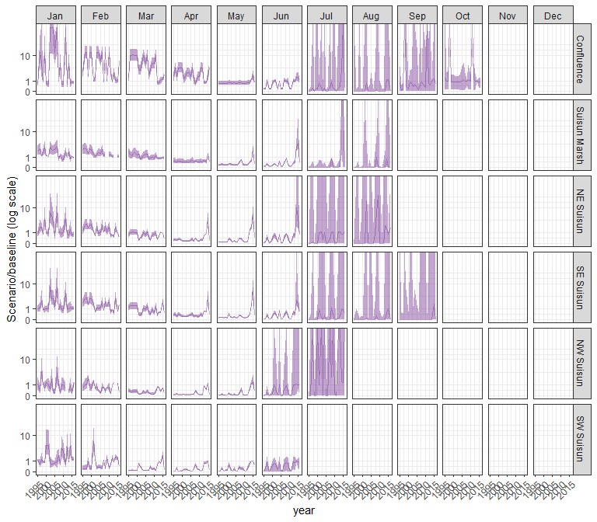

#### othcalad

## Warning in max(ids, na.rm = TRUE): no non-missing arguments to max; returning  
## -Inf

## Warning in max(ids, na.rm = TRUE): no non-missing arguments to max; returning  
## -Inf  
  
## Warning in max(ids, na.rm = TRUE): no non-missing arguments to max; returning  
## -Inf  
  
## Warning in max(ids, na.rm = TRUE): no non-missing arguments to max; returning  
## -Inf  
  
## Warning in max(ids, na.rm = TRUE): no non-missing arguments to max; returning  
## -Inf  
  
## Warning in max(ids, na.rm = TRUE): no non-missing arguments to max; returning  
## -Inf  
  
## Warning in max(ids, na.rm = TRUE): no non-missing arguments to max; returning  
## -Inf  
  
## Warning in max(ids, na.rm = TRUE): no non-missing arguments to max; returning  
## -Inf  
  
## Warning in max(ids, na.rm = TRUE): no non-missing arguments to max; returning  
## -Inf  
  
## Warning in max(ids, na.rm = TRUE): no non-missing arguments to max; returning  
## -Inf  
  
## Warning in max(ids, na.rm = TRUE): no non-missing arguments to max; returning  
## -Inf  
  
## Warning in max(ids, na.rm = TRUE): no non-missing arguments to max; returning  
## -Inf  
  
## Warning in max(ids, na.rm = TRUE): no non-missing arguments to max; returning  
## -Inf  
  
## Warning in max(ids, na.rm = TRUE): no non-missing arguments to max; returning  
## -Inf  
  
## Warning in max(ids, na.rm = TRUE): no non-missing arguments to max; returning  
## -Inf  
  
## Warning in max(ids, na.rm = TRUE): no non-missing arguments to max; returning  
## -Inf  
  
## Warning in max(ids, na.rm = TRUE): no non-missing arguments to max; returning  
## -Inf  
  
## Warning in max(ids, na.rm = TRUE): no non-missing arguments to max; returning  
## -Inf  
  
## Warning in max(ids, na.rm = TRUE): no non-missing arguments to max; returning  
## -Inf  
  
## Warning in max(ids, na.rm = TRUE): no non-missing arguments to max; returning  
## -Inf  
  
## Warning in max(ids, na.rm = TRUE): no non-missing arguments to max; returning  
## -Inf  
  
## Warning in max(ids, na.rm = TRUE): no non-missing arguments to max; returning  
## -Inf  
  
## Warning in max(ids, na.rm = TRUE): no non-missing arguments to max; returning  
## -Inf  
  
## Warning in max(ids, na.rm = TRUE): no non-missing arguments to max; returning  
## -Inf

## Warning: Removed 132 rows containing missing values (`geom_line()`).

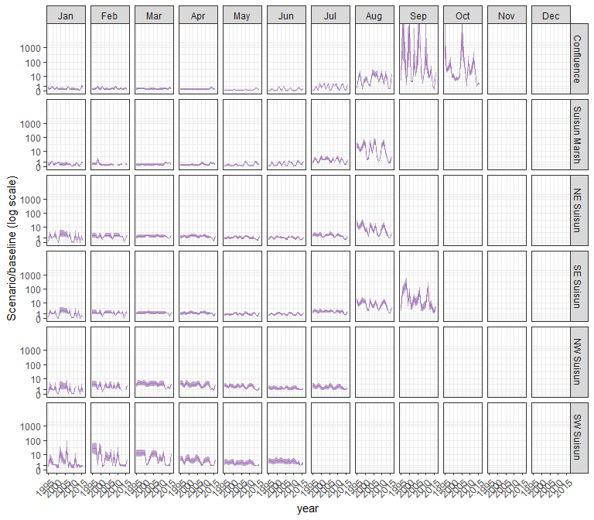

#### othcaljuv

## Warning in max(ids, na.rm = TRUE): no non-missing arguments to max; returning  
## -Inf

## Warning in max(ids, na.rm = TRUE): no non-missing arguments to max; returning  
## -Inf  
  
## Warning in max(ids, na.rm = TRUE): no non-missing arguments to max; returning  
## -Inf  
  
## Warning in max(ids, na.rm = TRUE): no non-missing arguments to max; returning  
## -Inf  
  
## Warning in max(ids, na.rm = TRUE): no non-missing arguments to max; returning  
## -Inf  
  
## Warning in max(ids, na.rm = TRUE): no non-missing arguments to max; returning  
## -Inf  
  
## Warning in max(ids, na.rm = TRUE): no non-missing arguments to max; returning  
## -Inf  
  
## Warning in max(ids, na.rm = TRUE): no non-missing arguments to max; returning  
## -Inf  
  
## Warning in max(ids, na.rm = TRUE): no non-missing arguments to max; returning  
## -Inf  
  
## Warning in max(ids, na.rm = TRUE): no non-missing arguments to max; returning  
## -Inf  
  
## Warning in max(ids, na.rm = TRUE): no non-missing arguments to max; returning  
## -Inf  
  
## Warning in max(ids, na.rm = TRUE): no non-missing arguments to max; returning  
## -Inf  
  
## Warning in max(ids, na.rm = TRUE): no non-missing arguments to max; returning  
## -Inf  
  
## Warning in max(ids, na.rm = TRUE): no non-missing arguments to max; returning  
## -Inf  
  
## Warning in max(ids, na.rm = TRUE): no non-missing arguments to max; returning  
## -Inf  
  
## Warning in max(ids, na.rm = TRUE): no non-missing arguments to max; returning  
## -Inf  
  
## Warning in max(ids, na.rm = TRUE): no non-missing arguments to max; returning  
## -Inf  
  
## Warning in max(ids, na.rm = TRUE): no non-missing arguments to max; returning  
## -Inf  
  
## Warning in max(ids, na.rm = TRUE): no non-missing arguments to max; returning  
## -Inf  
  
## Warning in max(ids, na.rm = TRUE): no non-missing arguments to max; returning  
## -Inf  
  
## Warning in max(ids, na.rm = TRUE): no non-missing arguments to max; returning  
## -Inf  
  
## Warning in max(ids, na.rm = TRUE): no non-missing arguments to max; returning  
## -Inf  
  
## Warning in max(ids, na.rm = TRUE): no non-missing arguments to max; returning  
## -Inf  
  
## Warning in max(ids, na.rm = TRUE): no non-missing arguments to max; returning  
## -Inf

## Warning: Removed 132 rows containing missing values (`geom_line()`).

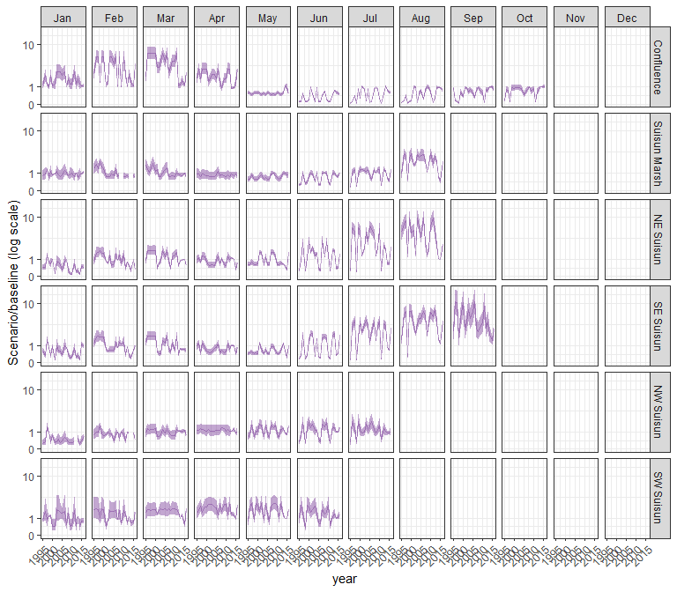

#### othclad

## Warning in max(ids, na.rm = TRUE): no non-missing arguments to max; returning  
## -Inf

## Warning in max(ids, na.rm = TRUE): no non-missing arguments to max; returning  
## -Inf  
  
## Warning in max(ids, na.rm = TRUE): no non-missing arguments to max; returning  
## -Inf  
  
## Warning in max(ids, na.rm = TRUE): no non-missing arguments to max; returning  
## -Inf  
  
## Warning in max(ids, na.rm = TRUE): no non-missing arguments to max; returning  
## -Inf  
  
## Warning in max(ids, na.rm = TRUE): no non-missing arguments to max; returning  
## -Inf  
  
## Warning in max(ids, na.rm = TRUE): no non-missing arguments to max; returning  
## -Inf  
  
## Warning in max(ids, na.rm = TRUE): no non-missing arguments to max; returning  
## -Inf  
  
## Warning in max(ids, na.rm = TRUE): no non-missing arguments to max; returning  
## -Inf  
  
## Warning in max(ids, na.rm = TRUE): no non-missing arguments to max; returning  
## -Inf  
  
## Warning in max(ids, na.rm = TRUE): no non-missing arguments to max; returning  
## -Inf  
  
## Warning in max(ids, na.rm = TRUE): no non-missing arguments to max; returning  
## -Inf  
  
## Warning in max(ids, na.rm = TRUE): no non-missing arguments to max; returning  
## -Inf  
  
## Warning in max(ids, na.rm = TRUE): no non-missing arguments to max; returning  
## -Inf  
  
## Warning in max(ids, na.rm = TRUE): no non-missing arguments to max; returning  
## -Inf  
  
## Warning in max(ids, na.rm = TRUE): no non-missing arguments to max; returning  
## -Inf  
  
## Warning in max(ids, na.rm = TRUE): no non-missing arguments to max; returning  
## -Inf  
  
## Warning in max(ids, na.rm = TRUE): no non-missing arguments to max; returning  
## -Inf  
  
## Warning in max(ids, na.rm = TRUE): no non-missing arguments to max; returning  
## -Inf  
  
## Warning in max(ids, na.rm = TRUE): no non-missing arguments to max; returning  
## -Inf  
  
## Warning in max(ids, na.rm = TRUE): no non-missing arguments to max; returning  
## -Inf  
  
## Warning in max(ids, na.rm = TRUE): no non-missing arguments to max; returning  
## -Inf  
  
## Warning in max(ids, na.rm = TRUE): no non-missing arguments to max; returning  
## -Inf  
  
## Warning in max(ids, na.rm = TRUE): no non-missing arguments to max; returning  
## -Inf

## Warning: Removed 132 rows containing missing values (`geom_line()`).

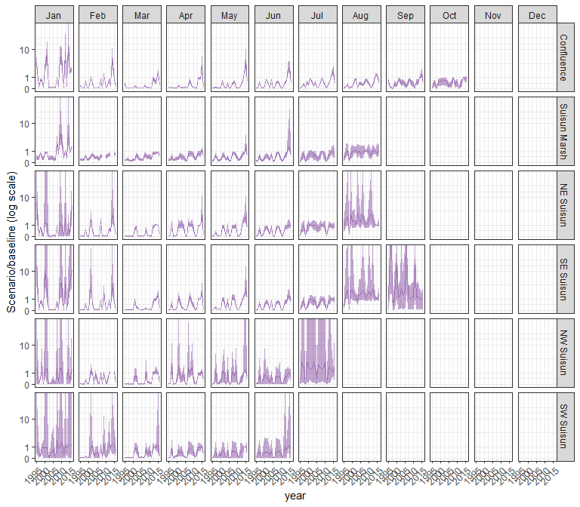

#### pdiapfor

## Warning in max(ids, na.rm = TRUE): no non-missing arguments to max; returning  
## -Inf

## Warning in max(ids, na.rm = TRUE): no non-missing arguments to max; returning  
## -Inf  
  
## Warning in max(ids, na.rm = TRUE): no non-missing arguments to max; returning  
## -Inf  
  
## Warning in max(ids, na.rm = TRUE): no non-missing arguments to max; returning  
## -Inf  
  
## Warning in max(ids, na.rm = TRUE): no non-missing arguments to max; returning  
## -Inf  
  
## Warning in max(ids, na.rm = TRUE): no non-missing arguments to max; returning  
## -Inf  
  
## Warning in max(ids, na.rm = TRUE): no non-missing arguments to max; returning  
## -Inf  
  
## Warning in max(ids, na.rm = TRUE): no non-missing arguments to max; returning  
## -Inf  
  
## Warning in max(ids, na.rm = TRUE): no non-missing arguments to max; returning  
## -Inf  
  
## Warning in max(ids, na.rm = TRUE): no non-missing arguments to max; returning  
## -Inf  
  
## Warning in max(ids, na.rm = TRUE): no non-missing arguments to max; returning  
## -Inf  
  
## Warning in max(ids, na.rm = TRUE): no non-missing arguments to max; returning  
## -Inf  
  
## Warning in max(ids, na.rm = TRUE): no non-missing arguments to max; returning  
## -Inf  
  
## Warning in max(ids, na.rm = TRUE): no non-missing arguments to max; returning  
## -Inf  
  
## Warning in max(ids, na.rm = TRUE): no non-missing arguments to max; returning  
## -Inf  
  
## Warning in max(ids, na.rm = TRUE): no non-missing arguments to max; returning  
## -Inf  
  
## Warning in max(ids, na.rm = TRUE): no non-missing arguments to max; returning  
## -Inf  
  
## Warning in max(ids, na.rm = TRUE): no non-missing arguments to max; returning  
## -Inf  
  
## Warning in max(ids, na.rm = TRUE): no non-missing arguments to max; returning  
## -Inf  
  
## Warning in max(ids, na.rm = TRUE): no non-missing arguments to max; returning  
## -Inf  
  
## Warning in max(ids, na.rm = TRUE): no non-missing arguments to max; returning  
## -Inf  
  
## Warning in max(ids, na.rm = TRUE): no non-missing arguments to max; returning  
## -Inf  
  
## Warning in max(ids, na.rm = TRUE): no non-missing arguments to max; returning  
## -Inf  
  
## Warning in max(ids, na.rm = TRUE): no non-missing arguments to max; returning  
## -Inf

## Warning: Removed 132 rows containing missing values (`geom_line()`).

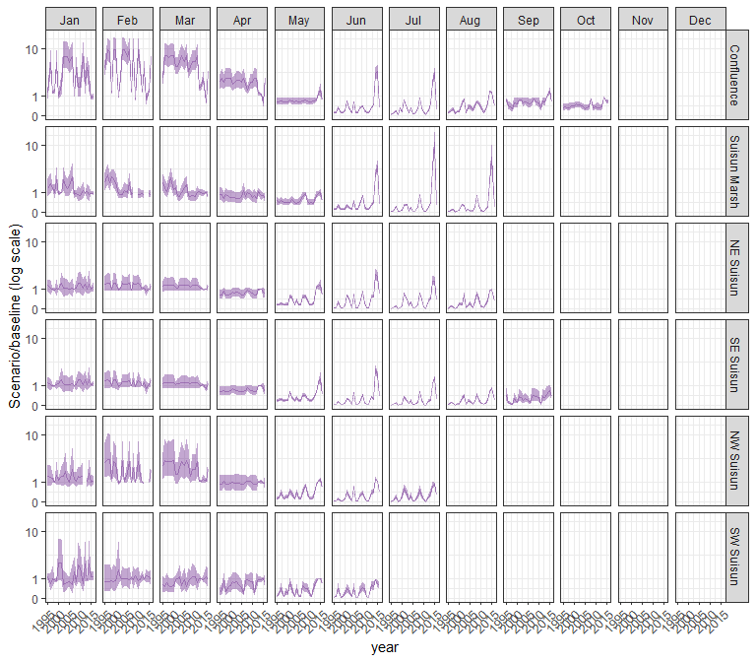

#### allcopnaup

## Warning in max(ids, na.rm = TRUE): no non-missing arguments to max; returning  
## -Inf

## Warning in max(ids, na.rm = TRUE): no non-missing arguments to max; returning  
## -Inf  
  
## Warning in max(ids, na.rm = TRUE): no non-missing arguments to max; returning  
## -Inf  
  
## Warning in max(ids, na.rm = TRUE): no non-missing arguments to max; returning  
## -Inf  
  
## Warning in max(ids, na.rm = TRUE): no non-missing arguments to max; returning  
## -Inf  
  
## Warning in max(ids, na.rm = TRUE): no non-missing arguments to max; returning  
## -Inf  
  
## Warning in max(ids, na.rm = TRUE): no non-missing arguments to max; returning  
## -Inf  
  
## Warning in max(ids, na.rm = TRUE): no non-missing arguments to max; returning  
## -Inf  
  
## Warning in max(ids, na.rm = TRUE): no non-missing arguments to max; returning  
## -Inf  
  
## Warning in max(ids, na.rm = TRUE): no non-missing arguments to max; returning  
## -Inf  
  
## Warning in max(ids, na.rm = TRUE): no non-missing arguments to max; returning  
## -Inf  
  
## Warning in max(ids, na.rm = TRUE): no non-missing arguments to max; returning  
## -Inf  
  
## Warning in max(ids, na.rm = TRUE): no non-missing arguments to max; returning  
## -Inf  
  
## Warning in max(ids, na.rm = TRUE): no non-missing arguments to max; returning  
## -Inf  
  
## Warning in max(ids, na.rm = TRUE): no non-missing arguments to max; returning  
## -Inf  
  
## Warning in max(ids, na.rm = TRUE): no non-missing arguments to max; returning  
## -Inf  
  
## Warning in max(ids, na.rm = TRUE): no non-missing arguments to max; returning  
## -Inf  
  
## Warning in max(ids, na.rm = TRUE): no non-missing arguments to max; returning  
## -Inf  
  
## Warning in max(ids, na.rm = TRUE): no non-missing arguments to max; returning  
## -Inf  
  
## Warning in max(ids, na.rm = TRUE): no non-missing arguments to max; returning  
## -Inf  
  
## Warning in max(ids, na.rm = TRUE): no non-missing arguments to max; returning  
## -Inf  
  
## Warning in max(ids, na.rm = TRUE): no non-missing arguments to max; returning  
## -Inf  
  
## Warning in max(ids, na.rm = TRUE): no non-missing arguments to max; returning  
## -Inf  
  
## Warning in max(ids, na.rm = TRUE): no non-missing arguments to max; returning  
## -Inf

## Warning: Removed 132 rows containing missing values (`geom_line()`).

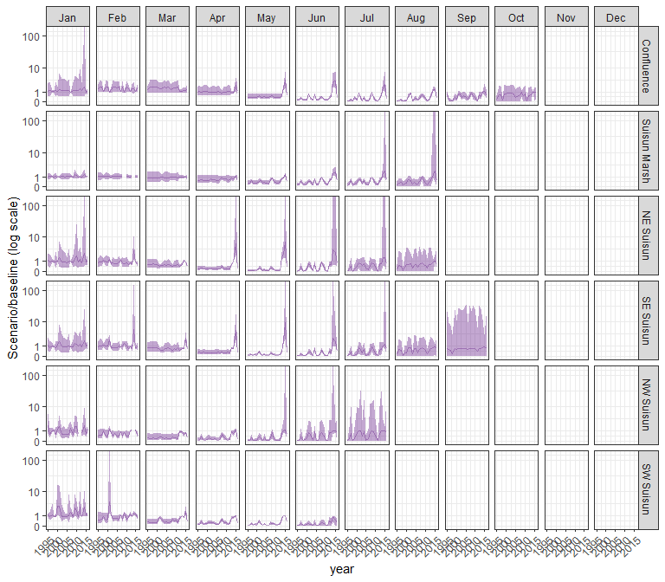

#### limno

## Warning in max(ids, na.rm = TRUE): no non-missing arguments to max; returning  
## -Inf

## Warning in max(ids, na.rm = TRUE): no non-missing arguments to max; returning  
## -Inf  
  
## Warning in max(ids, na.rm = TRUE): no non-missing arguments to max; returning  
## -Inf  
  
## Warning in max(ids, na.rm = TRUE): no non-missing arguments to max; returning  
## -Inf  
  
## Warning in max(ids, na.rm = TRUE): no non-missing arguments to max; returning  
## -Inf  
  
## Warning in max(ids, na.rm = TRUE): no non-missing arguments to max; returning  
## -Inf  
  
## Warning in max(ids, na.rm = TRUE): no non-missing arguments to max; returning  
## -Inf  
  
## Warning in max(ids, na.rm = TRUE): no non-missing arguments to max; returning  
## -Inf  
  
## Warning in max(ids, na.rm = TRUE): no non-missing arguments to max; returning  
## -Inf  
  
## Warning in max(ids, na.rm = TRUE): no non-missing arguments to max; returning  
## -Inf  
  
## Warning in max(ids, na.rm = TRUE): no non-missing arguments to max; returning  
## -Inf  
  
## Warning in max(ids, na.rm = TRUE): no non-missing arguments to max; returning  
## -Inf  
  
## Warning in max(ids, na.rm = TRUE): no non-missing arguments to max; returning  
## -Inf  
  
## Warning in max(ids, na.rm = TRUE): no non-missing arguments to max; returning  
## -Inf  
  
## Warning in max(ids, na.rm = TRUE): no non-missing arguments to max; returning  
## -Inf  
  
## Warning in max(ids, na.rm = TRUE): no non-missing arguments to max; returning  
## -Inf  
  
## Warning in max(ids, na.rm = TRUE): no non-missing arguments to max; returning  
## -Inf  
  
## Warning in max(ids, na.rm = TRUE): no non-missing arguments to max; returning  
## -Inf  
  
## Warning in max(ids, na.rm = TRUE): no non-missing arguments to max; returning  
## -Inf  
  
## Warning in max(ids, na.rm = TRUE): no non-missing arguments to max; returning  
## -Inf  
  
## Warning in max(ids, na.rm = TRUE): no non-missing arguments to max; returning  
## -Inf  
  
## Warning in max(ids, na.rm = TRUE): no non-missing arguments to max; returning  
## -Inf  
  
## Warning in max(ids, na.rm = TRUE): no non-missing arguments to max; returning  
## -Inf  
  
## Warning in max(ids, na.rm = TRUE): no non-missing arguments to max; returning  
## -Inf

## Warning: Removed 132 rows containing missing values (`geom_line()`).

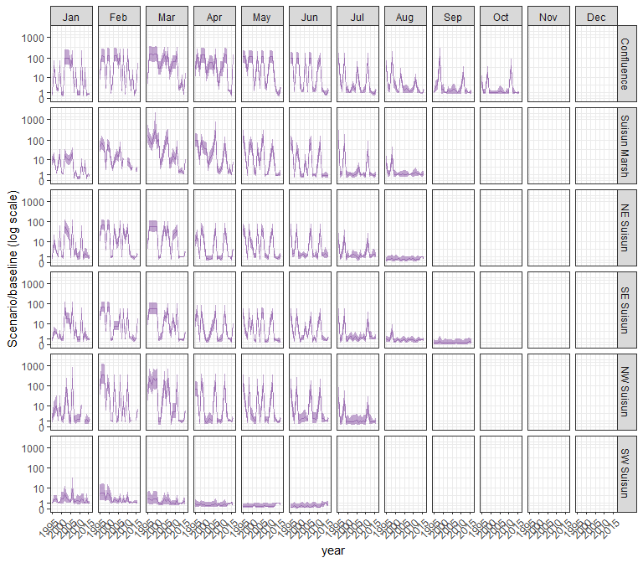

#### mysid

## Warning in max(ids, na.rm = TRUE): no non-missing arguments to max; returning  
## -Inf

## Warning in max(ids, na.rm = TRUE): no non-missing arguments to max; returning  
## -Inf  
  
## Warning in max(ids, na.rm = TRUE): no non-missing arguments to max; returning  
## -Inf  
  
## Warning in max(ids, na.rm = TRUE): no non-missing arguments to max; returning  
## -Inf  
  
## Warning in max(ids, na.rm = TRUE): no non-missing arguments to max; returning  
## -Inf  
  
## Warning in max(ids, na.rm = TRUE): no non-missing arguments to max; returning  
## -Inf  
  
## Warning in max(ids, na.rm = TRUE): no non-missing arguments to max; returning  
## -Inf  
  
## Warning in max(ids, na.rm = TRUE): no non-missing arguments to max; returning  
## -Inf  
  
## Warning in max(ids, na.rm = TRUE): no non-missing arguments to max; returning  
## -Inf  
  
## Warning in max(ids, na.rm = TRUE): no non-missing arguments to max; returning  
## -Inf  
  
## Warning in max(ids, na.rm = TRUE): no non-missing arguments to max; returning  
## -Inf  
  
## Warning in max(ids, na.rm = TRUE): no non-missing arguments to max; returning  
## -Inf  
  
## Warning in max(ids, na.rm = TRUE): no non-missing arguments to max; returning  
## -Inf  
  
## Warning in max(ids, na.rm = TRUE): no non-missing arguments to max; returning  
## -Inf  
  
## Warning in max(ids, na.rm = TRUE): no non-missing arguments to max; returning  
## -Inf  
  
## Warning in max(ids, na.rm = TRUE): no non-missing arguments to max; returning  
## -Inf  
  
## Warning in max(ids, na.rm = TRUE): no non-missing arguments to max; returning  
## -Inf  
  
## Warning in max(ids, na.rm = TRUE): no non-missing arguments to max; returning  
## -Inf  
  
## Warning in max(ids, na.rm = TRUE): no non-missing arguments to max; returning  
## -Inf  
  
## Warning in max(ids, na.rm = TRUE): no non-missing arguments to max; returning  
## -Inf  
  
## Warning in max(ids, na.rm = TRUE): no non-missing arguments to max; returning  
## -Inf  
  
## Warning in max(ids, na.rm = TRUE): no non-missing arguments to max; returning  
## -Inf  
  
## Warning in max(ids, na.rm = TRUE): no non-missing arguments to max; returning  
## -Inf  
  
## Warning in max(ids, na.rm = TRUE): no non-missing arguments to max; returning  
## -Inf

## Warning: Removed 132 rows containing missing values (`geom_line()`).

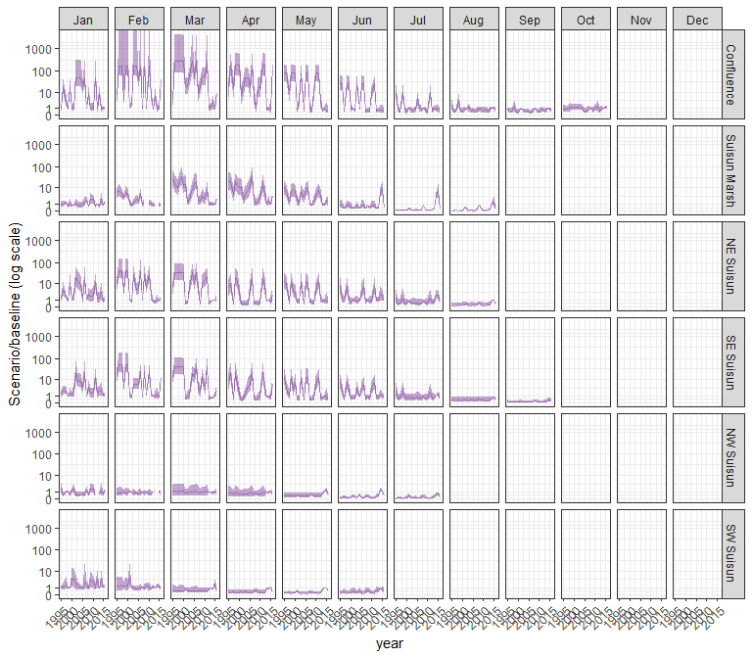

#### othcyc

## Warning in max(ids, na.rm = TRUE): no non-missing arguments to max; returning  
## -Inf

## Warning in max(ids, na.rm = TRUE): no non-missing arguments to max; returning  
## -Inf  
  
## Warning in max(ids, na.rm = TRUE): no non-missing arguments to max; returning  
## -Inf  
  
## Warning in max(ids, na.rm = TRUE): no non-missing arguments to max; returning  
## -Inf  
  
## Warning in max(ids, na.rm = TRUE): no non-missing arguments to max; returning  
## -Inf  
  
## Warning in max(ids, na.rm = TRUE): no non-missing arguments to max; returning  
## -Inf  
  
## Warning in max(ids, na.rm = TRUE): no non-missing arguments to max; returning  
## -Inf  
  
## Warning in max(ids, na.rm = TRUE): no non-missing arguments to max; returning  
## -Inf  
  
## Warning in max(ids, na.rm = TRUE): no non-missing arguments to max; returning  
## -Inf  
  
## Warning in max(ids, na.rm = TRUE): no non-missing arguments to max; returning  
## -Inf  
  
## Warning in max(ids, na.rm = TRUE): no non-missing arguments to max; returning  
## -Inf  
  
## Warning in max(ids, na.rm = TRUE): no non-missing arguments to max; returning  
## -Inf  
  
## Warning in max(ids, na.rm = TRUE): no non-missing arguments to max; returning  
## -Inf  
  
## Warning in max(ids, na.rm = TRUE): no non-missing arguments to max; returning  
## -Inf  
  
## Warning in max(ids, na.rm = TRUE): no non-missing arguments to max; returning  
## -Inf  
  
## Warning in max(ids, na.rm = TRUE): no non-missing arguments to max; returning  
## -Inf  
  
## Warning in max(ids, na.rm = TRUE): no non-missing arguments to max; returning  
## -Inf  
  
## Warning in max(ids, na.rm = TRUE): no non-missing arguments to max; returning  
## -Inf  
  
## Warning in max(ids, na.rm = TRUE): no non-missing arguments to max; returning  
## -Inf  
  
## Warning in max(ids, na.rm = TRUE): no non-missing arguments to max; returning  
## -Inf  
  
## Warning in max(ids, na.rm = TRUE): no non-missing arguments to max; returning  
## -Inf  
  
## Warning in max(ids, na.rm = TRUE): no non-missing arguments to max; returning  
## -Inf  
  
## Warning in max(ids, na.rm = TRUE): no non-missing arguments to max; returning  
## -Inf  
  
## Warning in max(ids, na.rm = TRUE): no non-missing arguments to max; returning  
## -Inf

## Warning: Removed 132 rows containing missing values (`geom_line()`).

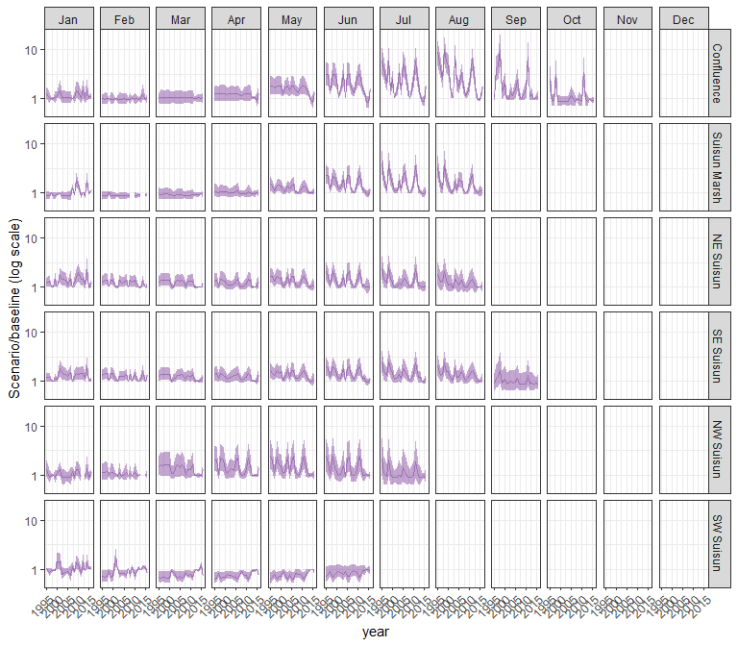

#### other

## Warning in max(ids, na.rm = TRUE): no non-missing arguments to max; returning  
## -Inf

## Warning in max(ids, na.rm = TRUE): no non-missing arguments to max; returning  
## -Inf  
  
## Warning in max(ids, na.rm = TRUE): no non-missing arguments to max; returning  
## -Inf  
  
## Warning in max(ids, na.rm = TRUE): no non-missing arguments to max; returning  
## -Inf  
  
## Warning in max(ids, na.rm = TRUE): no non-missing arguments to max; returning  
## -Inf  
  
## Warning in max(ids, na.rm = TRUE): no non-missing arguments to max; returning  
## -Inf  
  
## Warning in max(ids, na.rm = TRUE): no non-missing arguments to max; returning  
## -Inf  
  
## Warning in max(ids, na.rm = TRUE): no non-missing arguments to max; returning  
## -Inf  
  
## Warning in max(ids, na.rm = TRUE): no non-missing arguments to max; returning  
## -Inf  
  
## Warning in max(ids, na.rm = TRUE): no non-missing arguments to max; returning  
## -Inf  
  
## Warning in max(ids, na.rm = TRUE): no non-missing arguments to max; returning  
## -Inf  
  
## Warning in max(ids, na.rm = TRUE): no non-missing arguments to max; returning  
## -Inf  
  
## Warning in max(ids, na.rm = TRUE): no non-missing arguments to max; returning  
## -Inf  
  
## Warning in max(ids, na.rm = TRUE): no non-missing arguments to max; returning  
## -Inf  
  
## Warning in max(ids, na.rm = TRUE): no non-missing arguments to max; returning  
## -Inf  
  
## Warning in max(ids, na.rm = TRUE): no non-missing arguments to max; returning  
## -Inf  
  
## Warning in max(ids, na.rm = TRUE): no non-missing arguments to max; returning  
## -Inf  
  
## Warning in max(ids, na.rm = TRUE): no non-missing arguments to max; returning  
## -Inf  
  
## Warning in max(ids, na.rm = TRUE): no non-missing arguments to max; returning  
## -Inf  
  
## Warning in max(ids, na.rm = TRUE): no non-missing arguments to max; returning  
## -Inf  
  
## Warning in max(ids, na.rm = TRUE): no non-missing arguments to max; returning  
## -Inf  
  
## Warning in max(ids, na.rm = TRUE): no non-missing arguments to max; returning  
## -Inf  
  
## Warning in max(ids, na.rm = TRUE): no non-missing arguments to max; returning  
## -Inf  
  
## Warning in max(ids, na.rm = TRUE): no non-missing arguments to max; returning  
## -Inf

## Warning: Removed 132 rows containing missing values (`geom_line()`).

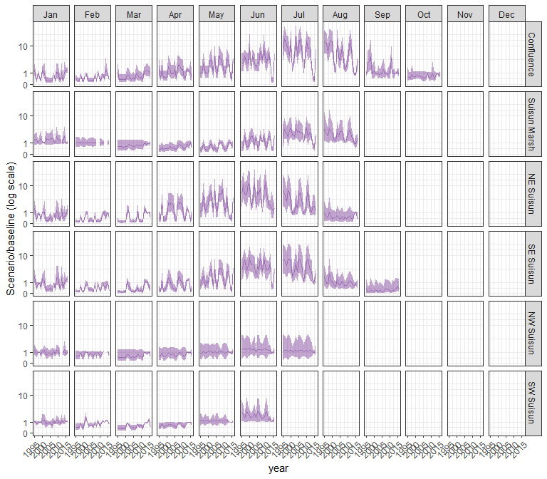

### sal_EXP3

#### acartela

## Warning in max(ids, na.rm = TRUE): no non-missing arguments to max; returning  
## -Inf

## Warning in max(ids, na.rm = TRUE): no non-missing arguments to max; returning  
## -Inf  
  
## Warning in max(ids, na.rm = TRUE): no non-missing arguments to max; returning  
## -Inf  
  
## Warning in max(ids, na.rm = TRUE): no non-missing arguments to max; returning  
## -Inf  
  
## Warning in max(ids, na.rm = TRUE): no non-missing arguments to max; returning  
## -Inf  
  
## Warning in max(ids, na.rm = TRUE): no non-missing arguments to max; returning  
## -Inf  
  
## Warning in max(ids, na.rm = TRUE): no non-missing arguments to max; returning  
## -Inf  
  
## Warning in max(ids, na.rm = TRUE): no non-missing arguments to max; returning  
## -Inf  
  
## Warning in max(ids, na.rm = TRUE): no non-missing arguments to max; returning  
## -Inf  
  
## Warning in max(ids, na.rm = TRUE): no non-missing arguments to max; returning  
## -Inf  
  
## Warning in max(ids, na.rm = TRUE): no non-missing arguments to max; returning  
## -Inf  
  
## Warning in max(ids, na.rm = TRUE): no non-missing arguments to max; returning  
## -Inf  
  
## Warning in max(ids, na.rm = TRUE): no non-missing arguments to max; returning  
## -Inf  
  
## Warning in max(ids, na.rm = TRUE): no non-missing arguments to max; returning  
## -Inf  
  
## Warning in max(ids, na.rm = TRUE): no non-missing arguments to max; returning  
## -Inf  
  
## Warning in max(ids, na.rm = TRUE): no non-missing arguments to max; returning  
## -Inf  
  
## Warning in max(ids, na.rm = TRUE): no non-missing arguments to max; returning  
## -Inf  
  
## Warning in max(ids, na.rm = TRUE): no non-missing arguments to max; returning  
## -Inf  
  
## Warning in max(ids, na.rm = TRUE): no non-missing arguments to max; returning  
## -Inf  
  
## Warning in max(ids, na.rm = TRUE): no non-missing arguments to max; returning  
## -Inf  
  
## Warning in max(ids, na.rm = TRUE): no non-missing arguments to max; returning  
## -Inf  
  
## Warning in max(ids, na.rm = TRUE): no non-missing arguments to max; returning  
## -Inf  
  
## Warning in max(ids, na.rm = TRUE): no non-missing arguments to max; returning  
## -Inf  
  
## Warning in max(ids, na.rm = TRUE): no non-missing arguments to max; returning  
## -Inf

## Warning: Removed 132 rows containing missing values (`geom_line()`).

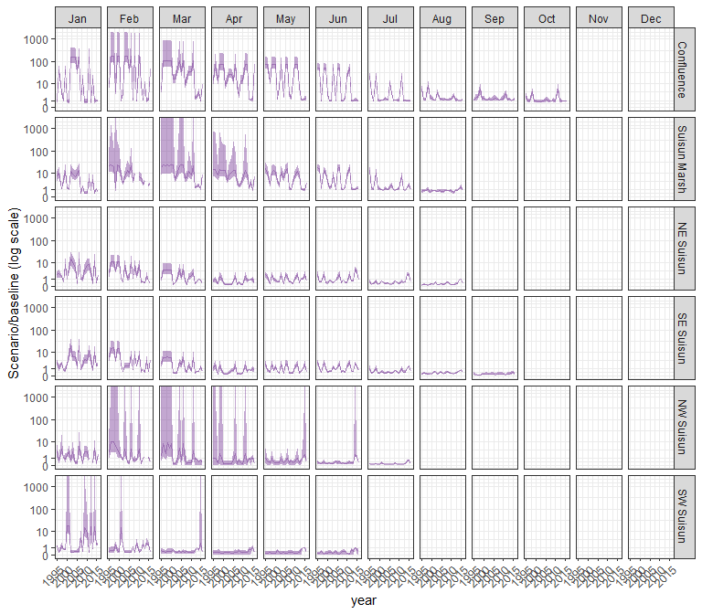

#### daphnia

## Warning in max(ids, na.rm = TRUE): no non-missing arguments to max; returning  
## -Inf

## Warning in max(ids, na.rm = TRUE): no non-missing arguments to max; returning  
## -Inf  
  
## Warning in max(ids, na.rm = TRUE): no non-missing arguments to max; returning  
## -Inf  
  
## Warning in max(ids, na.rm = TRUE): no non-missing arguments to max; returning  
## -Inf  
  
## Warning in max(ids, na.rm = TRUE): no non-missing arguments to max; returning  
## -Inf  
  
## Warning in max(ids, na.rm = TRUE): no non-missing arguments to max; returning  
## -Inf  
  
## Warning in max(ids, na.rm = TRUE): no non-missing arguments to max; returning  
## -Inf  
  
## Warning in max(ids, na.rm = TRUE): no non-missing arguments to max; returning  
## -Inf  
  
## Warning in max(ids, na.rm = TRUE): no non-missing arguments to max; returning  
## -Inf  
  
## Warning in max(ids, na.rm = TRUE): no non-missing arguments to max; returning  
## -Inf  
  
## Warning in max(ids, na.rm = TRUE): no non-missing arguments to max; returning  
## -Inf  
  
## Warning in max(ids, na.rm = TRUE): no non-missing arguments to max; returning  
## -Inf  
  
## Warning in max(ids, na.rm = TRUE): no non-missing arguments to max; returning  
## -Inf  
  
## Warning in max(ids, na.rm = TRUE): no non-missing arguments to max; returning  
## -Inf  
  
## Warning in max(ids, na.rm = TRUE): no non-missing arguments to max; returning  
## -Inf  
  
## Warning in max(ids, na.rm = TRUE): no non-missing arguments to max; returning  
## -Inf  
  
## Warning in max(ids, na.rm = TRUE): no non-missing arguments to max; returning  
## -Inf  
  
## Warning in max(ids, na.rm = TRUE): no non-missing arguments to max; returning  
## -Inf  
  
## Warning in max(ids, na.rm = TRUE): no non-missing arguments to max; returning  
## -Inf  
  
## Warning in max(ids, na.rm = TRUE): no non-missing arguments to max; returning  
## -Inf  
  
## Warning in max(ids, na.rm = TRUE): no non-missing arguments to max; returning  
## -Inf  
  
## Warning in max(ids, na.rm = TRUE): no non-missing arguments to max; returning  
## -Inf  
  
## Warning in max(ids, na.rm = TRUE): no non-missing arguments to max; returning  
## -Inf  
  
## Warning in max(ids, na.rm = TRUE): no non-missing arguments to max; returning  
## -Inf

## Warning: Removed 132 rows containing missing values (`geom_line()`).

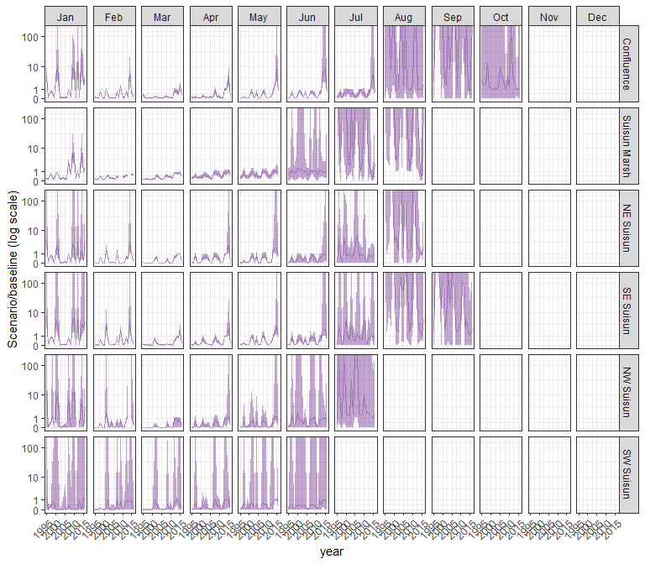

#### eurytem

## Warning in max(ids, na.rm = TRUE): no non-missing arguments to max; returning  
## -Inf

## Warning in max(ids, na.rm = TRUE): no non-missing arguments to max; returning  
## -Inf  
  
## Warning in max(ids, na.rm = TRUE): no non-missing arguments to max; returning  
## -Inf  
  
## Warning in max(ids, na.rm = TRUE): no non-missing arguments to max; returning  
## -Inf  
  
## Warning in max(ids, na.rm = TRUE): no non-missing arguments to max; returning  
## -Inf  
  
## Warning in max(ids, na.rm = TRUE): no non-missing arguments to max; returning  
## -Inf  
  
## Warning in max(ids, na.rm = TRUE): no non-missing arguments to max; returning  
## -Inf  
  
## Warning in max(ids, na.rm = TRUE): no non-missing arguments to max; returning  
## -Inf  
  
## Warning in max(ids, na.rm = TRUE): no non-missing arguments to max; returning  
## -Inf  
  
## Warning in max(ids, na.rm = TRUE): no non-missing arguments to max; returning  
## -Inf  
  
## Warning in max(ids, na.rm = TRUE): no non-missing arguments to max; returning  
## -Inf  
  
## Warning in max(ids, na.rm = TRUE): no non-missing arguments to max; returning  
## -Inf  
  
## Warning in max(ids, na.rm = TRUE): no non-missing arguments to max; returning  
## -Inf  
  
## Warning in max(ids, na.rm = TRUE): no non-missing arguments to max; returning  
## -Inf  
  
## Warning in max(ids, na.rm = TRUE): no non-missing arguments to max; returning  
## -Inf  
  
## Warning in max(ids, na.rm = TRUE): no non-missing arguments to max; returning  
## -Inf  
  
## Warning in max(ids, na.rm = TRUE): no non-missing arguments to max; returning  
## -Inf  
  
## Warning in max(ids, na.rm = TRUE): no non-missing arguments to max; returning  
## -Inf  
  
## Warning in max(ids, na.rm = TRUE): no non-missing arguments to max; returning  
## -Inf  
  
## Warning in max(ids, na.rm = TRUE): no non-missing arguments to max; returning  
## -Inf  
  
## Warning in max(ids, na.rm = TRUE): no non-missing arguments to max; returning  
## -Inf  
  
## Warning in max(ids, na.rm = TRUE): no non-missing arguments to max; returning  
## -Inf  
  
## Warning in max(ids, na.rm = TRUE): no non-missing arguments to max; returning  
## -Inf  
  
## Warning in max(ids, na.rm = TRUE): no non-missing arguments to max; returning  
## -Inf

## Warning: Removed 132 rows containing missing values (`geom_line()`).

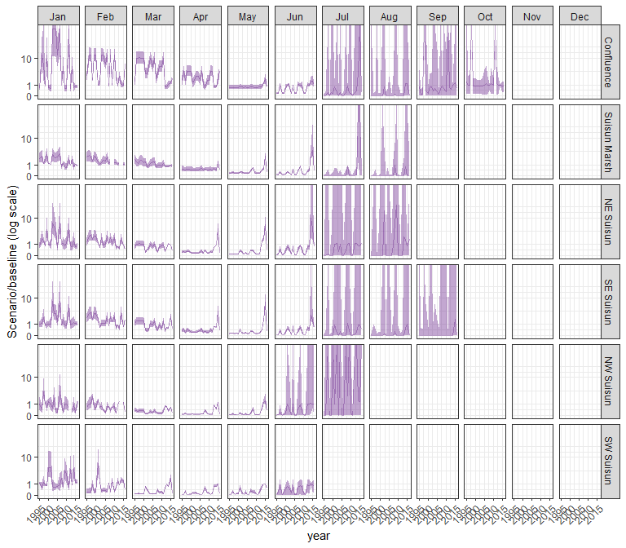

#### othcalad

## Warning in max(ids, na.rm = TRUE): no non-missing arguments to max; returning  
## -Inf

## Warning in max(ids, na.rm = TRUE): no non-missing arguments to max; returning  
## -Inf  
  
## Warning in max(ids, na.rm = TRUE): no non-missing arguments to max; returning  
## -Inf  
  
## Warning in max(ids, na.rm = TRUE): no non-missing arguments to max; returning  
## -Inf  
  
## Warning in max(ids, na.rm = TRUE): no non-missing arguments to max; returning  
## -Inf  
  
## Warning in max(ids, na.rm = TRUE): no non-missing arguments to max; returning  
## -Inf  
  
## Warning in max(ids, na.rm = TRUE): no non-missing arguments to max; returning  
## -Inf  
  
## Warning in max(ids, na.rm = TRUE): no non-missing arguments to max; returning  
## -Inf  
  
## Warning in max(ids, na.rm = TRUE): no non-missing arguments to max; returning  
## -Inf  
  
## Warning in max(ids, na.rm = TRUE): no non-missing arguments to max; returning  
## -Inf  
  
## Warning in max(ids, na.rm = TRUE): no non-missing arguments to max; returning  
## -Inf  
  
## Warning in max(ids, na.rm = TRUE): no non-missing arguments to max; returning  
## -Inf  
  
## Warning in max(ids, na.rm = TRUE): no non-missing arguments to max; returning  
## -Inf  
  
## Warning in max(ids, na.rm = TRUE): no non-missing arguments to max; returning  
## -Inf  
  
## Warning in max(ids, na.rm = TRUE): no non-missing arguments to max; returning  
## -Inf  
  
## Warning in max(ids, na.rm = TRUE): no non-missing arguments to max; returning  
## -Inf  
  
## Warning in max(ids, na.rm = TRUE): no non-missing arguments to max; returning  
## -Inf  
  
## Warning in max(ids, na.rm = TRUE): no non-missing arguments to max; returning  
## -Inf  
  
## Warning in max(ids, na.rm = TRUE): no non-missing arguments to max; returning  
## -Inf  
  
## Warning in max(ids, na.rm = TRUE): no non-missing arguments to max; returning  
## -Inf  
  
## Warning in max(ids, na.rm = TRUE): no non-missing arguments to max; returning  
## -Inf  
  
## Warning in max(ids, na.rm = TRUE): no non-missing arguments to max; returning  
## -Inf  
  
## Warning in max(ids, na.rm = TRUE): no non-missing arguments to max; returning  
## -Inf  
  
## Warning in max(ids, na.rm = TRUE): no non-missing arguments to max; returning  
## -Inf

## Warning: Removed 132 rows containing missing values (`geom_line()`).

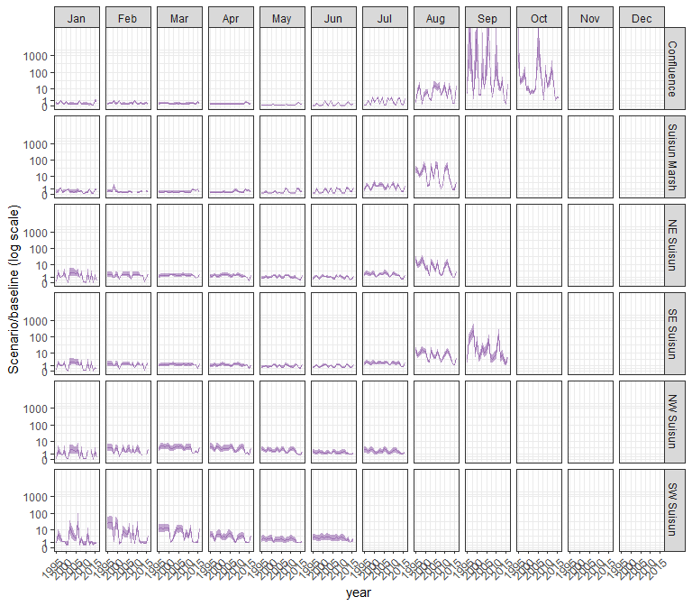

#### othcaljuv

## Warning in max(ids, na.rm = TRUE): no non-missing arguments to max; returning  
## -Inf

## Warning in max(ids, na.rm = TRUE): no non-missing arguments to max; returning  
## -Inf  
  
## Warning in max(ids, na.rm = TRUE): no non-missing arguments to max; returning  
## -Inf  
  
## Warning in max(ids, na.rm = TRUE): no non-missing arguments to max; returning  
## -Inf  
  
## Warning in max(ids, na.rm = TRUE): no non-missing arguments to max; returning  
## -Inf  
  
## Warning in max(ids, na.rm = TRUE): no non-missing arguments to max; returning  
## -Inf  
  
## Warning in max(ids, na.rm = TRUE): no non-missing arguments to max; returning  
## -Inf  
  
## Warning in max(ids, na.rm = TRUE): no non-missing arguments to max; returning  
## -Inf  
  
## Warning in max(ids, na.rm = TRUE): no non-missing arguments to max; returning  
## -Inf  
  
## Warning in max(ids, na.rm = TRUE): no non-missing arguments to max; returning  
## -Inf  
  
## Warning in max(ids, na.rm = TRUE): no non-missing arguments to max; returning  
## -Inf  
  
## Warning in max(ids, na.rm = TRUE): no non-missing arguments to max; returning  
## -Inf  
  
## Warning in max(ids, na.rm = TRUE): no non-missing arguments to max; returning  
## -Inf  
  
## Warning in max(ids, na.rm = TRUE): no non-missing arguments to max; returning  
## -Inf  
  
## Warning in max(ids, na.rm = TRUE): no non-missing arguments to max; returning  
## -Inf  
  
## Warning in max(ids, na.rm = TRUE): no non-missing arguments to max; returning  
## -Inf  
  
## Warning in max(ids, na.rm = TRUE): no non-missing arguments to max; returning  
## -Inf  
  
## Warning in max(ids, na.rm = TRUE): no non-missing arguments to max; returning  
## -Inf  
  
## Warning in max(ids, na.rm = TRUE): no non-missing arguments to max; returning  
## -Inf  
  
## Warning in max(ids, na.rm = TRUE): no non-missing arguments to max; returning  
## -Inf  
  
## Warning in max(ids, na.rm = TRUE): no non-missing arguments to max; returning  
## -Inf  
  
## Warning in max(ids, na.rm = TRUE): no non-missing arguments to max; returning  
## -Inf  
  
## Warning in max(ids, na.rm = TRUE): no non-missing arguments to max; returning  
## -Inf  
  
## Warning in max(ids, na.rm = TRUE): no non-missing arguments to max; returning  
## -Inf

## Warning: Removed 132 rows containing missing values (`geom_line()`).

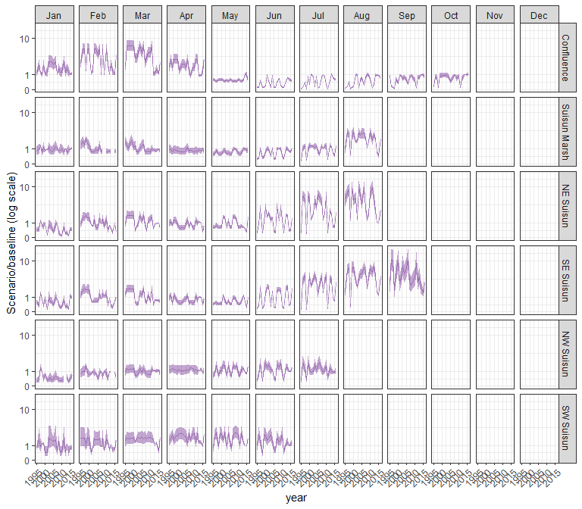

#### othclad

## Warning in max(ids, na.rm = TRUE): no non-missing arguments to max; returning  
## -Inf

## Warning in max(ids, na.rm = TRUE): no non-missing arguments to max; returning  
## -Inf  
  
## Warning in max(ids, na.rm = TRUE): no non-missing arguments to max; returning  
## -Inf  
  
## Warning in max(ids, na.rm = TRUE): no non-missing arguments to max; returning  
## -Inf  
  
## Warning in max(ids, na.rm = TRUE): no non-missing arguments to max; returning  
## -Inf  
  
## Warning in max(ids, na.rm = TRUE): no non-missing arguments to max; returning  
## -Inf  
  
## Warning in max(ids, na.rm = TRUE): no non-missing arguments to max; returning  
## -Inf  
  
## Warning in max(ids, na.rm = TRUE): no non-missing arguments to max; returning  
## -Inf  
  
## Warning in max(ids, na.rm = TRUE): no non-missing arguments to max; returning  
## -Inf  
  
## Warning in max(ids, na.rm = TRUE): no non-missing arguments to max; returning  
## -Inf  
  
## Warning in max(ids, na.rm = TRUE): no non-missing arguments to max; returning  
## -Inf  
  
## Warning in max(ids, na.rm = TRUE): no non-missing arguments to max; returning  
## -Inf  
  
## Warning in max(ids, na.rm = TRUE): no non-missing arguments to max; returning  
## -Inf  
  
## Warning in max(ids, na.rm = TRUE): no non-missing arguments to max; returning  
## -Inf  
  
## Warning in max(ids, na.rm = TRUE): no non-missing arguments to max; returning  
## -Inf  
  
## Warning in max(ids, na.rm = TRUE): no non-missing arguments to max; returning  
## -Inf  
  
## Warning in max(ids, na.rm = TRUE): no non-missing arguments to max; returning  
## -Inf  
  
## Warning in max(ids, na.rm = TRUE): no non-missing arguments to max; returning  
## -Inf  
  
## Warning in max(ids, na.rm = TRUE): no non-missing arguments to max; returning  
## -Inf  
  
## Warning in max(ids, na.rm = TRUE): no non-missing arguments to max; returning  
## -Inf  
  
## Warning in max(ids, na.rm = TRUE): no non-missing arguments to max; returning  
## -Inf  
  
## Warning in max(ids, na.rm = TRUE): no non-missing arguments to max; returning  
## -Inf  
  
## Warning in max(ids, na.rm = TRUE): no non-missing arguments to max; returning  
## -Inf  
  
## Warning in max(ids, na.rm = TRUE): no non-missing arguments to max; returning  
## -Inf

## Warning: Removed 132 rows containing missing values (`geom_line()`).

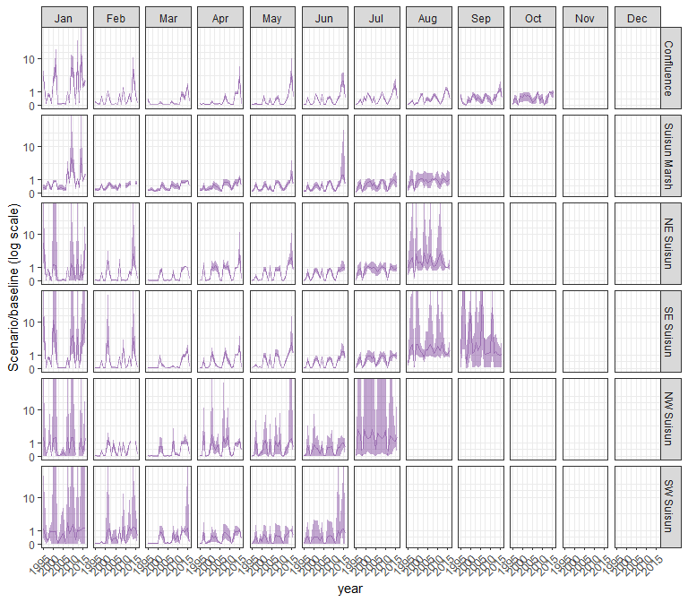

#### pdiapfor

## Warning in max(ids, na.rm = TRUE): no non-missing arguments to max; returning  
## -Inf

## Warning in max(ids, na.rm = TRUE): no non-missing arguments to max; returning  
## -Inf  
  
## Warning in max(ids, na.rm = TRUE): no non-missing arguments to max; returning  
## -Inf  
  
## Warning in max(ids, na.rm = TRUE): no non-missing arguments to max; returning  
## -Inf  
  
## Warning in max(ids, na.rm = TRUE): no non-missing arguments to max; returning  
## -Inf  
  
## Warning in max(ids, na.rm = TRUE): no non-missing arguments to max; returning  
## -Inf  
  
## Warning in max(ids, na.rm = TRUE): no non-missing arguments to max; returning  
## -Inf  
  
## Warning in max(ids, na.rm = TRUE): no non-missing arguments to max; returning  
## -Inf  
  
## Warning in max(ids, na.rm = TRUE): no non-missing arguments to max; returning  
## -Inf  
  
## Warning in max(ids, na.rm = TRUE): no non-missing arguments to max; returning  
## -Inf  
  
## Warning in max(ids, na.rm = TRUE): no non-missing arguments to max; returning  
## -Inf  
  
## Warning in max(ids, na.rm = TRUE): no non-missing arguments to max; returning  
## -Inf  
  
## Warning in max(ids, na.rm = TRUE): no non-missing arguments to max; returning  
## -Inf  
  
## Warning in max(ids, na.rm = TRUE): no non-missing arguments to max; returning  
## -Inf  
  
## Warning in max(ids, na.rm = TRUE): no non-missing arguments to max; returning  
## -Inf  
  
## Warning in max(ids, na.rm = TRUE): no non-missing arguments to max; returning  
## -Inf  
  
## Warning in max(ids, na.rm = TRUE): no non-missing arguments to max; returning  
## -Inf  
  
## Warning in max(ids, na.rm = TRUE): no non-missing arguments to max; returning  
## -Inf  
  
## Warning in max(ids, na.rm = TRUE): no non-missing arguments to max; returning  
## -Inf  
  
## Warning in max(ids, na.rm = TRUE): no non-missing arguments to max; returning  
## -Inf  
  
## Warning in max(ids, na.rm = TRUE): no non-missing arguments to max; returning  
## -Inf  
  
## Warning in max(ids, na.rm = TRUE): no non-missing arguments to max; returning  
## -Inf  
  
## Warning in max(ids, na.rm = TRUE): no non-missing arguments to max; returning  
## -Inf  
  
## Warning in max(ids, na.rm = TRUE): no non-missing arguments to max; returning  
## -Inf

## Warning: Removed 132 rows containing missing values (`geom_line()`).

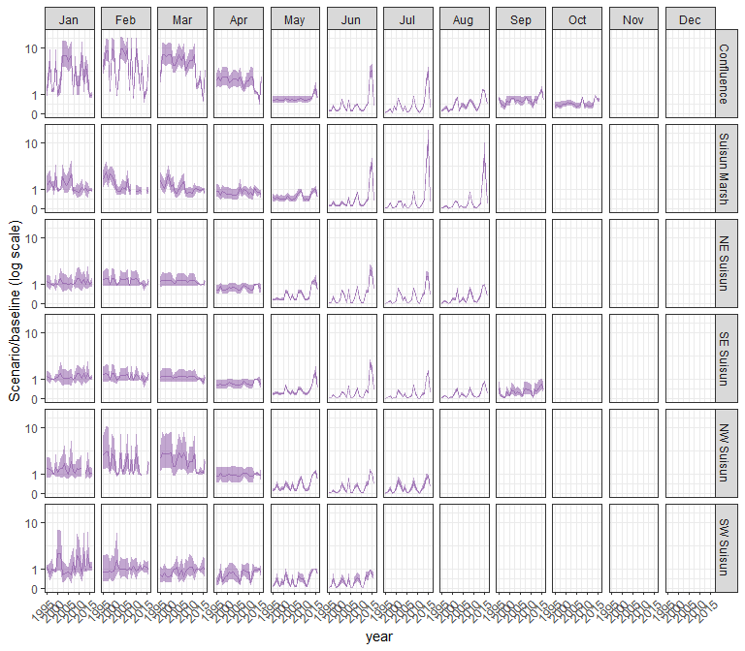

#### allcopnaup

## Warning in max(ids, na.rm = TRUE): no non-missing arguments to max; returning  
## -Inf

## Warning in max(ids, na.rm = TRUE): no non-missing arguments to max; returning  
## -Inf  
  
## Warning in max(ids, na.rm = TRUE): no non-missing arguments to max; returning  
## -Inf  
  
## Warning in max(ids, na.rm = TRUE): no non-missing arguments to max; returning  
## -Inf  
  
## Warning in max(ids, na.rm = TRUE): no non-missing arguments to max; returning  
## -Inf  
  
## Warning in max(ids, na.rm = TRUE): no non-missing arguments to max; returning  
## -Inf  
  
## Warning in max(ids, na.rm = TRUE): no non-missing arguments to max; returning  
## -Inf  
  
## Warning in max(ids, na.rm = TRUE): no non-missing arguments to max; returning  
## -Inf  
  
## Warning in max(ids, na.rm = TRUE): no non-missing arguments to max; returning  
## -Inf  
  
## Warning in max(ids, na.rm = TRUE): no non-missing arguments to max; returning  
## -Inf  
  
## Warning in max(ids, na.rm = TRUE): no non-missing arguments to max; returning  
## -Inf  
  
## Warning in max(ids, na.rm = TRUE): no non-missing arguments to max; returning  
## -Inf  
  
## Warning in max(ids, na.rm = TRUE): no non-missing arguments to max; returning  
## -Inf  
  
## Warning in max(ids, na.rm = TRUE): no non-missing arguments to max; returning  
## -Inf  
  
## Warning in max(ids, na.rm = TRUE): no non-missing arguments to max; returning  
## -Inf  
  
## Warning in max(ids, na.rm = TRUE): no non-missing arguments to max; returning  
## -Inf  
  
## Warning in max(ids, na.rm = TRUE): no non-missing arguments to max; returning  
## -Inf  
  
## Warning in max(ids, na.rm = TRUE): no non-missing arguments to max; returning  
## -Inf  
  
## Warning in max(ids, na.rm = TRUE): no non-missing arguments to max; returning  
## -Inf  
  
## Warning in max(ids, na.rm = TRUE): no non-missing arguments to max; returning  
## -Inf  
  
## Warning in max(ids, na.rm = TRUE): no non-missing arguments to max; returning  
## -Inf  
  
## Warning in max(ids, na.rm = TRUE): no non-missing arguments to max; returning  
## -Inf  
  
## Warning in max(ids, na.rm = TRUE): no non-missing arguments to max; returning  
## -Inf  
  
## Warning in max(ids, na.rm = TRUE): no non-missing arguments to max; returning  
## -Inf

## Warning: Removed 132 rows containing missing values (`geom_line()`).

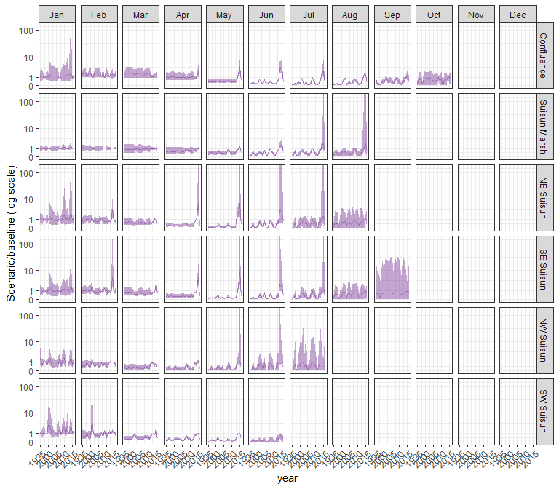

#### limno

## Warning in max(ids, na.rm = TRUE): no non-missing arguments to max; returning  
## -Inf

## Warning in max(ids, na.rm = TRUE): no non-missing arguments to max; returning  
## -Inf  
  
## Warning in max(ids, na.rm = TRUE): no non-missing arguments to max; returning  
## -Inf  
  
## Warning in max(ids, na.rm = TRUE): no non-missing arguments to max; returning  
## -Inf  
  
## Warning in max(ids, na.rm = TRUE): no non-missing arguments to max; returning  
## -Inf  
  
## Warning in max(ids, na.rm = TRUE): no non-missing arguments to max; returning  
## -Inf  
  
## Warning in max(ids, na.rm = TRUE): no non-missing arguments to max; returning  
## -Inf  
  
## Warning in max(ids, na.rm = TRUE): no non-missing arguments to max; returning  
## -Inf  
  
## Warning in max(ids, na.rm = TRUE): no non-missing arguments to max; returning  
## -Inf  
  
## Warning in max(ids, na.rm = TRUE): no non-missing arguments to max; returning  
## -Inf  
  
## Warning in max(ids, na.rm = TRUE): no non-missing arguments to max; returning  
## -Inf  
  
## Warning in max(ids, na.rm = TRUE): no non-missing arguments to max; returning  
## -Inf  
  
## Warning in max(ids, na.rm = TRUE): no non-missing arguments to max; returning  
## -Inf  
  
## Warning in max(ids, na.rm = TRUE): no non-missing arguments to max; returning  
## -Inf  
  
## Warning in max(ids, na.rm = TRUE): no non-missing arguments to max; returning  
## -Inf  
  
## Warning in max(ids, na.rm = TRUE): no non-missing arguments to max; returning  
## -Inf  
  
## Warning in max(ids, na.rm = TRUE): no non-missing arguments to max; returning  
## -Inf  
  
## Warning in max(ids, na.rm = TRUE): no non-missing arguments to max; returning  
## -Inf  
  
## Warning in max(ids, na.rm = TRUE): no non-missing arguments to max; returning  
## -Inf  
  
## Warning in max(ids, na.rm = TRUE): no non-missing arguments to max; returning  
## -Inf  
  
## Warning in max(ids, na.rm = TRUE): no non-missing arguments to max; returning  
## -Inf  
  
## Warning in max(ids, na.rm = TRUE): no non-missing arguments to max; returning  
## -Inf  
  
## Warning in max(ids, na.rm = TRUE): no non-missing arguments to max; returning  
## -Inf  
  
## Warning in max(ids, na.rm = TRUE): no non-missing arguments to max; returning  
## -Inf

## Warning: Removed 132 rows containing missing values (`geom_line()`).

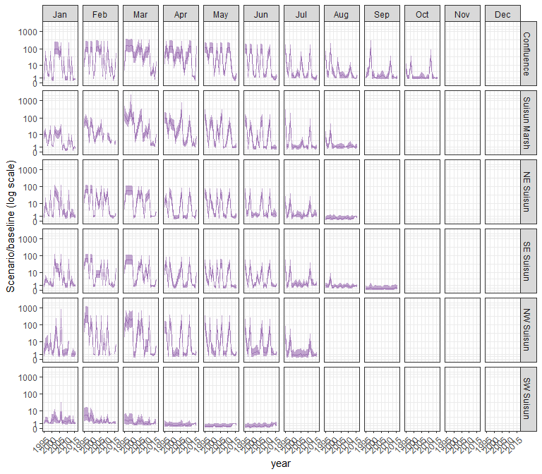

#### mysid

## Warning in max(ids, na.rm = TRUE): no non-missing arguments to max; returning  
## -Inf

## Warning in max(ids, na.rm = TRUE): no non-missing arguments to max; returning  
## -Inf  
  
## Warning in max(ids, na.rm = TRUE): no non-missing arguments to max; returning  
## -Inf  
  
## Warning in max(ids, na.rm = TRUE): no non-missing arguments to max; returning  
## -Inf  
  
## Warning in max(ids, na.rm = TRUE): no non-missing arguments to max; returning  
## -Inf  
  
## Warning in max(ids, na.rm = TRUE): no non-missing arguments to max; returning  
## -Inf  
  
## Warning in max(ids, na.rm = TRUE): no non-missing arguments to max; returning  
## -Inf  
  
## Warning in max(ids, na.rm = TRUE): no non-missing arguments to max; returning  
## -Inf  
  
## Warning in max(ids, na.rm = TRUE): no non-missing arguments to max; returning  
## -Inf  
  
## Warning in max(ids, na.rm = TRUE): no non-missing arguments to max; returning  
## -Inf  
  
## Warning in max(ids, na.rm = TRUE): no non-missing arguments to max; returning  
## -Inf  
  
## Warning in max(ids, na.rm = TRUE): no non-missing arguments to max; returning  
## -Inf  
  
## Warning in max(ids, na.rm = TRUE): no non-missing arguments to max; returning  
## -Inf  
  
## Warning in max(ids, na.rm = TRUE): no non-missing arguments to max; returning  
## -Inf  
  
## Warning in max(ids, na.rm = TRUE): no non-missing arguments to max; returning  
## -Inf  
  
## Warning in max(ids, na.rm = TRUE): no non-missing arguments to max; returning  
## -Inf  
  
## Warning in max(ids, na.rm = TRUE): no non-missing arguments to max; returning  
## -Inf  
  
## Warning in max(ids, na.rm = TRUE): no non-missing arguments to max; returning  
## -Inf  
  
## Warning in max(ids, na.rm = TRUE): no non-missing arguments to max; returning  
## -Inf  
  
## Warning in max(ids, na.rm = TRUE): no non-missing arguments to max; returning  
## -Inf  
  
## Warning in max(ids, na.rm = TRUE): no non-missing arguments to max; returning  
## -Inf  
  
## Warning in max(ids, na.rm = TRUE): no non-missing arguments to max; returning  
## -Inf  
  
## Warning in max(ids, na.rm = TRUE): no non-missing arguments to max; returning  
## -Inf  
  
## Warning in max(ids, na.rm = TRUE): no non-missing arguments to max; returning  
## -Inf

## Warning: Removed 132 rows containing missing values (`geom_line()`).

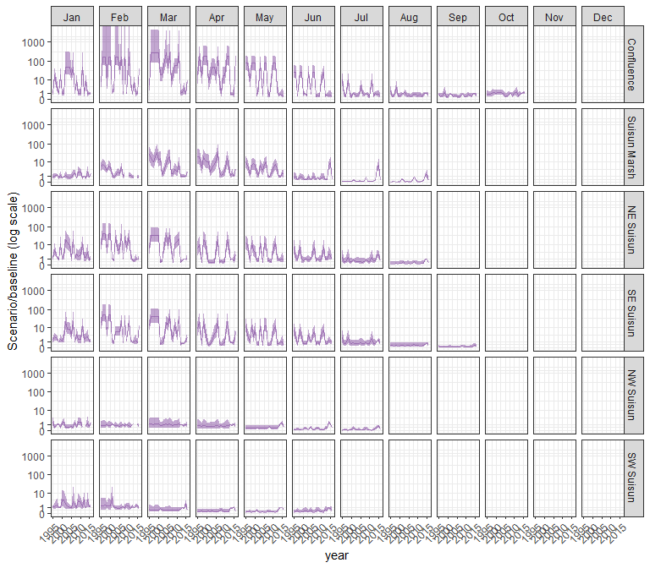

#### othcyc

## Warning in max(ids, na.rm = TRUE): no non-missing arguments to max; returning  
## -Inf

## Warning in max(ids, na.rm = TRUE): no non-missing arguments to max; returning  
## -Inf  
  
## Warning in max(ids, na.rm = TRUE): no non-missing arguments to max; returning  
## -Inf  
  
## Warning in max(ids, na.rm = TRUE): no non-missing arguments to max; returning  
## -Inf  
  
## Warning in max(ids, na.rm = TRUE): no non-missing arguments to max; returning  
## -Inf  
  
## Warning in max(ids, na.rm = TRUE): no non-missing arguments to max; returning  
## -Inf  
  
## Warning in max(ids, na.rm = TRUE): no non-missing arguments to max; returning  
## -Inf  
  
## Warning in max(ids, na.rm = TRUE): no non-missing arguments to max; returning  
## -Inf  
  
## Warning in max(ids, na.rm = TRUE): no non-missing arguments to max; returning  
## -Inf  
  
## Warning in max(ids, na.rm = TRUE): no non-missing arguments to max; returning  
## -Inf  
  
## Warning in max(ids, na.rm = TRUE): no non-missing arguments to max; returning  
## -Inf  
  
## Warning in max(ids, na.rm = TRUE): no non-missing arguments to max; returning  
## -Inf  
  
## Warning in max(ids, na.rm = TRUE): no non-missing arguments to max; returning  
## -Inf  
  
## Warning in max(ids, na.rm = TRUE): no non-missing arguments to max; returning  
## -Inf  
  
## Warning in max(ids, na.rm = TRUE): no non-missing arguments to max; returning  
## -Inf  
  
## Warning in max(ids, na.rm = TRUE): no non-missing arguments to max; returning  
## -Inf  
  
## Warning in max(ids, na.rm = TRUE): no non-missing arguments to max; returning  
## -Inf  
  
## Warning in max(ids, na.rm = TRUE): no non-missing arguments to max; returning  
## -Inf  
  
## Warning in max(ids, na.rm = TRUE): no non-missing arguments to max; returning  
## -Inf  
  
## Warning in max(ids, na.rm = TRUE): no non-missing arguments to max; returning  
## -Inf  
  
## Warning in max(ids, na.rm = TRUE): no non-missing arguments to max; returning  
## -Inf  
  
## Warning in max(ids, na.rm = TRUE): no non-missing arguments to max; returning  
## -Inf  
  
## Warning in max(ids, na.rm = TRUE): no non-missing arguments to max; returning  
## -Inf  
  
## Warning in max(ids, na.rm = TRUE): no non-missing arguments to max; returning  
## -Inf

## Warning: Removed 132 rows containing missing values (`geom_line()`).

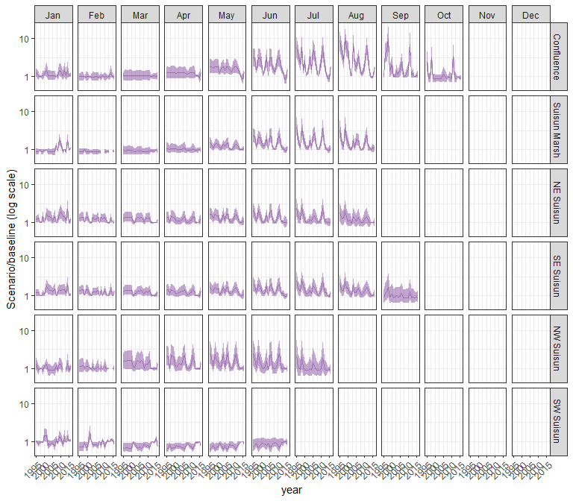

#### other

## Warning in max(ids, na.rm = TRUE): no non-missing arguments to max; returning  
## -Inf

## Warning in max(ids, na.rm = TRUE): no non-missing arguments to max; returning  
## -Inf  
  
## Warning in max(ids, na.rm = TRUE): no non-missing arguments to max; returning  
## -Inf  
  
## Warning in max(ids, na.rm = TRUE): no non-missing arguments to max; returning  
## -Inf  
  
## Warning in max(ids, na.rm = TRUE): no non-missing arguments to max; returning  
## -Inf  
  
## Warning in max(ids, na.rm = TRUE): no non-missing arguments to max; returning  
## -Inf  
  
## Warning in max(ids, na.rm = TRUE): no non-missing arguments to max; returning  
## -Inf  
  
## Warning in max(ids, na.rm = TRUE): no non-missing arguments to max; returning  
## -Inf  
  
## Warning in max(ids, na.rm = TRUE): no non-missing arguments to max; returning  
## -Inf  
  
## Warning in max(ids, na.rm = TRUE): no non-missing arguments to max; returning  
## -Inf  
  
## Warning in max(ids, na.rm = TRUE): no non-missing arguments to max; returning  
## -Inf  
  
## Warning in max(ids, na.rm = TRUE): no non-missing arguments to max; returning  
## -Inf  
  
## Warning in max(ids, na.rm = TRUE): no non-missing arguments to max; returning  
## -Inf  
  
## Warning in max(ids, na.rm = TRUE): no non-missing arguments to max; returning  
## -Inf  
  
## Warning in max(ids, na.rm = TRUE): no non-missing arguments to max; returning  
## -Inf  
  
## Warning in max(ids, na.rm = TRUE): no non-missing arguments to max; returning  
## -Inf  
  
## Warning in max(ids, na.rm = TRUE): no non-missing arguments to max; returning  
## -Inf  
  
## Warning in max(ids, na.rm = TRUE): no non-missing arguments to max; returning  
## -Inf  
  
## Warning in max(ids, na.rm = TRUE): no non-missing arguments to max; returning  
## -Inf  
  
## Warning in max(ids, na.rm = TRUE): no non-missing arguments to max; returning  
## -Inf  
  
## Warning in max(ids, na.rm = TRUE): no non-missing arguments to max; returning  
## -Inf  
  
## Warning in max(ids, na.rm = TRUE): no non-missing arguments to max; returning  
## -Inf  
  
## Warning in max(ids, na.rm = TRUE): no non-missing arguments to max; returning  
## -Inf  
  
## Warning in max(ids, na.rm = TRUE): no non-missing arguments to max; returning  
## -Inf

## Warning: Removed 132 rows containing missing values (`geom_line()`).

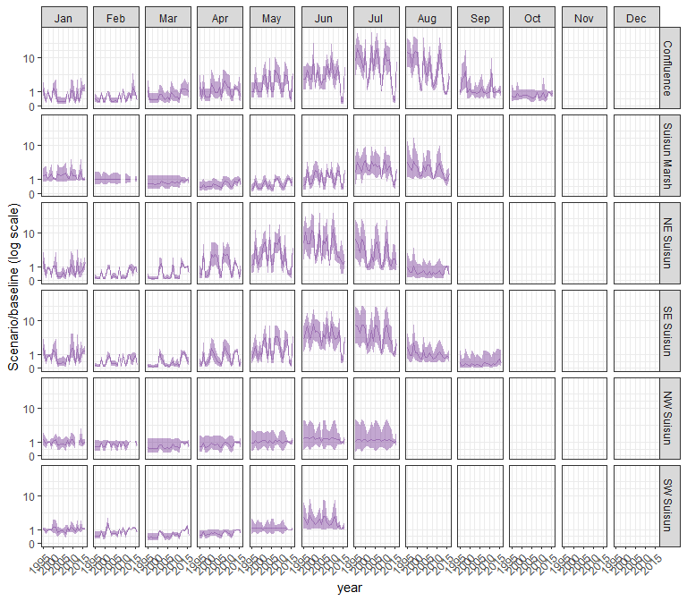

### sal_NAA

#### acartela

## Warning in max(ids, na.rm = TRUE): no non-missing arguments to max; returning  
## -Inf

## Warning in max(ids, na.rm = TRUE): no non-missing arguments to max; returning  
## -Inf  
  
## Warning in max(ids, na.rm = TRUE): no non-missing arguments to max; returning  
## -Inf  
  
## Warning in max(ids, na.rm = TRUE): no non-missing arguments to max; returning  
## -Inf  
  
## Warning in max(ids, na.rm = TRUE): no non-missing arguments to max; returning  
## -Inf

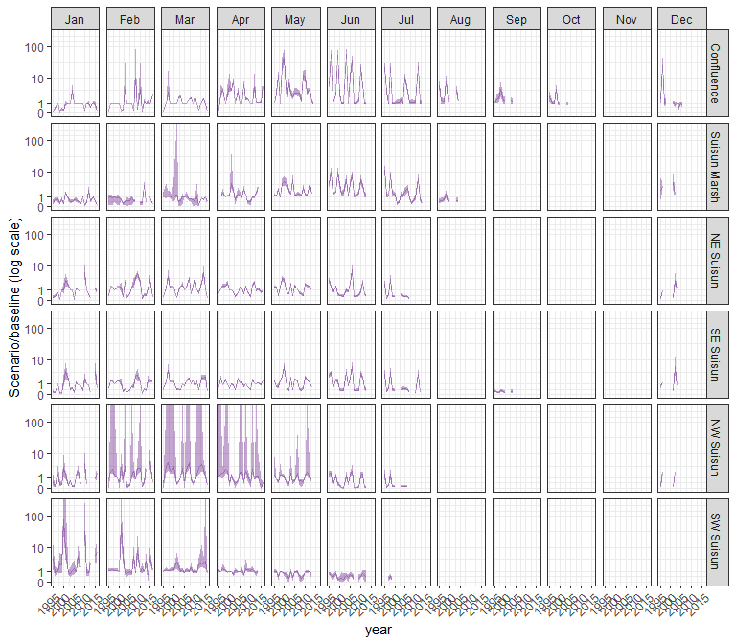

#### daphnia

## Warning in max(ids, na.rm = TRUE): no non-missing arguments to max; returning  
## -Inf  
  
## Warning in max(ids, na.rm = TRUE): no non-missing arguments to max; returning  
## -Inf  
  
## Warning in max(ids, na.rm = TRUE): no non-missing arguments to max; returning  
## -Inf  
  
## Warning in max(ids, na.rm = TRUE): no non-missing arguments to max; returning  
## -Inf  
  
## Warning in max(ids, na.rm = TRUE): no non-missing arguments to max; returning  
## -Inf

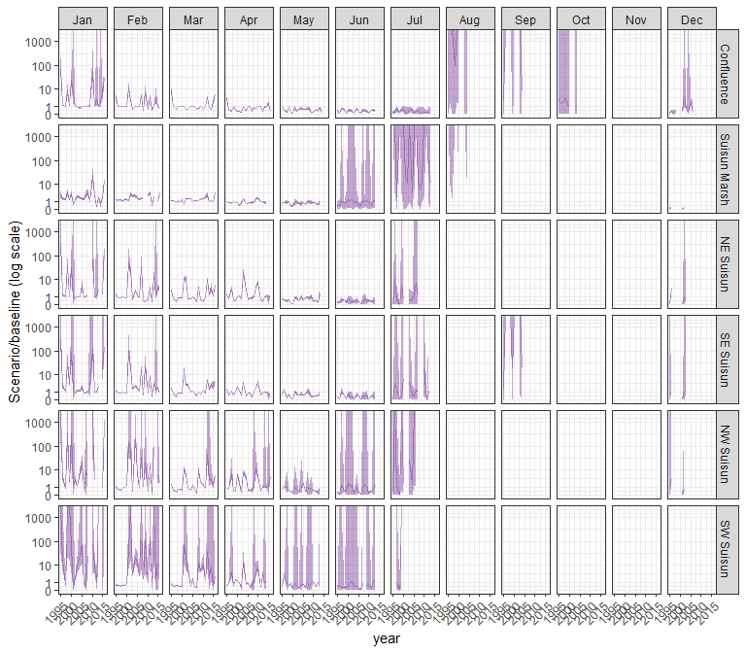

#### eurytem

## Warning in max(ids, na.rm = TRUE): no non-missing arguments to max; returning  
## -Inf  
  
## Warning in max(ids, na.rm = TRUE): no non-missing arguments to max; returning  
## -Inf  
  
## Warning in max(ids, na.rm = TRUE): no non-missing arguments to max; returning  
## -Inf  
  
## Warning in max(ids, na.rm = TRUE): no non-missing arguments to max; returning  
## -Inf  
  
## Warning in max(ids, na.rm = TRUE): no non-missing arguments to max; returning  
## -Inf

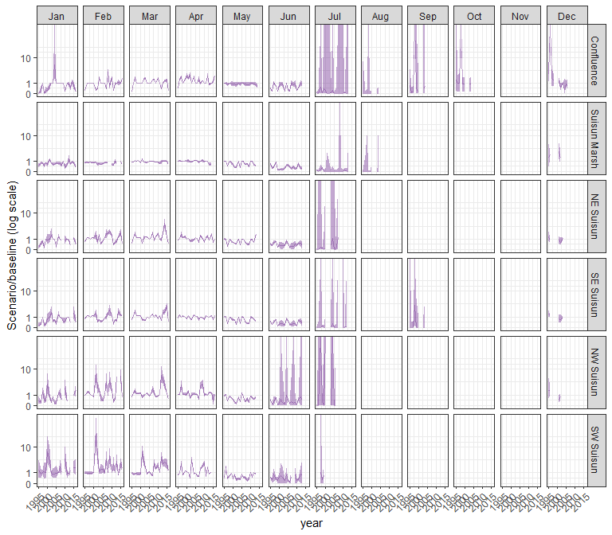

#### othcalad

## Warning in max(ids, na.rm = TRUE): no non-missing arguments to max; returning  
## -Inf  
  
## Warning in max(ids, na.rm = TRUE): no non-missing arguments to max; returning  
## -Inf  
  
## Warning in max(ids, na.rm = TRUE): no non-missing arguments to max; returning  
## -Inf  
  
## Warning in max(ids, na.rm = TRUE): no non-missing arguments to max; returning  
## -Inf  
  
## Warning in max(ids, na.rm = TRUE): no non-missing arguments to max; returning  
## -Inf

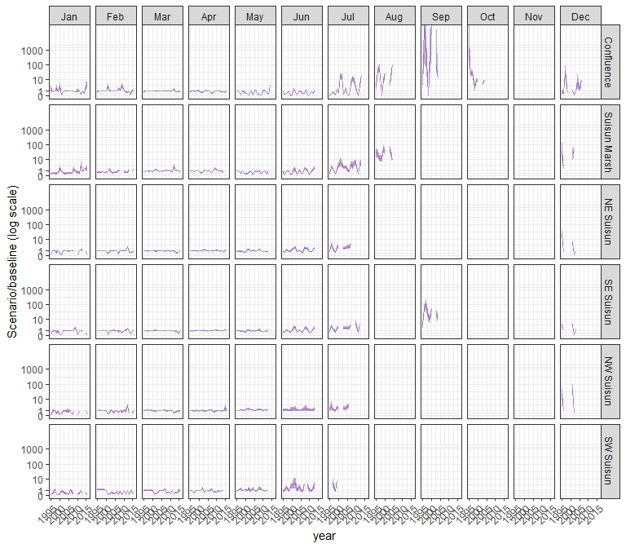

#### othcaljuv

## Warning in max(ids, na.rm = TRUE): no non-missing arguments to max; returning  
## -Inf  
  
## Warning in max(ids, na.rm = TRUE): no non-missing arguments to max; returning  
## -Inf  
  
## Warning in max(ids, na.rm = TRUE): no non-missing arguments to max; returning  
## -Inf  
  
## Warning in max(ids, na.rm = TRUE): no non-missing arguments to max; returning  
## -Inf  
  
## Warning in max(ids, na.rm = TRUE): no non-missing arguments to max; returning  
## -Inf

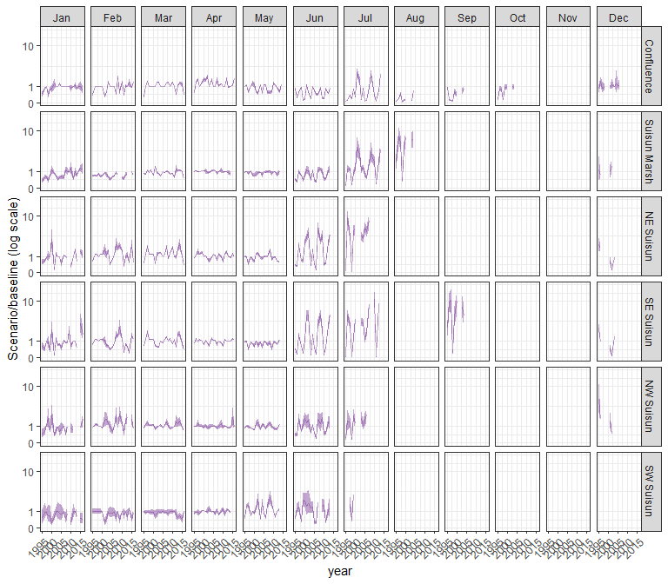

#### othclad

## Warning in max(ids, na.rm = TRUE): no non-missing arguments to max; returning  
## -Inf  
  
## Warning in max(ids, na.rm = TRUE): no non-missing arguments to max; returning  
## -Inf  
  
## Warning in max(ids, na.rm = TRUE): no non-missing arguments to max; returning  
## -Inf  
  
## Warning in max(ids, na.rm = TRUE): no non-missing arguments to max; returning  
## -Inf  
  
## Warning in max(ids, na.rm = TRUE): no non-missing arguments to max; returning  
## -Inf

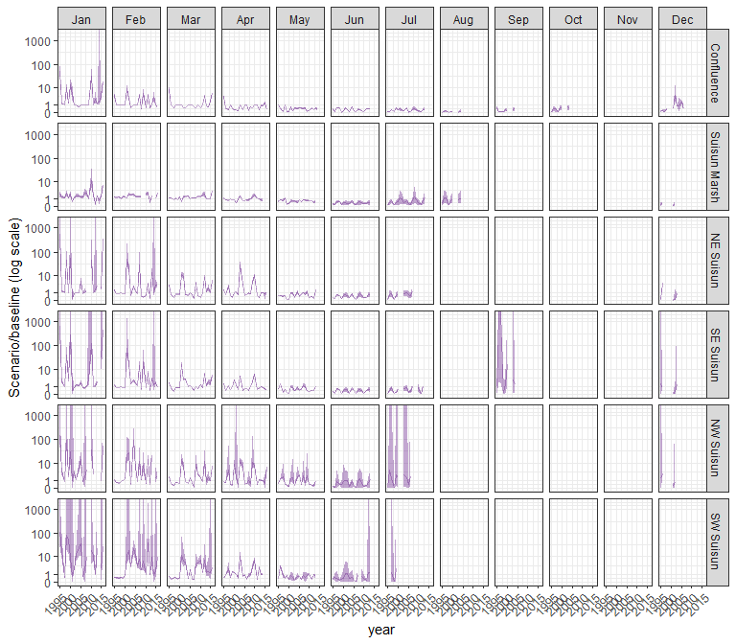

#### pdiapfor

## Warning in max(ids, na.rm = TRUE): no non-missing arguments to max; returning  
## -Inf  
  
## Warning in max(ids, na.rm = TRUE): no non-missing arguments to max; returning  
## -Inf  
  
## Warning in max(ids, na.rm = TRUE): no non-missing arguments to max; returning  
## -Inf  
  
## Warning in max(ids, na.rm = TRUE): no non-missing arguments to max; returning  
## -Inf  
  
## Warning in max(ids, na.rm = TRUE): no non-missing arguments to max; returning  
## -Inf

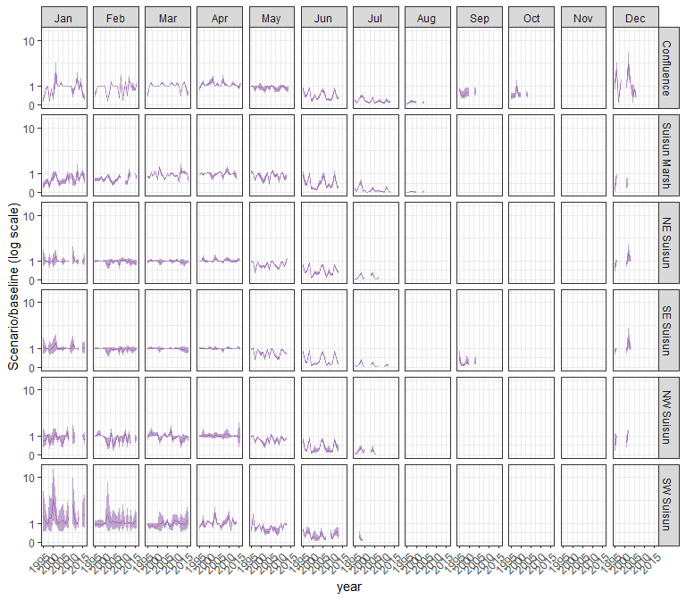

#### allcopnaup

## Warning in max(ids, na.rm = TRUE): no non-missing arguments to max; returning  
## -Inf  
  
## Warning in max(ids, na.rm = TRUE): no non-missing arguments to max; returning  
## -Inf  
  
## Warning in max(ids, na.rm = TRUE): no non-missing arguments to max; returning  
## -Inf  
  
## Warning in max(ids, na.rm = TRUE): no non-missing arguments to max; returning  
## -Inf  
  
## Warning in max(ids, na.rm = TRUE): no non-missing arguments to max; returning  
## -Inf

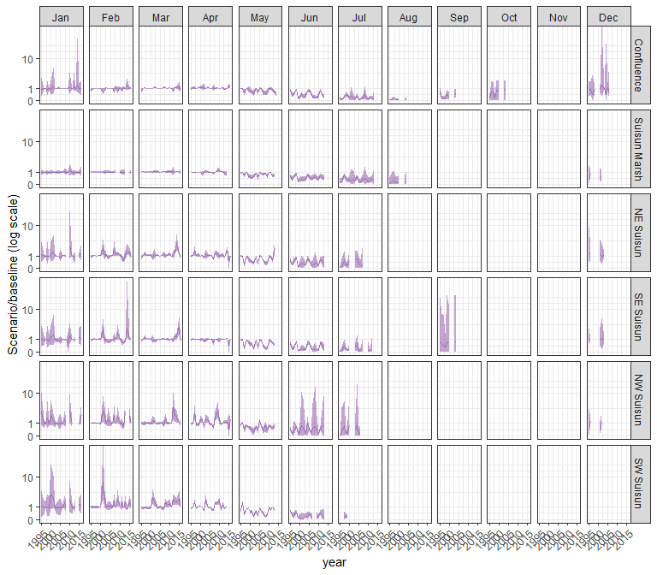

#### limno

## Warning in max(ids, na.rm = TRUE): no non-missing arguments to max; returning  
## -Inf  
  
## Warning in max(ids, na.rm = TRUE): no non-missing arguments to max; returning  
## -Inf  
  
## Warning in max(ids, na.rm = TRUE): no non-missing arguments to max; returning  
## -Inf  
  
## Warning in max(ids, na.rm = TRUE): no non-missing arguments to max; returning  
## -Inf  
  
## Warning in max(ids, na.rm = TRUE): no non-missing arguments to max; returning  
## -Inf

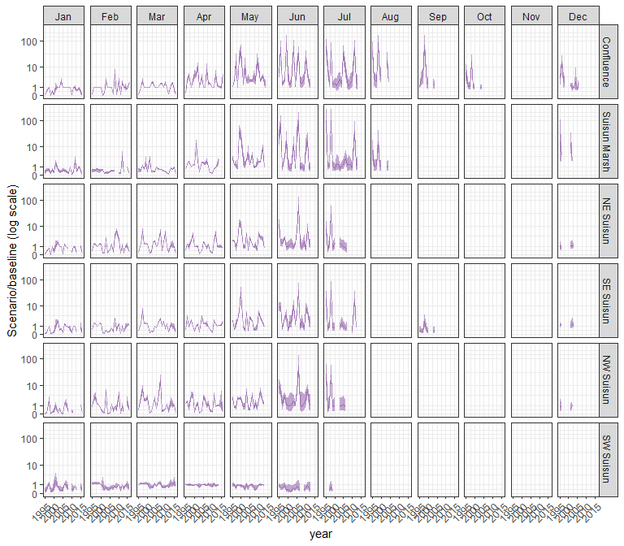

#### mysid

## Warning in max(ids, na.rm = TRUE): no non-missing arguments to max; returning  
## -Inf  
  
## Warning in max(ids, na.rm = TRUE): no non-missing arguments to max; returning  
## -Inf  
  
## Warning in max(ids, na.rm = TRUE): no non-missing arguments to max; returning  
## -Inf  
  
## Warning in max(ids, na.rm = TRUE): no non-missing arguments to max; returning  
## -Inf  
  
## Warning in max(ids, na.rm = TRUE): no non-missing arguments to max; returning  
## -Inf

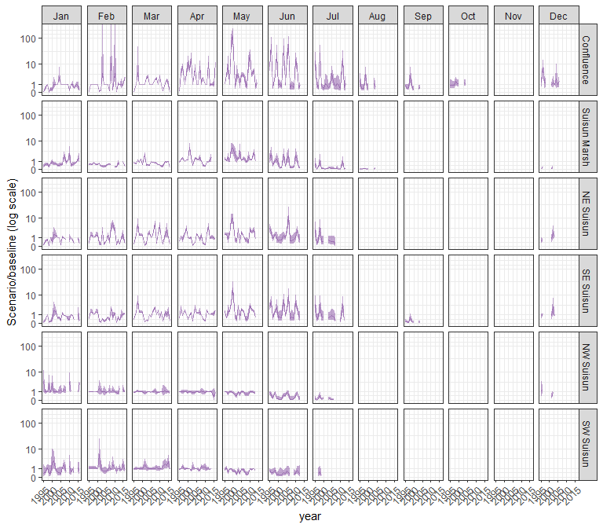

#### othcyc

## Warning in max(ids, na.rm = TRUE): no non-missing arguments to max; returning  
## -Inf  
  
## Warning in max(ids, na.rm = TRUE): no non-missing arguments to max; returning  
## -Inf  
  
## Warning in max(ids, na.rm = TRUE): no non-missing arguments to max; returning  
## -Inf  
  
## Warning in max(ids, na.rm = TRUE): no non-missing arguments to max; returning  
## -Inf  
  
## Warning in max(ids, na.rm = TRUE): no non-missing arguments to max; returning  
## -Inf

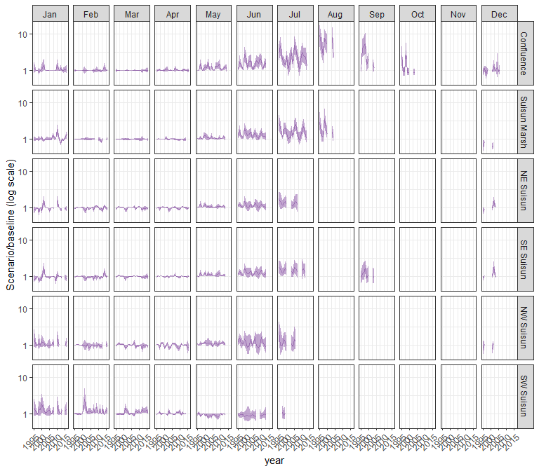

#### other

## Warning in max(ids, na.rm = TRUE): no non-missing arguments to max; returning  
## -Inf  
  
## Warning in max(ids, na.rm = TRUE): no non-missing arguments to max; returning  
## -Inf  
  
## Warning in max(ids, na.rm = TRUE): no non-missing arguments to max; returning  
## -Inf  
  
## Warning in max(ids, na.rm = TRUE): no non-missing arguments to max; returning  
## -Inf  
  
## Warning in max(ids, na.rm = TRUE): no non-missing arguments to max; returning  
## -Inf

