PRELIMINARY DATA: Redd Dewatering Estimates for Keswick Fall Flow Scenarios

BDO Science Division

01 October, 2024

This script constructs real-time winter-run redd dewatering estimates based on most recent data available from CDFW (NA) for winter-run data and dewatering estimates from USFWS (2006; see citation). Data are also available in 2024 Winter-run Data file.xls online at [calfish.org](https://gcc02.safelinks.protection.outlook.com/?url=https%3A%2F%2Fwww.calfish.org%2FProgramsData%2FConservationandManagement%2FCentralValleyMonitoring%2FCDFWUpperSacRiverBasinSalmonidMonitoring.aspx&data=05%7C01%7Clelliott%40usbr.gov%7C689ebb9a6c8243b4f96c08da90f5c542%7C0693b5ba4b184d7b9341f32f400a5494%7C0%7C0%7C637981682646098788%7CUnknown%7CTWFpbGZsb3d8eyJWIjoiMC4wLjAwMDAiLCJQIjoiV2luMzIiLCJBTiI6Ik1haWwiLCJXVCI6Mn0%3D%7C3000%7C%7C%7C&sdata=A1eQkWPxbkXxnzEvc2K8%2FTmslZ8H8zvxdks3%2F78Yrvw%3D&reserved=0).

This document is also now available on [SacPAS](https://www.cbr.washington.edu/sacramento/workgroups/usst.html#redd_dewater). However, data on the SacPAS webpage may not immediately reflect data in the document as updates to the webpage with newest flow and redd data may be pending.

Please note that all data are preliminary until data collection is finalized. Likewise, there are uncertainties with forecasts which may lead to changes in proposed operations.

# Current Winter-run Chinook Salmon Redd Count

As of September 10, 2024, the unexpanded redd count is **152** Winter-run redds. It is important to note that until data collection is completed for the year these are the **minimum** number of possible redds. The Winter-run number will always expand upon final analysis but gives an in-season guard rail of the minimum number of redds this year.

Given that the number of Winter-run redds is always larger than the early season carcass counts, an expansion number based on historic data is multiplied by the carcass count to estimate the total number of redds for the season before the end of the season’s final estimate is developed and the final redd count is known. Average 2005-2022 expansion was 1.98 * the total redd count, and thus we focus on an expansion factor of 2 to represent expected final redd count and support decision-making.

Table 1. Estimated total number of Winter-run redds and resulting number of redds that represent 1% of the population. Estimated total redds are based on current count and expansion number representing average 2005-2022 expansion.

| Name | Expansion Number | Total Redds | 1% |
| --- | --- | --- | --- |
| Current Count | 1 | 152 | 1.52 |
| Anticipated Expansion | 2 | 304 | 3.04 |

## Chinook Salmon Dewatered Redd Estimates

As of NA, **6** Winter-run redds have **emerged** and **0** have been **dewatered**. This leaves **11** shallow water redds of concern.

There is no real time data on fall-run redd counts. Estimates are predicted based on estimated dewatering percentages from USFWS (2006) and spring-run and fall-run spawn timing based on fresh female carcasses encountered by week from 2003 through 2022. Emergence timing were predicted from average water temperatures over the same time period. Fall-run dewatered redd estimates range from **9.8** to **13.4%**. Note that fall-run dewatering estimates are likely overestimated using the dewatering percentages from USFWS (2006), and likely do not reflect actual dewatering percentages and should only be used for comparative purposes between scenarios. A comparative analysis between field and modeled dewatering percentages by Gosselin and Beer (2024) can be found here: <https://www.cbr.washington.edu/sacramento/fishmodel/Note_on_Redd_Dewatering_Observed_v_Predicted.pdf>.

## Carryover Effects to Next Year Winter-run Brood

An analysis on the relationship between winter-run chinook salmon temperature dependent mortality relationship and Shasta Reservoir end-of-year storage suggests a threshold of 2,200 TAF end of September Shasta Storage to assess the impacts of TDM impacts on next year’s cohort. Next year’s cohort is expected to experience minimal TDM impacts when end of September Shasta Storage is greater than this threshold, while values lower than 2,200 TAF are correlated with potentially more negative TDM impacts. As of August, End of September Shasta Storage is expected to be **2717** TAF.All proposed scenarios are anticipated to have EOS storage greater than the 2200 TAF threshold and therefore would not be expected to contribute to TDM impacts to winter-run chinook salmon in the subsequent year (see Table 2).

## Preliminary Predicted Results

Table 2. Summary of water volume and winter-run and fall-run dewatering estimates related to flow scenarios. Each scenario uses actual flow-to-date as of most current report and proposed flows for the remainder of the incubation period. Percentage of the population lost is based on the September 10, 2024 count of 152 Winter-run redds. See Scenario Descriptions file for additional information on each scenario.

| Metric | aug90wradjdec | aug90wrdec | aug90wrflatdec | aug90wrfr6000 | aug90wrfr6500 | aug90wrshape2dec |
| --- | --- | --- | --- | --- | --- | --- |
| Avg Sept Flow (cfs) | 8358 | 8358 | 8358 | 8358 | 8358 | 8358 |
| Avg Oct Flow (cfs) | 6871 | 7065 | 7500 | 6274 | 6629 | 7000 |
| Sept-Feb Total Volume (TAF) | 1974 | 1944 | 1971 | 1964 | 1976 | 1940 |
| Aug-Sept Total Volume (TAF) | 1213 | 1213 | 1213 | 1213 | 1213 | 1213 |
| Anticipated EOS Storage (TAF) | 2717 | 2717 | 2717 | 2717 | 2717 | 2717 |
| Winter-run Redds Dewatered | 2 | 2 | 1 | 2 | 2 | 1 |
| Winter-run Percent Lost (current count) | 1.32 | 1.32 | 0.66 | 1.32 | 1.32 | 0.66 |
| Winter-run Percent Lost (mean expansion of 2) | 0.66 | 0.66 | 0.33 | 0.66 | 0.66 | 0.33 |
| Winter-run Redds Dewatered (250 cfs buffer) | 2 | 2 | 1 | 2 | 2 | 1 |
| Winter-run Percent Lost (250 cfs buffer) | 1.32 | 1.32 | 0.66 | 1.32 | 1.32 | 0.66 |
| Fall-run dewatered (%) | 13.4 | 10.5 | 11.1 | 10 | 12.7 | 9.8 |

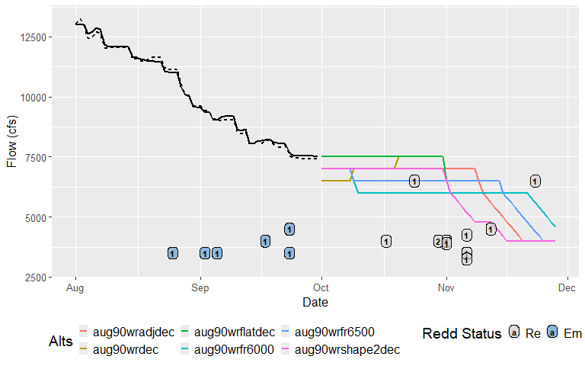

Actual or estimated emergence dates of SRWC redds and actual or estimated dewatering flow for the September-October estimated redd emergence dates as compared to Keswick flow (in cfs) of proposed management alternatives. Points represent dewatered (De), emerged (Em), or remaining (Re) redds. Numbers inside of points indicate how many redds share that estimated emergence date and actual/estimated dewatering flow. Points that fall above/to the right of a flow alternative line are expected to be dewatered given that management alternative is followed. Points that fall below/to the left of/on a flow alternative line are not expected to be dewatered, given that management alternative is followed. Shaded gray box shows period of real-time flow data; dashed black line equals KWK gauge flow and solid black line equals KES flow (from [SacPas](https://www.cbr.washington.edu/sacramento/data/query_river_table.html)).

Table 3. Description of scenarios being considered and compared by the Upper Sacramento Scheduling Team. Scenario name includes the shorthand notion in parentheses for cross-referencing with graph and tables.

| Scenario | Description |
| --- | --- |
| Aug 90% WR dec (aug90wrdec) | Developed on 9/6/2024. Based on the 90% forecast exceedance. Follows ramping rates. Keswick releases decrease in late September and then increase as demand increases later in October. |
| Aug 90% WR flat dec (aug90wrflatdec) | Developed on 9/6/2024. Based on the 90% forecast exceedance. Follows ramping rates. Flows remain at 7,500 cfs in October. |
| Aug 90% WR FR 6000 (aug90wrfr6000) | Developed on 10/01/2024. Based on the 90% forecast exceedance. Follows ramping rates. Flows remain at 6000 cfs in October and November. Fisheries Agency Requested |
| Aug 90% WR FR 6500 (aug90wrfr6500) | Developed on 10/01/2024. Based on the 90% forecast exceedance. Follows ramping rates. Flows remain at 6500 cfs in October and November. Fisheries Agency Requested |

# References

Gard, Mark. 2006. Relationships between flow fluctuations and redd dewatering and juvenile stranding for Chinook Salmon and Steelhead in the Sacramento River between Keswick Dam and Battle Creek. 94 pages.

Gosselin, J.L. and W.N. Beer. 2024. Sacramento River Winter-run Chinook Salmon Redd Dewatering: a Note on Comparing Observed and Predicted. Central Valley Prediction and Assessment of Salmon (SacPas; <https://www.cbr.washington.edu/sacramento/>). Columbia Basin Research, School of Aquatic and Fishery Sciences, University of Washington.