PRELIMINARY DATA: Redd Dewatering Estimates for Keswick Fall Flow Scenarios

BDO Science Division

2025-07-14

## Background

This script constructs real-time winter-run redd dewatering estimates based on most recent data available from CDFW (as of July 10, 2025) for winter-run data and using a redd dewatering estimate tool from USFWS (2006; see citation). Data are also available in the 2025 Winter-run Data file.xls online at [calfish.org](https://www.calfish.org/ProgramsData/ConservationandManagement/CentralValleyMonitoring/CDFWUpperSacRiverBasinSalmonidMonitoring.aspx).

This document is also now available on [SacPAS](https://www.cbr.washington.edu/sacramento/workgroups/usst.html#redd_dewater). However, data on the SacPAS webpage may not immediately reflect data in the document as updates to the webpage with newest flow and redd data may be pending.

Please note that all data are preliminary until data collection is finalized. Likewise, there are uncertainties with forecasts which may lead to changes in proposed operations.

## Winter-run Redd Counts

As of July 06, 2025, the unexpanded redd count is **115** Winter-run redds. It is important to note that until data collection is completed for the year these are the **minimum** number of possible redds. The Winter-run number will always expand upon final analysis but gives an in-season guard rail of the minimum number of redds this year.

Given that the number of Winter-run redds is always larger than the early season carcass counts, an expansion number based on historic data is multiplied by the carcass count to estimate the total number of redds for the season before the end of the season’s final estimate is developed and the final redd count is known. Average 2005-2022 expansion was 1.98 * the total redd count, but we illustrate several different expansion scenarios in the table below.

Estimated total number of Winter-run redds with varying expansion factors and resulting number of redds that represent 1 percent of the population.

| Expansion Factor | Total Redds | Dewatering Threshold (1%) |
| --- | --- | --- |
| 1.0 | 115 | 1.15 |
| 1.5 | 172 | 1.72 |
| 2.0 | 230 | 2.30 |
| 2.5 | 288 | 2.88 |
| 3.0 | 345 | 3.45 |
| 3.5 | 402 | 4.02 |
| 4.0 | 460 | 4.60 |

## Redd dewatering estimates

As of July 10, 2025, **0** Winter-run redds have **emerged** and **0** have been **dewatered**. This leaves **28** shallow water redds of concern.

There is no real time data on fall-run redd counts. Estimates are predicted based on estimated dewatering percentages from USFWS (2006) and spring-run and fall-run spawn timing based on fresh female carcasses encountered from 2014 through 2023. Emergence timing were predicted from water temperatures below Keswick individually for each year and dewatering was estimated for each scenario for each year to capture annual variance in spawn timing. Fall-run dewatering estimates range from **7.2** to **13.7%** (see detailed data in table below). Note that fall-run dewatering estimates are likely overestimated using the dewatering percentages from USFWS (2006), and likely do not reflect actual dewatering percentages and should only be used for comparative purposes between scenarios. A comparative analysis between field and modeled dewatering percentages by Gosselin and Beer (2024) can be found [here](https://www.cbr.washington.edu/sacramento/fishmodel/Note_on_Redd_Dewatering_Observed_v_Predicted.pdf).

Estimated fall-run redd dewatering for each scenario by year

| Scenario | 2014 | 2015 | 2016 | 2017 | 2018 | 2019 | 2020 | 2021 | 2022 | 2023 |
| --- | --- | --- | --- | --- | --- | --- | --- | --- | --- | --- |
| A1 | 12.5 | 12 | 7.8 | 7.5 | 11.0 | 10.5 | 11.1 | 13.7 | 12.7 | 7.2 |
| B1 | 12.5 | 12 | 8.2 | 7.8 | 11.1 | 10.5 | 11.1 | 13.4 | 12.2 | 7.5 |

## Carryover Effects to Next Year Winter-run Brood

Carryover effects as it relates to temperature-dependent mortality will be evaluated when additional scenarios have been developed.

## Preliminary Predicted Results

Below are summarized results of scenarios as they relate to total volume, winter-run redd dewatering, and fall-run redd dewatering by scenario. Note that winter-run redd dewatering is predicted and based on estimated flow in which a redd may be dewatered prior to emergence. Fall-run redd dewatering is averaged over multiple years of spawning data.

Summary of water volume and winter-run and fall-run dewatering estimates related to flow scenarios. Each scenario uses actual flow-to-date as of most current report and proposed flows for the remainder of the incubation period. Percentage of the population lost is based on most recent cound data of Winter-run redds. See scenarios description table for further detailed explanation of scenarios.

| Measure | A1 | B1 |
| --- | --- | --- |
| Avg Sept Flow (cfs) | 8000.0 | 7700.0 |
| Avg Oct Flow (cfs) | 6800.0 | 6800.0 |
| Sept-Feb Total Volume (TAF) | 1905.0 | 2171.0 |
| Aug-Sept Total Volume (TAF) | 799.0 | 553.0 |
| Winter-run Redds Dewatered | 2.0 | 2.0 |
| Winter-run % Lost (current count) | 1.7 | 1.7 |
| Winter-run % Lost (mean expansion of 2) | 0.9 | 0.9 |
| Winter-run Redds Dewatered (250 cfs buffer) | 2.0 | 2.0 |
| Winter-run % Lost (250 cfs buffer) | 1.7 | 1.7 |
| Fall-run % Redds Dewatered | 10.6 | 10.6 |

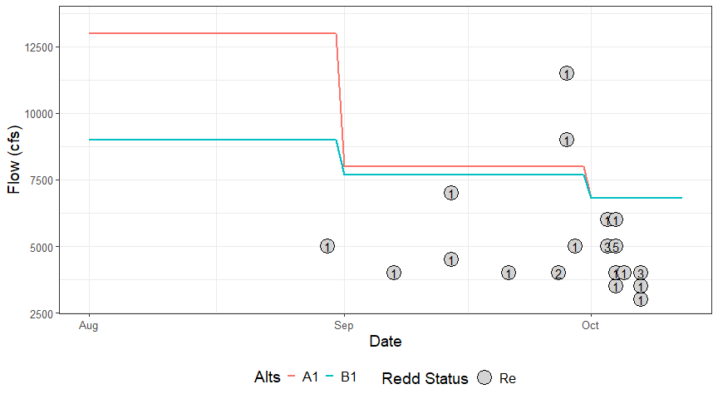

Actual or estimated emergence dates of SRWC redds and actual or estimated dewatering flow for the September-October estimated redd emergence dates as compared to Keswick flow (in cfs) of proposed management alternatives. Points represent dewatered (De), emerged (Em), or remaining (Re) redds. Numbers inside of points indicate how many redds share that estimated emergence date and actual/estimated dewatering flow. Points that fall above/to the right of a flow alternative line are expected to be dewatered given that management alternative is followed. Points that fall below/to the left of/on a flow alternative line are not expected to be dewatered, given that management alternative is followed

Description of scenarios being considered and compared by the Upper Sacramento Scheduling Team

| Scenario | Description |
| --- | --- |
| A1 | Scenario using June 90% Exceedance Forecast developed on July 3, 2025. Does not use ramping rate criteria. |
| B1 | Scenario using June 50% Exceedance Forecast developed on July 3, 2025.Does not use ramping rate criteria. |

## References

Gard, Mark. 2006. Relationships between flow fluctuations and redd dewatering and juvenile stranding for Chinook Salmon and Steelhead in the Sacramento River between Keswick Dam and Battle Creek. 94 pages.

Gosselin, J.L. and W.N. Beer. 2024. Sacramento River Winter-run Chinook Salmon Redd Dewatering: a Note on Comparing Observed and Predicted. Central Valley Prediction and Assessment of Salmon (SacPas; https://www.cbr.washington.edu/sacramento/). Columbia Basin Research, School of Aquatic and Fishery Sciences, University of Washington.