Weekly Assessment of CVP and SWP Delta Operations on ESA-listed Species

Bureau of Reclamation

November 15, 2022

## Chinook Salmon

### TABLES

#### TABLE 2. Historic migration and salvage patterns

| **Species** | **RedBluffDiversionDam** | **TisdaleRst** | **KnightsLandingRst** | **SacTrawlSherwoodCatchIndex** | **ChippsIslandTrawlCatchIndex** | **Salvage** |
| --- | --- | --- | --- | --- | --- | --- |
| Chinook, Winter-run, Unclipped | 82.3%(74.5%,90.1%) BY: 2012 - 2021 | 23.1%(5.7%,40.5%) BY: 2012 - 2021 | 26.2%(3.3%,49.0%) BY: 2013 - 2021 | 9.9%(-9.4%,29.1%) BY: 2012 - 2021 | 1.4%(-1.8%,4.7%) BY: 2012 - 2021 | 0.0%(0.0%,0.0%) WY: 2013 - 2022 |
| Chinook, Spring-run, Unclipped | 4.7%(-1.5%,10.8%) BY: 2012 - 2021 | 0.3%(0.1%,0.6%) BY: 2012 - 2021 | 1.9%(-1.5%,5.2%) BY: 2013 - 2021 | 0.0%(0.0%,0.0%) BY: 2012 - 2021 | 0.0%(0.0%,0.0%) BY: 2012 - 2021 | 0.0%(0.0%,0.0%) WY: 2013 - 2022 |
| Steelhead, Unclipped (January-December) |  |  |  |  |  |  |
| Steelhead, Unclipped (December-March) |  |  |  |  |  | 0.0%(0.0%,0.0%) WY: 2013 - 2022 |
| Steelhead, Unclipped (April-June) |  |  |  |  |  | 0.0%(0.0%,0.0%) WY: 2013 - 2022 |

#### TABLE 3. Knight’s Landing (KLCI) and Sacramento Seine and Trawl (SCI).

| **Date** | **Knights Landing RST: Winter Chinook: Catch Index** | **Knights Landing RST: Older Chinook: Catch Index** | **Sacramento Trawls: Older Chinook: Catch Index** | **Sacramento Beach Seines: Older Chinook: Catch Index** | **Alert: Catch Index > 5** | **Alert: Catch Index 3 < X ≤ 5** |
| --- | --- | --- | --- | --- | --- | --- |
| 2022-11-14 |  |  |  |  |  |  |
| 2022-11-13 |  |  |  |  |  |  |
| 2022-11-12 |  |  |  |  |  |  |
| 2022-11-11 |  |  |  |  |  |  |
| 2022-11-10 |  |  |  | 0 |  |  |
| 2022-11-09 |  |  | 0 | 0 |  |  |
| 2022-11-08 |  |  | 0 |  |  |  |
| 2022-11-07 |  |  | 0 | 0 |  |  |
| 2022-11-06 |  |  |  |  |  |  |

#### TABLE 4. Mean daily flow and percent change (Wilkins Slough, Deer Creek, Mill Creek; cfs from CDEC) and temperature and percent change (Knights Landing; °F from RST)

| **Date** | **Mill Creek (MLM): mean daily flow (cfs)** | **Mill Creek (MLM): flow percent change** | **Mill Creek (MLM): Alert** | **Deer Creek (DCV): mean daily flow (cfs)** | **Deer Creek (DCV): flow percent change** | **Deer Creek (DCV): Alert** | **Wilkins Slough (WLK): mean daily flow (cfs)** | **Knights Landing RST: water temperature (f)** | **Alert Triggered** |
| --- | --- | --- | --- | --- | --- | --- | --- | --- | --- |
| 11/14/2022 | 111.4 | -3.3% | Flow>95cfs | 86.5 | -4.1% |  | 3,445.2 |  |  |
| 11/13/2022 | 115.2 | -2.2% | Flow>95cfs | 90.2 | -1.6% |  | 3,447.5 |  |  |
| 11/12/2022 | 117.8 | -3.6% | Flow>95cfs | 91.6 | -3.5% |  | 3,743.3 |  |  |
| 11/11/2022 | 122.2 | -16.6% | Flow>95cfs | 95.0 | -13.8% |  | 4,077.7 |  |  |
| 11/10/2022 | 146.5 | -31.7% | Flow>95cfs | 110.2 | -27.9% | Flow>95cfs | 4,104.7 |  |  |
| 11/9/2022 | 214.5 | 10.8% | Flow>95cfs | 153.0 | -2.4% | Flow>95cfs | 3,914.8 |  |  |
| 11/8/2022 | 193.5 | 40.9% | Flow>95cfs | 156.7 | 36.0% | Flow>95cfs | 3,703.2 |  |  |

#### TABLE 5. STARS model simulations for route-specific entrainment, travel times, and survival

| **Stock** | **Date** | **Parameter** | **Delta Cross Channel** | **Georgiana Slough** | **Sutter and Steamboat Slough** | **Interior Delta** |
| --- | --- | --- | --- | --- | --- | --- |
| Winter Chinook | 2022-11-18 | Median Travel Time |  |  |  | 7.000000 |
| Winter Chinook | 2022-11-18 | Survival |  |  |  | 0.051226 |
| Winter Chinook | 2022-11-18 | Routing Probability |  |  |  | 0.136170 |
| Late-fall Chinook | 2022-11-19 | Median Travel Time |  | 19.24600 | 12.13400 |  |
| Late-fall Chinook | 2022-11-19 | Survival |  | 0.14819 | 0.35004 |  |
| Late-fall Chinook | 2022-11-19 | Routing Probability | 0 | 0.31200 | 0.24000 |  |

#### TABLE 6. a) WY 2022 loss and salvage predictor data: Predicted weekly loss of winter-run Chinook salmon and steelhead at CVP and SWP facilities.

| **Parameter** | **Modeled Current Week** | **Modeled Next Week** |
| --- | --- | --- |
| Predicted Steelhead, Median % | 0 | 0 |
| Predicted Steelhead, High % | 17 | 17 |
| Predicted Chinook Winter Run, Median % | 0 | 0 |
| Predicted Chinook Winter Run, High % | 8 | 4 |

#### TABLE 6. b) Environmental details, current and forecast.

| **Parameter** | **Data** | **Forecast** |
| --- | --- | --- |
| Temperature (Mallard Island, C) | 14.7 | 20 |
| Precipitation (5-d running sum, inches) | 0.54 | 0 |
| Old and Middle River Flows (cfs) | -2690 | -3039 |
| Sacramento River Flow (Freeport, cfs) | 7799 | 6993 |
| DCC Gates | closed | closed |
| San Joaquin River Flow (Vernalis, cfs) | 708 | 262 |
| Export | 2227 | 1887 |

### FIGURES

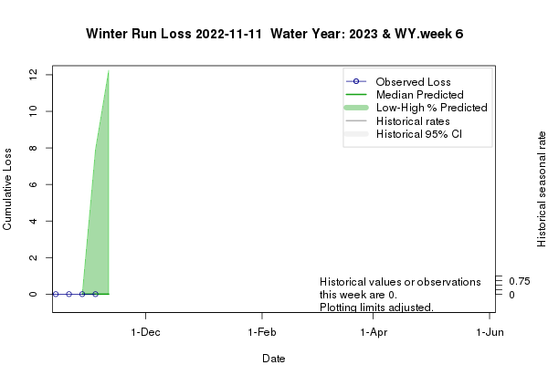 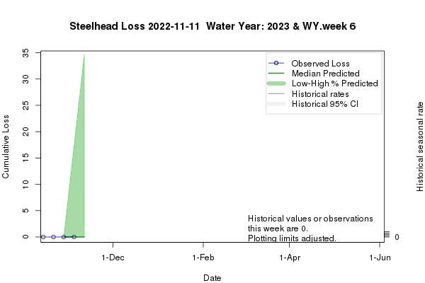

#### Figure 1. Predicted weekly loss of steelhead and winter-run Chinook salmon at the CVP and SWP facilities