Weekly Assessment of CVP and SWP Delta Operations on ESA-listed Species

Bureau of Reclamation

December 11, 2023

## Chinook Salmon

### TABLES

#### TABLE 2. Historic migration and salvage patterns.Last updated 12/11/2023

| **Species** | **RedBluffDiversionDam** | **TisdaleRst** | **KnightsLandingRst** | **SacTrawlSherwoodCatchIndex** | **ChippsIslandTrawlCatchIndex** | **Salvage** |
| --- | --- | --- | --- | --- | --- | --- |
| Chinook, Winter-run, Unclipped | 92.2%(88.0%,96.5%) BY: 2013 - 2022 | 38.3%(15.8%,60.8%) BY: 2013 - 2022 | 46.8%(21.0%,72.5%) BY: 2013 - 2022 | 17.1%(-6.1%,40.4%) BY: 2013 - 2022 | 2.0%(-1.3%,5.3%) BY: 2013 - 2022 | 0.0%(0.0%,0.0%) WY: 2014 - 2023 |
| Chinook, Spring-run, Unclipped | 9.5%(3.4%,15.5%) BY: 2013 - 2022 | 2.0%(-0.6%,4.6%) BY: 2013 - 2022 | 9.3%(-4.0%,22.7%) BY: 2013 - 2022 | 1.0%(-1.1%,3.0%) BY: 2013 - 2022 | 0.0%(0.0%,0.0%) BY: 2013 - 2022 | 0.0%(0.0%,0.0%) WY: 2014 - 2023 |
| Steelhead, Unclipped (January-December) |  |  |  |  |  |  |
| Steelhead, Unclipped (December-March) |  |  |  |  |  | 0.1%(-0.2%,0.4%) WY: 2014 - 2023 |
| Steelhead, Unclipped (April-June) |  |  |  |  |  |  |

#### TABLE 3. Mean daily flow and percent change (Wilkins Slough, Deer Creek, Mill Creek; cfs from CDEC) and temperature and percent change (Knights Landing; °F from RST)

| **Date** | **Mill Creek (MLM): mean daily flow (cfs)** | **Mill Creek (MLM): flow percent change** | **Mill Creek (MLM): Alert** | **Deer Creek (DCV): mean daily flow (cfs)** | **Deer Creek (DCV): flow percent change** | **Deer Creek (DCV): Alert** | **Wilkins Slough (WLK): mean daily flow (cfs)** | **Knights Landing RST: water temperature (f)** | **Alert Triggered** |
| --- | --- | --- | --- | --- | --- | --- | --- | --- | --- |
| 12/10/2023 | 120.4 | -1.9% | Flow>95cfs | 118.4 | -5.6% | Flow>95cfs | 4,928.4 |  |  |
| 12/9/2023 | 122.7 | -11.3% | Flow>95cfs | 125.4 | -12.5% | Flow>95cfs | 4,828.4 |  |  |
| 12/8/2023 | 138.4 | -7.2% | Flow>95cfs | 143.3 | -1.6% | Flow>95cfs | 4,628.1 |  |  |
| 12/7/2023 | 149.1 | 21.4% | Flow>95cfs | 145.6 | 23.1% | Flow>95cfs | 4,635.0 |  |  |
| 12/6/2023 | 122.8 | -1.9% | Flow>95cfs | 118.2 | -4.3% | Flow>95cfs | 4,674.2 |  |  |
| 12/5/2023 | 125.2 | -9.2% | Flow>95cfs | 123.6 | -15.0% | Flow>95cfs | 4,456.0 |  |  |
| 12/4/2023 | 137.8 | 1.0% | Flow>95cfs | 145.5 | 10.1% | Flow>95cfs | 4,305.6 |  |  |

#### TABLE 4. STARS model simulations for route-specific entrainment, travel times, and survival. Travel time is calculated in days.

| **Stock** | **Date** | **Route** | **Median Travel Time** | **Survival** | **Routing Probability** |
| --- | --- | --- | --- | --- | --- |
| Winter Chinook | 2023-12-09 | Overall | 6.63 | 0.30 |  |
| Winter Chinook | 2023-12-09 | Sacramento River | 6.18 | 0.32 | 0.59 |
| Winter Chinook | 2023-12-09 | Yolo Bypass | 9.75 | 0.55 | 0.00 |
| Winter Chinook | 2023-12-09 | Sutter Slough | 6.32 | 0.32 | 0.14 |
| Winter Chinook | 2023-12-09 | Steamboat Slough | 6.05 | 0.39 | 0.14 |
| Winter Chinook | 2023-12-09 | Interior Delta | 9.60 | 0.08 | 0.13 |
| Late-fall Chinook | 2023-12-09 | Overall | 12.48 | 0.39 |  |
| Late-fall Chinook | 2023-12-09 | Delta Cross Channel | NA | NA | 0.00 |
| Late-fall Chinook | 2023-12-09 | Georgiana Slough | 17.16 | 0.18 | 0.28 |
| Late-fall Chinook | 2023-12-09 | Sacramento River | 10.59 | 0.52 | 0.46 |
| Late-fall Chinook | 2023-12-09 | Sutter and Steamboat Slough | 10.99 | 0.40 | 0.26 |

#### TABLE 5. a) WY 2022 loss and salvage predictor data: Predicted weekly loss of winter-run Chinook salmon and steelhead at CVP and SWP facilities.

| **Parameter** | **Modeled Current Week** | **Modeled Next Week** |
| --- | --- | --- |
| Predicted Steelhead, Median % | 0 | 0 |
| Predicted Steelhead, High % | 17 | 17 |
| Predicted Chinook Winter Run, Median % | 0 | 0 |
| Predicted Chinook Winter Run, High % | 12 | 12 |

#### TABLE 5. b) Environmental details, current and forecast.

| **Parameter** | **Data** | **Forecast** |
| --- | --- | --- |
| Temperature (Mallard Island, C) | 12.6 | 12.6 |
| Precipitation (5-d running sum, inches) | 0.01 | 0.01 |
| Old and Middle River Flows (cfs) | -4473 | -4473 |
| Sacramento River Flow (Freeport, cfs) | 10080 | 10080 |
| DCC Gates | closed | closed |
| San Joaquin River Flow (Vernalis, cfs) | 1288 | 1288 |
| Export | 4732 | 4732 |

### FIGURES

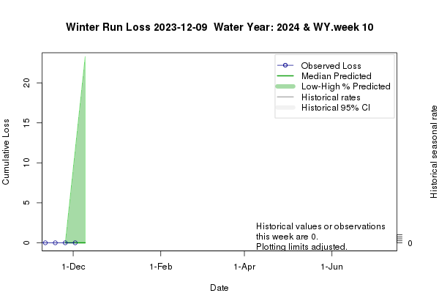 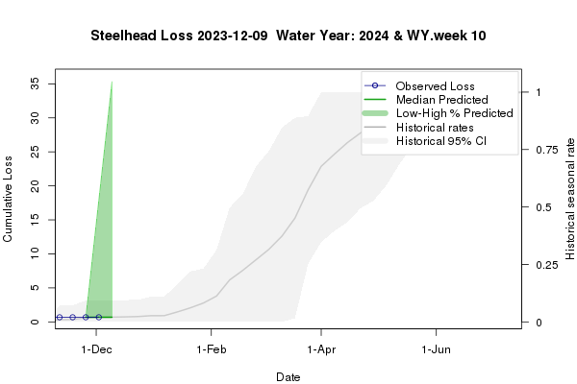

#### Figure 1. Predicted weekly loss of steelhead and winter-run Chinook salmon at the CVP and SWP facilities

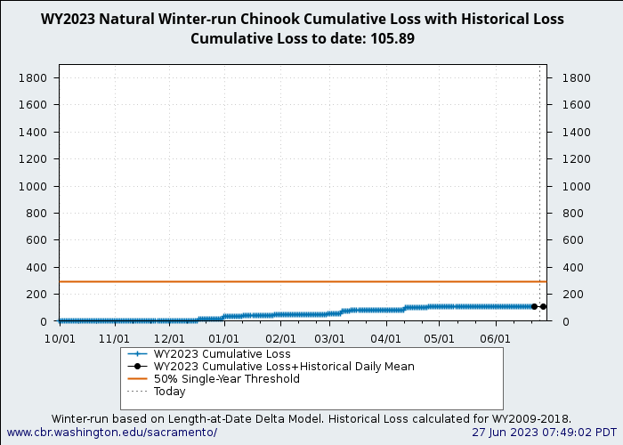 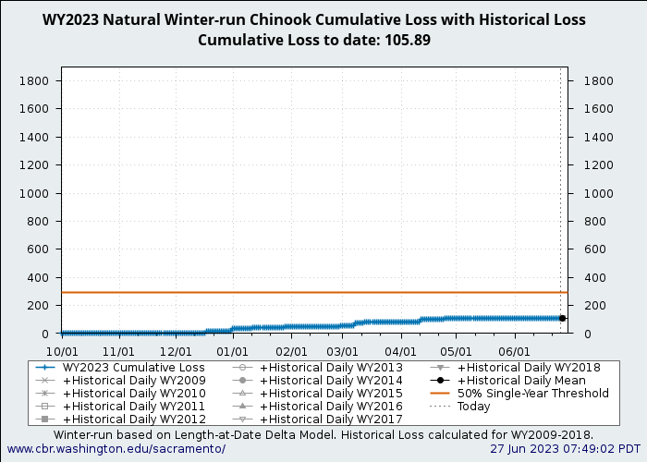

#### Figure 2. Cumulative natural winter-run Chinook salmon loss for the year (blue) and 2009 – 2018 historic cumulative loss (gray, different symbols). Historic daily mean plotted in black circles

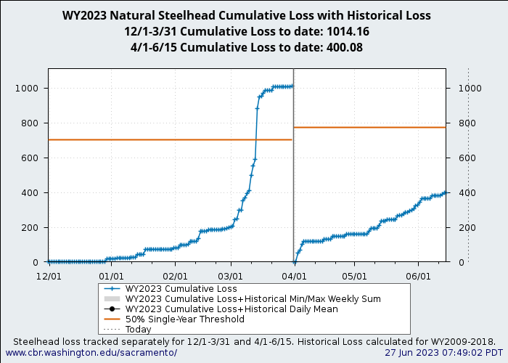

“Steelhead Cumulative Loss”

#### Figure 3. Cumulative natural steelhead loss for the year (blue) and 2009 – 2018 historic cumulative loss (gray). Historic daily mean plotted in black circles.