Weekly Assessment of CVP and SWP Delta Operations on ESA-listed Species

Bureau of Reclamation

2022-08-09

# Executive Summary

# Operational and Regulatory Conditions

# Biology, Distribution, and Evaluation Winter-run Chinook salmon, Spring-run Chinook salmon, Central Valley Steelhead

## POPULATION STATUS

### Winter-run Chinook Salmon

#### Delta Life Stages

#### Brood Year 2021 Productivity

* Natural Winter-run Chinook salmon: **historical data number and estimate passed RBDD**
* Hatchery Winter-run Chinook salmon:

### Spring-run Chinook Salmon

#### Delta Life Stages

#### Brood Year 2021 Productivity

* Natural Spring-run Chinook salmon: **historical data number**
* Hatchery Spring-run Chinook salmon:
* Hatchery Spring-run Chinook salmon surrogates associated with the ITP
* San Joaquin River Restoration Program (SJRRP) Salmon Conservation and Research Facility (SCARP) Chinook salmon:

### Central Valley Steelhead

#### Delta Life Stages

#### Brood Year 2021 Productivity

* Spawner abundance:
* Natural steelhead:
* Hatchery steelhead:

## DISTRIBUTION

### Winter-run Chinook Salmon

#### Current Distribution

* **info on percentage in Delta, exited Delta**
* **info on natural loss**
* **info on hatchery loss**
* **info on flows at Mill and Deer creek**

#### Historic Trends

* **percent of winter-run Chinook salmon that should have been observed in salvage by this time of the water year (Table 3)**

#### Forecasted Distribution within Central Valley and Delta regions

* **info on entrainment tool estimates of median and maximum loss**
* **Genetic information from salvage**

### Spring-run Chinook Salmon

#### Current Distribution

* **percent of CV spring-run present in Delta (Table 1)**

#### Historical Trends

#### Forecasted Distribution within Central Valley and Delta Regions

* **percent of YOY spring-run observed in salvage by this time of the water year (Table 3)**
* **Deer Creek flows**

### Central Valley Steelhead

#### Current Distribution

* **percent present in the Delta (Table 1)**
* **total hatchery loss**
* **total natural loss Dec-Mar**
* **combined natural loss Apr-June**

#### Historical Trends

* **historical trends percent steelhead in salvage**

#### Forecasted Distribution within Central Valley and Delta regions

* **percent present in Delta**
* **entrainment tool estimates (SacPAS)**

### TABLES

#### TABLE 1.Salmonid distribution estimates

<https://www.cbr.washington.edu/sacramento/data/juv_monitoring.html>

#### TABLE 2. Historic migration and salvage patterns

#### TABLE 3. STARS model output

**Table** : TABLE 4. Mean daily flow and percent change (Wilkins Slough, Deer Creek, Mill Creek; cfs from CDEC) and temperature and percent change (Knights Landing; °F from RST)

| MLM_flow | MLM_change | MLM_alert | DCV_flow | DCV_change | DCV_alert | WLK_flow | WLK_change |
| --- | --- | --- | --- | --- | --- | --- | --- |
| 99.5 | 0.4 | Flow>95cfs | 63.2 | -0.7 | Flow>95cfs | 3,229.1 | -2.6 |
| 100.5 | 1.0 | Flow>95cfs | 63.7 | 0.8 | Flow>95cfs | 3,192.3 | -1.1 |
| 99.3 | -1.3 | Flow>95cfs | 63.2 | -0.8 | Flow>95cfs | 3,171.2 | -0.7 |
| 98.1 | -1.2 | Flow>95cfs | 62.5 | -1.2 | Flow>95cfs | 3,200.9 | 0.9 |
| 97.1 | -1.0 | Flow>95cfs | 61.7 | -1.2 | Flow>95cfs | 3,215.6 | 0.5 |
| 96.3 | -0.9 | Flow>95cfs | 61.1 | -1.1 | Flow>95cfs | 3,254.6 | 1.2 |
| 97.1 | 0.8 | Flow>95cfs | 61.2 | 0.1 | Flow>95cfs | 3,221.3 | -1.0 |
| 98.0 | 1.0 | Flow>95cfs | 61.0 | -0.3 | Flow>95cfs | 3,168.0 | -1.7 |

#### TABLE 5. a) WY 2022 loss and salvage predictor data: Predicted weekly loss of winter-run Chinook salmon and steelhead at CVP and SWP facilities. b) Environmental details, current and forecast.

#### TABLE 6. Preliminary survival (Φ) results for acoustically tagged salmonids (Chinook and steelhead). Individual studies denoted by rows with bold lines.

### FIGURES

#### FIGURE 1.

#### FIGURE 2.

#### FIGURE 3.Predicted weekly loss of steelhead and winter-run Chinook salmon at the CVP and SWP facilities

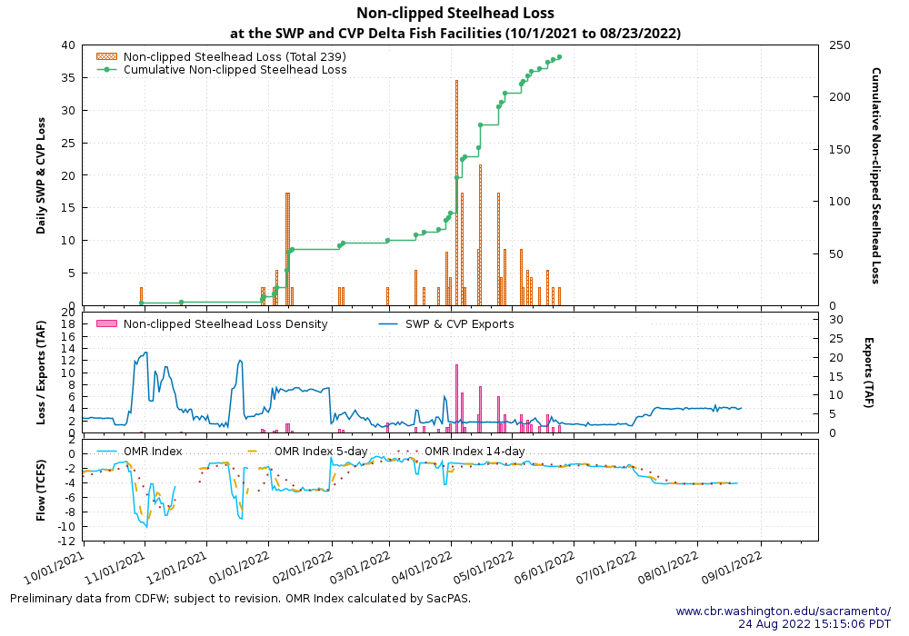

## EVALUATION

### 1.

### 2.

### 3. What is the likelihood of increased loss exceeding the next annual loss threshold (50%, 75% or 90% of threshold) resulting in OMR management actions based on population distribution, abundance, and behavior of fish in the Delta?

**Calculate Loss**

*Also relevant to Table 2a in Outlook*

| species_race | loss_unclipped | loss_clipped |
| --- | --- | --- |
| SH-early | 84.28 | 308.27 |
| SH-late | 154.38 | 331.52 |
| F | 596.29 | 45.48 |
| LF | 12.23 | 507.12 |
| S | 552.69 | 116.89 |
| W | 73.04 | 392.61 |

# Biology, Distribution, and Evaluation of Delta Smelt

## Distribution

### Current Distribution

### Cultured Delta Smelt Experimental Releases

### Historical Trends

### Forecasted Distribution within Central Valley and Delta Regions

# ABIOTIC CONDITIONS

## Turbidity

Use CDECRetrieve - SensorDownload.R Look at just data from the past week - Water temperature, Flow - 3 day averages

Download Data

## X2 Conditions

## Other Environmental Conditions

# Evaluation

# Delta Smelt References