PRELIMINARY DATA: Current Delta Hydrologic Conditions
Last updated: December 03, 2025

Operational and Regulatory Conditions
DCC gates are the current controlling factor. See most recent weekly outlook for more information.

Current Conditions
Most recent inflow at Freeport in the Sacramento River and Vernalis in the San Joaquin River is 11,010 and 883 cfs respectively. Most recent 1-day, 5-day, and 14-day OMRI measurements were -5,355, -5,790, and -7,182 respectively, and most recent export data were 1,782 for Jones Pumping Plant and 4,046 for Henry O. Banks Pumping Plant.
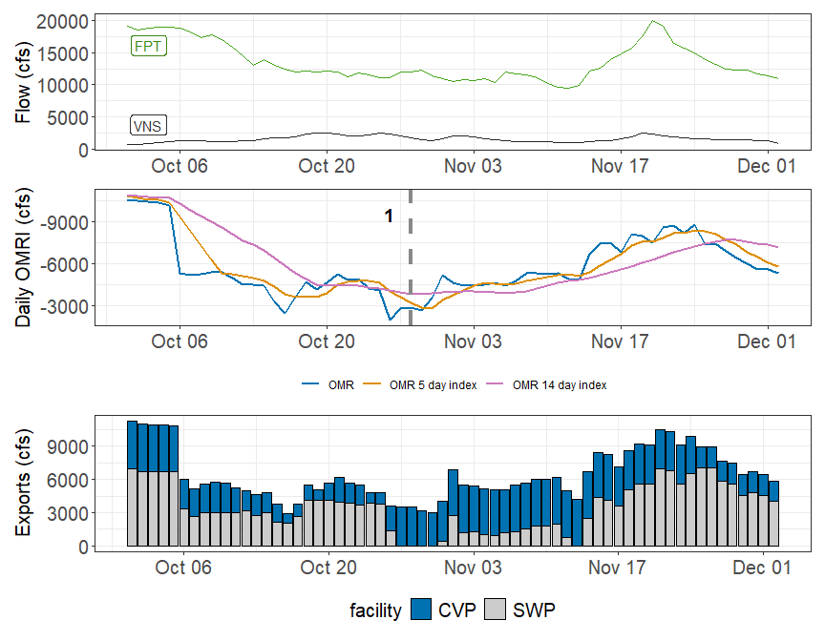
Figure 1: Operations and Action Summary, WY 2026. The colors in the OMRI plot indicate different types of triggers (see Table 1). OMRI data calculated by SacPAS, Freeport (FPT) and Vernalis (VNS) flow data from CDEC, and CVP (TRP) and SWP (HRO) exports data from CDEC.
Table 1: Summary of Actions and Triggers, WY 2026
Label | Action | Date Triggered | Date Implemented | Number Days Implemented | Regulation
1 | DCC Gate Closure | 10/28/2025 | 10/30/2025 | Ongoing | DCC gates

Zone of Influence
The Zone of Influence (ZOI) analysis served as a Line of Evidence for comparing alternative actions in the Long Term Operations EIS. This analysis evaluated the spatial extent of hydrologic alteration resulting from pumping under varying Old and Middle River flow conditions and Sacramento-San Joaquin river inflow conditions. This analysis was adapted for the assessment by focusing on a single alternative, Alt2woTUCPDeltaVa, which served as the proposed action in the LTO, and binned maps into 1 of 9 categories based on low, medium, and high inflows from the Sacramento and San Joaquin flow. In general, changes in channel length across OMR levels may correlate with entrainment risk, where larger increases in channel length from more positive to more negative OMR represent greater entrainment risk.
Current conditions at Freeport and Vernalis indicate that delta hydrology falls within the ‘lolo’ category (see appendix for hydrology bin definitions). The altered channel length for the ‘lolo’ hydrology is 16 kilometers (km) for an OMR of -2000 and 163 km for an OMR of <-5500. Change in altered channel length between OMR levels is 147 km, which represents 20.6% of change in altered channel length among the nine hydrology bins
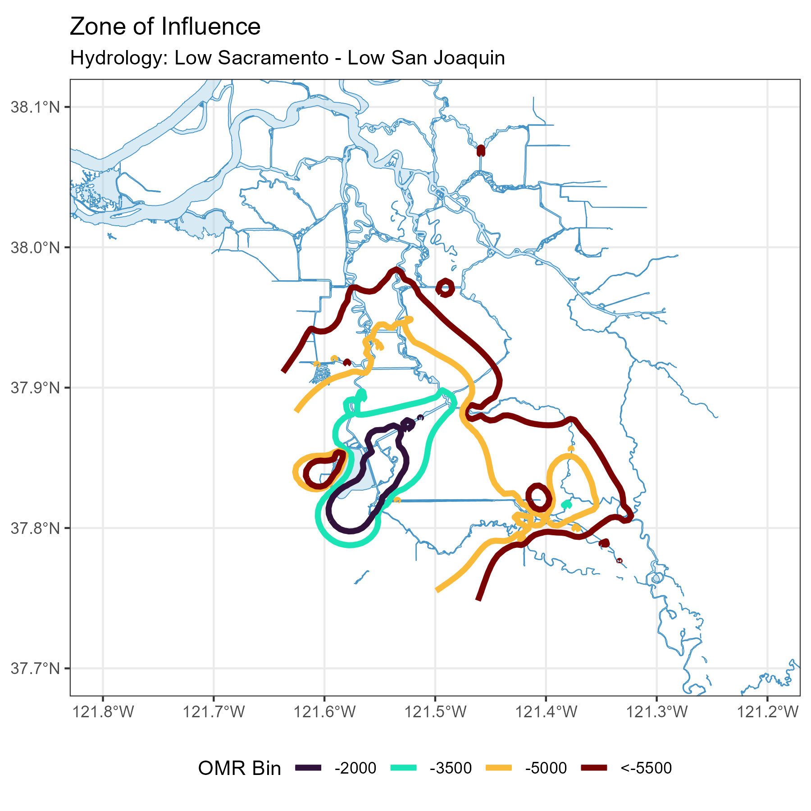
Modeled Zone of Influence at different OMRI scenarios based on current inflow hydrology from the Sacramento River and San Joaquin River

