PRELIMINARY DATA: Assessment for Delta Operations on ESA and CESA-listed Salmonids
Last updated: December 03, 2025

Executive Summary
- DCC gates are currently closed and is the controlling factor. Gates will continue to operate in accordance to Table 3-6 in the Proposed Action.
- Winter-run catch is high at delta entry monitoring locations. No loss has yet to occur at export facilities.
- Central Valley Steelhead catch is low and no loss has yet to occur at export facilities.

Natural Winter-run Chinook

Juvenile Production Estimate and Current Status
Give update on migration, salvage, monitoring, and STARs patterns.
The Juvenile Production Estimate for winter-run has not been established for the current water year. Historically, as of Dec 02, 28.4% of length-at-date (LAD) winter-run have entered the delta based on Knights Landing RST catch, 0.9% have exited the delta based on Chipps Island Trawl Catch, and 0.0% of DNA confirmed winter-run have been salvaged.
Species | Red Bluff Diversion Dam | Tisdale RST | Knights Landing RST | Sac Trawl (Sherwood) | Chipps Island Trawl | Salvage
Chinook, LAD Winter-run, Unclipped | 92.0% | 28.3% | 28.4% | 16.9% | 0.9% | 0.0%
Chinook, DNA Winter-run, Unclipped (Water Year) |  |  |  |  |  | 0.0%

Annual Loss
The Juvenile Production Estimate has not been established for the current water year so thresholds are absent or are included from the previous water year. As of December 02 cumulative loss of genetically confirmed winter-run is 0 or 0.00% of the annual loss threshold. Cumulative loss in the past 7 days has been 0.
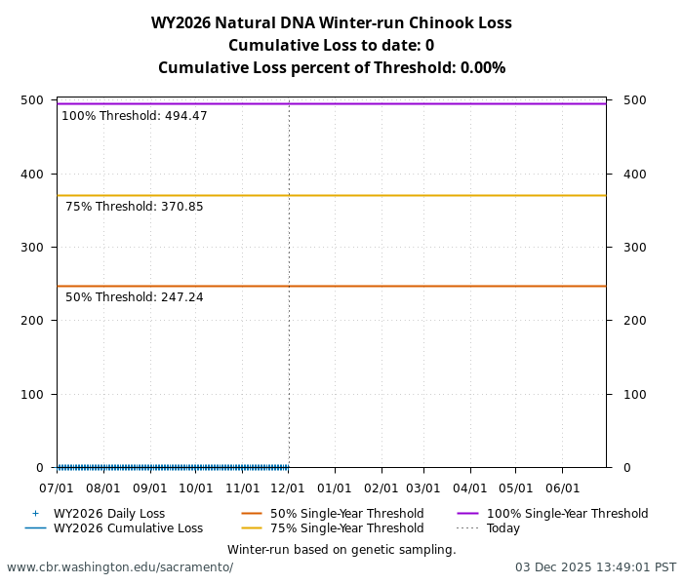
Cumulative loss of natural-origin winter-run for WY 2026. Cumulative loss is based on genetically confirmed winter-run captured in salvage or length-at-date winter-run in which genetic confirmation was unable to be obtained

STARs
The Delta STARS Model is an individual-based simulation model that predicts survival, travel time, and routing of juvenile salmon migrating through the Sacramento–San Joaquin River Delta. This model gives insight into survival and routing patterns of winter-run based on most current conditions.
As of December 02, overall through delta STARs estimated survival probability (with 80% credible intervals) is 0.28 (0.18-0.37) placing it in the 26th percentile of historical STARs survival estimates for the month of December (WYs 2018-2025). STARs estimated rounting and survival probabilities (with 80% credible intervals) into the interior delta are 0.13 (0.1-0.17) and 0.08 (0.02-0.15), respectively, corresponding to the 83th and 22th percentiles of historical December estimates (WYs 2018-2025).
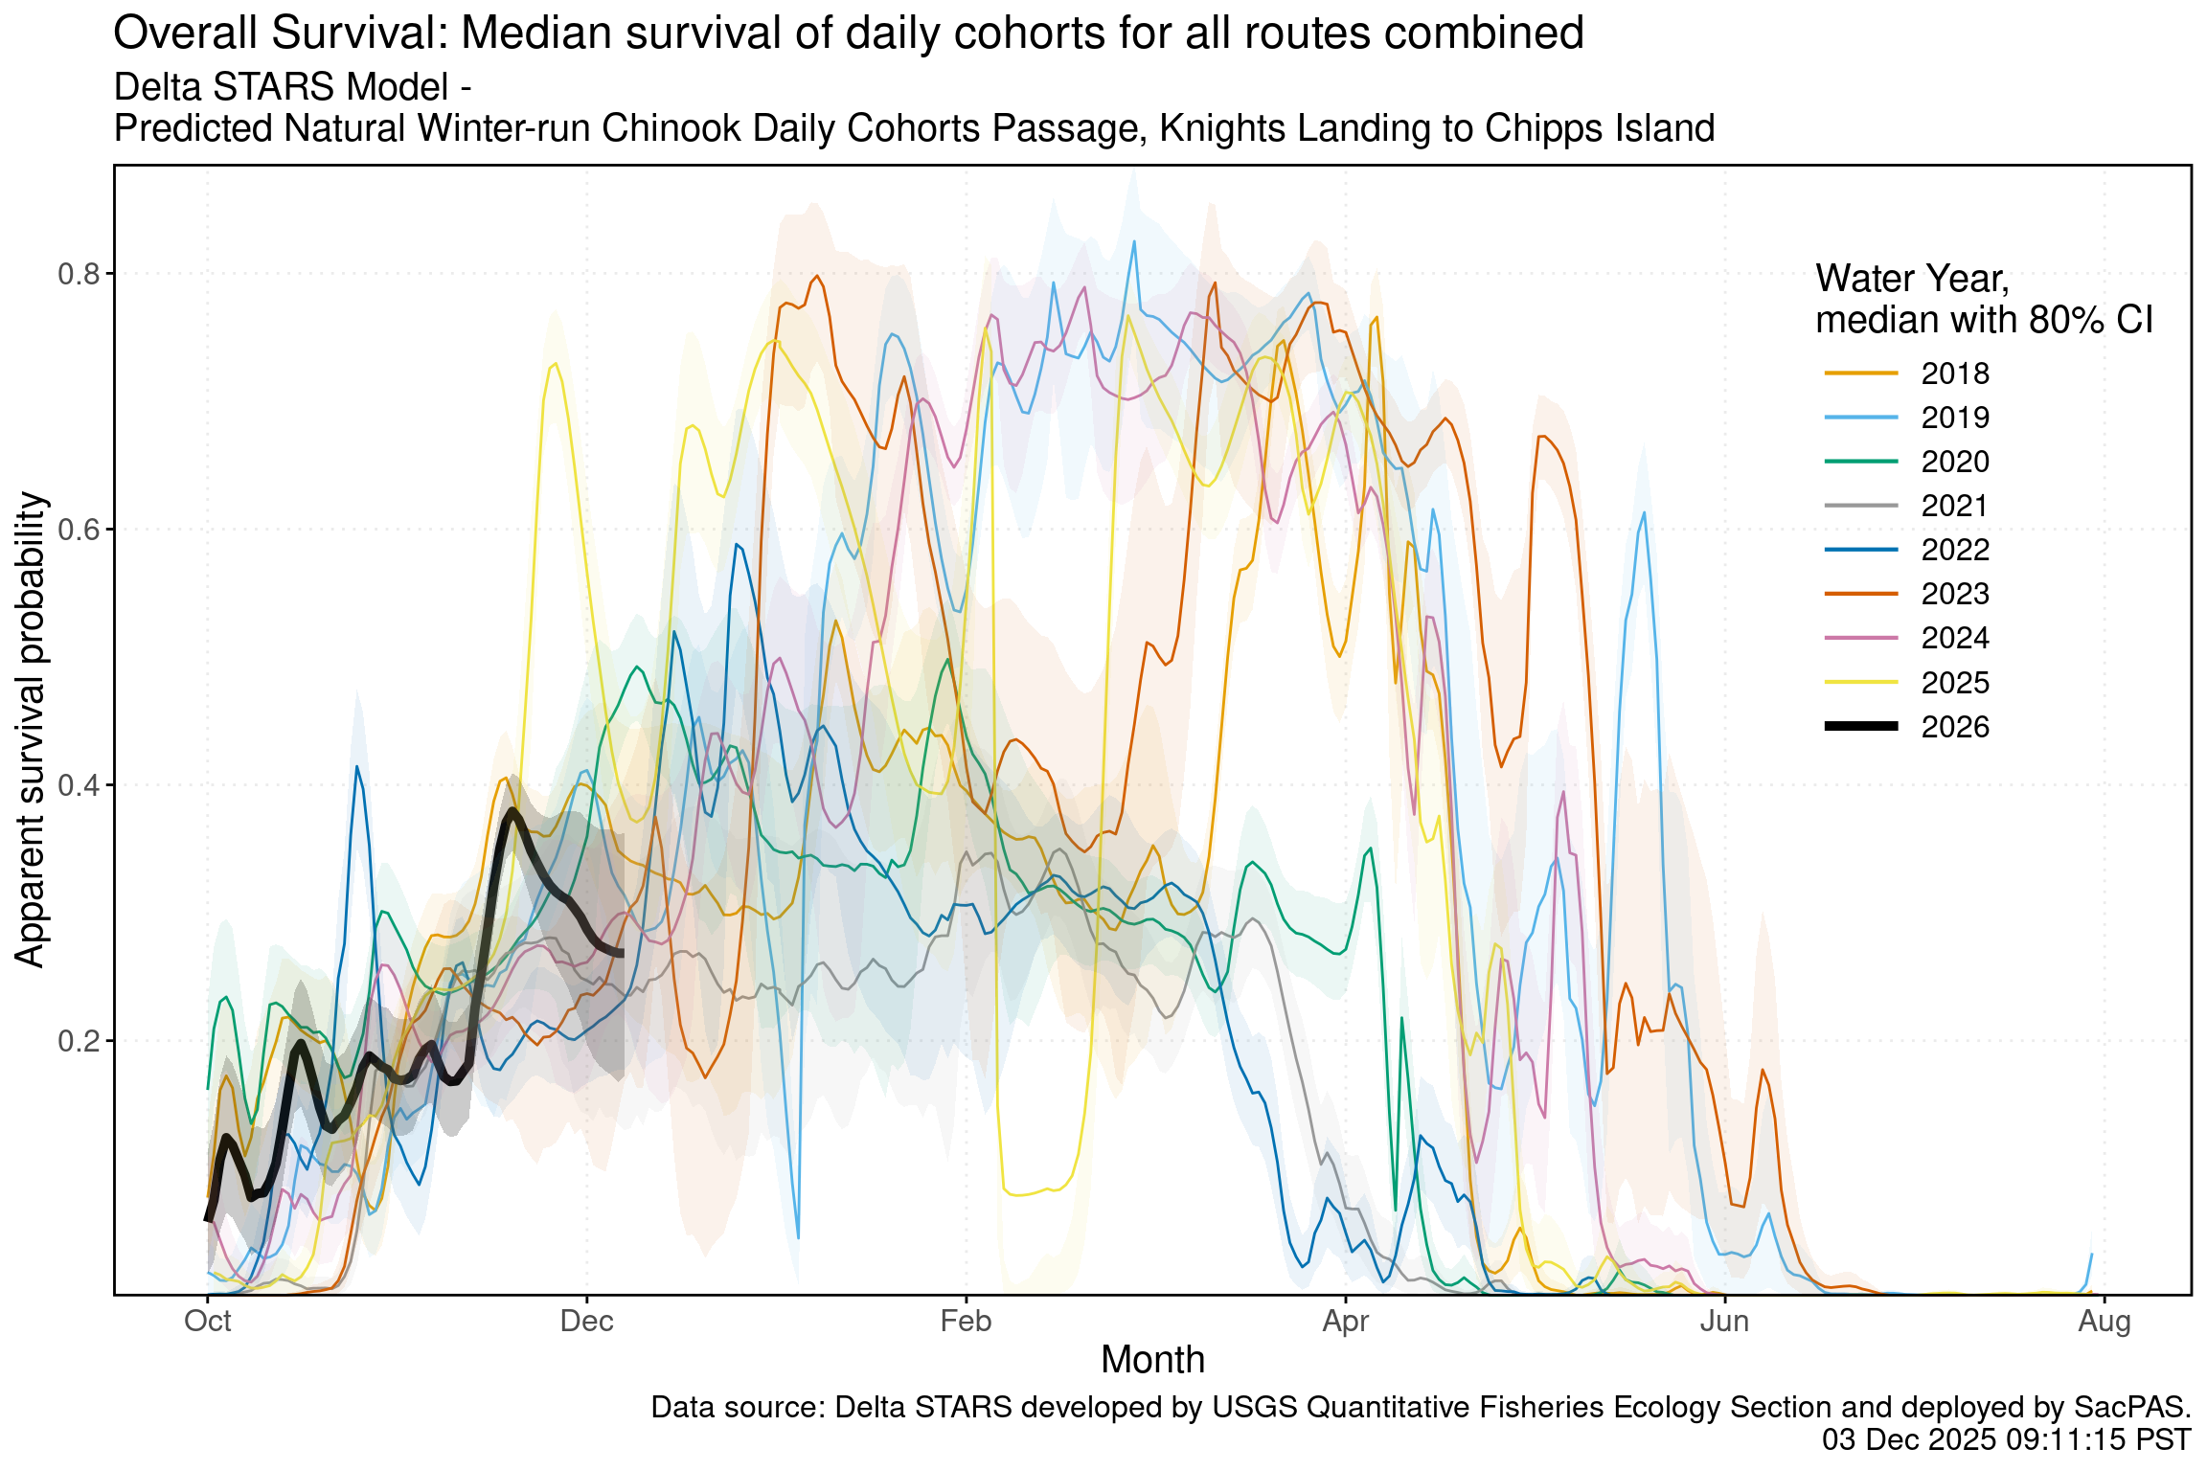
Estimated overall winter-run survival from Knights Landing to Chipps Island. Black line indicates the current water-year, and other colored lines correspond to past water years.
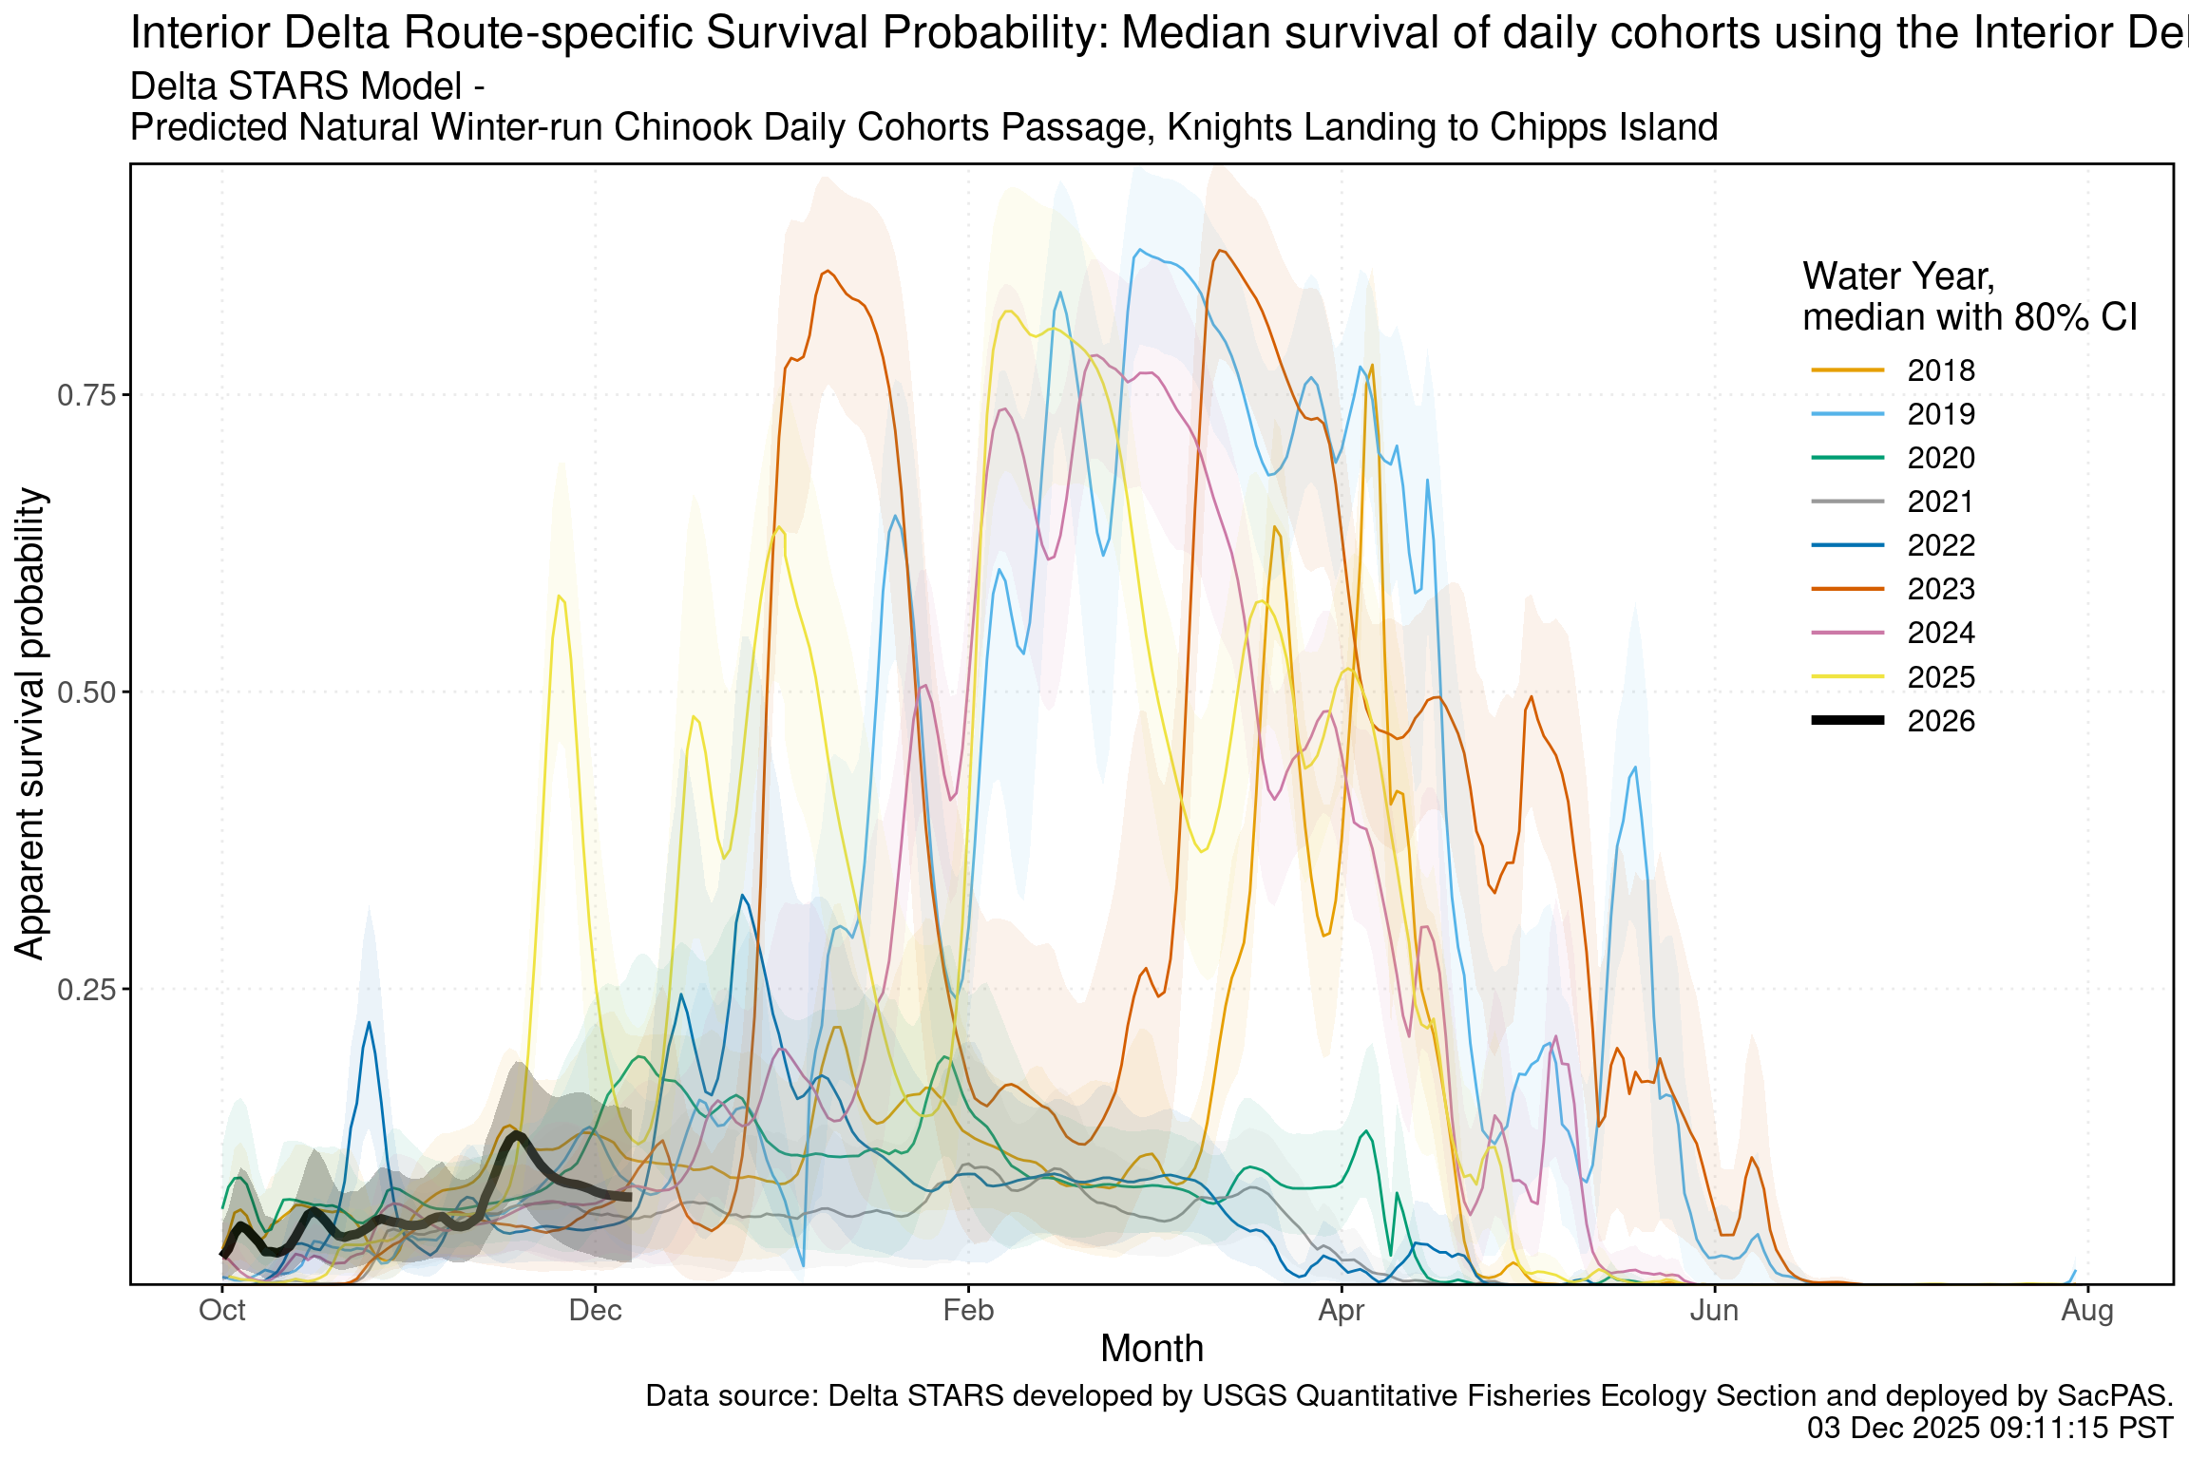
Estimated survival from Knights Landing to Chipps Island of simulate winter-run cohorts that route through the interior delta. Black line indicates the current water-year, and other colored lines correspond to past water years.
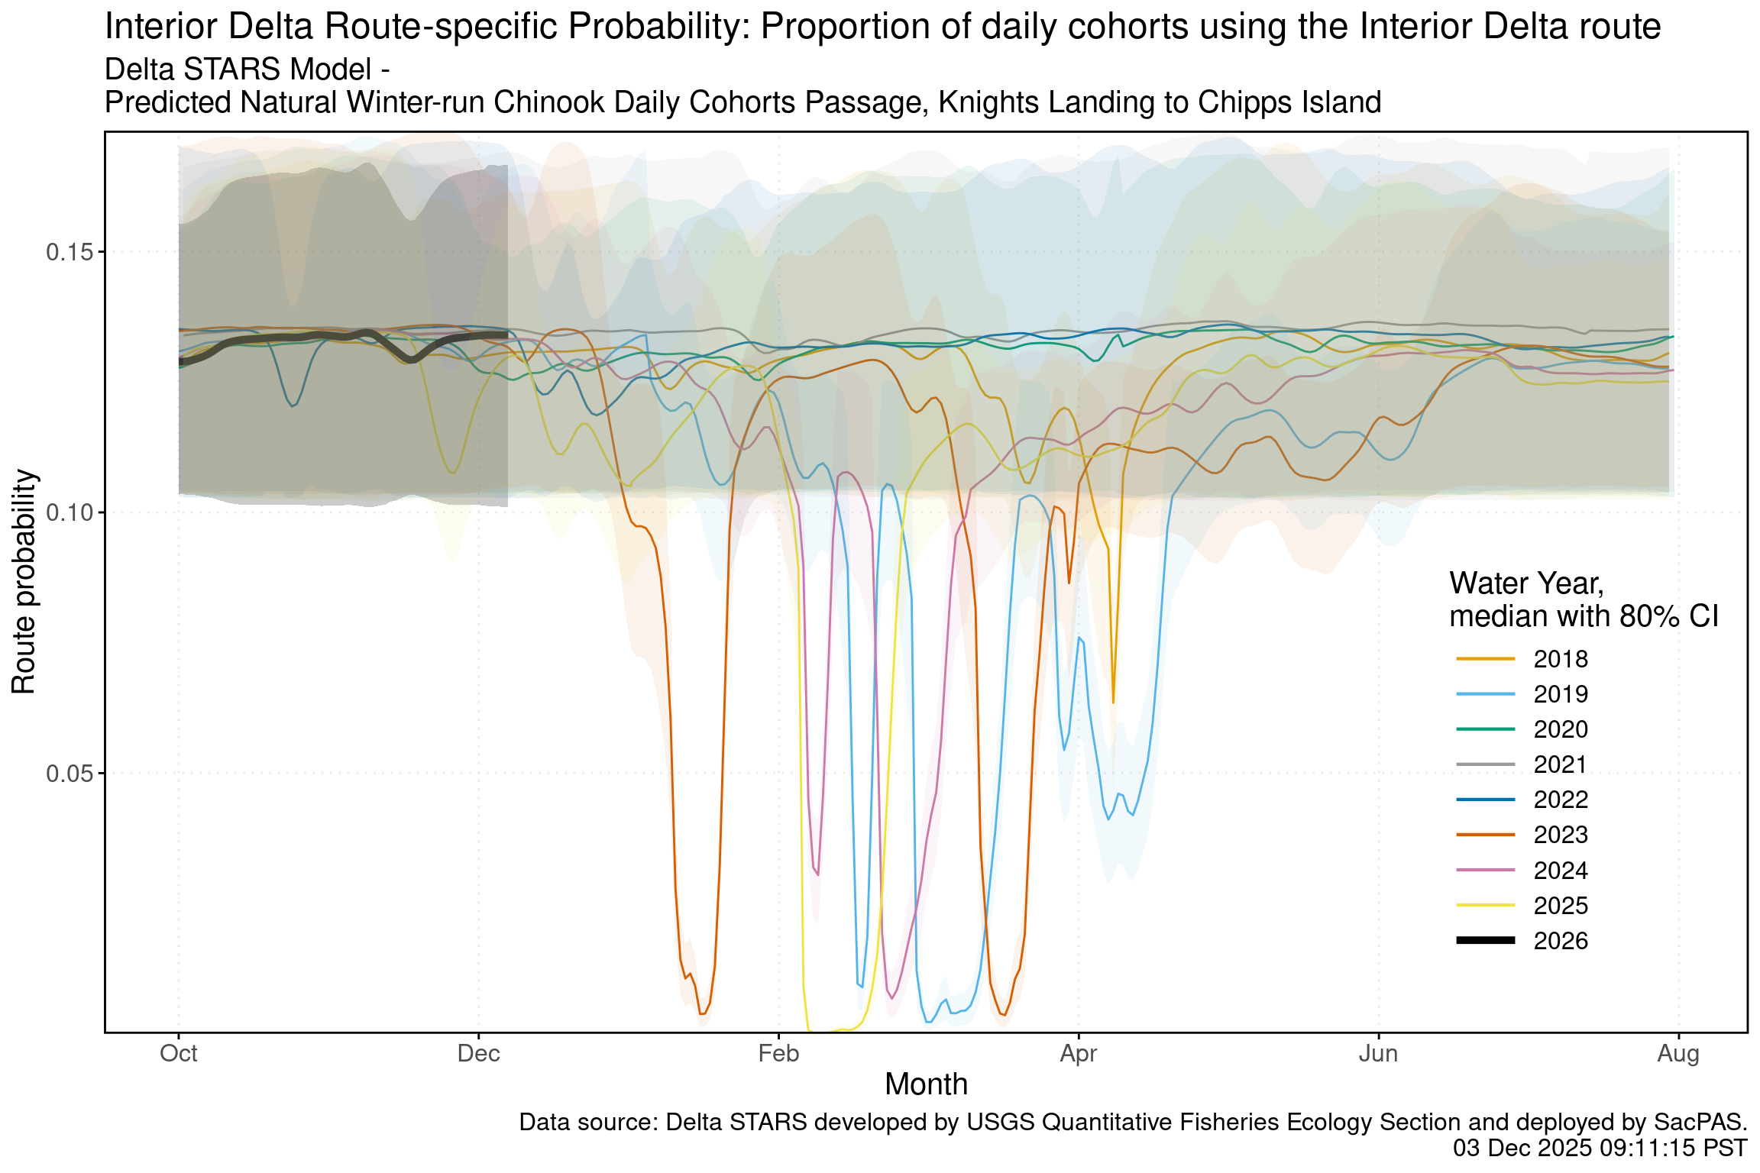
Estimated probability of winter-run routing into the interior delta. Black line indicates the current water-year, and other colored lines correspond to past water years.

Hatchery Winter-run Chinook

Juvenile Production Estimate and Current Status
The Juvenile Production Estimate for Livingstone Stone hatchery winter-run has not been established for the current water year. To date, no winter-run Livingstone hatchery releases have occurred in WY 2026

Annual Loss
The Juvenile Production Estimate has not been established for the current water year so thresholds are absent or are included from the previous water year. To date, no loss has occurred as no hatchery winter-run have been released.

Natural-origin Central Valley Steelhead

Current Status
Historically, as of Dec 02, 0% of CCV steelhead have entered the delta based on Knights Landing RST catch, 0% have exited the delta based on Chipps Island Trawl Catch, and 1.0% have been salvaged.
Species | Red Bluff Diversion Dam | Tisdale RST | Knights Landing RST | Sac Trawl (Sherwood) | Chipps Island Trawl | Salvage
Steelhead, Unclipped |  |  |  |  |  | 1.0%

Annual Loss
As of December 02 cumulative loss of unclipped steelhead is 0 or 0.00% of the annual loss threshold. Cumulative loss in the past 7 days has been 0.
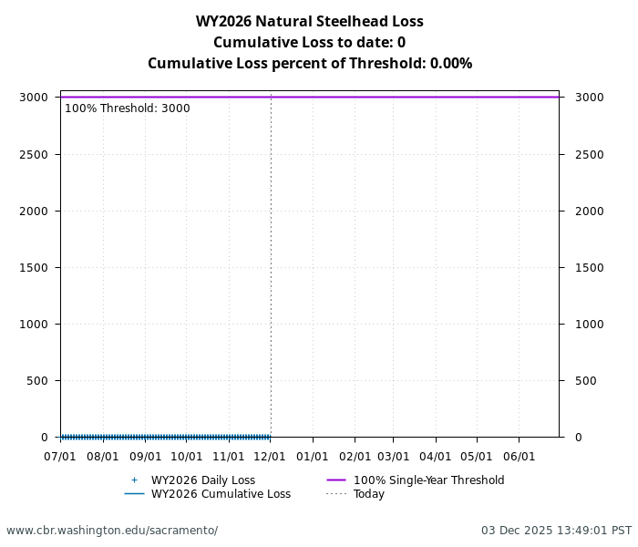
Cumulative loss of natural-origin and hatchery steelhead for WY 2026.

Hatchery-origin Central Valley Steelhead

Juvenile Production Estimate and Current Status

Annual Loss

Spring-run

Current Status

Surrogate Releases and Current Loss

References

