Weekly Assessment for Delta Operations on ESA and CESA-listed Osmerids
Last updated: December 16, 2025

Executive Summary
- First flush is not anitipated to occur in the weekly outlook, but could initiate the start of the Entrainment Management season for Delta smelt
- Freeport flows and turbidity are expected to increase late this week due to incoming storms
- No Delta Smelt salvage has been observed this water year

Operational and Regulatory Conditions
- See current Weekly Fish and Water Operations Outlook document.
- Additional information also available on the SacPAS SMT page.

Delta Smelt

Biological
- Delta Smelt Life Stages: Adult, Juvenile
- Abundance estimate: 10092 (95% CL: 2,302 to 29,101) as of the week of December 8–12, 2025
- Releases: A total of 138,743 hatchery Delta Smelt have been released for WY 2026. The most recent releases of 67,583 fish occurred in Belden’s Landing boat ramp in Suisun Marsh on Nov 05, 2025 to Nov 04, 2025.
- Delta Smelt count: 6 adult Delta Smelt and 3 juvenile Delta smelt have been detected this water year. See Table 1 for recent detections, Figure 1 for spatial distribution, and Figure 2 for temporal distribution.
- Delta Smelt salvage: 0 Delta Smelt have been salvaged, and the cumulative seasonal salvage is 0.
Notes
- Since there are few recent detections of Delta Smelt, estimation of distribution within the Delta is limited.
- See SacPAS SMT Page for additional details on releases and detection in surveys and salvage.
- Historical salvage trends can be found at: SacPAS Salvage Timing
Table 1: Delta Smelt Detections in the last 2 weeks. Fork Length > 58mm = Adult, Fork Length 20-58mm = Juvenile, Fork Length < 20mm = Larva.
Survey | Date | Region | Stratum | Life Stage | Catch
edsm | 2025-12-04 | North | Sac DW Ship Channel | Adult | 1
edsm | 2025-12-09 | West | Suisun Marsh | Adult | 3
edsm | 2025-12-11 | West | Suisun Marsh | Adult | 2
edsm | 2025-12-11 | West | Suisun Marsh | Juvenile | 3

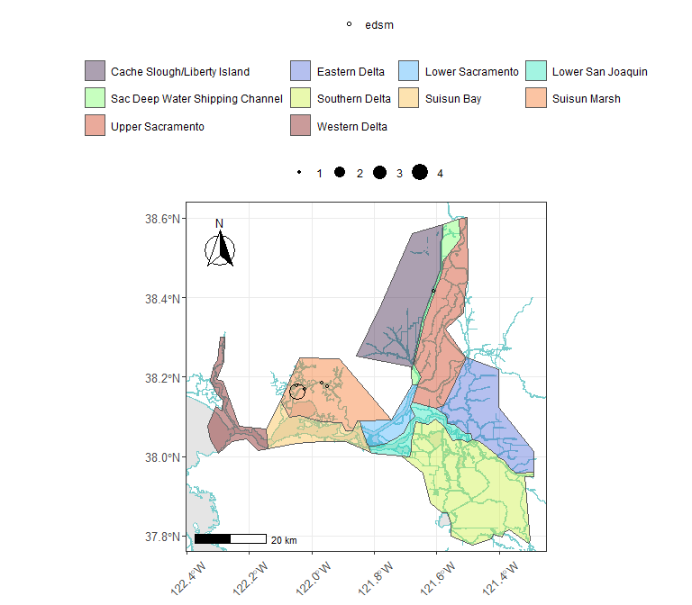
Figure 1: Delta Smelt Distribution for WY 2026
Table 2: Delta Smelt Water Year Totals by Life Stage
Survey | Region | Life Stage | Total
edsm | North | Adult | 1
edsm | West | Adult | 5
edsm | West | Juvenile | 3

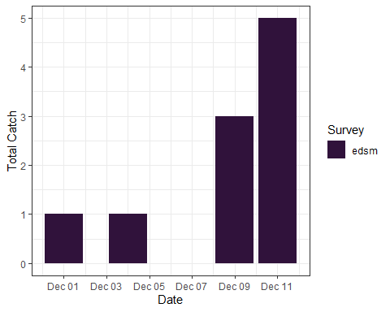
Figure 2: Time Series of Delta Smelt Catch, WY 2026

Environmental

First Flush
Threshold: 3-day avg FPT flow ≥ 25,000 cfs and 3-day avg FPT turbidity ≥ 50 FNU
- FPT Flow (3-day average): 9925 cfs as of Dec 15, 2025
- FPT Turbidity (3-day average): 7.03 FNU as of Dec 15, 2025
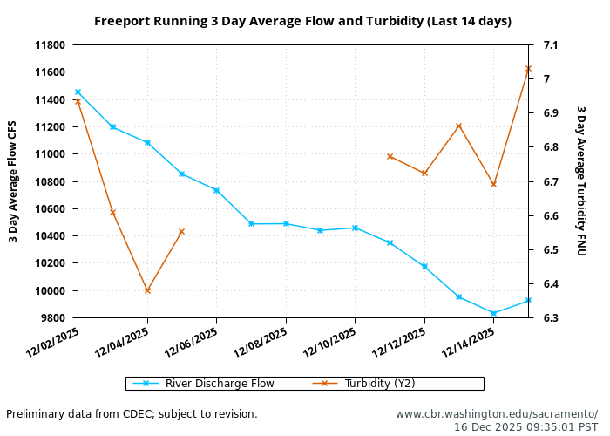

Real-time Assessment Thresholds
- Jersey Point Flow (JPF): Reclamation and DWR would compute JPF based on San Joaquin River Inflow at Vernalis, Cosumnes River Inflow, Mokelumne River Inflow, Calaveras River Inflow, Flow from Sacramento River through DCC, Flow from Sacramento River through Georgiana Slough, 65% of in-Delta precipitation, -65% of in-Delta diversions, and -Export Pumping at (Banks + Jones).

Adult Delta Smelt
- Not relevant
- See Bay-Delta Live for recent Delta-wide turbidity conditions.

Larval/Juvenile Delta Smelt
- Not relevant

Longfin Smelt

Biological
- Longfin Smelt Life Stages: Adult, Juvenile
- Longfin Smelt count: 13 adult Longfin Smelt and 31 juvenile Longfin smelt have been detected this water year. See Table 3 for recent detections, Figure 3 for spatial distribution, and Figure 4 for temporal distribution.
- Longfin Smelt salvage: 0 Longfin Smelt have been salvaged, and the cumulative seasonal salvage is 0.
Table 3: Longfin Smelt Detections in the last 2 weeks. Fork Length > 84mm = Adult, Fork Length 20-84mm = Juvenile, Fork Length < 20mm = Larva.
Survey | Date | Region | Stratum | Life Stage | Catch
edsm | 2025-12-10 | Far West | Suisun Bay | Adult | 2
edsm | 2025-12-10 | Far West | Suisun Bay | Juvenile | 6
edsm | 2025-12-11 | West | Suisun Marsh | Adult | 9
edsm | 2025-12-11 | West | Suisun Marsh | Juvenile | 23
edsm | 2025-12-15 | West | Suisun Bay | Adult | 2
edsm | 2025-12-15 | West | Suisun Bay | Juvenile | 2

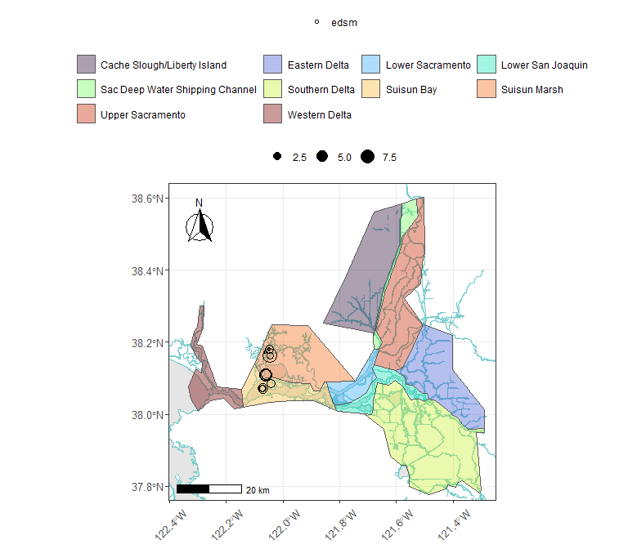
Figure 3: Longfin Smelt Distribution for WY 2026
Table 4: Longfin Smelt Water Year Totals by Life Stage
Survey | Region | Life Stage | Total
edsm | Far West | Adult | 2
edsm | Far West | Juvenile | 6
edsm | West | Adult | 11
edsm | West | Juvenile | 25

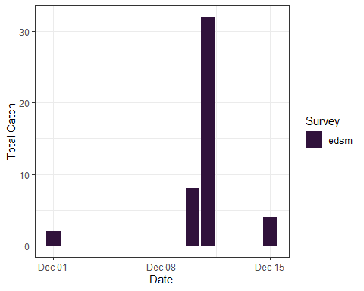
Figure 4: Time Series of Longfin Smelt Catch, WY 2026

Real-time Assessment Thresholds

Start of Entrainment Management (Adult Longfin Smelt)
- Threshold: JPF < 0 cfs AND salvage of adult longfin exceeds 26.8 fish (5% of FMWT Index + 1)
  - 7-day average JPF: -616.81 cfs as of Dec 15, 2025
  - Water year total Age 1+ longfin smelt salvage = 0

Adult Longfin Smelt
- Threshold: JPF < 0 cfs AND annual loss is on a trajectory to exceed 5% of the adult population abundance
  - 7-day average JPF: -616.81 cfs as of Dec 15, 2025
  - Water year total adult longfin smelt salvage = 0

Larval/Juvenile Longfin Smelt
- Threshold: JPF < 0 cfs AND population model demonstrates need to reduce entrainment to avoid population decline
  - 7-day average JPF: -616.81 cfs as of Dec 15, 2025

End of Smelt OMR Management
- Not relevant

References

