PRELIMINARY DATA: Assessment for Delta Operations on ESA and CESA-listed Salmonids
Last updated: December 22, 2025

Executive Summary
- Entrainment management season is not active at this time.
- No salmonids have been salvaged this season.
- Winter-run presence in the delta is high.

Operational and Regulatory Conditions
DCC gates are the current controlling factor. See most recent weekly outlook for more information.

Current Conditions
Most recent inflow at Freeport in the Sacramento River and Vernalis in the San Joaquin River is 20,661 and 4,788 cfs respectively. Most recent 1-day, 5-day, and 14-day OMRI measurements were -7,941, -4,723, and -3,278 respectively, and most recent export data were 3,525 for Jones Pumping Plant and 6,499 for Henry O. Banks Pumping Plant.
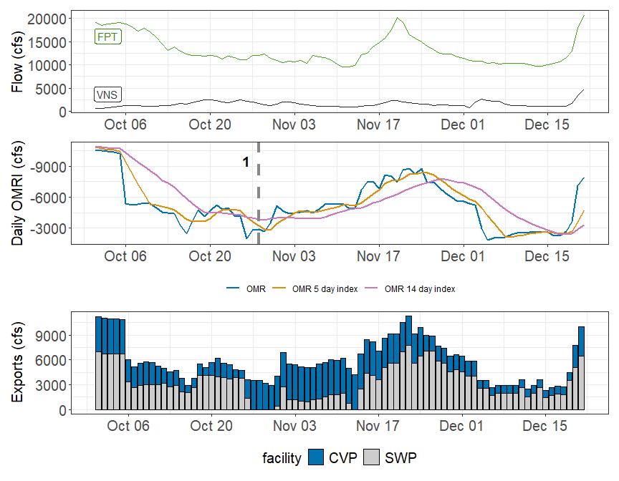
Figure 1: Operations and Action Summary, WY 2026. The colors in the OMRI plot indicate different types of triggers (see Table 1). OMRI data calculated by SacPAS, Freeport (FPT) and Vernalis (VNS) flow data from CDEC, and CVP (TRP) and SWP (HRO) exports data from CDEC.
Table 1: Summary of Actions and Triggers, WY 2026
Label | Action | Date Triggered | Date Implemented | Number Days Implemented | Regulation
1 | DCC Gate Closure | 10/28/2025 | 10/30/2025 | Ongoing | DCC gates

Zone of Influence
The Zone of Influence (ZOI) analysis served as a Line of Evidence for comparing alternative actions in the Long Term Operations EIS. This analysis evaluated the spatial extent of hydrologic alteration resulting from pumping under varying Old and Middle River flow conditions and Sacramento-San Joaquin river inflow conditions. This analysis was adapted for the assessment by focusing on a single alternative, Alt2woTUCPDeltaVa, which served as the proposed action in the 2024 Record of Decision, and binned maps into 1 of 9 categories based on low, medium, and high inflows from the Sacramento and San Joaquin flow. In general, changes in channel length across OMR levels may correlate with entrainment risk, where larger increases in channel length from more positive to more negative OMR represent greater entrainment risk.
Current conditions were queried from most recent Freeport flow data on the Sacramento River and Vernalis flow data on the San Joaquin river from SacPAS. Forecasted flows were queried from short range deterministic flows provided by the California Nevada River Forecast Center.
Current conditions at Freeport and Vernalis indicate that delta hydrology falls within the ‘medhi’ category. Forecasted conditions averaged across the next 7 days falls within the ‘hihi’ category.
The altered channel length for the current, “medhi” hydrology is 55, kilometers (km) for an OMR of -2000 and 153 km for an OMR of -5000. The altered channel length for forecasted, “hihi” hydrology is 99, kilometers (km) for an OMR of -2000 and 114 km for an OMR of <-5500.
Change in altered channel length between OMR levels is 98 km for current conditions and 15 km for forecasted conditions indicating that ZOI impacts to OMR based on ZOI would decrease under forecasted hydrology.
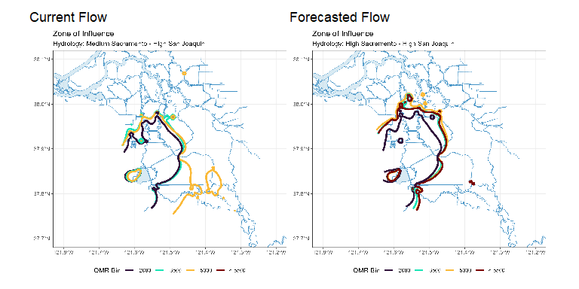
Figure 2: Modeled Zone of Influence at different OMRI scenarios based on current inflow hydrology (left) and forecasted inflow hydrology (right) from the Sacramento River and San Joaquin River

Natural Winter-run Chinook

Juvenile Production Estimate
The Juvenile Production Estimate for winter-run has not been established for the current water year.

Current Status
Entry Timing - Historically, as of Dec 21, 57% of length-at-date (LAD) winter-run have entered the delta based on Knights Landing RST catch, 2% have exited the delta based on Chipps Island Trawl Catch, and 4% of DNA confirmed winter-run have been salvaged.
Table 1: Average Percent of annual emigrating population for unclipped LAD winter-run captured at the following locations and LAD and DNA confirmed winter-run salvaged at SWP and CVP Delta facilities for the past 10 years.
Species | Red Bluff Diversion Dam | Tisdale RST | Knights Landing RST | Sac Trawl (Sherwood) | Chipps Island Trawl | Salvage
Chinook, LAD Winter-run, Unclipped | 96% | 56% | 57% | 33% | 2% | 4%
Chinook, DNA Winter-run, Unclipped (Water Year) |  |  |  |  |  | 4%

Red Bluff Diversion Dam Passage Estimate - As of Dec 16 estimated passage to date of LAD winter run at Red Bluff Diversion is approximately 2.66 million fish. * Note that outmigration timing overlaps with spring run migrating fish, and true winter-run abundance likely differs from these estimates.
Delta Monitoring - Total catch of LAD winter run at RSTs at Delta Entry (Tisdale, Knights Landing, Lower Sacramento River between Dec 08 and Dec 17 is 21 individuals. Total catch at Sacramento Trawl and Beach Seines in the delta between Dec 08 and Dec 19 is 51 individuals. Total catch at Delta Exit at Chipps Island between Dec 08 and Dec 19 is 0 individuals.

Annual Loss
The Juvenile Production Estimate has not been established for the current water year so thresholds are absent or are included from the previous water year. As of December 21 cumulative loss of genetically confirmed winter-run is 0 or 0.00% of the annual loss threshold. Cumulative loss in the past 7 days has been 0.
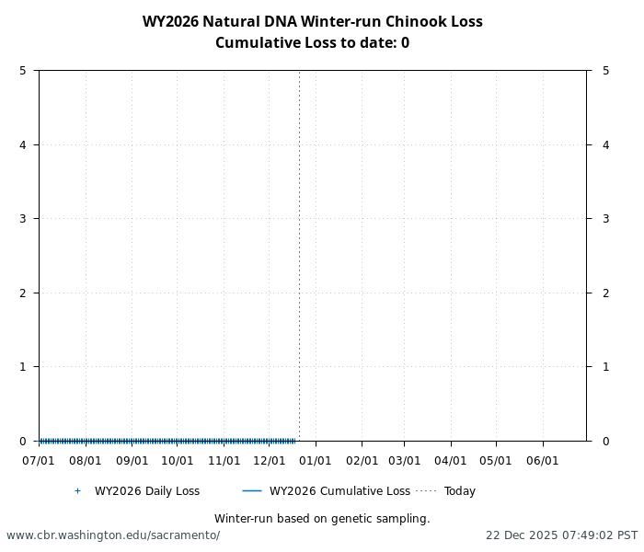
Figure 1: Cumulative loss of natural-origin winter-run for WY 2026. Cumulative loss is based on genetically confirmed winter-run captured in salvage or length-at-date winter-run in which genetic confirmation was unable to be obtained

STARS
The Delta STARS Model is an individual-based simulation model that predicts survival, travel time, and routing of juvenile salmon migrating through the Sacramento–San Joaquin River Delta. This model gives insight into survival and routing patterns of winter-run based on most current conditions.
As of December 21, overall through delta STARS estimated survival probability (with 80% credible intervals) is 0.7 (0.66-0.74) placing it in the 97th percentile of historical STARS survival estimates for the month of December (WYs 2018-2025). STARS estimated routing and survival probabilities (with 80% credible intervals) into the interior delta are 0.11 (0.09-0.13) and 0.6 (0.5-0.69), respectively, corresponding to the 2th and 98th percentiles of historical December estimates (WYs 2018-2025).
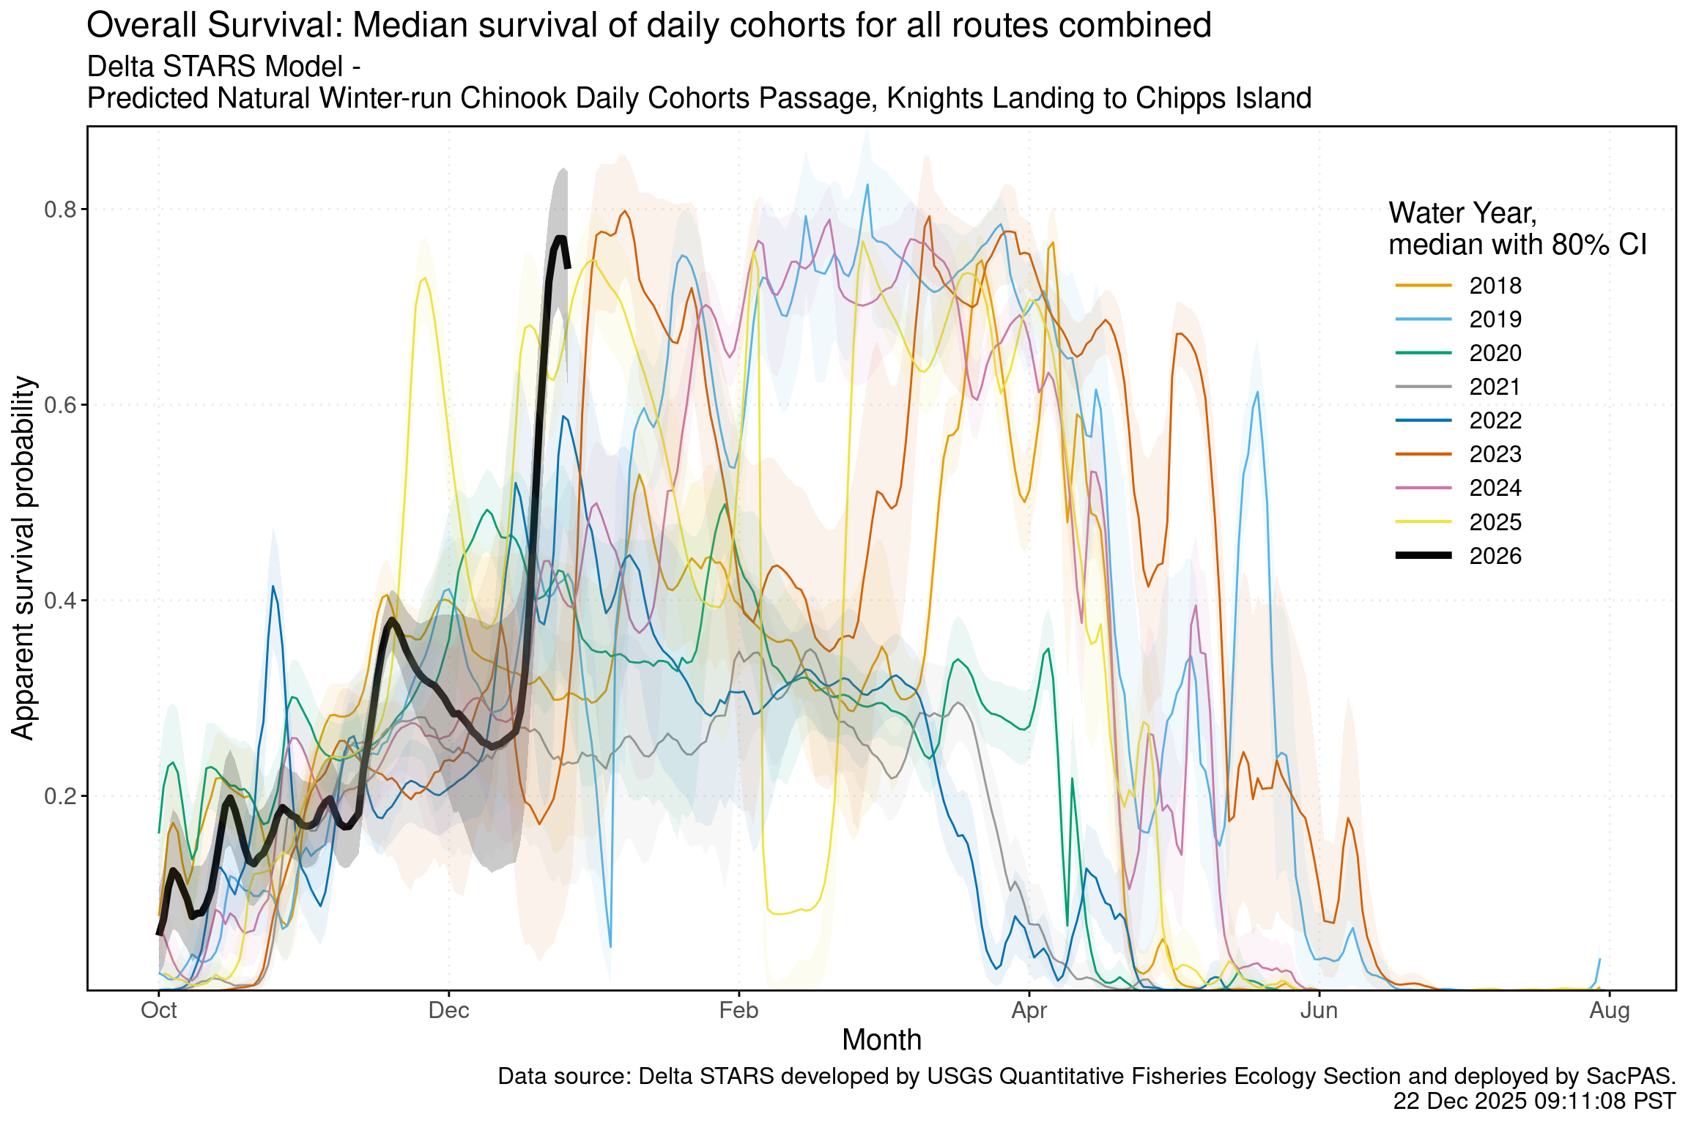
Figure 2: Estimated overall winter-run survival from Knights Landing to Chipps Island. Black line indicates the current water-year, and other colored lines correspond to past water years.
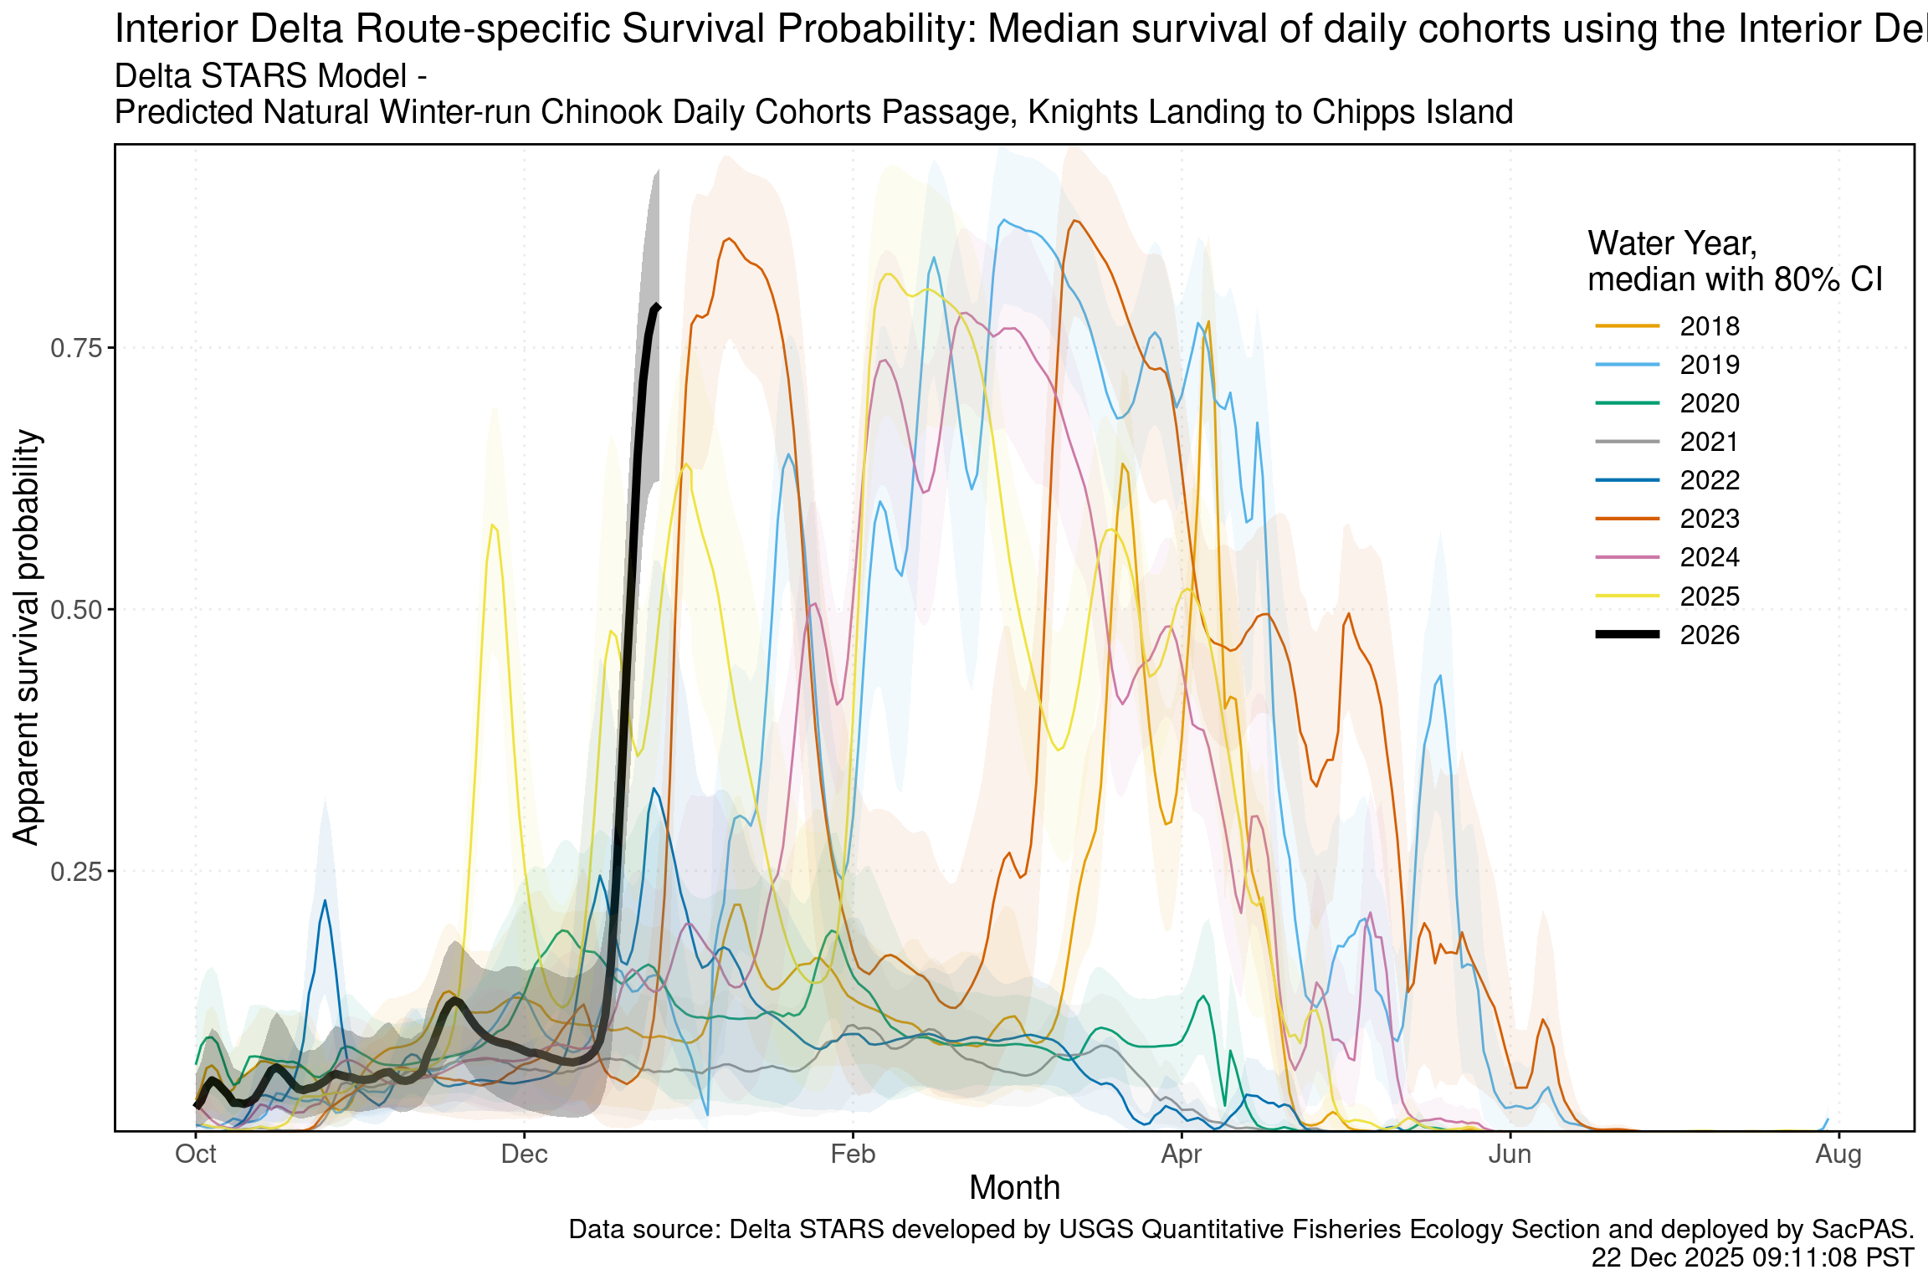
Figure 3: Estimated survival from Knights Landing to Chipps Island of simulate winter-run cohorts that route through the interior delta. Black line indicates the current water-year, and other colored lines correspond to past water years.
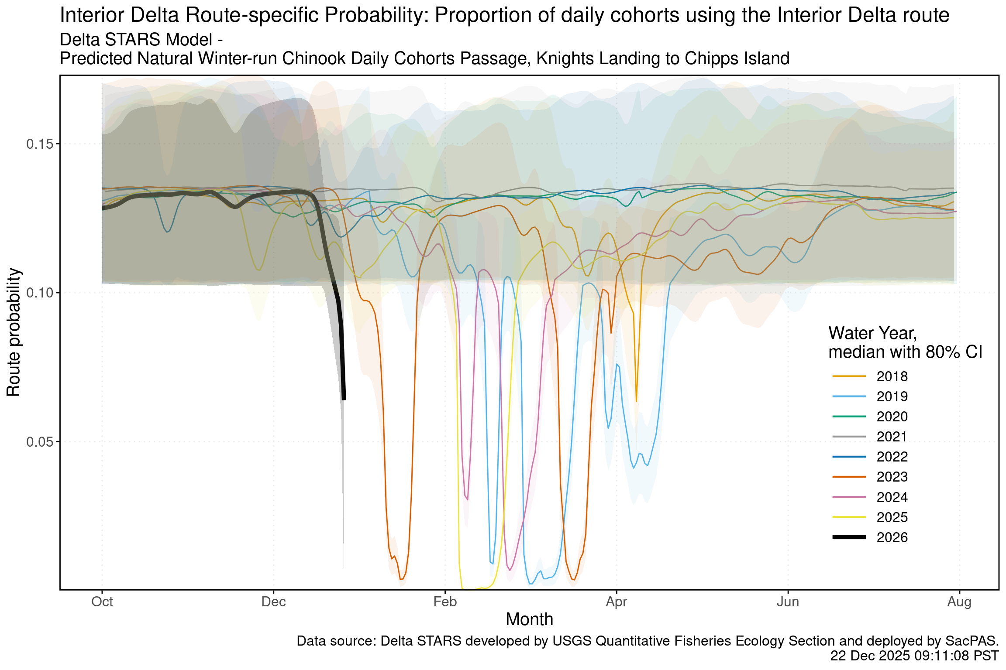
Figure 4: Estimated probability of winter-run routing into the interior delta. Black line indicates the current water-year, and other colored lines correspond to past water years.

