outlook_plot

Outlook Plot

Get data

Define start and end dates

Exports Data - not sure if this is the best source (CDEC)

OMRI - Daily value from SacPAS. Lots of missing data.

Freeport and Vernalis Flow

Triggers
This file needs to be updated manually when an action is triggered

Make Plot
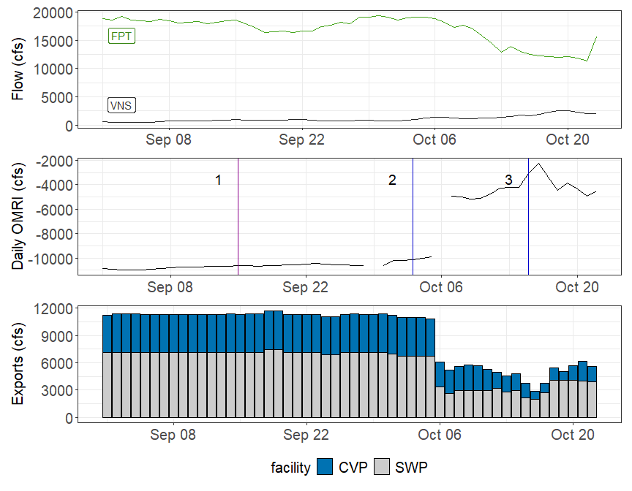
Figure 1: Operations and Action Summary, WY 2026. The colors in the OMRI plot indicate different types of triggers (see Table 1). OMRI data calculated by SacPAS, Freeport (FPT) and Vernalis (VNS) flow data from CDEC, and CVP (TRP) and SWP (HRO) exports data from CDEC.
Table 1: Summary of Actions and Triggers, WY 2026
Label | Action | Date Triggered | Date Implemented | Number Days Implemented | Regulation
1 | September Salinity | 9/15/2025 | 9/18/2025 | 15 | D1641
2 | Salmon Action | 10/3/2025 | 10/6/2025 | 7 | OMR
3 | Delta Smelt Action | 10/15/2025 | 10/18/2025 | 3 | OMR

