Table of contents

Delta Real-Time Forecast Summary
Date Published: August 31, 2026
Forecast Period: 06/23/2026 – 07/13/2026
Forecast Week 1: 06/23/2026 – 06/29/2026
Forecast Week 2: 06/30/2026 – 07/06/2026
Forecast Week 3: 07/07/2026 – 07/13/2026

Common Assumptions
The model run results cover the period June 23, 2026 through July 13, 2026 and are based on the following assumptions established by DWR:
- CCFB Gates are operating to Priority 2 until June 30, after which they will switch to Priority 3.
- The Delta Cross Channel gates are closed and will be open on June 26.
- Suisun Marsh Salinity Control flashboards are in. All three gates are open and will be in tidal operation starting July 1.
- San Joaquin River flow at Vernalis is at 1142 cfs at the beginning of the forecast period and is estimated to decrease to 500 cfs by the end of the forecast period.
- San Joaquin River EC at Vernalis is at 321 umhos/cm at the beginning of the forecast period and is estimated to increase to 428 umhos/cm at the end of the forecast period.
- Sacramento River flow at Freeport is at 15475 cfs at the beginning of the forecast period and is expected to increase to 20900 cfs by the end of the forecast period.
- CCFB inflow is at 291 cfs at the beginning of the forecast period and is expected to increase to 6500 cfs by the end of the forecast period.
- Export at Jones Pumping Plant is at 921 cfs at the beginning of the forecast period and is expected to increase to 2800 cfs to the end the forecast period.
- The Middle River barrier gates are in intermediate tidal operation starting June 2, and will move to full operation starting June 30.
- The Old River near Tracy barrier gates are in intermediate tidal operation starting June 1, and will move to full operation starting June 30.
- The Grant Line Canal barrier gates will be in intermediate tidal operation starting June 9, and will move to full operation starting June 30.
As shown in the next section, assumptions 4 and 6 are updated based on Reclamation forecast data, and assumption 8 and exports at Banks Pumping Plant have been modified to include four different forecast scenarios at an Old and Middle River (OMR) index of -6,500 cfs, -5,000 cfs, -3,500 cfs, and -2,000 cfs.

Reclamation Forecast Flow and Export Data
Table 1: Weekly Averaged Forecasted Flow Data and Flow Bins
Forecast Week | Sacramento River at Freeport (cfs) | Sac Flow Bin | San Joaquin River at Vernalis (cfs) | SJR Flow Bin | Delta Inflow Bin
Week 1 (06/23/2026 - 06/29/2026) | 11,956 | lo | 1,345 | lo | lolo
Week 2 (06/30/2026 - 07/06/2026) | 11,950 | lo | 1,345 | lo | lolo
Week 3 (07/07/2026 - 07/13/2026) | 11,950 | lo | 1,345 | lo | lolo

Key: cfs = cubic feet per second, Sac = Sacramento River, SJR = San Joaquin River
Table 2: Weekly Averaged CVP and SWP Exports by OMR Bin
Forecast Week | OMR Bin (cfs) | CVP Exports (cfs) | SWP Exports (cfs) | Total Exports (cfs) | CVP Exports (% of total) | SWP Exports (% of total)
Week 1: 06/23/2026 – 06/29/2026 | -5,000 | 1,674 | 3,477 | 5,152 | 32% | 68%
Week 1: 06/23/2026 – 06/29/2026 | -3,500 | 902 | 2,590 | 3,492 | 26% | 74%
Week 1: 06/23/2026 – 06/29/2026 | -2,000 | 902 | 859 | 1,760 | 51% | 49%
Week 2: 06/30/2026 – 07/06/2026 | -5,000 | 1,803 | 3,106 | 4,909 | 37% | 63%
Week 2: 06/30/2026 – 07/06/2026 | -3,500 | 902 | 2,375 | 3,277 | 28% | 72%
Week 2: 06/30/2026 – 07/06/2026 | -2,000 | 902 | 802 | 1,703 | 53% | 47%
Week 3: 07/07/2026 – 07/13/2026 | -5,000 | 1,803 | 3,106 | 4,909 | 37% | 63%
Week 3: 07/07/2026 – 07/13/2026 | -3,500 | 902 | 2,304 | 3,206 | 28% | 72%
Week 3: 07/07/2026 – 07/13/2026 | -2,000 | 902 | 802 | 1,703 | 53% | 47%

Notes:
¹ One pumping unit is currently out of service at Jones Pumping Plant until August 2026. The current maximum pumping rate at Jones Pumping Plant (CVP Exports) is 4,200 cfs.
² There is still a low probability that an OMR of -6,500 cfs would be realized, so that scenario is omitted from this assessment.
Key: cfs = cubic feet per second, CVP = Central Valley Project, OMR = Old and Middle River, SWP = State Water Project
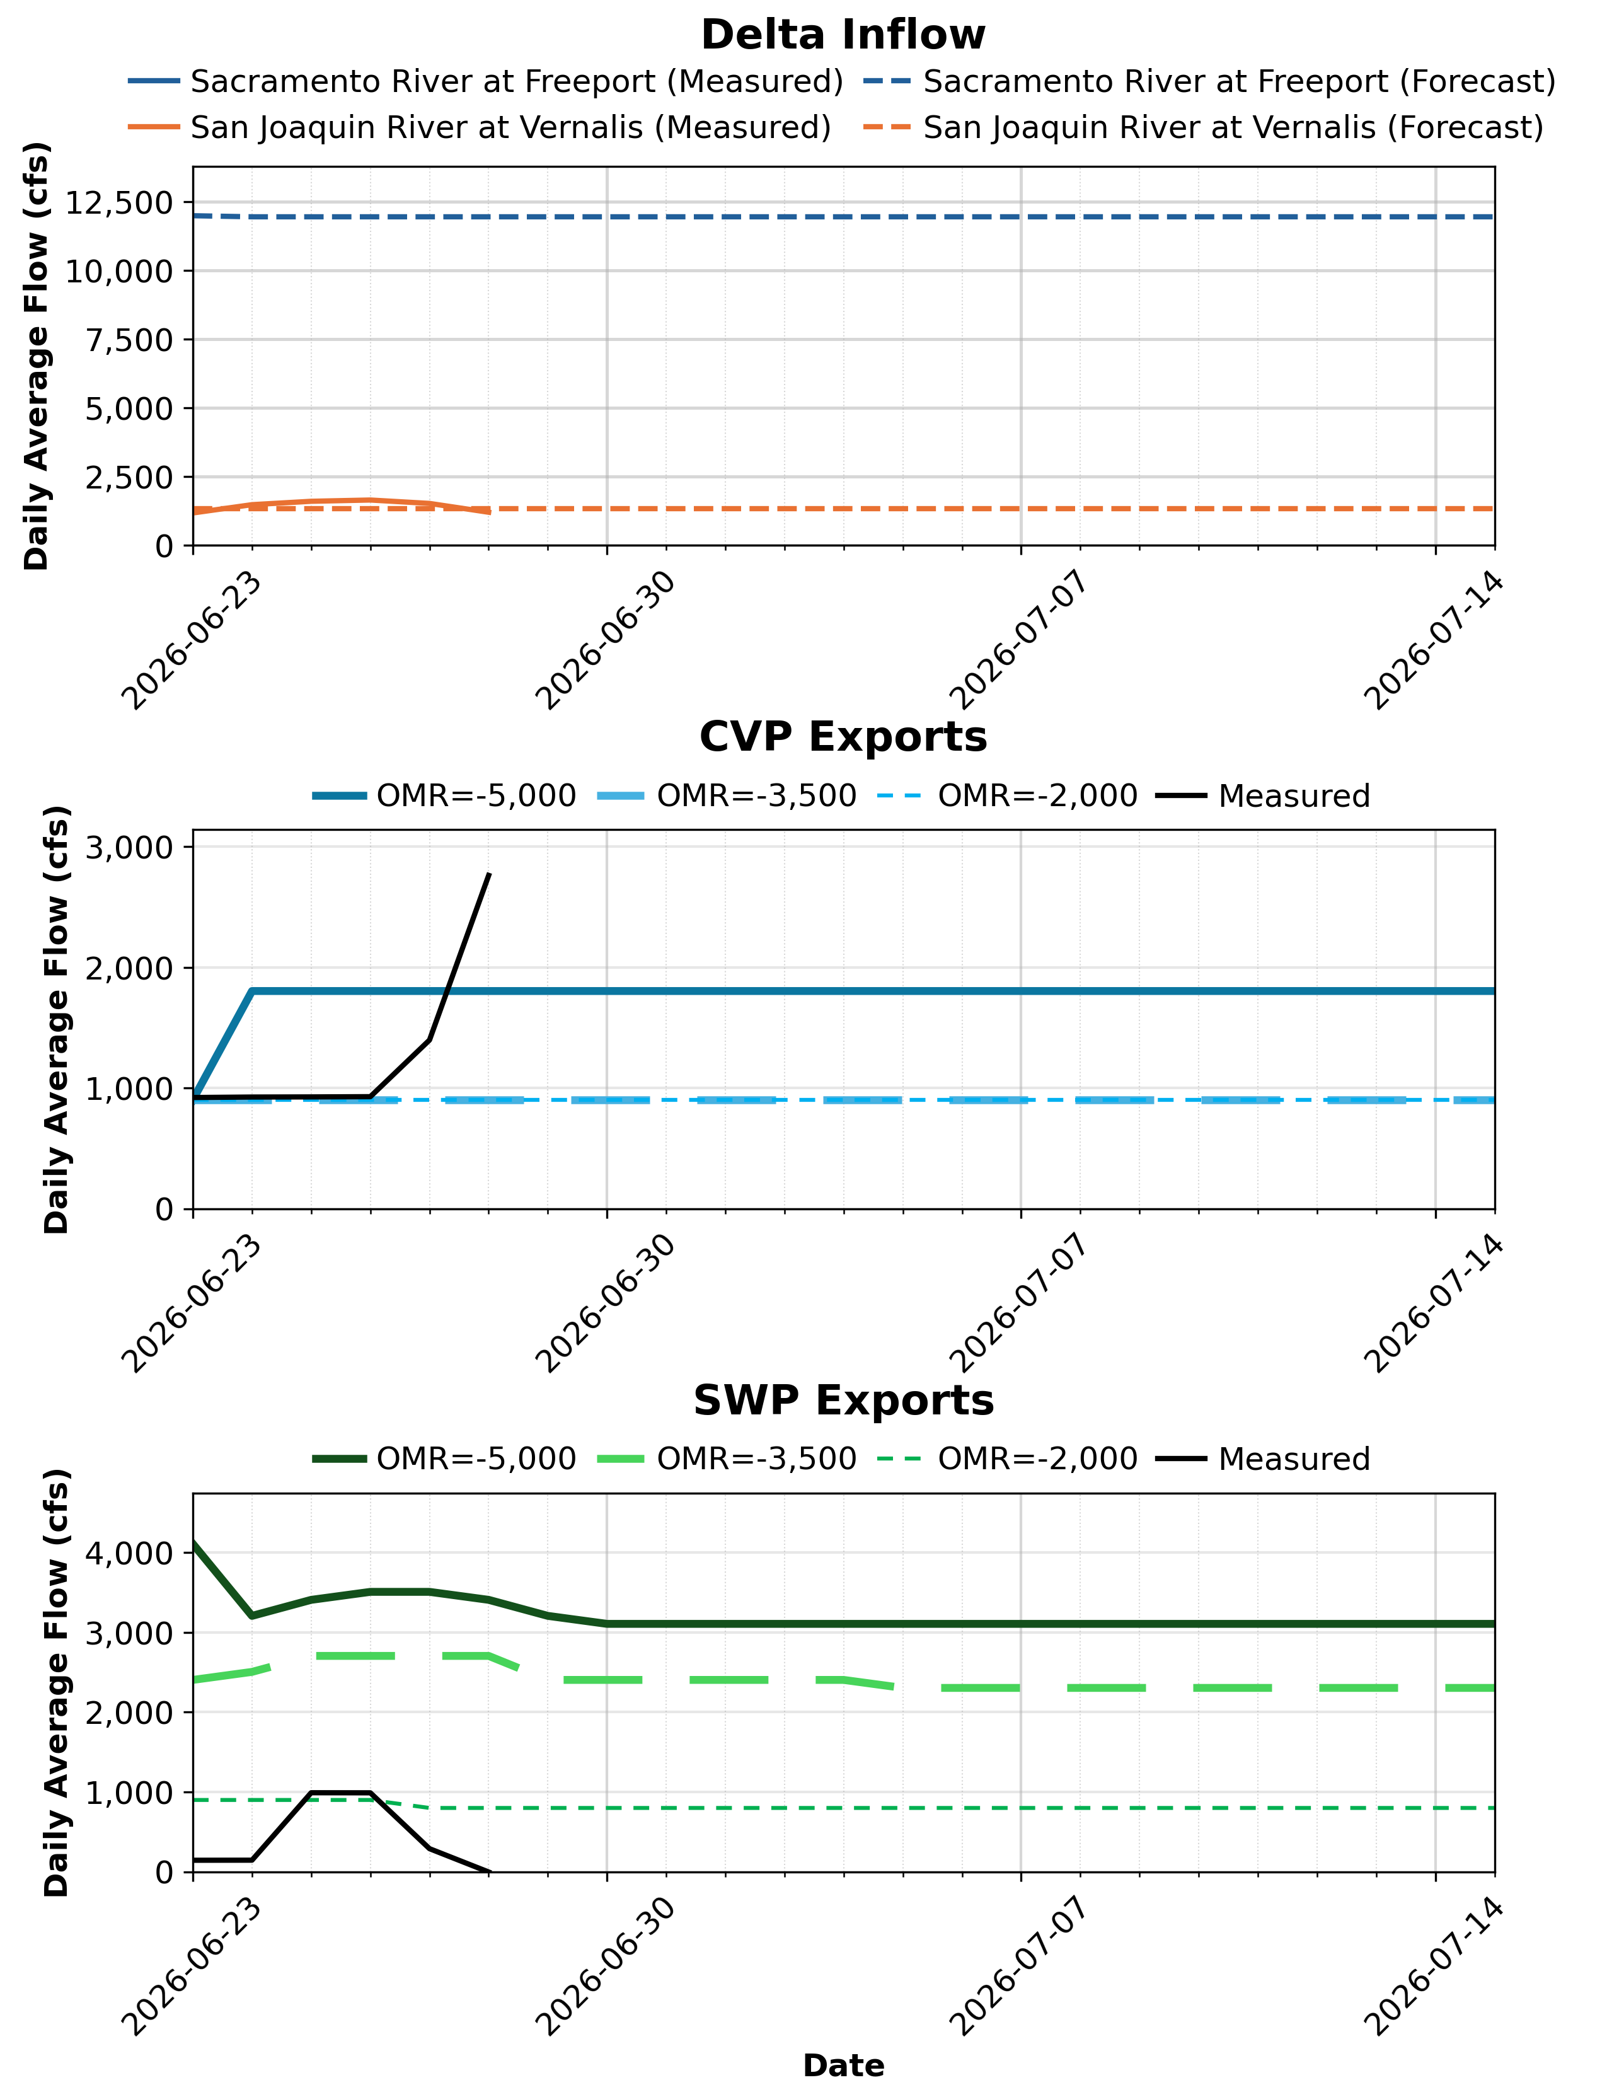
Figure 1: Daily Average Flow for Measured and Forecasted Delta Inflow, CVP Exports, and SWP Exports
Key: CVP = Central Valley Project, OMR = Old and Middle River, SWP = State Water Project

Delta Export Zone of Influence
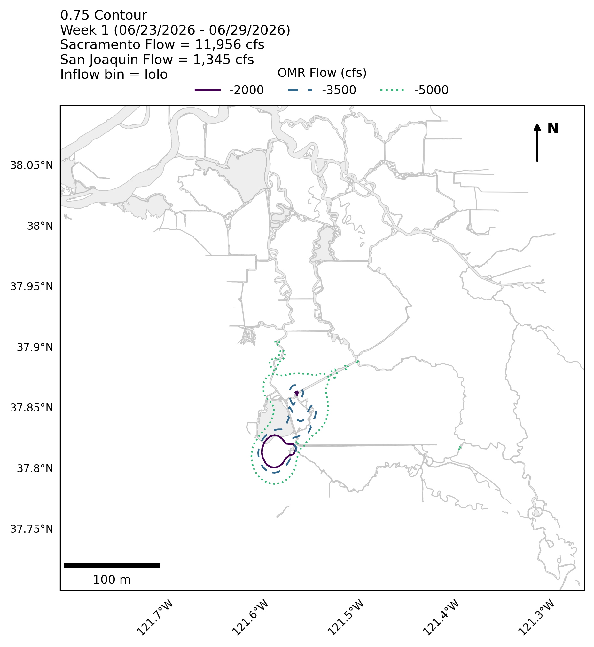
Figure 2: Delta Zone of Influence for Week 1
Notes: Contours indicate the proportional overlap of hourly average velocity Gaussian KDEs for a one-week period from DSM2 hydro simulations with and without Delta exports active. DSM2 nodes that were sufficiently different from neighboring nodes to create isolated contours at several OMR flows were removed.
Key: cfs = cubic feet per second, OMR = Old and Middle River
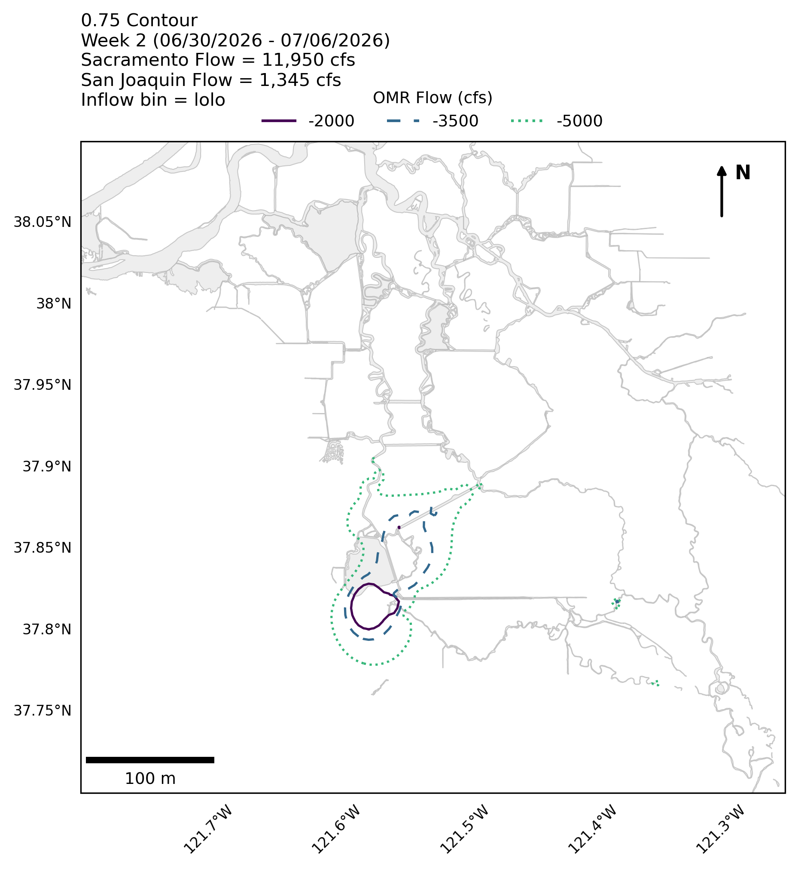
Figure 3: Delta Zone of Influence for Week 2
Notes: Contours indicate the proportional overlap of hourly average velocity Gaussian KDEs for a one-week period from DSM2 hydro simulations with and without Delta exports active. DSM2 nodes that were sufficiently different from neighboring nodes to create isolated contours at several OMR flows were removed.
Key: cfs = cubic feet per second, OMR = Old and Middle River
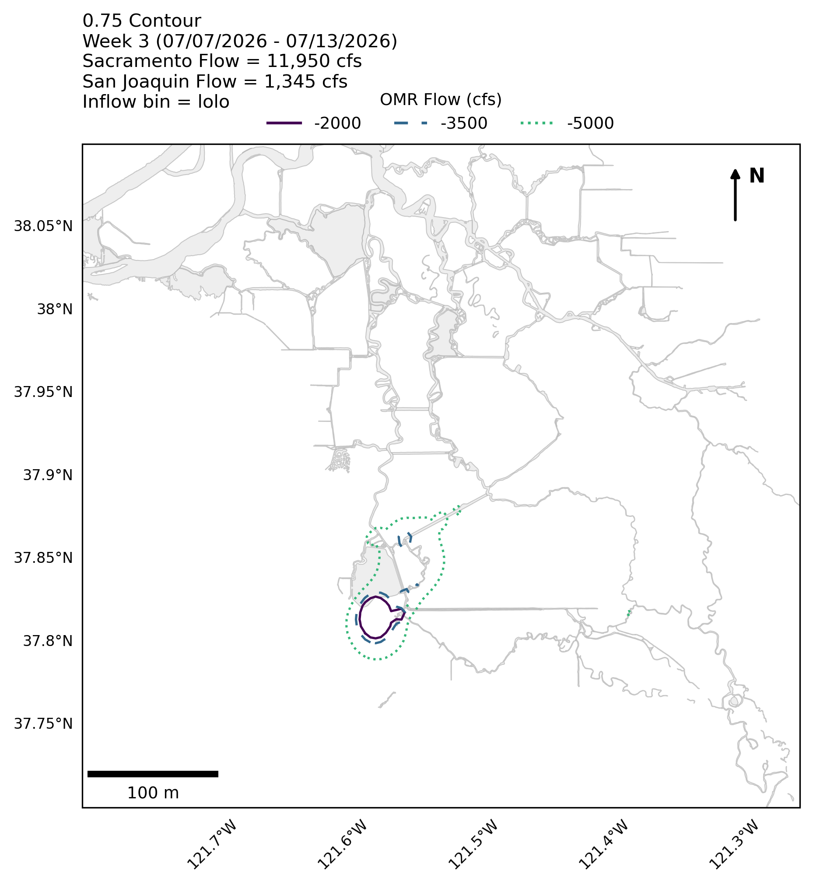
Figure 4: Delta Zone of Influence for Week 3
Notes: Contours indicate the proportional overlap of hourly average velocity Gaussian KDEs for a one-week period from DSM2 hydro simulations with and without Delta exports active. DSM2 nodes that were sufficiently different from neighboring nodes to create isolated contours at several OMR flows were removed.
Key: cfs = cubic feet per second, OMR = Old and Middle River
Table 3: Proportion of DSM2 Channel Length with Hydrologic Alteration from Pumping
Weekly Model Run | OMR Bin (cfs) | Sum Channel Length with Low HA (miles) | Channel Length with Low HA (%) | Sum Channel Length with Medium HA (miles) | Channel Length with Medium HA (%) | Sum Channel Length with High HA (miles) | Channel Length with High HA (%)
Week 1: 06/23/2026 - 06/29/2026 | -5,000 | 651.73 | 96.6% | 21.82 | 3.2% | 0.85 | 0.1%
Week 1: 06/23/2026 - 06/29/2026 | -3,500 | 665.46 | 98.7% | 8.09 | 1.2% | 0.85 | 0.1%
Week 1: 06/23/2026 - 06/29/2026 | -2,000 | 672.00 | 99.6% | 1.55 | 0.2% | 0.85 | 0.1%
Week 2: 06/30/2026 - 07/06/2026 | -5,000 | 648.74 | 96.2% | 24.80 | 3.7% | 0.85 | 0.1%
Week 2: 06/30/2026 - 07/06/2026 | -3,500 | 658.05 | 97.6% | 15.49 | 2.3% | 0.85 | 0.1%
Week 2: 06/30/2026 - 07/06/2026 | -2,000 | 672.00 | 99.6% | 1.55 | 0.2% | 0.85 | 0.1%
Week 3: 07/07/2026 - 07/13/2026 | -5,000 | 658.28 | 97.6% | 15.26 | 2.3% | 0.85 | 0.1%
Week 3: 07/07/2026 - 07/13/2026 | -3,500 | 669.97 | 99.3% | 3.57 | 0.5% | 0.85 | 0.1%
Week 3: 07/07/2026 - 07/13/2026 | -2,000 | 672.00 | 99.6% | 1.55 | 0.2% | 0.85 | 0.1%

Notes: Sum channel length includes the length of channels within the Delta that have a calculated hydrologic alteration level falling within each category.
Key: HA = hydrologic alteration, OMR = Old and Middle River
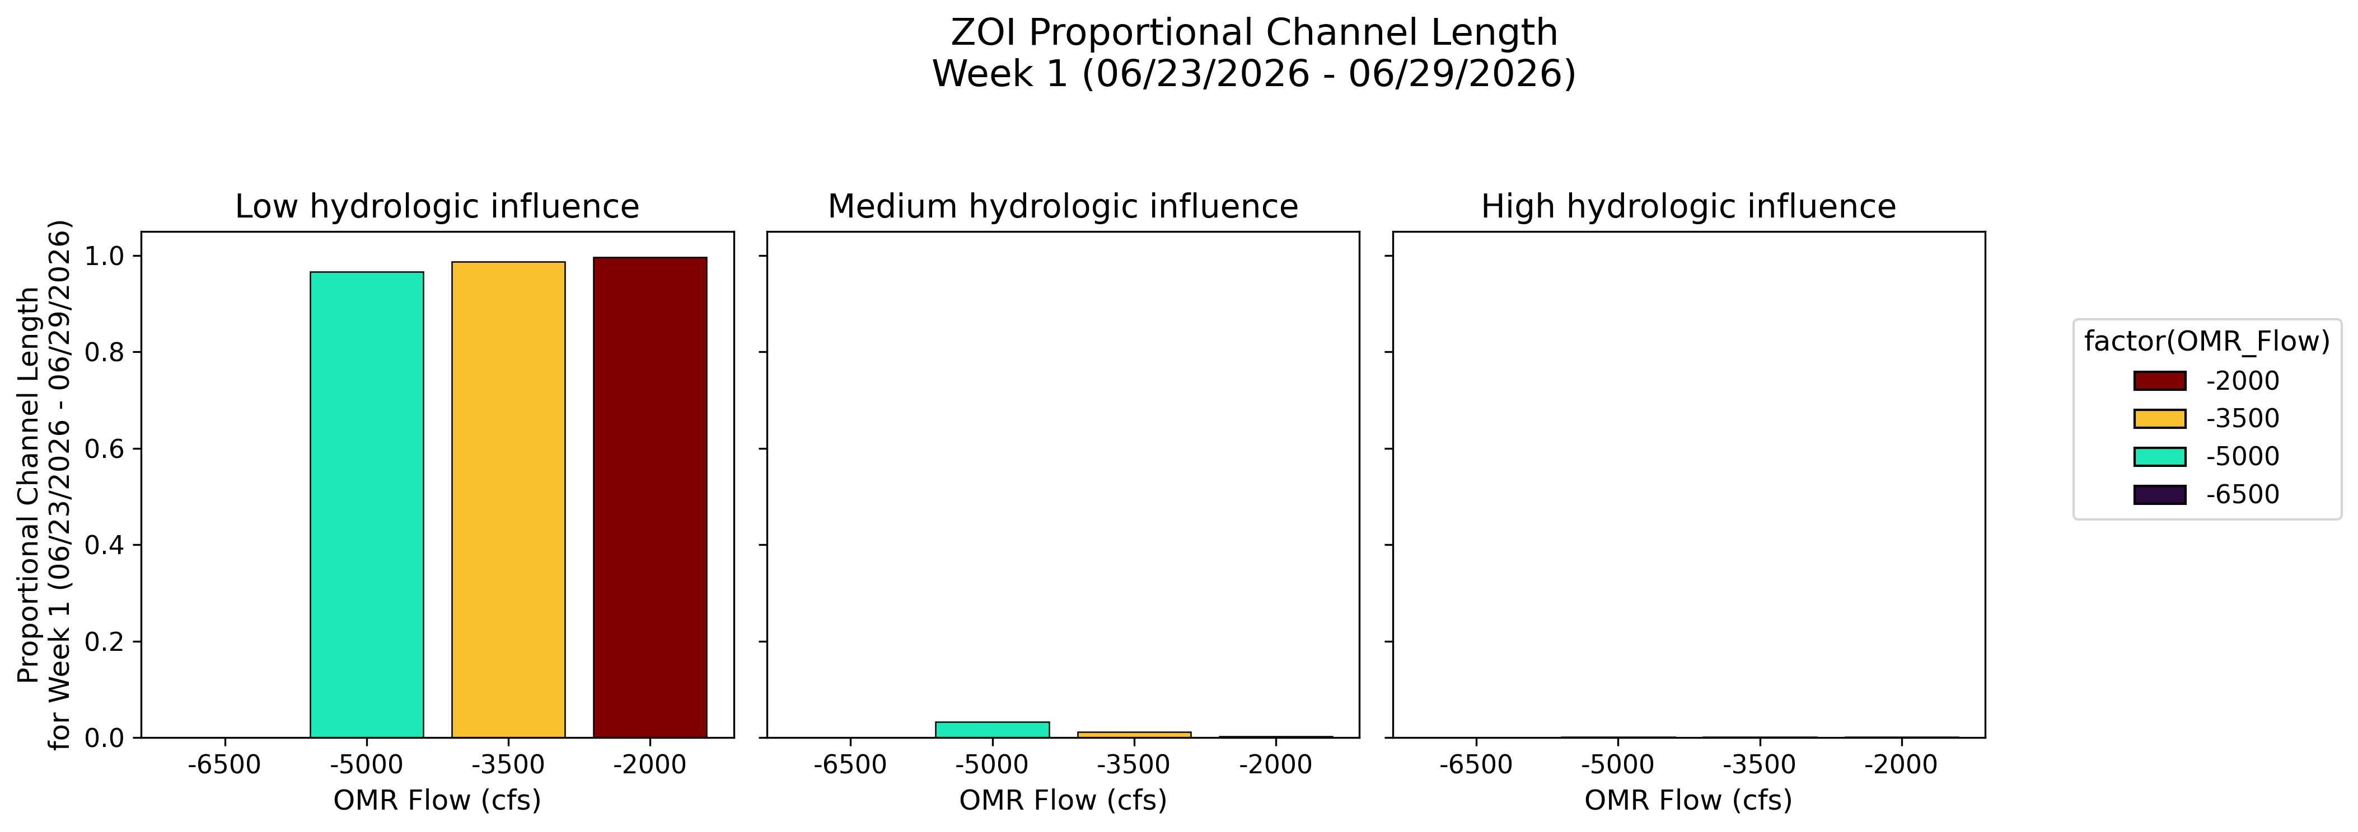
Figure 5: Proportional Channel Length for Week 1

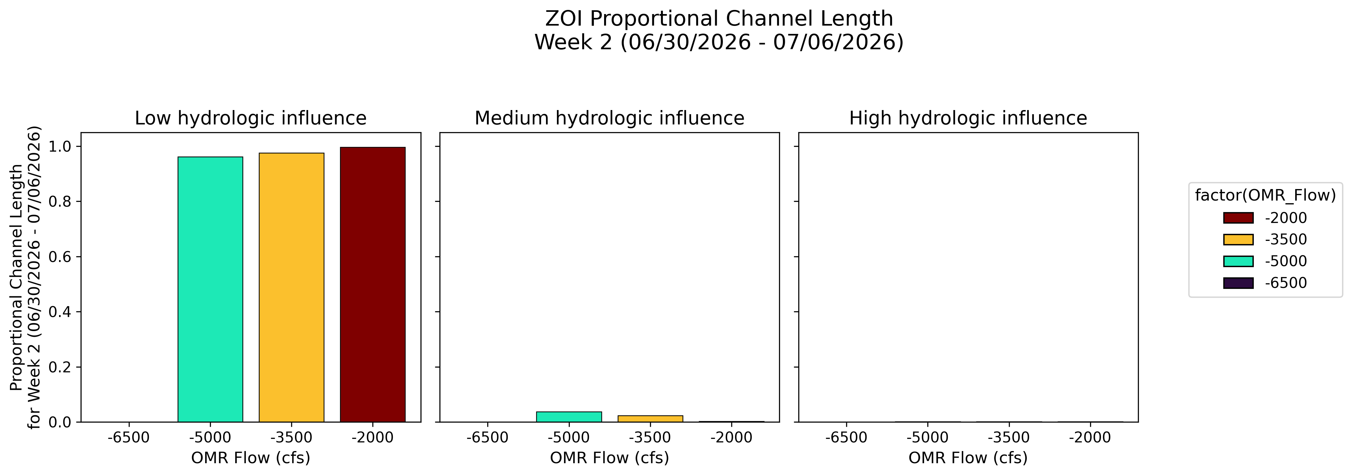
Figure 6: Proportional Channel Length for Week 2

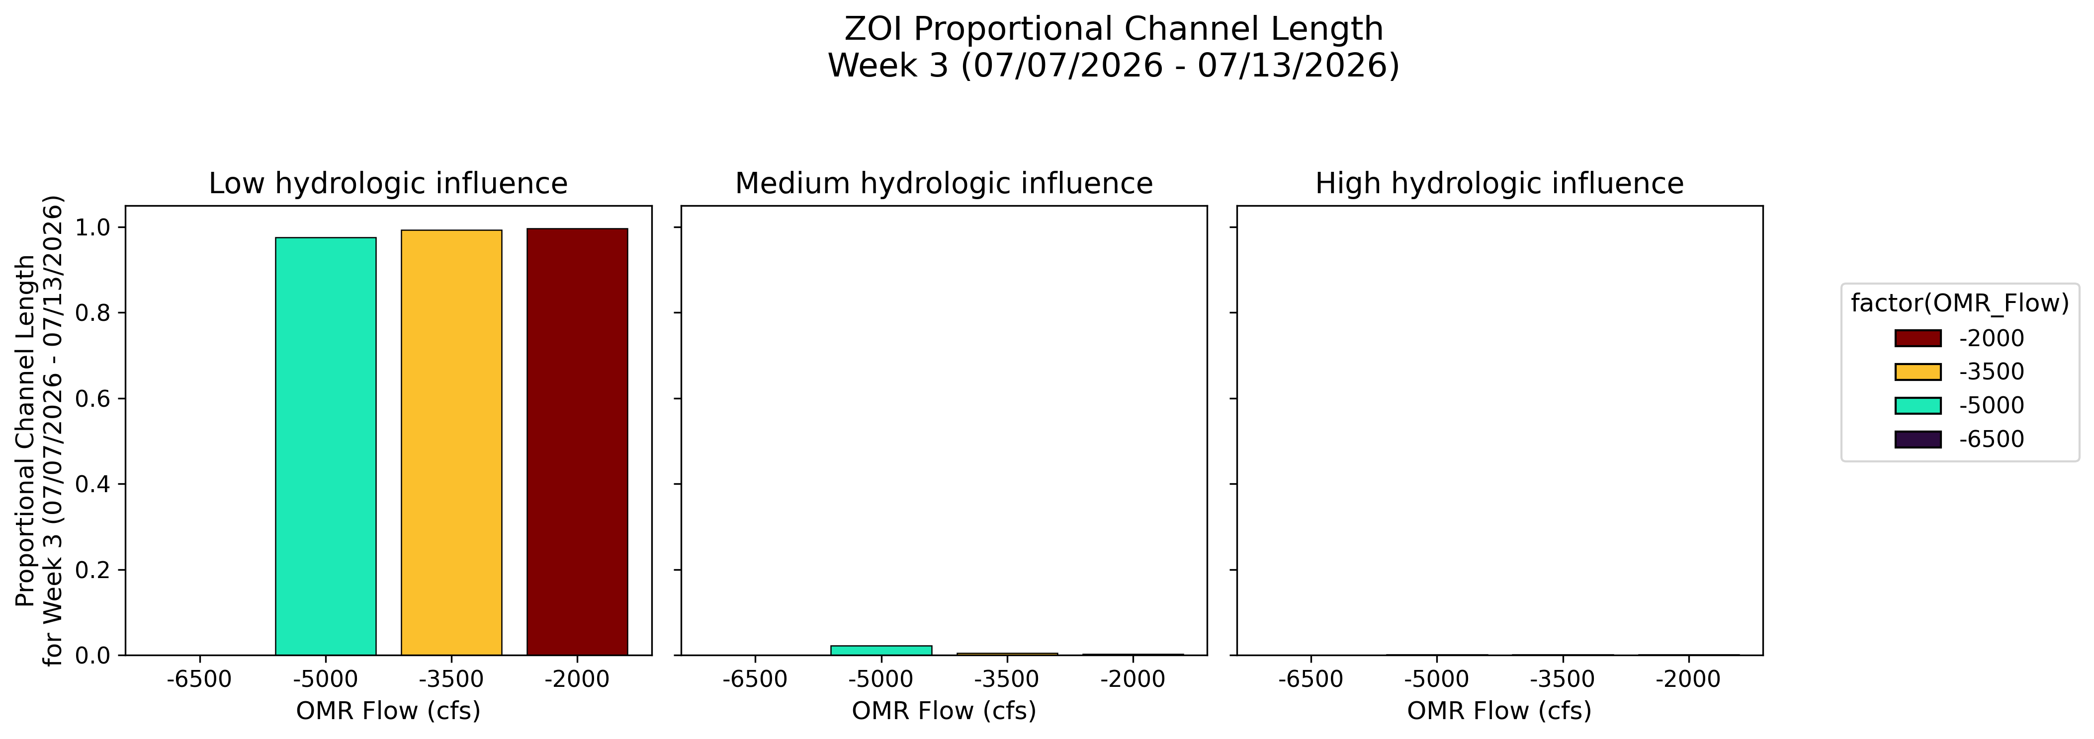
Figure 7: Proportional Channel Length for Week 3
Key: cfs = cubic feet per second, OMR = Old and Middle River

PTM (Particle Tracking Model) Results
PTM Flux Evaluation Period: 06/23/2026 – 07/13/2026
Particles Injected: 06/23/2026
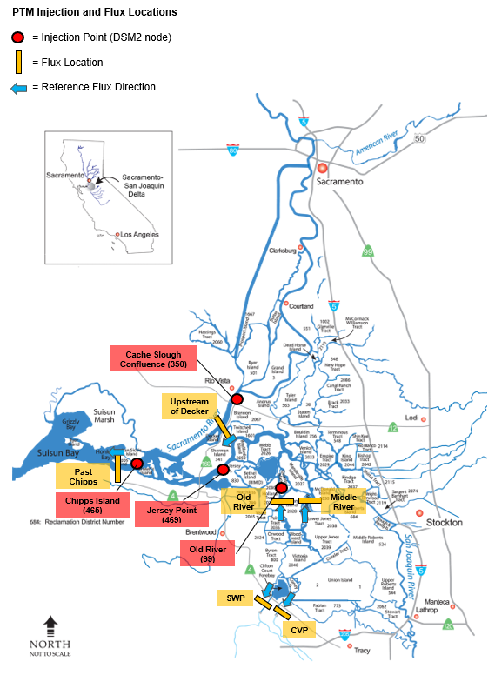
Figure 8: Map of PTM Injection and Flux Locations

Neutrally Buoyant Particles (NP)
Table 4: Neutral Particle Fate (percent flux across boundary) for Particles Injected at Chipps (DSM2 Node 465)
Forecast Week | OMR Flow Bin (cfs) | Past Chipps | Upstream of Decker | Unresolved in Central Delta | Unresolved in OMR corridor | CVP Entrainment | SWP Entrainment
Week 1: 06/23/2026 – 06/29/2026 | -5,000 | 58.7 | 0.1 | 41.3 | 0.0 | 0.0 | 0.0
Week 1: 06/23/2026 – 06/29/2026 | -3,500 | 65.5 | -0.1 | 34.5 | 0.0 | 0.0 | 0.0
Week 1: 06/23/2026 – 06/29/2026 | -2,000 | 54.3 | 0.0 | 45.8 | 0.0 | 0.0 | 0.0
Week 2: 06/30/2026 – 07/06/2026 | -5,000 | 82.2 | 0.3 | 17.9 | 0.1 | 0.0 | 0.0
Week 2: 06/30/2026 – 07/06/2026 | -3,500 | 86.3 | 0.1 | 13.7 | 0.0 | 0.0 | 0.0
Week 2: 06/30/2026 – 07/06/2026 | -2,000 | 77.9 | 0.3 | 22.1 | 0.0 | 0.0 | 0.0
Week 3: 07/07/2026 – 07/13/2026 | -5,000 | 76.0 | 0.3 | 24.1 | 0.1 | 0.0 | 0.0
Week 3: 07/07/2026 – 07/13/2026 | -3,500 | 82.0 | 0.2 | 18.0 | 0.0 | 0.0 | 0.0
Week 3: 07/07/2026 – 07/13/2026 | -2,000 | 71.5 | 0.3 | 28.5 | 0.0 | 0.0 | 0.0

Note: Values between 0.0 and 0.1 are indicated with <0.1.
Key: CVP = Central Valley Project, OMR = Old and Middle River, SWP = State Water Project
Table 5: Neutral Particle Fate (percent flux across boundary) for Particles Injected at Cache Slough (DSM2 Node 350)
Forecast Week | OMR Flow Bin (cfs) | Past Chipps | Upstream of Decker | Unresolved in Central Delta | Unresolved in OMR corridor | CVP Entrainment | SWP Entrainment
Week 1: 06/23/2026 – 06/29/2026 | -5,000 | 0.7 | 62.8 | 99.6 | 0.3 | 0.0 | 0.0
Week 1: 06/23/2026 – 06/29/2026 | -3,500 | 1.1 | 63.5 | 99.0 | 0.1 | 0.0 | 0.0
Week 1: 06/23/2026 – 06/29/2026 | -2,000 | 0.3 | 51.8 | 99.7 | 0.0 | 0.0 | 0.0
Week 2: 06/30/2026 – 07/06/2026 | -5,000 | 30.1 | 71.8 | 72.5 | 2.0 | 0.3 | 0.3
Week 2: 06/30/2026 – 07/06/2026 | -3,500 | 39.3 | 73.4 | 62.0 | 1.0 | 0.0 | 0.2
Week 2: 06/30/2026 – 07/06/2026 | -2,000 | 23.7 | 64.3 | 76.9 | 0.6 | 0.0 | 0.0
Week 3: 07/07/2026 – 07/13/2026 | -5,000 | 32.4 | 75.2 | 72.2 | 2.2 | 1.0 | 1.4
Week 3: 07/07/2026 – 07/13/2026 | -3,500 | 42.0 | 76.5 | 60.3 | 1.6 | 0.1 | 0.6
Week 3: 07/07/2026 – 07/13/2026 | -2,000 | 26.6 | 66.5 | 74.6 | 1.1 | 0.0 | 0.1

Note: Values between 0.0 and 0.1 are indicated with <0.1.
Key: CVP = Central Valley Project, OMR = Old and Middle River, SWP = State Water Project
Table 6: Neutral Particle Fate (percent flux across boundary) for Particles Injected at Jersey Point (DSM2 Node 469)
Forecast Week | OMR Flow Bin (cfs) | Past Chipps | Upstream of Decker | Unresolved in Central Delta | Unresolved in OMR corridor | CVP Entrainment | SWP Entrainment
Week 1: 06/23/2026 – 06/29/2026 | -5,000 | 0.7 | 19.1 | 101.2 | 1.9 | 0.0 | 0.0
Week 1: 06/23/2026 – 06/29/2026 | -3,500 | 0.8 | 18.8 | 99.8 | 0.6 | 0.0 | 0.0
Week 1: 06/23/2026 – 06/29/2026 | -2,000 | 1.4 | 16.8 | 98.7 | 0.1 | 0.0 | 0.0
Week 2: 06/30/2026 – 07/06/2026 | -5,000 | 18.1 | 31.8 | 88.6 | 4.2 | 1.3 | 1.2
Week 2: 06/30/2026 – 07/06/2026 | -3,500 | 26.2 | 30.2 | 76.0 | 1.8 | 0.1 | 0.3
Week 2: 06/30/2026 – 07/06/2026 | -2,000 | 21.1 | 28.1 | 80.2 | 1.3 | 0.0 | 0.0
Week 3: 07/07/2026 – 07/13/2026 | -5,000 | 21.6 | 35.3 | 89.5 | 5.0 | 3.2 | 2.9
Week 3: 07/07/2026 – 07/13/2026 | -3,500 | 31.4 | 31.9 | 73.2 | 2.8 | 0.6 | 1.1
Week 3: 07/07/2026 – 07/13/2026 | -2,000 | 24.6 | 30.5 | 77.7 | 1.7 | 0.5 | 0.1

Note: Values between 0.0 and 0.1 are indicated with <0.1.
Key: CVP = Central Valley Project, OMR = Old and Middle River, SWP = State Water Project
Table 7: Neutral Particle Fate (percent flux across boundary) for Particles Injected at Old River (DSM2 Node 99)
Forecast Week | OMR Flow Bin (cfs) | Past Chipps | Upstream of Decker | Unresolved in Central Delta | Unresolved in OMR corridor | CVP Entrainment | SWP Entrainment
Week 1: 06/23/2026 – 06/29/2026 | -5,000 | 0.0 | 0.0 | 6.5 | 57.7 | 17.5 | 18.3
Week 1: 06/23/2026 – 06/29/2026 | -3,500 | 0.0 | 0.1 | 14.6 | 73.7 | 5.0 | 6.6
Week 1: 06/23/2026 – 06/29/2026 | -2,000 | 0.0 | 0.4 | 33.9 | 66.0 | 0.0 | 0.1
Week 2: 06/30/2026 – 07/06/2026 | -5,000 | 0.1 | 0.7 | 4.7 | 25.9 | 22.0 | 47.3
Week 2: 06/30/2026 – 07/06/2026 | -3,500 | 0.2 | 1.0 | 10.7 | 41.1 | 14.7 | 33.4
Week 2: 06/30/2026 – 07/06/2026 | -2,000 | 0.7 | 3.0 | 27.3 | 56.3 | 13.0 | 2.7
Week 3: 07/07/2026 – 07/13/2026 | -5,000 | 0.1 | 0.7 | 3.6 | 16.9 | 24.1 | 55.3
Week 3: 07/07/2026 – 07/13/2026 | -3,500 | 0.5 | 1.5 | 9.2 | 28.4 | 16.5 | 45.4
Week 3: 07/07/2026 – 07/13/2026 | -2,000 | 1.7 | 3.9 | 23.8 | 46.0 | 19.9 | 8.6

Note: Values between 0.0 and 0.1 are indicated with <0.1.
Key: CVP = Central Valley Project, OMR = Old and Middle River, SWP = State Water Project
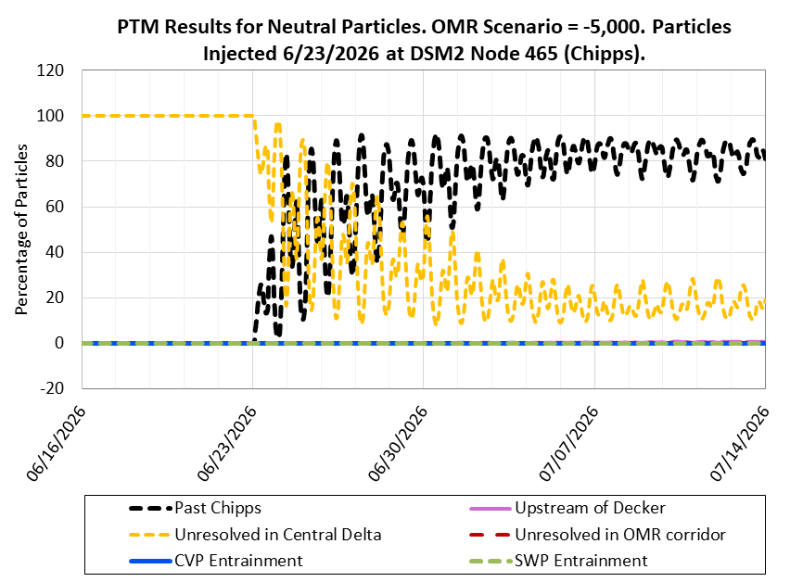
Figure 9: PTM Results for Neutral Particles. OMR Scenario -5,000 cfs. Particles Injected 06/23/2026 at DSM2 Node 465 (Chipps)

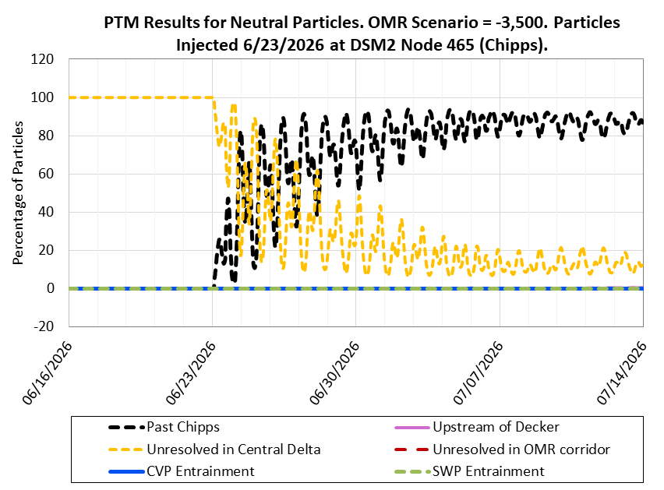
Figure 10: PTM Results for Neutral Particles. OMR Scenario -3,500 cfs. Particles Injected 06/23/2026 at DSM2 Node 465 (Chipps)

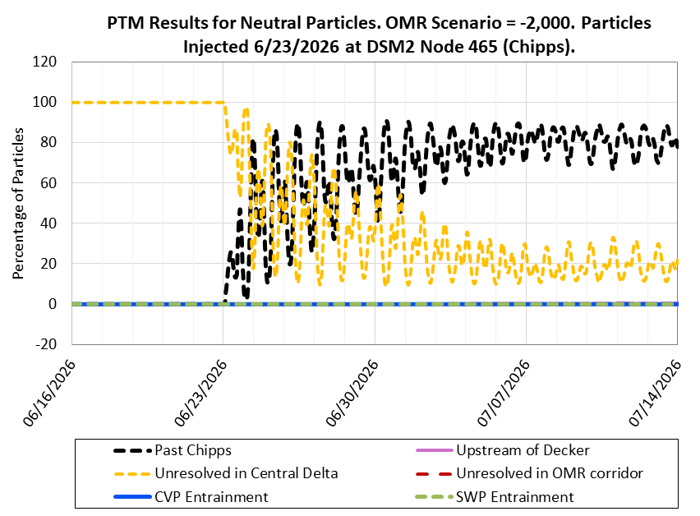
Figure 11: PTM Results for Neutral Particles. OMR Scenario -2,000 cfs. Particles Injected 06/23/2026 at DSM2 Node 465 (Chipps)

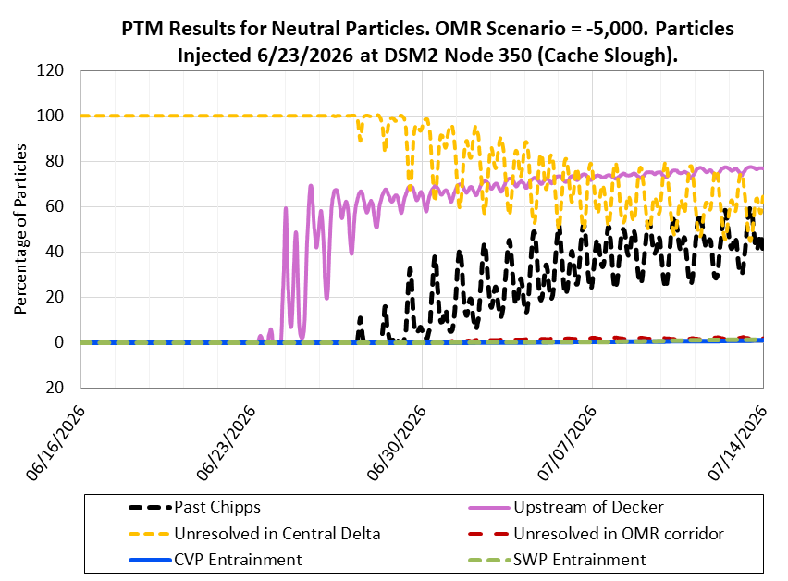
Figure 12: PTM Results for Neutral Particles. OMR Scenario -5,000 cfs. Particles Injected 06/23/2026 at DSM2 Node 350 (Cache Slough)

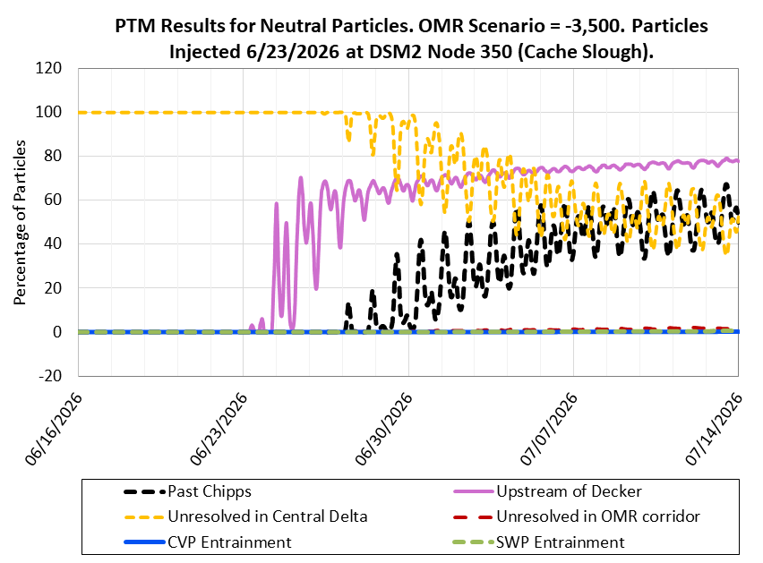
Figure 13: PTM Results for Neutral Particles. OMR Scenario -3,500 cfs. Particles Injected 06/23/2026 at DSM2 Node 350 (Cache Slough)

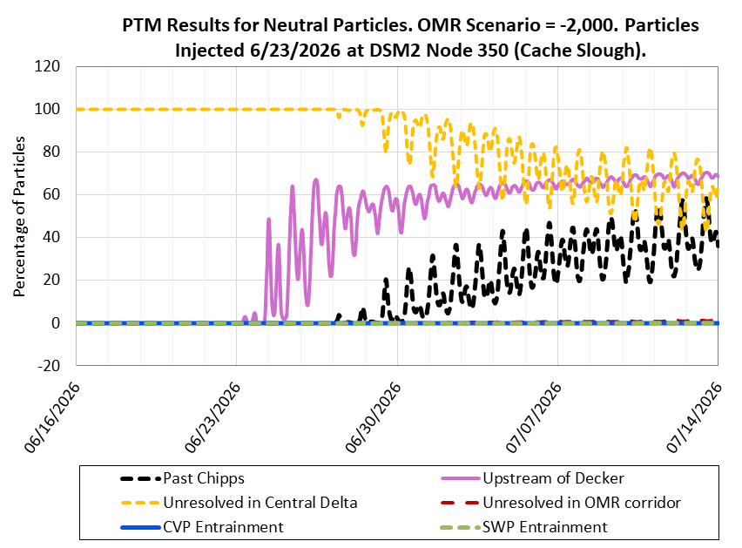
Figure 14: PTM Results for Neutral Particles. OMR Scenario -2,000 cfs. Particles Injected 06/23/2026 at DSM2 Node 350 (Cache Slough)

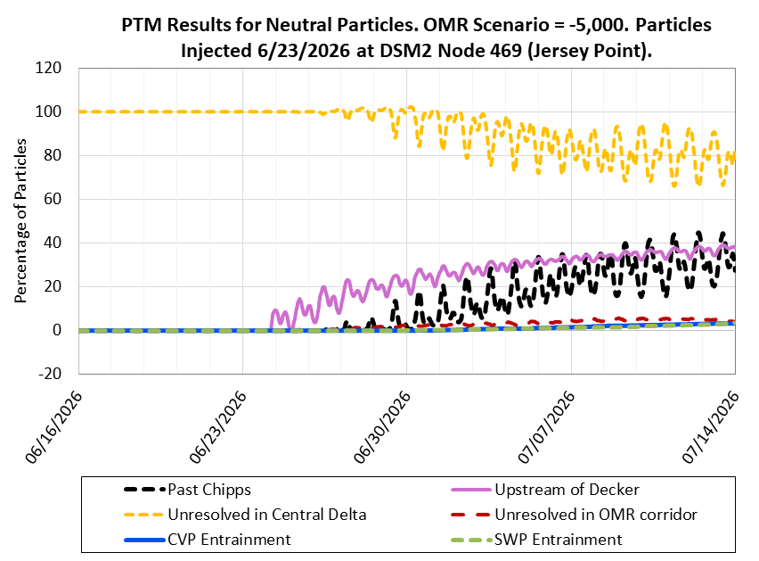
Figure 15: PTM Results for Neutral Particles. OMR Scenario -5,000 cfs. Particles Injected 06/23/2026 at DSM2 Node 469 (Jersey Point)

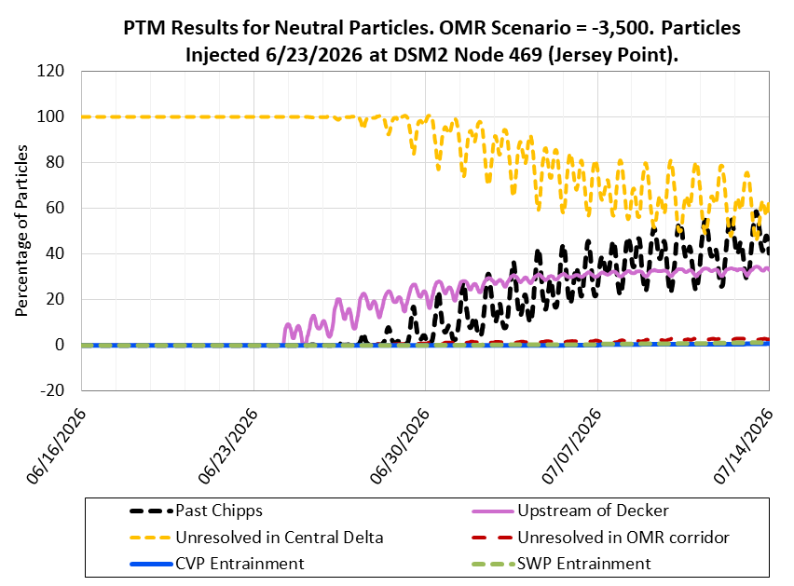
Figure 16: PTM Results for Neutral Particles. OMR Scenario -3,500 cfs. Particles Injected 06/23/2026 at DSM2 Node 469 (Jersey Point)

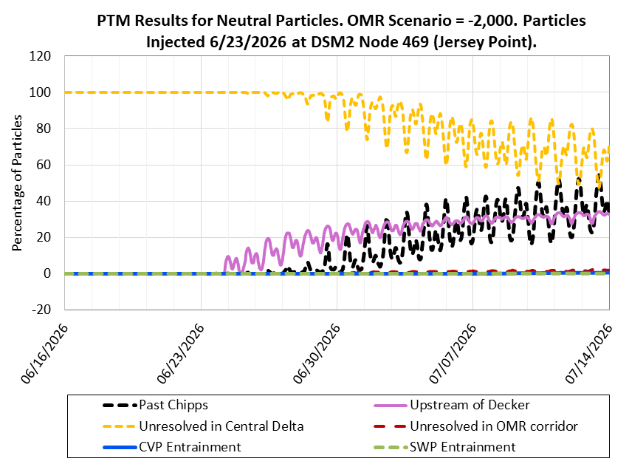
Figure 17: PTM Results for Neutral Particles. OMR Scenario -2,000 cfs. Particles Injected 06/23/2026 at DSM2 Node 469 (Jersey Point)

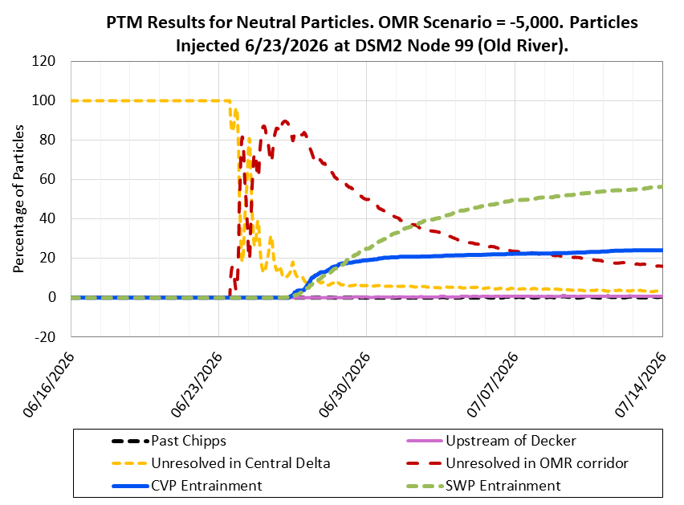
Figure 18: PTM Results for Neutral Particles. OMR Scenario -5,000 cfs. Particles Injected 06/23/2026 at DSM2 Node 99 (Old River)

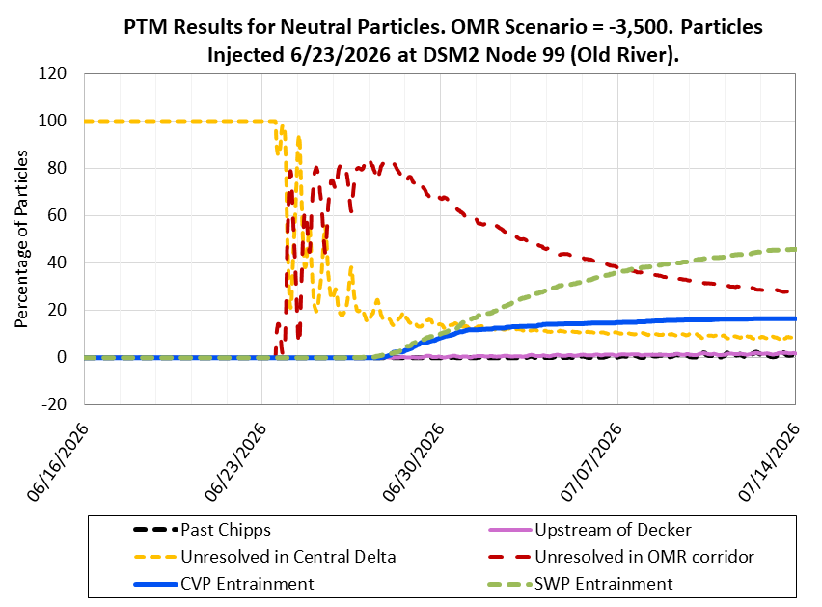
Figure 19: PTM Results for Neutral Particles. OMR Scenario -3,500 cfs. Particles Injected 06/23/2026 at DSM2 Node 99 (Old River)

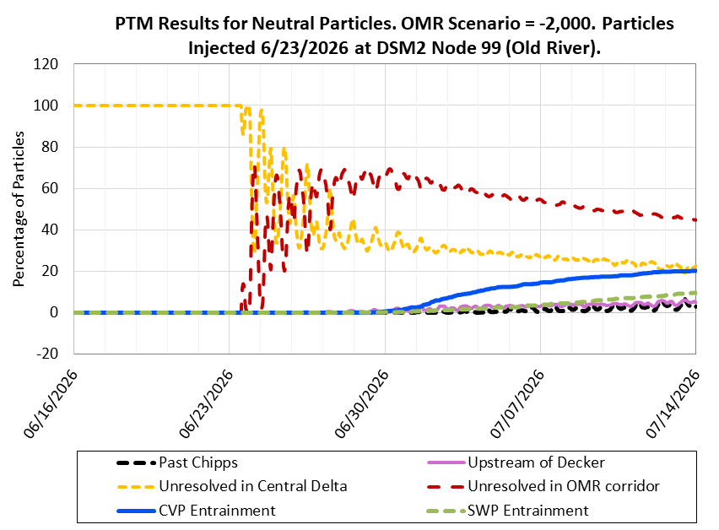
Figure 20: PTM Results for Neutral Particles. OMR Scenario -2,000 cfs. Particles Injected 06/23/2026 at DSM2 Node 99 (Old River)

Surface Oriented Particles (PP)
Table 8: Surface Oriented Particle Fate (percent flux across boundary) for Particles Injected at Chipps (DSM2 Node 465)
Forecast Week | OMR Flow Bin (cfs) | Past Chipps | Upstream of Decker | Unresolved in Central Delta | Unresolved in OMR corridor | CVP Entrainment | SWP Entrainment
Week 1: 06/23/2026 – 06/29/2026 | -5,000 | 74.0 | 0.0 | 26.0 | 0.0 | 0.0 | 0.0
Week 1: 06/23/2026 – 06/29/2026 | -3,500 | 77.4 | 0.0 | 22.6 | 0.0 | 0.0 | 0.0
Week 1: 06/23/2026 – 06/29/2026 | -2,000 | 71.8 | -0.1 | 28.2 | 0.0 | 0.0 | 0.0
Week 2: 06/30/2026 – 07/06/2026 | -5,000 | 92.4 | 0.2 | 7.7 | 0.0 | 0.0 | 0.1
Week 2: 06/30/2026 – 07/06/2026 | -3,500 | 94.1 | 0.0 | 5.9 | 0.0 | 0.0 | 0.0
Week 2: 06/30/2026 – 07/06/2026 | -2,000 | 91.7 | -0.2 | 8.3 | 0.0 | 0.0 | 0.0
Week 3: 07/07/2026 – 07/13/2026 | -5,000 | 91.8 | 0.2 | 8.3 | 0.0 | 0.0 | 0.1
Week 3: 07/07/2026 – 07/13/2026 | -3,500 | 92.9 | 0.0 | 7.2 | 0.1 | 0.0 | 0.0
Week 3: 07/07/2026 – 07/13/2026 | -2,000 | 89.9 | -0.1 | 10.2 | 0.1 | 0.0 | 0.0

Note: Values between 0.0 and 0.1 are indicated with <0.1.
Key: CVP = Central Valley Project, OMR = Old and Middle River, SWP = State Water Project
Table 9: Surface Oriented Particle Fate (percent flux across boundary) for Particles Injected at Cache Slough (DSM2 Node 350)
Forecast Week | OMR Flow Bin (cfs) | Past Chipps | Upstream of Decker | Unresolved in Central Delta | Unresolved in OMR corridor | CVP Entrainment | SWP Entrainment
Week 1: 06/23/2026 – 06/29/2026 | -5,000 | 6.2 | 58.9 | 93.9 | 0.1 | 0.0 | 0.0
Week 1: 06/23/2026 – 06/29/2026 | -3,500 | 7.9 | 61.8 | 92.3 | 0.2 | 0.0 | 0.0
Week 1: 06/23/2026 – 06/29/2026 | -2,000 | 1.9 | 51.9 | 98.3 | 0.2 | 0.0 | 0.0
Week 2: 06/30/2026 – 07/06/2026 | -5,000 | 48.3 | 71.1 | 54.2 | 1.6 | 0.6 | 0.3
Week 2: 06/30/2026 – 07/06/2026 | -3,500 | 55.8 | 71.0 | 45.5 | 0.9 | 0.2 | 0.2
Week 2: 06/30/2026 – 07/06/2026 | -2,000 | 39.0 | 64.5 | 62.1 | 1.1 | 0.0 | 0.0
Week 3: 07/07/2026 – 07/13/2026 | -5,000 | 50.5 | 73.3 | 54.2 | 1.8 | 1.6 | 1.3
Week 3: 07/07/2026 – 07/13/2026 | -3,500 | 60.1 | 74.1 | 42.4 | 1.8 | 0.4 | 0.3
Week 3: 07/07/2026 – 07/13/2026 | -2,000 | 45.5 | 65.4 | 56.3 | 1.2 | 0.5 | 0.1

Note: Values between 0.0 and 0.1 are indicated with <0.1.
Key: CVP = Central Valley Project, OMR = Old and Middle River, SWP = State Water Project
Table 10: Surface Oriented Particle Fate (percent flux across boundary) for Particles Injected at Jersey Point (DSM2 Node 469)
Forecast Week | OMR Flow Bin (cfs) | Past Chipps | Upstream of Decker | Unresolved in Central Delta | Unresolved in OMR corridor | CVP Entrainment | SWP Entrainment
Week 1: 06/23/2026 – 06/29/2026 | -5,000 | 4.5 | 19.1 | 98.4 | 2.6 | 0.1 | 0.2
Week 1: 06/23/2026 – 06/29/2026 | -3,500 | 5.3 | 19.2 | 96.1 | 1.3 | 0.0 | 0.1
Week 1: 06/23/2026 – 06/29/2026 | -2,000 | 4.7 | 18.8 | 96.6 | 1.4 | 0.0 | 0.0
Week 2: 06/30/2026 – 07/06/2026 | -5,000 | 38.1 | 28.3 | 70.9 | 5.6 | 1.9 | 1.5
Week 2: 06/30/2026 – 07/06/2026 | -3,500 | 47.4 | 28.0 | 56.4 | 2.6 | 0.6 | 0.6
Week 2: 06/30/2026 – 07/06/2026 | -2,000 | 45.1 | 25.6 | 58.2 | 2.8 | 0.5 | 0.1
Week 3: 07/07/2026 – 07/13/2026 | -5,000 | 42.2 | 29.8 | 70.7 | 4.5 | 4.0 | 4.4
Week 3: 07/07/2026 – 07/13/2026 | -3,500 | 54.8 | 29.5 | 51.9 | 3.7 | 1.5 | 1.4
Week 3: 07/07/2026 – 07/13/2026 | -2,000 | 49.8 | 26.9 | 54.9 | 3.2 | 1.2 | 0.2

Note: Values between 0.0 and 0.1 are indicated with <0.1.
Key: CVP = Central Valley Project, OMR = Old and Middle River, SWP = State Water Project
Table 11: Surface Oriented Particle Fate (percent flux across boundary) for Particles Injected at Old River (DSM2 Node 99)
Forecast Week | OMR Flow Bin (cfs) | Past Chipps | Upstream of Decker | Unresolved in Central Delta | Unresolved in OMR corridor | CVP Entrainment | SWP Entrainment
Week 1: 06/23/2026 – 06/29/2026 | -5,000 | 0.0 | 0.3 | 8.5 | 52.8 | 19.7 | 18.9
Week 1: 06/23/2026 – 06/29/2026 | -3,500 | 0.0 | 0.2 | 16.5 | 64.6 | 9.2 | 9.8
Week 1: 06/23/2026 – 06/29/2026 | -2,000 | 0.1 | 0.6 | 29.7 | 68.7 | 1.3 | 0.2
Week 2: 06/30/2026 – 07/06/2026 | -5,000 | 0.6 | 0.8 | 5.8 | 26.0 | 25.5 | 42.1
Week 2: 06/30/2026 – 07/06/2026 | -3,500 | 1.9 | 2.0 | 11.6 | 33.6 | 15.9 | 37.0
Week 2: 06/30/2026 – 07/06/2026 | -2,000 | 1.6 | 3.1 | 23.7 | 53.5 | 17.0 | 4.3
Week 3: 07/07/2026 – 07/13/2026 | -5,000 | 0.7 | 1.0 | 5.0 | 17.6 | 27.5 | 49.3
Week 3: 07/07/2026 – 07/13/2026 | -3,500 | 3.2 | 2.5 | 8.0 | 23.0 | 18.0 | 47.8
Week 3: 07/07/2026 – 07/13/2026 | -2,000 | 3.9 | 3.6 | 17.9 | 45.5 | 22.5 | 10.2

Note: Values between 0.0 and 0.1 are indicated with <0.1.
Key: CVP = Central Valley Project, OMR = Old and Middle River, SWP = State Water Project
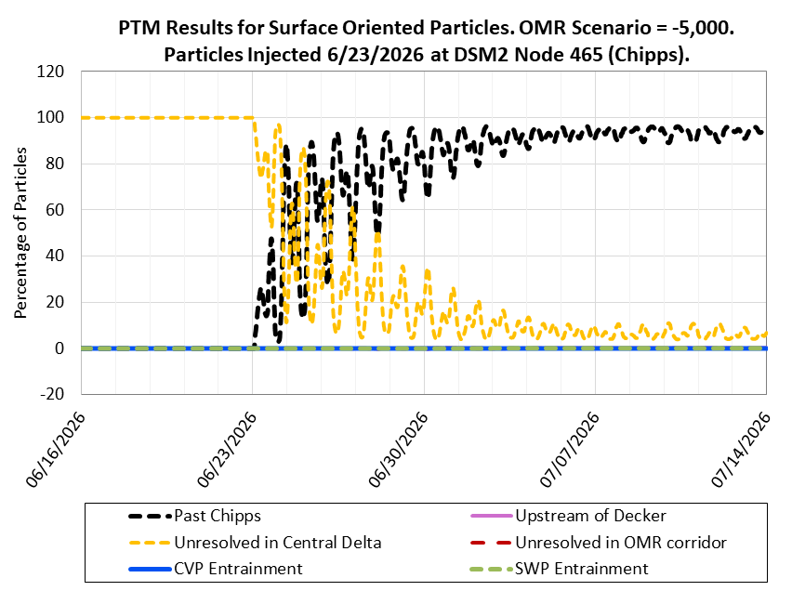
Figure 21: PTM Results for Surface Oriented Particles. OMR Scenario -5,000 cfs. Particles Injected 06/23/2026 at DSM2 Node 465 (Chipps)

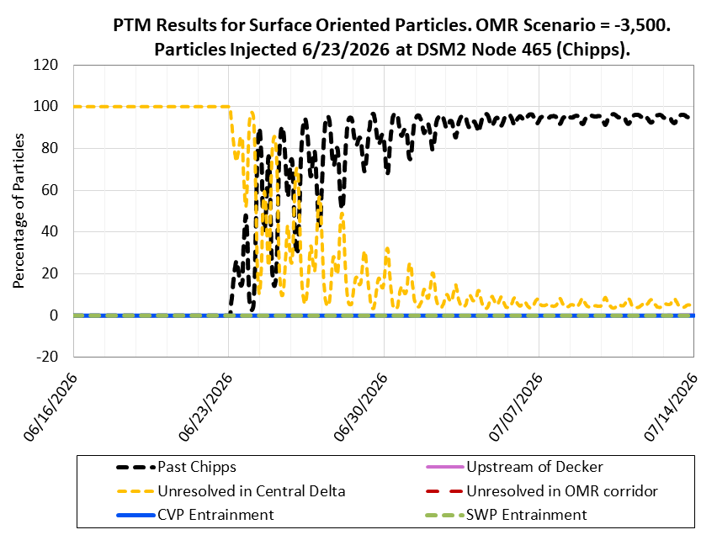
Figure 22: PTM Results for Surface Oriented Particles. OMR Scenario -3,500 cfs. Particles Injected 06/23/2026 at DSM2 Node 465 (Chipps)

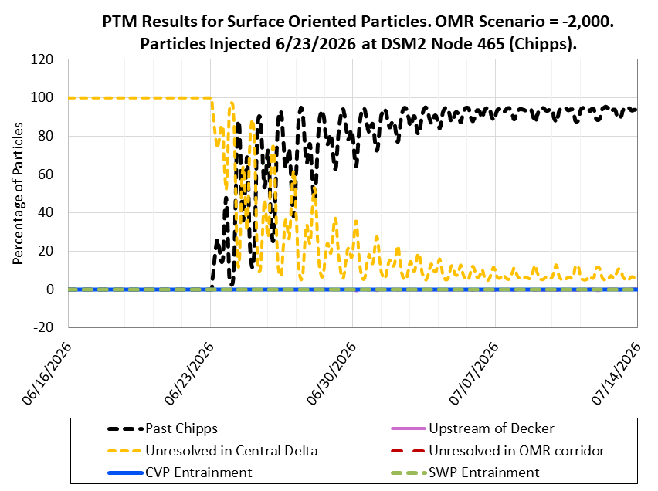
Figure 23: PTM Results for Surface Oriented Particles. OMR Scenario -2,000 cfs. Particles Injected 06/23/2026 at DSM2 Node 465 (Chipps)

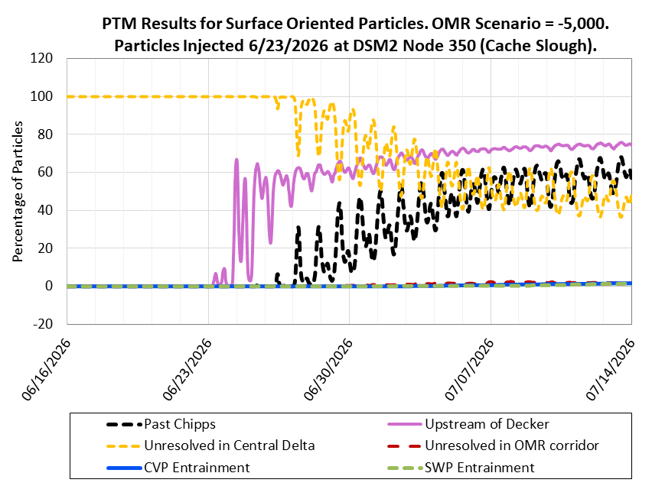
Figure 24: PTM Results for Surface Oriented Particles. OMR Scenario -5,000 cfs. Particles Injected 06/23/2026 at DSM2 Node 350 (Cache Slough)

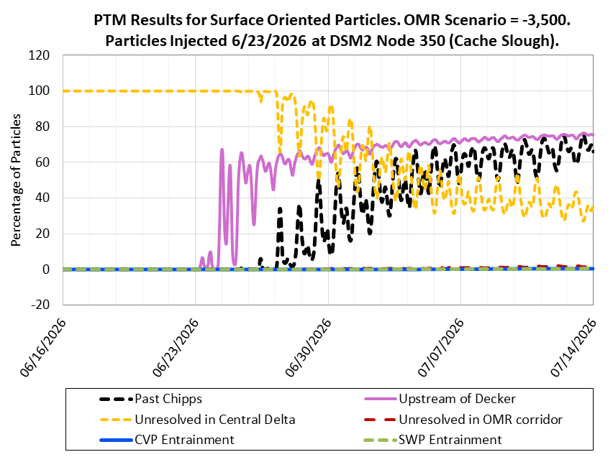
Figure 25: PTM Results for Surface Oriented Particles. OMR Scenario -3,500 cfs. Particles Injected 06/23/2026 at DSM2 Node 350 (Cache Slough)

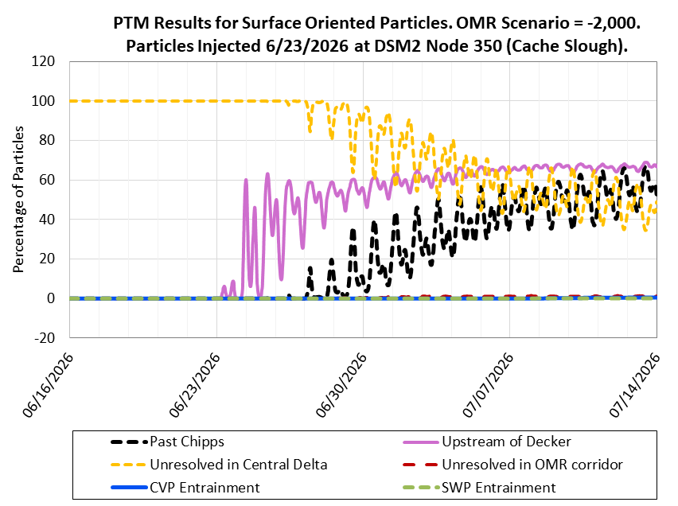
Figure 26: PTM Results for Surface Oriented Particles. OMR Scenario -2,000 cfs. Particles Injected 06/23/2026 at DSM2 Node 350 (Cache Slough)

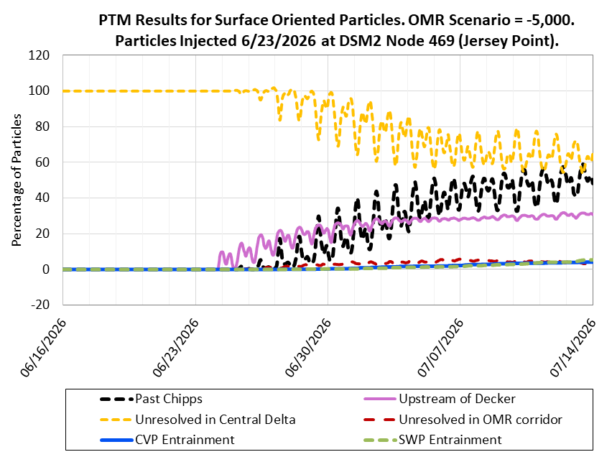
Figure 27: PTM Results for Surface Oriented Particles. OMR Scenario -5,000 cfs. Particles Injected 06/23/2026 at DSM2 Node 469 (Jersey Point)

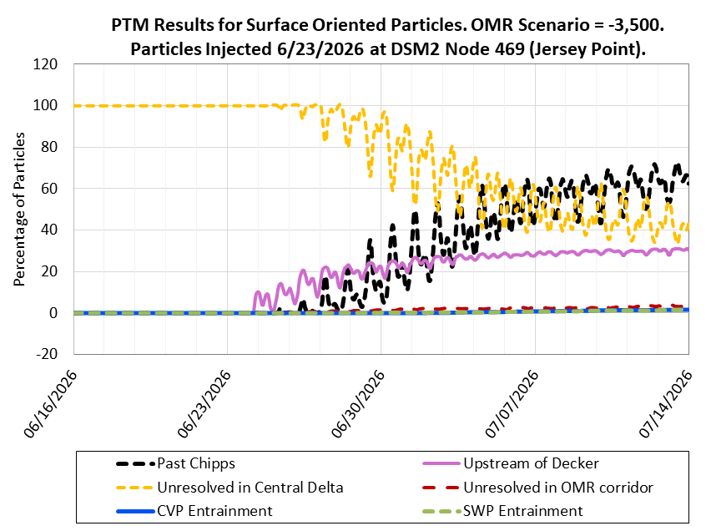
Figure 28: PTM Results for Surface Oriented Particles. OMR Scenario -3,500 cfs. Particles Injected 06/23/2026 at DSM2 Node 469 (Jersey Point)

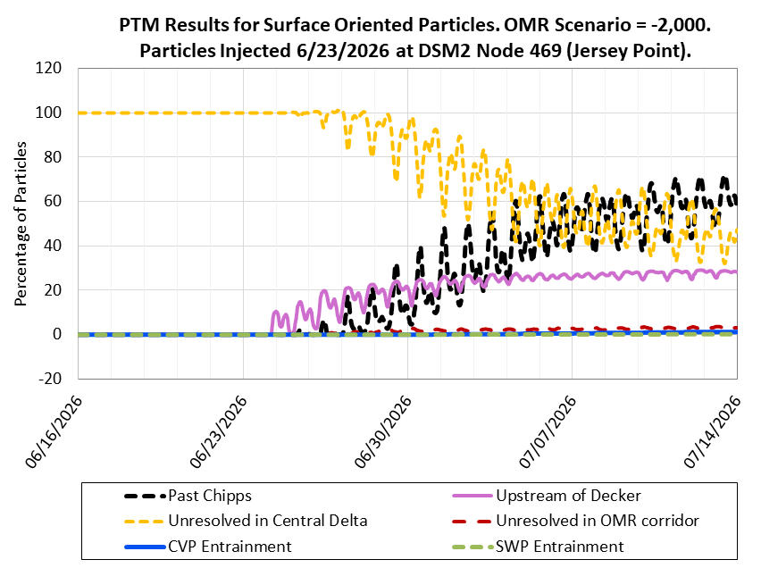
Figure 29: PTM Results for Surface Oriented Particles. OMR Scenario -2,000 cfs. Particles Injected 06/23/2026 at DSM2 Node 469 (Jersey Point)

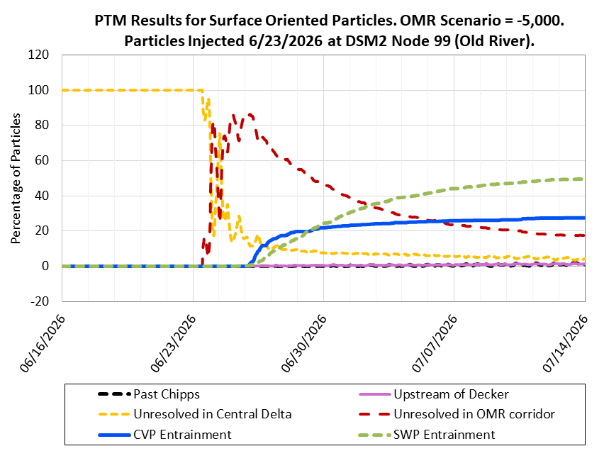
Figure 30: PTM Results for Surface Oriented Particles. OMR Scenario -5,000 cfs. Particles Injected 06/23/2026 at DSM2 Node 99 (Old River)

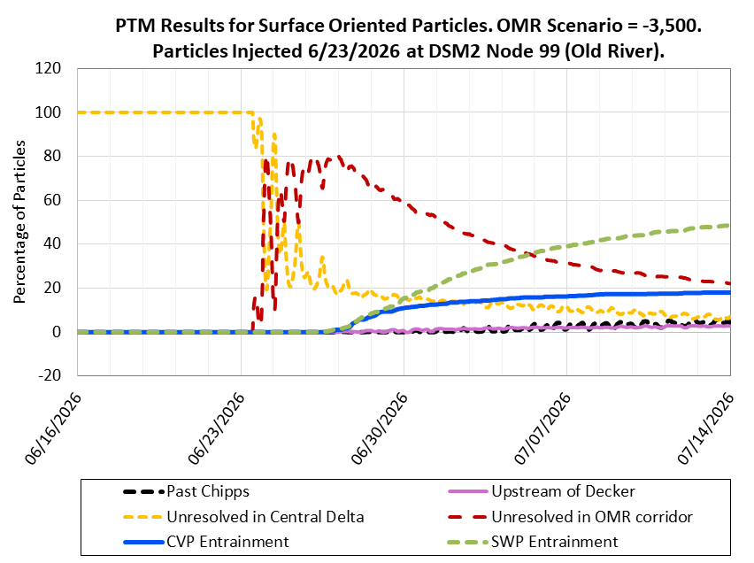
Figure 31: PTM Results for Surface Oriented Particles. OMR Scenario -3,500 cfs. Particles Injected 06/23/2026 at DSM2 Node 99 (Old River)

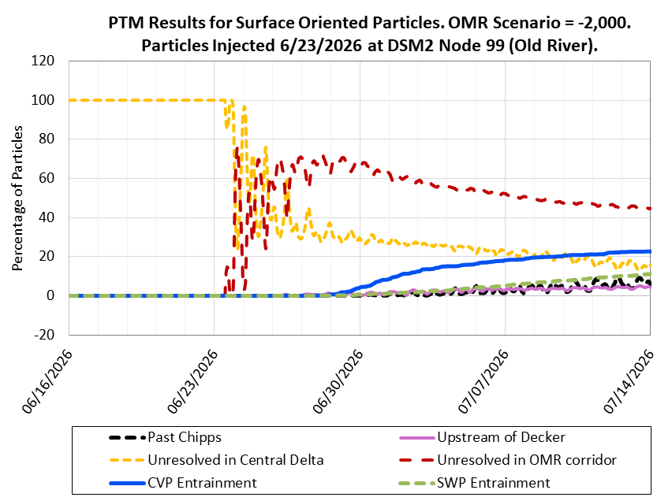
Figure 32: PTM Results for Surface Oriented Particles. OMR Scenario -2,000 cfs. Particles Injected 06/23/2026 at DSM2 Node 99 (Old River)

ECO-PTM (Ecological Particle Tracking Model)
ECO-PTM Results Evaluation Period: 06/23/2026 – 07/13/2026
Particles Injected: 06/23/2026
Injection Location: Sacramento River at Freeport
Table 12: Salmon Particle Route Ratio After 3 Weeks Ending 07/13/2026
-5,000 | 0.10 | 0.10 | 0.80 | 0.78 | 0.19
-3,500 | 0.10 | 0.10 | 0.80 | 0.77 | 0.20
-2,000 | 0.09 | 0.08 | 0.83 | 0.74 | 0.16

Note: Salmon particle route ratio for the Sacramento River (SS) Route reflects particles inserted at Freeport that are not routed through either Sutter Slough or Steamboat Slough. Salmon particle route ratio for the Sacramento River (GEO) Route reflects particles inserted at Freeport that are not routed through either Sutter Slough, Steamboat Slough, Georgiana Slough, or the Delta Cross Channel when operational.
Key: cfs = cubic feet per second, OMR = Old and Middle River
Table 13: Salmon Particle Route-Specific Survival After 3 Weeks Ending 07/13/2026
-5,000 | 41% | 51% | 44% | 24% | 40%
-3,500 | 41% | 50% | 43% | 25% | 40%
-2,000 | 43% | 51% | 42% | 19% | 37%

Key: cfs = cubic feet per second, OMR = Old and Middle River

Longfin Smelt Larval Population and PTM Analysis
PTM Results Evaluation Period: 06/23/2026 – 07/13/2026
Particles Injected: 06/23/2026
PTM Injection Location: Node(s) within each Delta Region identified in the maps below.
PTM Analysis Method: LFS larva abundance is estimated in each Enhanced Delta Smelt Monitoring (EDSM) program subregion. Cumulative particle flux into CVP and SWP facilities is represented in PTM by one injection location per subregion. LFS larva entrainment is estimated by multiplying the LFS subregion abundance by cumulative particle flux into CVP and SWP facilities from the corresponding subregion injection point. LFS entrainment from each subregion is added together and reported at the LFS Region scale.
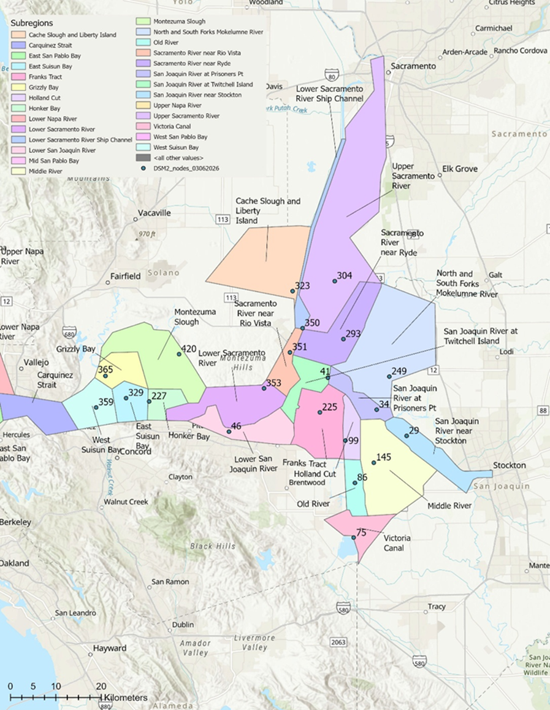
Figure 33: Map of Delta Showing Longfin Smelt Subregions and DSM2 Nodes
Note: No DSM2 nodes are west of the West Suisun Bay subregion, so the furthest west node in the DSM2 domain is used to represent particle entrainment for all subregions west of West Suisun Bay.
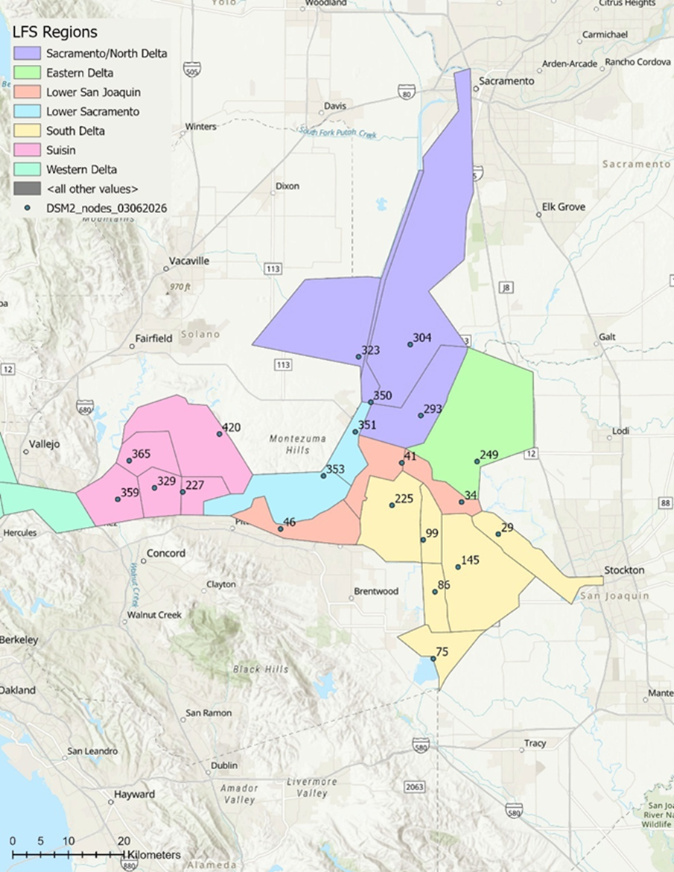
Figure 34: Map of Delta Showing Longfin Smelt Regions and DSM2 Nodes
Table 14: Percent of Smelt Larva Survey Sample Results Processed
1 | 12/29/2025 | 100% | 100% | 100% | 100% | 100% | 100% | 100%
2 | 1/12/2026 | 100% | 100% | 100% | 100% | 100% | 100% | 100%
3 | 1/26/2026 | 100% | 100% | 100% | 100% | 100% | 100% | 100%
4 | 2/9/2026 | 100% | 100% | 100% | 100% | 100% | 100% | 100%
5 | 2/23/2026 | 100% | 100% | 100% | 100% | 100% | 100% | 100%
6 | 3/9/2026 | 100% | 100% | 100% | 100% | 100% | 100% | 100%

Key: SLS = Smelt Larva Survey
The DSM2 node used as an injection point, EDSM subregion, and LFS Region for reporting are shown in the following table.
Table 15: DSM2 Injection Node, EDSM Subregion, and LFS Region
329 | East Suisun Bay | Suisun
365 | Grizzly Bay | Suisun
227 | Honker Bay | Suisun
420 | Montezuma Slough | Suisun
359 | West Suisun Bay | Suisun
359 | Carquinez Strait | Western Delta
359 | Upper Napa River | Western Delta
359 | Lower Napa River | Western Delta
359 | East San Pablo Bay | Western Delta
359 | West San Pablo Bay | Western Delta
359 | Mid San Pablo Bay | Western Delta
353 | Lower Sacramento River | Lower Sacramento
351 | Sacramento River near Rio Vista | Lower Sacramento
350 | Lower Sacramento River Ship Channel | Sacramento/ North Delta
293 | Sacramento River near Ryde | Sacramento/ North Delta
323 | Cache Slough and Liberty Island | Sacramento/ North Delta
304 | Upper Sacramento River | Sacramento/ North Delta
249 | North and South Forks Mokelumne River | East
46 | Lower San Joaquin River | Lower San Joaquin
41 | San Joaquin River at Twitchell Island | Lower San Joaquin
34 | San Joaquin River at Prisoners Point | Lower San Joaquin
225 | Franks Tract | South Delta
99 | Holland Cut | South Delta
86 | Old River | South Delta
29 | San Joaquin River near Stockton | South Delta
145 | Middle River | South Delta
75 | Victoria Canal | South Delta

Table 16: LFS Entrainment Estimate Using PTM with Surface Oriented Particles: Week 1 Ending 06/29/2026
 |  | LFS Larva Abundance Estimate | 117,633,687 | 145,677,478 | 304,865 | 4,078,739 | 3,695,676 | 0 | 0 | 271,390,445 | -
-5,000 | 5,152 | PTM Entrained (%) | 0 | 0 | 0 | 0.1 | 0 | 0 | 0 | - | -
-3,500 | 3,492 | PTM Entrained (%) | 0 | 0 | 0 | 0 | 0 | 0 | 0 | - | -
-2,000 | 1,760 | PTM Entrained (%) | 0 | 0 | 0 | 0 | 0 | 0 | 0 | - | -
-5,000 | 5,152 | Smelt Larva Entrained (#) | 0 | 0 | 0 | 5,830 | 0 | 0 | 0 | 5,830 | <0.1%
-3,500 | 3,492 | Smelt Larva Entrained (#) | 0 | 0 | 0 | 0 | 0 | 0 | 0 | 0 | 0%
-2,000 | 1,760 | Smelt Larva Entrained (#) | 0 | 0 | 0 | 0 | 0 | 0 | 0 | 0 | 0%

Notes: Values between 0.0 and 0.1 are indicated with <0.1.
The PTM entrained (%) value reflects the total entrained particles from all subregions within an LFS Region divided by the estimated LFS Region abundance.
Key: cfs = cubic feet per second, LFS = Longfin Smelt, OMR = Old and Middle River
Table 17: LFS Entrainment Estimate Using PTM with Surface Oriented Particles: Week 2 Ending 07/06/2026
 |  | LFS Larva Abundance Estimate | 117,633,687 | 145,677,478 | 304,865 | 4,078,739 | 3,695,676 | 0 | 0 | 271,390,445 | -
-5,000 | 4,909 | PTM Entrained (%) | 0 | 0 | 0.6 | 5.2 | 0.5 | 0 | 0 | - | -
-3,500 | 3,277 | PTM Entrained (%) | 0 | 0 | 0.1 | 1.8 | 0.2 | 0 | 0 | - | -
-2,000 | 1,703 | PTM Entrained (%) | 0 | 0 | 0 | 0.2 | <0.1 | 0 | 0 | - | -
-5,000 | 4,909 | Smelt Larva Entrained (#) | 0 | 0 | 1,829 | 212,420 | 17,205 | 0 | 0 | 231,455 | <0.1%
-3,500 | 3,277 | Smelt Larva Entrained (#) | 0 | 0 | 305 | 74,029 | 8,199 | 0 | 0 | 82,532 | <0.1%
-2,000 | 1,703 | Smelt Larva Entrained (#) | 0 | 0 | 0 | 9,963 | 404 | 0 | 0 | 10,367 | <0.1%

Notes: Values between 0.0 and 0.1 are indicated with <0.1.
The PTM entrained (%) value reflects the total entrained particles from all subregions within an LFS Region divided by the estimated LFS Region abundance.
Key: cfs = cubic feet per second, LFS = Longfin Smelt, OMR = Old and Middle River
Table 18: LFS Entrainment Estimate Using PTM with Surface Oriented Particles: Week 3 Ending 07/13/2026
 |  | LFS Larva Abundance Estimate | 117,633,687 | 145,677,478 | 304,865 | 4,078,739 | 3,695,676 | 0 | 0 | 271,390,445 | -
-5,000 | 4,909 | PTM Entrained (%) | 0 | 0 | 1.3 | 11.6 | 0.8 | 0 | 0 | - | -
-3,500 | 3,206 | PTM Entrained (%) | 0 | 0 | 0.4 | 5.9 | 0.3 | 0 | 0 | - | -
-2,000 | 1,703 | PTM Entrained (%) | 0 | 0 | 0.1 | 2.0 | 0.2 | 0 | 0 | - | -
-5,000 | 4,909 | Smelt Larva Entrained (#) | 0 | 0 | 3,963 | 473,233 | 28,169 | 0 | 0 | 505,365 | 0.2%
-3,500 | 3,206 | Smelt Larva Entrained (#) | 0 | 0 | 1,219 | 239,393 | 12,298 | 0 | 0 | 252,911 | <0.1%
-2,000 | 1,703 | Smelt Larva Entrained (#) | 0 | 0 | 305 | 83,364 | 6,522 | 0 | 0 | 90,191 | <0.1%

Notes: Values between 0.0 and 0.1 are indicated with <0.1.
The PTM entrained (%) value reflects the total entrained particles from all subregions within an LFS Region divided by the estimated LFS Region abundance.
Key: cfs = cubic feet per second, LFS = Longfin Smelt, OMR = Old and Middle River
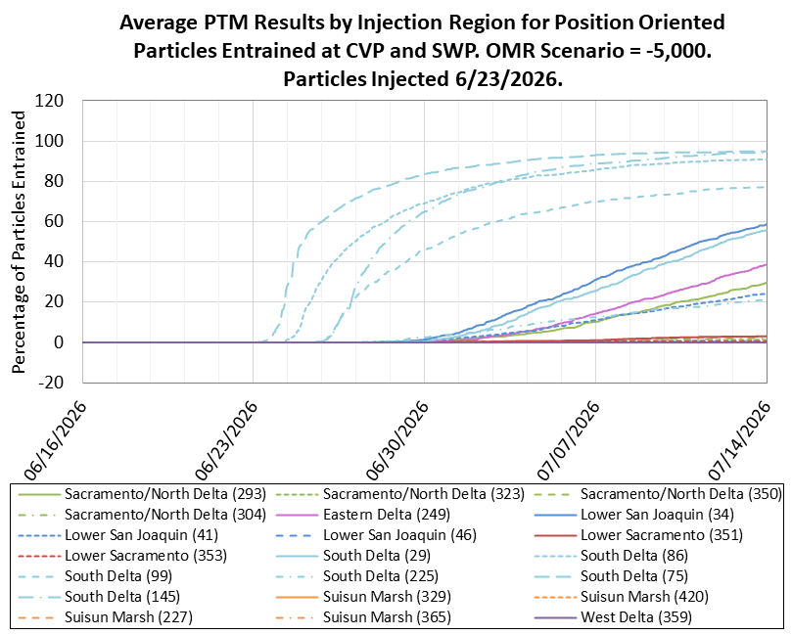
Figure 35: Average PTM Results by Injection Region for Surface Oriented Particles Entrained at CVP and SWP. OMR Scenario -5,000 cfs. Particles Injected 06/23/2026

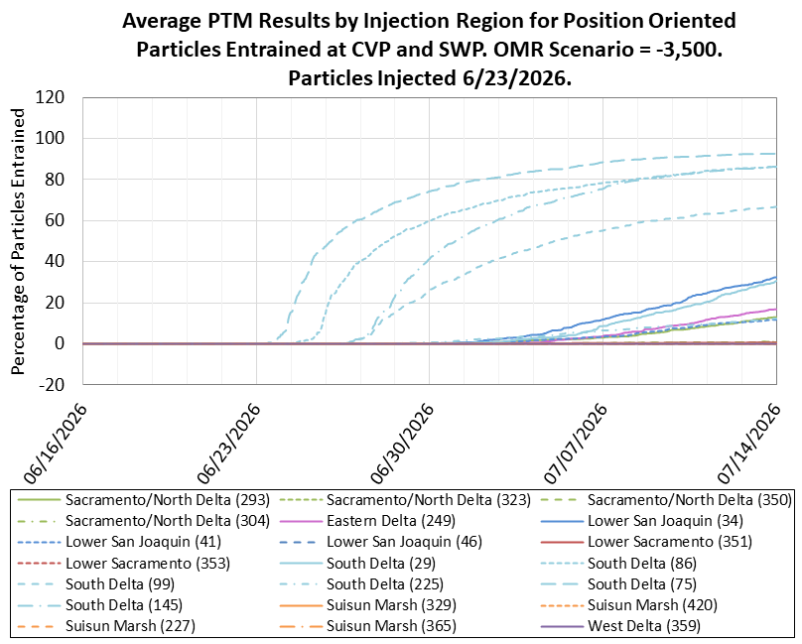
Figure 36: Average PTM Results by Injection Region for Surface Oriented Particles Entrained at CVP and SWP. OMR Scenario -3,500 cfs. Particles Injected 06/23/2026

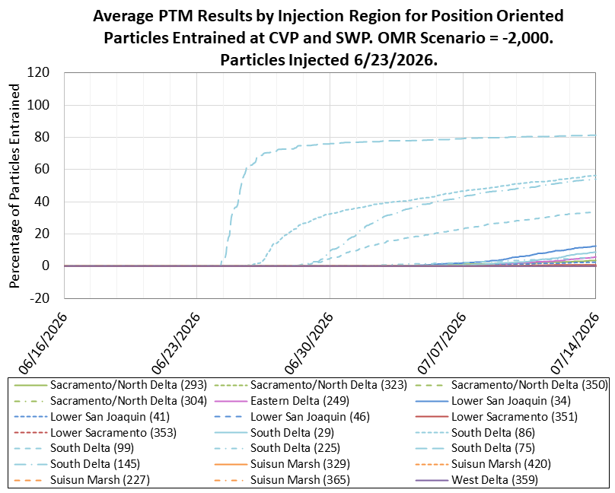
Figure 37: Average PTM Results by Injection Region for Surface Oriented Particles Entrained at CVP and SWP. OMR Scenario -2,000 cfs. Particles Injected 06/23/2026

