**WINTER-RUN GRAPHS**

Figure. STARS prediction with 80% CIs.

Figure. Cumulative Count of current and historic Genetic WR 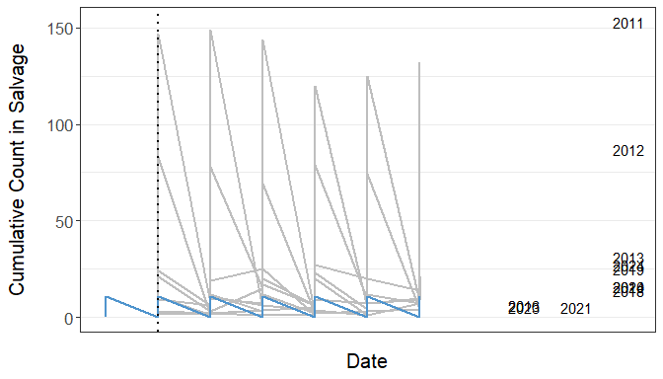

Figure. Histogram of historic genetic winter-run salvage

## `stat_bin()` using `bins = 30`. Pick better value with `binwidth`.

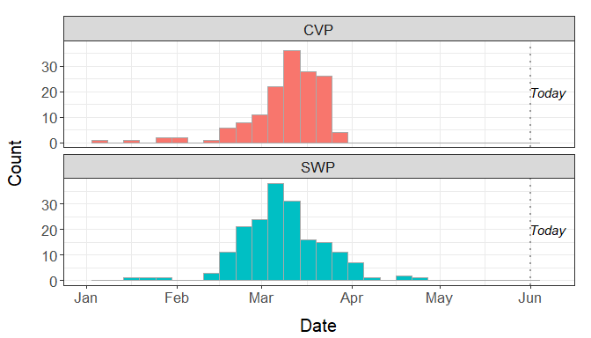

Figure. Summary of WY 2025 loss of CCV steelhead and wild and hatchery winter-run 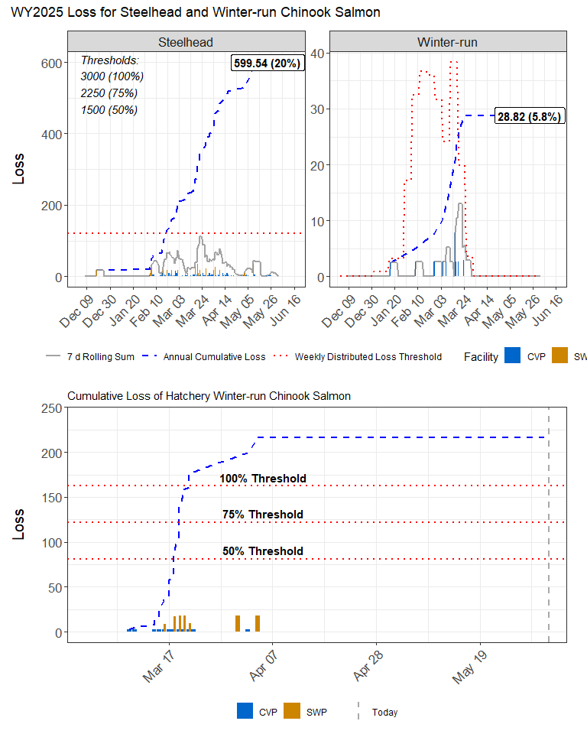

Figure. Tillotson predictions at different OMRI scenarios for winter-run 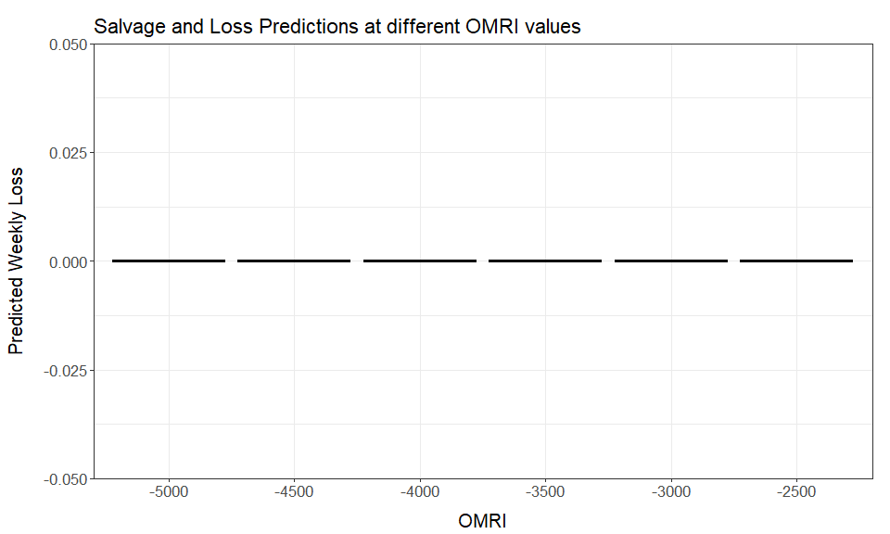 ### SACPAS TABLES TABLE X. Winter-run weekly distributed loss threshold.Last updated 06/02/2025

| Date | Winter-run Daily Loss | Winter-run 7-day rolling sum loss | Winter-run Daily Threshold | Winter-run Daily Trigger |
| --- | --- | --- | --- | --- |
| May 27 | 0 | 0 | 0 | No |
| May 28 | 0 | 0 | 0 | No |
| May 29 | 0 | 0 | 0 | No |
| May 30 | 0 | 0 | 0 | No |
| May 31 | 0 | 0 | 0 | No |
| Jun 01 | 0 | 0 | 0 | No |
| Jun 02 | 0 | 0 | 0 | No |

TABLE. Historic migration and salvage patterns.Last updated 06/02/2025

| Species | RedBluffDiversionDam | TisdaleRst | KnightsLandingRst | SacTrawlSherwoodCatchIndex | ChippsIslandTrawlCatchIndex | Salvage |
| --- | --- | --- | --- | --- | --- | --- |
| Chinook, LAD Winter-run, Unclipped | 100.0%(100.0%,100.0%) BY: 2015 - 2023 | 100.0%(100.0%,100.0%) BY: 2015 - 2023 | 100.0%(100.0%,100.0%) BY: 2015 - 2023 | 100.0%(100.0%,100.0%) BY: 2015 - 2023 | 100.0%(100.0%,100.0%) BY: 2015 - 2023 | 100.0%(100.0%,100.0%) WY: 2015 - 2024 |
| Chinook, LAD Spring-run, Unclipped | 99.9%(99.8%,100.0%) BY: 2015 - 2023 | 100.0%(100.0%,100.0%) BY: 2015 - 2023 | 100.0%(100.0%,100.0%) BY: 2015 - 2023 | 100.0%(100.0%,100.0%) BY: 2015 - 2023 | 99.9%(99.8%,100.0%) BY: 2015 - 2023 | 98.0%(94.7%,101.2%) WY: 2015 - 2024 |
| Steelhead, Unclipped (January-December) | 34.3%(16.8%,51.8%) BY: 2015 - 2024 | 86.7%(65.8%,107.5%) BY: 2015 - 2024 | 81.8%(64.6%,99.0%) BY: 2015 - 2024 | 96.8%(91.6%,102.1%) BY: 2015 - 2024 | 94.8%(89.9%,99.7%) BY: 2015 - 2024 |  |
| Chinook, DNA Winter-run, Unclipped (Water Year) |  |  |  |  |  | 100.0%(100.0%,100.0%) WY: 2020 - 2024 |
| Steelhead, Unclipped (Water Year) |  |  |  |  |  | 97.0%(93.0%,101.1%) WY: 2015 - 2024 |

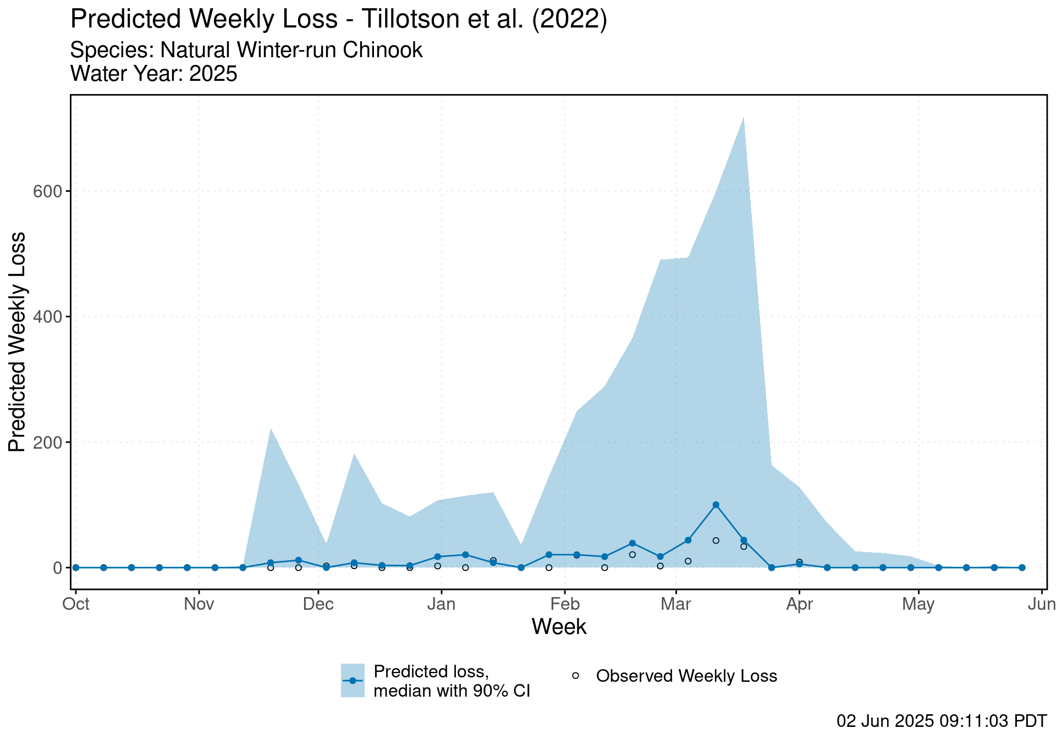 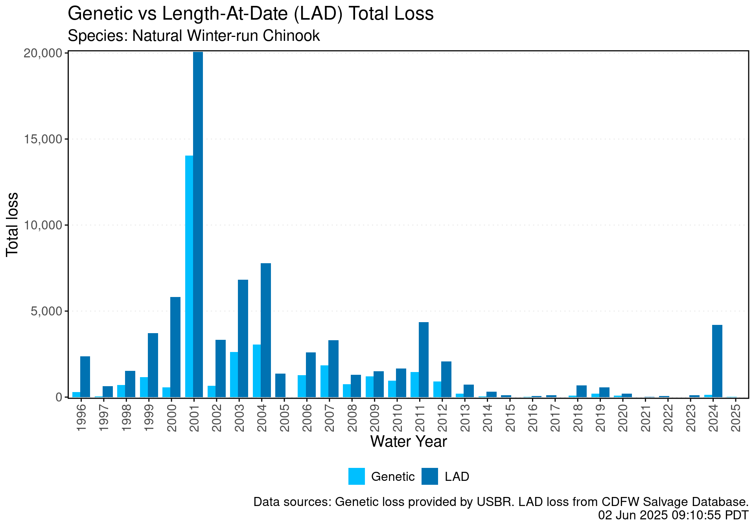

**STEELHEAD THINGS**

| Species | RedBluffDiversionDam | TisdaleRst | KnightsLandingRst | SacTrawlSherwoodCatchIndex | ChippsIslandTrawlCatchIndex | Salvage |
| --- | --- | --- | --- | --- | --- | --- |
| Steelhead, Unclipped (January-December) | 34.3%(16.8%,51.8%) BY: 2015 - 2024 | 86.7%(65.8%,107.5%) BY: 2015 - 2024 | 81.8%(64.6%,99.0%) BY: 2015 - 2024 | 96.8%(91.6%,102.1%) BY: 2015 - 2024 | 94.8%(89.9%,99.7%) BY: 2015 - 2024 |  |
| Steelhead, Unclipped (Water Year) |  |  |  |  |  | 97.0%(93.0%,101.1%) WY: 2015 - 2024 |

TABLE X. Steelhead weekly distributed loss threshold.Last updated 06/02/2025

Figures from SacPAS for steelhead

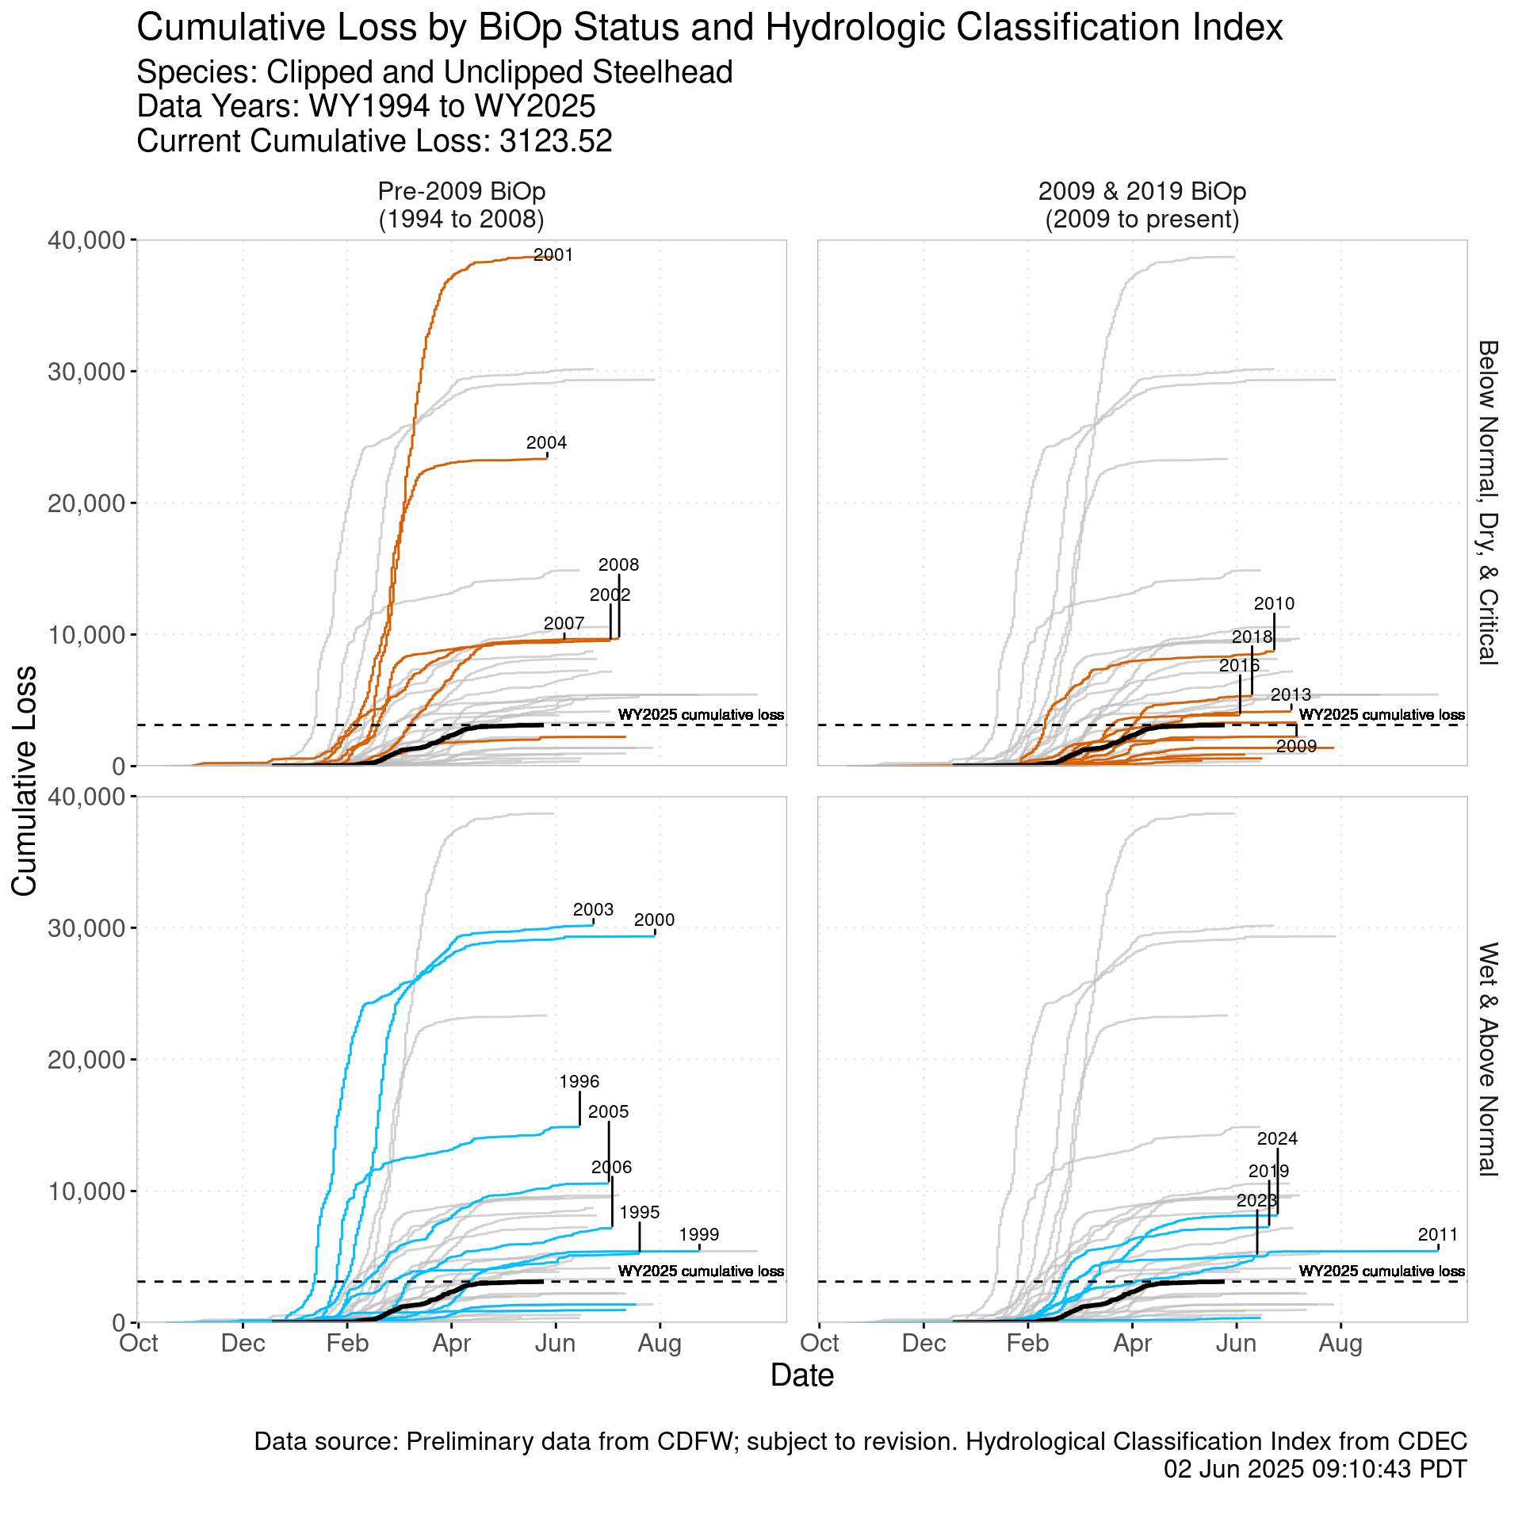 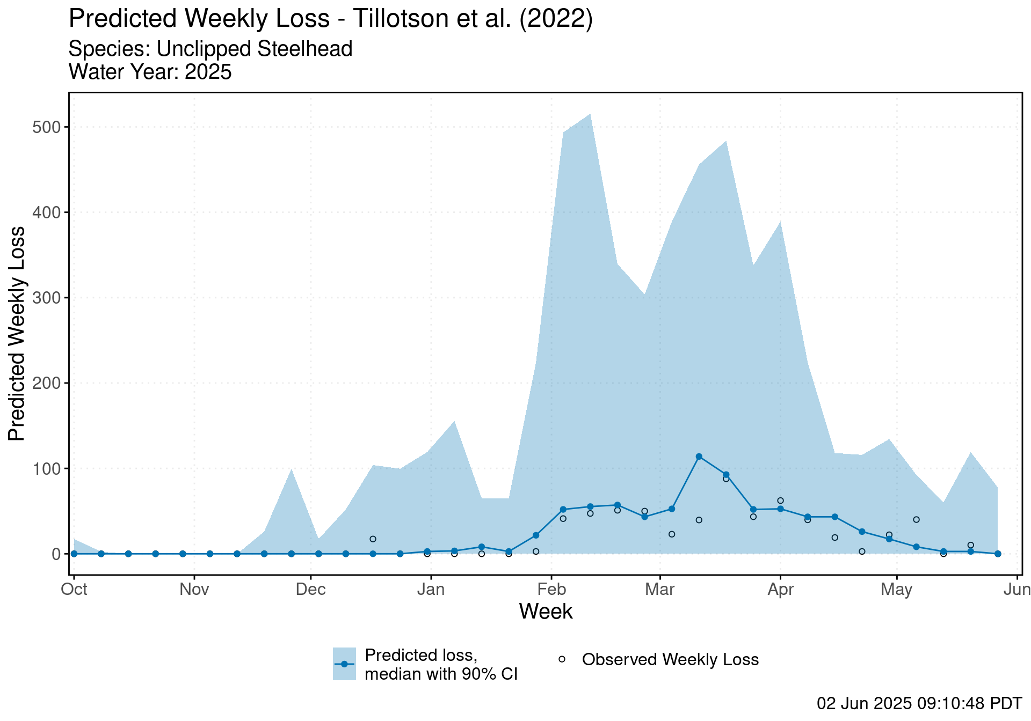 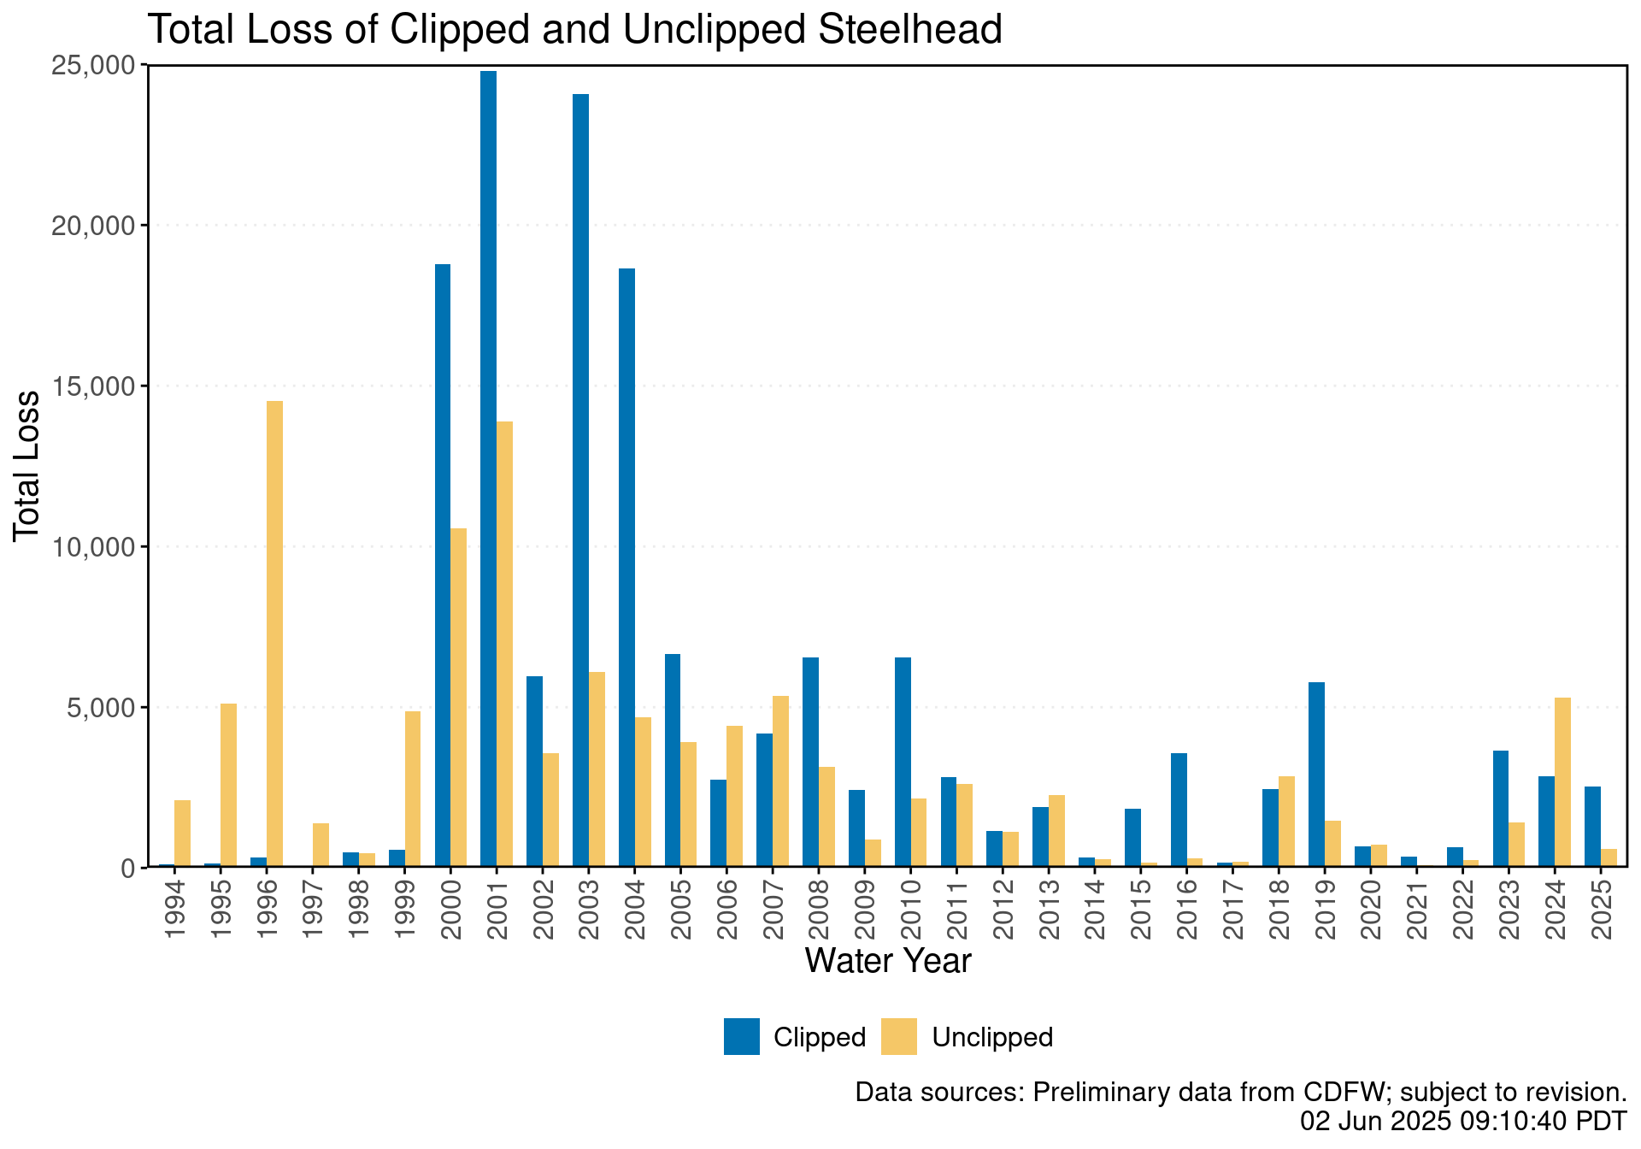

Figure. SH cumulative loss 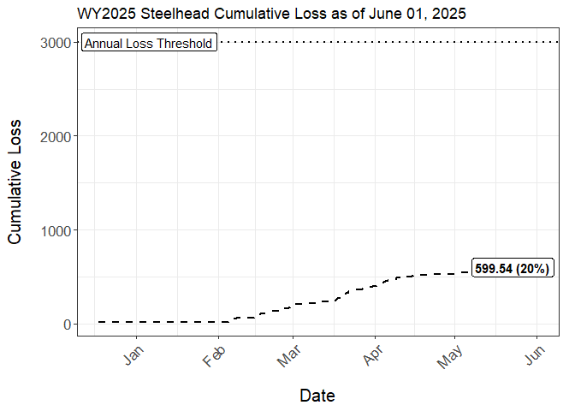

Figure. Histogram of historic clipped and unclipped steelhead salvage

## `stat_bin()` using `bins = 30`. Pick better value with `binwidth`.

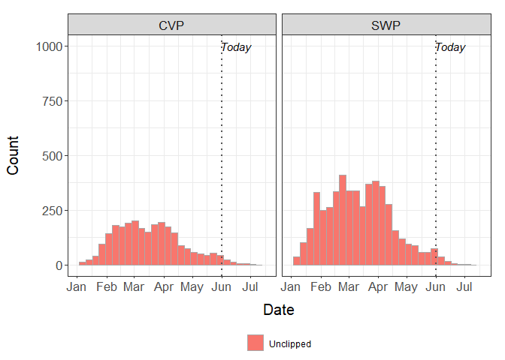

Figure. Tillotson predictions for steelhead at different OMRI scenarios 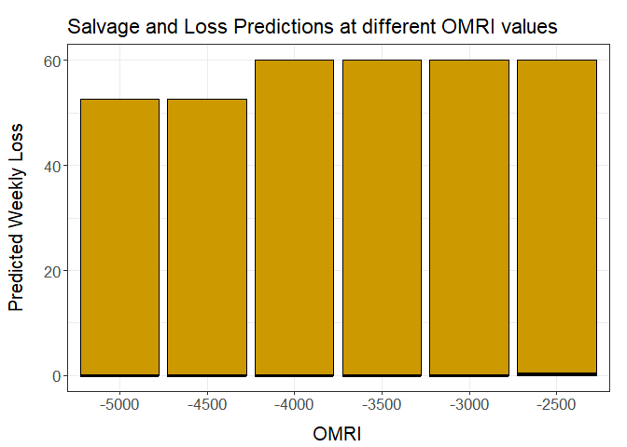

**SPRING-RUN THINGS**

TABLE X. Spring-run surrogate release information and loss.Last updated 06/02/2025

| Type | Hatchery | Release Date | Run | Release Size | CWT Released | Loss Threshold | Loss | First/Last Loss |
| --- | --- | --- | --- | --- | --- | --- | --- | --- |
| Yearling | Coleman NFH | 2024-11-20 | Late-Fall | 698,892 | 698,892 | 1,747.23 | 1051.21 (60.2%) | Nov 29/Apr 05 |
| Yearling | Coleman NFH | 2024-12-13 | Late-Fall | 77,355 | 77,355 | 193.39 | 72.52 (37.5%) | Dec 25/Jan 12 |
| Yearling | Coleman NFH | 2025-01-17 | Late-Fall | 74,425 | 74,425 | 186.06 | 43.34 (23.3%) | Jan 30/Apr 04 |
| Young-of-year | Feather River Hatchery | 2025-03-14 | Spring | 961,411 | 476,741 | 1,191.85 | 16.56 (1.4%) | Apr 06/Apr 06 |
| Young-of-year | Feather River Hatchery | 2025-03-21 | Spring | 962,741 | 475,831 | 1,189.58 | 110.13 (9.3%) | Mar 31/May 02 |
| Young-of-year | Feather River Hatchery | 2025-04-09 | Spring | 1,012,800 | 504,304 | 1,260.76 | 0 (0%) | NA/NA |
| Young-of-year | Feather River Hatchery | 2025-04-23 | Fall | 1,505,055 | 376,122 | 940.31 | 0 (0%) | NA/NA |
| Young-of-year | Coleman NFH | 2025-04-15 | Fall | 2,122,103 | 695,170 | 1,737.93 | 0 (0%) | NA/NA |
| Young-of-year | Coleman NFH | 2025-04-28 | Fall | 1,472,338 | 368,085 | 920.21 | 0 (0%) | NA/NA |