**Supplementary Materials for: From drought to deluge: variation in survival and riverine habitat use of an endangered migratory fish across spatial and temporal scales**

**Supplemental Figure S1:** Estimated daily arrival probabilities at Knights Landing, California (river kilometer 224) for acoustic tagged hatchery-reared winter run Chinook salmon released near the city of Redding, California (rkm 540 – 551). Points indicate the posterior mean arrival probability with error bars representing the 5th and 95th percentiles of the posterior.

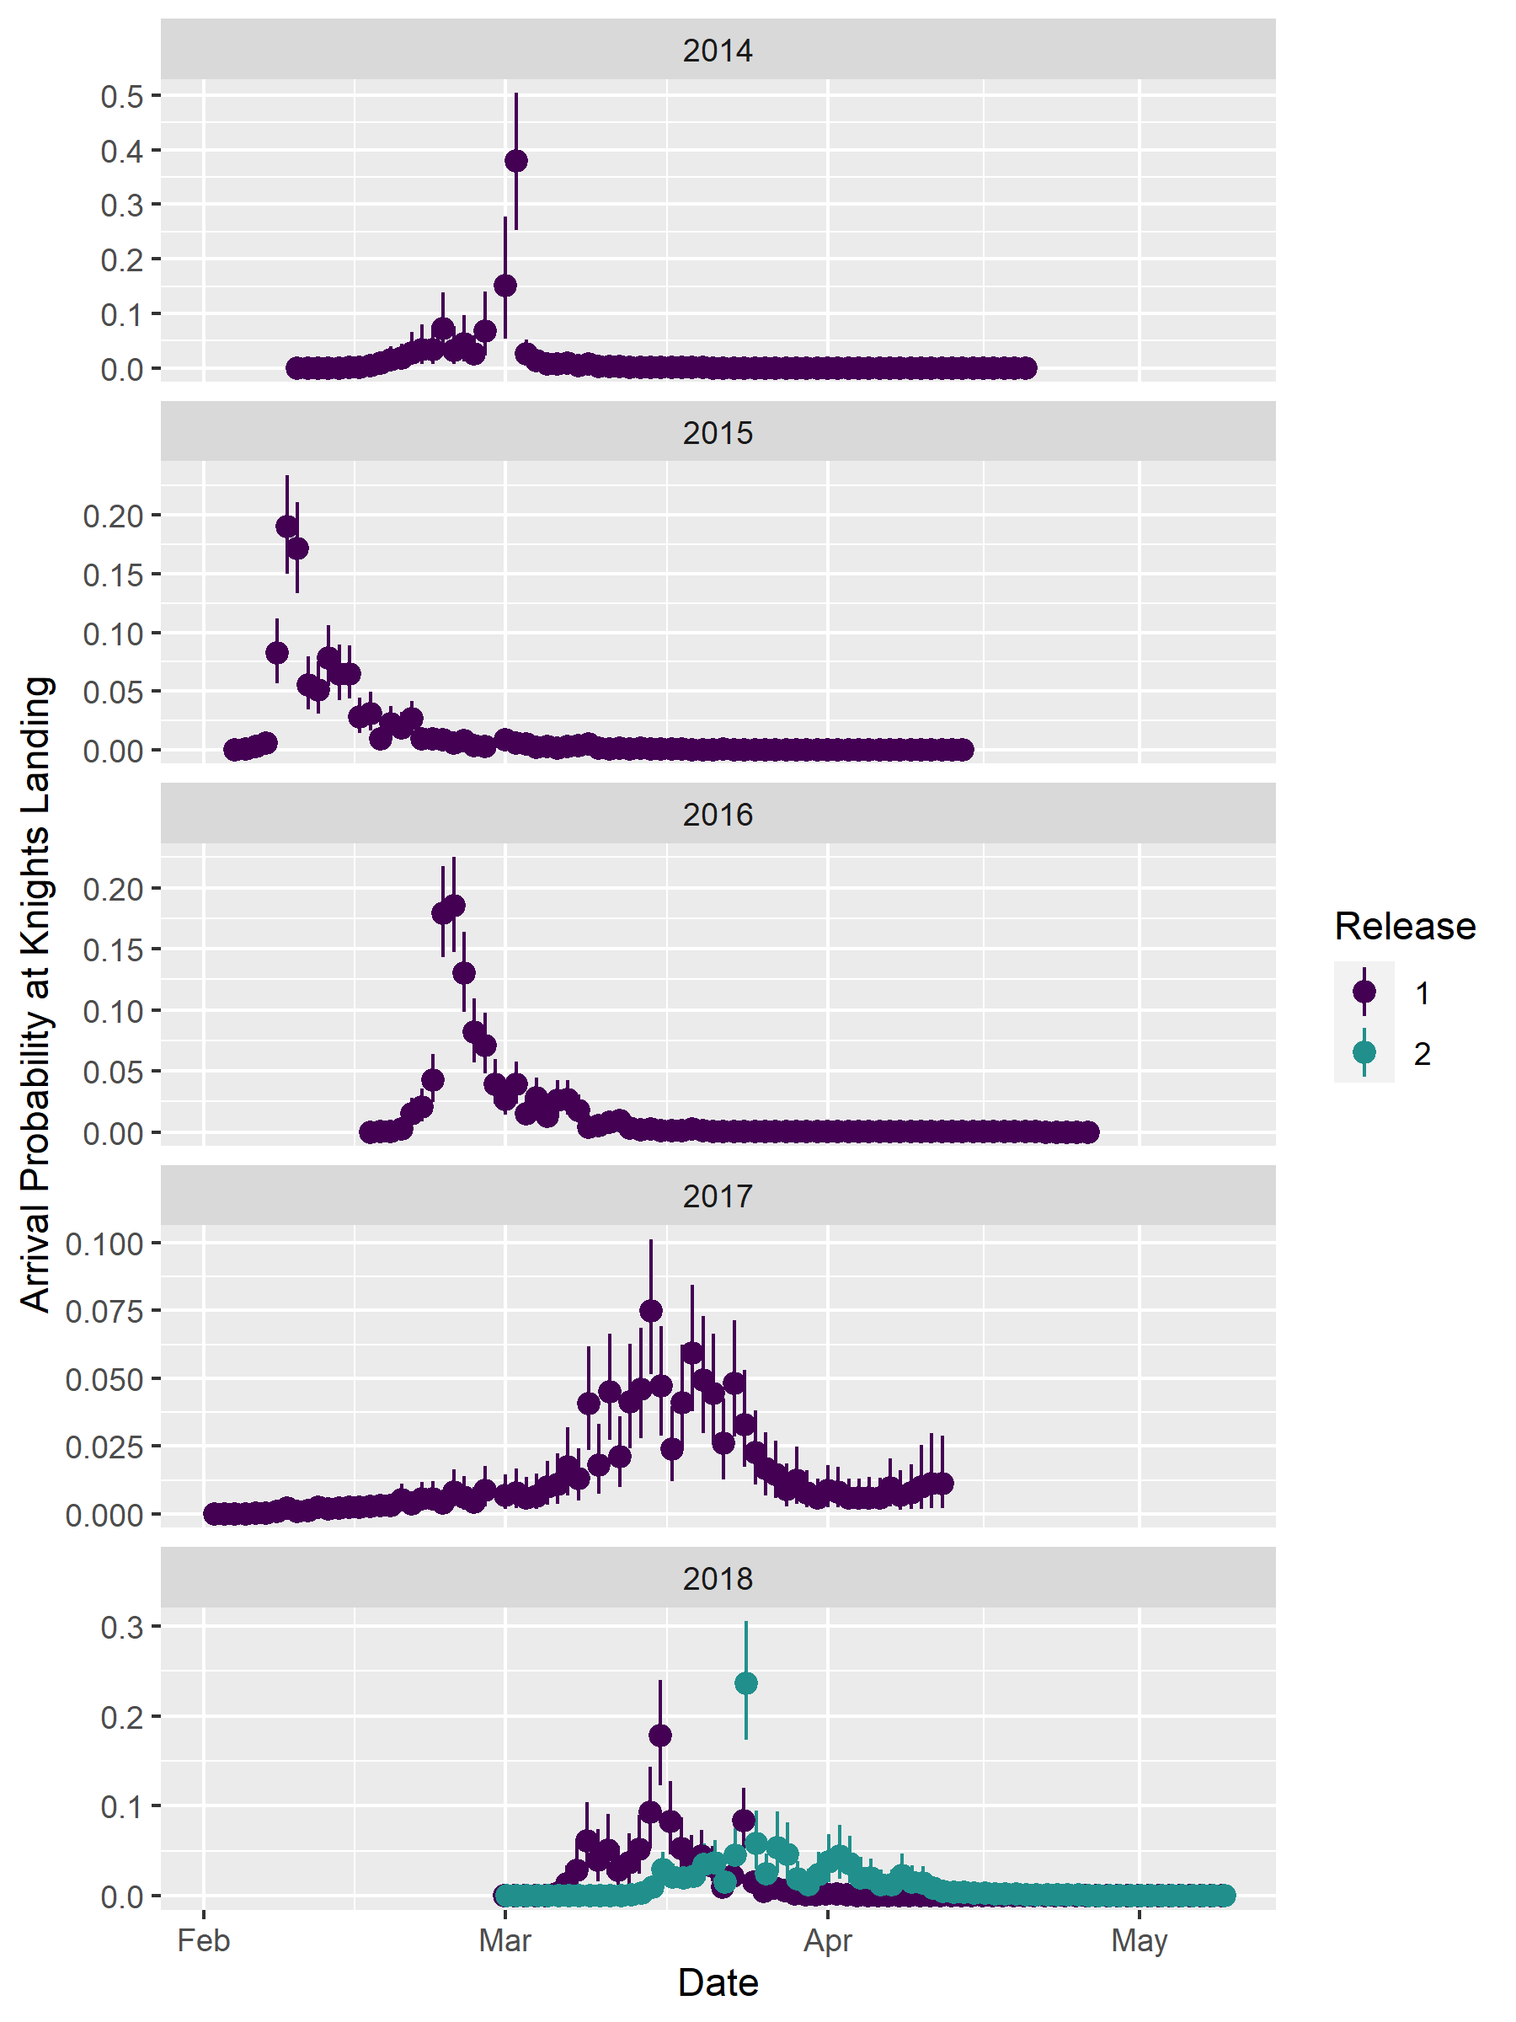

**Supplemental Figure S2:** Kaplan-Meier estimated percent of test tags still operating after activation.

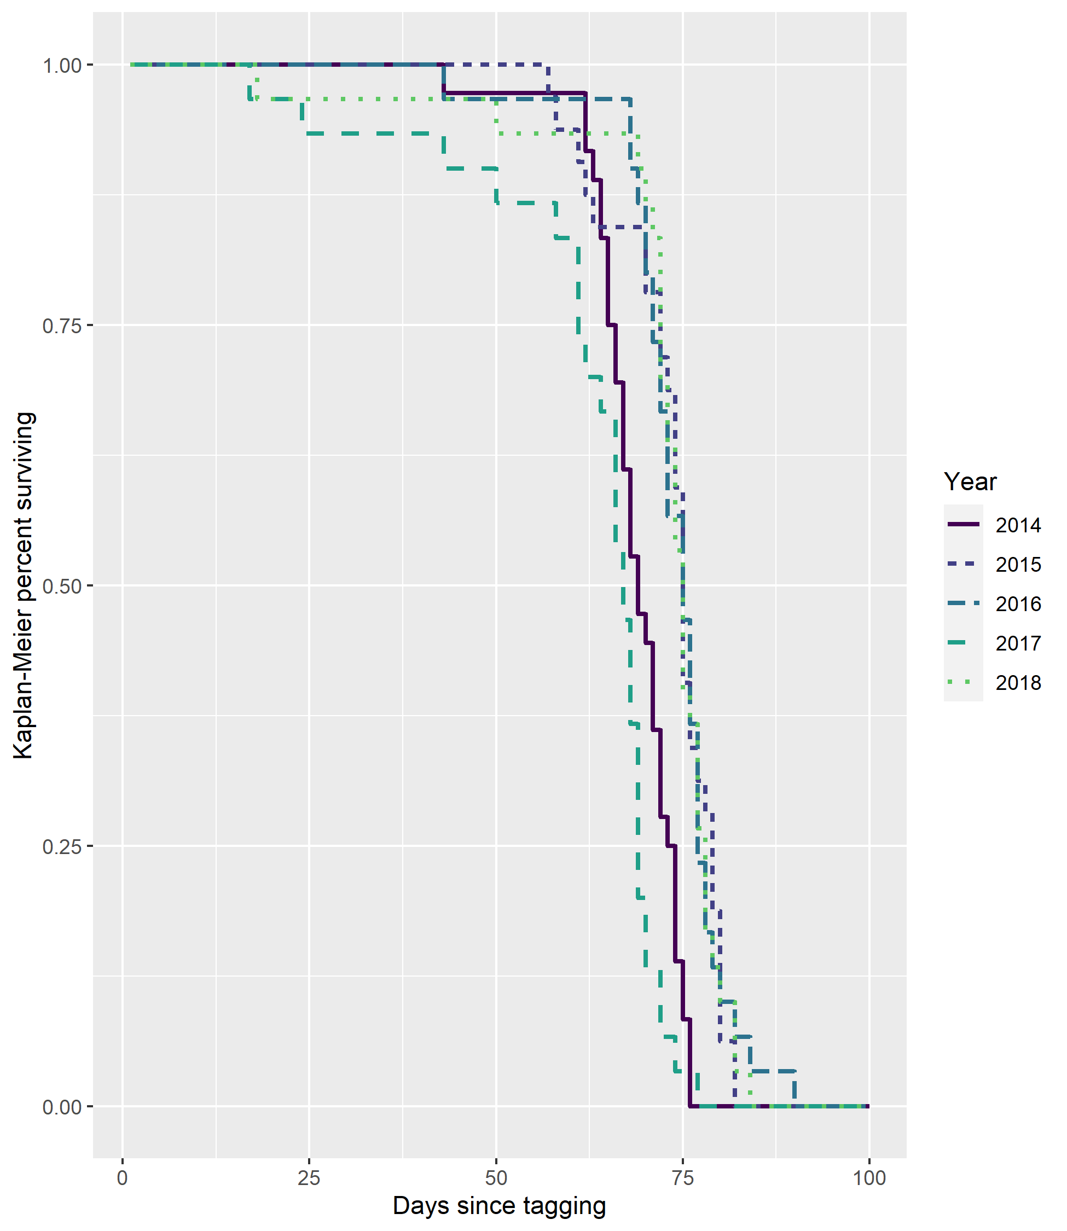

**Supplemental Figure S3:** Estimated daily reach-specific survival probabilities for hatchery-reared winter run Chinook salmon migrating through the Sacramento River Delta from 2014 through 2018. Lines denote the posterior mean and shaded area the 90% credible interval.

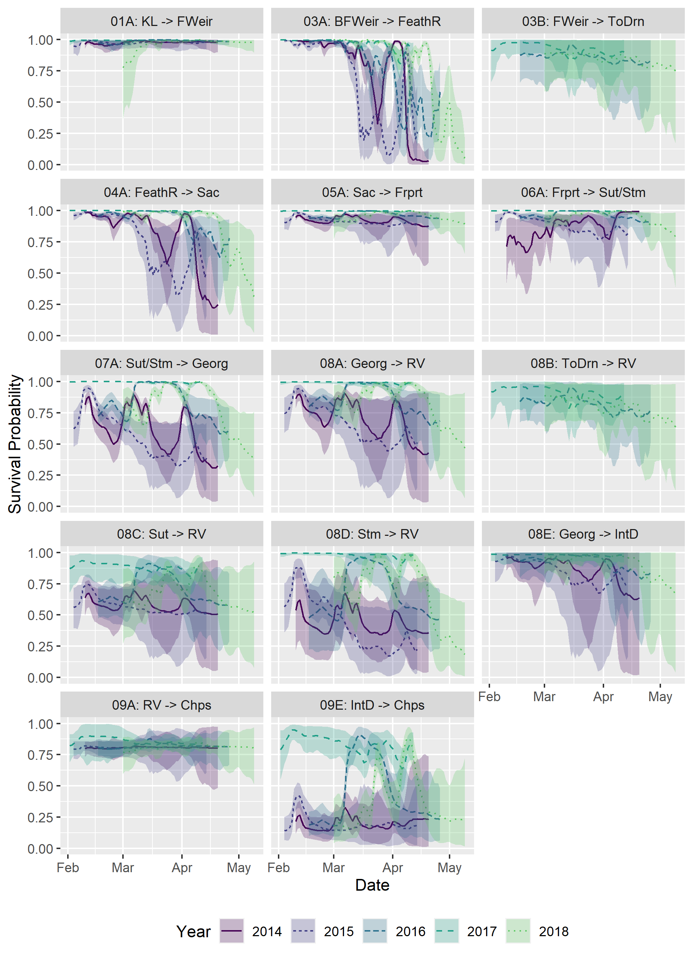

**Supplemental Figure S4:** Estimated daily reach-specific median travel times for hatchery-reared winter run Chinook salmon migrating through the Sacramento River Delta from 2014 through 2018. Lines denote the posterior mean and shaded area the 90% credible interval.

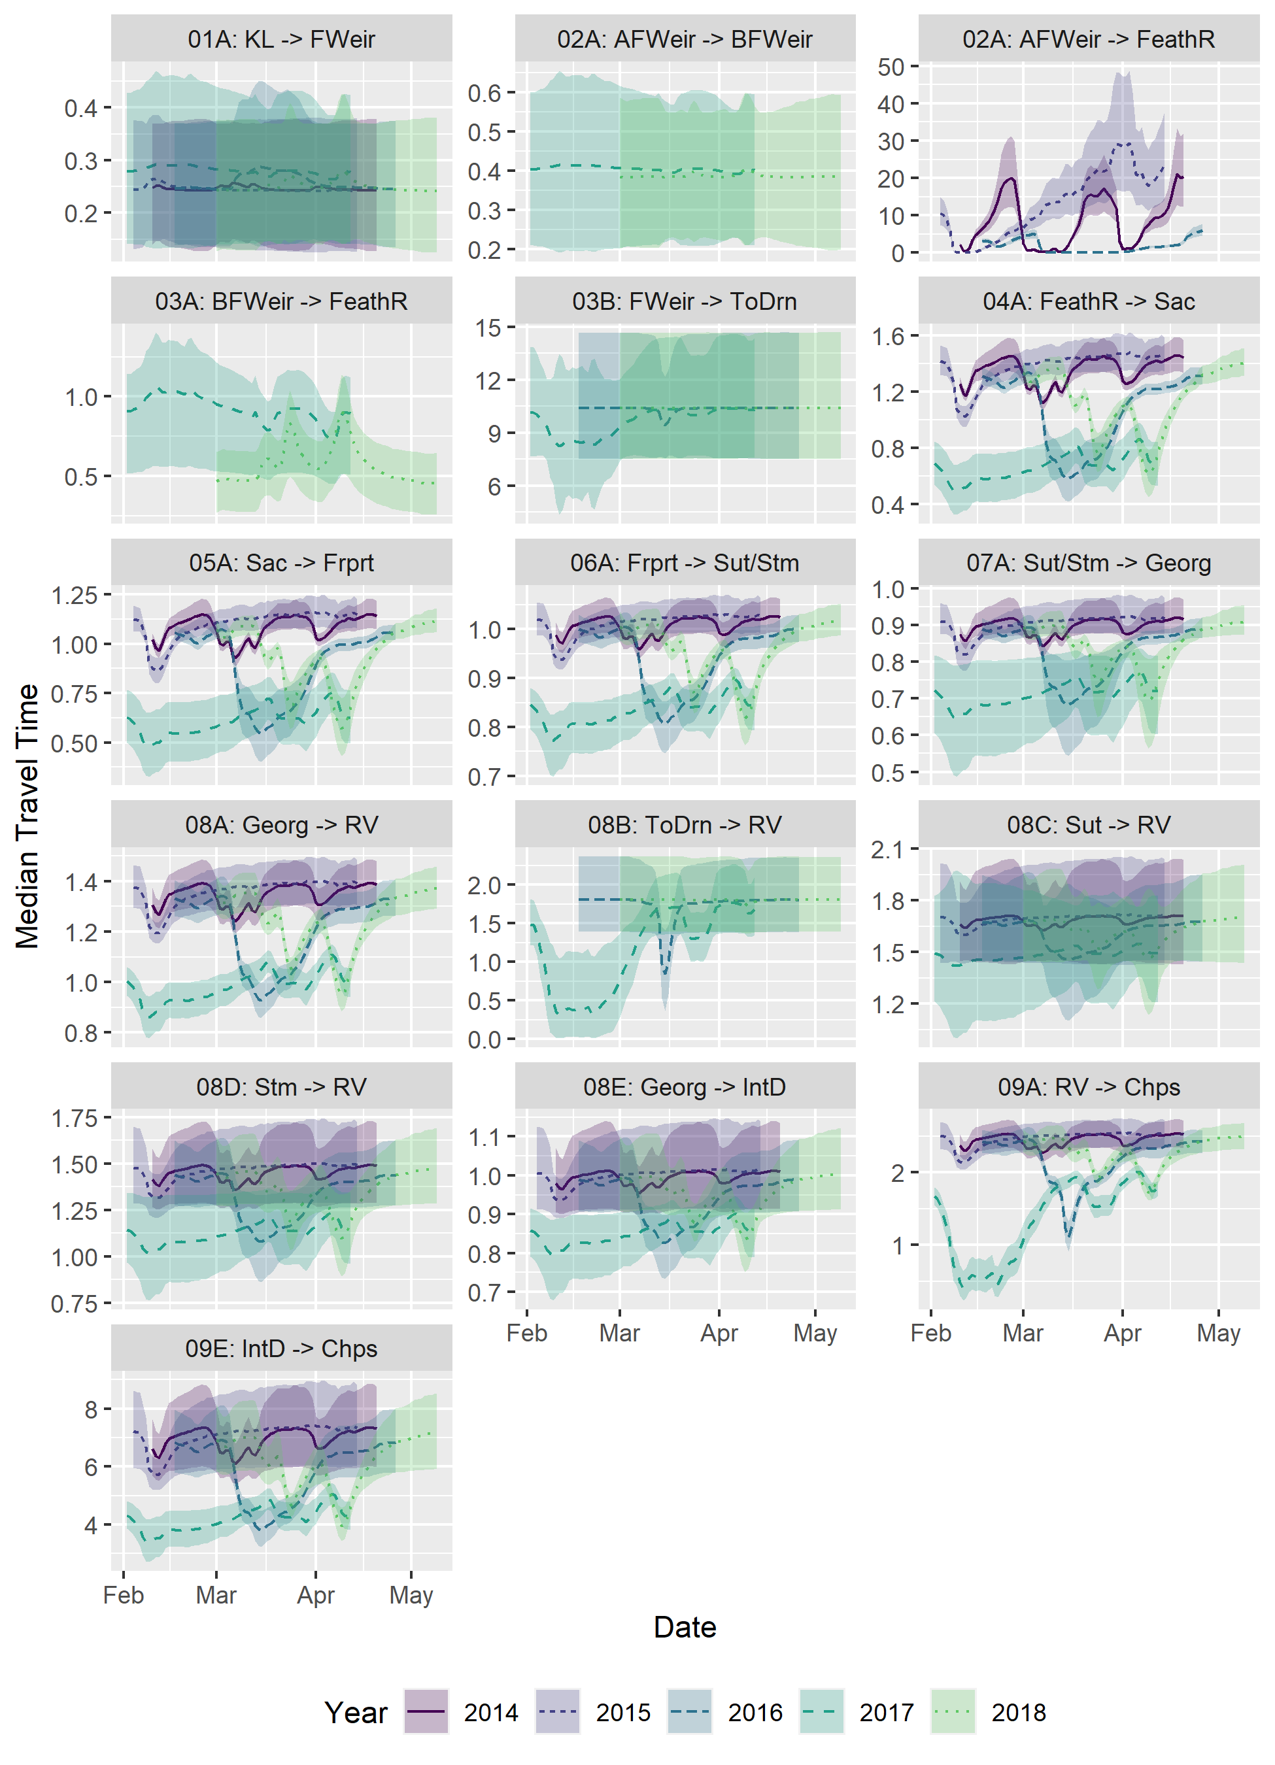

**Supplemental Figure S5:** Estimated daily routing probabilities at each transition point through time for hatchery-reared winter run Chinook salmon migrating through the Sacramento River Delta from 2014 through 2018. Lines denote the posterior mean and shaded area the 90% credible interval. Yolo Bypass is only accessible when the Fremont Weir is overtopping which occurred only in 2016, 2017 and 2018.

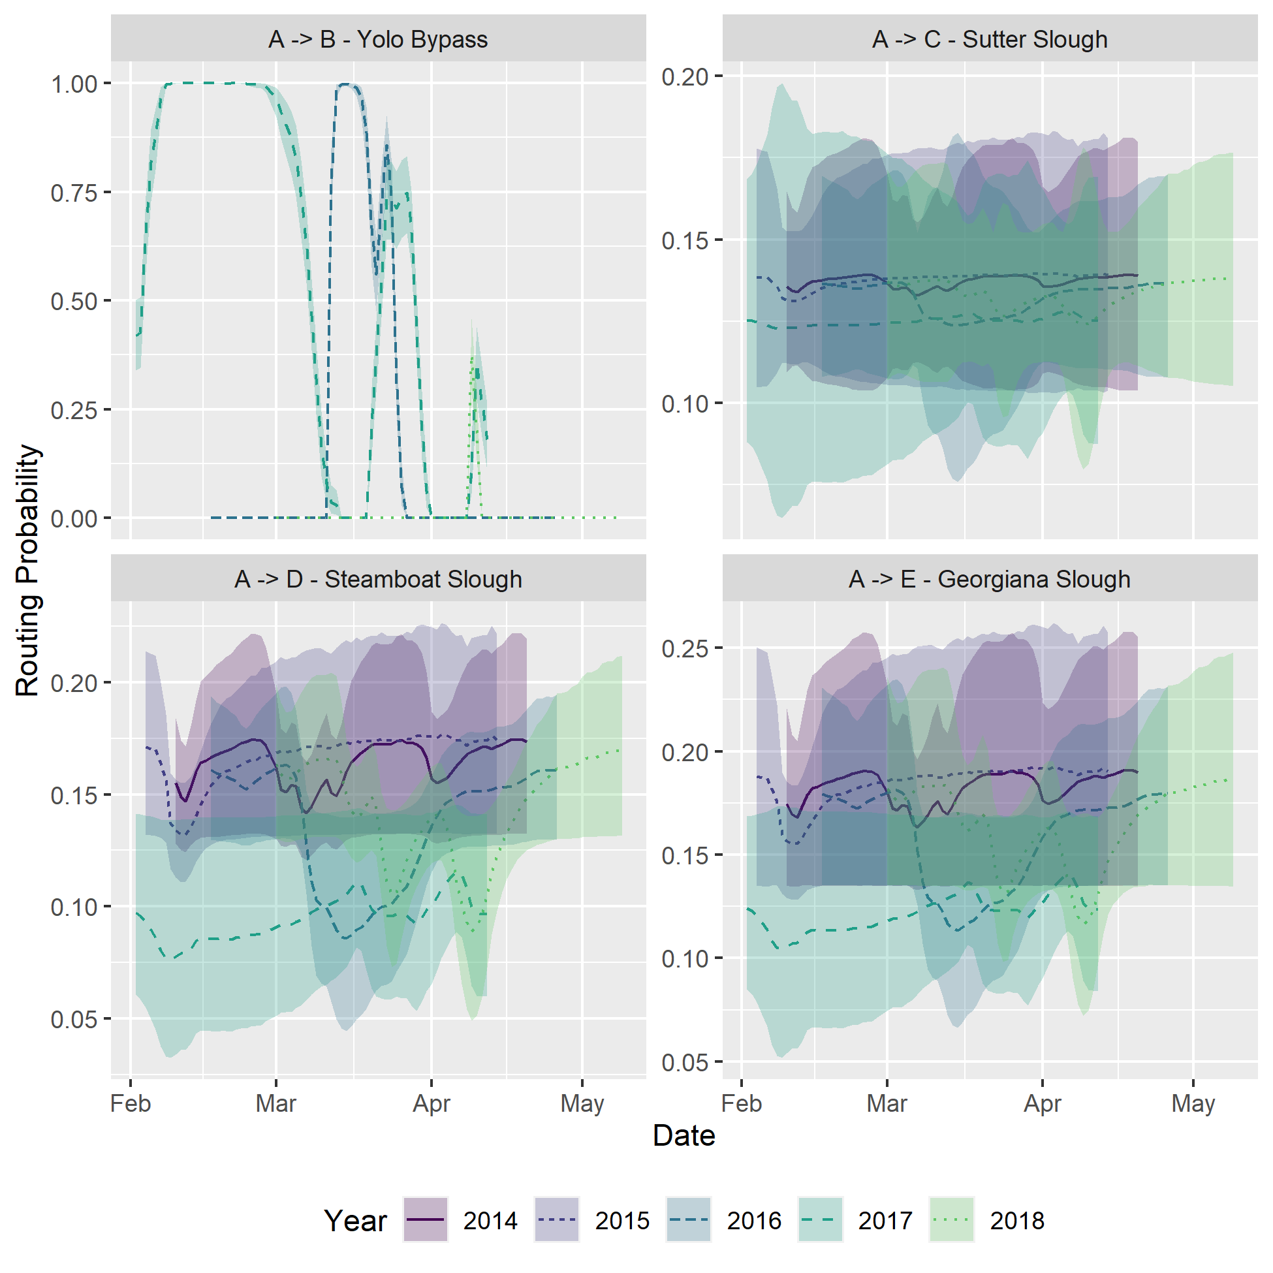

**Supplemental Figure S6:** Estimated daily reach-specific detection probabilities for acoustic-tagged hatchery-reared winter run Chinook salmon migrating through the Sacramento River Delta from 2014 through 2018. Lines denote the posterior mean and shaded area the 90% credible interval. When acoustic receivers were known to be offline due to damage, detection probability was set to zero.

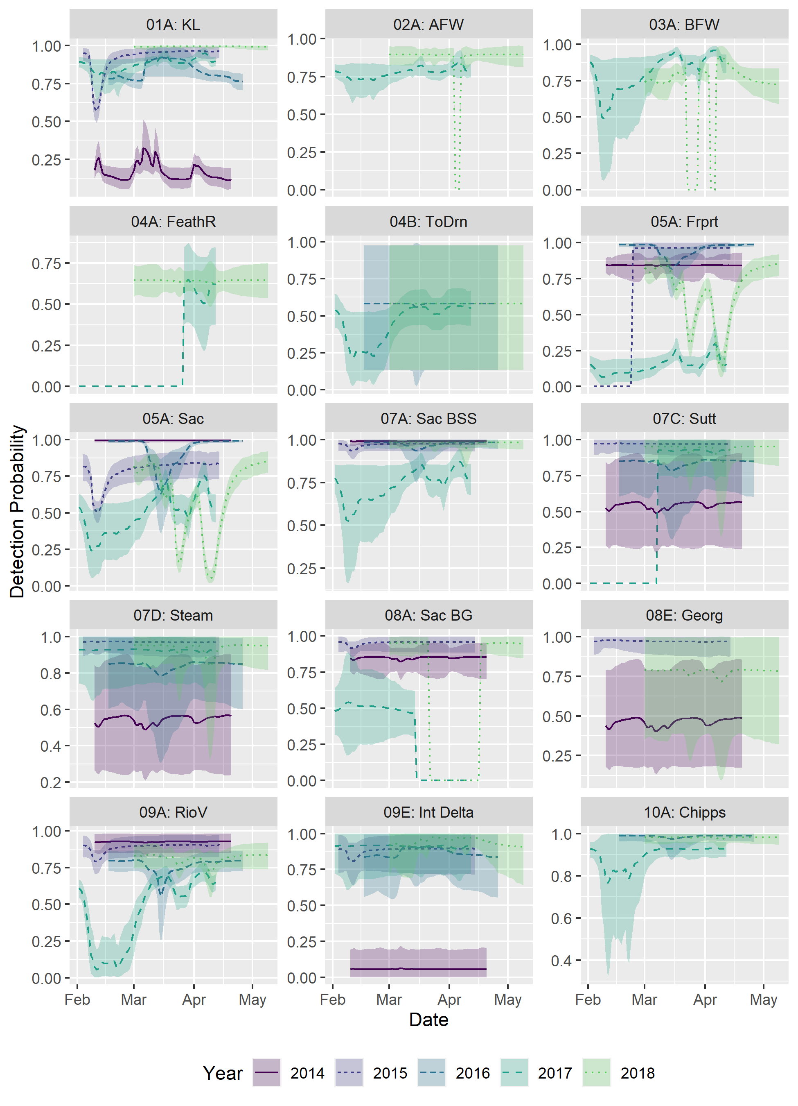

**Supplemental Figure S7:** Route selection probability Island for winter run Chinook salmon based on day of passage at Knights Landing. Overall route selection probability is condition on survival and calculated by summing through all possible arrival day and routing probabilities at downstream reaches conditional on entering a given route.

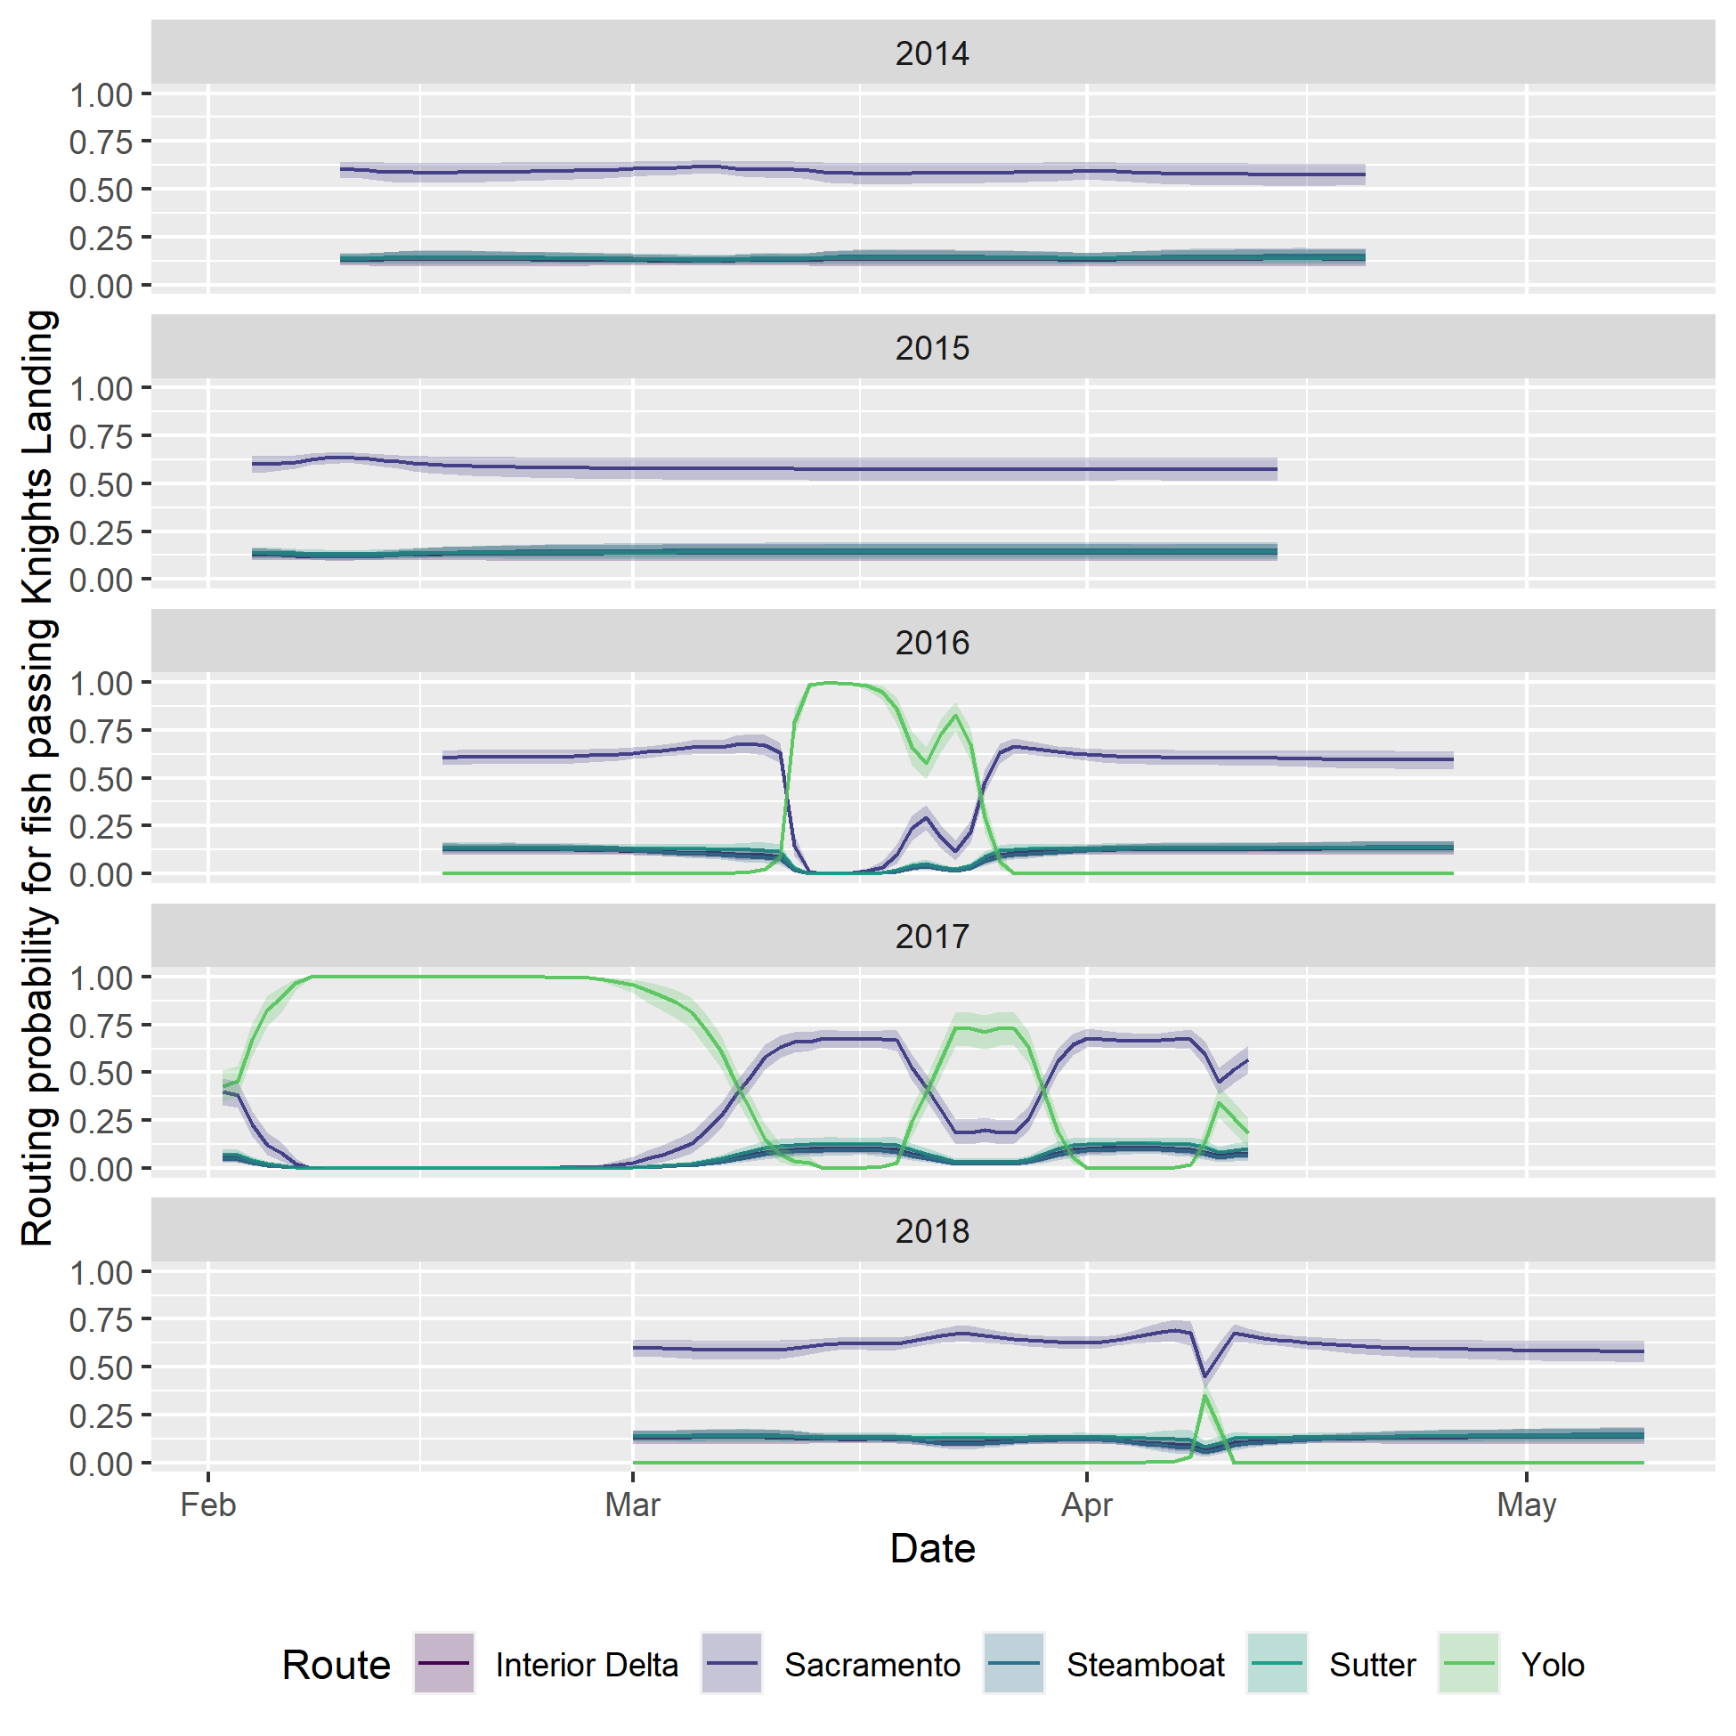

**Supplemental Figure S8:** Route specific survival through the Sacramento River Delta from Knights Landing to Chipps Island for winter run Chinook salmon based on day of passage at Knights Landing. Route specific survival is calculated by summing through all possible survival and arrival day probabilities at downstream reaches conditional on entering a given route. The shaded area represents the 90% uncertainty interval.

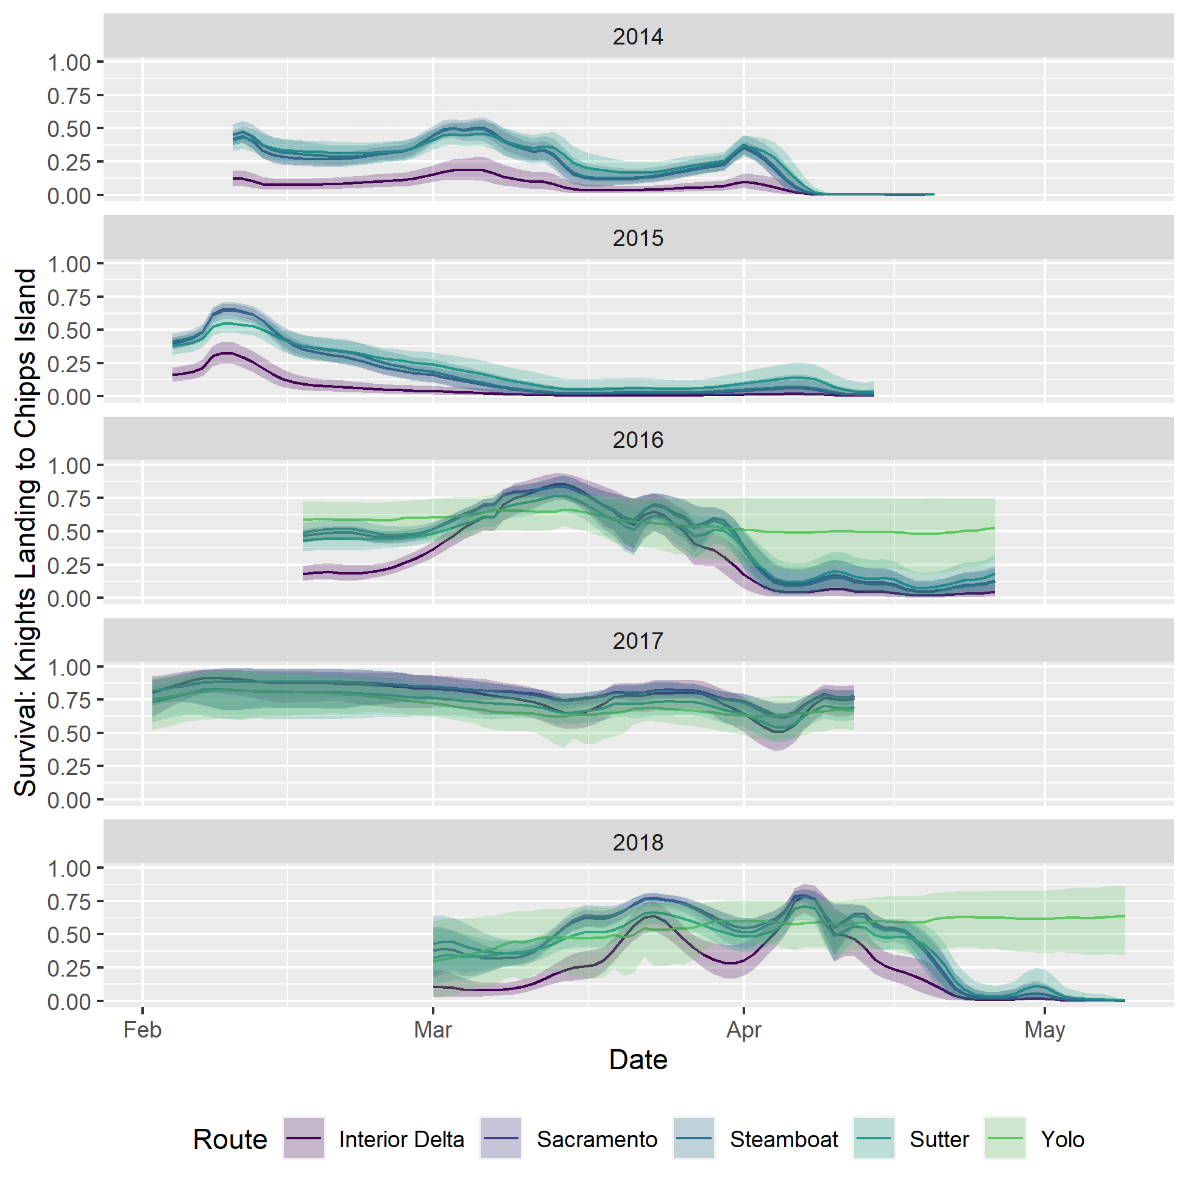

**Supplemental Figure S9a-s:** The following nineteen figures display posterior predictive checks for the temporally-stratified multistate mark-recapture model for survival, travel time and routing of winter run Chinook Salmon through the Sacramento River Delta. For 1000 draws from the posterior, we simulated new data under data generating process of the TSMSMR model. The posterior predictive checks display the observed data as a point and error bars representing the 5th and 95th percentiles of the posterior predictive distribution for various summary statistics.

