This test is implemented to ensure that the admin can view all the users in the database through the web browser

|  |  |  |  |  |  |
| --- | --- | --- | --- | --- | --- |
| **UC18** | | **Browse Users** | | | |
| Test ID | Description | | Expected Output | Actual Output | Result |
| 18.1 | Admin selects user’s tab and is populated with all the users | | List of users are displayed on screen | List of users are displayed on screen | Pass |

Testing Steps

Step 1: Input the admin credentials

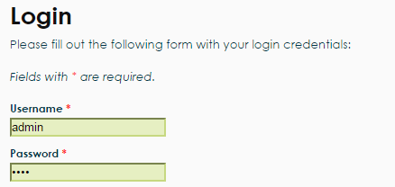

Step 2: Click on the User’s tab



Step 3: View Users List

