**Add User**

Once logged in, the administrator can add a new user into the system by first clicking on the ‘Users’ tab.

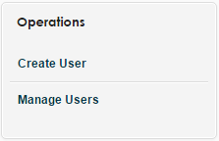

*Figure 1. Create user operation*

A new page will be loaded, displaying a list of users. On the right side menu, clicking on the ‘Create User’ link (see Figure 1) will redirect the administrator to another page where information about the new user can be entered. (see Figure 2).

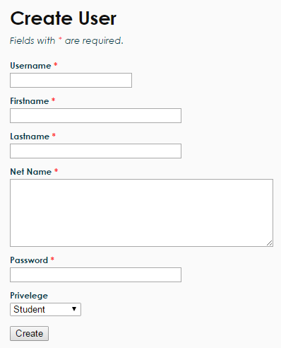

*Figure 2. Create user form*

All fields of the form must be completed to be valid. The password must be at least 6 characters long and this will be the password used to log into the system for the user, along with the username. The privilege options allow the administrator to select whether the new user is a student or an administrator.

Upon completing all fields of the form, the administrator may click on the ‘Create’ button at the bottom to submit it. If the user was successfully created, the newly created user’s information will be displayed on another page to the administrator, along with an ID number (see Figure 3).

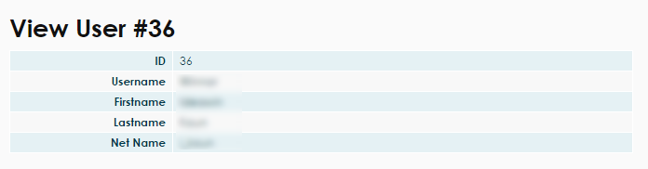

*Figure 3. View the newly created user’s information*