**Documentation**

# Team: RappelAbstraction

Table of contents:

Team members: …………………………………………………………………… 2

Description of the C++ functions……………………………………………. 3

Team members:

Boris Simeonov – SCRUM Trainer

[BDSimeonov19@codingburgas.bg](mailto:BDSimeonov19@codingburgas.bg)

Presyan Stefanov – Developer

[PSStefanov19@codingburgas.bg](mailto:PSStefanov19@codingburgas.bg)

Vasilen Mihaylov – QA Tester

[VMMihaylov19@codingburgas.bg](mailto:VMMihaylov19@codingburgas.bg)

Radoslav Lisitsov – Code Checker

[RPLisitsov19@codingburgas.bg](mailto:RPLisitsov19@codingburgas.bg)

Educational Institution

Vocational High School of Computer Programming and Innovations



Selected programming technologies:

C++

Description of C++ functions:

**Function name**: Menu

**value type**: void

**Arguments**: none

**Purpose**: Displays the game menu.

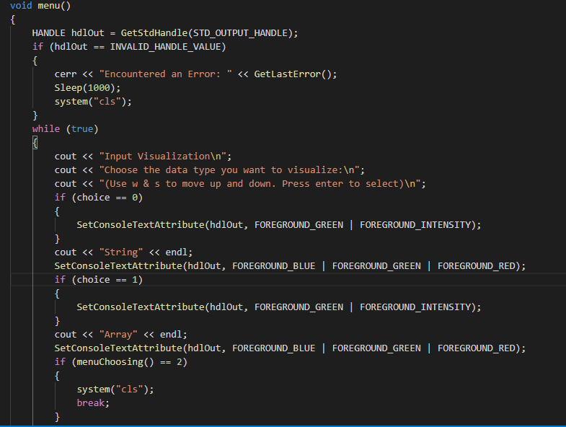

**Function name**: menuChoosing

**value type**: int

**Arguments**: choice

**Purpose**: Memorises user input and changes colours of selected option.

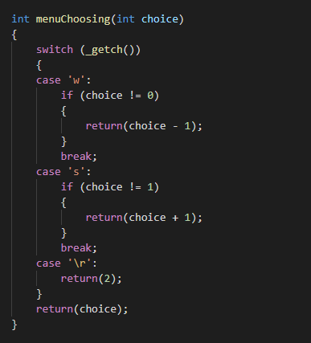

**Function name**: checkChoice

**value type**: void

**Arguments**: none

**Purpose**: Receives input from user.

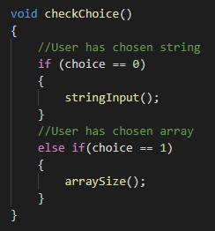

**Function name**: arraySize

**value type**: void

**Arguments**: none

**Purpose**: Receives input from user about the length of the array.

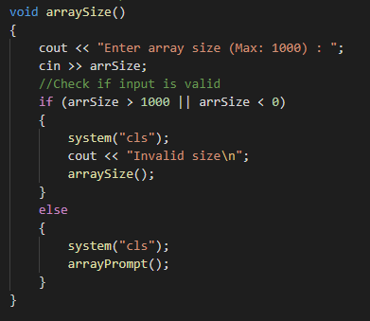

**Function name**: arrayPrompt

**value type**: void

**Arguments**: none

**Purpose**: Displays menu and allows to switch colours.

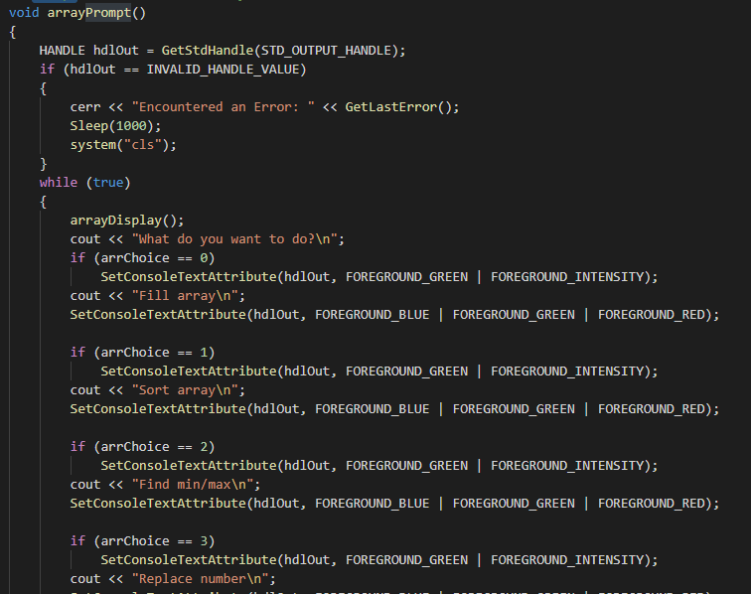

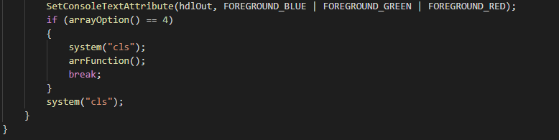

**Function name**: arrayOption

**value type**: int

**Arguments**: none

**Purpose**: Gathers user input and switches colours of the made choices.

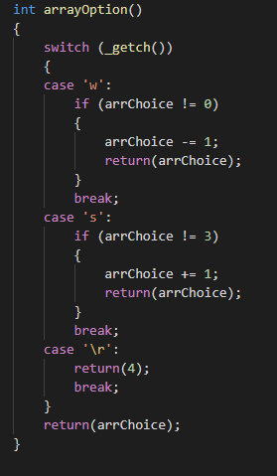

**Function name**: arrayDisplay

**value type**: void

**Arguments**: none

**Purpose**: Displays the current state of the array.

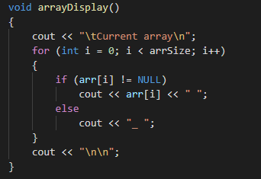

**Function name**: fillArray

**value type**: void

**Arguments**: none

**Purpose**: Gathers input from user and places it at the appropriate places in the array.

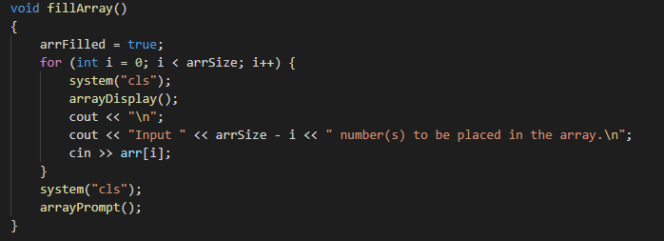

**Function name**: sortArray

**value type**: void

**Arguments**: none

**Purpose**: Displays the menu and is able to alternate colours.

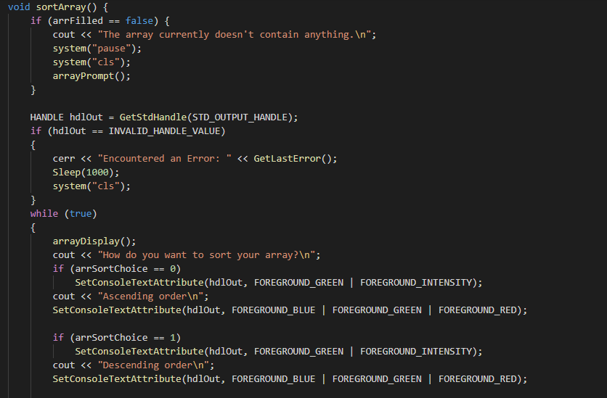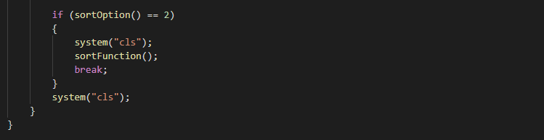

**Function name**: sortOption

**value type**: int

**Arguments**: none

**Purpose:** Controls colour changes and extracts user input.

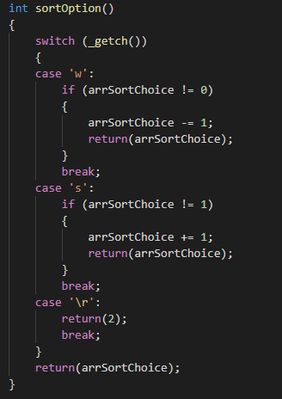

**Function name**: sortFunction

**value type**: void

**Arguments**: none

**Purpose**: Analyses the user’s input.

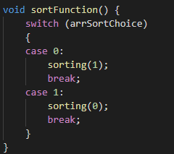

**Function name**: sorting

**value type**: void

**Arguments**: asc

**Purpose**: Places the array in an ascending or a descending order, depending on user input.

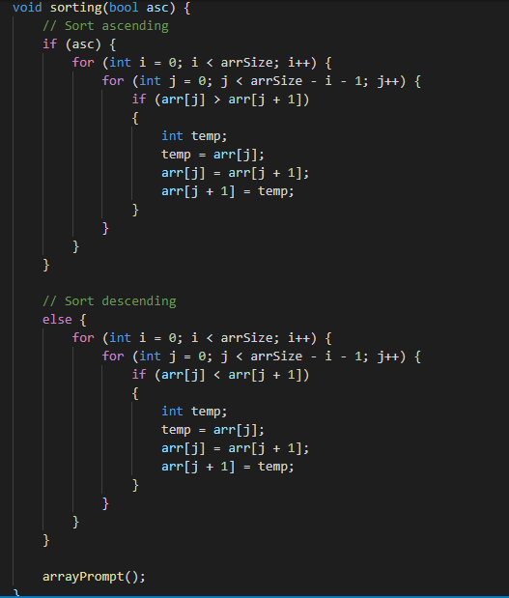

**Function name**: minMaxArray

**value type**: void

**Arguments**: none

**Purpose**: Identifies the biggest and smallest elements of the array.

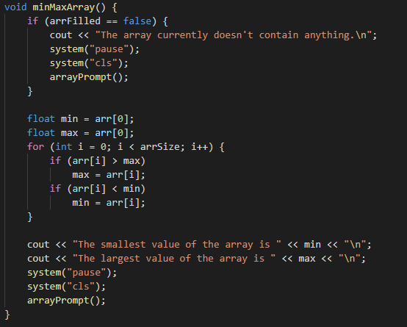

**Function name**: replaceIntArray

**value type**: void

**Arguments**: none

**Purpose**: Replaces one of the already existing elements of the array, with a given user input.

