Predicting the Big Bash League Player of the Match

A Comparative Analysis of Statistical and Regression Models

INTERNAL – NOT FOR EXTERNAL DISTRIBUTION

Prepared By David Bailey
Instructor: Dr ********

August 2025

Table of Contents:
Executive Summary 1
Section 1: Introduction 3
Section 2: Exploratory Data Analysis 4
2.1 - Raw Data and Preprocessing: 4
2.2 - Initial Data Analysis: 5
2.3 - Feature Engineering 9
Section 3: Modelling Methodology Justification 11
3.1 – Penalised Logistic Regression: 11
3.2 – Conditional Generalised Linear Model (GLM) 12
3.3 – Generalised Additive Model (GAM) 12
3.4 – Random Forest (RF) ensemble 13
Section 4: Model Findings and Comparative Analysis 13
Section 5: Discussion and Implications 17
5.1 – Key findings 17
5.2 – Practical applications 17
5.3 – Assumptions and limitations 18
Section 6: Conclusion and Recommendations 18

Player of the Match (PotM) award, recognising a player whose contribution fundamentally altered the game’s outcome for their team’s betterment.

Executive Summary
Can the Big Bash League Player of the Match (PoTM) be predicted using only objective performance data?

The report was motivated by the ambiguous nature of PotM award systems and aims to introduce a more data-driven methodical approach. This report demonstrates that objective performance data can be used to predict the PotM from match groupings. This project analysed 10 seasons of Big Bash League (BBL) data (7-men, 3-women) and applies four different modelling techniques. Player performance is measured using summarised match data and then worked to train machine learning models. The models used were: penalised Logistic Regression (LR) variants, conditional Generalized Linear Model (GLM) variants, a Generalized Additive Model (GAM), and a Random Forest (RF) ensemble.
Three consistent findings emerged from the modelling comparison:
- Fundamental Problem:
  - Candidates for each match total 22 (11 players per team), with only one player receiving the PotM award. This extreme class imbalance means a model that fails to identify any winner can still achieve a 95.45% accuracy score.
- Batting/bowling bias:
  - Given the high-pressure environment of T-20 cricket it is expected that batters take more risk then they would in other formats. Coupled with limited overs (~120 balls per innings, 1 innings per team) batting performance is a highly significant indicator of PotM outcome. In general bowling contribution affect’s PotM award, but is seen as a secondary driver for batting performance.
- Model Trade-offs:
  - There is an inherent trade-off between models identifying a single winner whilst providing well-calibrated probabilities. The logistic regression (elastic net, global scaling) achieved the highest top 1 accuracy picking the PotM winner in ~69% of matches. However, its calibration performed poorly. A GAM approach yields slightly lower top-1 accuracy (~67%) but produced the most reliable probabilities and the strongest shortlisting results. The RF ensemble’s conservative probability distribution, increasing calibration but reduced accuracy.
Model performance was evaluated under two conditions. First, how well each model ranked the true Player of the Match (PotM), and second, how true probabilities were.
The results lead to the conclusion that there is no best model that fits all criteria. The preferred approach is dependent on operator intent.
This project’s timing coincides with cricket’s increasing embrace of technology and analytics. Innovations like the Duckworth-Lewis-Stern (DLS) method, Hawk-eye, and UltraEdge enhance objectivity in decision adjudication. In the same spirit, this analysis uses statistical models to reduce systemic bias in player recognition by quantifying performance impact transparently. Whilst using cricket, the PotM prediction method generalises to other team sports where similar performance impact is awarded.
Additional applications include:
- Broadcasting platforms using models to highlight likely PotM candidates during and after matches.
- Coaches and team management setting objective benchmarks for individual contribution. Mapping trends over time.
- Provides a transparent and unbiased framework for player performance. This transparency offers a clear rationale for PotM awards.
- Sporting bookmakers use of probabilities manages log-odds distribution. Calibrated probability estimates translate to improved risk management.
In summary, the findings demonstrate a viable, tested baseline model for PotM prediction that complements human judgement and supports fair recognition of player performance.

Section 1: Introduction
The T-20 Big Bash League (BBL) is Australia’s dominant cricket competition, where displays of merit can dramatically shift match outcomes. Lacking a formal criterion for PotM I offer, formally recognising a player whose contribution fundamentally altered the game’s outcome for their team’s betterment. Similar PotM award structures exist throughout sport, yet the selection process is ambiguous, often blending objective statistics with influence-bias. Fans and commentators on occasion debate these choices, insighting that unweighted factors like a spectacular moment or popular fan sentiment overwhelm this decision making. This raises the intriguing question: Can we predict the PotM using only objective performance data?
The question poses a discrete choice problem: in each match, out of 22 players, exactly one is chosen. The goal is not to perfectly replicate historical judgement but to discover the data-defined patterns that underlie PotM selection.
Cricket as a sport has shown an increased willingness to use technology and data to inform crucial decision making. The international Cricket Council (ICC) has implemented tools like the Duckworth-Lewis-Stern method used to define fair run targets in rain-restricted conditions, the Hawk-Eye system reviews LBW appeals, and the UltraEdge system for detecting bat-ball contact. These tools show ICC intent to make the game’s outcome more objective. In the same manner, PotM modelling provides clarity, by quantifying contribution in a measurable way eliminating bias-controversy while complementing the traditional framework.

Section 2: Exploratory Data Analysis
To explore this idea, 10 seasons of BBL data are analysed (seven men’s BBL, three women’s WBBL). Developing and comparing four modelling approaches which exploitative leverage vary for data processing techniques.

2.1 - Raw Data and Preprocessing:
The dataset for this project was derived from ball-by-ball match record and match summary metadata. By constructing a player-match level dataset singular player performance can be observed. The target variable is a binary flag indicating whether that player was the PotM (1-true, 0-false).
After cleaning the data, the final dataset covers 424 matches spanning the 10 seasons. Of the 424 matches 422 PotM instances were observed (2 matches with no award).
Initial Features:
- Player Performance:
  - Runs scored, Balls Faced, Boundaries (fours, sixes), Strike rate, Overs bowled, Wickets taken, Runs conceded, Dot balls, Bowler Economy,
- Match Information:
  - Season, League, Innings, Winner, Toss result, Home/away designation.
- Player Traits:
  - Categorical flags for Batter, Bowler, All-rounder.
These features form the basis for feature engineering applied for modelling.

2.2 - Initial Data Analysis:
From the initial frame, early insight into the condition under which PoTM awards were made are recorded and examined through descriptive tabulation.
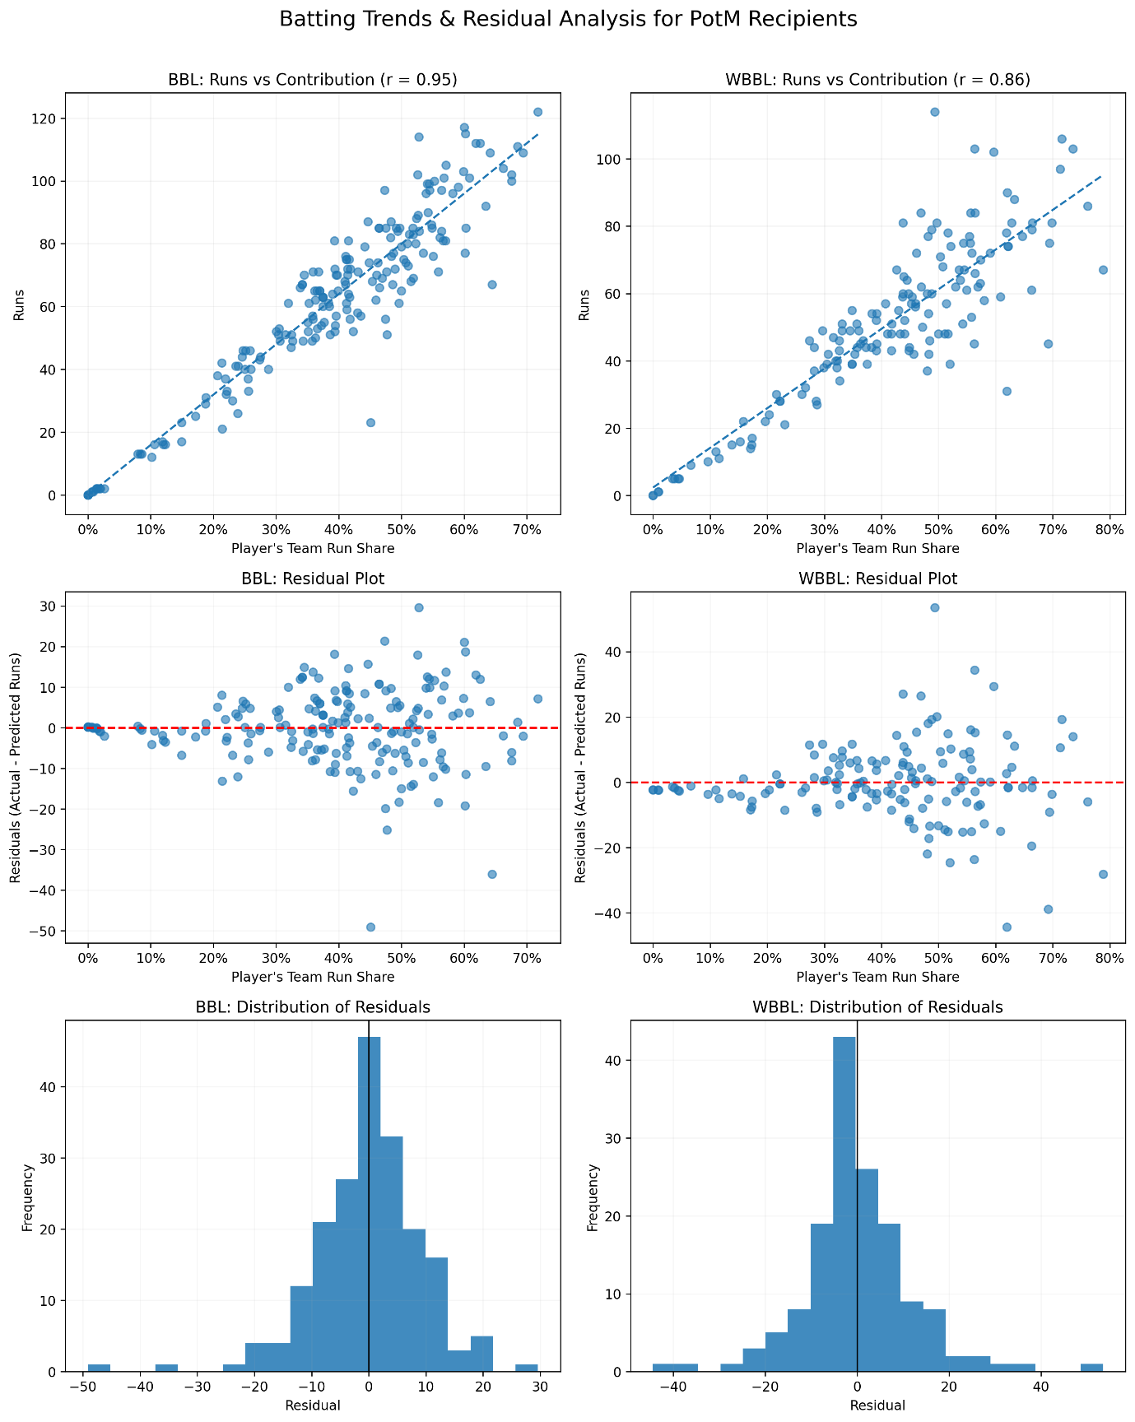
Figure 1: Batting contribution:

In the data, PotM’s scored a median of 51 runs in a match, compared to a median of 5 for non-winners. 72.99% of recipients recorded at least 20% of their teams total run share, and 19.91% of recipients had less then 1% of the team share. Unsurprinsgly, runs and run share are highly correlated (r ~ 0.90), this feature displays player influences proportional to team performance. High strike rates (runs/balls faced) also bolster batting impact.
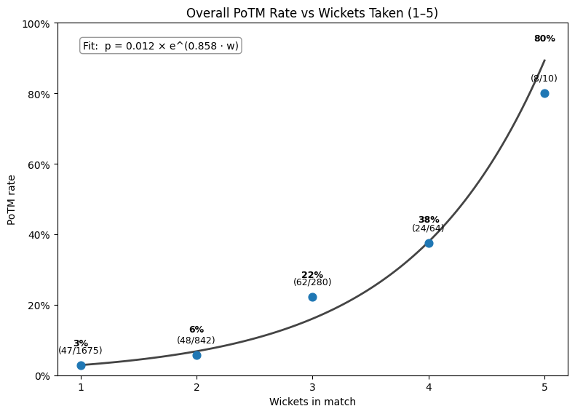
Figure 2: Bowling contribution:

Generally, the more wickets a player took, the higher their probability of PotM choice, observing an exponential relationship. It was also found that not all wickets are equal, bowler economy provides insight for average bowls/wicket. This rate influences PotM, has less effect that wicket count (appendix 1).

Match Information:
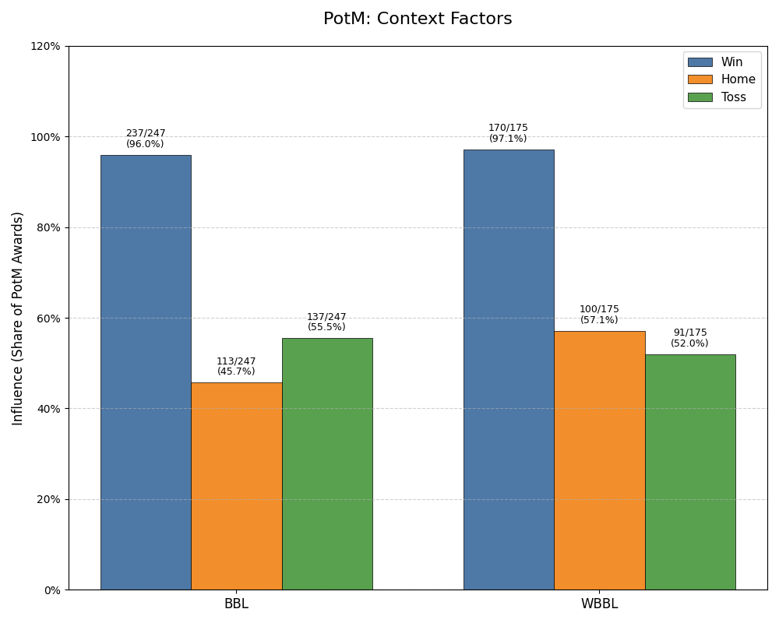
Figure 3: Contextual Factors:

The strongest context factor affecting PotM was whether the player’s team won the match. $\frac{407}{422}$, ~ 96.45% of all of all PotM winners were from the winning team. This recognised that any model will heavily favour players on the match-winning team, and will struggle to recognise PotM impact from losing teams. Contrasting, home team proportion is $\frac{213}{424}\sim 50.23\%$, toss-winner and PotM was a similar result.

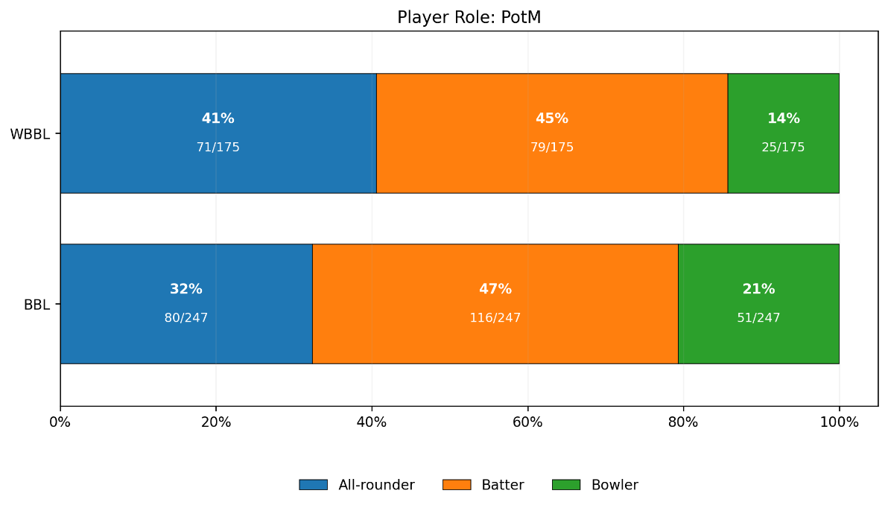
Figure 4: Player Role Contribution
Looking at PotM distributions across player roles, we observe batters having a 46.21%, all rounders 35.78% and bowlers having 18.01% share of the PotM awards. Player role influence reinforces that multi-dimensional contributions are highly valued in PotM selection.
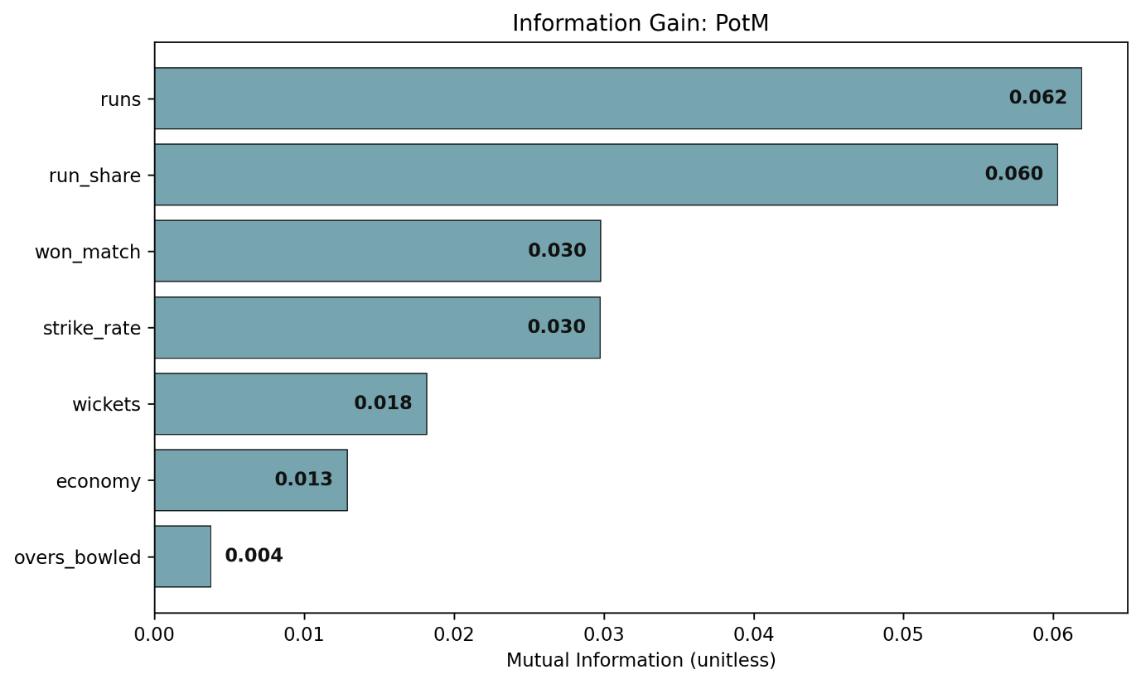
Figure 5: Information Gain

To quantify which features carry the most predictive signal for PotM, mututal information (MI) was calculated between each feature and PotM outcome. MI is a measure of how much a feature reduces uncertainty about the another (PotM). Runs scored and run share emerged as the two top predictors by wide margin. Other informative features were the Won Match flag, strike rate and to a lesser effect wicket taken. We additionally measured correlation between features, which can lead to inflated variance for feature coefficients (appendix 2).

2.3 - Feature Engineering
The insights from the exploratory analysis guided the creation of several engineered features to improve model learning. In total, the final modelling dataset includes 32 features, including those engineered from raw data. Notable engineered features include:
Full Engineered Feature List in appendix [3]

Section 3: Modelling Methodology Justification
In addressing a discrete choice task, four complementary modelling approaches were identified. Each possessing characteristics approach the problem. Given the nature of the data, potential non-linear effects, high dimensionality and correlated features. The models are:
- Penalised Logistic Regression (LR)
- Conditional Generalized Linear Model (GLM)
- Generalized Additive Model (GAM)
- Random Forest (RF) ensemble.

3.1 – Penalised Logistic Regression:
LR provides a natural starting point for binary choice prediction. It estimates the probability of a player winning PotM as the logistic function of features, coefficients offering an interpretable measure of each feature’s effect (ceteris paribus). Given the high-dimensional space, with measured feature correlation, and identified non-linearities. Simple logistic regression hinders, using it would lead to overfitting, unreliable coefficients, and extensive multicollinearity.
We use a penalisation term to minimise the loss function of the logistic regression. Methods: L1 (lasso), L2 (ridge), and a combination of ridge and lasso (elastic net) penalisation were compared to address this.
L1,L2 penalty:
$$L1= λ\sum_{i=1}^{p}{\left|β_{i}\right|} , L2= λ\sum_{i=1}^{p}{β_{i}^{2}}$$
Elastic Net Penalty:
$$EN=λ\left(α\sum_{i=1}^{p}{\left|β_{i}\right|}+\frac{1-α}{2}\sum_{i=1}^{p}{β_{i}^{2}}\right)$$
LR Features:
$η_{i}​=β_{0}​+x_{i}^{⊤}​β_{i}$ , $p_{i}​=σ\left(η_{i}​\right)\frac{1}{1+e^{-η_{i}}}$
Model Function:
$$\min_{β_{0},β_{k}}{\frac{1}{n}}\sum_{i=1}^{n}{[-y_{i}\log\left(p_{i}\right)-\left(1-y_{i}\right)\log\left(1-p_{i}\right)] }+λ\left[\frac{1-α}{2}{\left\|β\right\|}_{2}^{2}+α{\left\|β\right\|}_{1}\right]$$
For Net elastic penalisation lambda controls the overall strength of the penalty whilst alpha represents the mixing weighting parameter balancing L1 and L2. Naturally $0≤α≤1.$

3.2 – Conditional Generalised Linear Model (GLM)
An important aspect of the problem is the grouped structure with one winning outcome. Standard logistic regression could predict more than one player per game with >50% probability, which breaks the 1 outcome requirement. Incorporating per-match competition we use a conditional structure ensuring match probabilities sum to 1. This is analogous to discrete choice or link formulation, with:
Logit link,
$$P_{im}=\frac{e^{{(η}_{im})}}{\sum_{j∈1}{e^{{(η}_{im})}}}$$
Probit link,
$$P_{im}=Φ\left(η_{im}\right), where Φ is the standard normal CDF$$
Cauchit link,
$$P_{im}={CDF}_{Caunchy}\left(η_{im}\right)=\frac{1}{π}\tan^{-1}\left(η_{im}\right)+0.5$$
Loglog link,
$$P_{im}=1-e^{-e^{η_{im}}}$$
Cloglog link,
$$P_{im}=1-e^{-e^{{-η}_{im}}}$$
Whilst logit is standard for multinomial choice, capturing unobserved factors (probit) or extreme outliers (cauchit) can offer improved insight. Therefore a comprehensive approach is used.

3.3 – Generalised Additive Model (GAM)
The exploratory data analysis revealed non-linear relationships. Generalized Additive Models (GAMs) provide a flexible extension of logistic regression by allowing non-linear functions of each predictor. For a GAM, the log-odds of PotM are defined as:
$$\log\left(\frac{P\left(y=1 | X\right)}{1-P\left(Y=1 | X\right)}\right)=β_{o}+f_{1}\left(x_{1}\right)+f_{2}\left(x_{2}\right)+⋯f_{p}\left(x_{p}\right)$$
Where each $f_{p}\left(x_{p}\right)$ is a smooth function fit to the data. This means the model can learn non-linear relationships. Smoothing splines are key for reliable predictors. Further applying penalty for the smooth terms avoid overfitting complex relationships. It is expected that GAM’s excel in calibrating probabilities, leveraging its capture of nuanced data.

3.4 – Random Forest (RF) ensemble
Finally, a RF model, identifying non-parametric relationships capture complex interactions that simple regression methods fail. Bootstrapping the tree learning process aggregate predictions to inform an orbicular perspective.
Strengths:
- Handles complex non-linear relationships and feature interaction. Dynamic outlier handling, and dimensionality assessment.
Weakness:
- Poor interpretability. It doesn’t provide simple coefficients, though general feature importance can be estimated.
The RF model is used to set a performance benchmark for the other models.
Summary
- M1: Provides a simple, transparent baseline model that assumes linear relationships and uses penalty feature selection.
- M2: Specialised model that removed cross-match bias by comparing players within the same match.
- M3: A flexible interpretable model that captures non-linear effects, whilst maintaining interpretability.
- M4: A powerful approach used as a performance benchmark to capture complex relationships.
The main goal is to compare these diverse models to understand the trade-off between simplicity and accuracy. Observing if complex approaches outperform simpler linear approaches, determining the most effective and appropriate approach.

Section 4: Model Findings and Comparative Analysis
After training the models (using cross-validation and hold-out techniques) to tune hyperparameters), each model’s performance is evaluated. Given the extreme class imbalance (1 positive case of 22 players), overall accuracy would be misleading, as simply predicting no for all players would yield a 95.5% accuracy.
- Ranking metrics:
  - Mean Reciprocal Rank (MRR) is the average of the reciprocal of the rank of the actual winner. Where MRR=1 represents the winner being correctly identified.
  - NDCG@3 looks at the top 3 rankings and gives a weighted score $0≤NDCG≤1$, the closer to 1 the higher the credibility of specification.
- Probability Metrics:
  - Log loss (cross entropy) penalises the model for assigning low probability to the true winner, Los-loss=0 represents the best probability estimate.
  - Brier score is the $ε_{μ}^{2}$ of probability predictions, BS = 0 represent predicted probabilities specifying actual binary outcome flags.
  - Expected Calibration Error (ECE) measures the difference between predicted probabilities and actual frequencies using decile binning approach. A low ECE means that probability estimates are practically appliable.
For this specific problem, where one winner is chosen from 22 candidates the standard classification metric Recall (or sensitivity or True Positive Rate) is mathematically equivalent to Top-1 Accuracy [appendix 4] as both measure the proportion of times the single true winner was correctly identified. Additionally, I considered the Area Under the Receiver Operating Characteristic Curve (AUC-ROC) to measure each model’s ability to discriminate points between PotM winners and non-winners. The complete performance data is available in [appendix 5-6].
For fair comparison, all models are evaluated on the same held-out data (via cross-validation and out-of-fold methods). Additionally, we analyse model performance under three different feature scaling methods to test the sensitive to data pre-processing.
- No scaling (raw features):
  - Using the original units of each feature. More suitable for ensemble methods like Random Forests, lack scaling for linear models.
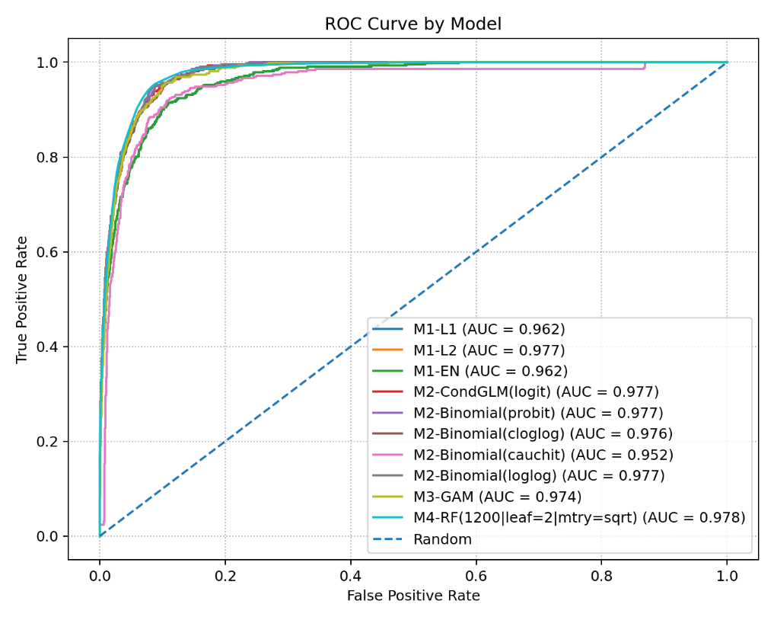
Figure 6: ROC curve for Raw Features
- Global Scaling:
  - Using a standard scalar on features across the entire dataset $\left(\frac{x_{i}-μ_{i}}{σ_{i}}\right)$.
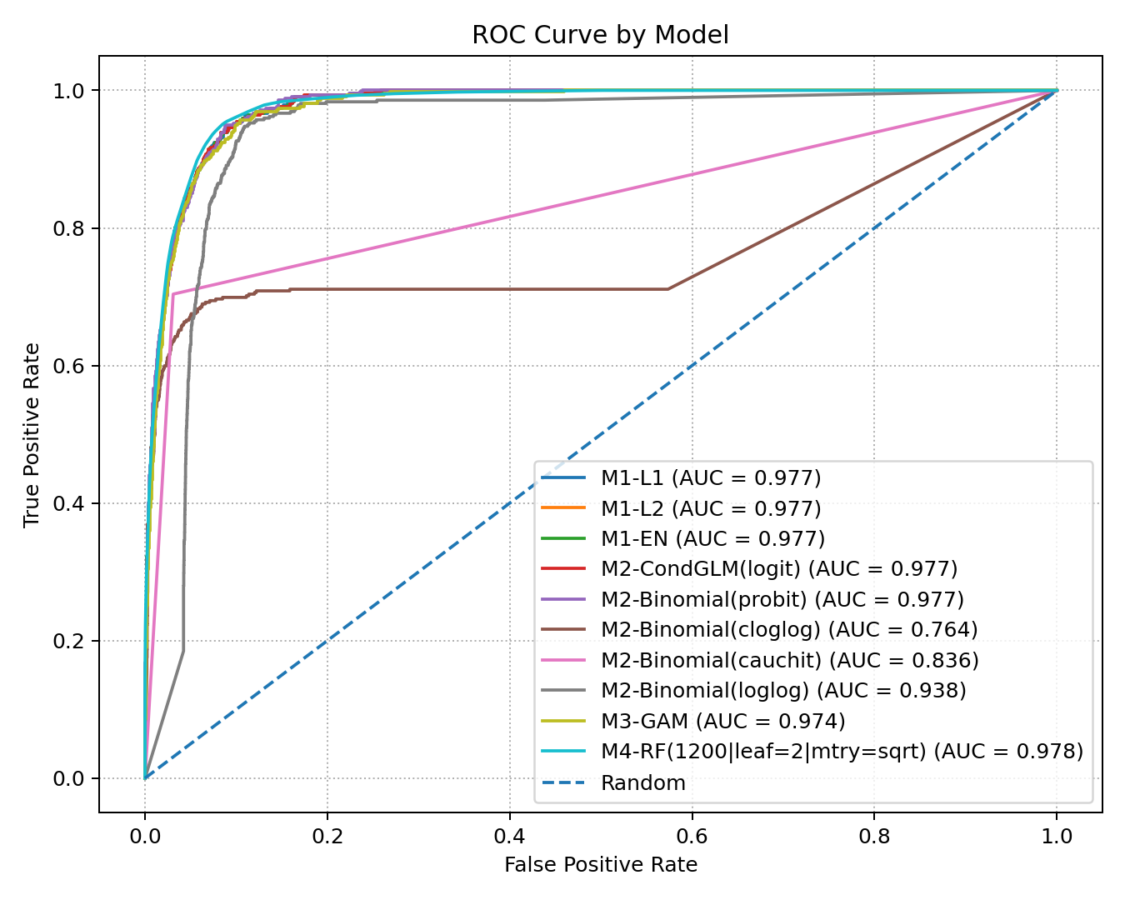
Figure 7: ROC curve for Global Scaling
- Match level Normalisation:
  - Standardising features within each match. Providing an effective measure of player performance for in game contexts.
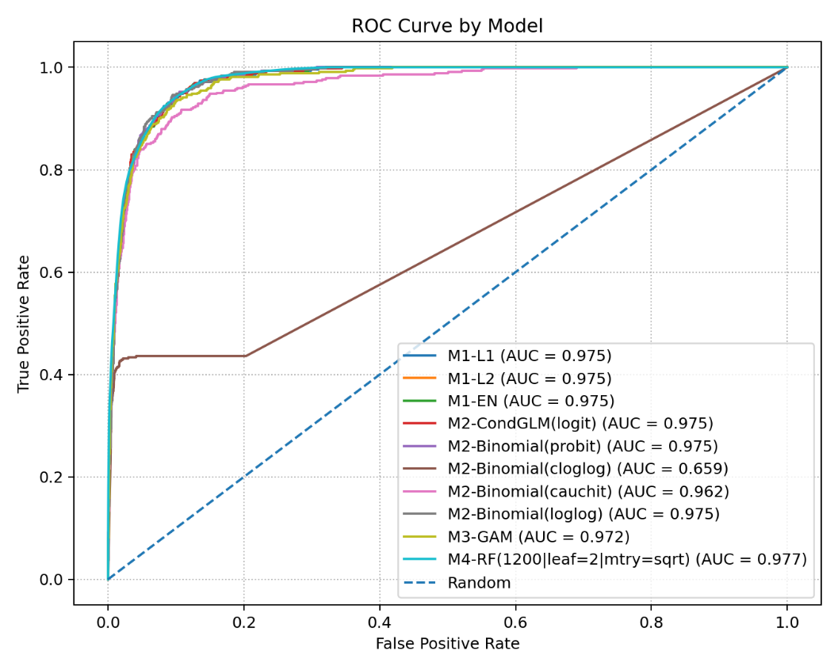
Figure 8: ROC curve for Match Z-scores

Full Results in appendix X.
It is observed that feature scaling had a notable influence on logistic models, performing best with global standardization, whereas the per-match z-scoring while conceptually appealing, scaling for the match without taking into consideration how good that game was historically. The conditional GLM model inherently works within-match so it was less affected by scaling. Random Forest saw its best performance on the raw data.

Model 1: Penalised Logistic Regression Results
Scenario | Model | Top-1 | Top-3 | MRR | NDCG3 | Logloss | Brier | ECE
Global Scale | EN | 0.6896 | 0.9360 | 0.8176 | 0.8376 | 0.8853 | 0.0203 | 0.0070
Raw Data | L2 | 0.6706 | 0.9384 | 0.8076 | 0.8312 | 0.8832 | 0.0202 | 0.0072

The elastic net (EN) penalty on globally scaled data produced the best ranking performance, correct identifying ~69% of matches. This model also demonstrated excellent discriminatory power with an AUC of 0.9769. However, its probability estimates were overstated as shown with a calibration slope of 1.36.
Model 2: Conditional GLM results
Scenario | Model | Top-1 | Top-3 | MRR | NDCG3 | Logloss | Brier | ECE
Global Scale | Logit | 0.6896 | 0.9336 | 0.8175 | 0.8364 | 0.8856 | 0.0203 | 0.0070
Raw Data | Probit | 0.6682 | 0.9431 | 0.8055 | 0.8314 | 0.8644 | 0.0202 | 0.0043
Match Z-score | Cauchit | 0.6209 | 0.8981 | 0.7664 | 0.7868 | 1.2505 | 0.0240 | 0.0155
Raw Data | Loglog | 0.6825 | 0.9455 | 0.8133 | 0.8382 | 0.8735 | 0.0204 | 0.0027

Unsurprisingly the logit link for conditional GLM mirrors L2 logistic regression. This is because both models apply the same transformation process.
$$LR= σ\left(η_{i}​\right)\frac{1}{1+e^{-η_{i}}} , {Logit}_{im}=\frac{e^{{(η}_{im})}}{\sum_{j∈1}{e^{{(η}_{im})}}}$$
The probit link, assumed a normal distribution of unobserved factors, offered slight improvement in probability estimation with reduced log loss and ECE. Surprisingly the asymmetric loglog link on raw data achieved the best calibration and strong shortlisting (Top-3 = 94.55%) performance (AUC matching L2 LR), making it a reliable choice for generating probabilities.
Model 3: GAM Results
Scenario | Model | Top-1 | Top-3 | MRR | NDCG3 | Logloss | Brier | ECE
Raw Data  /  Global Scale | GAM | 0.6730 | 0.9502 | 0.8093 | 0.8380 | 0.9027 | 0.0211 | 0.0024
Match Z-score | GAM | 0.6659 | 0.9123 | 0.7955 | 0.8121 | 0.9846 | 0.0215 | 0.0024

The GAM delivers the strongest overall performance under raw data and global scaling inputs. Achieving a balance between exceptional performance (top3 0.9502) and accurate probability calibration (ECE 0.0024).
Under z-scored inputs, it maintains strong rankings. Translating the dynamic versatility of GAM’s, capturing accurate rankings and producing faithful probabilities.

Model 4: RF Results
Scenario | Model | Top-1 | Top-3 | MRR | NDCG3 | Logloss | Brier | ECE
Raw Data | RF | 0.6777 | 0.9502 | 0.8108 | 0.8394 | 0.8360 | 0.0195 | 0.0045
Global Scale | RF | 0.6754 | 0.9502 | 0.8093 | 0.8382 | 0.8367 | 0.0195 | 0.0045
Match Z-score | RF | 0.6564 | 0.9218 | 0.7935 | 0.8149 | 0.8955 | 0.0204 | 0.0044
The RF model excelled on raw data, achieving the lowest log loss (0.8360) and highest AUC (0.978) of any model, indicating excellent discriminatory power. Ranking metrics were top-tier with an MRR of 0.8108 implying an average true PotM rank of ~1.23 and a top-3 matching the GAM at 95%. While its calibration was strong (ECE = 0.0045) it was slightly edged out by the GAM and loglog GLM, showcasing a minor trade-off between raw predictive power and precision of its probability estimation.

Section 5: Discussion and Implications
This section interprets the modelling results in practical and theoretical terms. Focusing on key findings, implications for discrete choice prediction and evaluation of PotM outcomes. It also reflects on the strengths and weaknesses of prediction methodology, identifying model strengths and limitations.

5.1 – Key findings
Performance is quantifiable, the results infer that it is feasible to predict Player of the Match (PotM) outcomes using objective performance data. The evaluation framework, finds equilibrium between ranking quality and probability calibration identifies model types and scaling strategies.
GAM (model 3) emerged as the most balanced and replicable model, achieving strong ranking metrics.
- Strongest top-3 accuracy, where PotM is found in the top-3 95.02% of the time.
- MRR = 0.8093: where $\frac{1}{0.8093}$ , averaging correct PotM rank 1.24
- Calibration ECE = 0.0024 throughout all data processing structures.
Conditional GLM (model 2) shows flexible behaviour across link function.
- The loglog and probit links particularly complement the findings of model 3. Achieving comparable ranking metrics with the added benefit of reduced log loss.
Logistic regression (model 1) performed as a competitive baseline, when properly scaled.
- The elastic net variant achieved the highest top 1 accuracy (68.96%) using globally scaled data. Confirming that regularisation improves ranking under linear constraint.
- Probability calibration was uncompetitive with GAM and GLM models.
- Model 1 log less was similar to improvements found in GLM’s.
Random forest (model 4) achieved the highest ranking and probability performance on raw inputs.
- Highest AUC = 0.9780.
- Top 3 = 95.02%
- MRR = 0.8108, average rank 1.23 for true PotM.
- Lowest logloss (0.8360). Reinforcing the assumption RF would provide a strong benchmark.

5.2 – Practical Implications
The findings carry several important implications for applying machine learning modelling to PotM or similar discrete choice settings:
- Models need to be match aware.
  - Methods like conditional GLM’s naturally handle the one-winner-per structure. Models that ignore this risk exceed the sample space.
- Context Relevance.
  - Per match z-scoring, while logically sound in theory, reduced accuracy. By removing the context of a player’s performance relative to historical data, this over-normalisation made it harder for models to identify definitive signal.
- Data Processing.
  - Scaling must be matched to the model family. Linear models benefited most from global standardisation, while the tree-based RF ensemble worked best on raw input.
- The “best” model:
  - For reliable probabilities (bookmaker odds) the GAM or a GLM with probit/loglog link is most appropriate.
  - For accurate ranking and short listing (broadcast commentary) the Random Forest of raw inputs delivers the best performance.

5.3 – Assumptions and limitations
- Simplified representation: The models rely solely on summary data and do not capture the broader narrative. Heterogenous variable incorporation such as weather, clutch moments, or crowd size potentially add value.
- Team-win feature: For in game broadcasting the inclusion of the match result as a feature introduces explicit bias, limiting the model’s features to account for this is better suited for live forecasting without a supplementary win prediction model.
- Data Grouping: The analysis assumes the criteria for awarding PotM has remained stable across all seasons and applies equally to BBL and WBBL matches.

Section 6: Conclusion and Recommendations
This project demonstrates that the BBL Player of the Match award can be predicted with accuracy and reliability using only objective performance statistics. Penalised logistic regression provided the best correct-ranking accuracy, while generalised additive and Random Forest models delivered improved calibration and consistent top‑three rankings. The analysis confirms that batting contribution and team victory are substantial determinants of T20 PotM, with bowling excellence and all‑round performance strong supporters.
From a broader perspective, the report illustrates how statistical learning techniques can increase transparency in award systems, complementing human judgement and boost fan engagement. Future work should incorporate temporal context, explore other flexible models (gradient‑boosted trees), and test the framework on other leagues or sports. A simple “PotM impact score” derived from the model’s coefficients could provide a user‑friendly metric for commentators, coaches and fans.
Overall, the findings support the adoption of data‑driven methods in recognising sporting excellence and suggest that objective metrics can meaningfully inform awards traditionally seen as subjective.

Git repo
https://github.com/BDavid03/DTSC_PotM

Section 7: References

Breiman, L. (2001). Random forests. Machine Learning, 45(1), 5–32.
Duckworth, F. C., & Lewis, A. J. (1998). A fair method for resetting the target in one-day cricket. Journal of the Operational Research Society, 49(3), 220–227.
Fawcett, T. (2006). An introduction to ROC analysis. Pattern Recognition Letters, 27(8), 861–874.
McFadden, D. (1974). Conditional logit analysis of qualitative choice behavior. In P. Zarembka (Ed.), Frontiers in econometrics (pp. 105–142). Academic Press.
Fawcett, T. (2006). An introduction to ROC analysis. Pattern Recognition Letters, 27(8), 861–874.
Hastie, T. J., & Tibshirani, R. J. (1990). Generalized additive models. Chapman & Hall/CRC.
McFadden, D. (1974). Conditional logit analysis of qualitative choice behavior. In P. Zarembka (Ed.), Frontiers in econometrics (pp. 105–142). Academic Press.
Zou, H., & Hastie, T. (2005). Regularization and variable selection via the elastic net. Journal of the Royal Statistical Society: Series B (Statistical Methodology), 67(2), 301–320.
Hastie, T., Tibshirani, R., & Friedman, J. (2009). The elements of statistical learning: Data mining, inference, and prediction (2nd ed.). Springer.

Appendix
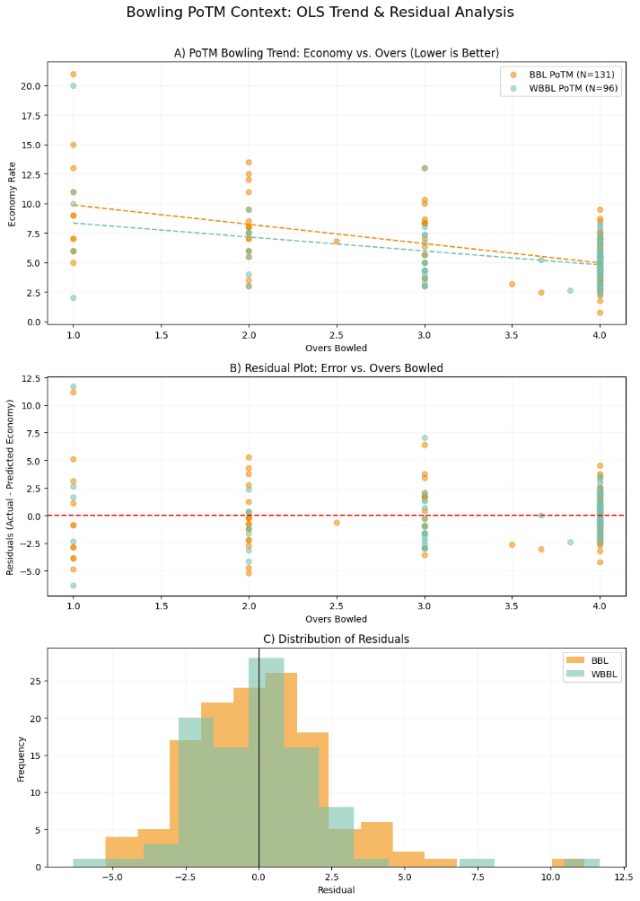  [1] | [2]  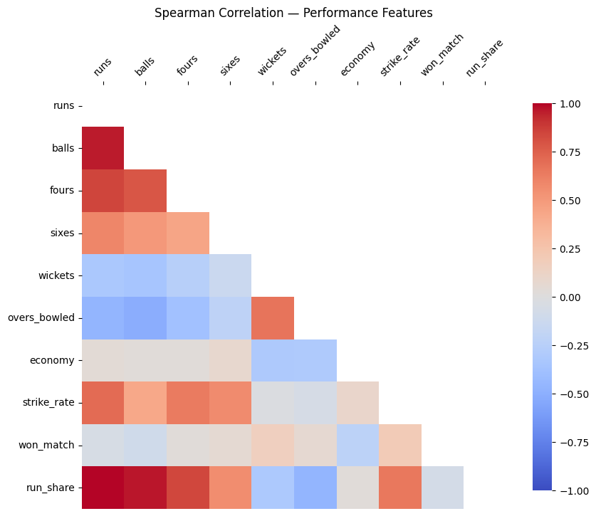
[3]  Feature Name Description Process  Game_ID A unique identifier for each match. Generated by combining league, season, and match number.  POTM (Target Variable) A binary flag (1/0) indicating if the player won the PotM award. Derived by comparing player name to the official PotM name.  Team_Won A binary flag (1/0) indicating if the player's team won the match. Derived from the official match winner record.  Team_Home A binary flag (1/0) indicating if the player's team was the designated home team. Derived from the official home team record.  Batter, Bowler, All_Rounder Binary flags indicating the player's role in the match. Determined by whether the player batted, bowled, or did both.  Run_Share Player's percentage of team runs scored. Calculated as Runs_Scored / Team_Total_Runs.  Wicket_Impact Exponential weighting of wicket counts. A transformation to capture the non-linear trend observed in the EDA. | [4]  scenario model top1 tpr recall sensitivity  scaled M1-EN 0.6896 0.6896 0.6896 0.6896  scaled M2-CondGLM(logit) 0.6896 0.6896 0.6896 0.6896  scaled M1-L2 0.6896 0.6896 0.6896 0.6896  raw M2-Binomial(loglog) 0.6825 0.6825 0.6825 0.6825  scaled M1-L1 0.6825 0.6825 0.6825 0.6825  raw M3-GAM 0.6730 0.6730 0.6730 0.6730  scaled M3-GAM 0.6730 0.6730 0.6730 0.6730  raw M4-RF(1200|leaf=2|mtry=sqrt) 0.6777 0.6706 0.6706 0.6706  raw M1-L2 0.6706 0.6706 0.6706 0.6706  raw M2-CondGLM(logit) 0.6706 0.6706 0.6706 0.6706  scaled M4-RF(1200|leaf=2|mtry=sqrt) 0.6754 0.6706 0.6706 0.6706  raw M2-Binomial(probit) 0.6682 0.6682 0.6682 0.6682  scaled M2-Binomial(probit) 0.6682 0.6682 0.6682 0.6682  zscore M3-GAM 0.6659 0.6659 0.6659 0.6659  raw M2-Binomial(cloglog) 0.6588 0.6588 0.6588 0.6588  zscore M1-L1 0.6588 0.6588 0.6588 0.6588  raw M1-EN 0.6564 0.6564 0.6564 0.6564  raw M1-L1 0.6564 0.6564 0.6564 0.6564  zscore M2-CondGLM(logit) 0.6564 0.6564 0.6564 0.6564  zscore M1-L2 0.6564 0.6564 0.6564 0.6564  zscore M4-RF(1200|leaf=2|mtry=sqrt) 0.6564 0.6540 0.6540 0.6540  zscore M1-EN 0.6540 0.6540 0.6540 0.6540  zscore M2-Binomial(probit) 0.6517 0.6517 0.6517 0.6517  zscore M2-Binomial(loglog) 0.6517 0.6517 0.6517 0.6517  zscore M2-Binomial(cauchit) 0.6209 0.6209 0.6209 0.6209  raw M2-Binomial(cauchit) 0.6114 0.6114 0.6114 0.6114  scaled M2-Binomial(loglog) 0.5758 0.5758 0.5758 0.5758  scaled M2-Binomial(cloglog) 0.5569 0.5569 0.5569 0.5569  scaled M2-Binomial(cauchit) 0.5237 0.5355 0.5355 0.5355  zscore M2-Binomial(cloglog) 0.4147 0.4100 0.4100 0.4100

[5]
scenario | model | top1 | top3 | mrr | ndcg3 | Group  logloss | brier | ece | Cal  slope | Cal  intercept | Entropy  mean | mass  dev_ind
raw | L1 | 0.6564 | 0.9005 | 0.7856 | 0.8011 | 1.1054 | 0.023 | 0.0098 | 1.3456 | 0.497 | 1.4757 | 0.398
scaled | L1 | 0.6825 | 0.9336 | 0.8142 | 0.8341 | 0.8846 | 0.0202 | 0.0074 | 1.3583 | 0.3776 | 1.1683 | 0.3319
zscore | L1 | 0.6588 | 0.9336 | 0.7964 | 0.8223 | 0.9561 | 0.0217 | 0.005 | 1.2164 | 0.2259 | 1.151 | 0.2643
raw | L2 | 0.6706 | 0.9384 | 0.8076 | 0.8312 | 0.8832 | 0.0202 | 0.0072 | 1.3711 | 0.3937 | 1.1787 | 0.3325
scaled | L2 | 0.6896 | 0.9336 | 0.8175 | 0.8364 | 0.8856 | 0.0203 | 0.007 | 1.3624 | 0.3825 | 1.1713 | 0.3333
zscore | L2 | 0.6564 | 0.936 | 0.7955 | 0.8226 | 0.9577 | 0.0218 | 0.0048 | 1.2125 | 0.2225 | 1.1521 | 0.2651
raw | EN | 0.6564 | 0.9005 | 0.7848 | 0.8005 | 1.1049 | 0.023 | 0.01 | 1.3444 | 0.4948 | 1.474 | 0.3976
scaled | EN | 0.6896 | 0.936 | 0.8176 | 0.8376 | 0.8853 | 0.0203 | 0.007 | 1.3615 | 0.3815 | 1.171 | 0.3327
zscore | EN | 0.654 | 0.936 | 0.7946 | 0.822 | 0.9565 | 0.0218 | 0.0048 | 1.2152 | 0.2249 | 1.1519 | 0.2647
raw | logit | 0.6706 | 0.9384 | 0.8076 | 0.8312 | 0.8832 | 0.0202 | 0.0072 | 1.3711 | 0.3937 | 1.1787 | 0.3325
scaled | logit | 0.6896 | 0.9336 | 0.8175 | 0.8364 | 0.8856 | 0.0203 | 0.007 | 1.3624 | 0.3825 | 1.1713 | 0.3333
zscore | logit | 0.6564 | 0.936 | 0.7955 | 0.8226 | 0.9577 | 0.0218 | 0.0048 | 1.2125 | 0.2225 | 1.1521 | 0.2651
raw | probit | 0.6682 | 0.9431 | 0.8055 | 0.8314 | 0.8644 | 0.0202 | 0.0043 | 1.299 | 0.2736 | 1.0507 | 0.3269
scaled | probit | 0.6682 | 0.9431 | 0.8055 | 0.8314 | 0.8644 | 0.0202 | 0.0043 | 1.299 | 0.2736 | 1.0507 | 0.3269
zscore | probit | 0.6517 | 0.9408 | 0.7952 | 0.8244 | 0.9536 | 0.022 | 0.0034 | 1.1515 | 0.1406 | 1.0588 | 0.2522
raw | cauchit | 0.6114 | 0.8744 | 0.7526 | 0.7665 | 1.3448 | 0.0256 | 0.0163 | 1.3233 | 0.6211 | 1.8158 | 0.588
scaled | cauchit | 0.5237 | 0.737 | 0.6498 | 0.6514 | 3.6033 | 0.0276 | 0.0126 | 0.1656 | -1.5783 | 0.8041 | 0.6588
zscore | cauchit | 0.6209 | 0.8981 | 0.7664 | 0.7868 | 1.2505 | 0.024 | 0.0155 | 1.323 | 0.6264 | 1.7691 | 0.4234
raw | loglog | 0.6825 | 0.9455 | 0.8133 | 0.8382 | 0.8735 | 0.0204 | 0.0027 | 1.2369 | 0.1878 | 0.9756 | 0.3115
scaled | loglog | 0.5758 | 0.8578 | 0.7299 | 0.741 | 1.3084 | 0.024 | 0.0042 | 0.8545 | -0.1531 | 1.1088 | 1.0987
zscore | loglog | 0.6517 | 0.936 | 0.7954 | 0.8224 | 0.9767 | 0.0222 | 0.0028 | 1.0869 | 0.0716 | 0.9996 | 0.2394
raw | cloglog | 0.6588 | 0.9313 | 0.7987 | 0.8214 | 0.9294 | 0.0207 | 0.0107 | 1.4216 | 0.514 | 1.2917 | 0.3379
scaled | cloglog | 0.5569 | 0.7393 | 0.6673 | 0.6636 | 2.1148 | 0.0263 | 0.0046 | 0.4398 | -1.3195 | 1.5105 | 0.4497
zscore | cloglog | 0.4147 | 0.5355 | 0.5133 | 0.486 | 3.0007 | 0.0322 | 0.0059 | 0.1991 | -2.2257 | 1.8021 | 0.5746
raw | GAM | 0.673 | 0.9502 | 0.8093 | 0.838 | 0.9027 | 0.0211 | 0.0024 | 1.0962 | 0.0892 | 0.9818 | 0.3703
scaled | GAM | 0.673 | 0.9502 | 0.8093 | 0.838 | 0.9027 | 0.0211 | 0.0024 | 1.0962 | 0.0892 | 0.9818 | 0.3703
zscore | GAM | 0.6659 | 0.9123 | 0.7955 | 0.8121 | 0.9846 | 0.0215 | 0.0024 | 0.9266 | -0.0691 | 0.8833 | 0.3077
raw | RF | 0.6777 | 0.9502 | 0.8108 | 0.8394 | 0.836 | 0.0195 | 0.0045 | 1.3381 | 0.2848 | 1.0268 | 0.3166
scaled | RF | 0.6754 | 0.9502 | 0.8093 | 0.8382 | 0.8367 | 0.0195 | 0.0045 | 1.3429 | 0.2884 | 1.029 | 0.315
zscore | RF | 0.6564 | 0.9218 | 0.7935 | 0.8149 | 0.8955 | 0.0204 | 0.0044 | 1.2335 | 0.2205 | 1.0493 | 0.2582

[6]
scenario | model | Auc  roc | tp | fn | fp | tn | tpr | recall | Sens  itivity | fnr | fpr | tnr | prevalence | accuracy | f1
raw | L1 | 0.9618 | 277 | 145 | 145 | 8493 | 0.6564 | 0.6564 | 0.6564 | 0.3436 | 0.0168 | 0.9832 | 0.0466 | 0.968 | 0.6564
scaled | L1 | 0.9769 | 288 | 134 | 134 | 8504 | 0.6825 | 0.6825 | 0.6825 | 0.3175 | 0.0155 | 0.9845 | 0.0466 | 0.9704 | 0.6825
zscore | L1 | 0.9746 | 278 | 144 | 144 | 8494 | 0.6588 | 0.6588 | 0.6588 | 0.3412 | 0.0167 | 0.9833 | 0.0466 | 0.9682 | 0.6588
raw | L2 | 0.977 | 283 | 139 | 139 | 8499 | 0.6706 | 0.6706 | 0.6706 | 0.3294 | 0.0161 | 0.9839 | 0.0466 | 0.9693 | 0.6706
scaled | L2 | 0.9768 | 291 | 131 | 131 | 8507 | 0.6896 | 0.6896 | 0.6896 | 0.3104 | 0.0152 | 0.9848 | 0.0466 | 0.9711 | 0.6896
zscore | L2 | 0.9745 | 277 | 145 | 145 | 8493 | 0.6564 | 0.6564 | 0.6564 | 0.3436 | 0.0168 | 0.9832 | 0.0466 | 0.968 | 0.6564
raw | EN | 0.9618 | 277 | 145 | 145 | 8493 | 0.6564 | 0.6564 | 0.6564 | 0.3436 | 0.0168 | 0.9832 | 0.0466 | 0.968 | 0.6564
scaled | EN | 0.9769 | 291 | 131 | 131 | 8507 | 0.6896 | 0.6896 | 0.6896 | 0.3104 | 0.0152 | 0.9848 | 0.0466 | 0.9711 | 0.6896
zscore | EN | 0.9746 | 276 | 146 | 146 | 8492 | 0.654 | 0.654 | 0.654 | 0.346 | 0.0169 | 0.9831 | 0.0466 | 0.9678 | 0.654
raw | logit | 0.977 | 283 | 139 | 139 | 8499 | 0.6706 | 0.6706 | 0.6706 | 0.3294 | 0.0161 | 0.9839 | 0.0466 | 0.9693 | 0.6706
scaled | logit | 0.9768 | 291 | 131 | 131 | 8507 | 0.6896 | 0.6896 | 0.6896 | 0.3104 | 0.0152 | 0.9848 | 0.0466 | 0.9711 | 0.6896
zscore | logit | 0.9745 | 277 | 145 | 145 | 8493 | 0.6564 | 0.6564 | 0.6564 | 0.3436 | 0.0168 | 0.9832 | 0.0466 | 0.968 | 0.6564
raw | probit | 0.9771 | 282 | 140 | 140 | 8498 | 0.6682 | 0.6682 | 0.6682 | 0.3318 | 0.0162 | 0.9838 | 0.0466 | 0.9691 | 0.6682
scaled | probit | 0.9771 | 282 | 140 | 140 | 8498 | 0.6682 | 0.6682 | 0.6682 | 0.3318 | 0.0162 | 0.9838 | 0.0466 | 0.9691 | 0.6682
zscore | probit | 0.9747 | 275 | 147 | 147 | 8491 | 0.6517 | 0.6517 | 0.6517 | 0.3483 | 0.017 | 0.983 | 0.0466 | 0.9675 | 0.6517
raw | cauchit | 0.9517 | 258 | 164 | 164 | 8474 | 0.6114 | 0.6114 | 0.6114 | 0.3886 | 0.019 | 0.981 | 0.0466 | 0.9638 | 0.6114
scaled | cauchit | 0.8364 | 226 | 196 | 196 | 8442 | 0.5355 | 0.5355 | 0.5355 | 0.4645 | 0.0227 | 0.9773 | 0.0466 | 0.9567 | 0.5355
zscore | cauchit | 0.9621 | 262 | 160 | 160 | 8478 | 0.6209 | 0.6209 | 0.6209 | 0.3791 | 0.0185 | 0.9815 | 0.0466 | 0.9647 | 0.6209
raw | loglog | 0.9774 | 288 | 134 | 134 | 8504 | 0.6825 | 0.6825 | 0.6825 | 0.3175 | 0.0155 | 0.9845 | 0.0466 | 0.9704 | 0.6825
scaled | loglog | 0.9377 | 243 | 179 | 179 | 8459 | 0.5758 | 0.5758 | 0.5758 | 0.4242 | 0.0207 | 0.9793 | 0.0466 | 0.9605 | 0.5758
zscore | loglog | 0.9751 | 275 | 147 | 147 | 8491 | 0.6517 | 0.6517 | 0.6517 | 0.3483 | 0.017 | 0.983 | 0.0466 | 0.9675 | 0.6517
raw | cloglog | 0.9758 | 278 | 144 | 144 | 8494 | 0.6588 | 0.6588 | 0.6588 | 0.3412 | 0.0167 | 0.9833 | 0.0466 | 0.9682 | 0.6588
scaled | cloglog | 0.7638 | 235 | 187 | 187 | 8451 | 0.5569 | 0.5569 | 0.5569 | 0.4431 | 0.0216 | 0.9784 | 0.0466 | 0.9587 | 0.5569
zscore | cloglog | 0.6588 | 173 | 249 | 249 | 8389 | 0.41 | 0.41 | 0.41 | 0.59 | 0.0288 | 0.9712 | 0.0466 | 0.945 | 0.41
raw | GAM | 0.974 | 284 | 138 | 138 | 8500 | 0.673 | 0.673 | 0.673 | 0.327 | 0.016 | 0.984 | 0.0466 | 0.9695 | 0.673
scaled | GAM | 0.974 | 284 | 138 | 138 | 8500 | 0.673 | 0.673 | 0.673 | 0.327 | 0.016 | 0.984 | 0.0466 | 0.9695 | 0.673
zscore | GAM | 0.9721 | 281 | 141 | 141 | 8497 | 0.6659 | 0.6659 | 0.6659 | 0.3341 | 0.0163 | 0.9837 | 0.0466 | 0.9689 | 0.6659
raw | RF | 0.978 | 283 | 139 | 139 | 8499 | 0.6706 | 0.6706 | 0.6706 | 0.3294 | 0.0161 | 0.9839 | 0.0466 | 0.9693 | 0.6706
scaled | RF | 0.9779 | 283 | 139 | 139 | 8499 | 0.6706 | 0.6706 | 0.6706 | 0.3294 | 0.0161 | 0.9839 | 0.0466 | 0.9693 | 0.6706
zscore | RF | 0.9766 | 276 | 146 | 146 | 8492 | 0.654 | 0.654 | 0.654 | 0.346 | 0.0169 | 0.9831 | 0.0466 | 0.9678 | 0.654

[7]
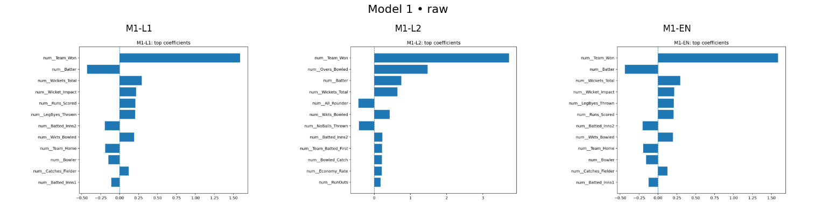
M1 – Coeff

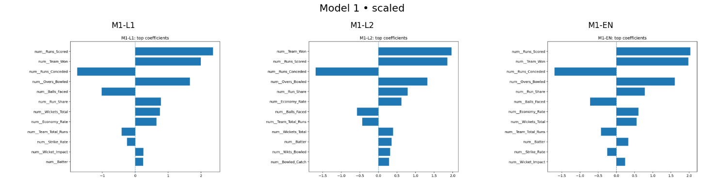
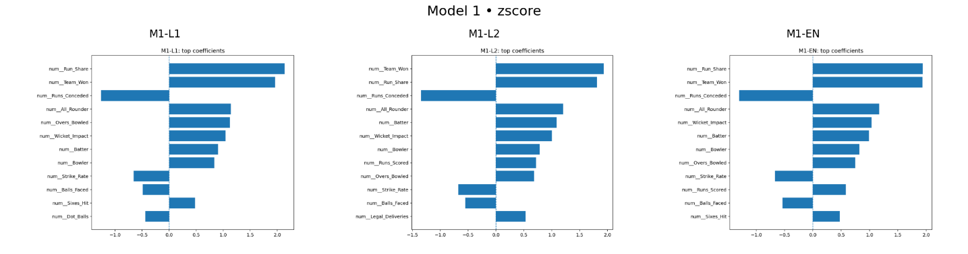

[8]
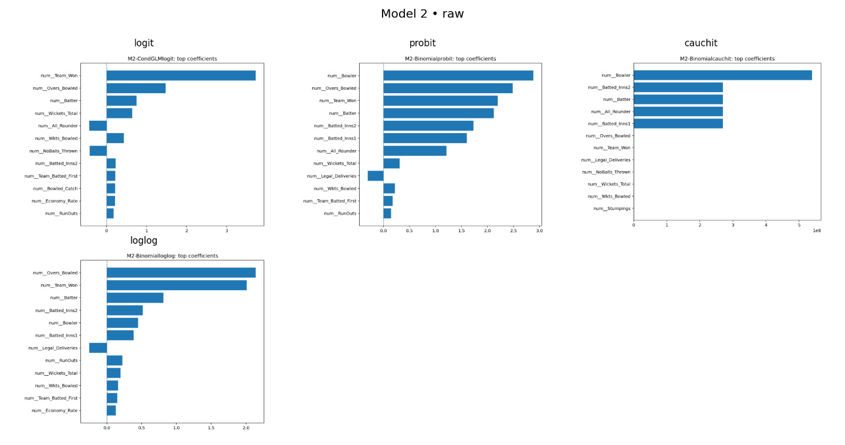
M2- Coeff

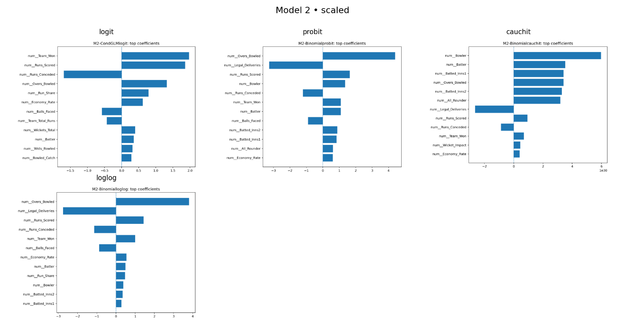

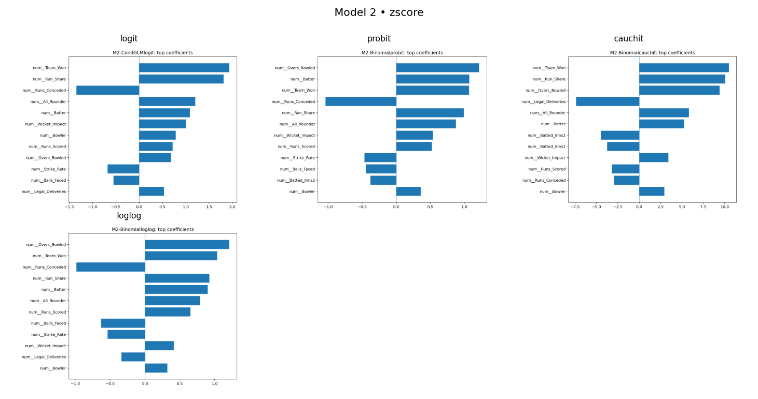

[9]
M3-coeff
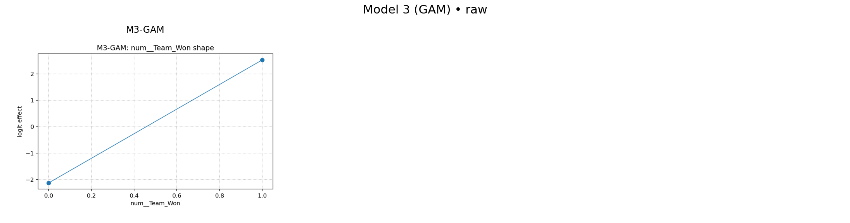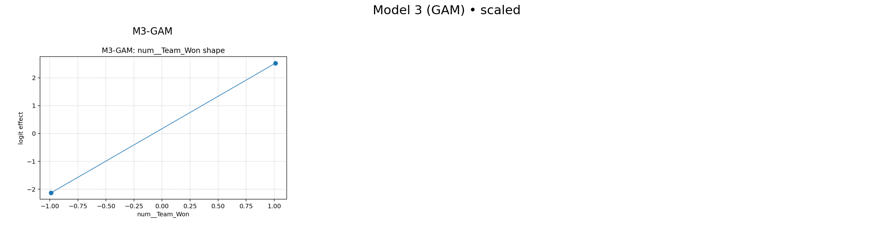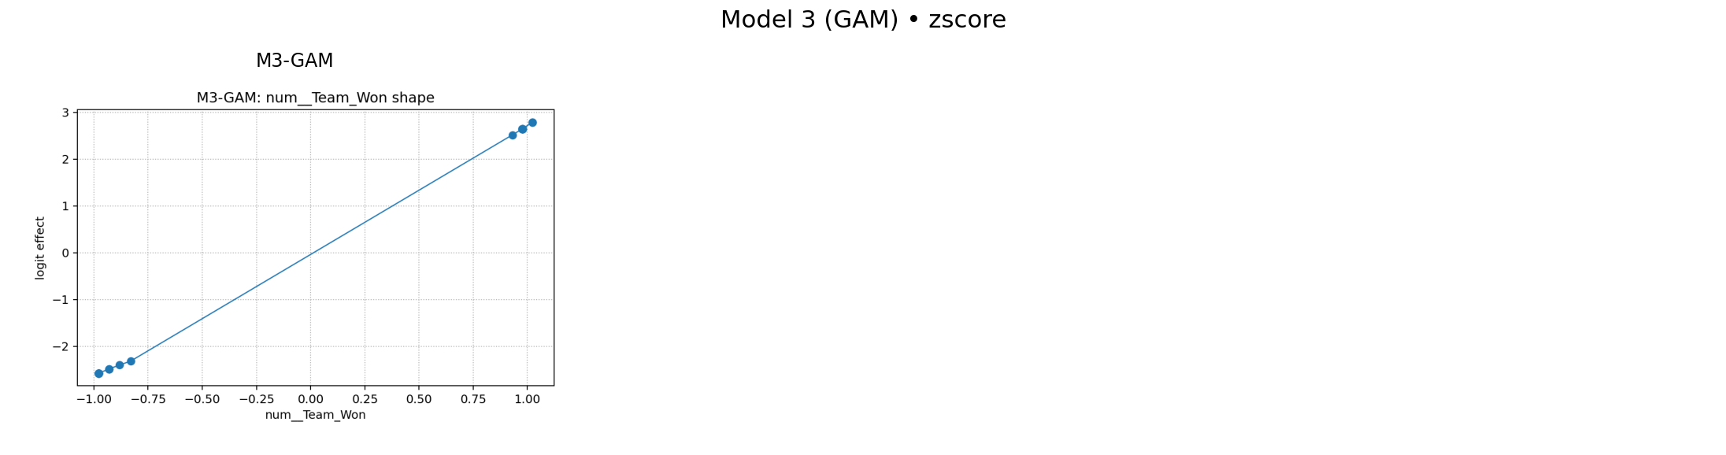

[10]

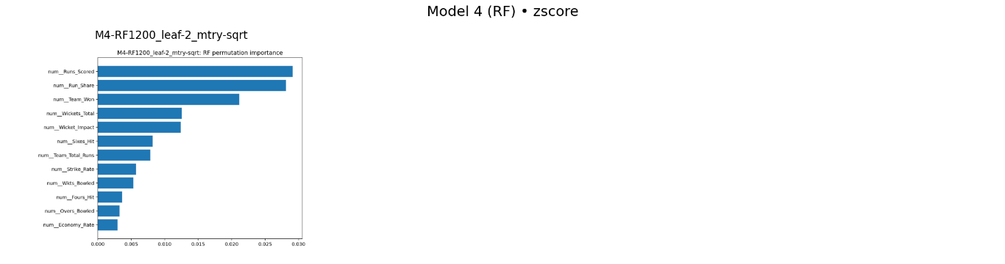
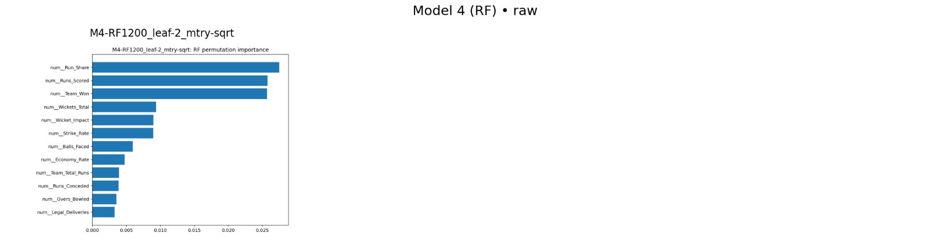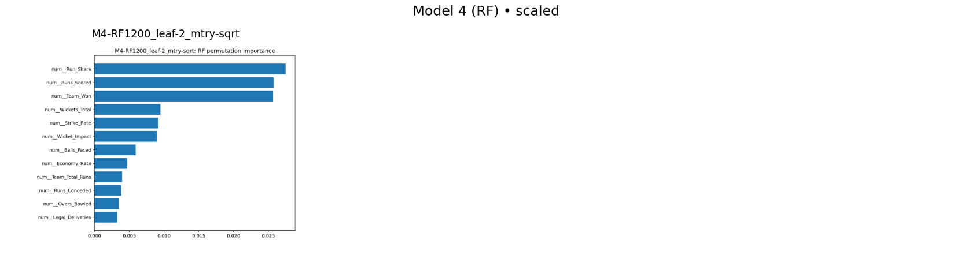
[11]  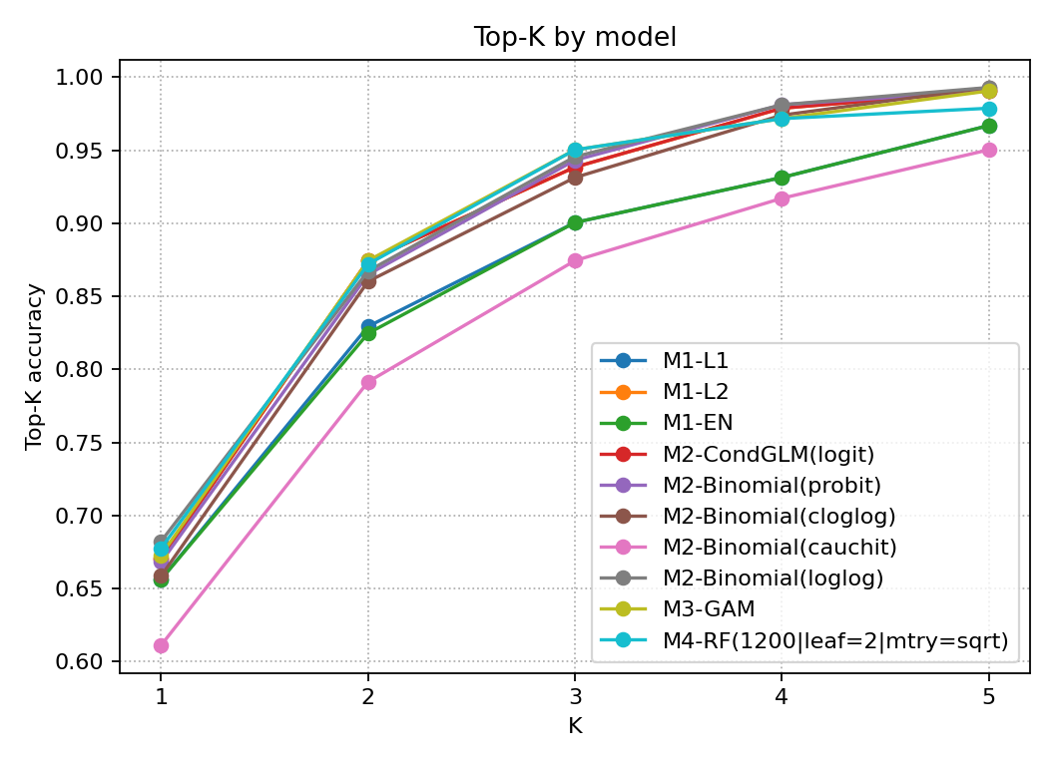  top – k - raw | 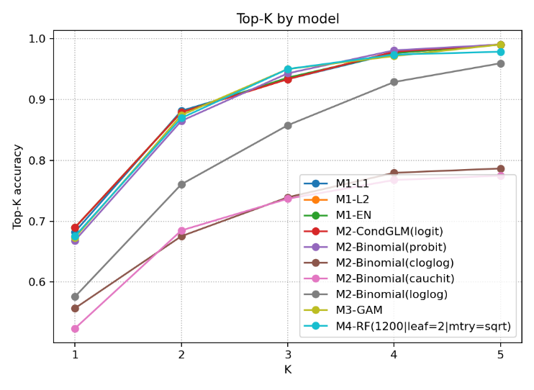  [12]  Top-k global features
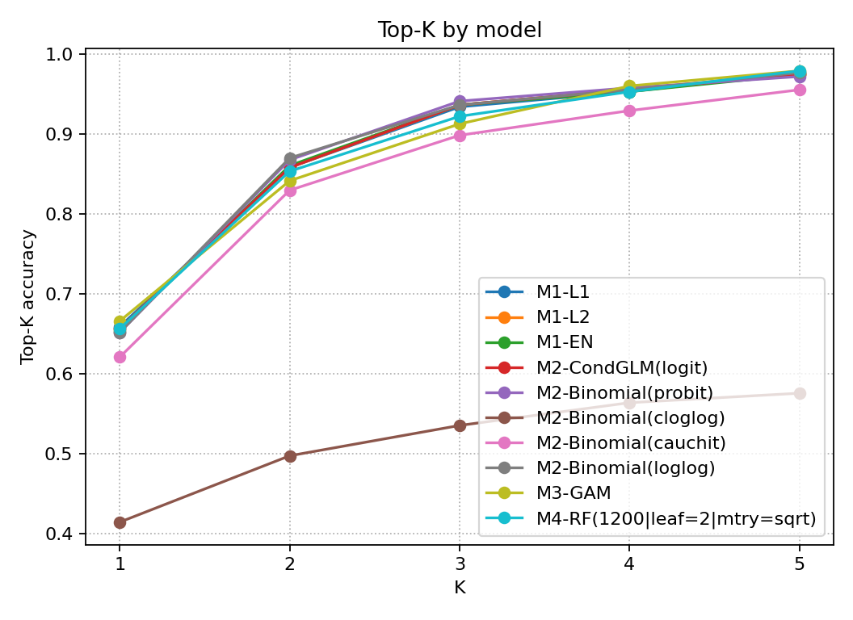
[13] top-k Z0score

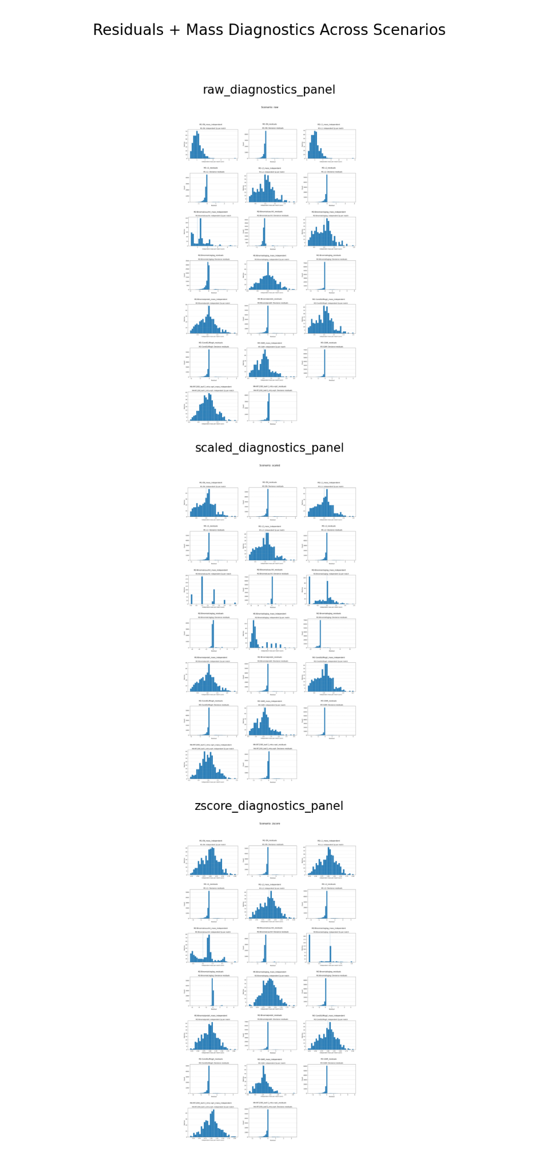
[15]
residuals

[16]

Mass charts
