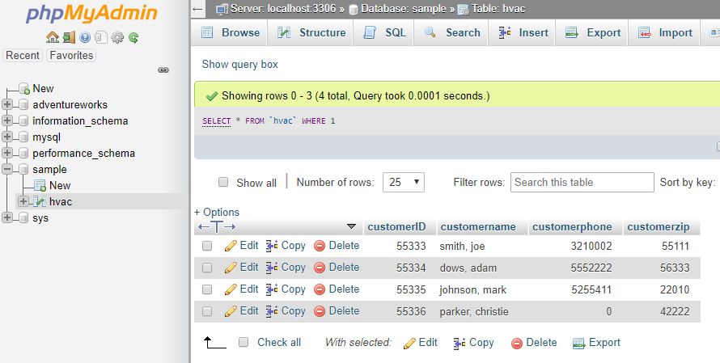

<http://sotd.us/brooklyndevroy/project/module3/DBConnection.php>

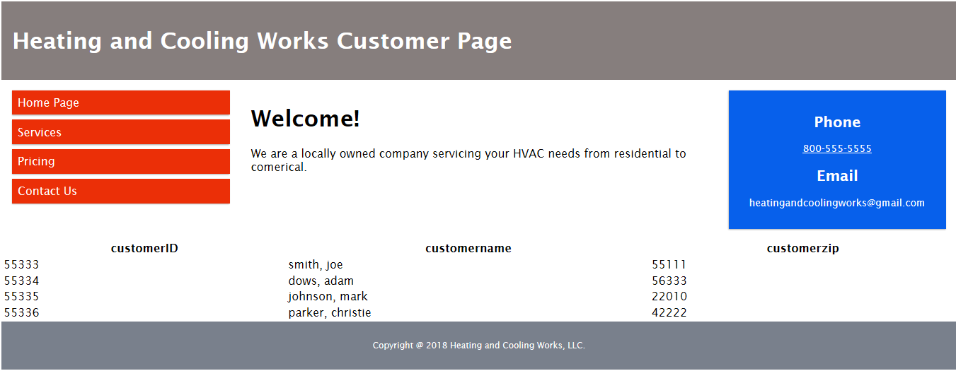

<http://sotd.us/brooklyndevroy/project/module3/CustomerPage.html>