Module 5 Project

Brooklyn Devroy

Rasmussen College

Author Note

This paper is being submitted on October 28, 2018, for Kris Jamsa CIS3801C Fundamentals of Mobile Web Application Development’s class.

Module 5 Project

**Original Site**

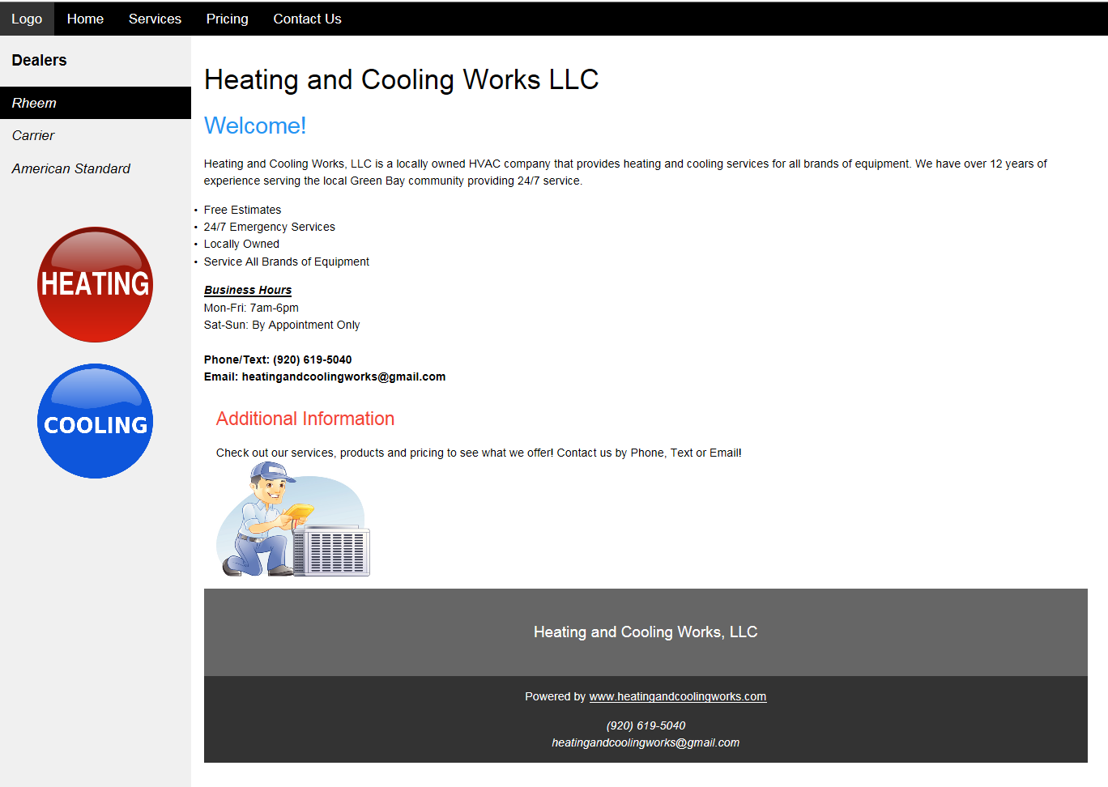

**CSS Change 1) Background Color Change**

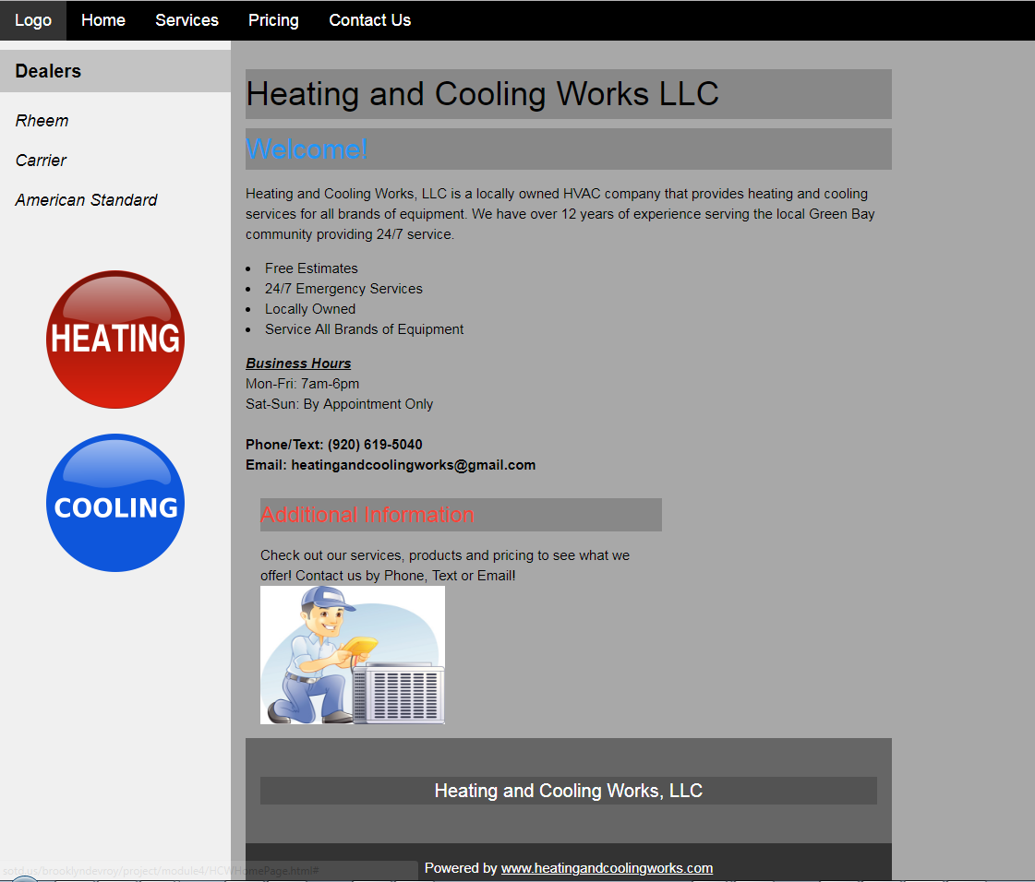

This view could be a little difficult for people to see because I have some gray colors already on the webpage. I think it looks better on a white background. By keep it on a white background it pops and is more crisp and clean.

**CSS Change 1) Font Change from Sans-Serif to Times New Roman**



I actually like this font a little better than my original font. I might change it permanently. You can choose from many different fonts but you want to make sure the fonts are legible and easy to read. You also want to make sure that any numbers can be read with the font you choose.

**CSS Change 1) Box Shadow**

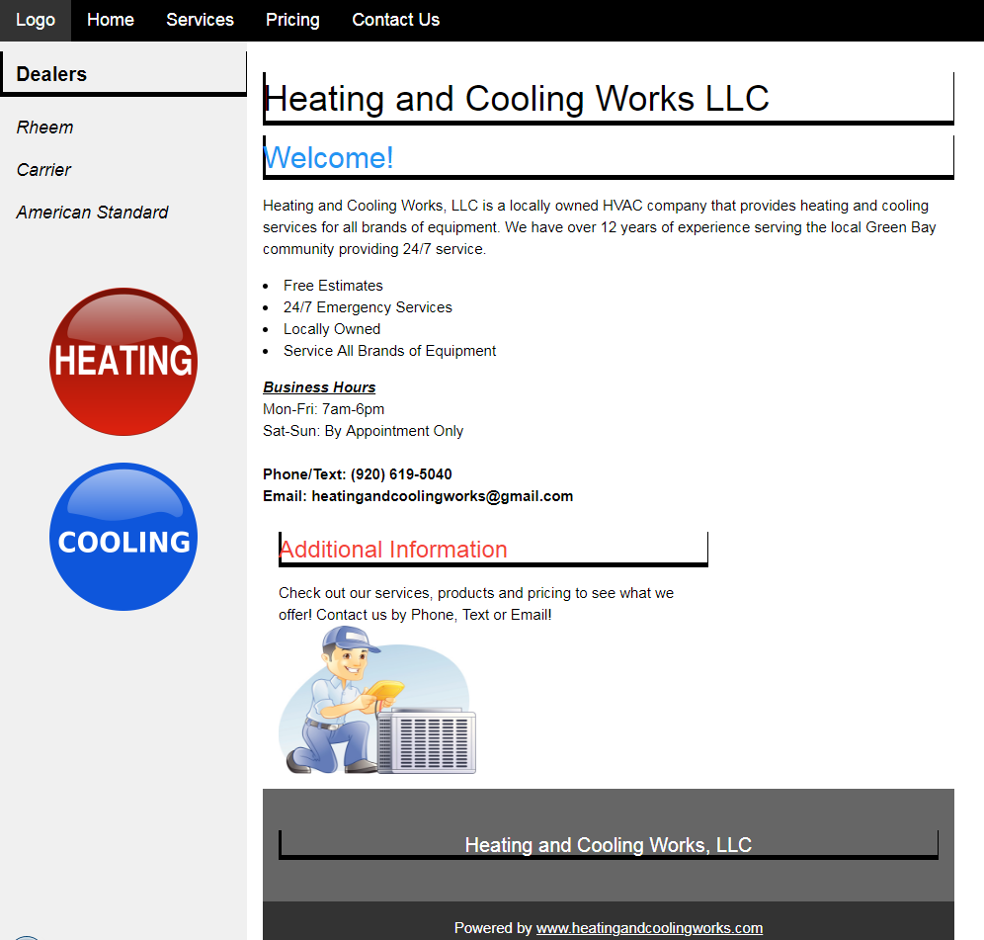

I was trying to get a box around the headers and I did but I do not think it looks good. It looks like partial lines and not a stand out type box I was looking for.

Some changes that show on the Chrome Developer tool page.

